

Component 2 - Research Report
Student Name: Ivaylo Georgiev
Student ID: 2128090
Teacher Name: Abdi Rahman
BMSW4003_BIRM
Digital Skills and Research Methods

Table of Contents
1. Introduction 3
2. Research Design 3
2.1 Research Question 3
2.2 Method 4
2.2.1 Research Philosophy 4
2.2.2 Data Collection Method 4
2.2.3 Data Sampling 4
2.2.4 Data Analysis 5
2.3 Ethical Considerations 5
3. Results 5
4. Discussion 9
4.1 Summary 10
5. Conclusion 10
5.1 Summary 10
5.2 Conclusion 11
6. Reference List 12
Appendix A 13
Survey Questions(screenshot) 14

1. Introduction
Technological factors are very popular nowadays and these are used in almost all sectors. People are used to using different digital tools to make a better approach to their jobs and this is also true for the students of UWTSD. Different digital tools are available for collaboration and educational approaches and most of the students are using these tools to make a proper up gradation. In short, this helps to make a better approach to every process and plan for any job.
According to Goldin et al. (2022), various digital tools are developed in this “industry 4.0” world and this makes a revolutionary change in all sectors. The educational system is also affected by this positively and students from different corners of the world are using these tools according to their comfort. One of the most important factors that the digital tools have served is a proper collaboration between different factors of learning and education. In the opinion of Amhaget al. (2019), digital tools are helpful to the students in particular situations and this can help the students as well as the educators to make a better approach to collaborative means. In short, the collaborative factors are always maintained by the digital tools and this can help the students to handle the factors properly.

2. Research Design
Research design can be taken as the framework of the whole research which serves the whole research process as proper guidance. This is important to make a proper idea about the factors related to the research aim and objectives which is the base of the whole research. One of the most important factors that can be described by the research design is the type of research method which serves the researcher a proper base to conduct the whole research (Dannels, 2018). This is one of the most important factors of a research paper and this must be mentioned by the researcher before research conduction. This research paper follows an observational research design focusing on the chosen topic and research objectives.

2.1 Research Question
The important research questions are as follows-
Which digital tool is most commonly used for collaboration at UWTSD?

2.2 Method
This is very important to ensure a proper research methodology to conduct proper and fruitful research. This is helpful for the researcher to choose a perfect research method before research conduction. This will help the researcher to align the whole research process and conduct the research methodically (Potter, 2018). This is helpful to understand the outcome of the research and make a proper assumption about the whole process. This research process follows a primary quantitative method to conduct the whole research.

2.2.1 Research Philosophy
This research project is conducted to make a proper assumption of the importance of different digital tools in UWTSD. The research project is focused on the essential digital tools that are important for all the activities in UWTSD. The research project aimed to find out the important beneficial factors of the tools and which tool the students are most comfortable with. The research project is important to understand the significance of the digital tools in UWTSD and how the features of the digital tool are helpful to UWTSD.

2.2.2 Data Collection Method
This is very important for any researcher to choose a proper data collection method that will help the person to make a better research project. The data collection method is the process to collect the important data and findings of the research to have a better result for the whole project (Arora et al., 2022). The data collection method is chosen according to the research aim and helps to find the authentic result. This research project follows the survey process to collect data to conduct the research.

2.2.3 Data Sampling
The data sampling method is defined as the process that helps to choose the proper information from the collected “big data”. This process serves a better understanding of the most important and relevant data for the research and helps the researcher to make a proper, aligned and focused research project (Song et al., 2021). Research data sampling also helps the researcher to manipulate the data and analyse it to the authentic result. This research project follows random data sampling to handle the collected data and research project.

2.2.4 Data Analysis
A proper data analysis method helps to make a proper understanding of the collected data and produce a proper result for the research project (Tsang et al., 2018). This is important for the researcher to choose a proper data analysis method so that the person can discuss and analyse the collected data according to the aims and objectives of the research project. This research project follows a quantitative data analysis technique to conduct the research project.

2.3 Ethical Considerations
This is important to maintain a proper ethical consideration for any research project. Proper ethical factors help to conduct the research by keeping the privacy of the research samples and avoiding the conflict of opinions (Suri, 2020). This also helps to maintain the codes of conduct throughout the research process and serve proper, safe and peaceful research conduction. One of the most important factors that are essential to follow in a research conduction process is to make better public relations with the interviewees and maintain privacy for all of them. This research process is conducted following the important codes of conduct and maintaining the privacy of the interviewees and serving a proper and friendly relationship with them.

3. Results
The important research results are as follows-
Q 01: “Do you use MS Teams more than other digital tools to work with your peers?”
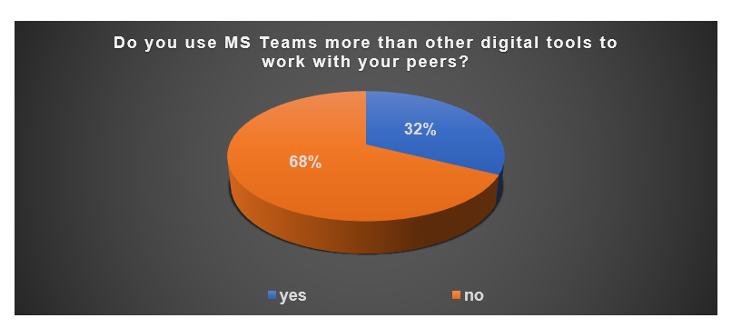
The result of this question has said that very few people from UWTSD are using MS Teams applications in their daily job. Most people are following other applications to handle their duty.
Q 02: “Do you use the OneDrive more than other digital tools to collaborate with peers?”
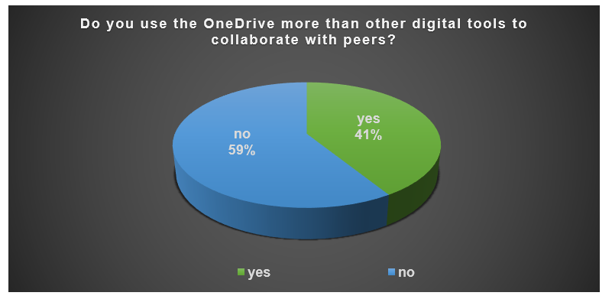
The result of this question has revealed that very few interviewees are using the OneDrive application. The rest of the interviewees are interested in other different applications.
Q 03: “Do you use WhatsApp more than other digital tools to collaborate with your peers?”
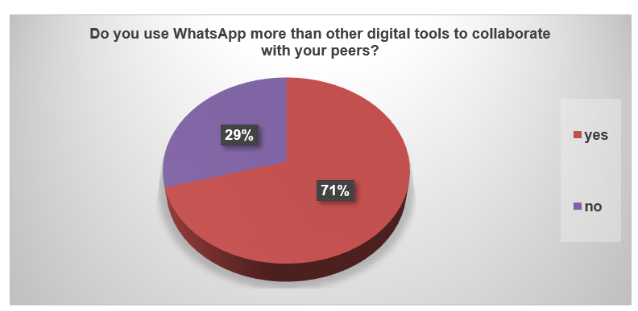
This result says that most of the people from UWTSD are using WhatsApp to contact others. Only 29% of the whole interviewees are not using WhatsApp.
Q 04: “When collaborating with peers do you use one digital tool more than others?”
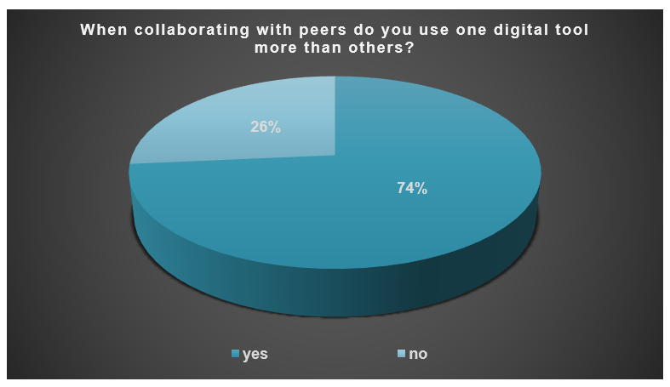
The result of this question has said that most of the interviewees are using a single application more than others to collaborate with their peers. However, some of the interviewees (26%) are also using different tools to collaborate.
Q 05: “Rank these applications in order according to how frequently you use them to collaborate with others.”
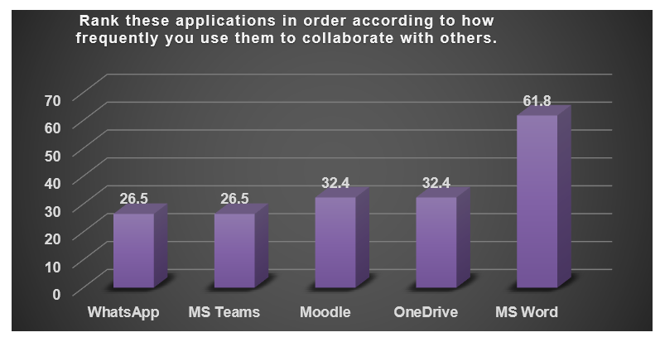
The result of this question has revealed that most of the interviewees are using MS Word more frequently than other applications. Moodle and OneDrive are used by some people. Only a few people are interested in WhatsApp and MS Teams.
Q 06: “Rank these applications according to how frequently you use them to collaborate with others.”
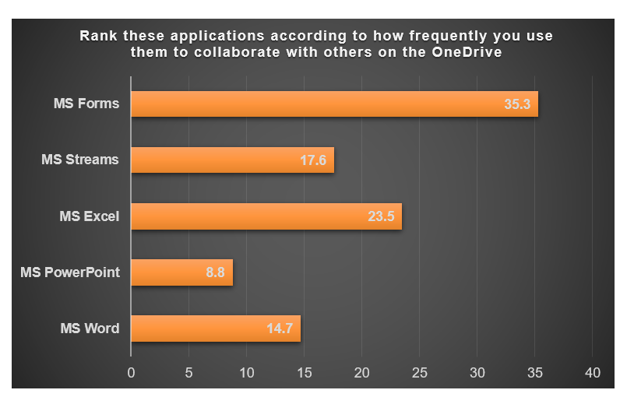
This result has revealed that MS Form is used most frequently by the interviewees to collaborate with others. MS Excel is used a little less than MS Forms and 23.5% of people are using it for collaboration. MS Streams and MS Word are used most rarely, only 17.6% and 14.7% respectively.

Q 07: “State how strongly you agree or disagree with the statements below.”
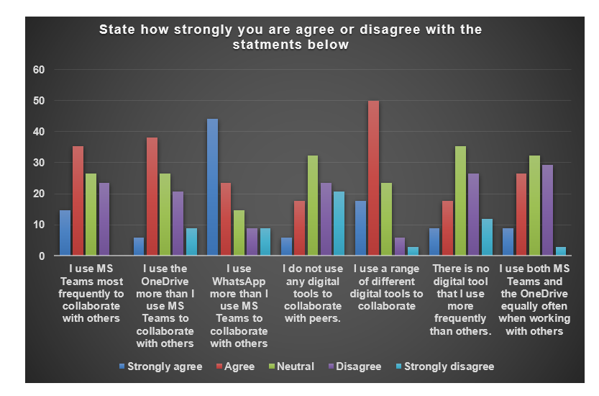
This result said that the interviewees usually agreed with the fact that they use a different digital tool to collaborate with peers. This result has also said that the peers have different opinions about digital tools.

4. Discussion
The result of the research process serves as a better assumption of the aims and objectives of the research. This makes a better idea about the research topic and this serves as a better assumption of the research outcome answering the research questions. The important discussion of the research outcomes is as follows-
The result of the research project has revealed that the students of UWTSD are using different digital tools to handle the different factors of their study. Pupils of UWTSD are using digital tools like MS Word, WhatsApp, OneDrive, MS Excel and other digital applications to collaborate with their peers. The research result also revealed that the students of UWTSD use the tools to make a proper collaboration with peers and this helps to make a better idea about the factors that serve them good understanding. The research result also makes a better idea about the importance of these digital tools which are used by peers. The result has also revealed that the peers have used the tools to collaborate and this is helping them to make the proper approach.
From the result, this can be said that the students are using a particular digital tool more often than the other tools. This is because the tool is more handy, easy and frequent than the other tools and helps the students to make a proper collaboration. According to the result, the students are using “MS Word” to collaborate on the digital platform. This reveals that they found this tool more fruitful than others and they are trying to make a better approach to collaborative study using this tool. This serves the opinion of Goldin et al. (2022) that says people usually use digital media according to their needs and comfort.
Another very important factor revealed from the result is that the students more frequently use “MS Forms” to collaborate through OneDrive. This serves the idea that they have found this tool more responsive and fruitful than others to make a better approach to collaborating with others. Most importantly, the students have found this tool safer than other tools which helps them to handle the factors of education. In short, the tool helps them to make a better approach to the collaboration process and serves the students a proper approach to the educational process. This supports the idea of Amhaget al. (2019) that people use different tools to collaborate in different situations and possibilities.

4.1 Summary
Different collaborating tools are used by students of UWTSD and these tools are useful to make a better collaboration for them. These tools are used according to the importance and ease of the students and help to maintain a proper collaboration between them. The research result serves some important factors about the tools that are used by the students of UWTSD and serve a better idea about the importance of it. The discussion has revealed that the students use a particular tool in a particular situation to collaborate with others. The discussion found similarities with literary articles on the same topic.

5. Conclusion

5.1 Summary
The research project has revealed the importance of collaborative digital tools in education and helped the researcher to understand which tools are used more frequently by the students of UWTSD. This research project also served the idea that the students are using a better collaborative approach with these tools and they are having the ease to their educational approach. This research project has also revealed that the students are using different tools in different situations which serves a better collaboration in that particular situation.

5.2 Conclusion
The use of digital tools in education is a very popular approach nowadays and this serves a better outcome of the whole process. This is very important to any educational institution to ensure collaboration to peer-to-peer as well as student-to-educator approaches and the digital tools are helpful to handle these. One of the most important factors that are important to follow is to understand the importance of a particular tool to make a better collaboration. This research project served a proper idea of the digital tools used by the students of UWTSD and the importance of these tools in collaboration.

6. Reference List
Amhag, L., Hellström, L. and Stigmar, M., 2019. Teacher educators’ use of digital tools and needs for digital competence in higher education. Journal of Digital Learning in Teacher Education, 35(4), pp.203-220.
Arora, S., Batra, I., Malik, A., Luhach, A.K., Alnumay, W.S. and Chatterjee, P., 2022. Seed: secure and energy efficient data-collection method for IoT network. Multimedia Tools and Applications, pp.1-15.
Dannels, S.A., 2018. Research design. In The reviewer’s guide to quantitative methods in the social sciences (pp. 402-416). Routledge.
Goldin, T., Rauch, E., Pacher, C. and Woschank, M., 2022. Reference architecture for an integrated and synergetic use of digital tools in education 4.0. Procedia Computer Science, 200, pp.407-417.
Potter, A., 2018. Managing productive academia/industry relations: the interview as research method. Media Practice and Education, 19(2), pp.159-172.
Song, Q., Li, T., Fong, S. and Wu, F., 2021. An ECG data sampling method for home-use IoT ECG monitor system optimization based on brick-up metaheuristic algorithm. Mathematical Biosciences and Engineering, 18(6), pp.9076-9093.
Suri, H., 2020. Ethical considerations of conducting systematic reviews in educational research. Systematic Reviews in Educational Research, pp.41-54.
Tsang, K.W., Rollier, M., Ghosh, A., Samajdar, A., Agathos, M., Chatziioannou, K., Cardoso, V., Khanna, G. and Van Den Broeck, C., 2018. A morphology-independent data analysis method for detecting and characterizing gravitational wave echoes. Physical Review D, 98(2), p.024023.

Appendix A

Survey Questions
- “Do you use MS Teams more than other digital tools to work with your peers?”
- “Do you use the OneDrive more than other digital tools to collaborate with peers?”
- “Do you use WhatsApp more than other digital tools to collaborate with your peers?”
- “When collaborating with peers do you use one digital tool more than others?”
- “Rank these applications in order according to how frequently you use them to collaborate with others.”
- “Rank these applications according to how frequently you use them to collaborate with others.”
- “State how strongly you are agreeing or disagree with the statements below.”



