Skye Turner
1902886
Applied Drama: Education, Well-being, Community

Task 1 - Julia Lockheart-Manifesto Writing: “What do I believe in?”
We no longer NEED gay bars. 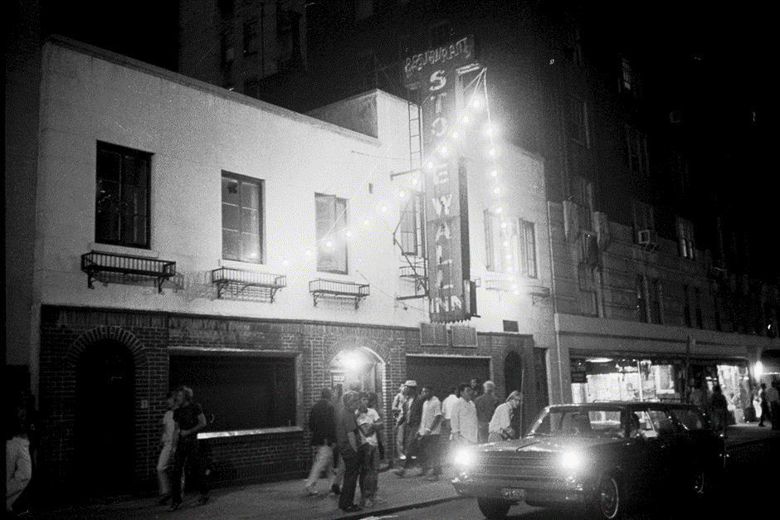
Do we need gay bars? Gay bars were cultivated during a time when being gay was not okay. A stereotypical gay bar in the 1960’s had blacked out windows, a closed door and strict door-staff. This dark idea of a gay bar was overpowered by what a gay bar meant to people. Larry Beck describes LGBT+ bars in the 1960’s as a fortress of solitude for the gay youth of the time who were disadvantaged due to their sexuality:
“LGBT bars were social centers where people felt a sense of kinship with others like them, where they could know that they weren’t alone. Many LGBT youth had been thrown out of the house by their parents and some disowned. So the bars provided a haven of solace, acceptance, and perhaps a chance to find love.” (Beck, 2019, p. 36)
The story of the Stonewall riots is infamous and is arguably what kicked off today’s LGBT+ rights even in the UK. The Stonewall riot/rebellion marks the day that gay people fought back in 1969.
A video called “Being gay in the 1960’s” (https://www.youtube.com/watch?v=1McOv2ZoUgk) highlights how the media portrayed the most negative image of gay people to society, referring to as gay people as ill and “sexual deviants.” Historically, being gay has left people as inequal but what about today? Fast forward 50 years from the Stonewall riots to 2019 where we hold annual Pride marches throughout the UK; are gay people still at a disadvantage?
It’s safe to say that gay bars because they needed to be. In the sense that a gay person was unwelcome in any other place, for some, even at home. Now we have same-sex marriage and laws against discrimination. We convict people for homophobia, and we see LGBT+ people more and more in our media. Do we still need our own place of solitude? I asked myself this question when I heard somebody ask, should we have trans bars?
I don’t believe that we should begin to open trans bars the same way we have gay bars simply because there is some transphobia in the UK. I think that completely trivialises what gay bars were for. The Stonewall inn existed because it’s customers could not walk in the street safely and there was nowhere to go. However gay bars usually welcome everybody, whether they’re Trans, Cis, Gay, Straight or bi.
Do we need gay bars? The short answer is “no.”
So, are we beyond gay bars? No! We may be beyond the need for gay bars. However, we should definitely not start ruling them out of our weekend plans as going to a gay bar holds a completely different night in store for you than if you were to go to a regular bar. With frequent drag acts, “gay” music, relatable people, a few hen parties and a hint of drama, you know that you can enjoy your entire night on the gay scene.

Reference list:
- Beck, Larry. (2019) "The Stonewall Riots: Then and 50 Years Later." Legacy (National Association for Interpretation) 30.1 (2019) Web.
- Morgan, Richard. "The American Gay Bar Is Down, But Don't Count It Out Just Yet." Bloomberg.com (2019): N.PAG. Web.
- Morgan, Richard. "The American Gay Bar Is Down, But Don't Count It Out Just Yet." Bloomberg.com (2019): N.PAG. Web.
Statements:
- We shouldn’t promote bad health
- Capitalism is key.
- Feminism has changed.
- Reversed Racism doesn’t exist.
- We should have free speech.
- Cannabis should be legal.
- Gay bars are redundant.
- There is a binary.

Task 2 - Jon Pugh-Reflective Writing: Do you know what you think?
Pride flag
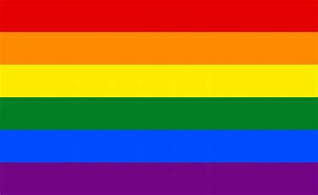
The gay flag, the pride flag, the LGBT+ flag, the queer flag, the rainbow flag, whatever you call this flag, you what it represents. It represents every person in the world who is a minority due to their gender identity and/or sexuality. Every year around the time of the pride march, businesses will stock up with rainbow merchandise and will add rainbow to all of their branding.
So when you see this bright flag waving, or a Pride labelled beanie you would probably guess that it is supporting the LGBT+ movement. However, that’s not always correct. A lot of the time, large companies will target the community in hopes for large profit. A question asked within the LGBT+ community is whether large companies should Capitalise from the movement. Rachel Lubitz from Mic.com wrote an article on the topic that is so frequently discussed within the LGBT+ community. She pointed out how businesses could change that opinion and stated that “Rather than being a company that, for instance, creates a rainbow Oreo meme as a sign of support for Pride Month, Nike has taken things one step further and ensured that it's not just a company that supports the LGBTQ communities visually, but offers the chance for its consumers to feel like they're making a difference.” (Lubitz, 2016)
She proceeds to point out clothing companies that are doing the right thing and speaks about Nike’s “Be True Collection” that donated profits from it’s rainbow/pride themed merchandise to LGBT+ charities whereas there are many companies out their making mass profit through a liberation movement.
It’s important to remember why we have the flag. The original flag was first designed to move away from the pink triangle that represented gay rights. This is what gay people were forced to wear by Nazis during the holocaust and though it may be “reclaimed” now, people did not want to rally an Nazi concentration badge back when the flag was designed in 1978.
According to Time.com, Gilbert Baker, who was the designer of the original flag said “We needed something that expressed us. The rainbow really fits that, in terms of: we’re all the colors, and all the genders and all the races,” he says. “It’s a natural flag; The rainbow is in the sky and it’s beautiful. It’s a magical part of nature. (Zorthian, 2015)
So, I have a bright flag with an abundance of history representing my closest community but why exactly is it so significant to me? I try to keep my queer experience out of everyday life as it shouldn’t define me yet I walk around flaunting s a bright rainbow tattoo on my arm. The rainbow has never really immediately affected and to some is just a bunch of colours but this flag is what myself and many likeminded people are drawn towards. You see that flag and can feel safe and know that people died for equality and that flag memorises them as well as celebrates what they achieved and what is to follow.

Reference list:
- Zorthian, Julia. (2015) ‘How the Rainbow Flag Became an Icon of LGBT Rights’, Time.com.
- Lubitz Rachel. (2016) ‘Why Brands Shouldn't Just Focus on the Rainbow During LGBTQ Pride — But the Cause Itself’, Mic.com
- Moura, Fabiola. "Brazil's Biggest Employer of Trans People Flies Its Pride Flag." Bloomberg.com (2019): N.PAG. Web.
- Gianfortune, Ross. "Play of the Day: The Pride Flag Is Not Going On Embassy Flagpoles." Government Executive (2019): N.PAG. Web.
- Goldberg, Hannah. "Starbucks Raises the Pride Flag Above Seattle Headquarters." Time.com (2014): 143-44. Web.

Task 3 - Ryan Moule-Observational Writing: Identify an image and write a semiotic analysis.
OMG
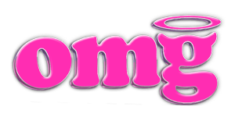
OMG! This is the logo of an LGBT+ bar & club company based throughout many cities within the UK including Liverpool, Bristol and Plymouth. Their logo can be seen on every menu and its bright pink highlight contrasts the venues black walls which is what makes an OMG venue stand out. But what exactly does this logo show?
Firstly, the unbalanced O. The O is one of those things that may go unnoticed to those drinking withing the venue. It may even be mistaken for a technical error however this slight change is another example of the uniqueness of the logo. Being known as a gay bar can lead to all of the regular anti-LGBT+ slurs such as “bent.” Was this slight technicality with the O a reference to being called bent? Is this what catches new customers eyes or is it that G?
Moving onto the G and looking into this acronym, what does this G stand for. According to Urban Dictionary’s number 2 answer, OMG stands for Oh my god and is known for its use in text talk.
After speaking to customers of the company, their seems to be a discussion as to whether the G actually stands for “Gay” and is simply a play on words for the well-known acronym. Could OMG actually be “Oh My Gay?” Needless to say, the G, with its horns and halo, is definitely the most eye-catching letter in the logo.
The G in some ways can represent the “smiling imp” emoji which looks like a purple horned face. This, according to Allison P. Davis from the CUT, is sometimes used to represent somebody feeling “horny.” She leaves this to reader interpretation though stating: “How you express your horniness is a personal choice unto you…” (https://www.thecut.com/2017/05/which-emoji-face-is-the-best-for-sexting.html)
However you choose to portray your horniness via message, there is no denying that some people definitely go with this emoji.
So why did the company go with the horny idea? Gay bars have had their fair few changes since the 1969 Stonewall riots with their now open-door policy since the legalisation of homosexuality yet they are still sometimes perceived as sexual, and continue to have an overly sexualised stigma put onto them.
Is this G another example of the company using stigma as a means to “take back” negative stigma within their business? Do the horns just contrast the halo above? Maybe the 2 together resemble the diversity of the company’s customers, proving that not all within a gay bar may be the horny “smiling imps.”
And finally, the most eye-catching part of the logo, the bright pink hue. Colour can mean a lot. Pink is widely perceived in modern day society as a feminine colour. Though society has attempted to drift off from gendered colours, there is no denying the vernacular surrounding the colour pink.
All of the OMG company, from staff to décor, from the logo to their aimed customer, is camp. I believe their use of the bright pink is supposed to represent the femininity and campness that pink is widely known for.
The entire logo is the companies hint at terms that are widely known regardless of the negative connotations.
Reference list:
- https://www.color-meanings.com/pink-color-meaning-the-color-pink/
- "SYMBOLIC MEANING OF COLOURS." Bow Bells : A Magazine of General Literature and Art for Family Reading 2.34 (1865): 180. Web.
- https://www.thecut.com/2017/05/which-emoji-face-is-the-best-for-sexting.html
- http://www.omgclubs.com/
- https://web-b-ebscohost-com.ezproxy.uwtsd.ac.uk/ehost/pdfviewer/pdfviewer?vid=1&sid=eba80233-6c42-4795-bda6-fefc20b07480%40pdc-v-sessmgr05
- http://acronymsandslang.com/OMG-meaning.html
- https://www.urbandictionary.com/define.php?term=Omg

