

MODULE CODE: Digital Skills for Personal Development and Business Growth BMSW4008

ASSESSMENT COMPONENT: PORTFOLIO

STUDENT NAME: Conor Pullen

STUDENT NUMBER: 2528764

LECTURER: Manjit

DATE: 16/03/26
Contents
Task 1 3
Assessment of Digital Skills 3
References 3
Task 2 4
LinkedIn Learning Certificates for Office365 4
Task 3 5
Essay on Relevance of Excel in professional and personal life. 5
References 5
Task 4 6
7 Minute Reflective Presentation 6
References 6

Task 1

Assessment of Digital Skills
Portfolio Example
Image 1
Screen shot of your JISC report
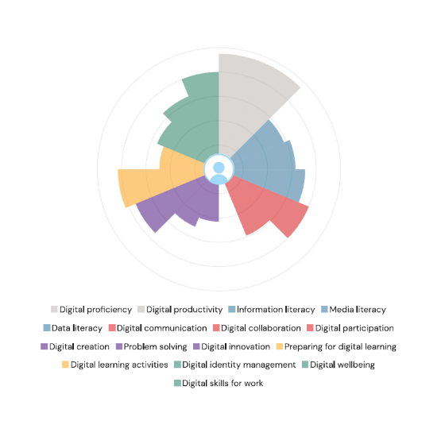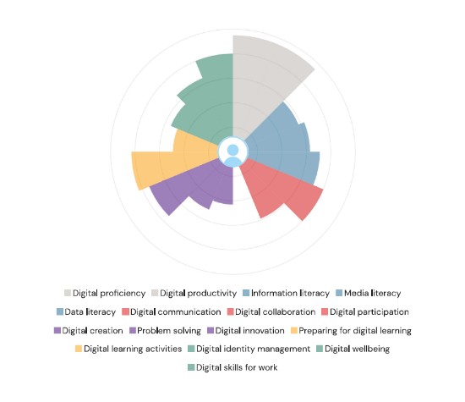

Digital skills have become essential for effective learning, employability, and participation in an increasingly technology-driven society. Higher education now relies heavily on virtual learning environments, online communication, digital research tools, and data-driven decision-making. As highlighted in the JISC framework, digital capability encompasses a broad range of competencies that enable learners to “use digital devices, networks, applications, software and services” confidently and critically (2nd JISC Report). Developing these skills is therefore fundamental not only for academic success, but also for future professional practice.
My two JISC Digital Capability reports, completed in January and March 2026, provide a clear picture of my current strengths and areas for development. Across both assessments, I consistently scored at a Proficient level in several areas, including digital proficiency, data literacy, digital creation, and preparing for digital learning. For example, the second report notes that I “might be able to earn digital badges or more formal accreditation” due to my strong proficiency. These results indicate that I am confident in navigating digital tools, producing digital content, and managing my learning environment effectively.
There is also evidence of improvement between the two assessments. In January, I was rated Developing in digital participation, but by March this had increased to Proficient. The first report encouraged me to “set aside a time each day when you deal with social media” and to begin engaging with professional networks. The later report suggests that I acted on this guidance, becoming more confident in contributing to online communities and building digital networks.
Two clear strengths emerge from the reports. First, data literacy is consistently identified as an area of high confidence. The second report states that I should “use your interest in data where you can in your coursework,” highlighting my ability to analyse, interpret, and present data effectively. This strength is valuable for academic research, where data-driven arguments and evidence-based decision-making are essential. Second, digital creation is another strong area, with both reports rating me as Proficient. The second report guidance encourages me to “look for opportunities to bring digital creativity into your coursework,” demonstrating that I already possess the skills to design digital artefacts, visualisations, and multimedia content. These capabilities support effective communication and enhance the quality of academic outputs.
The reports also identify two weaker areas that require targeted development. First, digital productivity; rated Capable rather than Proficient in both assessments. The second report advises me to “monitor the time you spend on different applications” and to improve my organisation of files, bookmarks, and workflows. This suggests that although I can use digital tools effectively, I could benefit from refining my efficiency and adopting more structured digital habits. Second, digital communication; rated Capable. The second report highlights the need to “reflect on how you deal with conflict in online communications” and to engage more confidently with diverse audiences. Strengthening this skill will support clearer, more professional communication in academic and workplace settings.
To address these weaker areas, I have developed two SMART goals. The first is to improve digital productivity through structured workflow management, where I will implement a consistent digital organisation system using OneDrive and Outlook, aiming to reduce the number of unorganised files and emails by 80%. This is achievable through the use of built-in tools such as folders, tags, and automated rules, and is directly relevant to my JISC-identified productivity weakness, with a time frame of eight weeks for completion. The second goal is to strengthen digital communication by practising professional online engagement, which involves participating weekly in at least one academic or professional online discussion space, such as LinkedIn groups or course forums, and contributing a minimum of one meaningful post or comment per week. This is achievable because these platforms are already available to me, and it aligns with the report’s recommendation to improve communication with diverse audiences, with the intention of maintaining this practice for twelve consecutive weeks.

Improving my digital capability will have a direct impact on both my academic performance and future career. Enhanced productivity will enable me to manage deadlines, research tasks, and digital resources more efficiently, while stronger communication skills will support effective collaboration and professional networking. As digital expectations continue to grow across all sectors, developing these competencies will ensure that I remain adaptable, confident, and competitive in the workplace.

Task 2

LinkedIn Learning Certificates for Office365
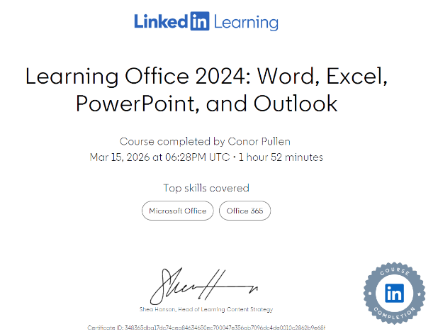

Task 3

Essay on Relevance of Excel in professional and personal life.

Microsoft Excel has become one of the most influential digital tools of the modern era, shaping how individuals and organisations manage, analyse, and interpret data. Since its introduction, Excel has evolved from a basic spreadsheet application into a sophisticated analytical environment capable of supporting financial modelling, automation, data visualisation, and decision-making across multiple sectors. Its continued relevance is driven by the increasing importance of data literacy, the growth of digital workplaces, and the demand for efficient, accurate, and flexible analytical tools. As a result, Excel remains a core component of modern digital skills, underpinning professional practice in business, finance, education, research, and administration.
One of Excel’s most significant strengths is its ability to support interactive data visualisation. Modern organisations rely heavily on dashboards to monitor performance, track key metrics, and communicate insights. Olafusi and Oyinbooke (2024) highlight how Excel’s dashboarding capabilities have expanded through Microsoft 365, enabling users to build dynamic, interactive dashboards that integrate formulas, charts, slicers, and automation. These dashboards allow decision-makers to interpret complex datasets quickly, making Excel a vital tool for real-time business intelligence. The accessibility of these features means that users without specialist programming knowledge can still create professional-level visual analytics, reinforcing Excel’s role as a widely accessible analytical platform.
Excel’s importance is also evident in its capacity for automation through Visual Basic for Applications (VBA). Automation reduces repetitive tasks, minimises human error, and increases efficiency. Amalfitano et al. (2016) emphasise that VBA-based spreadsheet applications are widely used in industry, yet often complex and difficult to understand. Their research demonstrates the need for tools that help users comprehend and maintain VBA-driven spreadsheets, highlighting how deeply embedded Excel automation has become in organisational processes. VBA enables users to build custom functions, automate workflows, and create tailored applications within Excel, making it a flexible tool adaptable to diverse professional needs.
Financial modelling represents another area where Excel plays a critical role. According to Oluwa (2019), Excel remains the dominant platform for financial modelling due to its flexibility, transparency, and ability to integrate formulas, scenarios, and visual outputs. Financial analysts rely on Excel to build models that forecast performance, evaluate investments, and support strategic planning. The software’s grid structure, combined with its extensive library of financial and statistical functions, makes it ideal for constructing models that are both detailed and adaptable. Excel’s widespread adoption in finance also ensures that models can be shared, audited, and understood across teams, reinforcing its value as a universal analytical language.
The importance of Excel in automation and modelling is further supported by Martin (2012), who explains that VBA programming enhances Excel’s capabilities by allowing users to create custom solutions that extend beyond standard spreadsheet functions. This combination of manual and automated functionality makes Excel suitable for both simple tasks and highly complex analytical processes. As organisations increasingly rely on data-driven decision-making, the ability to automate calculations, generate reports, and streamline workflows has become essential, positioning Excel as a key tool in digital transformation.
Beyond finance and business, Excel is widely used in academic and administrative environments. Miller (2014) demonstrates how pivot tables and pivot charts support efficient data analysis in library administration, enabling staff to summarise usage statistics, track trends, and present findings clearly. Pivot tables allow users to reorganise and analyse large datasets quickly, making them valuable in any context where data needs to be categorised, compared, or summarised. Their ability to transform raw data into meaningful insights with minimal manual effort highlights Excel’s role in improving organisational efficiency.
Excel’s relevance in decision-making is also emphasised by Bălăcescu (2009), who argues that Excel supports financial modelling decisions by enabling users to test scenarios, evaluate alternatives, and interpret outcomes. The software’s flexibility allows decision-makers to adjust variables, assess risks, and explore the impact of different strategies. This capability is particularly important in environments where uncertainty and rapid change require adaptable analytical tools. Excel’s scenario analysis, goal seek, and data tables provide accessible methods for exploring complex decisions without requiring specialist software.
The continued importance of Excel is further reinforced by Bălăcescu’s (2009) later work, which highlights how Excel supports economic analysis and financial planning. The ability to integrate formulas, charts, and modelling tools within a single environment makes Excel a comprehensive platform for analysing economic data. Its widespread availability ensures that users across sectors can access the same analytical tools, promoting consistency and comparability in data analysis.
Finally, Excel’s accessibility and user-friendly design contribute significantly to its importance in the modern era. McFedries (2022) emphasises that Excel 365 offers a visually intuitive interface that supports both beginners and advanced users. Features such as templates, guided suggestions, and integrated help functions make it easier for users to develop digital skills. As digital literacy becomes increasingly essential in education and employment, Excel provides a practical entry point for developing analytical competence.
In summary, Excel’s importance in the modern era is rooted in its versatility, accessibility, and capacity to support complex analytical tasks. Its role in data visualisation, automation, financial modelling, and decision-making ensures that it remains a central tool across industries. The software’s continuous development through Microsoft 365 enhances its relevance, providing users with powerful tools for interactive dashboards, advanced analytics, and collaborative work. As organisations continue to rely on data-driven strategies, Excel’s combination of flexibility, functionality, and widespread adoption ensures that it will remain a foundational digital skill for years to come

References
Bălăcescu, A. (2009) Using the software Microsoft Office Excel for financial modeling decision. Analele Universităţii Constantin Brâncuşi din Târgu Jiu: Seria Economie.
Bălăcescu, A. (2009) Using the software Microsoft Office Excel for financial modeling decision. Academica Brâncuşi; Analele Universităţii Constantin Brâncuşi din Târgu Jiu: Seria Economie, 1(1), pp.357–366.
Martin, R. (2012) Excel Programming with VBA Starter. Packt Publishing.
McFedries, P. (2022) Teach Yourself Visually Excel 365. Visual.
Miller, A. (2014) ‘Application of Excel Pivot Tables and Pivot Charts for Efficient Library Data Analysis and Illustration’, Journal of Library Administration.
Oluwa, S. (2019) Hands-On Financial Modeling with Microsoft Excel 2019. Packt Publishing.
Olafusi, M. & Oyinbooke, O. (2024) Building Interactive Dashboards in Microsoft 365 Excel.

Embed your excel here

References

Task 4

7 Minute Re+flective Presentation
Create a PowerPoint presentation using techniques learned in class, reflecting on the module and what you have learned.
Maximum of 15 slides Minimum 7
You will reference your work where appropriate.
Embed PowerPoint here

References

