Viso examination

Context Diagram
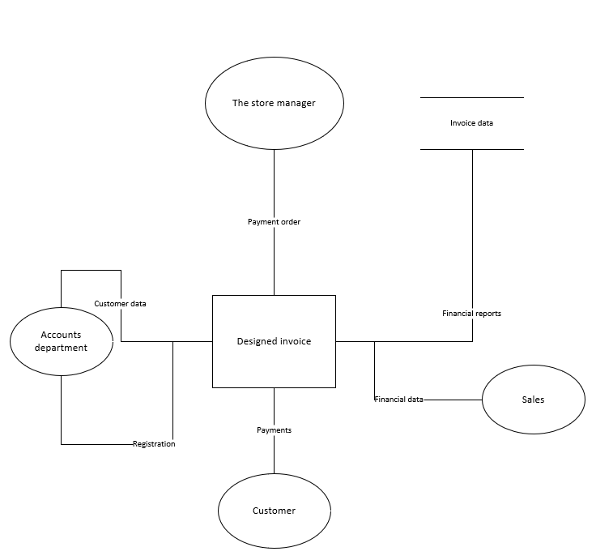
This is my Context design diagram which I have made for my exam to show all of my entities and how they briefly work together.

Entry Relationship Diagram
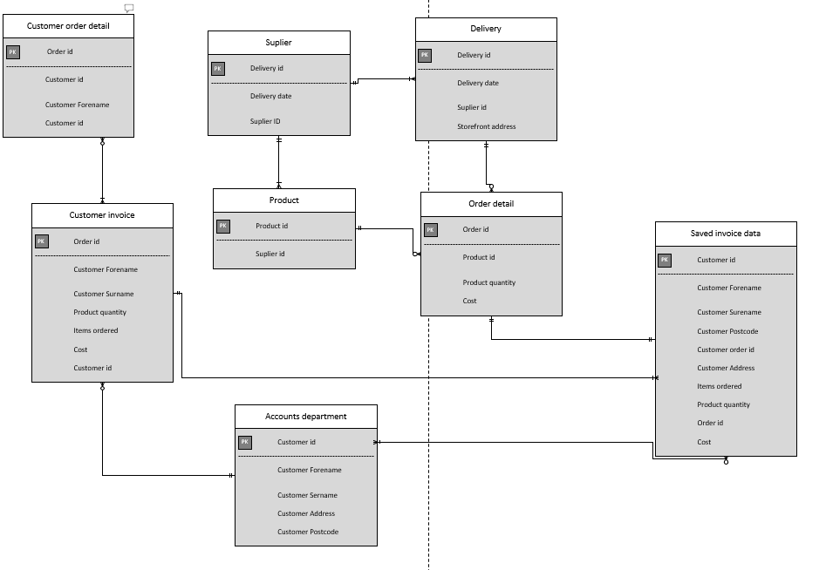

Here I have included my Entry Level Diagram which shows the relationships between each data storage by showing which data fields I believe are one to one, many to many and so on.
DFD Level 0
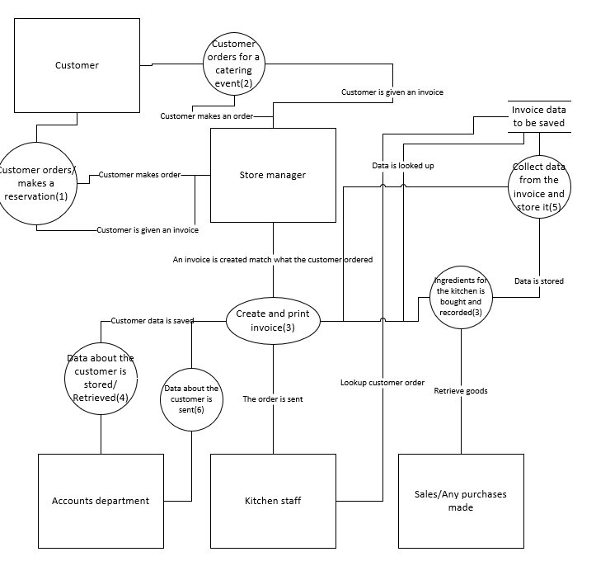

Here I have included my level 0 Data flow diagram which show all the processes and data processing within my design.

DFD Level 1
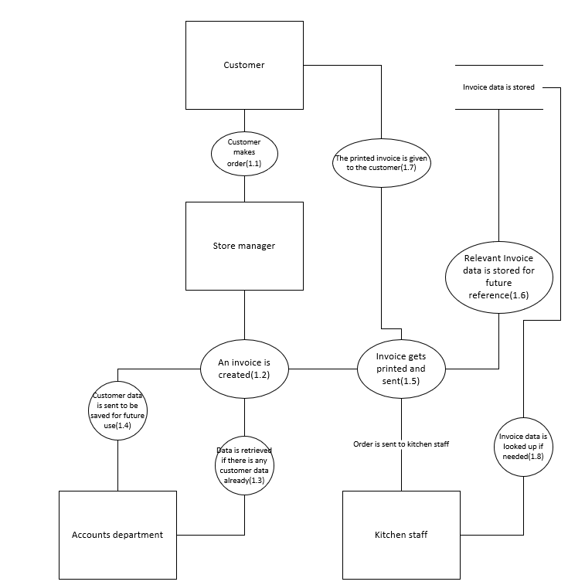

Here is my level 1 data flow diagram which I have chosen to demonstrate a customer making an order and all the processing and data storing that follows.

