School of Tourism & Hospitality Management BA International Hotel Management
Student name:Oana Nicoleta Manta
Student number:2124123
Module lead:Maggie-Lan Zhang

Autumn Term 2024
BMIH6008
Hotel Placement Research Project
LEVEL6
TOPIC: ENSURING HEALTH AND SAFETY STANDARDS IN THE HOSPITALITY INDUSTRY: CHALLENGES AND BEST PRACTICES IN HOTEL MANAGEMENT
AI Acknowledgement
I confirm that I have not presented any AI generated text as my own work. I confirm I have copies of my drafts, notes, and other resources I used before, and after the use of AI tools which I may be asked to provide in evidence
Executive Summary
The present study aims to evaluate the importance of health and safety standards in the UK hospitality industry, using the case study of Delta Hotel Nottingham Belfry. Delta Hotels Nottingham Belfry is a 4-star hotel under the brand name of Marriott and is located in a highly lucrative centralised location of Nottingham. The study has led to the identification of some key industrial best practices which can help enhance the health and safety performance of the establishment. The health and safety measures of the UK hospitality industry can be challenging for the hotels to follow. The Delta Hotel Nottingham Belfry also faces certain safety issues that can be the risk of fire from the kitchen. The hotel had to evacuate the rooms and the whole hotel due to the fire caused in the kitchen. The report has leveraged case study methodology followed by netnography and reflective account. This emphasised an effective interpretation of the health and safety standards in the hotel industry in the case study of Delta Hotel Nottingham Belfry. The report has leveraged case study methodology followed by netnography and reflective account. This emphasised an effective interpretation of the health and safety standards in hotel industry in the case study of Delta Hotel Nottingham Belfry. The hotel had to evacuate the rooms and the whole hotel due to the fire caused in the kitchen.
The health and safety measures of the UK hospitality industry can be challenging for the hotels to follow. The Delta Hotel Nottingham Belfry also faces certain safety issues that can be the risk of fire from 5 the kitchen. Driven by rising liabilities and decreasing assets Delta Hotels Nottingham Belfry is financially troubled. While guests report hotel sectors for comfort and service as positive, concerns related to poor communication and meal orders are prohibiting satisfaction. Achievement of these important strategic improvements in service quality and operational management is essential to boost guest loyalty and strengthen the operating performance. An evaluation of the external factors prevailing in the UK reveal that the hotel is facing a favourable as well as unfavourable business environment in the country with its political and economic factors posing operational threats while social and technological factors providing growth opportunities. Some of its key competitors include Mercure Sherwood by Accor Group, Travelodge Nottingham Wollaton Park Hotel, the Crowne Plaza Nottingham by IHG Hotels & Resorts and many more. The key competitive edge for Delta Hotels among these competitors is that it provides high-quality service at moderate prices.

Table of Contents
1. Introduction 7
1.1 Background 7
1.2 Aim and objectives 7
1.3 Case study overview 8
1.4 Key themes 8
2. Literature review 9
2.1 Various health and safety standards prevailing in the UK hospitality industry 9
2.2 Various health and safety measures implemented in the UK hospitality industry 9
2.3 Key challenges of areas of improvement in the hotel’s health and safety measures in the hospitality industry 10
2.4 Recommend various best practice measures for improving health and safety performance in the hospitality industry 11
2.5 Literature gap 12
2.6 Theoretical underpinning 12
3. Method 14
Introduction to case study methodology 14
Benefits of applying case study methodology 14
Overview of other key techniques or methods 15
4. Case study Discussion 17
4.1 Descriptive information about the case study hotel 17
4.2 SWOT 19
4.3 PEST 21
4.4 Competitor Analysis 24
4.5 Netnography 26
5. Theme exploration 32
6. Conclusion and recommendation 39
7. Reflective account 42
References 46

1. Introduction

1.1 Background
For hospitality organisations, health and safety is all the more essential as the products and/or services of such facilities may have direct implications for the overall well-being of clients. The UK hospitality industry is governed by some key laws or regulations which define the health and safety standards expected to be met by such organisations (MSL, 2024). Any failure to meet the expected health and safety standards can have significant repercussions for organisational reputation and image (Soliman et al., 2024). The present study seeks to evaluate the importance of key health and safety standards prevailing in the UK hospitality industry and standards are being followed by luxury hotels, focusing on Delta Hotels Nottingham Belfry.

1.2 Aim and objectives
Aim
The study aims to explore the importance of health and safety measures in the hospitality industry and identifying best practices and challenges using the case study example of Delta Hotel Nottingham Belfry
Objectives
- To identify the various health and safety standards prevailing in the UK hospitality industry.
- To assess the various health and safety measures implemented at the Delta Hotels Nottingham Belfry.
- To identify key challenges of areas of improvement in the hotel’s health and safety measures.
- To recommend various best practice measures for improving health and safety performance of the hotel.

1.3 Case study overview
The present study focuses on Delta Hotels Nottingham Belfry, a 4-star hotel located at Mellors way off Woodhouse Way at Nottingham (Delta Hotels Nottingham Belfry, 2024). It is a subsidiary of the global hotel brand, Marriott and is known for its state-of-the art facilities (Booking.com, 2024). This hotel was established by rebranding the previously-existing Nottingham Belfry, previously owned by Aprirose (Antcliff, 2019). It became a part of the Marriott Group’s Delta Hotels brand only recently in 2020.

1.4 Key themes
Key themes explored in the present study include
- Health and safety standard in hospitality
- Challenges
- Prevailing best practices

2. Literature review

2.1 Various health and safety standards prevailing in the UK hospitality industry
According to Varotsis, (2019), HACCP (or Hazard Analysis Critical Control Points) is one of the most important health and safety standards in the UK hospitality industry. HACCP is a food safety management system which identifies and controls biological, chemical and physical hazards in food production. Seven principles are involved to prevent food safety risks and potential risk from raw materials to consumption effectively.
In the UK, these EU food hygiene regulations retained after Brexit put all food businesses, including hotels and restaurants, under a legally required systematic preventive approach. Similarly Putri et al. (2020) stated that HACCP is used with identifying and controlling on identifying and controlling potential food safety hazards through a series of critical control points in the food preparation and service process. Ballantyne (2019) contrasted that the UK hospitality industry uses ISO 45001:2018/OHSAS 18001 health standards which constitutes a framework for the management of occupational health and safety risks in the hospitality environment. Whereas the ISO 45001 certification concentrates on both risk and opportunity, the OHSAS 18001 certification mainly addresses occupational risk for every organization.
In particular, the hospitality sector has significant local relevance, and contributes to fulfilling this standard through addressing the particular, and often unique, hazards to which workers in that sector may be exposed, including slip and fall, manual handling, exposure to cleaning chemicals, and workplace stress. In standard though, organisations are required to develop comprehensive risk assessment procedures, use preventive measures and establish ongoing monitoring and improvement processes.

2.2 Various health and safety measures implemented in the UK hospitality industry
As per the opinion of Agüeria et al. (2021), hotels in the UK have Modern cleaning techniques incorporated by hotels and restaurants, and high-touch areas are being sanitised more often. On the other hand, Hu et al. (2021), stated that the creation of a haven during the COVID crisis is one of the health and safety measures taken by the hospitality sector. Similarly, Bonfanti et al. (2021), stated that In the hospitality business, the 'haven' at a time like the Covid-19 pandemic is the creation of sound protection processes for employees and customers. One of these focuses on fostering deep compliance for safety procedures with employees actively participating in maintaining safety by not just following protocol superficially. Hospitality businesses can foster a real safe workplace through the communication of some good safety practices and the involvement of employees in reducing risk. According to Rosemberg (2020), the hospitality industry can improve their health and safety standards by implementing the NIOSH hierarchy control model.
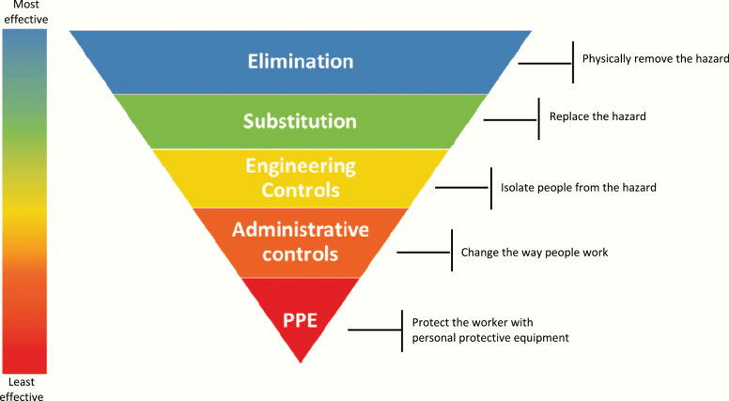
Figure 1: NIOSH hierarchy control model
(Source: Rosemberg, 2020. Pp 1)
Through its work, it has effectively prioritised the elimination of hazards, followed by engineering controls and administrative measures, and personal protective equipment (PPE) to mitigate workplace risk. Using effective PPE when cleaning and dealing with guests makes them safe. Revisions of sick leave policies and communications processes provide some administration of controls. By enabling employers to protect workers’ health. This is an overarching framework that will promote a safer and more resilient hospitality workforce. On the other hand, Smart et al. (2021), highlighted that to improve health and safety standards within a hospitality organisation, hotels should introduce requisite training about cleaning and disinfection standards to their employees. This training should focus on pointing out just how important it is to always practise consistent hygiene, use PPE, and new technology such as contactless service options. Engaged in ensuring a safer environment for both guests and staff, hotels can create a safety culture and give employees the knowledge and skills to maintain high standards globally, which will deliver a higher safety outcome.

2.3 Key challenges of areas of improvement in the hotel’s health and safety measures in the hospitality industry
The adoption of contactless service technologies such as robots is fraught for the hotel market with either management of guest satisfaction or providing people with health safety. The regulatory regime for regional food safety also varies, complicating compliance and resource allocation and threatening penalties and reputational impact. For hotels to address these complexities while also maintaining the core human touch of hospitality requires the interpretation of many guest health concerns.
According to Soliman et al. (2024), Implementing contactless service technologies, such as service robots, is one great challenge in hotel health and safety measures because of its capability to balance both guest satisfaction and emotional well-being. Deceleration of hotel, but not OTT, guest perception of privacy correlates with COVID-19 pandemic severity and the adoption of automated, allowing hotels more freedom in retaining existing online presence. However, getting used to these safety measures often means speaking in front of guests and may not sit well, given that many guests appreciate the traditional hospitality experience. Hotels seek to maintain a balance between the technological safety solutions available and one that can continue to create that human touch that's so imperative to the hospitality business along with guests' varied levels of health consciousness and comfort with robot-delivered services. On the other hand, Bardukova (2022), mentioned that complex food safety and hygiene regulations put the hotel industry in a difficult spot. However, these regulations vary by region and need extensive training and compliance, which frequently stresses the resources. Not adhering to it can bring severe penalties, damage to its reputation, and health risks for guests. The only way to keep operational standards and guest safety is to navigate this regulatory landscape.

2.4 Literature gap
The gap in the literature is significant with respect to health and safety standards in the UK hospitality industry, with particularly little data post COVID-19. Research found that so much of the existing research is about pandemic era challenges that that leaves a gap in the understanding of what is happening currently regarding health and safety. The gap in the literature also signals the need for studies which update current health and safety practices in the UK hospitality industry post COVID. This will allow addressing the void, which will give us insights to evolving standards and how guests are expecting and will bring to better adaptation to these contemporary challenges and will be better towards industry resilience and the safety of it. In addition, a lack of recent data limits an in-depth analysis of the current problems, and thus prevents developing effective methods to enhance health and safety measures in the field of hospitality as it changes.

2.5 Theoretical underpinning
The Health Belief Model
According to Rezapouraghdam and Karatepe (2020), the Health Belief Model (HBM) is a psychological framework used to explain people’s health related behaviour based upon perceptions of disease vulnerability, disease severity, and benefits and barriers to taking disease preventive action.
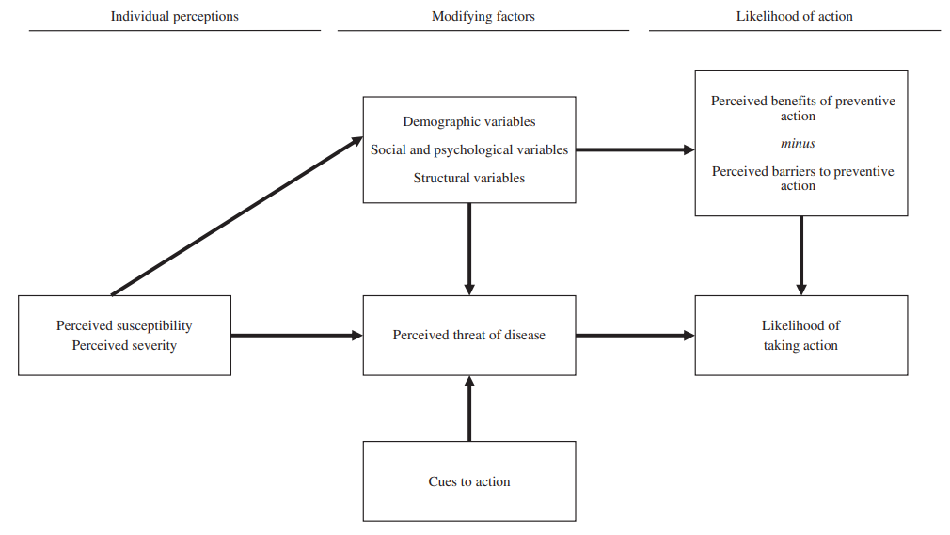
Figure 2: Health Belief Model
(Source: Rezapouraghdam and Karatepe, 2020)
There is relevance of HBM in the hospitality sector as it impacts employees’ fidelity to as well as standards of health and safety, that is, hygiene practices and protective measures in pandemics. Knowledge of these perceptions will assist hospitality management in developing strong training and communication strategies by ensuring that employees comply with the health protocol to protect public health. By applying this model, the hotel Delta can improve their business structure by considering the health and safety of the guest and employees to create better management.

3. Method

Introduction to case study methodology
The case study methodology is a qualitative research approach that provides rich, contextual insights by thoroughly examining a particular occurrence or organisation. Case studies are an excellent method for encouraging individuals to apply their knowledge of facts and skills to a real-world scenario (Santoso, 2021).

Benefits of applying case study methodology
Contextual Richness: One of the main benefits of case study research is its capability to present and deliver a sophisticated understanding of complex issues in a certain context (Gioia, 2021). This study uses the methodology to analyse the challenges faced by these hotels in measuring employee productivity and suggests the most appropriate method of measuring employee productivity in the hotel industry.
Holistic Viewpoint: The case study approach makes it easy to explore and analyze a variety of aspects such as employee development, customer experience and corporate direction of an organisational management practice (Eisenhardt, 2021). This comprehensive process can emphasise the connections between various types of facets regarding safety and health management. In addition to this, the safety and health policies are individual and unique to each organisation and an organisation's policy is based on the hazards and risks present in the organisation.
Practical Relevance: The practical relevance of this study lies in determining safety challenges as well as key health and best practices which can help develop organisational operational business and guest safety in the United Kingdom hospitality industry.
Limitations
Adaptability: As per the viwes of Priya (2021), it can be said that one of the main drawbacks of study methods in this field is the potential lack of adaptability. Conclusions drawn from Delta Hotels may not apply to other establishments as hotels differ in terms of location, customer relations, management information systems, accounting, finance, size, clientele as well as management style.
Subjectivity and Resource Intensity:
As per the viwes of Schoeman et al. (2020), the viewpoints and biases in research may occur intentionally or unintentionally which may compromise the objectivity of data interpretation. It has been also observed from the analysis that this type of viewpoint could not significantly reflect the larger context of the hotel industry. Also, collecting data for a comprehensive case study can take a lot of time and effort such as research, data collection as well as feedback.

Overview of other key techniques or methods
Reflective Writing: In the views of Stevens and Cooper (2023), an analytical method that challenges individuals to assess their practices critically is reflective writing. This study of the health and safety systems of the hospitality industry in the United Kingdom which can be challenging for hotels to follow. The Delta Hotel Nottingham Belfry also faces certain safety challenges such as fire from the kitchen. In addition to this, finding possibilities for improvement and areas of power or strengths is aided by this process.
Netnography: A qualitative research approach utilised to analyse and investigate online cultures and communities is called netnography. (Kozinets, 2020). It is relevant in the context of health and safety regulations in the hospitality industry as it is particularly helpful in analysing and investigating organisational consumers' behaviour and their attitudes.
Justification for the selection of the method
As per the viwes of Hu et al. (2021), maintaining health and safety regulations in the hospitality industry is a complex as well as complicated task that requires proactive planning and efficient administration.

4. Case study Discussion

4.1 Descriptive information about the case study hotel
Turnover
As of December 31 2022 Delta Nottingham Hotel Limited has a poor financial position. Total liabilities jumped and as a result total assets decreased by £627,960 from £533,000 to £626,972, while the net liability increased to £8,529,119 compared to £7,145,134 in 2021 (GOV UK, 2024).
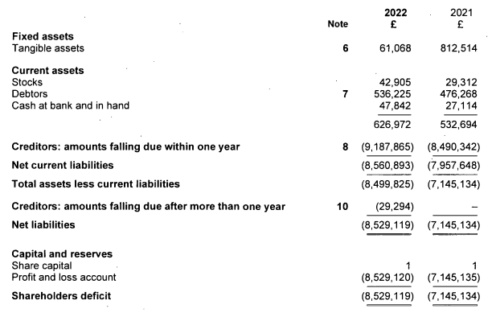
Figure 3: Financial statement of Delta Nottingham Hotel
(Source: GOV UK, 2024)
They are hotels with shareholders' deficits, which means that the hotels profitability and financial health is declining. The drop of fixed assets from £812,514 to £61,068 (GOV UK, 2024). This indicates potential asset liquidation or impairment, and as such there must be strategic financial management to yield sustainability.
Staffing
The employee number for the Delta Hotel Nottingham Belfry has 51-200 along with 27 associated members (LinkedIn, 2024).
Number of branches
The wider Delta Hotels brand includes several notable properties worldwide, featuring Delta Hotels by Marriott Nottingham Belfry becoming part of the property. Also located in Nottingham, other branches include: Delta Hotels by Marriott Toronto East, Calgary South, at Grand Okanagan Resort, Ottawa City Centre, Vancouver Downtown Suites, Seattle, and Houston North. Modern comfort and amenities are what are offered by each hotel (Delta Hotels, 2024a). All of which are tailored for the business and leisure traveller, with the brand’s mission of providing quality service.
Locations
Address: Mellors Way off Woodhouse Way, Nottingham, England, United Kingdom, NG8 6PY (Delta Hotels, 2024b).
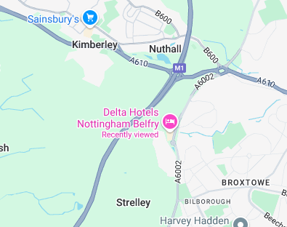
Figure 4: Locations of Delta Hotels Nottingham Belfry
(Source: Google Map)

4.2 SWOT
Strengths  - Wide range of service: Delta Hotel Nottingham Belfry offers contemporary lodging and outstanding visitor experiences (UK INBOUND, 2020). It serves corporate gatherings well as one of the biggest conference venues in the area (Delta Hotels, 2024b). This demonstrate that a wide range of services customers are getting from this hotel which is a strength for improving the market reputation.  - Priority to the customers safety: Well-developed customer management services (Marriott, 2024a). The health and safety of guests has the highest priority for the Delta Hotel Nottingham (HRS, 2024). Customer management is another biggest strength of this organisation to sustain in the market. | Weakness  - Customer dissatisfaction regarding room: The guest was not happy with the meal order, and the room smelled bad (Tripadvisor, 2024e). The consumer had a difficult experience as a result of miscommunication over dinner reservations and swimming availability (Tripadvisor, 2024g).  - Price On higher side: The price of the hotel is on higher side; thus, all the facilities are needed to be proper. However, the customer dissatisfaction demstrate this hotel is not value for money.  Poor management: Although, the hotel is concerned about the safety of customers; however, poor management and workers inefficiency is a leading weakness.
Opportunity  - Eager to create its own business by hosting more corporate events and business gatherings in its large conference once (Visit Nottinghamshire, 2024).  - Implement customer management services in improving guest satisfaction and guest loyalty through a personal experience. The hotel has already good safety measures; skilled employees are needed to be included for improving customer satisfaction. | Threats  - Poor online reviews caused by bad guest experiences can damage your hotel’s reputation and even bookings.  - Market competition is another threat for the business which is required to be mitigate with better customer service.
Table 2: SWOT analysis of Delta Hotels Nottingham Belfry
(Source: Self-created)

4.3 PEST
Factor(s) | Overview | Implication for the hotel
Political | - The UK recently witnessed a long period of political uncertainty (NDTV News, 2024).  - The hospitality industry in the country is suffering from staff shortages due to Brexit (Grenside, 2024). | The political condition of the UK can be characterised as being highly uncertain and volatile. This is expected to give rise to policy uncertainty among the various governments, posing a threat of abrupt operation disruptions for business organisations including the case study organisation. Furthermore, labour shortages due to Brexit are making it increasingly difficult for these establishments to maintain operations. These factors may prove especially challenging for Delta Hotel Nottingham Belfry. On one hand, the unprecedented disruption of policies would imply that the hotel has to modify its operational strategies as per the emergent policy developments which could also impact the hotel’s health and safety protocols. On the other hand, Brexit has exacerbated labour shortages in the country’s Midlands area (Midlands Engine, 2022). Thus, it may be inferred that this regional disruption of labour supply can prove challenging for the chosen hotel.
Economic | - The ongoing cost of living crisis in the country has led to a substantial decline in customer demand (Gupta, 2024)  - The country’s inflation rate is gradually declining, reaching 1.7% in September 2024, indicating a potential ease of the price rise situation prevailing in the country for the last few years (TRADING ECONOMICS, 2024).  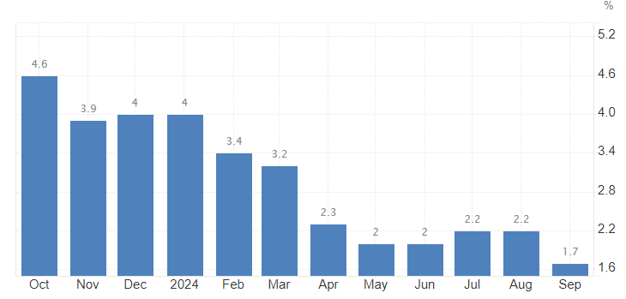  Figure 5: Inflation rate prevailing in the UK  (Source: TRADING ECONOMICS, 2024) | The economic condition prevailing in the UK can have potentially mixed implications for the Delta Hotels Nottingham Belfry. On one hand, the depleting consumer demand due to the perpetuating cost of living crisis in the country poses a significant threat to the hotel’s overall profitability. Contrarily, the gradually easing inflation rate of the country implies that price rise in the UK economy has slowed down, indicating a potentially low-risk of unsustainable increase of operational costs.
Social | - The UK hospitality industry is witnessing substantial consumption pressure from nearly 50% of the consumers preferring eco-friendly facilities while making their consumption decisions (Mintel, 2024).  - The UK is home to 56.2 million active social media users, representing 82.8% of the national populace (Dixon, 2024). | The social conditions in the UK may, again, have mixed implications for the hotel. Firstly, due to an increased demand for sustainable services, the hotel would be compelled to implement efficient sustainability standards and protocols. However, the hotel also has the opportunity of using its existing sustainability initiatives as key marketing tools to propel consumer demand (Delta Hotels Nottingham Belfry, 2024). As noted in the regional economic impacts report, Brexit and the subsequent onset of COVID-19 led to significant economic disruption in the entire Midlands region such as a lack of skilled labour in the region (Midlands Engine, 2022). This indicates that while the demand for sustainable services might be high in the country, similar demands may not be evident for Delta Hotels Nottingham Belfry. Increasing social media permeation in the country could also prove advantageous for the hotel’s marketing efforts.
Technological | - The UK hospitality industry is witnessing significant technological advancements with over 200 personalised applications, thousands of webpages and innumerous social media pages being implemented by these organisations (UK Hospitality, 2024).  - Multiple technological advancements are being introduced in the industry including Artificial Intelligence, robotics, self-service kiosks, mobile check-in services and Customer relationship management systems, among others (Modern Hospitality, 2024). | The increasing availability of latest technological advancements in the UK hospitality industry is a significant advantage for the hotel. Delta Hotels Nottingham Belfry could use various technological advancements in the industry to provide customers with high-end and seamless stay experiences. Technological advancements such as service automation are known to drive customer satisfaction in the hospitality industry (Naumov, 2019). Thus, the hotel has the option of introducing latest technological advancements, using the readily-available technologies to improve customer satisfaction at the establishment.
Table 3: PEST analysis of the UK hospitality industry
(Source: Self-developed)

4.4 Competitor Analysis
Competitive factors | Mercure Nottingham Sherwood Hotel | Travelodge Nottingham Wollaton Park Hotel | Crowne Plaza Nottingham, an IHG Hotel | Delta Hotels Nottingham Belfry
Owned by | Accor Group | Travelodge | IHG Hotels & Resorts | Marriott
Price | Mid to low range | High-range | Mid-range | Mid-range
Quality | Moderate to High quality/customer satisfaction | Moderate to poor quality/customer satisfaction | Moderate to poor quality/customer satisfaction | High quality/customer satisfaction
Table 4: Competitor analysis for Delta Hotels Nottingham Belfry
(Source: Self-developed)
The competitive scenario in the Nottingham area for Delta Hotels Nottingham Belfry is fairly intense with numerous renowned brands operating 4-star establishments in its vicinity including the Mercure by Accor Group, Travelodge Nottingham Wollaton Park Hotel, the Crowne Plaza Nottingham by IHG Hotels & Resorts and many more (Tripadvisor, 2024a). Each of these hotels provide all or most of the facilities available at Delta Hotels Nottingham Belfry. However, they vary in their price range as well as service quality. Firstly, among all of the chosen establishments, Mercure provides the lowest prices per night (Tripadvisor, 2024b). Contrarily, Travelodge Nottingham Wollaton Park Hotel charges the highest per night prices, indicating it is a high-range establishment (Tripadvisor, 2024c). However, both Crowne Plaza and Delta Hotels have similar price ranges, indicating it to be one of the key competitors for the hotel (Tripadvisor, 2024d; Tripadvisor, 2024f). Another key competitive aspect impacting the business performance of the above-mentioned establishments is service quality. A good indicator of quality standards could be customer reviews. Here, it must be noted that Travelodge received 53 poor reviews among 627, while for Crowne Plaza, the value is 161/2506 (Tripadvisor, 2024c; Tripadvisor, 2024d). This indicates that a substantial percentage of the customers for both of these establishments have been immensely displeased with the services provided. On the other hand, Mercure has received 26 poor reviews out of 439, while for Delta Hotels, the proportion of poor customer reviews is 86/1966 (Tripadvisor, 2024b; Tripadvisor, 2024f). Hence, it may be seen that, among all of the chosen competitors, Delta Hotels provides the best quality service at moderate prices, indicating a significant competitive advantage for the establishment.
Factors | Weight | Mercure Nottingham Sherwood Hotel | Travelodge Nottingham Wollaton Park Hotel | Crowne Plaza Nottingham, an IHG Hotel | Delta Hotels Nottingham Belfry
Advertising | 0.5 | Rating- 1  Score- 0.01 | Rating- 1  Score- 0.01 | Rating- 2  Score- 0.02 | Rating- 3  Score- 0.03
Price Competitiveness | 0.15 | Rating- 2  Score- 0.20 | Rating- 5  Score- 0.15 | Rating- 1  Score- 0.03 | Rating- 4  Score- 0.12
Product Variety | 0.10 | Rating- 3  Score- 0.06 | Rating- 4  Score- 0.08 | Rating- 5  Score- 0.10 | Rating- 5  Score- 0.10
Customer Loyalty | 0.12 | Rating- 4  Score- 0.8 | Rating- 1  Score- 0.02 | Rating- 2  Score- 0.06 | Rating- 2  Score- 0.02
Global Expansion | 0.10 | Rating- 4  Score- 0.40 | Rating- 1  Score- 0.02 | Rating- 5  Score- 0.10 | Rating- 4  Score- 0.08
Table 5: Competitor Profile Matrix
(Source: Self-developed)
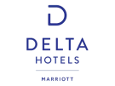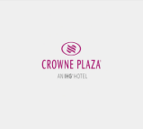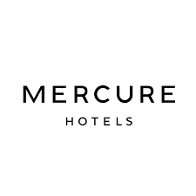

HIGH PRICE
LOW QUALITY
HIGH QUALITY
LOW PRICE
Figure 6: Positioning Map
(Source: Self-developed)

4.5 Netnography
As mentioned by Baptista (2022), Netnography combines participant-observational research with online fieldwork, including techniques for gathering data such as in-depth interviews conducted virtually and participant observation.
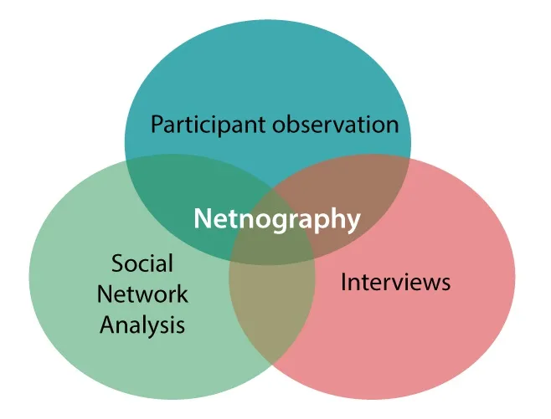
Figure 4: Elements of Netnography
(Source: Medium, 2021)
For Delta Hotels Nottingham Belfry netnography has been discussed below,
Participant observation
This can be derived from the customer perceptions from surveys, analysis such as reviews. For the aforementioned hotel, customer feedback interrod those instances where customers are dissatisfied such as poor management and services, ‘miscommunication over dinner reservations. Visitors have voiced unhappiness with their overall experience, citing particular grievances such "the room smelled bad" and unsatisfactory meal orders. These opinions highlight the necessity of better communication and higher-quality services in order to increase client satisfaction.
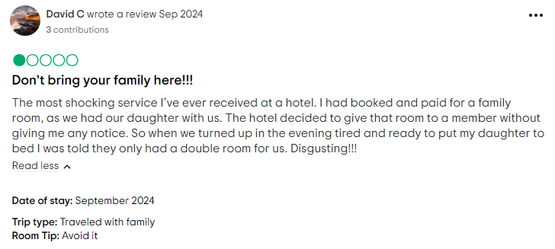
Figure 5: Dissatisfied customer review of Delta Hotels Nottingham Belfry
(Source: Tripadvisor, 2024h)
Further it has been seen that some of the customers have experienced better service facilities from the hotel management of Nottingham Belfry. They have found that their customer services are outstanding, staff were super friendly and generous (Tripadvisor, 2024i).

Figure 6: Satisfied customer review of Delta Hotels Nottingham Belfry
(Source: Tripadvisor, 2024i)
Social Network Analysis
Through the social network analysis of the Delta Hotel Nottingham Belfry it has been seen that the hotel is socially very much active on Instagram, Twitter. In Instagram they have 698 followers with average likes of 10 to 20 (Instagram, 2024).
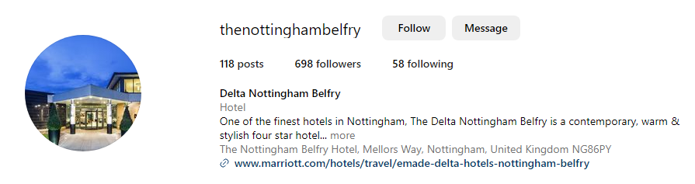
Figure 7: Instagram followers of The Nottingham Belfry
(Source: Instagram)
On analysis of X followers here, it has been seen that they have 1064 followers along with an average like of 5 to 10 (X, 2024).

Figure 8: Followers of Delta by Marriott Nottingham Belfry on X
(Source: X, 2024)
On Facebook, they have more than 2.1 followers which indicates that they are more engaged with the customer through their Facebook page (Facebook, 2024). Therefore, from the social network analysis, it can be said that not only do they have a strong social media presence on Facebook but the Delta Hotel Nottingham Belfry shows a strong social media presence. The total followers of this hotel on Facebook is 2.1K (Facebook, 2024). While there’s more engagement on Instagram and X, the low engagement combined indicates improvements in the way content and customer interaction are done on various platforms.
Interviews
Travellers have generally positive things to say about the Delta Hotels by Marriott Nottingham Belfry, with comfortable rooms, excellent breakfast and friendly staff able to impress. While views from some rooms were disappointing, and evening meal options, some guests were unhappy (Tripadvisor, 2024g). However, taking care of the quality of the dinner and the design of the room will make it so people just love being there and will come back often.
Therefore, it can be said that almost half of the guests remark on how comfortable the rooms are, the staff is warm and friendly, but the breakfast is good, this kind of stuff can be easily taken care of; but there are some blemishes such as: poor communication when placing an order for meals and the lack of a pleasant room view. Improving service quality could lead to improving the entire guest satisfaction, as well as loyalty.
Overall discussion of the Hotel Netnography
According to Kozinets (2020), netnography is a way of studying social media presence that maintains the culture complexity of its interactants’ itinerant experiences. In this study, studying the netnography of the Delta Hotels by Marriott Nottingham Belfry has been provided above. It has been found that the company is focused on mixed culture and welcomes every tourist. Based on the participants' data, it has been found that they hold good and bad reviews from customers which indicates high engagement rate. Praxis maintains by giving best services to the guest and giving them extra facilities by making them happy. Hence, Netnography of the organisation is strong according to the above discussion.

5. Theme exploration
Critically analysis of the placement hotel
“Health and safety standards regarding maintaining the food hygiene and guidelines of safety prevalent in the hospitality industry of the UK”
Health and safety measures are important to address in every business sector including the hospitality industry. As stated by Ali et al. (2021) the success of the hospitality industry lies in providing satisfaction to the employees and the customers. The UK hospitality industry serves various people every day. There have been various stringent health regulations under which the UK hotels have to operate (Labourlaws, 2024). Various such regulations which are related to the Health and Safety at Work Act 1974 have to be followed by the UK hospitality industry (HRS, 2024). The health and safety regulations provide the sector with the general duties that keeps people safe in the workplace. This has answered the objective of identifying the various safety standards prevailing in the hospitality industry of the UK. Responsibilities of maintaining the health and safety in this sector lies with the employers.
The wide range of responsibilities of the employers in maintaining workplace safety and health of the employees lies in the processes of mitigating risks and hazards effectively (Labourlaws, 2024). The employers of the sector have to play their important parts in the process of establishing comprehensive policies of safety. For instance, the safety measures of the Delta Hotel Nottingham Belfry UK include keeping distance among the facilities (HRS, 2024). This has been helpful for the hotel employees to maintain safety according to the guidelines of safety. The objective of the identification of health and safety measures that are followed in the Delta Hotels Nottingham Belfry. These measures of workplace health and safety can be counted as the evidence of the observation during the placement essentially. As per the statement of Kamboj et al. (2020), the main safety measures that the sector have to take part in is the health measures and quality of their food that they serve. The importance of food safety and hygiene practices is the main priority that ensures the safety and well-being of the customers.
The food and safety measurements of the hospitality industry of the UK are adopted and maintained with the help of abiding by the guideline of The Food Safety Act 1990 (Legislation, 2024). This act provides and creates the framework for legislation of food. It works in creating the offences in relation to the quality, safety and labelling of food products that are being sold by the sector companies (Visitbritain, 2024). There have been various other food hygiene and safety standards that were developed for maintaining the norms within the hospitality industry. These safety measures have been followed in the hotels that are operating in the industry that have impacted the placement options for people in the hotel industry. The provisions of health and safety have been important in every professional field which attracts people as prominent and potential employees.
As opined by Agüeria et al. (2021), the process of maintaining the food hygiene of the hotels of the country is one of the major components of health and safety measures. These measures are maintained by the hotels of the UK which promote the health and safety of the customers (Cpdonline, 2024). The visitors of the hotels have to be satisfied with the services of the companies which can make them come and visit again. In the Delta Hotel Nottingham Belfry, a selection of formats of online food hygiene for use across various websites, applications and social media platforms (Ratings, 2024). This shows that the hotel is involved in the maintenance of the health measures of the customers by making their food hygienic and safe. The safety measures that the Delta Hotels have been following in their food have made the brand developed globally. Thus, it can also be counted for the placement of people in this brand for their future ventures. The UK safety and hygiene of the hospitality industry have been maintained in both ways which is for employees and visitors. Health and safety of employees are maintained by making the workplace safe for them to work and providing training to them. The safety and health of customers are maintained with the help of maintaining the food hygiene and safety according to different legislations of food safety of the UK.
“Safety standards practised within the Delta Hotel Nottingham Belfry helps the hotel to avoid possible risks including safety hazards”
In the view of Anichiti et al. (2021), the safety protocols of the hotel encompass various types of areas, such as health and hygiene, fire safety as well as emergency preparedness. The UK's Delta Hotel Nottingham Belfry features "120 well-appointed bedrooms, a flexible conference facility and revitalising leisure club and spa (HRS, 2024). Delta Hotel Nottingham Belfry adheres to strict safety standards such as fire safety measures including regular drills, and clear signage for emergency exits to ensure the well-being of guests and staff. The organisation has also installed fire detection and suppression systems to ensure that guests and organisational employees are familiar with emergency procedures as well as evacuation routes. This has attracted people for placement in this Hotel as they can have a protected and safe working place that can help them to delve and get indulged to have a better and safe professional future. In addition to this, Delta Hotel Nottingham Belfry in the UK features strict cleaning protocols in terms of health and hygiene, especially in the wake of the recent global health crisis. Delta Hotel Nottingham Belfry encourages guest feedback on safety practices and online satisfaction surveys, completed following a variety of scenarios and basic life support as well as procedures to ensure effective handling of incidents (Marriott, 2024b). For example, the 'Risk Assessment' management approach of Delta Hotel Nottingham Belfry in the UK is consistent with health and executive 5-step risk assessment such as “potential hazards, decide who might be harmed, evaluate risk and decide precautions, record finding and review” (The Belfry, 2021). Delta Hotel Nottingham Belfry has conducted regular risk assessments to identify and take proactive measures to mitigate their organisational risks. The guest feedback of the hotel has been the basic strategy of the firm to get to know regarding the operations that have to be enhanced and the strategies that have to be eradicated. The provisions of risk assessment can be helpful for avoiding risks that are observed during the placement as with the help of these assessments the hotel can develop strategies for future safety.
As a result, these notably include the availability of hand sanitising stations, frequent sanitisation of high-touch surfaces, as well as adherence to food safety regulations in dining areas. Delta Hotel Nottingham Belfry has enhanced its “cleaning protocol” and “PPE and face covering (PPE)” specifically in response to heightened health concerns for risks in their workplace during and after the COVID-19 pandemic (The Belfry, 2021). In addition to this, the introduction of a “Enhanced hand hygiene” program assigns specific staff members to support frequent hand washing for their organisational teams (The Belfry, 2021). In the viewers of Alexander (2020), the hotel in the UK maintains an emergency response as a safety standards plan which significantly includes plans, procedures for different types of scenarios including severe weather events as well as medical emergencies. As a result, all examples related to Safety Standards explain the effective steps for Delta Hotel Nottingham Belfry to takes and maintain and address a safe environment for its organisational guests and employees. The hotel demonstrates its business process commitment to operational excellence and guest satisfaction by incorporating strict security protocols and standards and promoting a culture of security awareness.
Challenges such as inappropriate training, vulnerable to fire and possible areas of improvement such as process of maintaining the food safety and hygiene
The hospitality industry has been found to be facing various challenges in maintaining health and safety standards. As per the statement of King (2020), food safety is the major reason that makes the hotels and hospitality companies a failure in maintaining the standards. The process of maintaining the food safety and hygiene that can be safe handling of food, proper food storage and cleaning regularly are the major aspects that make the process of safety and hygiene maintenance difficult. The hotels face the challenge of understanding the major safety and health standards of food. The employees are found to be not aware of the guidelines and are not provided with appropriate training regarding the aspects. These are the challenges that have slo been observed during the placement which have impacted the decision negatively. There are different health and safety regulations that can be followed by the hospitality industry. These regulations are Health and Safety Work etc Act 1974 and The Management of Health and Safety at Work Regulations 1999 are to be followed by the companies (Ferrett, 2020). The process of following the regulations of the Health and Safety etc Act 1974 has been challenging for the companies. The regulation aims to maintain the safety of the employees at the workplace. This is the biggest challenge that has impacted the placement process and has been deeply observed to have certain strategies ready for future problems.
As opined by Binns and Kempf (2021), hotels are found to be vulnerable to fire which cannot be maintained as the hotels have the kitchen area. This is the most important risk factor that can make the hospitality industry not able to follow and abide by the guidelines of the act. This can be an area of improvement that the hotels have to work upon and formulate certain strategies to protect the consequences. For instance, the Delta Hotel Nottingham Belfry has faced such a challenge that has to be improved in the future. The hotel has to evacuate their hotel rooms and the employees due to a fire in their kitchen (BBC, 2024). After the fire started the hotel had to be evacuated which had more than 50 guests and emergency crew had to be called (BBC, 2024). Thus, it can be said that the unavailable risk that the hotel industry has to tackle is the fire risk due to the amenities inside the kitchen. They cannot cut off the kitchen from their infrastructure and have to strategies the risk mitigation strategies for their future. This risk factor has provided a practical instance of the challenge that the Hotel has faced and might face in future as the kitchen cannot be eradicated. This has been observed at the time of placement very seriously which has impacted the process. Slips, trips & falls of the housekeeping staff can lead to hazards and risks due to slippery floors and food and drink spillage. The same challenge can take place with the visitors that can lead to a serious issue and accident. As said by King (2020), the cleaning agents that are used by the housekeeping and cleaning staff of the hotels can contain hazardous chemicals. This can cause skin irritations, chemical burns and respiratory issues to the employees as well as to the visitors. This part has been able to achieve the objective of identification of the key challenges and areas of improvement in the health and safety measures of the Hotel.
Best practices such as safety representatives, safety committees, guest room security, food safety in hotel management to ensure health and safety standards
Establish a comprehensive organisational own policy for health and safety policies in hotel management such as the "Occupational Safety and Health (OSH) Policy" which can outline Delta Hotel Nottingham Belfry's commitment to maintaining a safe environment. In this context, as per the views of Ferrett (2020), the Occupational Safety and Health (OSH) policy is specific and unique to the hotel, and is communicated to the responsibilities of all employees, safety representatives, safety committees (Ferrett, 2020). In addition to this, the organisation can conduct regular training sessions for their organisational staff which can strongly highlight the importance of health and safety protocols. They can include more fire safety and increase availability of first aid, emergency response as well as proper handling of hazardous materials in their communities. Delta Hotel Nottingham Belfry in the UK regularly conducts risk assessments to determine and correct their organisational potential hazards in hotels including guest room security, food safety, electrical and chemical, common area, kitchen and outdoor space security assessments. As per the views of Vincoli (2024), risks related to safety standards are identified and addressed through risk identification, risk analysis, risk monitoring and implementation of corrective measures including taking safety measures to eliminate or reduce any identified risks. These processes are the positive instances or observations during the placement in the hotel.
The organisation can establish more stringent cleaning protocols to regularly disinfect high-touch surfaces and ensure proper ventilation. As per the views of McEntire (2021), developing an emergency response plan significantly covers different types of scenarios such as medical emergencies, organisational policies, fires or natural disasters. It can be said that Delta Hotel Nottingham Belfry may implement a health screening system for their organisational staff especially those working in food service and housekeeping to encourage them to report any illness and provide assistance for leave. For Delta Hotel Nottingham Belfry, they can provide food service as well as adhering to strict food safety standards and train kitchen staff on safe food handling practices such as proper cooking temperatures, cross-contamination prevention and storage. They can educate guests by post their social media marketing content about the hotel’s health and safety measures upon check-in. Also, provide a variety of safety information about emergency procedures, health-related resources available on site, and hygiene protocols to improve their organisational safety standards (Sorensen et al. 2021). Delta Hotel Nottingham Belfry in the UK can conduct routine inspections of the organisational facilities such as electrical systems, plumbing and address maintenance problems promptly to prevent accidents. In the views of Teh and Husain (2024), establish a maintenance schedule for HVAC systems for good quality filters and regular replacement as needed to ensure proper air quality and temperature control. In this context, the organisation can use HVAC systems to contribute to noise reduction within hotel premises and minimise disruptive sounds that could disturb guests' sleep or conversations. Delta Hotel Nottingham Belfry in the UK can create a safe and welcoming environment for their organisational guests and staff alike by implementing all the best and appropriate practices. Additionally, the organisation can regularly review and update their organisational health and safety protocols which will ensure ongoing adaptation and compliance to their new challenges. The selection provides some of the strategies that are risk specific that have answered the last objective of the study.

6. Conclusion and recommendation
Conclusion
- Delta hotel Nottingham Belfry is a 4-star hotel of the Marriott brand known for its unique amenities and strategic location
Formerly known as Nottingham Belfry, the hotel became a part of Delta Hotels by Marriott in 2020. It provides multiple state-of-the-art facilities and comprises a workforce of 51-200 employees. A good service quality and medium pricing approach are its key competitive advantages over other hotel brands in the area.
- Health and Safety standards are essential aspects of the UK hospitality industry
The UK hospitality industry is closely-regulated by various health and safety standards or regulations. These include the Health and Safety at Work Act 1974 and the Food safety Act of 1990. All hospitality organisations in the country, irrespective of their size, must strictly comply with these standards to ascertain customer satisfaction and business sustainability.
- The hotel has substantial growth opportunities owing to its inherent suitability for both business and leisurely purposes
One of the biggest growth opportunities for the hotel is that it is duly equipped to hold large-scale corporate events while also welcoming guests on leisure trips. From multiple fully-equipped meeting rooms to comfortable and adequately furnished individual rooms, the hotel boasts of a wide range of amenities suited for all types of guests. However, in trying to expand its business reach among corporate clients, the hotel is facing significant challenges in maintaining basic health and hygiene standards which could be a threat to the overall brand image and the establishment’s profitability.
- The external factors prevailing in the UK are both favourable and unfavourable for the hotel.
Upon conducting a PEST analysis, the report found that there are multiple such factors that could have negative implications for the establishment including a declining consumption demand due to cost of living crisis, political instability, staffing crisis and many more. However, some of the conditions in the country may be favourable for the hotel. These include high social media permeation which will benefit their marketing initiatives and the ready availability of latest technological advancements that can drive customer satisfaction.
- Delta Hotels Nottingham Belfry has multiple health and safety standards in place, although it is yet to achieve optimal implementation.
The hotel has multiple health and safety standards in place, aimed at ascertaining the due affluence and well-being of staff as well as visitors. These were especially improved during the recent pandemic when ascertaining health and safety of staff and guests became a massive challenge. During such challenging times, the hotel stepped up to the occasion and launched a wide range of sanitisation and infection prevention measures. Furthermore, the hotel conducts regular risk assessments and audits to identify and prevent potential accidents. Even then, the hotel recently suffered from a major fire incident at the kitchen, indicating a potential gap in its risk detection and mitigation strategies.
Recommendations
Recommendation 1: Revising Organisational Health and Safety Policy
Organisational health and safety policies or regulations often help hospitality organisations inform staff about the key safety measures or protocols needed to ascertain a healthy and safe stay for the guests (Zhang et al., 2020). The Delta Hotels Nottingham Belfry could also ensure the same by regularly revising its health and Safety policies to reflect any emergent threats or crises. It would allow the organisation to be duly prepared for mitigating emergent health threats and guarantee a safe stay for the guests.
Recommendation 2: Training staff in safety and hazard management protocols
The hotel should conduct regular staff training in various safety protocols, such as emergency response, hazardous substance/equipment handling, food safety protocols and many more. This would allow the hotel to avoid future instances of fires or other accidents taking place at the establishment, further elevating the quality of the stay experience for the guests.
Recommendation 3: Regular audit of safety measures and risk mitigation protocols and Uploading instructional videos on the company website for informing guests about various health and safety measures
The hotel should conduct regular safety screening and risk audits to ensure that their mitigation plans and emergency response measures are duly efficient. Another aspect of ensuring guest safety and well-being would be to educate the guests in various safety and well-being measures. For this, the hotel could upload instructional videos on its website as well as social media pages.

7. Reflective account
I got the opportunity to become really involved with the nuances of health and safety regulations in the hospitality sector during my internship at the Delta Hotel Nottingham Belfry. I can discuss the difficulties and best practices in hotel administration, especially with regard to health and safety procedures, using my professional observations and insights using the Gibbs reflective cycle.
Description
I worked in many facets of hotel operations at the Delta Hotel Nottingham Belfry, with a particular emphasis on health and safety procedures. Among my duties were helping guest’s check-in, keeping an eye on day-to-day operations, taking part in staff training sessions, and keeping an eye on adherence to health and safety protocols. Implementing and maintaining stringent protocols not only safeguards guests but also enhances a hotel's reputation and guest trust. Attending a training course on the hotel's health and safety rules, which included topics like food hygiene, COVID-19 procedures, and fire safety, was one noteworthy event. Additionally, I got to observe the housekeeping crew and learn about their protocols for keeping public spaces and guest rooms safe and hygienic. I experienced a number of difficulties throughout my placement, including making sure a diverse workforce complied with safety standards and adjusting to evolving health rules.
Feelings
It was really eye-opening to take part in the training sessions. As I realized how important the topic being covered was, I had a mixture of worry and excitement. Seeing how dedicated the employees are to maintaining health and safety regulations made me feel proud to be a member of a team that puts the welfare of its guests first. The range of duties related to health and safety in a hotel setting initially made me feel overburdened. I was aware that safety violations might have detrimental effects on both visitors and employees. Professionals who are self-assured are more likely to seek out difficult tasks, take on leadership roles, and pursue promotions. However, as I learned more about the rules and regulations, I started to have more faith that I could make a significant contribution to the hotel's operations.
Evaluation
As I thought back on my experiences, a number of significant advantages and disadvantages in relation to Delta Hotel's health and safety management were clear. I saw management and employees communicating about health and safety procedures in an efficient manner. Everyone's understanding of their roles and any modifications to procedures was guaranteed by frequent meetings and updates. To keep all employees informed about health and safety procedures, frequent training sessions are essential. This proactive strategy aided in fostering a culture of awareness and safety. The administration showed a significant dedication to following local health codes. To guarantee compliance, frequent audits and inspections were carried out, which encouraged staff members to take responsibility for their actions.
However, there were some negative insights also that I experienced during my internship. The varied staff members' differing degrees of comprehension and involvement presented one difficulty for me. My lack of familiarity with health and safety regulations among certain personnel have resulted in inconsistent practices. During the COVID-19 pandemic, the hotel did a good job of adapting to new health standards, but several employees were perplexed by how quickly things had changed. In my perspective, this emphasised the necessity of continuous assistance and lucidity throughout changes. Adapting to the changing circumstances is a necessary business management approach to fit the changing industrial requirements. The frequency of safety assessments and training sessions was occasionally restricted by a lack of resources. This affects how well the hotel's health and safety procedures work.
Analysis
It is possible to examine the observations I made throughout my placement in light of more general hospitality management concepts. Both business success and guest satisfaction depend on efficient health and safety procedures in hotel management. My skills, which include proactive training and unambiguous communication, are in line with industry best practices. It is possible to examine the observations I made throughout my placement in light of more general hospitality management concepts. Both business success and guest satisfaction depend on efficient health and safety procedures in hotel management. My skills, which include proactive training and unambiguous communication, are in line with industry best practices. However, the shortcomings I pointed up also represent typical issues hotels deal with. Different interpretations and adherence to health and safety requirements may result from the staff's diversity. Management must put policies in place that encourage consistent comprehension and adherence from all staff members. Furthermore, the necessity of flexibility in hotel management is highlighted by the quick changes caused by outside forces.
Conclusion
In conclusion, my internship at the Delta Hotel Nottingham Belfry has been a priceless learning opportunity that has expanded my knowledge of health and safety in the hospitality sector. I have been able to evaluate my experiences critically, pinpoint my advantages and disadvantages, and create a plan of action for future development.
Action plan
My internship at the Delta Hotel Nottingham Belfry provided me with important knowledge about the difficulties and best ways to maintain health and safety regulations in the hospitality sector. I saw directly how dedicated the hotel staff is to maintaining high standards and how crucial training and efficient communication are. The hotel showed good procedures, although there was room for development given the issues with personnel diversity and resource limitations. It is obvious that every hospitality establishment's success depends on having a strong health and safety culture. creating specialized training curricula that take into account employees' varied experiences and backgrounds. To guarantee that every employee is completely aware of health and safety procedures, this could involve interactive seminars and practical training. Apart from this, to keep employees updated on modifications to health and safety regulations, I believe that conducting frequent check-ins and feedback sessions is beneficial. Any misunderstandings can be cleared up and an accountable culture can be promoted by setting up an open discussion forum.

References
Agüeria, D.A., Libonatti, C. and Civit, D., (2021). ‘Cleaning and disinfection programmes in food establishments: a literature review on verification procedures’. Journal of applied microbiology, 131(1), pp.23-35. DOI: https://doi.org/10.1111/jam.14962
Alexander, D.E. (2020) ‘Building emergency planning scenarios for viral pandemics: UCL-IRDR Covid-19 Observatory’.
Ali, B.J., Gardi, B., Othman, B.J., Ahmed, S.A., Ismael, N.B., Hamza, P.A., Aziz, H.M., Sabir, B.Y., Sorguli, S. and Anwar, G. (2021) ‘Hotel service quality: The impact of service quality on customer satisfaction in hospitality’. International Journal of Engineering, Business and Management, 5(3), pp.14-28. DOI: https://dx.doi.org/10.22161/ijebm.5.3.2
Anichiti, A., Dragolea, L.L., Tacu Hârșan, G.D., Haller, A.P. and Butnaru, G.I. (2021) ‘Aspects regarding safety and security in hotels: Romanian experience’. Information, 12(1), p.44. https://doi.org/10.3390/info12010044
Antcliff, K. (2019) Nottingham Belfry re-brands as a Delta Hotel by Marriott after £1.5m refurbishment. Available at: https://www.business-live.co.uk/enterprise/nottingham-belfry-re-brands-delta-17349135 (Accessed: 19 October 2024)
Ballantyne, M., 2019. What is the correlation between safety management systems and International Organization for Standardization (ISO 45001: 2018-OHSAS 18001: 2007) and the reduction of workplace accidents and serious incidents?. The Centre for Lifelong Learning, A thesis presented in fulfilment of the requirements for the degree of Master of Science In Safety and Risk Management. DOI: https://www.academia.edu/download/60663694/45001-And_the_reduction_of_workplace_accidents_and_serious_incidents20190921-8688-1knbteq.pdf
Baptista, N. (2022) ‘A critical realist inspired multilevel research method: combining netnography and social network analysis to study consumer behavior in online communities.’ European Journal of Management and Marketing Studies, 7(4). DOI: http://www.oapub.org/soc
Bardukova, L. (2022) ‘Normative requirements and practical-applied skills of personnel employed in the hotel industry-problems and challenges.’ Economics and computer science, 2, pp.43-51. DOI: https://eknigibg.net/Volume8/Issue2/spisanie-br2-2022.pdf#page=43
BBC (2024) ‘Nottingham hotel evacuated over kitchen’. Available at: firehttps://www.bbc.com/news/uk-england-nottinghamshire-11051960 (Accessed: 18 October 2024)
Binns, C. and Kempf, R.J. (2021) ‘Safety and security in hotels and home sharing’. Springer.
Bonfanti, A., Vigolo, V. and Yfantidou, G. (2021) ‘The impact of the Covid-19 pandemic on customer experience design: The hotel managers’ perspective.’ International Journal of Hospitality Management, 94, p.102871. DOI: https://www.ncbi.nlm.nih.gov/pmc/articles/PMC8631526/
Booking.com (2024) Delta Hotels by Marriott Nottingham Belfry. Available at: https://www.booking.com/hotel/gb/thenottinghambelfry.en-gb.html (Accessed: 19 October 2024)
Cpdonline (2024) ‘Food Safety Guide for Hotels’. Available at: https://cpdonline.co.uk/food-safety-guides/food-safety-guide-for-hotels/ (Accessed: 18 October 2024)
Delta Hotels (2024a) Where You Need Us. Available at: https://delta-hotels.marriott.com/our-locations/ (Accessed 16 October 2024).
Delta Hotels (2024b) Delta by Marriott Hotel Nottingham Belfry. Available at: https://www.marriott.com/en-us/hotels/emade-delta-hotels-nottingham-belfry/overview/?scid=f2ae0541-1279-4f24-b197-a979c79310b0 (Accessed 17 October 2024).
Delta Hotels Nottingham Belfry (2024) Overview. Available at: https://www.marriott.com/en-us/hotels/emade-delta-hotels-nottingham-belfry/overview/ (Accessed: 19 October 2024)
Dixon, S.J. (2024) Active social media audience in the United Kingdom (UK) in January 2024. Available at: https://www.statista.com/statistics/507405/uk-active-social-media-and-mobile-social-media-users/ (Accessed: 19 October 2024)
Eisenhardt, K.M. (2021) ‘What is the Eisenhardt Method, really?’. Strategic organization, 19(1), pp.147-160. DOI: https://doi.org/10.1177/1476127020982866
Facebook (2024) Delta By Marriott Nottingham Belfry Hotel Available at: https://www.facebook.com/NottinghamBelfryHotel/ (Accessed 18 October 2024).
Ferrett, E. (2020) ‘Introduction to Health and Safety at Work: for the NEBOSH National General Certificate in Occupational Health and Safety’. Routledge. DOI: https://www.taylorfrancis.com/books/mono/10.4324/9781003039075/introduction-health-safety-work-phil-hughes-mbe-ed-ferrett
Ferrett, E. (2020) ‘Introduction to Health and Safety at Work: for the NEBOSH National General Certificate in Occupational Health and Safety’. Routledge.
Gioia, D. (2021) ‘A systematic methodology for doing qualitative research’. The Journal of Applied Behavioral Science, 57(1), pp.20-29. DOI: https://doi.org/10.1177/0021886320982715
GOV UK (2024) Delta Nottingham Hotel Limited Fillated Financial Statements. Available at: https://find-and-update.company-information.service.gov.uk/company/10921260/filing-history/MzM5NTQyMTEzNmFkaXF6a2N4/document?format=pdf&download=0 (Accessed 16 October 2024).
Grenside, J. (2024) How Brexit impacted the hospitality industry. Available at: https://www.theaccessgroup.com/en-gb/hospitality/resources/hospitality-staff-and-hr-resources/brexit-impact/. (Accessed: 19 October 2024)
Gupta, A. (2024) Navigating The Hospitality Industry During A Cost-of-Living Crisis: Challenges & Opportunities. Available at: https://thebusinessinfluencer.co.uk/navigating-the-hospitality-industry-during-a-cost-of-living-crisis-challenges-opportunities/. (Accessed: 19 October 2024)
HRS (2024) Delta Hotels by Marriott Nottingham Belfry. Available at: https://www.hrs.com/en/hotel/380971/ (Accessed: 18 October 2024).
Hu, X., Yan, H., Casey, T. and Wu, C.H. (2021) Creating a safe haven during the crisis: How organizations can achieve deep compliance with COVID-19 safety measures in the hospitality industry. International Journal of Hospitality Management, 92, p.102662. DOI: https://www.sciencedirect.com/science/article/pii/S0278431920302140
Hu, X., Yan, H., Casey, T. and Wu, C.H., (2021). ‘Creating a safe haven during the crisis: How organizations can achieve deep compliance with COVID-19 safety measures in the hospitality industry’. International Journal of Hospitality Management, 92, p.102662.
Instagram (2024) thenottinghambelfry. Available at: https://www.instagram.com/thenottinghambelfry/ (Accessed 18 October 2024).
Kamboj, S., Gupta, N., Bandral, J.D., Gandotra, G. and Anjum, N. (2020) ‘Food safety and hygiene’: A review. International journal of chemical studies, 8(2), pp.358-368. DOI: https://doi.org/10.22271/chemi.2020.v8.i2f.8794
King, H. (2020) ‘Food Safety Management Systems’. Achieving Active Managerial Control of Foodborne Illness.
Kozinets, R.V. (2020) ‘E-tourism research, cultural understanding, and netnography’. Handbook of e-Tourism, pp.1-16. DOI: https://doi.org/10.1007/978-3-030-05324-6_43-1
Labourlaws (2024) ‘Ensuring Health and Safety in UK Hospitality Industry’. Available at: https://labourlaws.co.uk/health-and-safety-in-the-hospitality-industry/. (Accessed: 18 October 2024)
Legislation (2024) ‘Food Safety Act 1990’. Available at: https://www.legislation.gov.uk/ukpga/1990/16/contents (Accessed: 18 October 2024)
LinkedIn (2024) Delta by Marriott Nottingham Belfry. Available at: https://www.linkedin.com/company/the-nottingham-belfry/about/ (Accessed 16 October 2024).
Marriott (2024a) Delta by Marriott Hotel Nottingham Belfry. Available at: https://www.marriott.com/en-us/hotels/emade-delta-hotels-nottingham-belfry/overview/#. (Accessed: 18 October 2024).
Marriott (2024b) Delta Hotels Nottingham Belfry. Available at: https://www.marriott.com/en-gb/hotels/emade-delta-hotels-nottingham-belfry/reviews/(Accessed: 17 October 2024)
McEntire, D.A. (2021) ‘Disaster response and recovery: strategies and tactics for resilience’. John Wiley & Sons.
Medium (2021) What is Netnography? why is this methodology being used for this PhD Project…and why is this important for this project?. Available at: https://markashmorefrsa.medium.com/what-is-netnography-36d91adf02a1 (Accessed 18 October 2024).
Midlands Engine (2022) MIDLANDS ENGINE REGIONAL ECONOMIC IMPACT MONITOR. Available at: https://www.midlandsengine.org/wp-content/uploads/2022/02/Midlands-Engine-Brexit-Monitor-Final.pdf (Accessed: 4 november 2024)
Mintel (2024) UK Sustainability in Foodservice Market Report 2024. Available at: https://store.mintel.com/report/uk-sustainability-in-foodservice-market-report (Accessed: 19 October 2024)
Modern Hospitality (2024) Technology Trends Shaping the Hospitality Industry For 2024. Available at: https://modernhospitality.co.uk/hospitality-industry-technology-trends-2024/ (Accessed: 19 October 2024)
MSL (2024) The Importance of Health and Safety Compliance in Hospitality. Available at: https://msl-ltd.co.uk/health-and-safety-compliance-in-hospitality/ (Accessed: 19 October 2024)
Naumov, N. (2019) ‘The impact of robots, artificial intelligence, and service automation on service quality and service experience in hospitality’. In Robots, artificial intelligence, and service automation in travel, tourism and hospitality (pp. 123-133). Emerald Publishing Limited. DOI: 10.1108/978-1-78756-687-320191007
NDTV News (2024) UK Political Crisis: Why The Country Has Seen 3 Prime Ministers In 3 Years. Available at: https://www.ndtv.com/world-news/uk-political-crisis-why-the-country-has-seen-3-prime-ministers-in-3-years-6008758. (Accessed: 19 October 2024)
Priya, A. (2021) ‘Case study methodology of qualitative research: Key attributes and navigating the conundrums in its application’. Sociological Bulletin, 70(1), pp.94-110. https://doi.org/10.1177/0038022920970318
Putri, N.T., Rhamadani, A. and Wisnel, W. (2020) ‘Designing food safety standards in beef jerky production process with the application of hazard analysis critical control point (HACCP).’ Nutrition & Food Science, 50(2), pp.333-347. DOI: http://dx.doi.org/10.1108/NFS-04-2019-0139
Ratings (2024) ‘Nottingham Belfry Hotel | Rating Business Details’. Available at: https://ratings.food.gov.uk/business/1095081/nottingham-belfry-hotel (Accessed: 18 October 2024)
Rezapouraghdam, H. and Karatepe, O.M. (2020) ‘Applying health belief model to unveil employees’ workplace COVID-19 protective behaviors: Insights for the hospitality industry.’ International Journal of Mental Health Promotion, 22(4), pp.233-247. DOI: https://www.researchgate.net/profile/Osman-Karatepe/publication/343988441
Rosemberg, M.A.S. (2020) ‘Health and safety considerations for hotel cleaners during Covid-19.’ Occupational Medicine, 70(5), pp.382-383. DOI: https://www.ncbi.nlm.nih.gov/pmc/articles/PMC7197552/
Santoso, M.H. (2021) ‘Application of association rule method using apriori algorithm to find sales patterns case study of indomaret tanjung anom’. Brilliance: Research of Artificial Intelligence, 1(2), pp.54-66. https://doi.org/10.47709/briliance.vxix.xxxx
Schoeman, Y., Oberholster, P. and Somerset, V. (2020) ‘Value stream mapping as a supporting management tool to identify the flow of industrial waste: A case study’. Sustainability, 13(1), p.91. DOI: https://dx.doi.org/10.3390/su13010091
Smart, K., Ma, E., Qu, H. and Ding, L. (2021) ‘COVID-19 impacts, coping strategies, and management reflection: A lodging industry case.’ International Journal of Hospitality Management, 94, p.102859. DOI: https://www.ncbi.nlm.nih.gov/pmc/articles/PMC8586796/
Soliman, M., Gulvady, S., Elbaz, A.M., Mosbah, M. and Wahba, M.S. (2024) ‘Robot-delivered tourism and hospitality services: how to evaluate the impact of health and safety considerations on visitors’ satisfaction and loyalty?’. Tourism and Hospitality Research, 24(3), pp.393-409. DOI: 10.1177/14673584231153367
Soliman, M., Gulvady, S., Elbaz, A.M., Mosbah, M. and Wahba, M.S. (2024) ‘Robot-delivered tourism and hospitality services: how to evaluate the impact of health and safety considerations on visitors’ satisfaction and loyalty?.’ Tourism and Hospitality Research, 24(3), pp.393-409. DOI: https://www.ncbi.nlm.nih.gov/pmc/articles/PMC9892884/
Sorensen, G., Dennerlein, J.T., Peters, S.E., Sabbath, E.L., Kelly, E.L. and Wagner, G.R. (2021) ‘The future of research on work, safety, health and wellbeing: A guiding conceptual framework’. Social science & medicine, 269, p.113593. https://doi.org/10.the 1016/j.socscimed.2020.113593
Stevens, D.D. and Cooper, J.E. (2023) Journal keeping: How to use reflective writing for learning, teaching, professional insight and positive change. Taylor & Francis.
Teh, P. and Husain, S.H. (2024) ‘Strategizing Effective Maintenance Strategies for Air Conditioning Systems in Commercial Buildings in Malaysia: A Systematic Literature Review’. Journal of Advanced Research Design, 118(1), pp.42-55. https://doi.org/10.37934/ard.118.1.4255
The Belfry (2021) hotel & resort. Available at: https://www.thebelfry.com/media/2106/risk-assessment-positioning-statement-2021.pdf (Accessed: 17 October 2024)
TRADING ECONOMICS (2024) United Kingdom Inflation Rate. Available at: https://tradingeconomics.com/united-kingdom/inflation-cpi#. (Accessed: 19 October 2024)
Tripadvisor (2024a) 4-Star Hotels in Nottingham and Places to Stay. Available at: https://www.tripadvisor.in/Hotels-g186356-zfc4-a_ufe.true-Nottingham_Nottinghamshire_England-Hotels.html. (Accessed: 19 October 2024)
Tripadvisor (2024b) Mercure Nottingham Sherwood Hotel. Available at: https://www.tripadvisor.in/Hotel_Review-g186356-d16890724-Reviews-Mercure_Nottingham_Sherwood_Hotel-Nottingham_Nottinghamshire_England.html. (Accessed: 19 October 2024)
Tripadvisor (2024c) Travelodge Nottingham Wollaton Park Hotel. Available at: https://www.tripadvisor.in/Hotel_Review-g186356-d2070810-Reviews-Travelodge_Nottingham_Wollaton_Park_Hotel-Nottingham_Nottinghamshire_England.html. (Accessed: 19 October 2024)
Tripadvisor (2024d) Crowne Plaza Nottingham, an IHG hotel. Available at: https://www.tripadvisor.in/Hotel_Review-g186356-d192641-Reviews-Crowne_Plaza_Nottingham_an_IHG_hotel-Nottingham_Nottinghamshire_England.html. (Accessed: 19 October 2024)
Tripadvisor (2024e) Disappointed start to finish. Available at: https://www.tripadvisor.in/ShowUserReviews-g186356-d596349-r942324158-Delta_by_Marriott_Hotel_Nottingham_Belfry-Nottingham_Nottinghamshire_England.html (Accessed 18 October 2024).
Tripadvisor (2024f) Delta by Marriott Hotel Nottingham Belfry. Available at: https://www.tripadvisor.in/Hotel_Review-g186356-d596349-Reviews-Delta_by_Marriott_Hotel_Nottingham_Belfry-Nottingham_Nottinghamshire_England.html. (Accessed: 19 October 2024)
Tripadvisor (2024g) Disappointed with service and management attitude. Available at: https://www.tripadvisor.in/ShowUserReviews-g186356-d596349-r771063402-Delta_by_Marriott_Hotel_Nottingham_Belfry-Nottingham_Nottinghamshire_England.html (Accessed 18 October 2024).
Tripadvisor (2024h) Delta by Marriott Hotel Nottingham Belfry. Available at: https://www.tripadvisor.com/Hotel_Review-g186356-d596349-Reviews-Delta_by_Marriott_Hotel_Nottingham_Belfry-Nottingham_Nottinghamshire_England.html#REVIEWS (Accessed 18 October 2024).
Tripadvisor (2024i) Delta by Marriott Hotel Nottingham Belfry. Available at: https://www.tripadvisor.com/ShowUserReviews-g186356-d596349-r973001573-Delta_by_Marriott_Hotel_Nottingham_Belfry-Nottingham_Nottinghamshire_England.html (Accessed 18 October 2024).
UK Hospitality (2024) Tech consolidation: the future of the UK hospitality industry. Available at: https://www.ukhospitality.org.uk/tech-consolidation-the-future-of-uk-hospitality-industry/. (Accessed: 19 October 2024)
UK INBOUND (2024) The Nottingham Belfry rebrands to Delta Hotel by Marriott. Available at: https://www.ukinbound.org/member-news/the-nottingham-belfry-rebrands-to-delta-hotel-by-marriott/ (Accessed: 18 October 2024).
Varotsis, N. (2019) ‘Quality standards in hospitality industry: Ionian region.’ Journal of Tourism and Hospitality, 8(5), p.417. DOI: https://www.researchgate.net/profile/Nikolaos-Varotsis/publication/338548866_Quality_Standards_in_Hospitality_Industry_Ionian_Region/links/5e1c5ee092851c8364c938a9/Quality-Standards-in-Hospitality-Industry-Ionian-Region.pdf
Vincoli, J.W. (2024) ‘Basic guide to system safety’. John Wiley & Sons.
Visit Nottinghamshire (2024) Delta Hotels Nottingham Belfry. Available at: https://www.visit-nottinghamshire.co.uk/stay/delta-hotels-nottingham-belfry-p888301 (Accessed 18 October 2024)
Visitbritain (2024) ‘Food safety and hygiene’. Available at: https://www.visitbritain.org/business-advice/pink-book/food-safety-and-hygiene (Accessed: 18 October 2024)
X (2024) Delta By Marriott Nottingham Belfry. Available at: https://x.com/nottbelfryhotel (Accessed 18 October 2024).
Zhang, J., Xie, C., Wang, J., Morrison, A.M. and Coca-Stefaniak, J.A. (2020) ‘Responding to a major global crisis: the effects of hotel safety leadership on employee safety behavior during COVID-19’. International Journal of Contemporary Hospitality Management, 32(11), pp.3365-3389. DOI: 10.1108/IJCHM-04-2020-0335

