Marketing Plan (The Grand Hyatt Hotel)

Student name: Lavinia-Maria Curtean
Student ID: 2232073
The Module Title: Marketing Essentials (BMIH4005)
Lecturer’s name: Gayathri Mudiyanselage
Word Count: 1520

Table of Contents
Introduction 3
Situation Analysis 3
Objectives 6
Strategy 7
Tactics 7
Action 9
Control 9
Conclusion 10
Reference list 11
Appendix 12

Introduction
The purpose of the marketing plan of Grant Hyatt is to analyse the company strategy that can be used in the implication of the products and services of the company. Moreover, the marketing plan will help to determine the target market by situation analysis and identify the key objectives of this study through the SOSTAC and competitive analysis with “Bowman's strategy clock”. In addition to this, with the help of the 5’C model, SWOT and PESTLE analysis and marketing mix will be presented in this study. SMART objectives will be recognized to target each “P” and will be examined to introduce a new effective strategy for the company.

Situation Analysis
Company
Strengths  - Grant Hyatt Provides trained staff with a professional skill  - Grant Hyatt has built a reliable network in their potential business market (Chaffey, and Smith, 2022) | Weakness  - The company offers expensive travel packages  - Grant Hyatt spends a significant amount on staff training and it impacts the labour flow
Opportunities  - International business expansion can be developed by Grant Hyatt  - An affordable hotel to spend the weekend can increase the booking rate in Grant Hyatt. | Threads  - Increasing the rate of competency is the major thread for Grant Hyatt  - The customer expectation can be reached high by the company

Customers
Segmentation | Grant Hyatt segments itself among the several different markets of travel tourists that are included in upscale, upper-upscales with luxury, and luxury wellness.
Targeting | The target audience of the Grant Hyatt is teenagers to elderly business travellers.

Competition
Grant Hyatt faces major competition from Marriot Internationalist, InterContinental Hotel Group, Accor Hotels Group, Wyndham Hotels, and Hilton Worldwide Holdings.
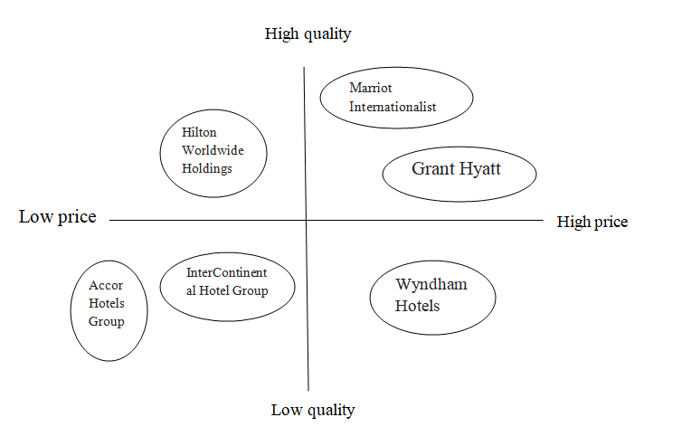
Figure: Positioning map of Grand Hyatt
(Source: Self-created)
The positioning map of Grand Hyatt shows the graphical representations of the competitors of the company that helps to understand the company's position in the competitor's market.

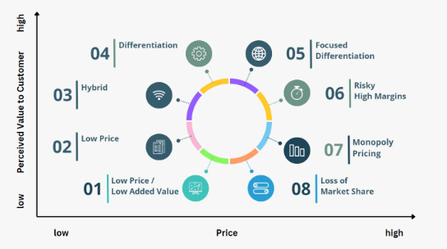
Figure: “Bowman's strategy clock”
(Source: Strategypunk.com, 2022)
Bowman’s Strategy Clock helps Grant Hyatt to get a competitive position and potential strategies for improvement and is represented by a clock face that is divided into eight segments that represent different competitive positions.
Collaboration
The company has different types of collaboration with B2B relationships. Grand Hyatt has collaborated with airlines, car rental companies, and restaurants, which helps to offer affordable packing deals and promotions. Moreover, Franchise properties are available in different locations of the tourism spots.
Climate
Political | Trade relationship with other countries is stable and strong to help Grant Hyatt in order to maintain affiliations easily and smoothly
Economical | Desirable tax policies support the business growth of Grant Hyatt and develop will allow the business expansion in creating economic value
Social | A higher portion of the younger population is facilities for the Grant Hyatt that will allow the company a larger consumer base
Technological | The improvement of the technological infrastructure helps to attract foreign direct investment and a high level of investment in R&D to develop the business (Istikomahet al. 2022)
Legal | Grand Hyatt follows the strong regulation in health and safety management
Environmental | Escalating the confirmed environmental stability can influence the customer demand for eco-friendly amenities and practices

Objectives
Specific: The specific goal of Grant Hyatt provide high-quality services in the market with reasonable returns for investment

Measurable: The service quality can be measured by getting feedback from the customers. It will help to measure the financial performance of the company (Ago et al. 2023).
Action: Grant Hyatt will critically evaluate the marketing plan so that the ho0tel chain can improve the financial profitability in the market
Relevant: a relevant object of Grant Hyatt is to utilize the KPIs or Key performance indicators to get accurate performances in the hotel industry.
Time bound: The objectives of Grant Hyatt will be met within 2024

Strategy
Market penetration
Market penetration can be helped to increase the sales touch points and reach directly to the customers in order to improve the dealer network. Moreover, increasing the customer lifetime value and increasing the basket share of customer total spending.
Market development
Market development strategy is involved in efforts on the part of Grant Hyatt to create new markets and channels for the current services (Vieira et al. 2019). This may involve entering internal markets in entering the new domestic markets that derive sales of the services.
Product development
Product development in Grant Hyatt involved adding new features to the development of the correct service for the existing market. Microsoft constantly release windows office version after a specific duration of the time
Diversification
Grant Hyatt can also use a diversification strategy in the market and products in new. In addition to this, a diversification strategy is used in an organization to see the opportunities in an adjective industry.

Tactics
Marketing mix
Product:
Grand Hyatt offers luxurious hotel services with advanced amenities and modern facilities. The hotel also offers various options for celebrations like weddings, business meetings, and banquets. However, this company can increase its profitability by adopting a low-cost services strategy with a wide range of event planning. Therefore, it will attract many customers and increase the profitability of the company by developing the booking rate.

Place:
The company has an international presence with Francis' strategy of the explanation of the hotel chain. The marketing plan of the company has been utilized in that the company has various distribution channels that are included in the direct booking, online travel agencies, and partnerships with airlines with the purpose of reaching potential customers (Purwanti et al. 2023). The company can use the tactics of servicing not only tourist places but also in local residential places or near the airport, railway station where people need to book hotels and wait for the transport.
Price:
Grand Hyatt focuses on select services and products in luxurious settings. The company has adopted a Premium pricing policy for its services and offering products to the high profile customer. Their pricing policy proved that success as the customers are showing interest to get this experience (Percy, 2023). Therefore, it can be evaluated that the pricing strategy of Grant Hyatt has the potentiality to improve the generated revenues and offers the discount on the group booking with a voucher for meals and complimentary suit and lucrative deals for the regular customer.
Promotion:
The company offers a discount and promotions to potential customers. In addition to this, social media campaigning and several taglines; moreover, Grand Hyatt was ranked at 47th position in “Fortune Magazine”'. However, the company needs to shift traditional promotion to technical promotion to improve the promotional strategy and establish a strong brand image with the customers.

Action
Gantt chart
Activities | Week 1 | Week 2 | Week 3 | Week 4 | Week 5 | Week 6 | Week 7
SOSAC analysis
Creating 5 C Model
SWOT analysis
PESTLE analysis
SMART objectives
Investing in technology
Social media campaigning
Following “Premium pricing policy”
Offering luxurious settings
Providing discount
Using franchises marketing

Activities | Information that is discussed | Marketing channel
SWOT analysis | Internal strength and the weakness of the company with opportunities and threads | Social media
PESTLE analysis | External or macro environment of the company | Magazine, newspaper
Marketing mix | Analytics of the marketing strategy | Email, a communication tool
SMART objectives | The specific objects and the time goal of the archive | KPIs
“Bowman's strategy clock” | To analyse the position in the competitive market | Framework
Investing in technology | The company will take an strong initiatives to invest in the technology | Investors
Social media campaigning | To reach more potential customers in the market | Facebook, Instagram, twitter, YouTube
Following “Premium pricing policy” | Increasing the annual net profit | Financial budget analysis
Offering luxurious settings | To attack high profile customer | Promoting through the Facebook, Instagram, twitter, YouTube
Providing discount | Improve the booking rate | Promotional code, referring code
Using franchises marketing | Expand the business in local areas | Small Business operators

Control
- Revenues growth of Gantt Hyatt: Gantt Hyatt reported the first quarter of the financial results for 2023 that the net income was $58 million
- Revenue per client: revenues per client are fixed in the hotel, the allocated revenue is $ 145 dollar
- A profit margin of Gantt Hyatt: Profit margin can be defined as percentages of the revues after the deduction of expenses, Gantt Hyatt's net profit margin is 9.31%.
- Client retention rate: the client retention of the Gantt Hyatt is 100% as the quality of the company helps to retain the clients and employees (Morgan et al. 2019)
- Customer satisfaction: In Google, the company rating is 4.5 out of 5 and it presents customer satisfaction for the company

Conclusion
From the above discussion, Grant Hyatt's marketing plan is to analyze the business strategies that can be used as a result of the company's products and services. SOSTAC and Bowman's Strategic Clock define the main objectives of this study. In addition, this study presents a SWOT and PESTLE analysis and a marketing mix using the 5'C model. SMART objectives are identified for each "P" to be achieved and explored to implement an effective new strategy for the company. It can be recommended that the company can increase its profit by developing their franchises marketing in various localities in the global hotel business.

Reference list
Ago, G., Bayu, B., Hierdawati, T., Gani, I.P. and Sucandrawati, N.L.K.A.S., 2023.SELECTION OF MARKETING STRATEGIES THROUGH ONLINE MARKETING PLATFORMS FOR MSMES.JurnalEkonomi, 12(01), pp.874-878.
Chaffey, D. and Smith, P.R., 2022. Digital marketing excellence: planning, optimizing and integrating online marketing. Taylor & Francis.
Istikomah, I., Saputra, G.W. and Yusuf, M., 2022.Marketing Mix Strategy and Financial Capabilities in Improving Sharia Stock Investment.Journal of Applied Management and Business Administration, 1(1), pp.21-27.
Morgan, N.A., Whitler, K.A., Feng, H. and Chari, S., 2019.Research in marketing strategy.Journal of the Academy of Marketing Science, 47, pp.4-29.
Percy, L., 2023. Strategic integrated marketing communications. Taylor & Francis.
Purwanti, A., Reza, A., Musa, U., Nurhadi, Z.F. and Triyadi, A., 2023. NEW MEDIA AS INTERNET MARKETING COMMUNICATIONS IN RETAIL COMPANY.JIM UPB (JurnalIlmiahManajemenUniversitasPuteraBatam), 11(1), pp.95-104.
Strategypunk.com, 2022. Available at: https://www.strategypunk.com/bowmans-strategy-clock-powerpoint-template/
Vieira, V.A., de Almeida, M.I.S., Agnihotri, R., da Silva, N.S.D.A.C. and Arunachalam, S., 2019. In pursuit of an effective B2B digital marketing strategy in an emerging market.Journal of the Academy of Marketing Science, 47, pp.1085-1108.

Appendix

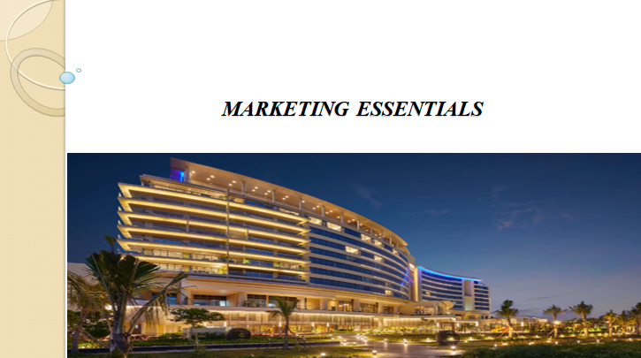Introduction and situation analysis
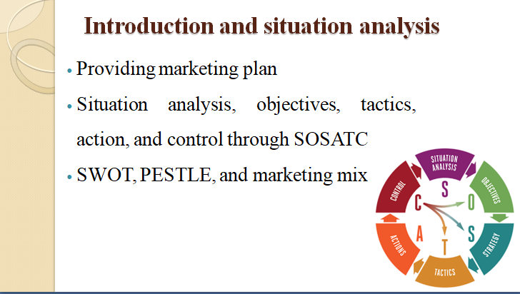

Objectives and strategy
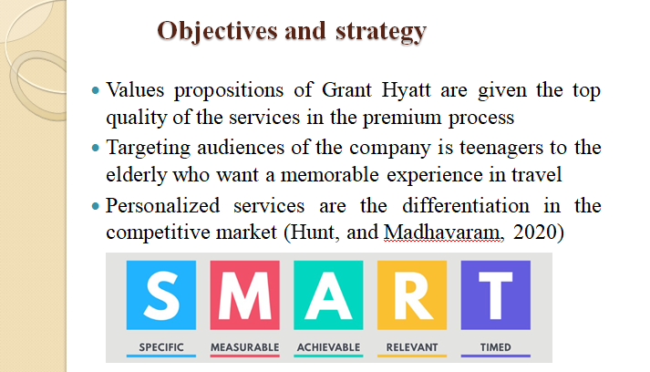
Tactics-Marketing mix
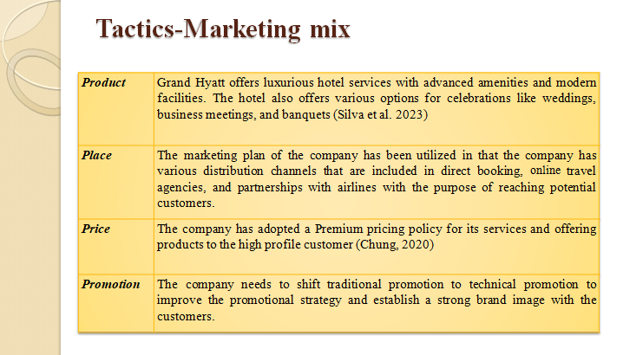

Tactics- Marketing channels schedules

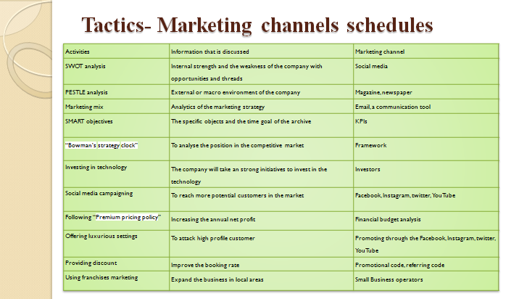
Control and Conclusion
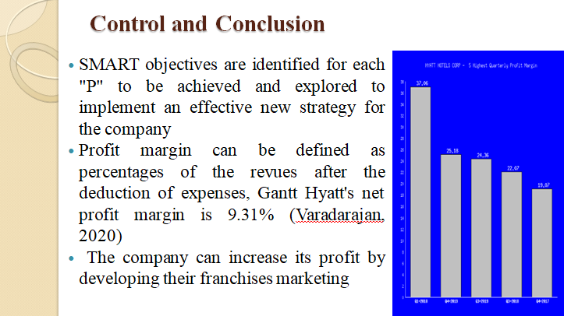
Reference list


