How to create an Allen Key
In this solidworks tutorial, you will create simple allen key.
- Click New.Click Part,OK.

Click Option (Tools>Option…) , select Document Properties tab. Select Units , under Unit System select IPS (inch, pound, second) OK.
2. Click Front Plane and click on Sketch.
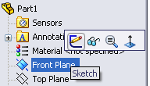
3. Click Line, skecth a L shape.
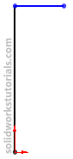
4. Click Smart Dimension,and dimension sketch as 2.5″ and 1″.
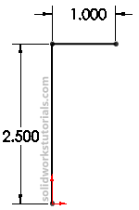
5. Click Sketch Fillet,add 0.3″ fillet at L corner.
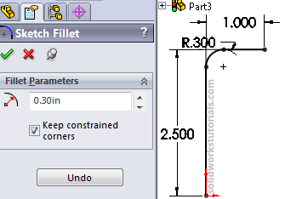
6. Exit sketch,
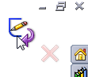

click on Top Plane and click Sketch.
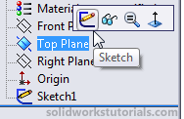
7. Click on Sketch2 and click Normal To.
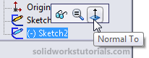
8. Click Polygon,sketch a polygon at origin.
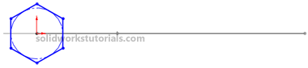
9. Click Smart Dimension,and dimension sketch diameter to 0.15″.
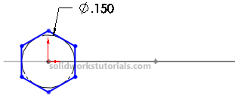
10. Exit sketch,click on Isometric view.
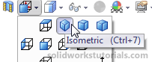
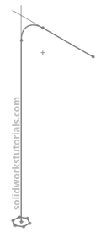

11. Click Features>Swept Boss/Base,
for profile click on Sketch2 and for path click on Sketch1 and OK.
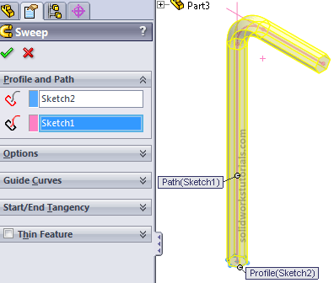
You’re done!.


