Module Name: Networks and Cyber Security Essentials
Module Number: ACCA4024
Assignment Title: Secure the network from common threats and attacks

Student Name: Abigail Davies
Student Number: 2114472
Course: BSC2-PT Computing (Software Engineering)

Table of Contents
List of Figures / Tables 3
Abstract 4
Introduction 4
Possible Security Breaches (Task 1) 4
Access Control 4
Complimentary Wi-fi 5
Infrastructure 5
Disgruntled Employees 5
Weak Passwords 5
Threats, Vulnerabilities and Attacks (Task 2) 6
Threats 6
Vulnerabilities 6
Attacks 7
“.rekt” File Format Attack 7
Importance of Implementing Security Measures (Task 3) 8
Completion of “Introduction to Packet Tracer” Course 8
Certificate - Appendix 1 8
Digital Badge - Appendix 2 8
Topologies 8
Packet Tracer File 10
Suggested Security Devices 10
Recommended Guidelines - Draft (Task 4) 11
Staff Members 11
Customers 11
Conclusion, Recommendation and Future Work 12
References 13
Abbreviations 17
Appendix 18
Appendix 1 18
Appendix 2 18

List of Figures / Tables

Figure 1 8
Figure 2 9
Figure 3 9
Figure 4 10
Figure 5 10
Figure 6 11

Abstract

Batman Textiles is a textiles showroom owned by Bruce who has recently employed Alfred to be Head of Marketing. Bruce’s aim is to increase sales and promote the business. Alfred has suggested and implemented many strategies to reach the key goals. Although, with these objectives in mind, the security of the business has been disregarded. Some examples of threats the business is exposed to are information theft, loss of data and disruption of service. To counteract these, employees should receive the correct training, implement strong passwords across all accounts and follow all security policies in place. To conclude, security is a crucial aspect of owning a business.

Introduction

In the scenario provided, Bruce owns a textiles showroom called Batman Textiles. Originally, there were 12 Sales Executives, 2 Sales Heads and 1 Accounts Officer, totalling 15 employees. However, to reduce costs after difficult times during the pandemic, both Sales Head positions were removed, and their responsibilities were given to the roles of Sales Executives. Attached to this showroom, Bruce has also recently opened a restaurant following the advice of Alfred, the new Head of Marketing. He believes that this is an additional approach of promoting the business and increasing their sales. Nevertheless, security within the business should still be a high priority. According to, Athena Information Solutions Pvt. Ltd, cybercriminals are exploiting the pandemic to attack organisations for information [1]. Even though, Batman Textiles has slightly different circumstances to the organisations mentioned in Magazine, the business should still be apprehensive about cyber-attacks. For this reason, this report evaluates the possible security breaches that have been highlighted as a result of these measures, and the different types of threats, vulnerabilities, and attacks that Batman Textiles could be subjected to. There will also be an example of how business owners could efficiently implement security measures, and a drafted guideline of how their employees and customers can be more responsible in a digital space.

Possible Security Breaches (Task 1)

Access Control

Following the withdrawal of the two Sales Head positions, all employees now have full access to the business. Blum mentions that the access within a business should be controlled based on the identity of users, services, and devices, as well as the protection of data. This allows businesses to lower their risk of breaching laws and allows them to adhere to privacy-related laws. Furthermore, Blum continues highlighting the importance of balancing access controls with accountability so that the business is at a reduced risk, but employees are still able to work efficiently [2].

Complimentary Wi-fi

One of Alfred’s business methods for improving footfall in the businesses was to offer complimentary wi-fi to all customers. This is otherwise known as public or open wi-fi which can cause many security risks. Norton Security suggest that a Man-in-the-Middle attack is the most common threat to individuals using this type of network. [3] This type of threat could lead to a breach in business and /or personal data as it is a form a cyber eavesdropping. With this in mind, Batman Textiles will not only be putting themselves at risk but also their customers.
Additionally, business owners offering these services have very little control to what sites or what emails customers open whilst using their network. This means customers could unintentionally be exposing the business network to phishing attacks. A phishing attack is the attempt to retrieve sensitive information and are often disguised as a reliable source [4].
Furthermore, open wi-fi networks allow any individuals to connect [5]. These types of individuals include employees, customers and /or hackers.

Infrastructure

Following on from complimentary wi-fi, not only does this have its own risks but also for cost-saving reasons, Alfred decided to offer this service from the same network that the business applications run on. Some of the dangers of this include individuals using the network to transmit illegal documents, Denial-of-Service attacks (DoS) and criminals intercepting the conversation to steal credentials. Bushell implies businesses and organisations are the usual target of DoS attacks due to it involving attackers controlling several hosts to disable the network [5].

Disgruntled Employees

One of the Sales Head employees who lost their role in the business was unsettled by the decision. Unhappy employees can cause many issues for a business, including cyber sabotage which is seen as one of the most damaging forms of sabotage a business can encounter [6]. In fact, Schouteren states that numerous cyber incidents are acts of employees within an organisation, specifically disgruntled employees [7]. Additionally, this particular employee had privilege access whilst they were part of the firm. This means the individual is likely to have knowledge of how the business applications ran and the steps required to access them.

Weak Passwords

Weak passwords can increase the risks of being hacked for any individual or business. In fact, researchers suggest that they are a major role in any hack [8]. Chauhan and Panda also mention that strong passwords are not compulsory on many applications so that the user’s journey is simplified. However, if employees of Batman Textiles are not aware of how a strong password is structured then they would also be at a greater risk.
There are many common characteristics of a password that would consider it to be vulnerable. Williams indicates these include repetitive password use or login code, words found in the dictionary, keyboard patterns and your own or family members name [9].

Threats, Vulnerabilities and Attacks (Task 2)

Threats

According to the dictionary, a cyberthreat is the likelihood of someone attempting to cause damage or destroy a computer network, system, or website [10]. There are various types of threats that an organisation could be exposed to. The four main types of threats would be information theft, loss of data and /or manipulation, identity theft and lastly, service disruption [11].
Identity theft is a form of information theft [11]. Van der Kleut suggests that criminals who have stolen personal identities may open new credit cards in the individuals /business name or file a tax return using the social security number [12]. As this is written from an American’s perspective, a social security number would convert to a national insurance number or unique taxpayer reference number in the UK.
Loss of data could be a result of deliberate or accidental damage. There are several main causes of data loss which include, human error, computer viruses and natural disasters [13].
Disruption of service prevents genuine users from gaining access to a service. This type of threat would include DoS attacks [11], where attackers attempt to overwhelm the service with requests, with the hope that it exhausts the target, leading to system failure [14].
The individual or group attempting to cause damage could be both internal and external intruders due to there being various ways that an attacker can misuse a network. For example, internal attackers are likely to know what type of information is valuable and accessible, whilst an external hacker would need to gain access the network via the internet, as well as learn and understand how the network functions [11].

Vulnerabilities

According to the detailed information provided by the National Cyber Security Centre (NCSC), a vulnerability is weakness that can be manipulated by an attacker that arise from features, flaws, or human error. These could be a consequence of poor design or human error during implementation [15].
One type of vulnerability is known as Zero Day which means it is unknown to the product vendor. This also means that a fix is not available and once it is public knowledge, the vendor becomes under pressure to release a fix. Brooks suggests that these types of vulnerabilities can be found by accident or from reverse-engineering the application [16].
Another common vulnerability is when operating systems and /or firewalls have been misconfigured by allowing or using default settings. According to PurpleSec Youtube channel, it is the security team’s responsibility to check whether these are enabled when completing security checks for the overall system [17].

Attacks

The official definition of a cyberattack, claimed by Oxford Learner’s Dictionaries, is that it is the act of attempted damage to a computer system, network, or website from unauthorised access [18].
Attackers are also known as hackers and there are many different types. Some examples would include black hat attackers, grey hat attackers and white hat attackers. A black hat attacker would be classified as an unethical hacker, whereas a white hat attacker tends to involve ethical hacking. Furthermore, a black hat attacker would break into a network for personal gain, compared to white hat attacker who would do this to identify any weakness for future improvements. In addition, there are also script kiddies which black hat attackers tend to take advantage of, when they use their existing tools [11].
A common attack would be malicious software, which is otherwise known as malware. There are many kinds of malware, including viruses, worms, logic bomb and ransomware. Cyber-criminals use a variety of these to launch an attack when they are installed on the target network or system [19].
Cyber-criminals can also attack a system via the targeted user’s email. Some examples of this would be SPAM emails, spyware and phishing. SPAM is commonly known as junk mail from advertisement, but they can also have malicious software embedded in them [19].

“.rekt” File Format Attack

Meskauskas states that a file with “.rekt” extension has ransomware installed. The researcher further explains that the files are usually encrypted with an asymmetric algorithm meaning a public and private key are essential in decrypting the files. Furthermore, cyber-criminals launching this type of attack generally extort money from the affected user before delivering the private key. Although, even then, some are known to not give this up. Additionally, the expert states that there are currently no tools available that can restore the affected files and therefore, the only way to restore the files would be from a back-up [20]. In addition, this accentuates the significance of having regular back-ups in place.

Importance of Implementing Security Measures (Task 3)

Completion of “Introduction to Packet Tracer” Course

Certificate - Appendix 1
https://uowtsd-my.sharepoint.com/:b:/g/personal/2114472_student_uwtsd_ac_uk/ERP3uJvTYAJJi3iGDqCrmlgBbf5LtSjL7PGxVeyyHzFCQA?e=112ylj

Digital Badge - Appendix 2
https://www.credly.com/badges/279d5b22-a56b-44a4-bb8a-3cd7e610da2f/public_url

Topologies

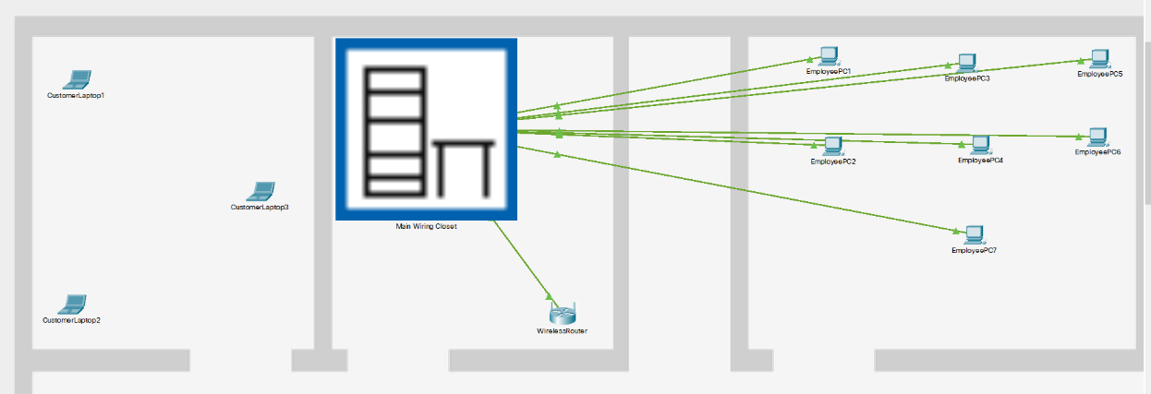
Physical Topology
Figure 1

Figure 2

Logical Topology - Device Information

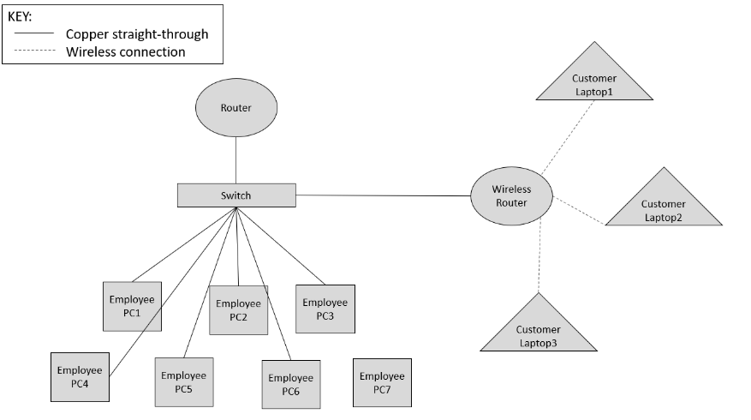
Figure 4

Device | Interface | IP Address | Subnet Mask | Default Gateway
Router | Gig0/0/0 | 192.168.1.1 | 255.255.255.0 | N/A
EmployeePC1 | FastEthernet0 | 192.168.1.4 | 255.255.255.0 | 192.168.1.1
EmployeePC2 | FastEthernet0 | 192.168.1.5 | 255.255.255.0 | 192.168.1.1
EmployeePC3 | FastEthernet0 | 192.168.1.6 | 255.255.255.0 | 192.168.1.1
EmployeePC4 | FastEthernet0 | 192.168.1.7 | 255.255.255.0 | 192.168.1.1
EmployeePC5 | FastEthernet0 | 192.168.1.8 | 255.255.255.0 | 192.168.1.1
EmployeePC6 | FastEthernet0 | 192.168.1.9 | 255.255.255.0 | 192.168.1.1
EmployeePC7 | FastEthernet0 | 192.168.1.10 | 255.255.255.0 | 192.168.1.1
Switch | N/A | N/A | N/A | N/A
WirelessRouter | LAN | 192.168.0.1 | 255.255.255.0 | N/A
WirelessRouter | Internet | 192.168.1.3 | 255.255.255.0 | 192.168.1.1
CustomerLaptop1 | Wireless0 | 192.168.1.102 | 255.255.255.0 | 192.168.0.1
CustomerLaptop2 | Wireless0 | 192.168.1.100 | 255.255.255.0 | 192.168.0.1
CustomerLaptop3 | Wireless0 | 192.168.1.101 | 255.255.255.0 | 192.168.0.1

Figure 3

Packet Tracer File
https://uowtsd-my.sharepoint.com/:u:/g/personal/2114472_student_uwtsd_ac_uk/EaonssQIpStHgX_jTL48BdQB1KD5i1uinei32mxG9k6akw?e=PbpBTl

Suggested Security Devices

NCSC suggest that there are many ways that a small business can improve their security via affordable measures. One step involves protecting your business from malware, by utilising an anti-virus software [21].

Figure 5

[22]

Following investigation into the best anti-virus software that’s currently available, researchers indicate that one would be AVG. One advantage this software has would be that businesses can use a feature that eliminates malware affected files [23].


[24]
Figure 6
Additionally, Cisco Meraki MX64 is a cloud management security appliance that offers many features such as protection against recent vulnerabilities, as well there being simple steps to deployment, reducing the need for expert training [24].

Recommended Guidelines - Draft (Task 4)

Staff Members

One principle that members of staff should always follow would be to use strong passwords. Norton suggest that a strong password has at least 10 characters containing, digits, symbols, and both lowercase and uppercase letters [25].
Secondly, Norton also state that it is important that employees of an organisation have the correct training. If an individual is unsure on a particular policy, then this will give them the opportunity to clarify any misunderstandings [25].
Moreover, employees locking their computers before leaving it unattended, would add to reducing the security risks within a business. Jackson suggests that leaving a computer unlocked gives thieves the opportunity to access sensitive data [26].
Additionally, implementing multi-factor authentication allows an employee’s account to be more secure. This means the employee will have an additional step before logging into their account, where they will have to verify themselves via a different device. Kaila and Nyman suggest that an example of a different device, an individual could use, would be a mobile phone. The second device would usually be sent a unique code to enter before allowing access to the account [27].
Kaila and Nyman also recommend that organisations create awareness within the workplace of phishing attacks or other similar scams. They further explain how criminals are now creating sites that are identical to sites that individuals typically trust [27]. Phishing is a fraudulent act that criminals use to gather sensitive information [19].
Sadok, Alter and Bednar’s research found that 48% of candidates in their study were not aware of the current security controls in their workplace [28]. This highlights the importance of regularly reviewing security polices in the workplace and sharing regular reminders of the importance of all employees obeying them.

Customers

Similarly, customers should also follow some guidelines to ensure safety in digital spaces. Principles such as using strong passwords, ensuring their digital devices are locked before leaving them unattended and being mindful of phishing scams would also be important for any individual.
In addition, customers should ensure they log out of any accounts they have used during the period they are logged into a public-network. Individuals should also try to avoid using applications when on a public-network by using a company’s HTTPS website instead [3]. The HTTPS protocol is a development of HTTP as it creates an encrypted connection between the user and site [29].
Furthermore, customers should be aware of any emails they open. As previously cited, even though SPAM emails tend to be advertisement, they can also embed harmful links or malware [19]. This would not only put the customer’s device at risk but also the whole network e.g., other customers using the network.
Lastly, customers should ensure their devices are up to date. NCSC cite that manufacturers such as Windows and iOS regularly release updates. These commonly include essential security updates that are aimed to protect the device. Also, it’s a quick and simple process that is free and, on some devices, individuals can set this update to be performed automatically [21].

Conclusion, Recommendation and Future Work

To conclude, security within a business is vital. There are many ways a business can implement effective security measures, that are also cost effective. Additionally, as highlighted throughout the report, there are many research studies available that can develop and assist with the understanding of more detailed security principles, that should be implemented in the workplace. Unfortunately, there are currently no solutions available to restore the files affected by the malicious software. Although, this does highlight the importance of having procedures in place that can protect data from these types of attacks. As well as this, malware is not the only threat, organisations are exposed to, which also emphasises the significance of a secure network.

References

[1] Athena Information Solutions Pvt. Ltd., “The importance of CyberSecurity during COVID-19”, PCQuest; Gurgaon, Apr 29, 2020. [Online]. Available: https://www.proquest.com/docview/2395491962/fulltext/C56970740C124C66PQ/1?accountid=130472 .[Accessed Dec. 13, 2021].

[2] D. Blum, Rational Cybersecurity for Business: The Security Leaders' Guide to Business Alignment, 2020. [E-book].

[3] NortonLifeLock employee, “The risks of public Wi-Fi”, Norton, May 26, 2018. [Online]. Available: https://us.norton.com/internetsecurity-privacy-risks-of-public-wi-fi.html [Accessed Dec. 13, 2021].

[4] T. Edmands, “Cybersecurity Awareness: Phishing and Whaling”, Linkedin, 2017. [Online]. Available: https://www.linkedin.com/learning/cybersecurity-awareness-phishing-and-whaling/understanding-phishing?autoAdvance=true&autoSkip=false&autoplay=true&resume=false&u=77966930 [Accessed Dec. 14, 2021].

[5] K. Bushell, “EXAMINING THE RISKS OF INSECURE PUBLIC WI-FI NETWORKS”, The University of Arizona, pp. 7-8, 2018. [Online]. Available: https://repository.arizona.edu/bitstream/handle/10150/630451/azu_etd_hr_2018_0021_sip1_m.pdf?sequence=1&isAllowed=y [Accessed Dec. 14, 2021].

[6] T. Wilhelm, J. Andress, “Ninja Hacking”, ScienceDirect, 2011. [Online]. Available: https://www.sciencedirect.com/topics/computer-science/disgruntled-employee [Accessed Jan. 2, 2022].

[7] S. Schouteren, “From wooden shoe to click of a button: the risk of disgruntled employees”, Computer fraud & security, vol. 3, Mar 2019. [Online]. Available: https://www-magonlinelibrary-com.ezproxy.uwtsd.ac.uk/doi/abs/10.1016/S1361-3723%2819%2930029-6 [Accessed Dec. 14, 2021].

[8] S. Chauhan, N. Panda. “Hacking Web Intelligence”, ScienceDirect, 2015. [Online]. Available: https://www.sciencedirect.com/topics/computer-science/weak-password#:~:text=Weak%20passwords%20can%20be%20guessable,needed%20to%20be%20stored%20properly. [Accessed Jan. 2, 2022].

[9] M. Williams, “7 Characteristics of Weak Passwords (Infographic)”, Government Technology, Oct. 5, 2012. [Online]. Available: https://www.govtech.com/security/7-characteristics-of-weak-passwords-infographic.html [Acessed Jan. 2, 2022].

[10] Oxford Learner’s Dictionaries, “cyberthreat”, Oxford Learner’s Dictionaries. [Online]. Available: https://www.oxfordlearnersdictionaries.com/definition/english/cyberthreat?q=cyberthreat [Accessed Jan. 2, 2022].

[11] N. Kaliyamurthy, Class Lecture, Topic: “Lecture 5 Understanding Networks and Cybersecurity”, University of Wales Trinity Saint David, Oct. 25, 2021.

[12] J. van der Kleut, “Identity theft: What is it and how to avoid it”, Norton. [Online]. Available: https://us.norton.com/internetsecurity-id-theft-what-is-identity-theft.html [Accessed Jan. 2, 2022].
[13] Corporate Finance Institute, “Data Loss”, Corporate Finance Institute. [Online]. Available: https://corporatefinanceinstitute.com/resources/knowledge/data-analysis/data-loss/ [Accessed Jan. 2, 2022].

[14] Cisco, “What Is a DDoS Attack?”, Cisco. [Online]. Available: https://www.cisco.com/c/en_uk/products/security/what-is-a-ddos-attack.html [Accessed Jan. 2, 2022].

[15] National Cyber Security Centre, “Understanding vulnerabilities”, Oct. 14, 2015. [Online]. Available: https://www.ncsc.gov.uk/information/understanding-vulnerabilities [Accessed Jan. 2, 2022].

[16] C. J. Brooks, Cybersecurity Essentials, 1st ed., Sybex, 2018, ch.24, pp.591-592. [E-book].

[17] PurpleSec, “Common Types Of Network Security Vulnerabilities In 2021 | PurpleSec”, YouTube, Sep. 27, 2020. [Online]. Available: https://www.youtube.com/watch?v=2VaPTIuRs4k [Accessed Jan. 3, 2022].

[18] Oxford Learner’s Dictionaries, “cyberattack”, Oxford Learner’s Dictionaries. [Online]. Available: https://www.oxfordlearnersdictionaries.com/definition/english/cyberattack?q=cyberattack [Accessed Jan. 3, 2022].

[19] N. Kaliyamurthy, Class Lecture, Topic: “Lecture 7 Cybersecurity Threats, Vulnerabilities and Attacks”, University of Wales Trinity Saint David, Nov. 15, 2021.

[20] T. Meskauskas, “REKTLocker Ransomware”, PC risk, Dec. 9, 2021. [Online]. Available: https://www.pcrisk.com/removal-guides/10351-rektlocker-ransomware [Accessed Jan. 3, 2022].

[21] National Cyber Security Centre, “Small Business Guide: Cyber Security”, Oct. 11, 2017. [Online]. Available: https://www.ncsc.gov.uk/collection/small-business-guide/protecting-your-organisation-malware [Accessed Jan. 4, 2022].

[22] AVG, “Homepage”, AVG. [Online]. Available: https://www.avg.com/en-gb/homepage#pc [Accessed Jan. 4, 2022].
[23] Tech Insight Team, “10 of the best antivirus software packages for business”, Business Tech Weekly, Jun. 24, 2021. [Online]. Available: https://www.businesstechweekly.com/cybersecurity/application-security/business-antivirus/ [Accessed Jan. 4, 2022].

[24] Cloudse, “Cisco Meraki MX64”, Cloudse. [Online]. Available: https://www.cloudse.co.uk/product/meraki-mx64/?gclid=EAIaIQobChMIkfe25P-Y9QIVtGLmCh0bTgdCEAYYASABEgLtcPD_BwE [Accessed Jan. 4, 2022].

[25] A. Johansen, “10 cybersecurity best practices that every employee should know”, Norton, Apr. 9, 2019. [Online]. Available: https://us.norton.com/internetsecurity-how-to-cyber-security-best-practices-for-employees.html [Accessed Jan. 4, 2022].

[26] D. Jackson, “”, Net Standard, Apr. 1, 2020. [Online]. Available: https://www.netstandard.com/always-lock-computer [Accessed Jan. 4, 2022].

[27] U. Kaila, L. Nyman, “Information Security Best Practices: First Steps for Startups and SMEs”, Technology Innovation Management Review, vol. 8, iss. 11, pp.32-42, Nov. 28, 2018. [Online]. Available: https://www.proquest.com/docview/2151125953?accountid=130472&parentSessionId=3F88qcpXxYX629u8Sd6%2Bm2W0Vw6T7o0QYk7LsLhms1s%3D&pq-origsite=primo [Accessed Jan. 5, 2022].

[28] M. Sadok, S. Alter, P. Bednar, “It is not my job: exploring the disconnect between corporate security policies and actual security practices in SMEs”, Information management & computer security, vol. 28, iss. 3, pp.467-483, May. 30, 2020. [Online]. Available: https://www.proquest.com/docview/2498996386?accountid=130472 [Accessed Jan. 5, 2022].

[29] CLOUDFLARE, “Why is HTTP not secure? | HTTP vs. HTTPS”, CLOUDFLARE. [Online]. Available: https://www.cloudflare.com/en-gb/learning/ssl/why-is-http-not-secure/ [Accessed Jan. 5, 2022].

Abbreviations

DoS – Denial-of-Service
NCSC – National Cyber Security Centre

Appendix

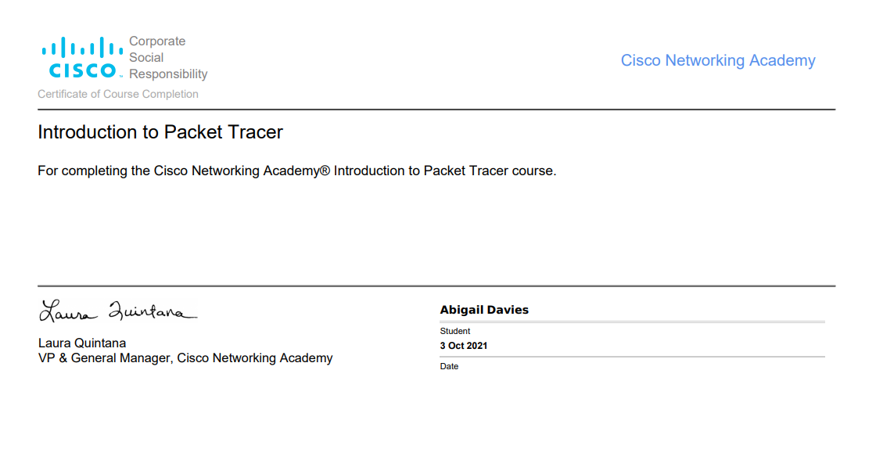
Appendix 1

Appendix 2


