
Certificate of Higher Education Skills for the Workplace (Health and Social Care)
LCHS4008: Introduction to Public Health
Report on a Health Issue: Type-2 Diabetes

Lecturer: Gillian Weaver
Student Name:Maryam Waseem
Student ID:2433389

Word Count: 1596
Executive Summary
Type-2 Diabetes (T2D) is associated with enhancement of blood glucose level in the body that is caused by issues in generation of insulin. This report elaborates about the consequences of this disease in the community along with the NHS in the UK. Additionally, strategies such as maintaining a healthy lifestyle also have been described as important for controlling diabetes. Moreover, several factors such as biological, emotional, socio-economic and others are also described in this report that causes T2D.
Table of contents
1. Introduction 4
2. Main Body 4
2.1 Consequences of Type-2 Diabetes in the community considering NHS 4
2.2 Strategies for controlling this T2D 6
2.3 Assessment of factors that influences health along with well-being of people affected by Type-2 Diabetes 7
3. Conclusion 8
Reference list 9

1. Introduction
Type-2 Diabetes or T2D, also referred to as Diabetes Mellitus, is a condition in which the level of blood sugar of people has enhanced due to lack of insulin production. In this chronic metabolic issue, the increase of excessive glucose in blood causes the damage of nerves, blood vessels and the other vital organs of the body. The main symptoms associated with T2D are enhancement of thirst, weight loss, blurred vision, fatigue, skin infections along with frequent urination. Signs also include increased hunger, numbness, dark skin patches and slow healing of injuries. According to data of 2022, 830 million people in the world and 1.6 million people directly died due to this disease (WHO, 2024). Particular to UK, about 6.3 million of the adult population is living with pre-diabetic symptoms that reflect the growth trend of this disease. Accordingly, this report focuses on illustrating the consequences of this disease on communities along with the NHS and also elaborate about strategies for controlling this T2D.

2. Main Body

2.1 Consequences of Type-2 Diabetes in the community considering NHS
Type-2 Diabetes has a severe impact on the health of people in the UK and also enhances pressure of the NHS regarding initiation of the program for controlling this disease. The main impact of Type-2 Diabetes can be observed in the quality of life of people. This disease enhances the issues associated with the vision of people, induces fatigue and also increases the possibility of heart disease that can affect life expectancy. According to recent data, about 4.1 million people in the UK are living with diabetes and 90% among these people are suffering from Type-2 Diabetes (T2D) (Chambers, 2022). T2D also reduces the immunity of people and makes an impact on the level of energy that is crucial in maintaining the ability of work. Challenges associated with absenteeism also have been enhanced in the UK due to diabetes that induces problems regarding productivity of people (Hex et al. 2024). Thus, reduction of overall productivity enhances challenges for organisations in the UK to maintain sustainability of business and incidents like layoff have been enhanced in this country.
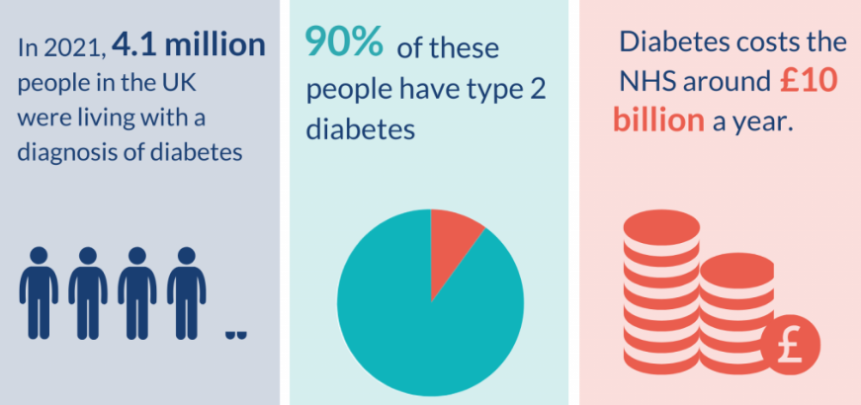
Figure 1: Diabetes in the UK
(Source: Chambers, 2022)
The T2D also causes depression as well as anxiety among people that increases mental health issues in the UK. According to data 2024, about 33%-50% of patients associated with diabetes are suffering from mental distress (CDC, 2024). Thus, this type of challenge also induces pressure on the NHS to develop a framework for supporting people regarding mental issues. Similarly, the T2D is higher by about 2.3 times among the poorer section of the population in the UK that highlights the significance of a good lifestyle for avoiding challenges such as diabetes (Parliament, 2025). Thus, health inequality shows in the society have been enhanced by increase in issues such as T2D.
Enhancement of T2D increases pressure on the NHS regarding more investment of the budget in controlling this disease. According to recent data, the NHS has allocated about 10 billion in each year for controlling as well as managing diabetes (Chambers, 2022). Thus, the increase of this disease can enhance the financial burden of the NHS and lack of resources can create problems linked with enhancement of vulnerability of poorer sections of the population. In the UK, the percentage of T2D is also higher than Type-1 diabetes that enhances concerns of the NHS regarding the control of this disease (Gov, 2025). In this case this organisation needs to make more investment in enhancement of beds in hospitals and recruiting more professionals for primary care. Moreover, pressure on the NHS has been induced due to enhancement of requirements linked with emergency care services due to T2D.
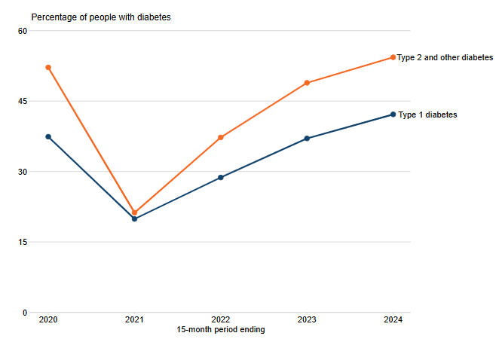
Figure 2: Growth rate of diabetes in the UK
(Source: Gov, 2025)

2.2 Strategies for controlling this T2D
The best way associated with controlling T2D is linked with enhancement of awareness among people regarding a proper lifestyle that can restrict diabetes. The Government of the UK along with the NHS can focus on enhancing awareness of people by organising campaigns in schools, colleges and other social places. Intensifying the Diabetes Prevention Program (NDPP) by the NHS is another strategy that can be useful for preventing the occurrences of diabetes that is crucial for controlling this disease (NHS, 2023). In this case, promoting the tool of Know Your Risk can also be useful for this organisation to enhance people's awareness about risk associated with diabetes. The remission program for people suffering from the early stage of T2D can also be beneficial for reducing rapid increase in this disease. As per this policy, the NHS can focus on providing multi-disciplinary support to patients by developing clinics for psychological support, primary care along with weight management.
The American Diabetes Association (ADA) has published a framework of Standards of Care in Diabetes-2025 that focuses on proper medication, exercise and regular monitoring that is crucial for preventing diabetes. This framework focuses on regular observation of HbA1c that is important for assessing the level of glycemia that directly influences the surge of glucose level and causes diabetes (Khandori, 2025). As per this framework, the NHS in the UK can also focus on supporting patients with guidance regarding the diet, exercise as well as medication. In addition, professionals can also influence people to monitor the glucose level regularly, which is important for understanding the trend of enhancement of glucose level. Moreover, doctors need to emphasise evidence-based prescriptions for the diabetic patients to regulate treatment as per individual requirements.
Digital innovation can be useful for the government to enhance the reach of services to patients associated with diabetes. Data Analytics can be utilised in this case for analysing data such as the communities that are highly vulnerable to diabetes and the impact of socio-economic aspects on this disease (Philip et al. 2022). Reduction of the health inequalities among the population is important for the government along with the NHS in the UK for reducing challenges of diabetes. Thus, inclusive development of society, affordability of treatment and proper guidance to people regarding T2D can be effective for the NHS to control this disease. Despite the challenges of resource allocation, optimal utilisation of available resources and coordination between the different government bodies can also help the NHS to control diabetes with prominence.

2.3 Assessment of factors that influences health along with well-being of people affected by Type-2 Diabetes
T2D can be considered as the genetic disease and a history of this particular disease in the family increases the possibility of becoming insulin resistant. Enhancement of age of people also increases challenges of T2D due to reduction in sensitivity of insulin along with slower rate of metabolism (Bellary et al. 2021). Prevalence of diabetes can also be observed at different levels among people from distinct ethnic backgrounds. Thus, these biological factors such as family history, age and ethnicity influence the prevalence of T2D.
Consumption of high levels of sugar, smoking, drinking excessive alcohol and physical activity can be considered as the lifestyle or behavioural factors that influence T2D. In England along with Scotland about 24% of the adult population drink regularly above the level of risk (Gov, 2025). This type of excessive and continuous consumption of alcohol induces the possibility of T2D. Different emotional factors such as distress, social isolation along with stigma can also induce the possibility of diabetes. In addition, socio-economic factors such as income, education level, accessibility to healthcare facilities also act as the main determinants of diabetes. According to Alrasheeday et al. (2024), a lower level of income reduces the ability of people to consume healthy food along with facilities of workout that are important for controlling diabetes. Similarly, lack of education enhances problems for the population to assess appropriate diet and medication that is crucial for checking blood sugar level.
An effective healthcare model or system in the country also acts as a factor that influences T2D. For example, Healthy Living for People with Type 2 Diabetes is an effective platform developed by the NHS that helps in enhancing accessibility to care linked with diabetes (NHS, 2022). Additionally, in the UK, about 42 Integrated Care Systems (ICS) have been developed for supporting people to reduce diseases such as diabetes that can decrease emergency situations caused by this disease (NHS, 2023). Therefore, consideration of biological, behavioural, emotional and social economic factors needs to be considered during development of strategies for preventing T2D.

3. Conclusion
Evaluation of the report reveals that prevalence of T2D can be observed among the population in the UK. Issues associated with lifestyle, socio-economic conditions and accessibility of medical support also enhances vulnerability regarding this disease. As per the findings, T2D makes a negative impact on the health as well as well-being of people and induces burden for the NHS to make more investment for controlling this disease. Thus, development of a proper framework to face this challenge and enhancing awareness of people about a good lifestyle is crucial for controlling diabetes. Furthermore, reduction of the inequalities in society is also necessary for enhancing the ability of people regarding maintenance of proper diet, medication and an overall good lifestyle that is important for avoiding T2D. Moreover, integration between government bodies is crucial for implementing plans such as enhancement of awareness of people and inducing accessibility of treatment to check T2D in the UK and other countries.

Reference list
Alrasheeday, A.M., Alshammari, H.S., Alshammari, B., Alkubati, S.A., Llego, J.H., Alshammari, A.D., Alshammari, M.H., Almohammed, R.A., Alsheeb, S.M.S. and Alshammari, F., (2024). Perceived barriers to healthy lifestyle adherence and associated factors among patients with type 2 diabetes mellitus: Implications for improved self-care. Patient preference and adherence, pp.2425-2439.
Bellary, S., Kyrou, I., Brown, J.E. and Bailey, C.J., (2021). Type 2 diabetes mellitus in older adults: clinical considerations and management. Nature Reviews Endocrinology, 17(9), pp.534-548.
CDC (2024) Diabetes and Mental Health. Available at: https://www.cdc.gov/diabetes/living-with/mental-health.html [Accessed 11/11/2025]
Chambers, L. (2022) “Diabetes, of all types, is a condition of self-management that places huge demands on people’s time, energy and cognitive resource. Preventing the development of type 2 diabetes also requires significant and sustained action from the individual.” Available at: https://evidence.nihr.ac.uk/collection/diabetes-putting-people-at-the-heart-of-services/ [Accessed 11/11/2025]
Gov (2025) Chapter 12: alcohol. Available at: https://www.gov.uk/government/publications/delivering-better-oral-health-an-evidence-based-toolkit-for-prevention/chapter-12-alcohol [Accessed 10/11/2025]
Gov (2025) Diabetes profile: statistical commentary, March 2025. Available at: https://www.gov.uk/government/statistics/diabetes-profile-update-march-2025/diabetes-profile-statistical-commentary-march-2025 [Accessed 11/11/2025]
Hex, N., MacDonald, R., Pocock, J., Uzdzinska, B., Taylor, M., Atkin, M., Wild, S.H., Beba, H. and Jones, R., (2024). Estimation of the direct health and indirect societal costs of diabetes in the UK using a cost of illness model. Diabetic Medicine, 41(9), p.e15326.
Khandori, R. (2025) Type 2 Diabetes Mellitus Treatment & Management. Available at: https://emedicine.medscape.com/article/117853-treatment?form=fpf [Accessed 11/11/2025]
NHS (2022) Healthy living for people with type 2 diabetes. Available at: https://www.england.nhs.uk/diabetes/digital-innovations-to-support-diabetes-outcomes/healthy-living/ [Accessed 10/11/2025]
NHS (2023) NHS Diabetes Prevention Programme (NHS DPP). Available at: https://www.england.nhs.uk/diabetes/diabetes-prevention/ [Accessed 11/11/2025]
NHS (2023) What are integrated care systems? Available at: https://www.england.nhs.uk/integratedcare/what-is-integrated-care/ [Accessed 10/11/2025]
Parliament (2025) DIABETES UK - WRITTEN EVIDENCE (FDO0074). Available at: https://committees.parliament.uk/writtenevidence/129467/html/ [Accessed 11/11/2025]
Philip, N.Y., Razaak, M., Chang, J., O’Kane, M. and Pierscionek, B.K., (2022). A data analytics suite for exploratory predictive, and visual analysis of type 2 diabetes. IEEE Access, 10, pp.13460-13471.
WHO (2024) Diabetes. Available at: https://www.who.int/news-room/fact-sheets/detail/diabetes [Accessed 11/11/2025]

