DS 1 Template

My Screenshots/Photos
.

Screenshot/Photo 1
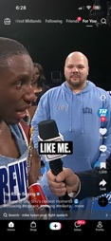
This is me using tick tok wich can be used for toutorials ,tips and tricks , and also business ideas such as car videos Wich include buying and selling , what to look for in the car industry and much more

Screenshot/Photo 2
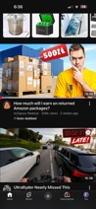
This is the YouTube app wich I like to use because it helps me get ideas in what’s trending in modern day society and also what’s going on in the world today

Screenshot/Photo 3
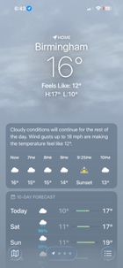
This is the weather app I use day to day to check what the weather will be like during the day Wich helps me decide to dress appropriate according the to the weather information it gives me

Screenshot/Photo 4
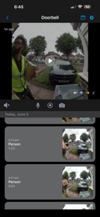
This is my doorbell camera help Wich is very useful as will ring my phone if someone was to press the button and also shows live visuals I think this is improtant as it helps provide safety for me and my family as if someone Because of someone was to try and break into my house I’ll be alerted instantly and be able to warn family members and police

My Short Reflection

I feel my digital skills are that of an advanced person as I use them very well, this can be shown with me using the doorbell app whereas other people may struggle. I sometimes feel nervous using apps I don’t know about as it can take a bit of time adjusting to it and becoming familiar with it. It’s important to me that I use digital skills in my life based on the present moment I’m in at that time. Things like digital skills can help me figure a way out of it or help me fix it. I’m confident in using the apps and skills I already know about but do want to expand my knowledge in situations I’m not familiar with. I hope this module will give the boost I need to be able to excel in my unfamiliarities and gain the knowledge I need to use these digital skills in real life when it may be necessary. This can include starting a business and needing to manage my files, I don’t have the skills to do that right now but I would love to learn how.

