

University of Wales Trinity Saint David (UWTSD)
Programmed: MSc Cybersecurity and Digital Forensics
Module: Digital Forensics Analysis
Module code: ACCA7031
Name: Dhrumil Acharya
Student Id: 2529430

Table of Contents
S. No. | Content | Page No.
1 | Introduction | 4
2 | Current State of the Field: Tools, Features, and Capabilities | 5
2.1 | Commercial Suites | 5
2.2 | Open-Source Tools | 5
3 | Intersection of Digital Forensics and Cybersecurity | 6
4 | Emerging Trends in Digital Forensics | 7
4.1 | Artificial Intelligence and Machine Learning | 7
4.2 | Cloud, Mobile, and IoT Forensics as the New Baseline | 7
4.3 | Automation and Analytics at Scale | 7
5 | Key Challenges | 8
5.1 | Case Example: Digital Forensics for the Cloud | 8
5.2 | Broader Challenges Across the Field | 8
6 | National and International Job Market | 9
7 | Conclusion | 10

DIGITAL FORENSIC INVESTIGATION REPORT
8 | Case Background | 12
9 | Evidence Inventory and Chain of Custody | 13
10 | Methodology | 14
11 | Findings | 15
11.1 | Device Attribution | 15
11.2 | Detailed Timeline of Events | 16
11.3 | Communication Analysis – Emma and Joe (EX-01, WhatsApp) | 18
11.4 | Communication Analysis – Joe and Norman (EX-02, Facebook Messenger) | 19
11.5 | Corroborating Evidence | 20
11.6 | File Analysis | 21
11.7 | Suspect Profiling | 21
12 | Limitations and Notes on Evidence Handling | 23
13 | Conclusion | 24
14 | Recommendations | 25
15 | References | 26

The State of Digital Forensics: Tools, Cybersecurity Convergence, Trends, Challenges, and the Job Market
Task 1 – Research Report

1. Introduction
Digital Forensics is an area of focus related to the search, seizure, extraction, analysis, and presentation in a legally admissible fashion of evidence that exists on a computer, mobile device, network, or cloud-based system. The area has gone from being a niche law-enforcement field to an integral part of enterprise cybersecurity and incident response with the proliferation of organizations moving infrastructure to the cloud, embracing Internet of Things (IoT) devices, and dealing with increasingly sophisticated cybercrime. This report examines the current state of digital forensics, the most prominent tools and potential, the relation between digital forensics and cybersecurity, trends, challenges (specifically focusing on cloud forensics) and the national & international job landscape regarding digital forensics practitioners.

2. Current State of the Field: Tools, Features, and Capabilities
Digital forensics has become well-established discipline and a structured process that includes identification, acquisition, preservation, examination, analysis, and reporting; to this end, researchers have proposed a taxonomy of digital forensic subdomains, such as computer, network, mobile, cloud, memory, and multimedia forensics [1]. Practitioners use a combination of commercial and open source tools for the different types of investigations.

2.1 Commercial suites
EnCase (OpenText) and Forensic Toolkit (FTK) (Exterro/AccessData) are the top two commercial platforms. EnCase pioneered the .Now a de facto industry standard, E01 forensic image format provides in-depth visibility of the file-system as well as the EnScript automation language that advanced examiners can use for their workflow [2] [4]. FTK is unique in that its indexing engine is database-backed, which ensures it maintains performance even with millions of files, as well as the inclusion of e-mail analysis, password recovery and decryption support, making it ideal for investigations that require fast indexing and a high number of files [2] [4]. Given the industry's move towards a cloud-first data source, both platforms have made major investments into native connectors to capture evidence from cloud services like Microsoft 365, Google Workspace, and Amazon Web Services.

2.2 Open-source tools
Autopsy, based on The Sleuth Kit, is the most popular open source platform—because it's modular, intuitive, free and it provides an easier timeline analysis, hash filtering, keyword search and unallocated space file recovery [2] [4]. The full SANS SIFT Workstation costs no money, but introduces a suite of complementary open-source tools, including FTK Imager (imaging/hashing), Guymager (Linux disk imaging), Wireshark (network traffic review), and Volatility (memory forensics) that extend the investigatory coverage without the licensing issues, and have yet to reach the same level of information or complexity within case law as commercial suites that have vendor support [2] [3].
In general, there isn't any single, “best” tool; rather in 2026, laboratories take an "everything but the kitchen sink" approach and use a commercial technology for essential case-imaging and reporting needs while using open-source technology for specific functions like memory and network analysis [4].

3. Intersection of Digital Forensics and Cybersecurity
Digital forensics and cybersecurity are well intertwined now. While cybersecurity is about preventing and detecting intrusions, digital forensics ensures the capability to respond to incidents afterwards, and is often referred to as Digital Forensics and Incident Response (DFIR) — that identifies how the incident happened and what was stolen or compromised, and who was responsible. Modern Security Operations Centers integrate forensic readiness into its incident-response procedures enabling logs, memory dumps, and network traffic to be saved with the incident, rather than in the aftermath of an alert after evidence has been erased. This melding is reflected in the nature of observed workforce classification: digital forensic examiners are commonly grouped with information security analysts as overall occupation in labor-market analysis and employer listings, which suggests that forensic skill sets are viewed less as a specialization and more as part of the overall cybersecurity skills.This merging can be seen in the observed workforce group-to-skill mapping: employers and analysts of the labor market are beginning to classify digital forensic examainers as part of the “information security analyst” occupational classification, pointing to the fact that forensic skill sets can now be regarded as a subset of the cybersecurity skill set, rather than a completely separate career path [19] [20]. This relationship is symbiotic: cybersecurity telemetry (SIEM logs, endpoint detection and response data, network flow records) is the raw materials for the forensic reconstruction but forensics from past incidents are fed back into threat-detection rules and security controls to in effect complete the circle between defence and investigation.

4. Emerging Trends in Digital Forensics

4.1 Artificial intelligence and machine learning
One of the biggest trends rising is the combination of artificial intelligence and machine learning in the forensic processes. With the dramatic increase in the amount of digital evidence, manual and human-based analysis has become a limitation of such systems, and automatic (supervised, unsupervised and deep learning) approaches are being used to classify malware, to analyze network traffic, and to verify the authenticity of images and videos, or to predict the trends of such criminal activities [14] [16]. The use of machine learning in evidence processing via automation is mentioned to be able to offer the much quicker and more correct evidence processing speed, enhancing and processing capacities in comparison with traditional manual methods, especially concerning anomaly detection, evidence recovery, and multimedia content analyses [15]. However, data-quality, algorithmic bias, explainability in court, and adversarial manipulation of evidence are also issues that limit the adoption of AI models [15].

4.2 Cloud, mobile, and IoT forensics as the new baseline
As cloud and mobile have become the primary source of evidence, Cloud Forensics, Mobile-Device Investigation and AI-assisted Analysis are said to no longer be specialist skills but the basic skills of practitioners [18]. This resulted in an appetite for Forensics-as-a-Service approaches and ZT methods of evidence handling in multi-tenant and shared infrastructure [8] [11].

4.3 Automation and analytics at scale
The vendors are turning their platforms into efficient triaging tools for examiners, who now may need to index terabyte-scaled datasets efficiently, using a centralized case-management dashboard, e.g., FTK Central, and search with natural language.

5. Key Challenges
Digital Forensics, even in today's technologically advanced world, continues to have a number of challenges many of which are exacerbated in Cloud Computing environments, and to be worthy of detailed study as it exposes some of the downfalls of traditional assumptions in today's environments.

5.1 Case example: Digital forensics for the cloud
Cloud Computing presents a number of difficulties for traditional digital forensics, with the major ones being that evidence is distributed, volatile and often not within investigators' physical control [5]. Data volatility and loss of access to physical data are significant issues as virtualised storage and transient logs can be overwritten [6], [9]. Isolation of evidence and privacy are challenges to multi-tenancy [7] [10]. It poses jurisdictional and legal issues due to cross-border data storage [11][13]. Investigators also rely heavily on the logs and evidence provided by cloud service providers however, concerns about which logs are complete and thus integral have been raised [8] [11]. Last but not least, there are no accepted cloud-forensic standards and the acquisition and preservation processes may depend on the case.

5.2 Broader challenges across the field
Apart from the cloud, the field struggles with the proliferation of data, because stored, processed time and examiner capacity is limited; strong encryption and anti-forensic techniques that work directly against investigators; the rapid pace of technological change, requiring continual retraining and updating of investigators' tools; and a shortage of qualified examiners who can be qualified in court, even as new technology and artificial intelligence is brought in to help the examiners!

6. National and International Job Market
Digital forensics and cybersecurity (DF+CS) is also an expanding field. Forensic science technician jobs in the U.S. are expected to rise by 13% from 2024 to 2034, and information-security technician positions could experience higher growth rates [17], [19], [20]. Salaries have also seen a spike as a result of the strong demand for experienced digital forensics and DFIR specialists, commanding substantial salaries [18]. It is due to the growth of cybercrime and the lack of tech-savvy and tech legal investigators with legal knowledge. Some of the key industries are government, financial, healthcare and consulting. Receiving certifications like EnCE and GCFA, as well as real-world experience with EnCase, FTK and Autopsy, can help advance a career [4].

7. Conclusion
Digital forensics is now no longer considered a small and specialized robotics field dedicated to law enforcement but is now a technically sophisticated field that is inextricably linked to mainstream cybersecurity operations. The tool landscape is now broad and includes well-established commercial solutions and robust open-source alternatives, and key technologies such as AI, cloud computing and mobile technologies are transforming practitioners' prospects and challenges alike. Cloud forensics is but one example of the rapid shift in ground rules – particularly in evidence control, jurisdiction and provider trust – that have to be reevaluated along with the changes in infrastructure. Meanwhile, strong, expanding job markets—domestic and international—indicate that digital forensics is a vital and necessary skill set in the broader field of cyber security and will continue to be an important area to pursue in the future.

DIGITAL FORENSIC INVESTIGATION REPORT

Suspected Theft and Attempted Sale of Patent QT-AI-2025
Case reference: | QT-AI-2025-DFIR
Client: | Quantum Tech (Patent Holder)
Subject matter: | Unauthorised access to and attempted sale of AI chip design patent QT-AI-2025
Persons of interest: | Emma (insider), Joe (intermediary), Norman (buyer-side contact)
Examiner: | Digital Forensic Examiner (candidate submission)
Tools used: | Cellebrite UFED 7.76.0.24 (Educational); Cellebrite Physical Analyzer 7.73.0.11
Report status: | Draft – prepared to support internal review and potential referral to law enforcement

8. Case Background
The occurrence was reported by Quantum Tech's IT security team, who found unauthorised access to the company's patent database, which included records of the development a top AI chip, QT-AI-2025, slated for deployment in the 2025 AI chipset. The Eng. Emma, who was a senior engineer, was identified as the main suspect, it was suspected that she tried to sell the data to NexGen Circuits via another intermediary named “Joe.” A forensic investigation was ordered to determine if disclosure happened, and who was involved. Three sets of smart phones were analyzed, Emma's, Joe's and Norman's. The USB of Emma was listed, but there was no data available to extract. Vanessa, the R&D Director of NexGen, was pointed out as a potential end consumer, but there is no direct evidence of a connection with Vanessa.

9. Evidence Inventory and Chain of Custody
Each device was recorded on a continuity of evidence sheet at the device acquisition site as per Quantum Tech requirements, including examiner information, device description and crime classification prior to the extraction of the device (Figure 2). The table below is a summary of the four evidence items and the role each device was investigated to serve.
Item ID | Description | Assigned Role | Acquisition Tool | Extraction Window (UTC)
EX-01 | Huawei P Smart (POT-LX1), Android 10, IMEI 860962043462662 | Emma – insider / suspect | Cellebrite UFED 7.76 → Physical Analyzer 7.73 (File System, ADB) | 28/10/2025 16:12–16:53
EX-02 | Samsung Galaxy A13 (SM-A137F), Android 14, IMEI 357898921470825 | Joe – intermediary | Cellebrite UFED 7.76 → Physical Analyzer 7.73 (Android Backup) | 28/10/2025 11:57–12:36
EX-03 | Nokia C2 2nd Edition, Android 11, IMEI 353766763818217 | Norman – buyer-side contact | Cellebrite UFED 7.76 → Physical Analyzer 7.73 (Android Backup) | 28/10/2025 16:01–16:03
EX-04 | Emma's USB flash drive (patent-related files) | Emma – insider / suspect | Not represented in the extraction data supplied for this analysis | Not acquired – see §5.5 / §6

All three smartphones were recovered as file-system/backup images and were processed by Cellebrite with “Extraction images are verified” confirmed in each Physical Analyzer case, providing reasonable assurance that there is a bit-for-bit match between the data analysed from the case and the image acquired from the phone.

10. Methodology
Acquisition was done using Cellebrite UFED and analysis of the images obtained was done using Cellebrite Physical Analyzer. The following workflow is shown using the standard UFED acquisition sequence, outlined below, for each handset: 2) Auto Detect, used to verify the make model of the handset, 3) Select an extraction location, 4) Select the types of content (call logs, contacts, SMS/MMS, calendar, media and app data), and 5) the Extraction Summary is generated to confirm the count of items acquired.
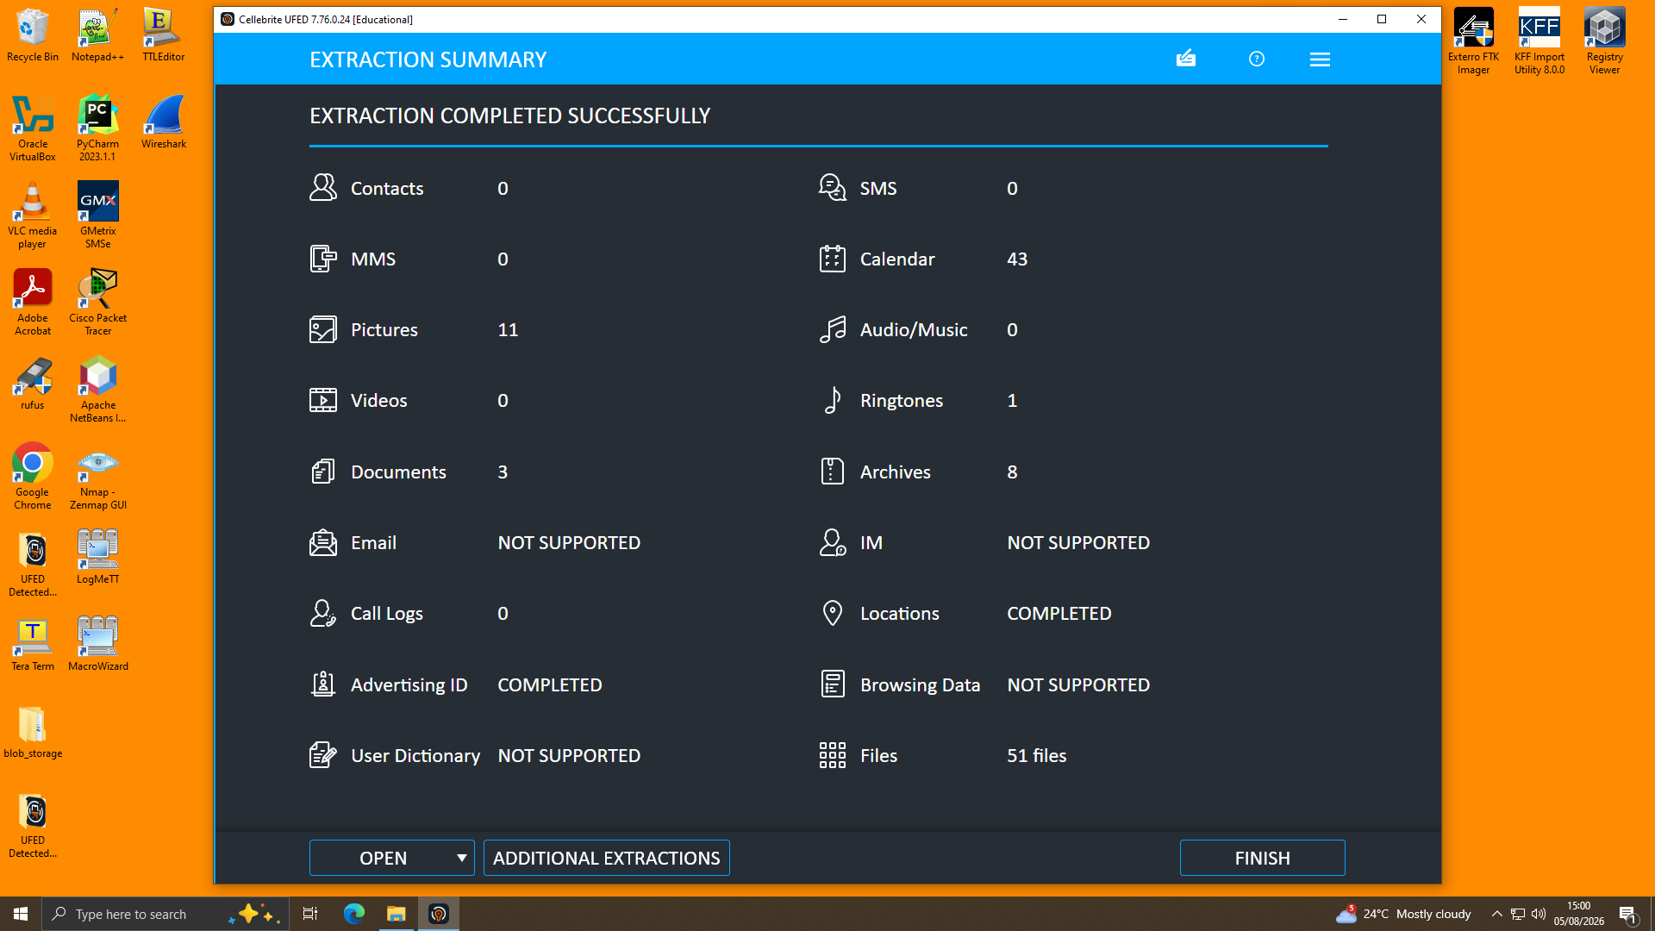
Figure 1. UFED Extraction Summary confirming successful, itemised extraction prior to hashing and export.
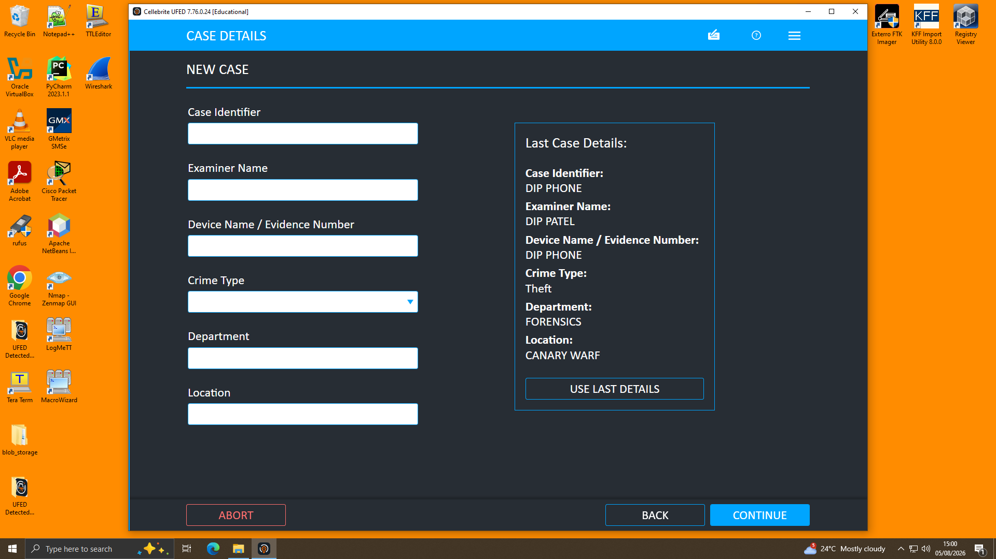
Figure 2. Case Details screen recording examiner, device/evidence number, crime type and location at the point of acquisition, supporting continuity of evidence.
Each image was analyzed in Physical Analyzer after acquisition, taking out artefacts belonging to the category’s application, communication, location, and media. Handset identities were confirmed from device information which included model, IMEI, chipset and OS build. The main area of analysis was WhatsApp and Facebook Messenger, along with the call logs and geotagged media files, and timings and locations were synced to create a common time-stamp across the devices. No malicious payloads nor obvious anti-forensic techniques to detect. The USB drive is not in the provided forensic material and thus could not be imaged and metadata analyzed and is outstanding.

11. Findings

11.1 Device Attribution
EX-01 was assigned to Emma and was a Huawei P Smart (POT-LX1). Its WhatsApp store holds a conversation between two parties where the owner introduces himself and requests the sale of “highly valuable information.”
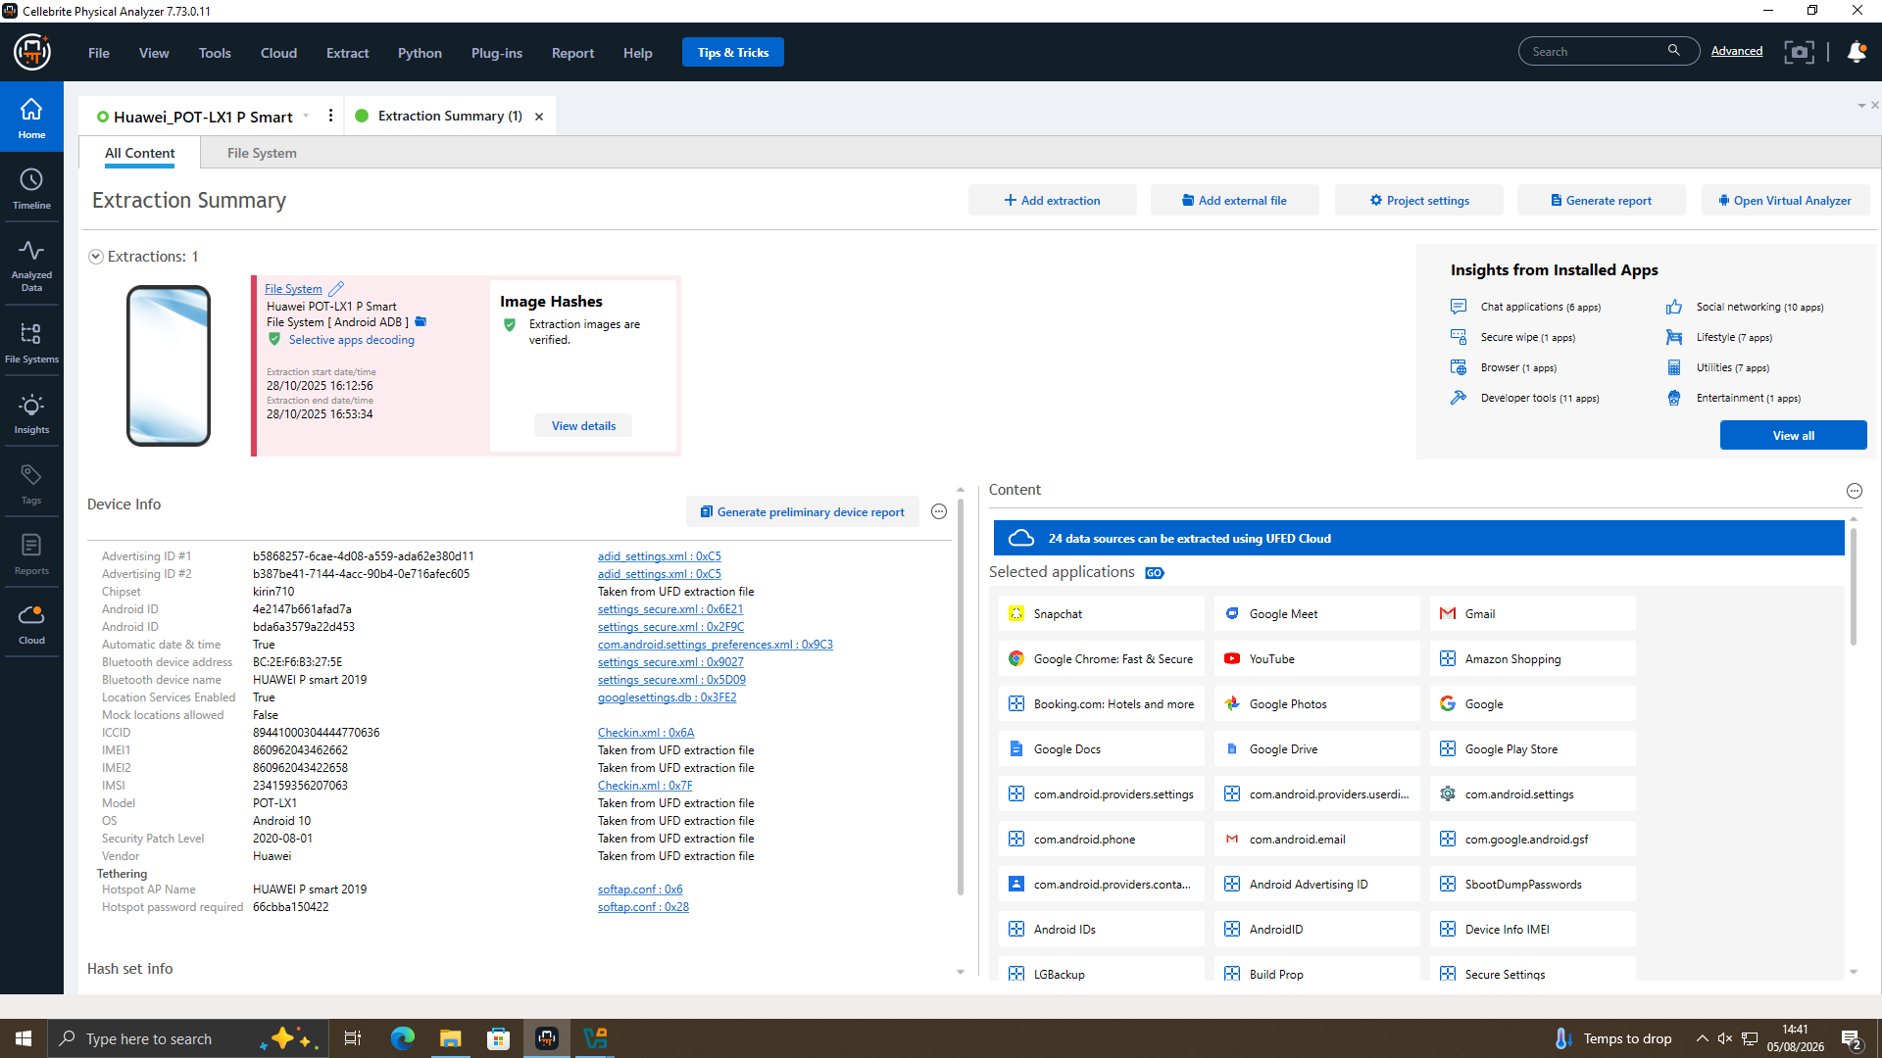
Figure 3. Physical Analyzer device-info panel for EX-01, confirming model POT-LX1, Android 10, and IMEIs recovered from the extraction file.
Joe was attributed to EX-02 which is Samsung Galaxy A13 (SM-A137F). Its Facebook Messenger value is revealed by the nickname “Peter Dover”, and its very own WhatsApp conversation (preserved contact “Top-up”, variety 447917162788 / 447917162891) is identical, but on the other facet, to what you will see in the negotiation on EX-01. This attribution is supported independently by the geolocation of the images on the camera placed in Glasgow on 29th August, 2024 and in the Manchester/Wigan area on 20th November, 2024, coinciding with the only two trips described in the WhatsApp chats by Joe (Section 4.4).
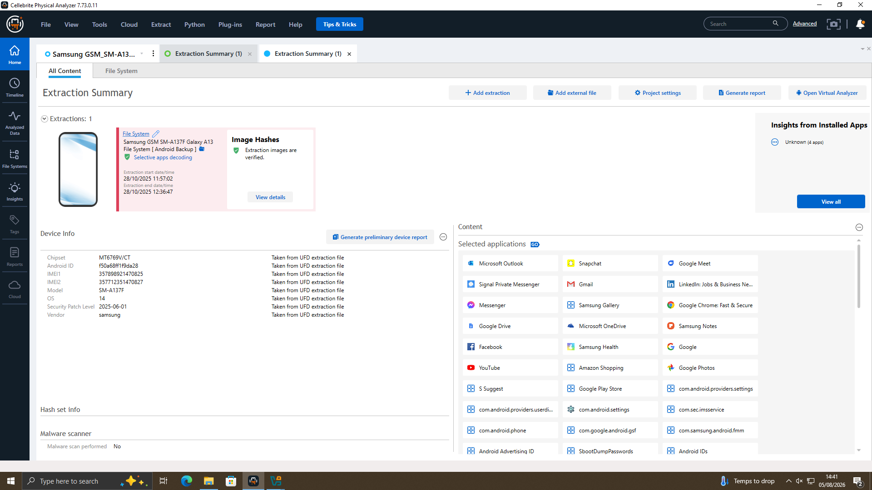
Figure 6. Physical Analyzer device-info panel for EX-02 (SM-A137F), the device attributed to Joe.
EX-03, a Nokia C2 2nd Edition, was attributed to Norman. It says hello to Joe's device as 'Norman Smith' and has a private image and 'near Swansea' geotag that date is the same as EX-02's hotel key-card/ticket image that Max confirms to have been captured during his journey to Swansea to meet Joe in person.
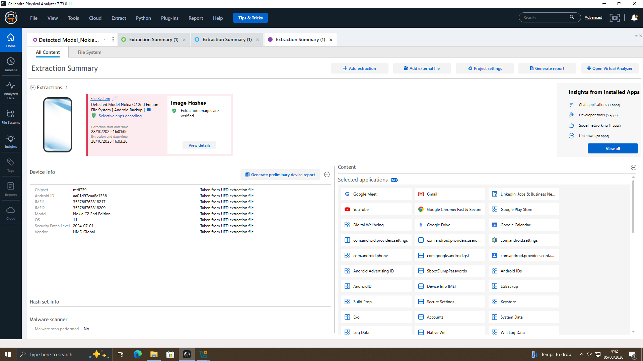
Figure 9. Physical Analyzer device-info panel for EX-03 (Nokia C2 2nd Edition), the device attributed to Norman.

11.2 Detailed Timeline of Events
The overall sequence of activity on all three devices from the earliest call-log contact from 02/08/2024 to the last Facebook Messenger contact from 31/01/2025 has been reconstructed and is shown below. Completely composed from timestamped artefacts gathered by Physical Analyzer (call log entries, individual WhatsApp and Facebook Messenger messages, geotagged image metadata) and ordered in strict chronological order, allowing the correspondence between what was said by both parties to be verified, artefact by artefact.
Date / Time (UTC) | Source | Event
02/08/2024, 20:38–20:39 | EX-01 (Call Log) | Two outgoing calls from Emma's device to Joe's number (07917162891); not answered.
10/08/2024, 04:55 | EX-01 (Call Log) | Outgoing call to a second number (00917907025586) associated with Joe; not answered.
13/08/2024, 11:52 | EX-01 (Call Log) | Two further outgoing calls to Joe's number; not answered.
17/08/2024, 05:16–05:20 | EX-01 (Call Log) | Incoming missed call from Joe's number, followed by an outgoing call from Emma; not answered.
18/08/2024, 06:57–09:04 | EX-01 (Call Log) | Four further outgoing calls to Joe's number across the morning; not answered.
19/08/2024, 09:23–09:25 | EX-01 (Call Log) | Three final outgoing calls (to Joe's number and the secondary number) shortly before WhatsApp contact begins; not answered. In total, 15 outgoing/incoming calls were logged between 02/08/2024 and 19/08/2024, all but one unanswered.
21/08/2024, 05:03 | EX-01 (WhatsApp) | Emma sends her first WhatsApp message to Joe: “Hey Joe. Hope you are well. Please let me know when you are available for a chat.”
21/08/2024, 07:27 | EX-01 (WhatsApp) | Emma: “I need your help with something sensitive. Do you have time to talk?”
21/08/2024, 08:14 | EX-01 (WhatsApp) | Joe: “Yes, I am available. What's going on?”
21/08/2024, 09:58 | EX-01 (WhatsApp) | Emma discloses she has access to “highly valuable information” related to a company AI product and is considering selling it.
21/08/2024, 10:06–10:10 | EX-01 (WhatsApp) | Joe asks who might be interested; Emma says she does not know but trusts Joe to find the right buyer.
21/08/2024, 11:13 | EX-01 (WhatsApp) | Joe: “I will see what I can do. I am meeting a few clients today at a meeting room in a hotel.”
21/08/2024, 11:47 | EX-01 (WhatsApp) | Emma: “Let's keep this under wraps. This could be huge for both of us.”
21/08/2024, 14:05 | EX-01 (WhatsApp) | Joe agrees to provide updates and “stay safe.”
26/08/2024, 07:04 | EX-01 (WhatsApp) | Joe reports his prior meeting was unsuccessful but he has secured contacts for a further meeting.
29/08/2024, 14:10 | EX-01 / EX-02 | Joe tells Emma he is “flying to Glasgow to meet a contact.” EX-02 independently contains two camera images geotagged in central Glasgow, timestamped the same date (Figure 8).
31/08/2024, 14:58 | EX-01 (WhatsApp) | Emma acknowledges Joe's update (“OK, thank you”).
04/09/2024 | EX-02 / EX-03 | EX-03 (Norman's device) contains a portrait photograph geotagged near Swansea; EX-02 contains an image of a hotel key-card/travel document created the same day – consistent with an in-person meeting between Joe and Norman (Figures 10 and 13).
14/10/2024, 18:57 | EX-01 (WhatsApp) | Joe reports travelling to Paris “to get some good deals,” promising an update once a deal is nearer.
30/10/2024, 10:50 | EX-01 (WhatsApp) | Joe sends an unrelated message about a minute's silence for flood victims in Valencia, Albacete and Andalusia – noted as background context, not material to the negotiation.
20/11/2024, 10:01 | EX-01 (WhatsApp) | Emma presses Joe for an update, warning “I may go with someone if u r not interested.”
20/11/2024, 10:03 | EX-01 / EX-02 | Joe: “I am in final talks about it. Meeting the client this week in Manchester.” EX-02 independently contains images geotagged in the Manchester / Wigan North Western area, timestamped 20/11/2024 (Figure 12).
31/01/2025, 10:15 | EX-01 (WhatsApp) | Emma: “Any updates? Need to move fast.”
31/01/2025, 10:17 | EX-01 (WhatsApp) | Joe: buyer “still playing slow, wants better numbers”; Emma asks whether to approach other buyers.
31/01/2025, 10:22 | EX-01 (WhatsApp) | Joe: buyer “wants a demo sample.” Emma declines but offers “a detailed breakdown” and asks about the “offshore arrangement” (Figure 5).
31/01/2025, 10:23 | EX-01 (WhatsApp) | Joe: “He's good with it. 5M secured. Waiting for confirmation.” Emma confirms the “local part stays as planned” and expresses frustration at the pace.
31/01/2025, 10:23–10:24 | EX-01 (WhatsApp) | Joe counsels patience (“We can push harder”); Emma agrees to wait, noting “I have others waiting.”
31/01/2025, 11:28 | EX-01 (WhatsApp) | Joe's final message in this thread: “We'll be watching…”
31/01/2025, 12:47 | EX-02 (Facebook Messenger) | “Peter Dover” (Joe) opens contact with “Norman Smith”: “Joe told me u r ready to proceed. Lets keep this clean and quick” (Figure 7).
31/01/2025, 12:49 | EX-02 (Facebook Messenger) | Norman proposes receiving the “blueprint” “in chunks”, citing risk; Joe rejects this – “Everything at once or no deal.”
31/01/2025, 12:51 | EX-02 (Facebook Messenger) | Norman compromises, requesting just the “head” first; Joe agrees but warns “once we start there is no backtracking.”
31/01/2025, 12:53 | EX-02 (Facebook Messenger) | Norman: “Agreed. First part releases, and 5M offshore reflects. Simple.” Joe closes the exchange: “Watch ur inbox in 48 hrs. After that we are ghosts.”

There are two salient points to be noted from the time-line as a whole. Initially, there are fifteen missed calls from Emma's phone to Joe's phone in the previous 14 days so likely, Emma tried to call Joe before she finally texted him on 21/08/2024. Three, each of these claims in the WhatsApp/Facebook text also has an independent geotagged artefact on other people's devices — that happened on 29/08/2024, around 04/09/2024, and 20/11/2024 — giving the three handsets a ‘one’ that's supported with a single consistent story.

11.3 Communication Analysis – Emma and Joe (EX-01, WhatsApp)
The WhatsApp conversation between Emma and Joe begins on 21/08/2024 with Emma reporting that she is in possession of “highly valuable information” pertaining to a firm's AI product and requesting Joe to seek an interested buyer, clearly stating that this information is to be “kept under wraps.”
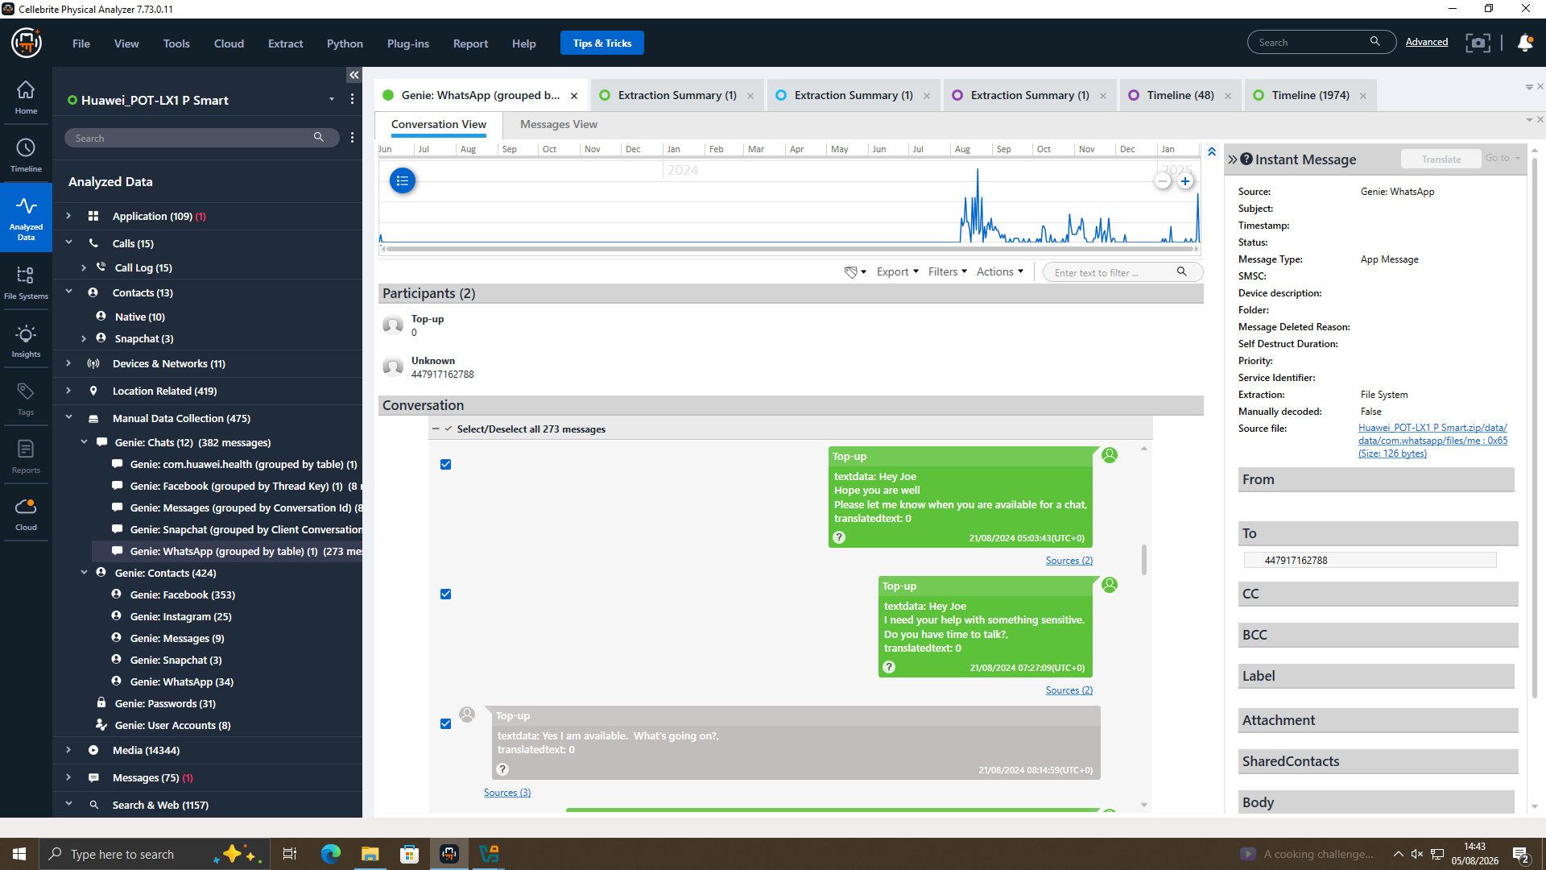
Figure 4. EX-01 WhatsApp – Emma's initial approach to Joe, 21/08/2024.
Joe then reports meetings in Glasgow and Paris over the following months whilst waiting for buyers to be found and over the following months there is periodic contact until 20/11/2024 when Joe reports being in “final talks” prior to a meeting in Manchester. There is a big change in tone on 31/01/2025 – within about a 90-minute period, Emma forces some urgency (“Any news? Joe responds, “Need to move fast”, the buyer then requests “a demo sample” which Emma dismisses, but proposes a detailed breakdown and asks for a response regarding “offshore arrangement” which Joe confirms that he has “5M secured, waiting for confirmation.”
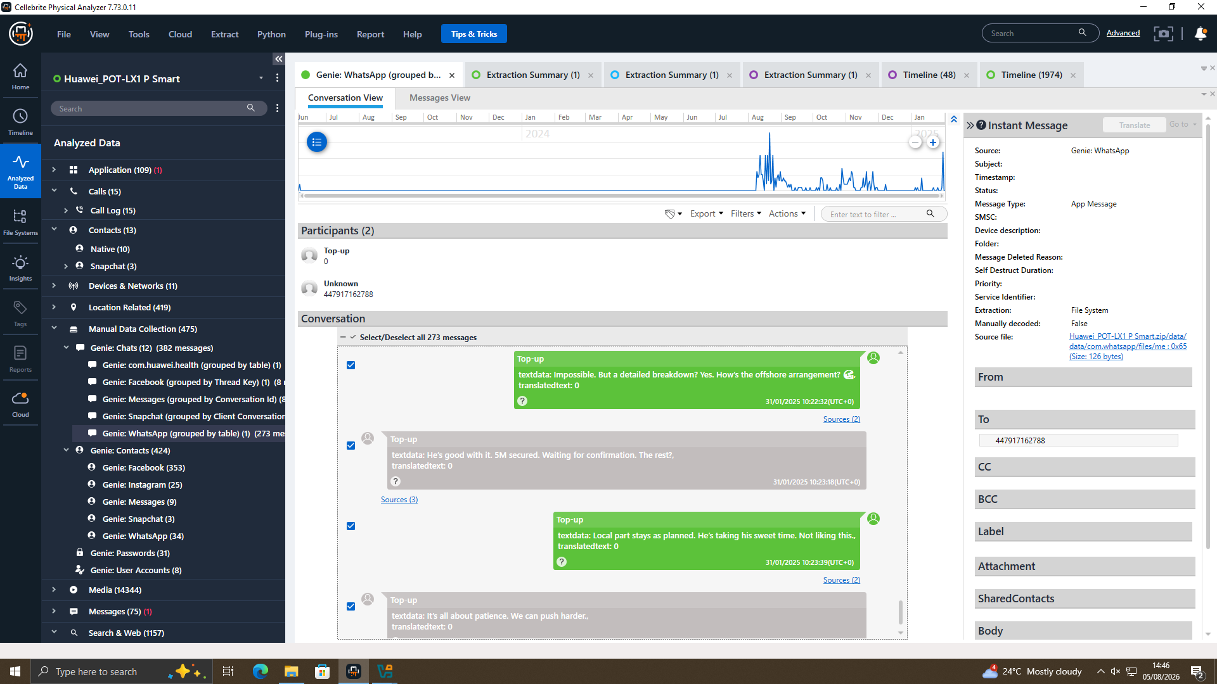
Figure 5. EX-01 WhatsApp – discussion of a demo sample, a detailed breakdown, and an offshore payment arrangement, 31/01/2025.
Together, this is a negotiation to receive unauthorised and proprietary technical material for a fee, set up so that no single point can be traced to a single hand-off ("in chunks," "an offshore arrangement," "get others waiting as a security").

11.4 Communication Analysis – Joe and Norman (EX-02, Facebook Messenger)
A Facebook Messenger conversation between “Peter Dover” (Joe) and “Norman Smith” started at 12:47 on 31/01/2025 – the same day and within hours of the EX-01 WhatsApp conversation referred to above. It's noteworthy that Joe starts the record by referring to himself in the third person as his account holder: Joe told me u r ready to proceed” (this is a similar style of naming as in Section 5.4 above, but where it appears here is, of course, significant).
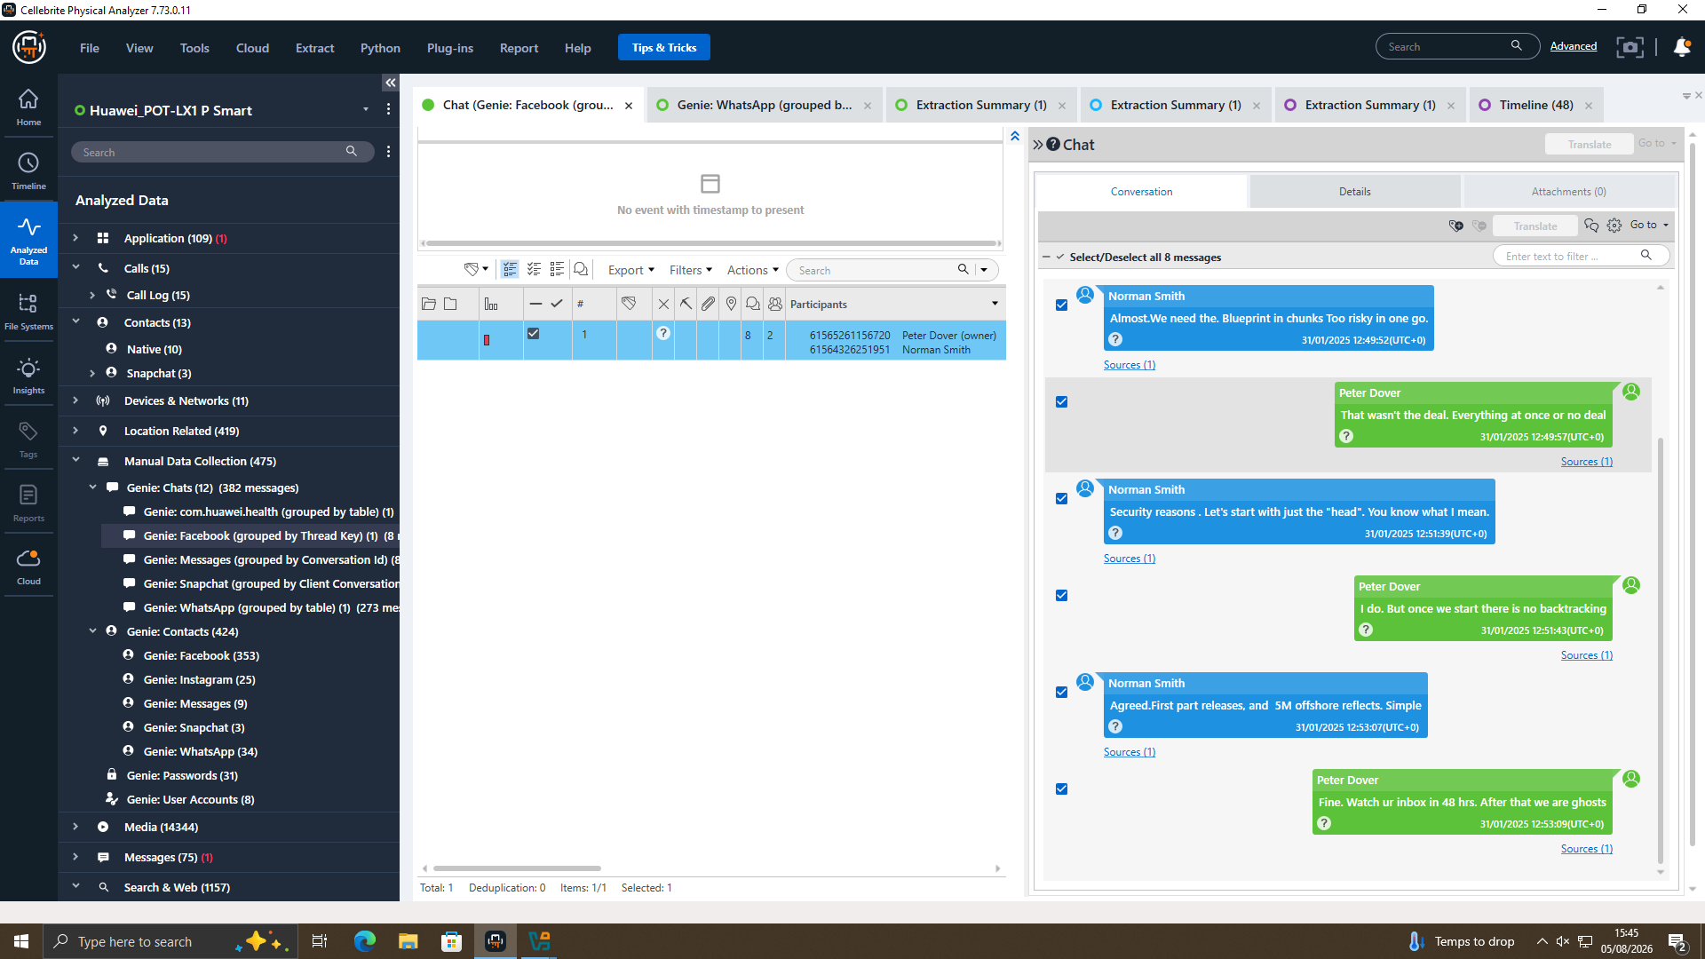
Figure 7. EX-02 Facebook Messenger – negotiation of staged delivery of a “blueprint” against payment, 31/01/2025.
Norman suggests accepting a “blueprint”, but not all at once hence ‘in chunks’; Joe says he either wants the whole thing or nothing, but eventually he says he will release just the ‘head' first. It is agreed that first part releases and 5M offshore reflects – the ‘5M' is what was discussed on WhatsApp with Emma on the same day – and the parties end by having Joe tell Norman to ‘watch ur inbox in 48 hrs. After that we are ghosts – language that is consistent with one-off, untraceable handover rather than a genuine business transaction.

11.5 Corroborating Evidence
Call log data recovered from the EX-01 shows a total of fifteen outgoing calls to numbers that match Joe's WhatsApp contacts (e.g. 447917162891/447917162788) made between 02/08/2024 and 19/08/2024, with the majority of them being flagged as “Not answered”. This is in keeping with attempts to contact Joe by voice before/around the WhatsApp input history from 21/08/2024 which is a form of communication between the two characters other than just the WhatsApp input.
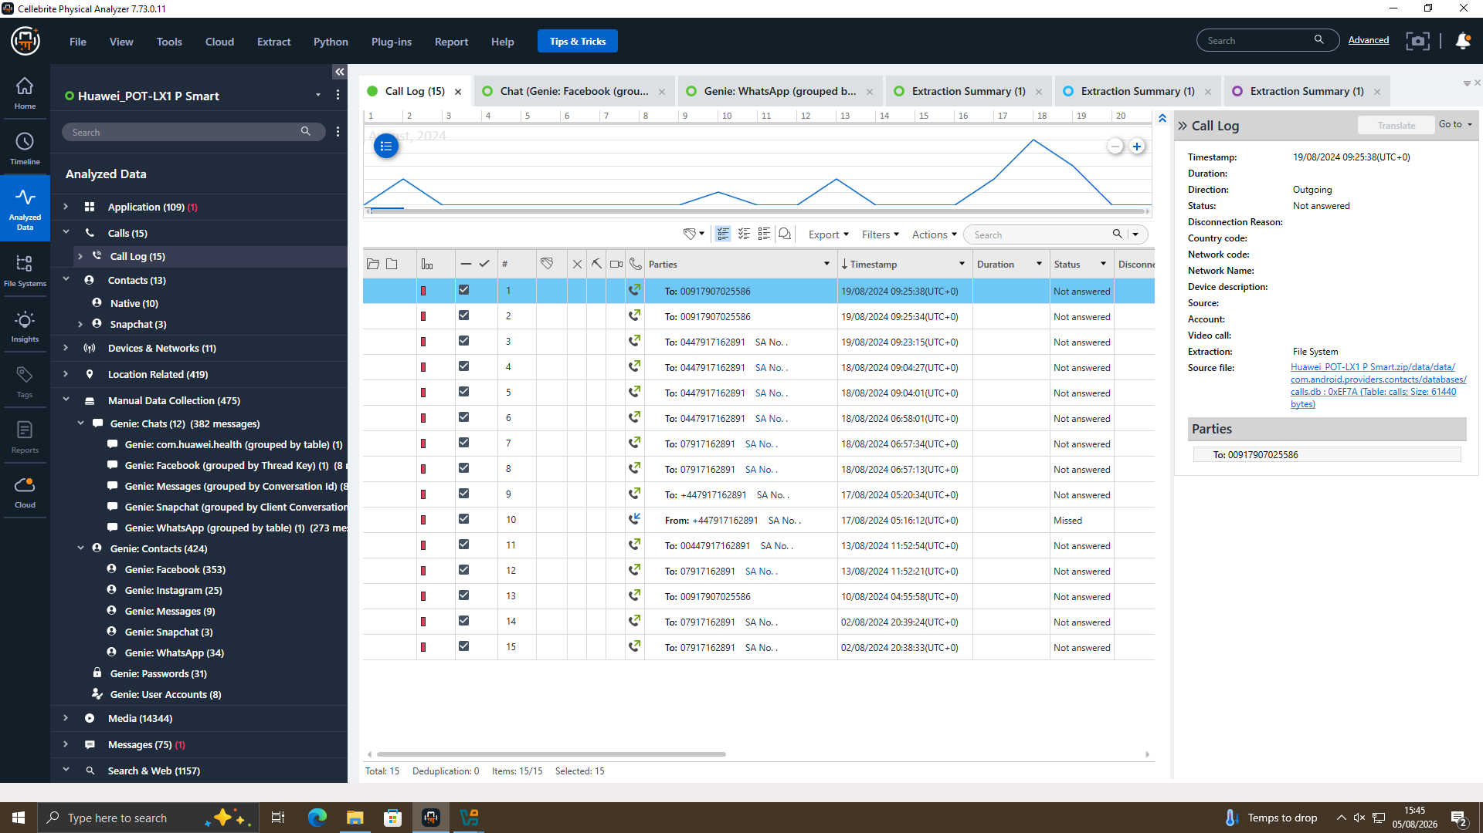
Figure 11. EX-01 call log showing repeated outgoing calls toward Joe's number in the weeks preceding the WhatsApp negotiation.
This computer-generated geolocation data from EX-02 independently supports Joe's own account of his movements. Two of these images are geotagged in the center of Glasgow on 29/08/2024 (Figure 8), the date Joe told Emma that he was “flying to Glasgow to meet a contact,” and (20/11/2024) other images are geotagged in the Manchester/Wigan North Western area, the week when Joe told Emma that he was “meeting the client this week in Manchester.” An additional image, a hotel key-card/travel ticket, is dated 04/09/2024, with the geotagged picture of EX-03 (Norman) near Swansea created on the same date, suggesting a face-to-face meeting between Joe and Norman around that time – prior to the meeting in Manchester on 20/11/2024, and the negotiation session in 31/01/2025.
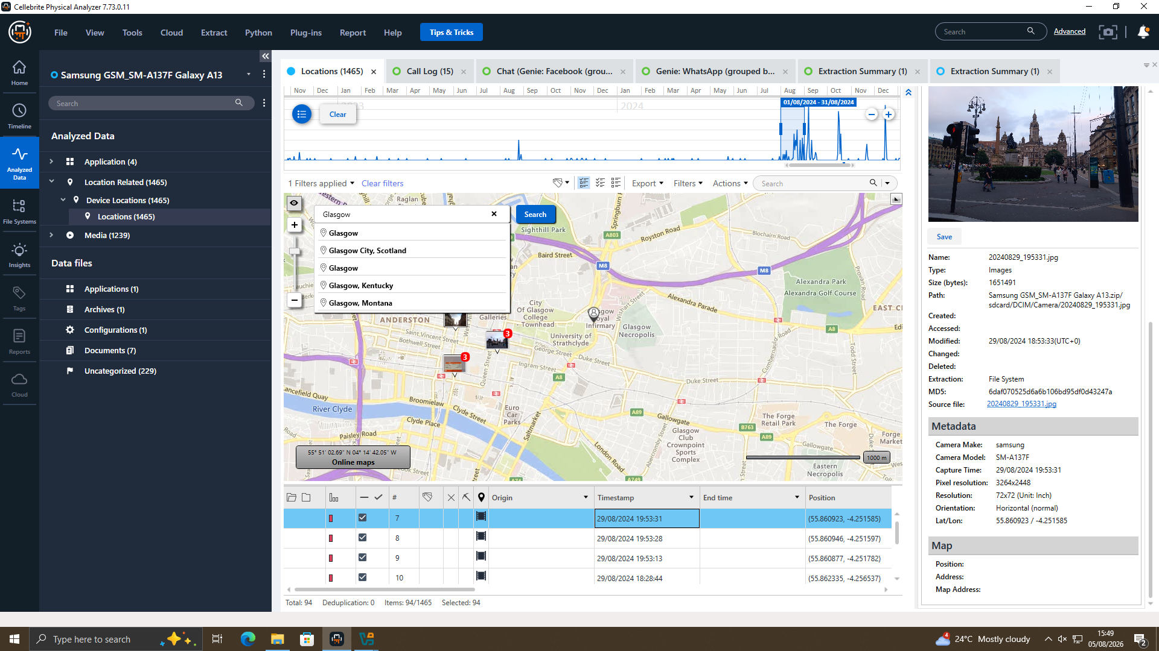
Figure 8. EX-02 geotagged image, Glasgow, 29/08/2024, corroborating the trip Joe reported to Emma the same day.
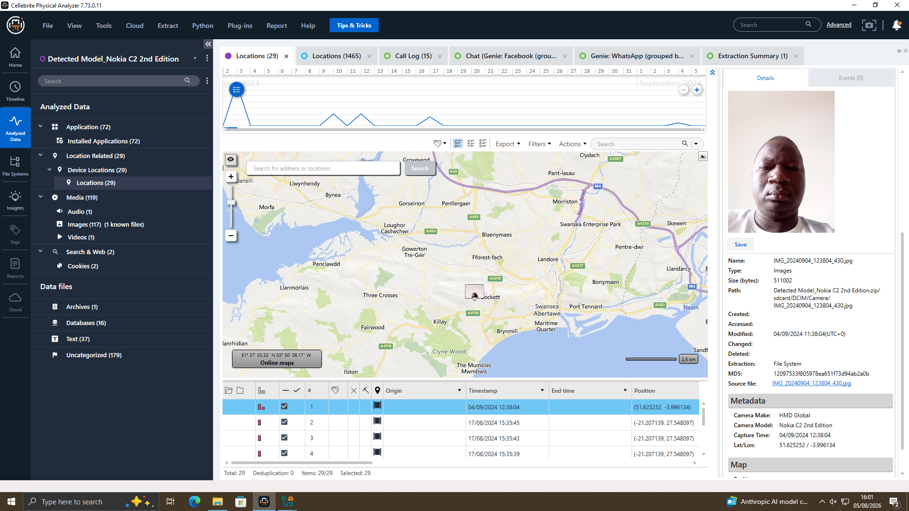
Figure 10. EX-03 geotagged photograph near Swansea, 04/09/2024, matching a travel document image on EX-02 dated the same day.

11.6 File Analysis
It was not possible to make any assessment of CAD files, PDFs or other patent material and their creation/ modification metadata as no file-system artefacts were evident in the data provided for this analysis relating to Emma's USB flash drive (EX-04). It is not a lack of fault, however but presented as an outstanding evidential gap (as is recommended in Section 6) as the flash drive is the most likely item in the possession of the suspect that will contain the technical patent material and not discussion of its sale.

11.7 Suspect Profiling
In combination, the communications extracted, the call records and the geolocation evidence indicate that the following roles were involved:
- Emma (EX-01) – the insider. Initiates the process and acts as if he/she owns the proprietary technical knowhow and dictates the commercial conditions (very specific terms rather than the demonstration, payment facilities offshore), and exerts pressure on Joe during the course of the performance.
- Joe (EX-02) – intermediary. Uses the name “Peter Dover” when dealing with Norman, sources business, handles relationships with the buyers, travels to meet “contacts” in Glasgow, near Swansea and Manchester, deals with both technical and money side of a deal (head first/£5M).
- Norman (EX-03) is the term used to refer to the Buyer-contact. Negotiates delivery of the material in a phased-in manner (for risk management purposes) and confirms funds and acts (on the evidence available) on behalf of NexGen Circuits, and not as a device for identifying Vanessa, or that NexGen leadership were aware of the agreement.

12. Limitations and Notes on Evidence Handling
- No assessment could be made of EX-04 (Emma’s USB) since this information was not provided as part of the extraction.
- The first EX related to Joe/Norman was a communication-based timestamp and location correlation of EX-02 and EX-03.
- An attribution consideration: EX-02 mentions “Joe” in this in the third person, which suggests the “Peter Dover” possible alias was used.
- There is no direct evidence incriminating Vanessa, nor showing exactly what her involvement could have been.
- No decrypting nor deleted message recovery or encrypted container issues were encountered and reviewed conversations were plain text.

13. Conclusion
The three smartphones all contain the same information that can be used to substantiate the suspected transaction. Emma's messages include the references to and plans for selling proprietary information, while Joe's device supports his character as an intermediary, with some of his photographs geolocated, matching his movements, which includes the buyer-side negotiations between Norman and the same £5M payment and staged delivery as represented in the messages. This is characteristic of an attempted sale of QT-AI-2025 material, in the secrecy, the manner of payment and planned 48-hour contact termination. The evidence is sufficient to prove Emma's, Joe's and Norman's respective roles but inadequate to prove the material was transferred or if NexGen Circuits had any corporate knowledge of the transferred material.

14. Recommendations
- Analyse and image Emma's USB flash drive as a priority, including for CAD/PDF files that match QT-AI-2025, creation and modification times within the negotiation window (31/01/2025).
- Get subscribers data of the phone numbers linked to WhatsApp (447917162788/ 447917162891) to confirm ownership other than an inferred device content.
- Seeking Quantum Tech's own network/database access logs for the patent record to determine the actual access or exportation of the material from the company's device, specifically, the QR-AI-2025, by Emma and to corroborate the device-level evidence with evidence found on the servers.
- Continue to search for more information relating to Norman's device and NexGen Circuits in particular and to Vanessa, to gauge if NexGen's leadership authorised or was aware of the negotiation being done on the buyer's side.
- Maintain control of all three device images and retain this report and pass this report to law enforcement and Quantum Tech's legal team as a basis for considering charges of corporate espionage, theft of trade secrets, and computer access without authority.
- For an explicit statement saying “after that we are ghosts”, consider the 48 hours window mentioned on 31/01/2025 to be time-critical as long as there is recoverable device and/or account and/or financial evidence to support it.

References
[1] A. Al-Dhaqm, R. A. Ikuesan, V. R. Kebande, S. A. Razak, G. Grispos, and K.-K. R. Choo, "Digital forensics subdomains: The state of the art and future directions," IEEE Access, vol. 9, pp. 152476–152502, 2021, doi: 10.1109/ACCESS.2021.3124262.
[2] Cyber Forensics Academy, "Top 10 digital forensic tools every investigator must know (2026 updated guide)," Dec. 2025. [Online]. Available: https://www.cyberforensicacademy.com/blog/top-10-digital-forensic-tools-every-investigator-must-know
[3] ForensicsColleges.com, "A guide to digital forensics and cybersecurity tools," Mar. 2026. [Online]. Available: https://www.forensicscolleges.com/blog/resources/guide-digital-forensics-tools
[4] Cyber Forensics Academy, "FTK vs EnCase vs X-Ways: Which forensic tool is best in 2025?," Dec. 2025. [Online]. Available: https://www.cyberforensicacademy.com/blog/ftk-vs-encase-vs-x-ways:-which-forensic-tool-is-best
[5] "Cloud forensics: A review of challenges, solutions and open problems," in Proc. IEEE Conf., IEEE Xplore Document 7149635. [Online]. Available: https://ieeexplore.ieee.org/document/7149635/
[6] "Cloud forensics: Issues and challenges," in Proc. IEEE Conf., IEEE Xplore Document 6754806. [Online]. Available: https://ieeexplore.ieee.org/document/6754806/
[7] "Cloud forensics: State-of-the-art and research challenges," in Proc. IEEE Conf., IEEE Xplore Document 6481255. [Online]. Available: https://ieeexplore.ieee.org/document/6481255/
[8] "A study on cloud forensics and challenges in SaaS application environment," in Proc. IEEE Conf., IEEE Xplore Document 7828448. [Online]. Available: https://ieeexplore.ieee.org/document/7828448
[9] "Challenges of digital forensic investigation in cloud computing," in Proc. IEEE Conf., IEEE Xplore Document 8080060. [Online]. Available: https://ieeexplore.ieee.org/abstract/document/8080060/
[10] "Exploring the effective strategies against major challenges in cloud forensics," in Proc. IEEE Conf., IEEE Xplore Document 10531603. [Online]. Available: https://ieeexplore.ieee.org/document/10531603/
[11] "A systematic study on cloud forensic framework, challenges and technologies used for evidence preservation," in Proc. IEEE Conf., IEEE Xplore Document 10837304. [Online]. Available: https://ieeexplore.ieee.org/document/10837304/
[12] "Cloud forensic technical challenges and solutions: A snapshot," IEEE Cloud Comput. Mag., IEEE Xplore Document 7057622. [Online]. Available: https://ieeexplore.ieee.org/document/7057622/
[13] "Cloud computing: Forensic challenges for law enforcement," in Proc. IEEE Conf., IEEE Xplore Document 5678033. [Online]. Available: https://ieeexplore.ieee.org/document/5678033/
[14] A. M. Qadir and A. Varol, "The role of machine learning in digital forensics," in Proc. 8th Int. Symp. Digital Forensics and Security (ISDFS), Beirut, Lebanon, 2020, pp. 1–5, doi: 10.1109/ISDFS49300.2020.9116298.
[15] "Automating digital forensic investigations: The impact of machine learning on electronic evidence," in Proc. IEEE Conf., IEEE Xplore Document 11095588. [Online]. Available: https://ieeexplore.ieee.org/document/11095588/
[16] "Applications of machine learning in digital forensics," in Proc. IEEE Conf., IEEE Xplore Document 9441543. [Online]. Available: https://ieeexplore.ieee.org/abstract/document/9441543/
[17] Cybersecurity Guide, "From classroom to career: Digital forensics degrees explained," Mar. 2026. [Online]. Available: https://cybersecurityguide.org/careers/digital-forensics/
[18] EC-Council University, "Why digital forensics is one of the fastest-growing careers in cybersecurity," Jul. 2026. [Online]. Available: https://www.eccu.edu/blog/digital-forensics-career-guide/
[19] Coursera, "Computer forensic investigator: 2026 career guide," Jul. 2026. [Online]. Available: https://www.coursera.org/articles/computer-forensic-investigator
[20] ForensicsColleges.com, "Computer forensics examiner job outlook & salary info," Mar. 2026. [Online]. Available: https://www.forensicscolleges.com/careers/computer-forensics-examiner

