

Task 1 – Reading Task Template
Upload your photo of your A3 in-class notes here:
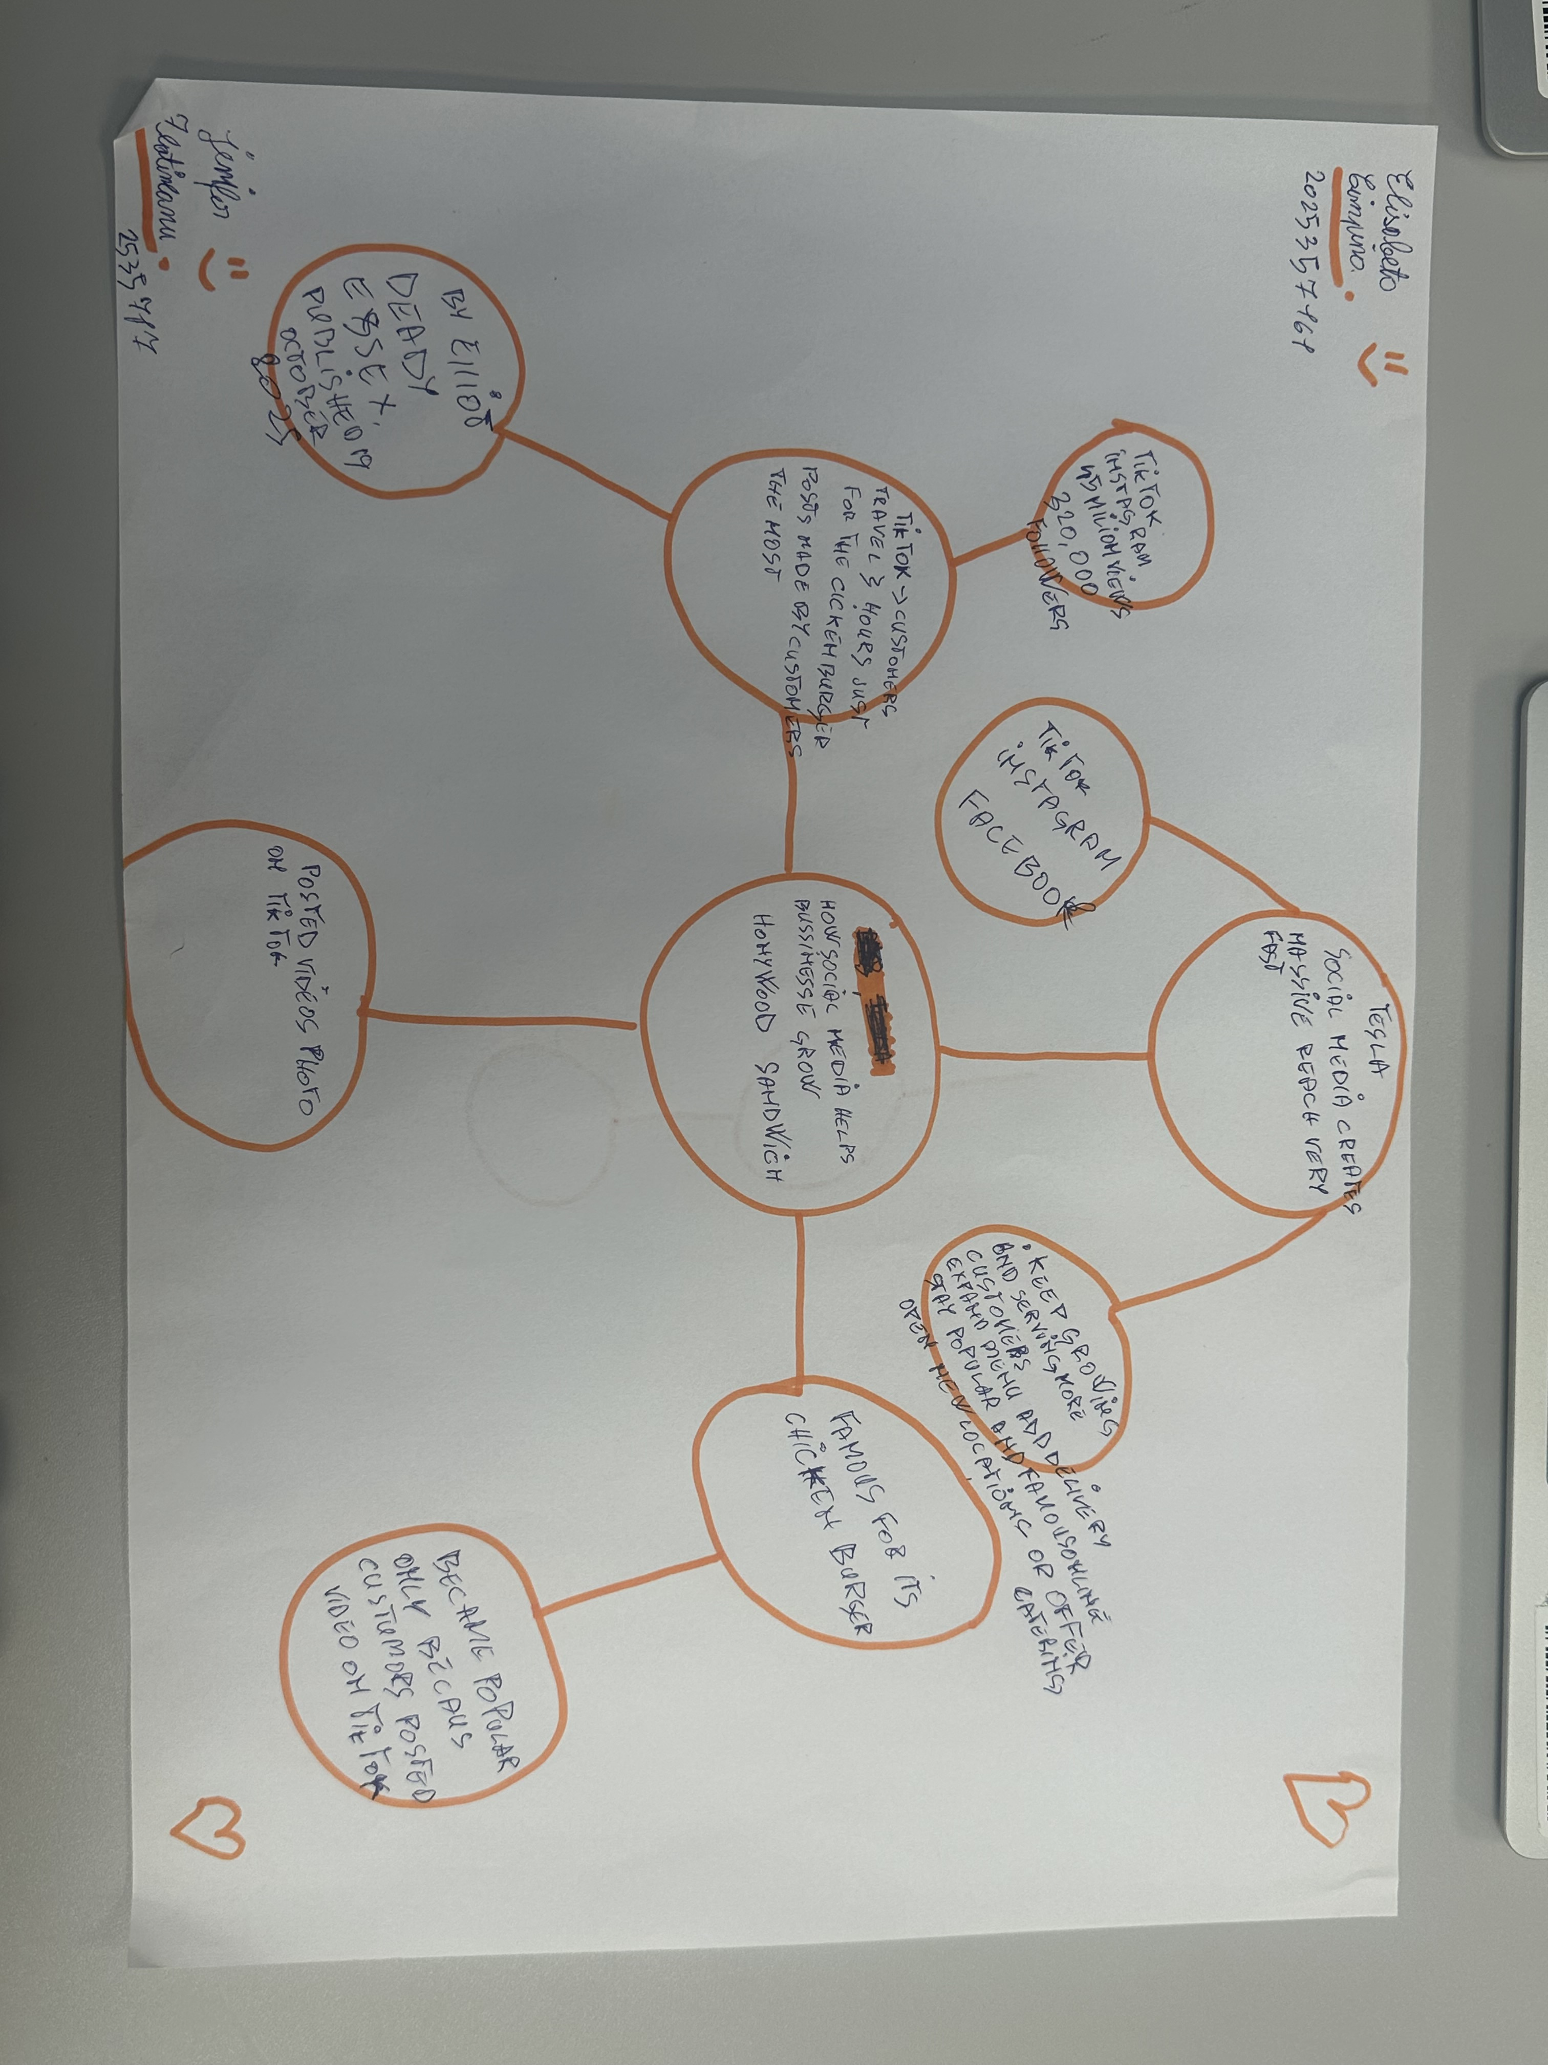

1. Answer these questions using the sentence starters below
a. What is the main idea of the text?
The main idea is that social media platsforms helps small local business grow rapidly become
b. What are two key points?
One key point is that customers travel very long distances
Another key point is that small business can quickly become famous and even sell
c. What part of the text did you find most important? Why?
The most important part is part is that business grow and become for free
d. Was anything unclear or difficult to understand?
I was not sure about nothing was difficult at all the details and examples
e. How did your group help you understand the text better? We worked together in paris they explaindet
My group helped me by
3. One sentence reflection
Question: What did you find challenging about this task?
The hardest part was

