

Emma Biggs
Student Number: 2308431

Principles of Systems Engineering (ACDA5021): Fault Tree Analysis Exercise

School of Applied Computing

Ordinance Munitions and Explosives

BEng

Academic Year: 2025 - 2026

Abstract
This report utilises Fault Tree Analysis (FTA) to calculate the probability of successfully making a cup of tea with milk and sugar under both normal and fatigued conditions. The task was broken down into discrete events to which Boolean logic operators were applied to demonstrate the relationships and dependencies between events. Under normal conditions, the probability of success was calculated to be 68.49%, falling to 34.67% upon the introduction of fatigue conditions. This analysis demonstrated the significant impact of human factors on system reliability despite high level hardware reliability.

Table of Contents
Abstract 2
Table of Contents 3
Table of Equations 4
Table of Figures 5
Table of Tables 5
1 Introduction 6
1.1 Overview of Fault Tree Analysis 6
1.2 Applications of Fault Tree Analysis 6
1.3 Overview of Human Factors 6
1.4 Exercise Context 7
2 Calculations 9
2.1 Normal Probability of Success 9
2.2 Probability of Success During the Night 14
3 Effect of Human Factors 20
4 Conclusions 21
5 References 22

Table of Equations
Equation 1 - Calculations for probability of success (water in kettle) 9
Equation 2 - Calculations for probability of success (power to element) 9
Equation 3 - Calculations for probability of success (cup selection) 10
Equation 4 - Calculations for probability of success (correct drink) 10
Equation 5 - Calculations for probability of success (sugar) 10
Equation 6 - Calculations for probability of success (milk) 10
Equation 7 - Calculations for probability of success (hot water) 11
Equation 8 - Calculations for probability of success (ingredients in cup) 11
Equation 9 - Calculations for probability of success (production of a hot drink with milk and sugar) 12
Equation 10 - Calculations for probability of success (water in kettle) 14
Equation 11 - Calculations for probability of success (power to element) 14
Equation 12 - Calculations for probability of success (cup selection) 14
Equation 13 - Calculations for probability of success (correct drink) 15
Equation 14 - Calculations for probability of success (sugar) 15
Equation 15 - Calculations for probability of success (milk) 15
Equation 16 - Calculations for probability of success (hot water) 16
Equation 17 - Calculations for probability of success (ingredients in cup) 16
Equation 18 - Calculations for probability of success (production of a hot drink with milk and sugar) 17

Table of Figures
Figure 1 – FT denoting the contributing factors and their associated relationships required to produce a Cup of Tea with milk and sugar 6
Figure 2 – FT of the probability of success under normal conditions annotated with base event values 9
Figure 3 – FT of the probability of success under normal conditions annotated with second level event values 10
Figure 4 – FT of the probability of success under normal conditions annotated with third level event values 11
Figure 5 – FT of the probability of success under normal conditions annotated with the top-level event value 12
Figure 6 – FT of the probability of success under fatigue conditions annotated with base event values 14
Figure 7 – FT of the probability of success under fatigue conditions annotated with second level event values 16
Figure 8 – FT of the probability of success under fatigue conditions annotated with third level event values 17
Figure 9 – FT of the probability of success under fatigue conditions annotated with the top-level event value 18

Table of Tables
Table 1 – Provided base event probabilities and numerical implications of human factors 7
Table 2 – Calculations of the required base event probabilities under normal conditions 8
Table 3 – Calculations of required base event probabilities of success under fatigued conditions 13

1 Introduction
This paper presents the concept of Fault Tree Analysis (FTA) in the context of calculating the probability of producing a cup of tea with milk and sugar, considering the effect of human factors on success rate. An overview of FTA, human factors and additional contextual information pertaining to the exercise are provided in the introduction.

1.1 Overview of Fault Tree Analysis
Fault Tree Analysis (FTA) is a deductive graphical method used to assess the occurrence probability of an undesired event at the system level (top level) [1]. A structured diagram known as a Fault Tree (FT) is produced to display the sequences and combinations of faults that can be traced from the top-level event through intermediate subsystems to component faults (known as basic events) [2][3]. These faults include events such as equipment failures, human failures, or software errors [4]. Boolean logic operators such as ‘and’ or ‘or’ gates are used to establish the relationship between these causal events [5]. By assigning Boolean logic operators and probabilities to the basic events, the probability of top level even failure / success can be determined.

1.2 Applications of Fault Tree Analysis
FTA is a commonly utilised method in system safety and reliability engineering to create a visual representation of the causal pathway leading to failures in multi-levelled systems [6]. It is implemented across a range of fields including aerospace, power generation and manufacturing to support risk assessment activities and improve system reliability [7]. The tool facilitates the decomposition of top-level failures into individual events to identify critical components and single points of failure within the system [8]. These findings can subsequently be integrated with Failure Mode and Effect Analysis (FMEA) to create a robust risk analysis framework covering both-top down and bottom-up system failure considerations [9]. This helps to ensure redundancy is built into the system and risk mitigations are distributed across all levels.

1.3 Overview of Human Factors
Human factors relate to the psychological, physiological and environmental influences that impact human performance, such as the likelihood of error during task execution [10][11]. The discipline recognises that humans form an integral component within the operation of complex systems and that their performance can alter dependent on individual, environmental and organisational factors such as fatigue, workload and delivery pressures [12]. Integrating human factors considerations into system design is critical to account for the variation in human attributes within the population and to ensure the system minimises the risk posed by their limitations [13].

1.4 Exercise Context
In the case of the exercise, FTA was utilised to calculate the probability of Bill successfully creating a cup of tea with milk and sugar under both normal and fatigue conditions. Working backwards from the top-level event (successful drink production), the contributing factors that had to occur correctly to ensure success were logically structured to demonstrate their relationship within a FT as shown in Figure 1.

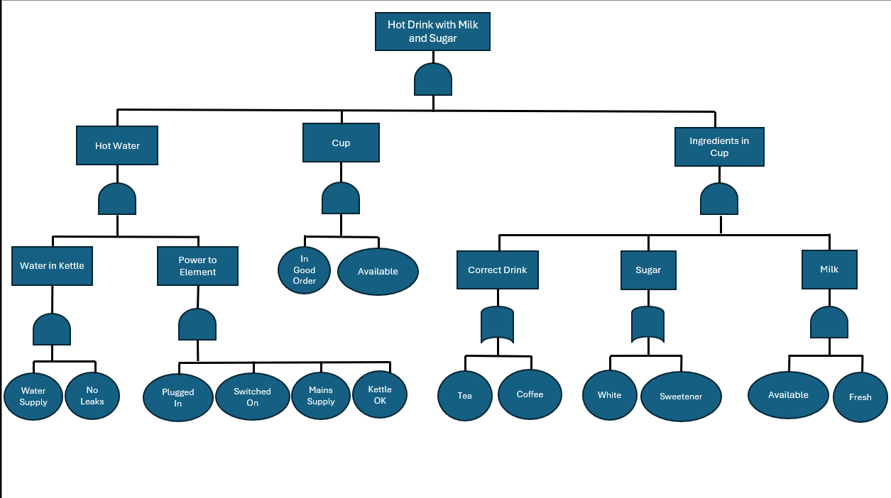
Figure 1 – FT denoting the contributing factors and their associated relationships required to produce a Cup of Tea with milk and sugar

To facilitate the calculation of the probability of success for the top-level event, base level event probabilities and the numerical implications of human factors were provided as shown in Table 1.

Contributing Factor | Given Probability
Water Supply Failure | 0.01
Leaky Kettle | 0.001
Kettle Plugged In | 0.89
Kettle Switched On | 0.89
Mains Failure | 0.01
Kettle OK | 0.99
Cup in Good Order | 0.99
Cup Available | 1
Tea Available | 0.98
Coffee Available | 0.98
White Sugar Available | 0.88
Sweetener Available | 0.99
Milk Available | 0.95
Milk Fresh | 0.99
Fatigue Effect on Plugging Kettle In | Reduces to 70% of Normal
Fatigue Effect on Switching Kettle On | Reduces to 70% of Normal
Fatigue Effect on Cup Selection | Reduces to 90% of Normal

Table 1 – Provided base event probabilities and numerical implications of human factors

2 Calculations

2.1 Normal Probability of Success

Using the principal that the probability of non-availability is equivalent to one minus the probability of availability and vice versa, the required base event probabilities were calculated. The calculation process is shown below in Table 2.

Given Probability | Probability Conversion | Final Probability
Water Supply Failure = 0.01 | Functional Water Supply = 1 – 0.01 | 0.99
Leaky Kettle = 0.001 | No Leaks = 1 – 0.001 | 0.999
Kettle Plugged In = 0.89 | N/A | 0.89
Kettle Switched On = 0.89 | N/A | 0.89
Mains Failure = 0.01 | Functional Mains = 1 – 0.01 | 0.99
Kettle OK = 0.99 | N/A | 0.99
Cup in Good Order = 0.99 | N/A | 0.99
Cup Available = 1 | N/A | 1
Tea Available = 0.98 | N/A | 0.98
Coffee Available = 0.98 | N/A | 0.98
White Sugar Available = 0.88 | N/A | 0.88
Sweetener Available = 0.99 | N/A | 0.99
Milk Available = 0.95 | N/A | 0.95
Milk Fresh = 0.99 | N/A | 0.95

Table 2 – Calculations of the required base event probabilities under normal conditions

The calculated final probabilities of each base event were then inputted into the FT in red text as shown in Figure 2 to further aid visualisation of the problem.
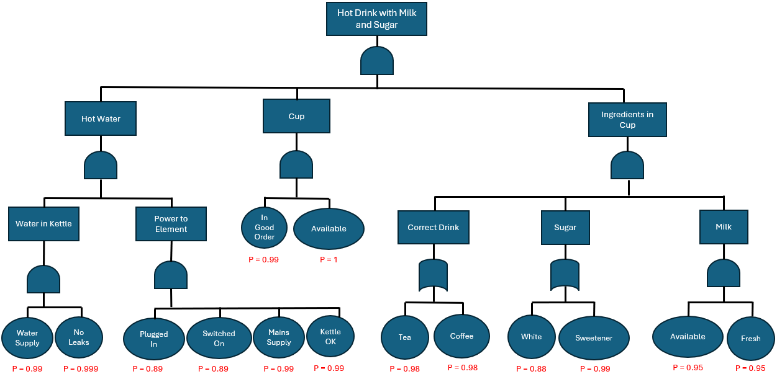
Figure 2 – FT of the probability of success under normal conditions annotated with base event values

Using the appropriate Boolean logic operators denoted in the above FT (Figure 2), the probabilities of success of each second level event was calculated. The expansion steps of these equations are shown below in Equations 1 through 6. To further aid visualisation of the problem, the values were added to the FT in purple text shown in Figure 3.

$$\text{P}\left(\text{Water in Kettle}\right)\text{ = P}\left(\text{Functional Water Supply ∩ No Leaks}\right) \\ \text{= P}\left(\text{Functional Water Supply}\right)\text{ × P}\left(\text{No Leaks}\right) \\ \text{= 0.99 × 0.999 } \\ \text{= 0.98901 }$$
Equation 1 - Calculations for probability of success (water in kettle)

$$\text{P(Power to Element) = P(Plugged in ∩ Switched on ∩ Functional Mains Supply ∩ Kettle OK)} \\ \text{= P}\left(\text{Plugged in}\right)\text{ × P}\left(\text{Switched on}\right)\text{ × P}\left(\text{Functional Mains Supply}\right)\text{ × P}\left(\text{Kettle OK}\right) \\ \text{= 0.89 × 0.89 × 0.99 × 0.99 } \\ \text{= 0.77633721 }$$
Equation 2 - Calculations for probability of success (power to element)

$$\text{P}\left(\text{Cup}\right)\text{ = P}\left(\text{Good Condition ∩ Available}\right) \\ \text{= P}\left(\text{Good Condition}\right)\text{ × P}\left(\text{Available}\right) \\ \text{= 0.99 × 1 } \\ \text{= 0.99 }$$
Equation 3 - Calculations for probability of success (cup selection)
$$\text{P}\left(\text{Correct Drink}\right)\text{ = P}\left(\text{Tea ∪ Coffee}\right) \\ \text{= 1 - }\left(\text{1 - P}\left(\text{Tea}\right)\right)\left(\text{1 - P}\left(\text{Coffee}\right)\right) \\ \text{= 1 - }\left(\text{1 - 0.98}\right)\left(\text{1 - 0.98}\right) \\ \text{= 1 - }\left(\text{0.02 × 0.02}\right) \\ \text{= 1 - 0.0004 } \\ = 0.9996$$
Equation 4 - Calculations for probability of success (correct drink)

$$\text{P}\left(\text{Sugar}\right)\text{ = P}\left(\text{White Sugar ∪ Sweetner}\right) \\ \text{= 1 - }\left(\text{1 - P}\left(\text{White Sugar}\right)\right)\left(\text{1 - P}\left(\text{Sweetner}\right)\right) \\ \text{= 1 - }\left(\text{1 - 0.88}\right)\left(\text{1 - 0.99}\right) \\ \text{= 1 - }\left(\text{0.12 × 0.01}\right) \\ \text{= 1 - }\left(\text{0.0012}\right) \\ \text{= 0.9988 }$$
Equation 5 - Calculations for probability of success (sugar)

$$\text{P}\left(\text{Milk}\right)\text{ = P}\left(\text{Available ∩ Fresh}\right) \\ \text{= P}\left(\text{Available}\right)\text{ × P}\left(\text{Fresh}\right) \\ \text{= 0.95 × 0.95 } \\ \text{= 0.9025 }$$
Equation 6 - Calculations for probability of success (milk)

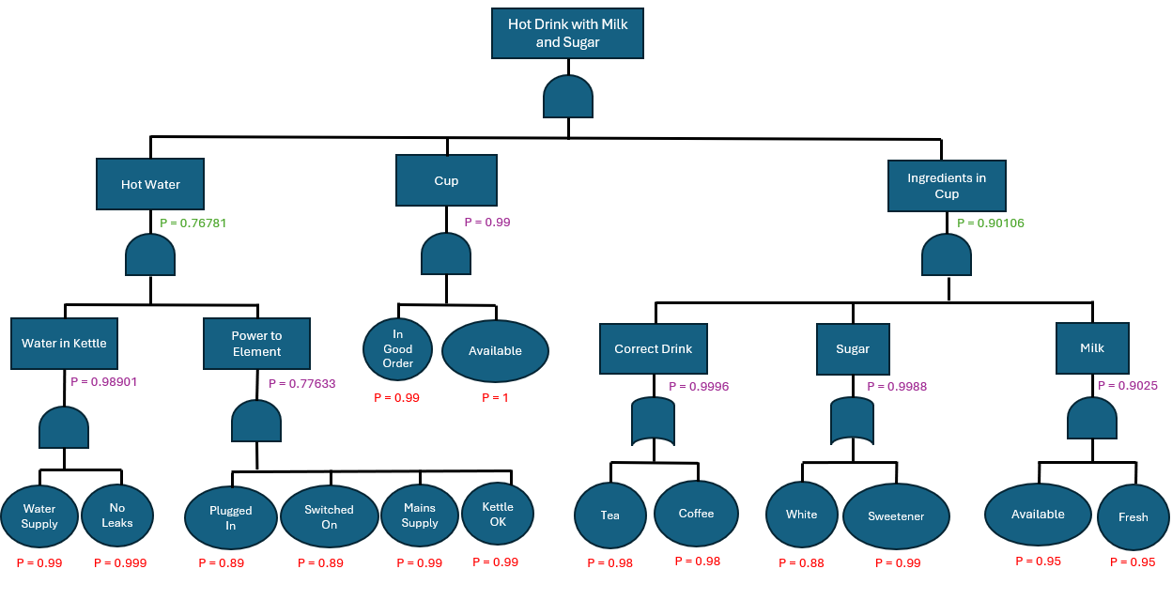
Figure 3 – FT of the probability of success under normal conditions annotated with second level event values
The previously described principle was used to calculate the probabilities of success of the third level events shown in Equations 7 and 8.

$$\text{P}\left(\text{Hot Water}\right)\text{ = P}\left(\text{Water in Kettle ∩ Power to Element}\right) \\ \text{= P}\left(\text{Water in Kettle}\right)\text{ × P}\left(\text{Power to Element}\right) \\ \text{= 0.98901 × 0.77633721 } \\ \text{= 0.76780526406 }$$
Equation 7 - Calculations for probability of success (hot water)

$$\text{P}\left(\text{Ingredients in Cup}\right)\text{ = P}\left(\text{Correct Drink ∩ Sugar ∩ Milk}\right) \\ \text{= P}\left(\text{Correct Drink}\right)\text{ × P}\left(\text{Sugar}\right)\text{ × P}\left(\text{Milk}\right) \\ \text{= 0.9996 × 0.9988 ×0.9025 } \\ \text{= 0.9010564332 }$$
Equation 8 - Calculations for probability of success (ingredients in cup)

To aid in visualising the problem, the calculated third level values were added in green text to the FT shown below in Figure 4.

Figure 4 – FT of the probability of success under normal conditions annotated with third level event values

Using the previously calculated values in combination with the Boolean logic operator shown in Figure 4, the probability of success of the top level even was determined. The expansion process is shown below in Equation 9.

$$\text{P}\left(\text{Hot Drink with Milk and Sugar}\right)\text{ = P}\left(\text{Hot Water ∩ Cup ∩ Ingredients in Cup}\right) \\ \text{= P}\left(\text{Hot Water}\right)\text{ × P}\left(\text{Cup}\right)\text{ × P}\left(\text{Ingredients in Cup}\right) \\ \text{= 0.76780526406 × 0.99 ×0.9010564332 } \\ \text{= 0.6849175139 }$$
Equation 9 - Calculations for probability of success (production of a hot drink with milk and sugar)

This value was added to the FT shown in Figure 5 in blue text to complete the annotated diagram.

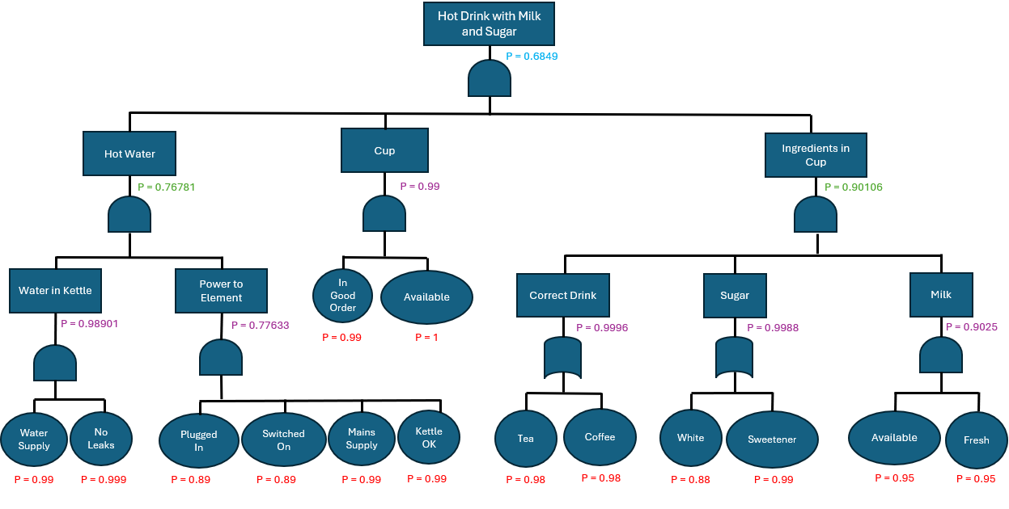
Figure 5 – FT of the probability of success under normal conditions annotated with the top-level event value

The final probability of Bill making a cup of tea with milk and sugar under normal conditions is 68.49% (2 d.p.).

2.2 Probability of Success During the Night

Using the previously described principle that probability of availability is equivalent to one minus the probability of non-availability and vice versa in addition to the coefficients representing the effect of fatigue, the probability of success of the base level events were calculated in Table 3.

Given Probability | Probability Conversion | Final Probability
Water Supply Failure = 0.01 | Functional Water Supply = 1 – 0.01 | 0.99
Leaky Kettle = 0.001 | No Leaks = 1 – 0.001 | 0.999
Kettle Plugged In = 0.89 | Plugged in Tired = 0.89 x 0.75 | 0.6675
Kettle Switched On = 0.89 | Switched on Tired = 0.89 x 0.75 | 0.6675
Mains Failure = 0.01 | Functional Mains = 1 – 0.01 | 0.99
Kettle OK = 0.99 | N/A | 0.99
Cup in Good Order = 0.99 | N/A | 0.99
Cup Available = 1 | N/A | 1
Tea Available = 0.98 | N/A | 0.98
Coffee Available = 0.98 | N/A | 0.98
White Sugar Available = 0.88 | N/A | 0.88
Sweetener Available = 0.99 | N/A | 0.99
Milk Available = 0.95 | N/A | 0.95
Milk Fresh = 0.99 | N/A | 0.95

Table 3 – Calculations of required base event probabilities of success under fatigued conditions

The final calculated probabilities of success for base events were inputted into the FT in red text as described in the normal condition scenario. These can be seen below in Figure 6.
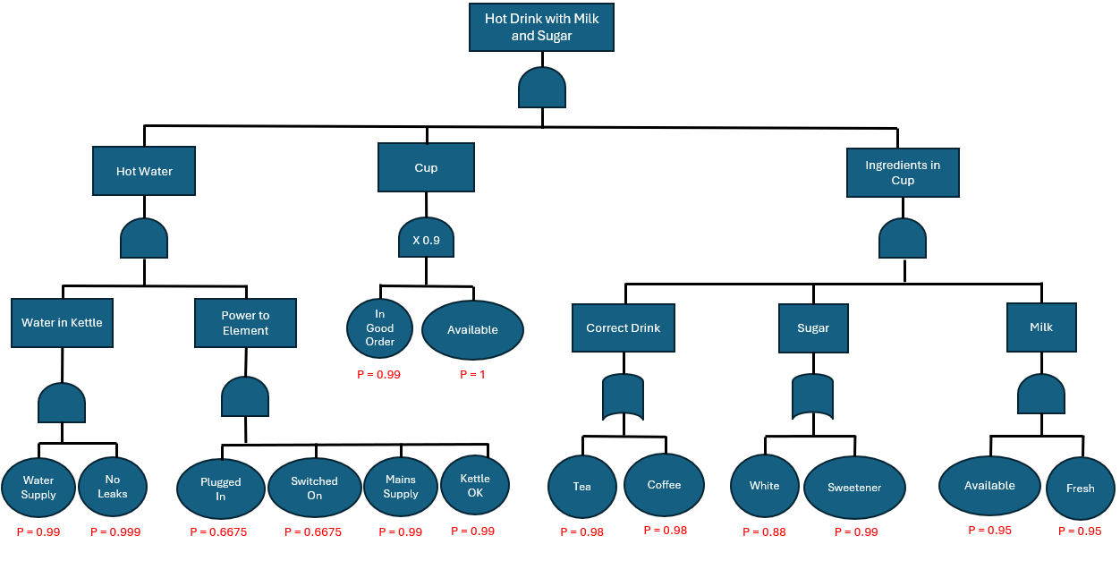
Figure 6 – FT of the probability of success under fatigue conditions annotated with base event values

Boolean logic operators were utilised to calculate the probability of success of the second level events. The calculations are shown below in Equations 10 through 15.

$$\text{P}\left(\text{Water in Kettle}\right)\text{ = P}\left(\text{Functional Water Supply ∩ No Leaks}\right) \\ \text{= P}\left(\text{Functional Water Supply}\right)\text{ × P}\left(\text{No Leaks}\right) \\ \text{= 0.99 × 0.999 } \\ \text{= 0.98901 }$$
Equation 10 - Calculations for probability of success (water in kettle)

$$\text{P(Power to Element) = P(Plugged in ∩ Switched on ∩ Functional Mains Supply ∩ Kettle OK)} \\ \text{= P}\left(\text{Plugged in}\right)\text{ × P}\left(\text{Switched on}\right)\text{ × P}\left(\text{Functional Mains Supply}\right)\text{ × P}\left(\text{Kettle OK}\right) \\ \text{= 0.6675 × 0.6675 × 0.99 × 0.99 } \\ \text{= 0.43668968062 }$$
Equation 11 - Calculations for probability of success (power to element)

$$\text{P}\left(\text{Cup}\right)\text{ = P}\left(\text{Good Condition ∩ Available}\right)\text{ × 0.9} \\ \text{= P}\left(\text{Good Condition}\right)\text{ × P}\left(\text{Available}\right)\text{ × 0.9} \\ \text{= 0.891 }$$
Equation 12 - Calculations for probability of success (cup selection)
$$\text{P}\left(\text{Correct Drink}\right)\text{ = P}\left(\text{Tea ∪ Coffee}\right) \\ \text{= 1 - }\left(\text{1 - P}\left(\text{Tea}\right)\right)\left(\text{1 - P}\left(\text{Coffee}\right)\right) \\ \text{= 1 - }\left(\text{1 - 0.88}\right)\left(\text{1 - 0.99}\right) \\ \text{= 1 - }\left(\text{0.02 × 0.02}\right) \\ \text{= 1 - 0.0004 } \\ \text{= 0.9996 }$$
Equation 13 - Calculations for probability of success (correct drink)

$$\text{P}\left(\text{Sugar}\right)\text{ = P}\left(\text{White Sugar ∪ Sweetner}\right) \\ \text{= 1 - }\left(\text{1 - P}\left(\text{White Sugar}\right)\right)\left(\text{1 - P}\left(\text{Sweetner}\right)\right) \\ \text{= 1 - }\left(\text{1 - 0.88}\right)\left(\text{1 - 0.99}\right) \\ \text{= 1 - }\left(\text{0.12 × 0.01}\right) \\ \text{= 0.9988 }$$
Equation 14 - Calculations for probability of success (sugar)

$$\text{P}\left(\text{Milk}\right)\text{ = P}\left(\text{Available ∩ Fresh}\right) \\ \text{= P}\left(\text{Available}\right)\text{ × P}\left(\text{Fresh}\right) \\ \text{= 0.95 × 0.95 } \\ \text{= 0.9025 }$$
Equation 15 - Calculations for probability of success (milk)

To aid in problem visualisation, the calculated values were added to the FT in purple text as shown in Figure 7.

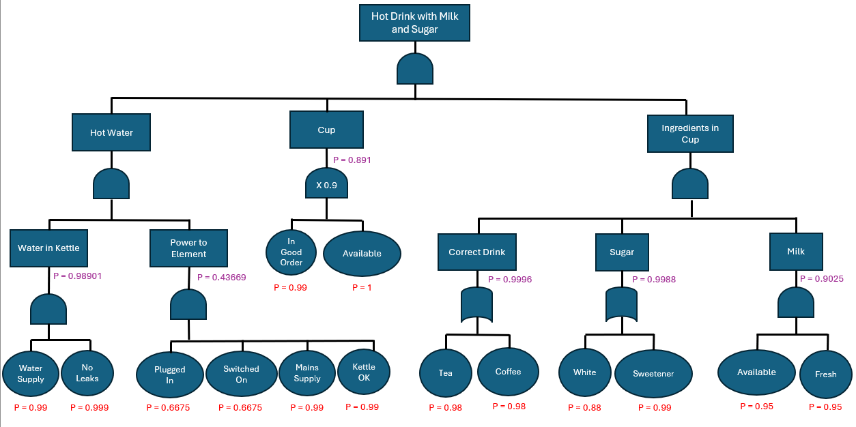
Figure 7 – FT of the probability of success under fatigue conditions annotated with second level event values

The previously described calculation process was followed to determine the probability of success of third level events shown in Equations 16 and 17.

$$\text{P}\left(\text{Hot Water}\right)\text{ = P}\left(\text{Water in Kettle ∩ Power to Element}\right) \\ \text{= P}\left(\text{Water in Kettle}\right)\text{ × P}\left(\text{Power to Element}\right) \\ \text{= 0.98901 × 0.43668968062} \\ \text{= 0.43189046103}$$
Equation 16 - Calculations for probability of success (hot water)

$$\text{P}\left(\text{Ingredients in Cup}\right)\text{ = P}\left(\text{Correct Drink ∩ Sugar ∩ Milk}\right) \\ \text{= P}\left(\text{Correct Drink}\right)\text{ × P}\left(\text{Sugar}\right)\text{ × P}\left(\text{Milk}\right) \\ \text{= 0.9996 × 0.9988 ×0.9025 } \\ \text{= 0.9010564332 }$$
Equation 17 - Calculations for probability of success (ingredients in cup)

These values were then added to the FT in green text shown below in Figure 8.
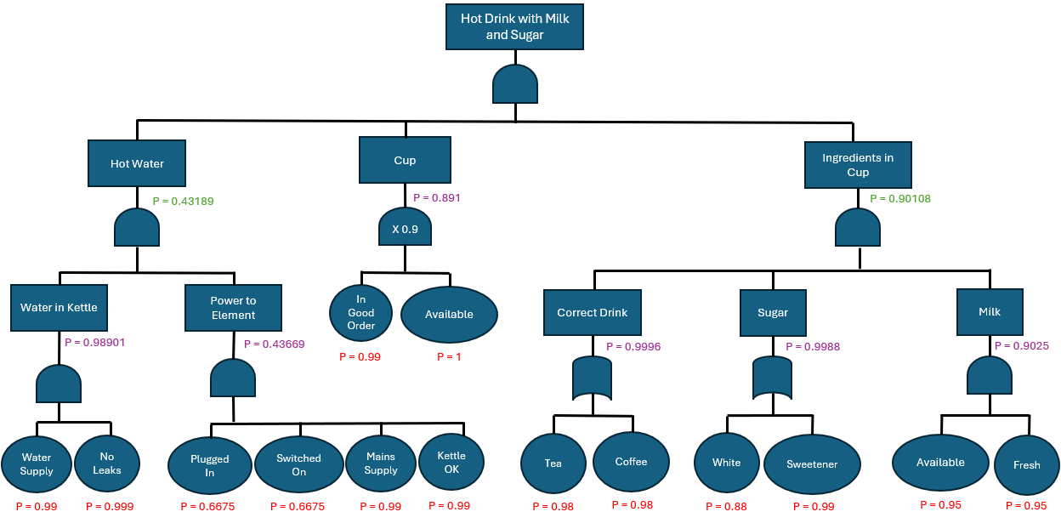
Figure 8 – FT of the probability of success under fatigue conditions annotated with third level event values

Previously calculated values were combined with the Boolean logic operator shown in Figure 8 to determine the probability of success of the top level even under fatigue conditions.

$$\text{P}\left(\text{Hot Drink with Milk and Sugar}\right)\text{ = P}\left(\text{Hot Water ∩ Cup ∩ Ingredients in Cup}\right) \\ \text{= P}\left(\text{Hot Water}\right)\text{ × P}\left(\text{Cup}\right)\text{ × P}\left(\text{Ingredients in Cup}\right) \\ \text{= 0.43189046103 × 0.891 ×0.9010564332 } \\ \text{= 0.34673949141 }$$
Equation 18 - Calculations for probability of success (production of a hot drink with milk and sugar)

This value was added to the FT in blue text shown in Figure 9 to complete the annotated diagram.

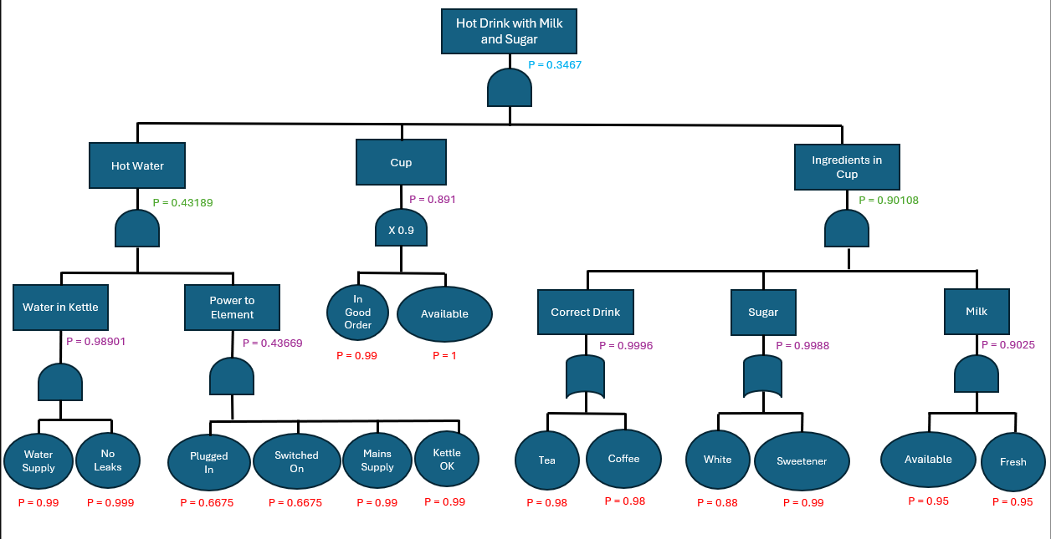
Figure 9 – FT of the probability of success under fatigue conditions annotated with the top-level event value

The final probability of Bill making a cup of tea with milk and sugar under fatigue conditions is 34.67% (2 d.p.).

3 Effect of Human Factors
Performance Shaping Factors (PSFs) are system dependent contextual conditions that influence the likelihood of human error by impacting performance [14]. Fatigue is a PSF that alters attention, motor coordination and decision-making skills within human operators [15]. The probability of human error increases in serial tasks (where each event relies on the previous one) when PSFs such as fatigue degrade cognitive or physical capability [16].
In the exercise, Bill’s ability to perform tasks involving attention, coordination and decision-making skills such as plugging the kettle in, switching it on and selecting a cup were negatively impacted by the PSF fatigue. When human reliability decreases, it compounds with the success probabilities of hardware to reduce the overall likelihood of success [17]. This is particularly visible in the decrease in probability of success for providing power to the element of the kettle from 77.63% to 43.67% when operating under fatigue conditions.
Human reliability assessments dictate that human error should not be viewed as an individual fault, rather a predictable outcome of system conditions that influence the likelihood of error [18]. In the case of the exercise these conditions include the time of night, lighting, Bill’s level of alertness, kitchen layout and kettle / plug design. The effect of these factors is subsequently amplified by PSFs such as fatigue, increasing their effect on success probability.
When operating under conditions of fatigue, the probability of Bill successfully producing a cup of tea with milk and sugar decreases from 68.49% to 34.67%. The significance of this decrease is due to the impacted events being at the start of the sequence, causing the reductions in success to propagate through the entire fault tree. The significant decrease demonstrates the critical impact of human factors within system reliability despite having reliable hardware components.

4 Conclusions
The completion of the FTA exercise demonstrated how systems can be broken down into a logically structured FTs to display relationships, dependencies and vulnerabilities. By breaking the process into discrete events and calculating their probabilities of success, the analysis demonstrates that system reliability is founded on the cumulative interaction of many small dependencies rather than a single factor. In doing so, the value of identifying single points of failure, quantifying risk and understanding how human / environmental factors impact system outcomes was highlighted.
Under normal conditions, Bill’s probability of successfully producing a cup of tea with milk and sugar was 68.49%. Upon introducing fatigue, the success rate of human dependant tasks such as plugging the kettle in, switching it on and selecting an appropriate cup significantly decreased. Due to the fact that these events occur early in the task sequence, their degradation significantly impacts the probability of success. As a result, the Bill’s probability of success decreased to just 34.67% during the night.
This demonstrates the significant impact of human factors on system reliability, especially in low automation environments. Despite hardware components having a high probability of success, a relatively small reduction in human performance can have a detrimental impact of system reliability. This demonstrates the need for automation, redundancy and error reduction within safety critical systems to reduce reliance on human performance.

5 References
[1] Z. Chen, "5 - Power electronic converter systems for direct drive renewable energy applications," in Electrical Drives for Direct Drive Renewable Energy Systems, M. Mueller and Henk Polinder, Ed., Woodhead Publishing, 2013, pp. 106–135. doi: 10.1533/9780857097491.1.106Available: https://www.sciencedirect.com/science/article/pii/B9781845697839500055
[2] M. Abbas and M. Shafiee, "An overview of maintenance management strategies for corroded steel structures in extreme marine environments," Mar.Struct. vol. 71, pp.102718, 05 2020, doi: 10.1016/j.marstruc.2020.102718. Available at: https://www.sciencedirect.com/science/article/pii/S0951833920300125.
[3] "Chapter 11 - Marine safety," in The Maritime Engineering Reference Book, A. F. Molland, Ed., Oxford: Butterworth-Heinemann, 2008, pp. 784–875. doi: 10.1016/B978-0-7506-8987-8.00011-1Available: https://www.sciencedirect.com/science/article/pii/B9780750689878000111
[4] H. J. Pasman and W. J. Rogers, "Chapter Three - Logic based methods for dynamic risk assessment," vol. 4, pp.61–122, 2020, doi: 10.1016/bs.mcps.2020.02.001. Available at: https://www.sciencedirect.com/science/article/pii/S2468651420300015.
[5] E. Ruijters and M. Stoelinga, "Fault tree analysis: A survey of the state-of-the-art in modeling, analysis and tools," vol. 15-16, pp.29–62, 05 2015, doi: 10.1016/j.cosrev.2015.03.001. Available at: https://www.sciencedirect.com/science/article/pii/S1574013715000027.
[6] F. Ojiemhende Ehiagwina, O. O. Kehinde, A. Sidiq Nafiu, O. Afolabi and I. Olatinwo, "Fault Tree Analysis and its Modifications as Tools for Reliability and
Risk Analysis of Engineering Systems – An Overview," vol. 3, no. 1, 01 2022,
[7] M. Yazdi, et al., "Fault tree analysis improvements: A bibliometric analysis and literature review," Quality &amp; Reliability Eng. vol. 39, no. 5, 01/05 2023, doi: 10.1002/qre.3271.
[8] S. Kabir, "An overview of fault tree analysis and its application in model-based dependability analysis," Expert Syst.Appl. vol. 77, pp.114–135, 2017, doi: 10.1016/j.eswa.2017.01.058. Available at: https://www.sciencedirect.com/science/article/pii/S0957417417300714.
[9] A. Chakhrit, N. E. H. Benharkat and I. H. M. Guetarni, "Integrating multilevel failure analysis with a systematic approach to functional safety requirements allocation in aviation systems," vol. 17, no. 1, pp.383–397, 06/09 2025, doi: 10.1007/s13272-025-00858-7. Available at: https://doi.org/10.1007/s13272-025-00858-7.
[10] J. C. F. de Winter and P. A. Hancock, "Why human factors science is demonstrably necessary: historical and evolutionary foundations," vol. 64, no. 9, pp.1115–1131, 09/02 2021, doi: 10.1080/00140139.2021.1905882. Available at: https://doi.org/10.1080/00140139.2021.1905882.
[11] Health and Safety Executive. "Introduction to human factors." [Online]. Available: https://www.hse.gov.uk/humanfactors/introduction.htm
[12] R. W. Proctor and T. Van Zandt,Human Factors in Simple and Complex Systems, Third Edition, 3rd Ed. London: Taylor and Francis, 2018.
[13] S. Saif Rashed Almazrouei, F. Camelia, R. Leal, T. L. J. Ferris, G. K. Kaya and M. Chatzimichailidou, "Human factors integration in complex systems: Awareness, challenges and strategies," pp.1–21, 7 2025, doi: 10.1080/00140139.2025.2536543. Available at: https://doi.org/10.1080/00140139.2025.2536543.
[14] P. R. Jha, V. Di Pasquale, J. J. Saleem and X. Wang, "Taxonomy of performance shaping factors in manufacturing: A systematic literature review," Hum Factors Ergon Manuf. vol. 34, no. 5, pp.367–385, 2024, doi: 10.1002/hfm.21036. Available at: https://doi.org/10.1002/hfm.21036.
[15] M. Rasmussen and K. Laumann, "The evaluation of fatigue as a performance shaping factor in the Petro-HRA method," Reliab.Eng.Syst.Saf. vol. 194, pp.106187, Feb 2020, doi: 10.1016/j.ress.2018.06.015. Available at: https://www.sciencedirect.com/science/article/pii/S0951832017310402.
[16] D. Birch, E. E. Miller and T. H. Bradley, "Human Reliability Analysis using a Human Factors Hazard Model," J. Syst. Saf. vol. 58, no. 2, -06-22 2023, doi: 10.56094/jss.v58i2.251.
[17] M. Behrens, et al., "Fatigue and Human Performance: An Updated Framework," vol. 53, no. 1, pp.7–31, 1/1 2023, doi: 10.1007/s40279-022-01748-2. Available at: https://doi.org/10.1007/s40279-022-01748-2.
[18] G. J. M. Read, S. Shorrock, G. H. Walker and P. M. Salmon, "State of science: evolving perspectives on ‘human error’," Ergonomics. vol. 64, no. 9, 08/06 2021, doi: 10.1080/00140139.2021.1953615.

