Kellogg’s

Course title : Introducing the Modern Workplace
Code of the course : LCBB4003
Lecturer name : Anupar Mazumdar
Students name and number:
- Bres Elisabeta -1806711-Goals and Objectives
- Antonella Palermo: 1805329 – Background
- Manolachi Madalina -1806712-Leadership and Management behaviour
- Circiu Alexandru – 1807495- Group and team behaviour
- Banuteanu Albert –1807719 Motivation and Perception

GOALS AND OBJECTIVES

In this project we will try to make known KELLOG’S company as we see it. Each one of us will have one sub point where we will talk about Kellogg’s! Most of the students find it difficult to make a difference between goals and objectives, but is quite simple.Goals is about what you try to accomplish or where do you try to get to and objectives are the sum of actions you take in accomplishing your goals.

Kellogg’s is a company that interest everyone ,including people who want to have a healthy life style, because of the variety of the products they create. Through they’re goals and objectives Kellogg’s always try to bring on the market, the best product. The high position that Kellogg’s has within the market is based on faith and confidence of costumers. Like all successful businesses, Kellogg’s is also based on goals and objectives, to help them find the main purpose of the business and identity the necessary actions that has to be taken. Both aims and objectives should be measurable and specific. Goals can refer to areas such as growth and gains and also costumers services, but with some well established objectives that can help on achieving those goals.
An common goal that Kellogg’s has with other business that has a profitable operation is increasing the gains and reducing the expenses.
Costumers service goals can be reached by increasing costumers service staff, and including a policy where costumers will receive a call by the end of the day for any complaints that they make.
Another common goal is to become more productive as a way to grow productivity. To accomplish this aim they established some objectives like increasing shipping times or finding new shipper and also improving production times.

Kellogg’s Vision: “To enrich and delight the world through foods and brands that matter”
Kellogg’s Purpose: “ Nourishing families so they can flourish and thrive”

After they created an goals and established objectives, KELLOGG insert a plan of strategy. In the area of food brand Kellogg’s introduces GDA (Guideline Daily Amounts) that helps people understand what amount of nutrients is served in Kellogg’s food. Later, GDA was also adopted by other big organisations.
After a well established goals,Kellogg’s managers make plans in taking right decisions. Each objective set for Kellogg’s was created to improve on reaching the goals. Some of those objectives were:
- Encourage physical activities in all the human categories
- Rise the bound between Kellogg’s and physical activity
- Use the packing to communicate the “balance” message to costumers
- Introduce food brand that will influence people in making decisions related to the right balance of food
All those objectives were called SMART (Specific,Measurable, Achievable, Realistic and Time-related)objectives. Each of them were adopted by the staff that put Kellogg’s in a high position on the market, in the next three yers.
A SWOT analysis of Kellogg’s shows us a overall image of the company.
STRENGTHS OF KELLOGG’S
- Very successful at Go To Market strategies for its products
- Always bringing something new on the market-product innovation
- Strong free cash flow- provide resources for opening new projects
- Strong distribution network
- Strong brand name
- Performance on the new market.
- Very skilled employees through successful training and learning processes. Kellogg’s invested a large amount of money in training the workforce.
WEAKNESS OF KELLOGG’S

In this area Kellogg’s can bring some improvement.
- Company find difficulties in moving to new product segments.
- They products are only successful in selling but when it comes to “originality “ they can have attacks from competitors
- Not very successful in adapting firm to new culture
- There are some gaps in the product range
- They need to invest more in new technologies to integrate in the process across the broad

OPPORTUNITIES FOR KELLOGG’S

- Attract new costumers and increase costumers spending
- Investing from cash flow in new technologies and also in new products
- Gain market share decreasing cost of transportation
- Increasing revenue through new tax policy
- Accepting new technologies standard and government free trade
- Attracting new costumers through online platform
- New environmental policies

THREATS

- The change of online costumers behavior
- The company can meet lawsuits in various markets given
- High competition
- Increasing raw materials
- Fake products that are cheaper than KELLOGGS products can be a threat

Keeping an eye on the market but in the same time on the company helps on improving the weaknesses, beware of the threats and take advantage of the opportunities.
All the powerful organisations put in practice all the ideas to keep their position in front line, so as Kellogg’s which instead of re-use the Nutri-Grain brand used another tolls who took in consideration the product life cycle, Ansoff’s matrix and the marketing mix. Kellogg’s saw that even Nutri-Grain has the healthy strategy structure, suitable cereal product was underperforming in the market. This acquaintance was used, along with the aims and objectives of the organisations,to expand the strategy for growing success.

Background
In 1906, W.K. Kellogg set up the Kellogg Company in Battle Creek, MI. More than 100 years after the fact, the Reality Central station is as yet situated in downtown Cereal City, USA (Kelloggs.com, 2019). The structural works of Straight to the point Lloyd Wright, Louis Sullivan, and Eliel Saarinen roused the plan of the present structure, which opened in June 1986. The Chief, Executive Authority Group, and workers crosswise over numerous elements of the North American and Worldwide organizations are situated in the Home office (Kelloggs.com, 2019). Workers here appreciate access to an assortment of courtesies including an on location exercise center with best in class gear, cafe, and cafeteria. Kellogg Company and vision articulations to portray its mission to center unsustainable growth, the wide meaning of social duty and genuine quality of the company-individuals and brands (Kelloggs.com, 2019). Company vision envelops all partners including investors, representatives, clients, buyers and networks. Its mission Offers where they are as a company today, and where they need to be later on. The study explains how Kellogg’s as an organisation has given importance to introduce a modern workplace. Kellogg’s is worlds one of the leading breakfast food producing organisation. The product of the organisation is being manufactured in 18 countries and is being sold in more than 180 countries. Effective management and leadership have enabled the Kellogg’s company to function successfully and expand their business. They have reported annual revenue of $12.932 billion in the fiscal year of 2017. Kellogg’s has always been modern and ahead of their time. In 1930, when other factory workers were made to work 40 hours a week, they had shifted their routine towards a 30 hour week. The management at Kellogg’s had proposed this change in order to provide mental support to their employees who were going through the depression era. They are still upholding these values and providing nutritious breakfast to the world (Kelloggs.com, 2019). Hence, being an organisation that has been in the business for more than hundred years now, the company can set an example for any other organisation which needs an idea about how to manage their workplace by introducing modern concepts.
This study explains the importance of introducing modern workplace in an organisation. For this study, Kellogg’s has been taken as an example of an organisation to analyze and give an idea how and why an organisation or a company should introduce modern concepts in their respective workplaces. Moreover, this explains how Kellogg’s being an organisation in the business for such a long time, how they have successfully managed to implement modern workplace concepts with the help of “Scientific Management Concept” in terms of leadership and management. Further, this also explains how Kellogg’s has implemented “Maslow’s Theory” to keep its employees motivated and loyal towards the organisation. An organisation must understand what will motivate the employees of the organisation to bring dedication to their work. This not only helps the organisation to keep its employees motivated and happy but also helpsitto successfully manage its employees to work more for the development of the organisation. That is why introducing modern concepts in the workplace becomes so important. This is where Kellogg’s as an organisation has been so successful. They have kept a clear vision about their goals and objectives in introducing modern workplace concepts, which in turn is helping them to keep the employees motivated bringing dedication to their work, which is in turn helping Kellogg’s to grow more and more as an organisation.
The performance of the employees of an organisation depends a lot on the organisation’s management skill. Kellogg’s have introduced “Scientific Management Concept” which was invented by Frederick Taylor. The concept explains that rewarding the efforts of employees motivates them which mean paying according to their effort can increase the rates of output. Kellogg’s keeps its employees motivated by allowing them to buy and sell their leaves or holidays. However, the concept has some limitations as well. As the concept explains that to keep employees motivated they should be paid according to the amount of work they do, employees tend to work more and try to increase the rate of productivity by focusing on quantity rather than quality. This, in turn, increases the rate of productivity but decreases the quality of the products which are being produced. Though the concept really helps to keep the employees motivated toward their work, it also limits the growth of an individual (Agnelloet al. 2015). Kellogg’s is an organisation which definitely gives productivity more priority, as the productivity of the organisation is directly proportional to the profit of the organisation, that is why Kellogg’s have been successful in implementing “Scientific Management Concept” in their workplace, that is introducing a modern concept in the workplace to keep the employees satisfied by paying them according to the amount of work they do, hence increasing both productivity and the amount of profit of the organisation (Georganta and Montgomery, 2016). In an organisation like Kellogg’s where the rate of production is the main priority, teamwork becomes the most important factor in the growth of the organisation. Kellogg’s have been successful in keeping the organisation stand together with a sole objective, which is the growth of the organisation. In this case of keeping the employees as a team, Kellogg’s have again introduced modern concept in the workplace. The moment employees of an organisation start to work together as a team, an organisation which looks to increase the rate of productivity, becomes successful in increasing the rate, which, in turn, increases the amount of profit as well (Shafritzet al. 2015).
Kellogg’s have been successful in keeping the employees motivated within the organisation by implementing “Maslow’s Theory”, which is another example of how they are successfully implementing modern concepts in the workplace. To keep the employees motivated within the organisation, the organisation should look to fulfil the basic needs of the employees within the workplace. The “Maslow’s Theory” states, that if an organisation looks on the basic, safety, social and better opportunity offering needs of an employee, it helps the organisation to keep the employees loyal towards the organisation. Kellogg’s as an organisation always look at all the needs that are mentioned above, which, in turn, motivates the employees of Kellogg’s to push their limits. Starting from paying them on the basis of their productivity, to offering them various benefits like life insurance within the company, many types of cash vouchers, allowing them to take breaks from work or sometimes offering work from home facilities, the company allows the employees to maintain a healthy work life balance. Apart from this, Kellogg’s also gives opportunities to its employees to push their limits and improve themselves and hosts rewards and recognition ceremonies to acknowledge the best performers.
Kellogg’s have been successful in introducing and implementing modern concepts and theories in the workplace. As mentioned earlier, Kelloggs’s have been in the business for over a hundred years now and it is one of the leading breakfast food manufacturing organisation in the world, so to be in the business and to create such an impact on the market is not a matter of joke, which concludes that Kellogg’s as an organisation is successful in keeping their vision clear about their goals and objectives in the introduction of modern workplace, leadership and management behaviours, keeping the employees within the organisation motivated, which means they are successful in the of modern workplace, which in return is increasing the rate of production and the amount of profit as well.

Leadership and management behaviour

Maintenance of proper leadership and management style in the organisation are helpful to flourish the business process. As described by Araújo and Bourbousson (2016, p.127), healthy leadership appears as advantageous as it motivated the workers and helps to form a healthy work environment. Thereby, the organisational authority of Kellogg’s is involved to implement the most appropriate leadership and management pattern in the organisation. It has been observed that behavioural leadership is critically maintained in the organisation.
Moreover, the leaders of the concerned organisation are essentially involved in providing proper training to the employees for producing a huge range of balanced diet for their customers. Development of the leadership pattern is advantageous for the organisation to enhance their rate of productivity. As mentioned by Sugden (2015, p.145), the enforcement of healthy leadership is essential to make the employees understand about the basic needs to develop their abilities. Thereby, they perform a number of duties to manage employee performances. The duties of the leaders of Kellogg’s are as mentioned below-
Roles of the leaders | Descriptions
Focusing to proper execution of plans | The leaders of Kellogg’s are involved to produce to provide healthy breakfast for huge numbers of potential customers. Hence, they are critically involved in proper execution of innovative plans.
Applying healthy strategies to meet organisational goals | The leaders are focused to build up a healthy organisational environment by meeting the employee needs with greater efficiency. This appears as helpful to meet organisational goals.
Providing supports to the weak employees | The leaders take the lead to guide the employee’s whose abilities and skills are not well developed.
Giving moral support | Providing moral support to the employees is essential to enhance their abilities (Healy, 2016, p.314). Thus, the leaders of the concerned organization critically perform the duty to provide moral support to the employees during working hours.
Table 1: Roles of leaders
(Source: Influenced by Widmann et al. 2018, p.10)
Thereby it can be stated that the leaders of Kellogg’s are essentially involved in understanding the employee needs for motivating them. Along with this, building up of positive, vitalising as well as pleasing environment in organisation appears as advantageous for employee motivation.

The leadership and management behaviours that are present in the organisation are described through the following points-
- Providing equal importance to the employees
The leaders of the company discusses with their employees about the ways to meet their financial targets (Kelloggs.co.uk, 2019). This appears as helpful to enhance the operational management of the organisation.
- Giving immense importance to business outcome
The management of the organisation focuses on their business outcomes to increase the amount of annual profit. This is also helpful to involve healthy ownership in the organisation which ultimately leads to employee motivation.
- Effective management of resources
The managers of the organisation at first train their leaders to guide the workers for engaging their best skills to enhance the rate of production.
Thus, the management of the company provides encouragement to the employees to speak positively and focuses on their strengths to develop the business process. As opined by Healy (2016, p.315), when the employees are given immense importance for expressing their views regarding the workplace, it makes them motivated to work in an efficient manner.

Leadership behaviour identified in Kellogg’s
The leaders of Kellogg’s are focused to maintain a strong relationship between their groups and teams to form a healthy workplace. In the view of Raes et al. (2015, p.7), formation of healthy work environment is helpful to maintain friendly relationship among the leaders and the workers. The leaders of this organisation are focused to develop their communication with the employees. This, in turn, appears as helpful to motivate the employees. Moreover, the leaders are focused to guide the employees when they are in serious problems. Thus, it is beneficial to form a stronger customer background by developing the employee abilities.
The leaders of Kellogg’s are involved to motivate the employees for contributing more for organisational growth. In this respect, development of the production occurs and this becomes possible through the active involvement of suitable team leaders (Kelloggs.co.uk, 2019).
Employee motivation is an important criterion to develop the organisational productivity. In words of Sugden (2015, p.145), the employees of an organisation are motivated when they are supported by healthy organisational culture along with proper monetary support. In this respect the leaders and managers of Kellogg’s focus to develop “piece of work”. This is greatly advantageous to enhance employee abilities. Besides, the authority has introduced appropriate division of labour system and healthy reward system to motivate the employees and provide encouragement to them.
The authority of the organisation motivates the employees through meeting their various requirements. The leaders are greatly involved to meet the employee requirements for modifying their rate of production.
Physiological needs
Providing competitive salaries and organising benefits programmes are helpful for the employees to be motivated. They can select the best benefits for their own advantages.
Safety needs
The authority provides healthy working pattern such as home working, part time working and career breaks. These are helpful to motivate the employees as their work life balance is maintained.
Social needs
Development of team leading ability is helpful to motivate the workers (Widmann et al. 2018, p.4). Thereby, the authority motivates the workers to contribute to their K values by providing rewards for staff achievements.
Self-actualisation
The organisation provides a scope to the employees to take ownership of a project. This is helpful to motivate them.
Thus, it can be concluded that involvement of healthy leadership and management is helpful for an organisation to meet their business goals. Thereby, the organisational authority of Kellogg’s is involved to develop their leadership pattern. The development of leadership is also helpful to motivate the workers. Besides, maintenance of effective team behaviour is considered as the critical factor for the organisation to reach to a greater market portion. The report also focuses on the ways that are helpful to determine the ways that are helpful for motivating workers of an organisation.

Appendix: Leadership development system
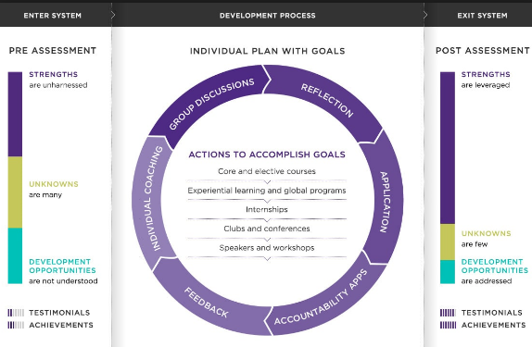
(Source: https://www.kellogg.northwestern.edu/career/leadership-development.aspx)

Group and team behaviours
The 5-member group of ours have been a part of the project team working on Kellogg’s case study. The aim of the group was to analyse the market potentials and market base of Kellogg’s, and how it can help the company to develop new strategies to improve the sales performance across the retail channels in the UK. Since it was a group-based activity, therefore, we had to ensure that each of us take on some important task that will help proceed with the group objectives.
So, the objective was to deliver a comprehensive strategic report on Kellogg’s to assist its market and sales operations. The reason that the objective was important is because it gave us the opportunity to review the operations and functions of Kellogg’s in practical and gave us the scope to deliver strategic suggestions for the company and thus, utilize our acquired skills and knowledge in solving real life problems. In order to improve our skills and knowledge, and to have our expertise enhanced, the objective of the project helped us a lot. And moreover, working with a reputed brand such as Kellogg’s, we got the opportunity to gain some important industry and company knowledge.
The work group we had formed was formally designed. We followed Tuckman’s group development theory and Belbin’s group dynamic theory as we formed the group among of ourselves. Tuckman’s five stage group development theory helped us systematically get together with a common objective of working on the Kellogg’s project and delivering a strategic report on it. At the forming stage, we came together and discussed the aim and decided on the group objectives. Then at the storming stage, we faced a problem with determining the group leader. However, one from among us was selected for this task and thus, we moved forward. At the norming stage, we finally were able to recognize our roles and responsibilities and started acting on them properly. At the performing stage, we were coordinating and cooperating with each other to produce the report and make the analysis (Beaumont, 1993). After completing our task, we disbanded officially, after having a group meeting.
We observed in the project team that group behaviours change at the different stages of the group. For example, when we first started the group project, we did not have proper knowledge of the directions and specifics of the activities. However, with proper communication and positive attitude towards each other, the group was directed effectively. The most positive group behaviours from all members were addressed at the performing stage. High level of cooperation and coordination were observed at this stage.
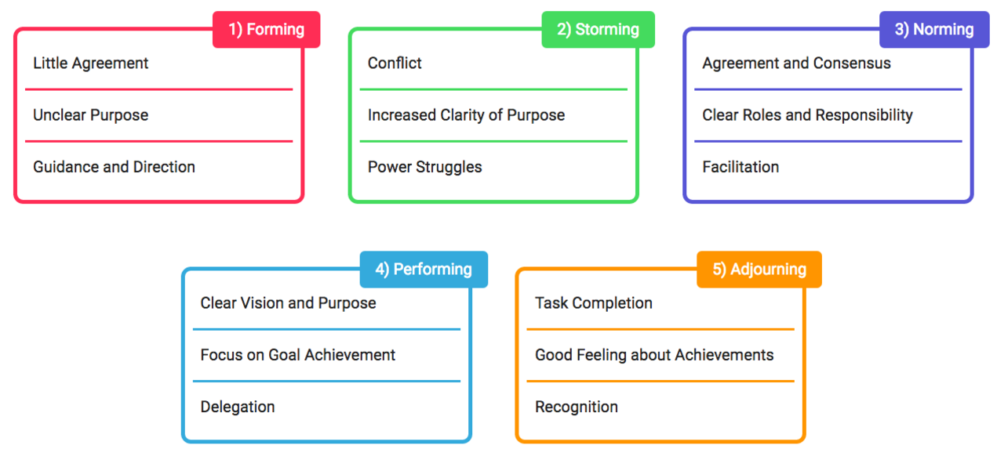
Figure: Group dynamics
As shown in the figure, we observed different dynamics among ourselves at the different stages of the group.
The group roles were divided based on Belbin’s role theory. The team roles were divided into resource investigator, coordinator and team workers.
At the performing stage, we reviewed different theories relevant to the case study. We had some disagreements to the effectiveness of the theories in context of the organization (Cook, 2009). For example, I reviewed how management theories such as scientific theory, motivation theories such as Herzberg’s two factor theory and leadership theories such as transactional and transformational theories relate to the given case study. In order to ensure that our report is accurate, I did check the theories in context of similar other organizations that are in a competitive position against Kellogg’s. I noticed that the theories do relate to the case of other companies. The group project gave us the opportunity to demonstrate leadership and management behaviours within the group, and at the same time, investigate the effectiveness of different management and leadership behaviours. While reviewing the case study, we observed how the scientific management theory helps an organization to gain efficiency and productivity in operations. We also observed how management concepts such as bureaucratic management can be obstructive to achieve the team performance. Applying scientific management theory in our own operations we observed that the approach does increase productivity and helps build up motivation (Cook, 2009).

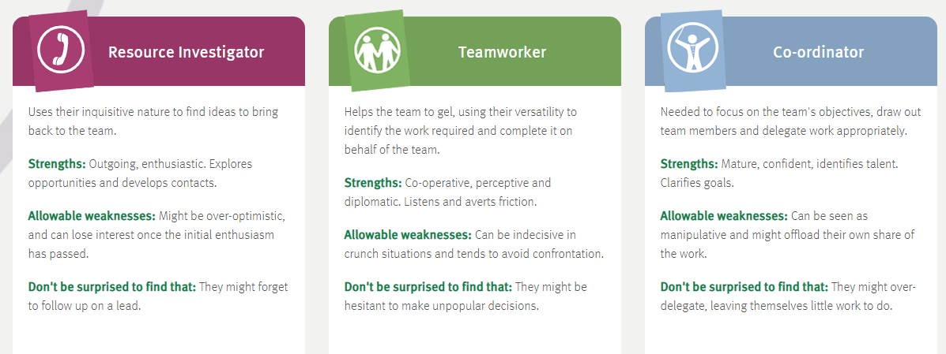
Figure: Belbin’s group role theories
Reflecting on my group behaviour as a resource investigator, I can say that at first, I had faced some problems following up with the lead. I was also over optimistic of my performance at first. But my enthusiasm did help me do a good job at the project team. Thus, the performing stage was eventually ended, and the group project was brought to a closure after a formal meeting and discussion on our individual performances.
My individual contribution to this group performance was that I was able to collaborate with my team mates and was performing my tasks effectively. I was able to understand my roles a responsibility and helped others with theirs.
Then I have reviewed the leadership skills relevant to the company case. I noted that the organization follows transformational leadership. So, in order to evaluate the effectiveness and relevance of this style, we reviewed other organizations like HP, Google, etc, which also follow this style, and had a role play scenario to see how performance differs in transactional leadership style to transformational leadership style. Transformational leadership is important for effective group working because it helps the group leader to engage with the group members and thus, increases the productivity and motivation of the group members. This is a specific knowledge that I have gained from the group working experience.
The group project gave us the opportunity to develop some important professional and industry skills. We learned a lot from our experience. Reflecting on my activities and performance, I can see that my knowledge and skills have improved a lot undertaking this project. Therefore, it is obvious that the learning outcomes have been properly addressed in this task.

Motivation and Perception
There are some theories which explain motivation concept in organisation. One of
such theory is maslow hierarchy of needs. It is motivational theory which takes cares needs of
employees in organisation to motivate them and to increase their interest towards work. It is
necessary to know employee needs to make workplace environment better. Structure of
organisation also lead to better workplace environment but to make it best, needs are to be
known. Management team of Kellogg’s follow maslow theory to motivate employees.
Maslow theory deals with four different types of needs. First are physiological
needs that are general needs of an employee. Kellogg’s take care of general needs like food, water,
shelter. Mineral water is provided by Kellogg’s management team to take care of employee health. It
makes benefits to employee to choose between healthier work place environment and unhealthier
one. Kellogg’s motivate employee to choose their organisation in meeting physiological needs.
This physiological need also consist of life insurance schemes for employees. It helps to increase
their retention level in organisation and to make them loyal. Second need is safety needs.
Kellogg is a food manufacturing company (Lee and Hanna, 2015). It deals with big machines to
have qualitative production of products.
Organisation has responsibility to provide safe and healthy environment to
employees so that accident can be prevented. Precautions like safety helmet, shoes are provided o
employees to wear them for prevention against accidents. Regular maintenance of machine is done
by Kellogg’s engineer to make sure that they are working in proper conditions. This reduces the
chances of hazards to be taken in workplace environment.
This makes employees motivate to work in Kellogg’s work place (Fallatah and Syed, 2018). This
comfort regarding also increase their work efficiency which results in positive chances of
achieving business objectives. Motivation is a big concept for organisation to have productivity,
growth and development. Employees’ motivation level leads an organisation to higher position.
Third need is of social needs. This deals with requirement of employee to have balance between
personal life and professional life. Employees are also in need of belonging love to make them
motivate and give them an aim to work in organisation with full efficiency (Lăzăroiu, 2015). A
person cannot work alone in work place. They are in need of other love that understand them and
motivate them. To fulfil such needs of employees. Kellogg’s provide sometimes flexible working
hours of employee to give their time to their family and friends. This can also be in work place to
be interaction with other employees who make them interested to do work (De Vito and et.al.,
2018). This approach of having open communication with other employees can have both
positive and negative impacts. Other employees who are unsatisfied with Kellogg’s environment
also demotivate positive employees. This is a loss for Kellogg’s to make retention of employees.
But sometimes, a employee cam motivate other employees too. This is helpful in efficient
process of transferring information which is a key to success. Motivate person sees the things in
positive attitude and tries to solve the conflicts that are occurred in between to achieve objectives
of business.
Another need is of self actualisation needs. This deals with self esteem need in which employee’s desire of respect from other employees. They are desire to have achievement in
their career life to motivate themselves. Responsibilities are handled by employees in efficient way if
employees’ needs are fulfilled accordingly. Kellogg’s management team give performance
appraisal to employees who work hard and smart for achieving business objectives. Managers try
to give performance appraisal in public or in front of employees to motivate others so that other
employees also try to work hard like other employees who are getting performance appraisal.
This benefit to both types of employees, good employee gets respect from other which is their
self esteem needs and other employees are also motivated. Kellogg’s also provide chance to
employees to being promoted by showing their skills for achieving objectives. Voluntary works
are distributed to employees to show their talent (Hung and Petrick, 2016). This helps
organisation to fulfil self actualisation needs of employees. Management team also get to know
about their needs by having involvement in different activities and events.
Hence, it can be analysed that maslow hierarchy of needs in which different needs are
evaluated which helps organisation to motivate employees and making work place environment
better. These factors are considered by management team of Kellogg’s to improve their
production level which will raise their profitability.
A scientific management concept is used by management team of Kellogg’s. Frederick
Taylor, a person found behind this scientific management. They believe that monetary reward
system is best system to motivate employees. In this system, employees are paid according to their
work performance. This has been analysed that individual paid system motivates employees to do
work with high efficiency because of their payment. Kellogg’s provide facility for employees to
reward their work accordingly and have a chance to buy and sell and their holidays against
money. This is beneficial for both company and employees to have profit. Employees are getting
money for their work and company is getting profit by employee’s work. Organisation is
focussed to have positive outcome instead of negative outcome. It also makes employee
relationship better and motivates employees to increase their interest to do work with better
efficiency (Welford, 2016).
Perception is how an individual selects, interprets and organizes the
information he receives from the environment with the help of senses, namely perception is
how we see as individuals the society in which we live.
The importance of consumer perception of the company is reflected in two main aspects:
1. Promoting the company and the values ​​that it supports towards the consumer through their products and their quality;
2. Attention to the needs of employees.
Kellogg emphasizes the use of raw material in a responsible way, a healthy ingredient, taking into account that it remains one of the largest grain-producing companies
Nowadays, a lot of emphasis is placed on healthy foods, without additives, dyes and preservatives, and such a diet is supported by Kellog by using the highest quality and harvested portion, transported for processing fast.

Reference List
Agnello, P., Ryan, R. and Yusko, K.P., 2015. Implications of modern intelligence research for assessing intelligence in the workplace. Human Resource Management Review, 25(1), pp.47-55.
Ben, B., 2016. On Workplace Investment in Employee Well-Being. Research in Economics and Management, 1, pp.166-174.
Georganta, K. and Montgomery, A., 2016. Exploring fun as a job resource: The enhancing and protecting role of a key modern workplace factor. International Journal of Applied Positive Psychology, 1(1-3), pp.107-131.
Jemielniak, D., 2016. Introducing the Laws of the Knowledge Workplace. In The Laws of the Knowledge Workplace (pp. 15-24). Abingdon: Routledge.
kelloggs.com (2019), Kellogg’s Available at:<https://www.kelloggs.com/en_US/who-we-are/our-history.html> Accessed on : 25th March, 2019
Lee, J.M. and Hanna, S.D., 2015. Savings goals and saving behavior from a perspective of Maslow's hierarchy of needs. Journal of Financial Counseling and Planning, 26(2).
Qiu, J.X. and Rooney, D., 2017. Addressing unintended ethical challenges of workplace mindfulness: A four-stage mindfulness development model. Journal of Business Ethics, pp.1-16.
Shafritz, J.M., Ott, J.S. and Jang, Y.S., 2015. Classics of organization theory. Boston: Cengage Learning.
Araújo, D. and Bourbousson, J., (2016). 9 Theoretical perspectives on interpersonal coordination for team behaviour. Interpersonal Coordination and Performance in Social Systems, 36(16), pp.126-132.
Healy, K., (2016). A Theory of Human Motivation by Abraham H. Maslow (1942). The British Journal of Psychiatry, 208(4), pp.313-315.
Kelloggs.co.uk (2019). Kellog’s. Available at: https://www.kelloggs.co.uk/en_GB/home.html [Accessed on 4th April 2019]
Raes, E., Kyndt, E., Decuyper, S., Van den Bossche, P. and Dochy, F., (2015). An exploratory study of group development and team learning. Human Resource Development Quarterly, 26(1), pp.5-30.
Sugden, R., (2015). Team reasoning and intentional cooperation for mutual benefit. Journal of Social Ontology, 1(1), pp.143-166.
Widmann, A., Mulder, R.H. and König, C., (2018). Team learning behaviours as predictors of innovative work behaviour–a longitudinal study. Innovation, 1(1), pp.1-19.
Beaumont, P. (1993). Human resource management. London: Sage.
Cook, S. (2009). Building a high-performance team. Ely, U.K: IT Governance.
Pope, S. and Blyth, E. (2008). Team leader workbook. Amherst, Mass.: HRD Press.
Schwartz, S. and Conley, C. (1998). Working as a team. Mankato, MN: Capstone High/Low Books.
- De Vito, L. and et.al., 2018. Employee motivation based on the hierarchy of needs, expectancy and the two-factor theories applied with higher education employees. IJAMEE.
- Fallatah, R.H.M. and Syed, J., 2018. A Critical Review of Maslow’s Hierarchy of Needs. In Employee Motivation in Saudi Arabia (pp. 19-59). Palgrave Macmillan, Cham.
- Hung, K. and Petrick, J.F., 2016. Developing a measurement scale for cruising motivations.
- Lăzăroiu, G., 2015. Employee motivation and job performance. Linguistic and Philosophical Investigations. (14). pp.97-102.
- Lee, J.M. and Hanna, S.D., 2015. Savings goals and saving behavior from a perspective of Maslow&#39;s hierarchy of needs. Journal of Financial Counseling and Planning. 26(2).
- Welford, R., 2016. Corporate environmental management 3: Towards sustainable development. Routledge.

