25/11/2025
Dinesh Pandey -Id- 2436555 -Module code-ACCA4023—Group -1
Ecoride
IWD : Database Design and Development
Assignment 01

Contents
Introduction to the case study 1
Entity Relationship Diagram (ERD): 2
Entities interact within the database. 3
Logical Design 4
Table Creation in MS – Access 4
Relationships between tables 6
Testing and Validation 7
Normalisation Process 8
MS- Access 9
Forms Creation 9
Queries Creation 11
Report Creation (create reports from each query and annotate them) 14
Calculations (show how you implement the calculation ( if any) and take screenshots) 16
Dashboard Creation (show how to navigate from dashboard to forms and forms to dashboard) 17
Conclusion 20
References 21

Tables
Table 1: Testing and Validation Table 7
Table 2: Rider_Details table 8
Table 3: Staff Table 8
Table 4: Rental_Details Table 9
Table 5: Tracking table 9
Table 6: Bike_Details_Table 9

Figures
Figure 1: Entity Relationship Diagram 2
Figure 2: Bikes Table 4
Figure 3: Locations Table 5
Figure 4: Maintenance Log Table 5
Figure 5: Rentals Table 5
Figure 6: Riders Table 5
Figure 7: Staff Table 6
Figure 8: Relationship Diagram 6
Figure 9: Maintenance Log Form 10
Figure 10: Renal Entry Form 10
Figure 11: Active Rentals Design, Datasheet and SQL view 12
Figure 12: Available Bikes Design, Datasheet and SQL view 12
Figure 13: Most Used Bikes Design, Datasheet and SQL view 13
Figure 14: Rental Revenue Design, Datasheet and SQL view 14
Figure 15: Active Rentals Report 15
Figure 16: Bikes Currently Available Report 15
Figure 17: Most Used Bikes report 16
Figure 18: Rental Revenue Report 16
Figure 19: Calculation for Charges per hourly rate 17
Figure 20: Dashboard View 19

Introduction to the case study
EcoRide is an upcoming electric bicycle rental company that was initiated by the local government. The service will help in encouraging the use of green transport in the city. Individuals have access to bikes that can be rented at different areas of the population, such as parks and train stations. Riders just swipe their ID tags at one location and drop the bike at any other location. Yet, the existing system is completely based on paper forms and unrefined spreadsheets (Date, 2019). It is a manual system that has created several major operational issues for the management team. The employees find it difficult to be able to see which bikes are available to be hired now. The system is also subject to the occasionality of double-bookings and problems with holding back the bikes. Moreover, it is extremely hard to trace maintenance requirements and investigate the overall utilisation of services. The report captures the design and development of a new relational database solution. This is aimed at streamlining all its operations for the expanding Eco Ride scheme. The new system will be automated to record the rider's details and the transactions of a rental. It would also keep superior records of all electric bikes and their service history. Eventually, the management team will have the correct and timely information in this database.

Entity Relationship Diagram (ERD):
An Entity Relationship Diagram is a blueprint of the whole database in the form of a visual model. It gives the locations of all the various tables and their relationship with each other. This is the diagram that was needed to plan the structure of the system before any building began. It shows the entities in a clear manner, which are the primary items we save data on, such as riders and bikes. The attributes, as the specifics of each entity, are also indicated in the diagram (Thalheim, 2013). As an illustration, the attributes of a rider consist of his or her name, address, and contact number. Above all, the ERD is used to depict how these various entities are related to each other. The identification of primary keys and foreign keys has been highlighted on this diagram. These keys are the basic components which form the connections between tables. The figure below gives a screenshot of the final ERD that was developed in Microsoft Access. This visual tool was to make sure that the database design was logical and comprehensive at the very outset. It assisted in coming up with the required tables and their relationships at the start of the process.
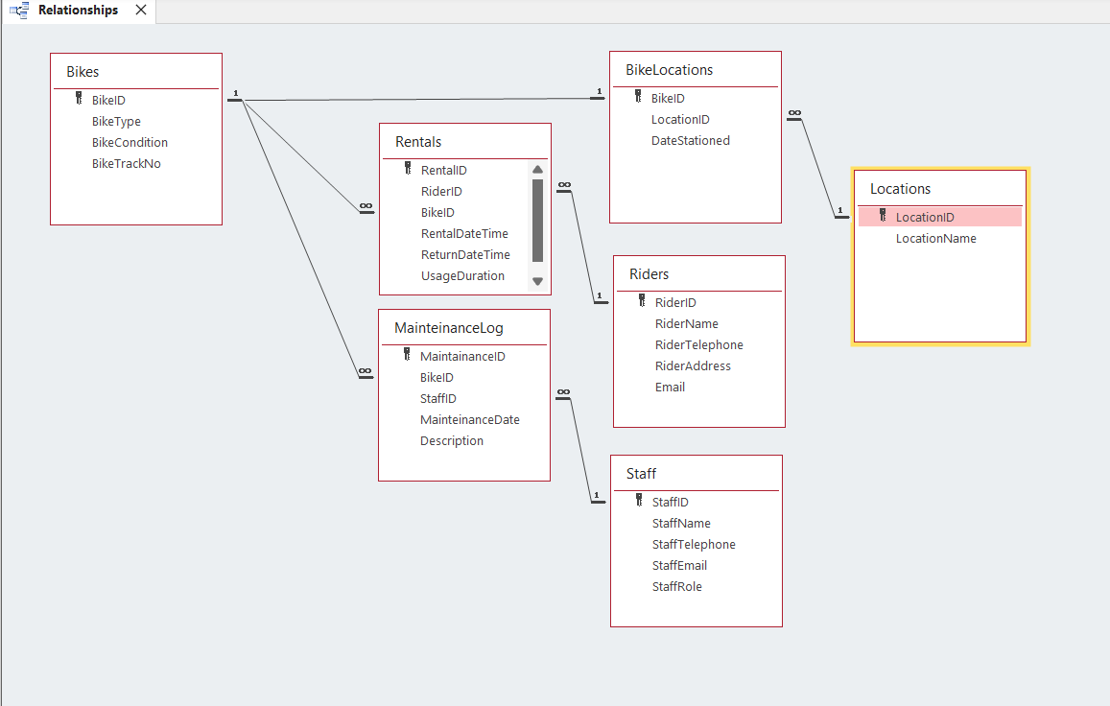
Figure 1: Entity Relationship Diagram
One – to – One Relationship between Entities
A one-to-one relationship is between one record of a table to one record of another table. The relationship between the Bikes table and the Bike Locations table is an excellent example in this database. A single location of a bike can exist only at a time (Yeung and Hall, 2007). Thus, a particular bike ID, such as BIK10, will exist in a single record of the Bike Locations table. Such an association can be used to monitor the exact position of each bike in the fleet. It will avoid confusion and make sure that the system is aware of the precise location of every bike.
One – to – Many Relationships between Entities
The most predominant relationship in this database is the one-to-many relation. It defines a scenario whereby a single record in a table will be related to many records in another table. As an example, a single rider of the Riders table may have numerous rental transactions of the Rentals table. On the same note, a particular bike may undergo numerous rental activities in its lifetime. There is also a one-to-many relationship between the Bikes table and the Maintenance Log table (Carvalho et al., 2021). It will imply that one bike can have a few maintenance records because it will be serviced throughout its lifetime. Similarly, a single employee of the Staff table may have a great number of maintenance jobs. These associations form the basis of the working logic of the database.

Entities interact within the database.
The database entities do not exist in isolation; they are in constant interaction. It is these interactions that allow the database to model real-world business processes of Eco Ride. An example is a typical hire-out is a multifarious exchange among various parties. It joins a particular rider in the table Riders and a particular bike in the table Bikes. This communication is then registered under the Rentals table, and all the necessary information is added. Likewise, another significant web of interactions is maintenance activities. A maintenance job is associated with a bike, a staff member of the Staff table, and the service of the Maintenance Log. These interactions were designed via the technique called Entity-Relationship modelling (Genero et al., 2000). This stage of the plan was critical in visualising the flow of data in the system. It was used in order to make sure that all the connections that were needed were incorporated in the final design. It is a properly designed framework that avoids information incongruence and system malfunctions in the future.

Logical Design
The logical design stage involved coming up with the specific table definitions and their structure. The Eco Ride database consists of seven main tables where all the required information will be stored. These are the Riders, Bikes, Rentals, Staff, Maintenance Log, Locations and Bike Locations tables. The tables were all designed in the Design View, and careful care was taken. This opinion enables the developer to specify all the field names and data types with accuracy (Aqlan et al., 2020). The Real Date Time field is aptly defined as the Date/Time data type, as an example. Establishing the appropriate type of data is essential towards data verification and correct query output. The appendix contains screenshots of the design view and datasheet view of all the tables. The datasheet view displays the data that has been entered in the sample and has been used to come up with results. Such sample data represents real-life scenarios, e.g., a list of riders and their rentals.
Table Creation in MS – Access
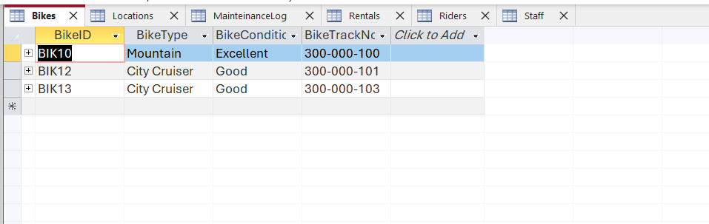
Figure 2: Bikes Table
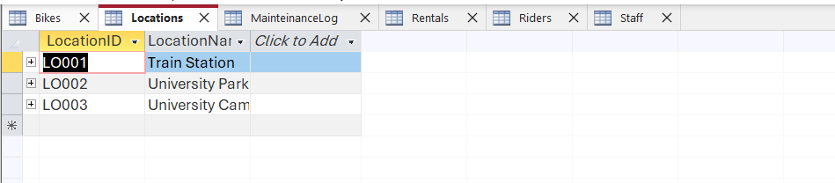
Figure 3: Locations Table
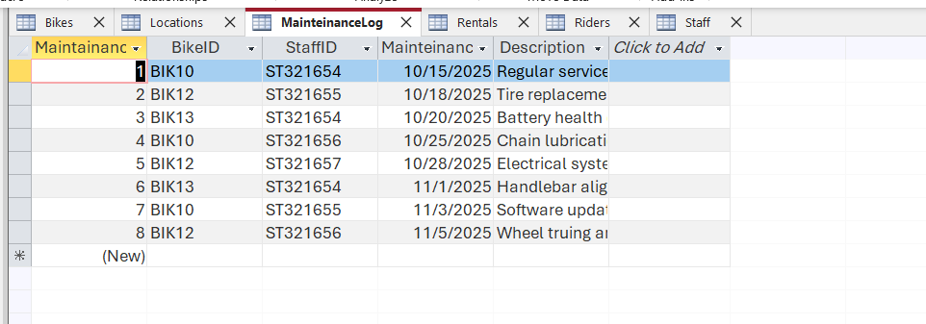
Figure 4: Maintenance Log Table
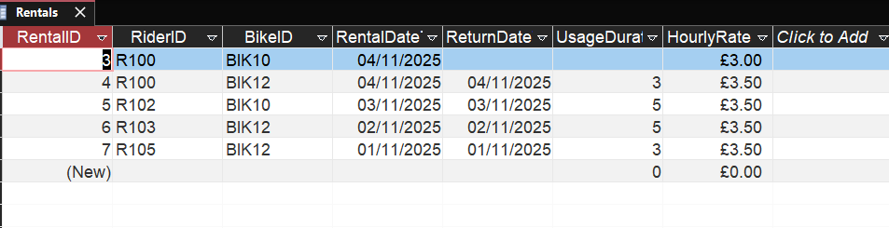
Figure 5: Rentals Table
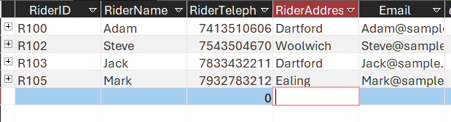
Figure 6: Riders Table
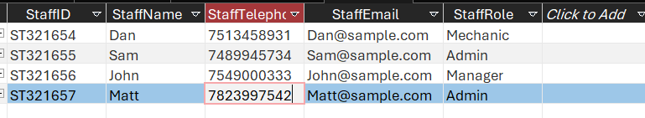
Figure 7: Staff Table

Relationships between tables
The tables are rationally connected by key attributes called primary keys and foreign keys. A key is a distinct identifier of each row in a table, such as RiderID in the Riders table. The field in one table that distinguishes a record in a separate table is referred to as a foreign key. An example is the RiderID, which is the primary key in the Riders table. The RiderID is a foreign key in the Rentals table (Blaha, 2005). This arrangement will generate a strong and trusted relationship between a rider and his or her rentals. Through MS Access, the enforced referential integrity was enabled on all relationships. This is an important feature that ensures data integrity throughout the database. It will not allow any user to erase a rider with an existing record of rental. It also prevents one from building a rental of a bike that is not present in the system.
Figure 8: Relationship Diagram

Testing and Validation
The final database system was put through extensive testing against the initial requirements. This was aimed at ensuring the system satisfies all the functional requirements of the EcoRide team. One of the requirements was checked systematically. A summary of this testing process and its ultimate results is given in the table below. This is tested to guarantee that the database is dependable and worth the purpose it is intended for.
Test Case | Expected Result | Actual Result | Any Discrepancies
Register Riders | The system should store rider details like name, contact, and ID number. | Riders' tables successfully store all required rider information without any errors. | No discrepancies were found during testing.
Maintain Bike Records | The system must track all bike details, including type, condition, and location. | Bikes and Bike Location tables work together to maintain complete and accurate bike records. | All bike data is stored correctly and can be easily retrieved.
Record Rental Transactions | The system should log every rental with start/end dates, duration, and cost. | The rentals table records all transaction details accurately and calculates costs correctly. | The system performs all required rental logging functions perfectly.
Data Integrity Check | The system must prevent invalid data entry through relational integrity. | Relationships successfully enforce referential integrity, blocking invalid data (Barida and Giok, 2012). | The system correctly produces error messages for invalid entries.
Table 1: Testing and Validation Table

Normalization Process
Normalisation is a formal procedure of organising information in a database. The primary objectives include the minimisation of data redundancy and the efficiency of data integrity. The Eco Ride database design was carried out according to the Third Normal Form or 3NF. A 3NF database implies that all non-key attributes are not only entirely dependent on the primary key (Kumar and Azad, 2017). This was done by analysing the original table structures in the spreadsheet with a lot of care. Several repetitions of data were determined and done away with at this point. The staff contact information repeating issue was solved, as an example. This was done through the establishment of a special Staff table in which every staff member is seen once. The database also makes sure that the location of the bike is saved in a separate dedicated table. Such a normalised database is more efficient, reliable and can be maintained more easily in the long run (Eessaar, 2016). It avoids the anomaly of updates in which one must make a change in more than one location.
Rider_Details table

Rider_ID | Rider_Name | Rider_Tele | Rider_Address | E-Mail
R100 | Adam | 7413510606 | Dartford | Adam@sample.com
R102 | Steve | 7543504670 | Woolwich | Steve@sample.com
R103 | Jack | 7833432211 | Dartford | Jack@sample.com
Mark | Sami | 7932783212 | Ealing | Mark@sample.com
Table 2: Rider_Details table
Staff Table
Staff_ID | Staff_Name | Staff_Tele | Staff_Mail | Staff_Task
ST321654 | Dan | 7513458931 | Dan@sample.com | Mechanic
ST321654 | Dan | 7513458931 | Dan@sample.com | Mechanic
ST321655 | Sam | 7489945734 | Sam@sample.com | Admin
ST321656 | John | 7549000333 | John@sample.com | Manager
ST321657 | Matt | 7823997542 | Matt@sample.com | Admin
Table 3: Staff Table
Rental_Details Table
Rider_ID | Date | Bike_ID | rental time | Return time | usage duration | hourly rate | Bike_Cost
R100 | 11/4/2025 | BIK10 | 8.00 | 14.00 | 6.00 | £3.50 | usage duration
R100 | 11/4/2025 | BIK12 | 15.00 | 18.00 | 3.00 | £3.50 | £6.00
R102 | 11/3/2025 | BIK10 | 7.00 | 12.00 | 5.00 | £3.50 | £3.00
R103 | 11/2/2025 | BIK12 | 10.00 | 15.00 | 5.00 | £3.50 | £5.00
R105 | 11/1/2025 | BIK13 | 9.30 | 12.30 | 3.00 | £3.50 | £5.00
Table 4: Rental_Details Table
Tracking table
Staff_ID | Bike_ID | Location_ID | Bike_Track_No | Bike_Location
ST321654 | BIK10 | LO002 | 300-000-100 | University Park
ST321654 | BIK12 | LO003 | 300-000-101 | Uni campus
ST321655 | BIK10 | LO001 | 300-000-101 | Train Station
ST321656 | BIK12 | LO002 | 300-000-102 | University Park
ST321657 | BIK13 | LO002 | 300-000-103 | University Park
Table 5: Tracking table
Bike_Details_Table
Bike_ID | Bike_Type | Bike_Condition
BIK10 | Mountain | Excellent
BIK12 | City cruiser | Good
BIK10 | Mountain | Excellent
BIK12 | City cruiser | Good
BIK13 | City cruiser | Good
Table 6: Bike_Details_Table

MS- Access

Forms Creation
MS Access forms offer easy and convenient ways of data entry. They also protect the users against the complexity of underlying table structures. In the case of the EcoRide system, a Rental Entry Form was designed. This form also enables the staff to add new records of rentals at a quick pace by choosing a rider and a bike. A Maintenance Log Form was also constructed so that the staff could use it to document services and inspections of the bikes. The forms render the system user-friendly and require little database training (Mitri, 2015). They also assist in minimising the errors of data entry by taking the user through the process. The forms make sure that all the necessary fields are duly filled. Below this are screenshots of these operational forms.
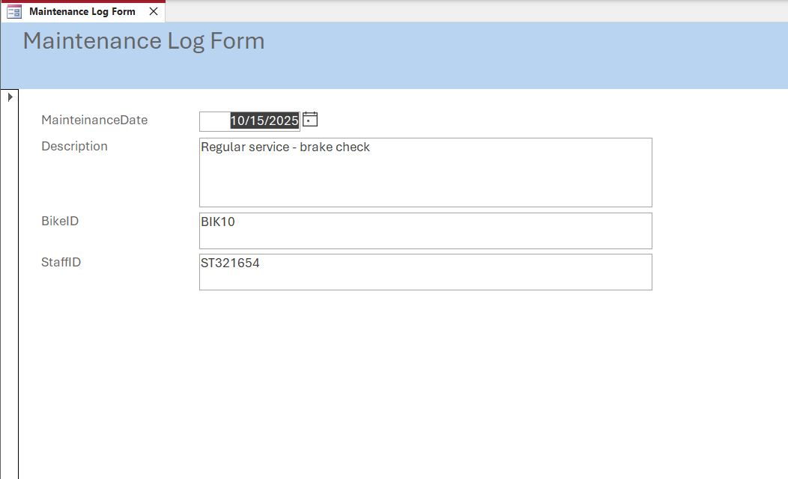
Figure 9: Maintenance Log Form
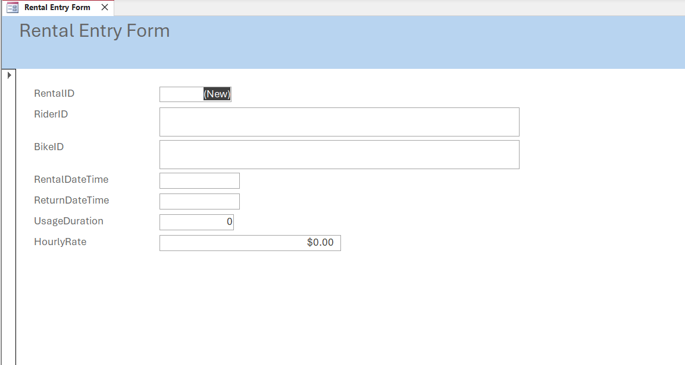
Figure 10: Renal Entry Form

Queries Creation
Queries are also effective to access, filter and analyse stored information. They respond to business questions that are specified by combining data in various tables. There were four general questions that were created to illustrate the powers of the EcoRide system. The initial query, Bikes Currently Available, gives all the bikes not under any rental. The second query, Active Rentals, displays all the bikes which are out with riders. The third query, Rental Revenue, will determine the total amount of the cost per completed rental transaction. The last query, Most Used Bikes, arranges the bikes according to their frequency of rental and the number of hours used. All queries were created and tested on the MS Access Query Design view (Taipalus, 2020). The design view, SQL view, and resulting datasheet for each query are shown as screenshots below.

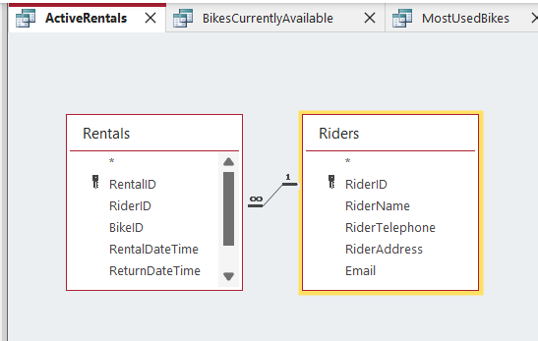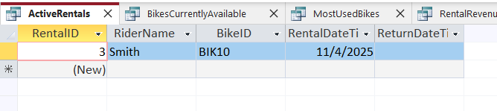
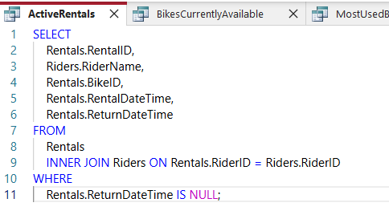
Figure 11: Active Rentals Design, Datasheet and SQL view
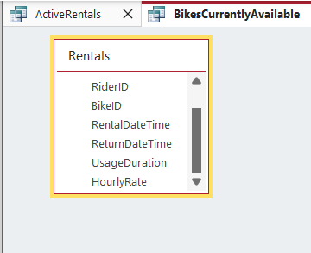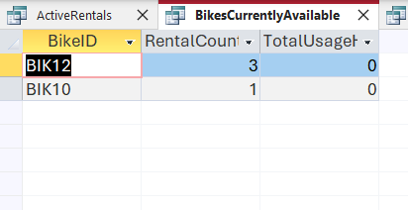
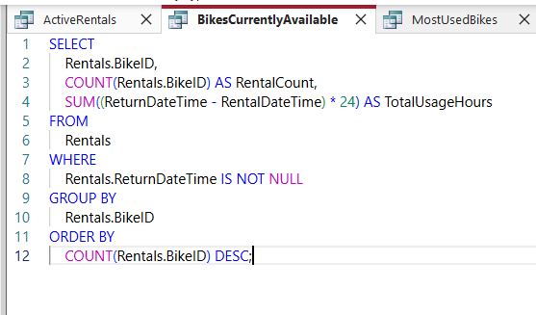
Figure 12: Available Bikes Design, Datasheet and SQL view
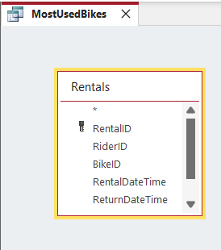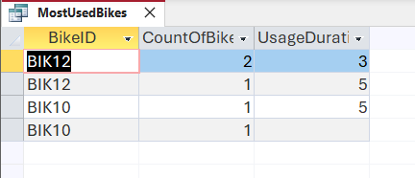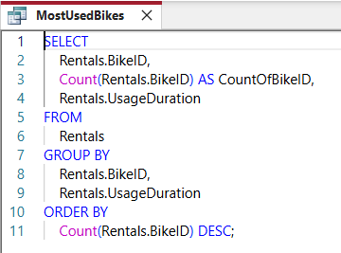
Figure 13: Most Used Bikes Design, Datasheet and SQL view
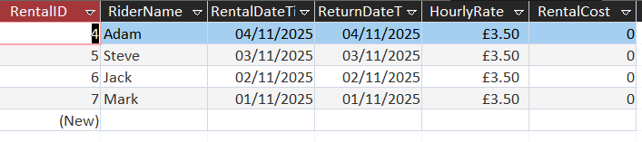
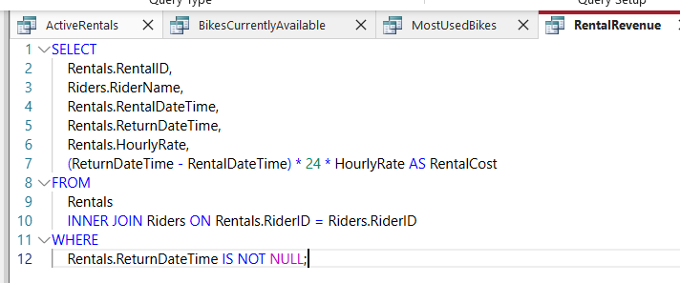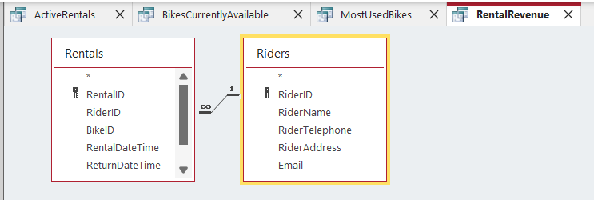
Figure 14: Rental Revenue Design, Datasheet and SQL view

Report Creation (create reports from each query and annotate them)
Data can be presented in a professional and smooth format in MS Access reports. These are intended to be printed or digitally distributed to help in decision-making. In the case of EcoRide, a query-based Available Bikes Report was produced as a direct result of the initial query. Such a report gives a very clear list of bikes that are available to be rented at any given time to managers. It was also shown as a Maintenance Summary Report created from the data in the MaintenanceLog table. The report assists in management planning for further servicing schedules, and the resources are allocated effectively. These reports will turn raw data into business intelligence that can be used to action by EcoRide (Oliveira et al., 2016). They provide an easy-to-understand summary of operations which could not have been done with the previous spreadsheet system. The new database solution has the advantage of being able to create such reports.
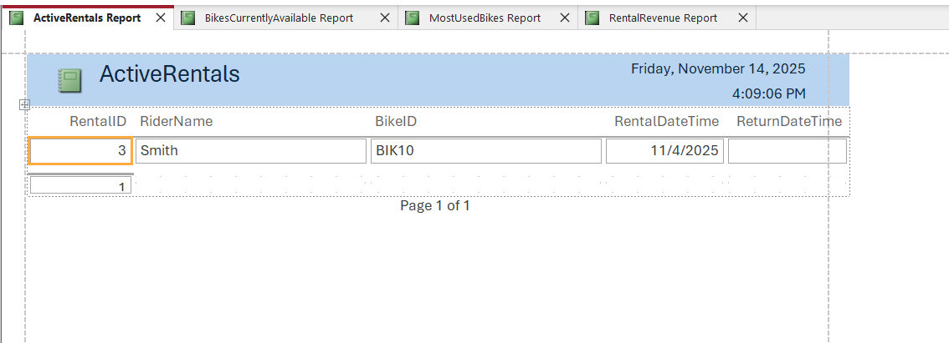
Figure 15: Active Rentals Report
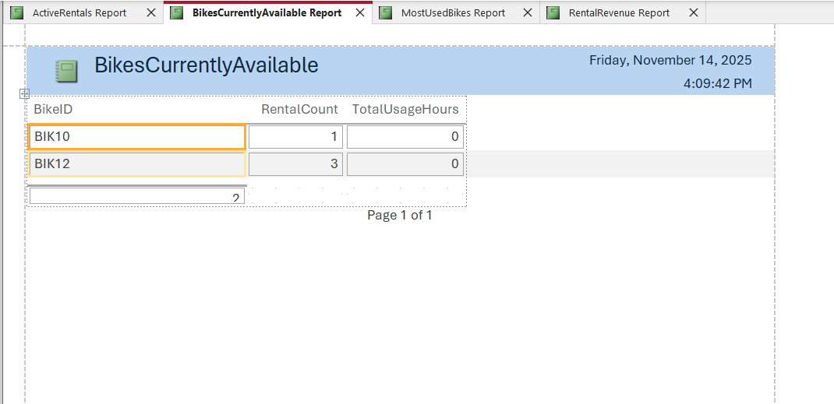
Figure 16: Bikes Currently Available Report
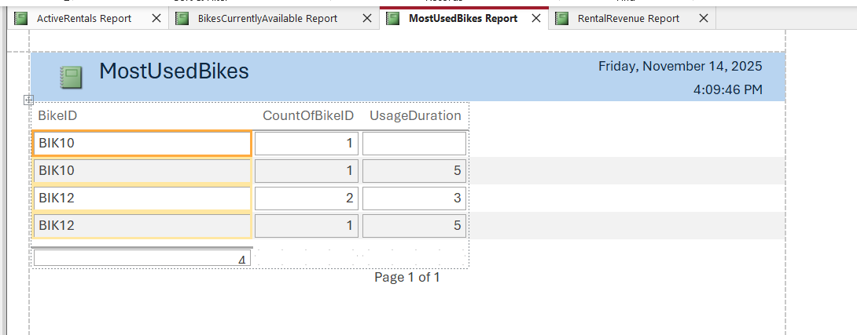
Figure 17: Most Used Bikes report
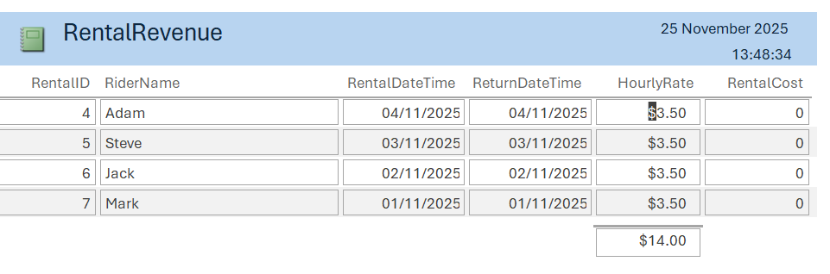
Figure 18: Rental Revenue Report

Calculations (show how you implement the calculation ( if any) and take screenshots)
The database also involves automatic calculations to give useful business information. One such characteristic is that the rental price is not hand-written in the database. It is rather computed dynamically each time it is required, e.g. in a query or report. The formula of calculation determines the difference between the return and rental time in hours. It then takes the duration and multiplies it by the hourly rate of the bike to determine the total cost (Cao, 2025). This approach will guarantee that the cost remains static and informed by the most recent information. Calculated values may be stored, and thus inconsistencies occur when the data used in the calculation is altered. The on-demand calculation of calculation removes this possible error. The query used to calculate this is provided as a screenshot in the appendix. This is a practical implementation of database computing power.
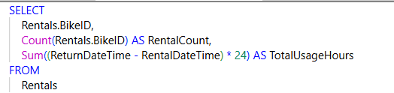
Figure 19: Calculation for Charges per hourly rate

Dashboard Creation (show how to navigate from dashboard to forms and forms to dashboard)
The EcoRide Management Dashboard is the key point of the whole system. Users browse; they merely need to click the horizontal tabs, which are labelled as Data Entry, Reports and Queries. As an example, when the Data Entry tab is clicked, there are buttons with the Rental Entry Form and Maintenance Log Form. One of the buttons that opens that particular form when a user wants to type in new rental transactions is followed by clicking the button named Rental Entry Form.
It is easy to go back to the dashboard when any type of report is accessed. Users only have to close the open form or report window by clicking the 'X' on the upper-right-hand side. This movement itself shows the central dashboard in the background since it is open. This is a seamless two-way navigation linked to the dashboard and the tools and vice versa, which guarantees a smooth and continuous working process. It removes confusion and enables the staff to handle all activities effectively, starting with a single point, and this makes the system easy to operate without the need to have any specific database training.
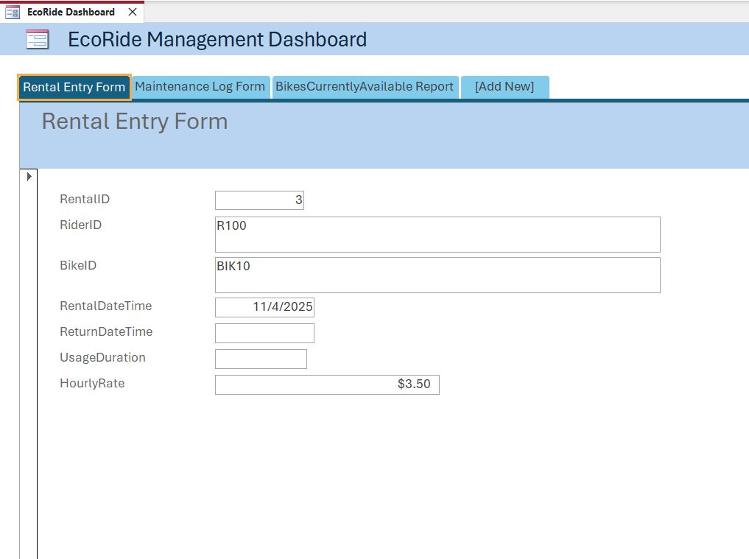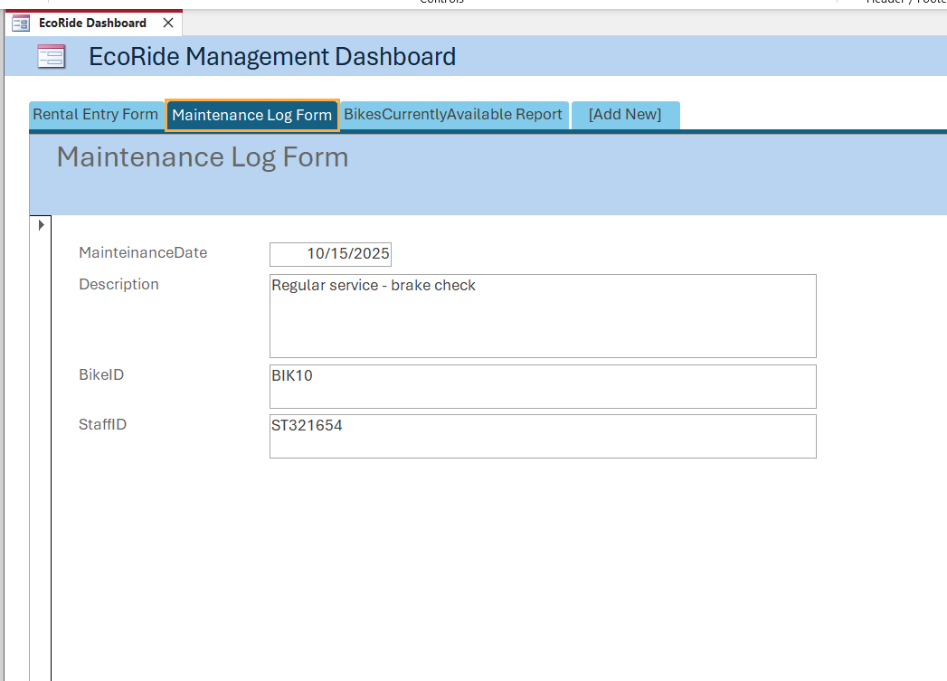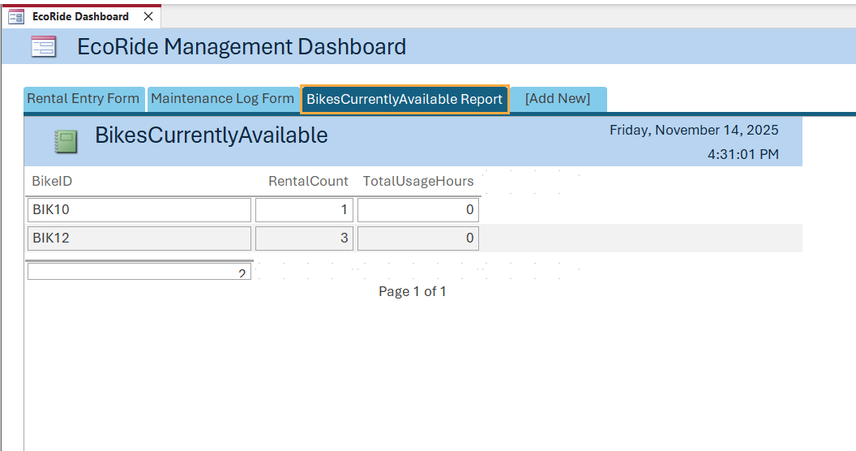
Figure 20: Dashboard View

Conclusion
To sum up, this project was able to design and implement a relational database for EcoRide. The new system is effective in addressing the problem of manual record-keeping that posed operational problems in its system. It simplifies the maintenance, control of the riders, bikes, rentals, and rentals via a normalised database. The development of convenient forms and useful queries, as well as informative reports, prove the viability of the solution. This database will give EcoRide the correct real-time information, which can be used in making decisions as well as managing services efficiently. The project meets all the functional requirements, which is a strong platform to facilitate the growth of the scheme and its mission of sustainable transport.

References
Date, C.J., 2019. Database design and relational theory: normal forms and all that jazz. Apress.
Thalheim, B., 2013. Entity-relationship modeling: foundations of database technology. Springer Science & Business Media.
Blaha, M., 2005. Referential integrity is important for databases. Modelsoft Consulting Corp.
Kumar, K. and Azad, S.K., 2017, October. Database normalization design pattern. In 2017 4th IEEE Uttar Pradesh Section International Conference on Electrical, Computer and Electronics (UPCON) (pp. 318-322). IEEE.
Mitri, M., 2015. Active learning via a sample database: the case of Microsoft's Adventure Works. Journal of Information Systems Education, 26(3), pp.177-186.
Cao, J., 2025. Enhance Database Query Performance through Software Optimization and Hardware Adaptation.
Carvalho, G., Mykolyshyn, S., Cabral, B., Bernardino, J. and Pereira, V., 2021. Comparative analysis of data modelling design tools. IEEE Access, 10, pp.3351-3365.
Yeung, A.K. and Hall, G.B., 2007. Spatial database systems: Design, implementation and project management (Vol. 87). Springer Science & Business Media.
Taipalus, T., 2020. The effects of database complexity on SQL query formulation. Journal of Systems and Software, 165, p.110576.
Barida, B.A.A.H. and Giok, K.L., 2012. Data Validation System For A Relational Database. International Journal of Advanced Research in Computer Science, 3(5).
Oliveira, G.N., Sotomayor, J.L., Torchelsen, R.P., Silva, C.T. and Comba, J.L., 2016. Visual analysis of bike-sharing systems. Computers & Graphics, 60, pp.119-129.
Eessaar, E., 2016. The Database Normalization Theory and the Theory of Normalized Systems: Finding a Common Ground. Baltic Journal of Modern Computing, 4(1).
Genero, M., Jiménez, L. and Piattini, M., 2000, October. Measuring the quality of entity relationship diagrams. In International Conference on Conceptual Modelling (pp. 513-526). Berlin, Heidelberg: Springer Berlin Heidelberg.
Aqlan, F., Nwokeji, J.C. and Shamsan, A., 2020, October. Teaching an introductory data analytics course using microsoft access® and excel®. In 2020 IEEE Frontiers in Education Conference (FIE) (pp. 1-10). IEEE.

