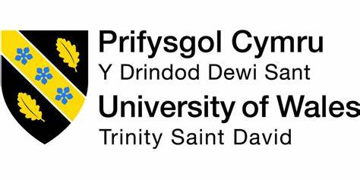

STRATEGIC ANALYSIS OF MARKS AND SPENCER

NAME: BADAGOWNI SRAVANA LAKSHMI
STUDENT NUMBER: 2116474
LECTURER: GLADIUS KOLOTHUNGAN
WORD COUNT:7767
SUBMISSION DATE: 08-MAY-2023

Table of Contents
Introduction 2
Mark and Spencer's Background 2
Mark and Spencer’s Mission and Objectives 3
Macro-Environment Analysis 4
PESTEL Analysis 7
Micro-Environment Analysis 8
Industry Life Cycle 10
Porter’s Industry Five Forces Analysis 11
Internal Analysis 12
Mark and Spencer’s Strategic Resources and Capabilities 12
Value Chain Analysis 13
Primary Activities 14
Secondary Activities 15
VRIO Analysis of Distinctive Resources and Capabilities 16
SWOT Analysis 17
Strategies to Sustain Competitive Advantage 19
Growth Strategies 20
Green Strategy and CSR 20
Conclusion 21
Recommendation 22
References 23

Introduction
For numerous years, Marks and Spencer (M&S), a large UK-based retailer, has been at the forefront of retail sustainability efforts. M&S has set lofty goals for becoming a corporate sustainability leader with its "Plan A" initiative and following sustainability policies. Among other things, the company's green strategy focuses on lowering carbon emissions, promoting sustainable agriculture, and employing sustainable products. Furthermore, M&S's CSR policy prioritises ethical labour practises and human rights. These sustainability efforts and commitments have helped to position M&S as a corporate sustainability leader, and the firm is working towards a more sustainable future through its "Plan A 2025" strategy. Through its sustainability programmes, Marks and Spencer (M&S) has made tremendous progress towards tackling social and environmental issues in the retail sector. The business has taken a number of steps to lessen its carbon footprint, including using renewable energy sources, energy-efficient equipment, and reducing trash. By purchasing food from growers who employ responsible practises, M&S has also made it a priority to support responsible agricultural practises. The business is also dedicated to supporting moral workplace policies and human rights.

Mark and Spencer's Background
Marks and Spencer, generally called M&S, is a primary British multinational store that became based in 1884. The company started out as a small marketplace stall in Leeds, England, and has grown right into a famend logo this is diagnosed worldwide. M&S has stores in over 50 countries worldwide, along with places for the duration of Europe, Asia, and the Middle East. As of 2021, Marks and Spencer employees about 78,000 humans throughout the globe, making it one in every of the biggest employers withinside the retail industry. These personnel paintings in a number of roles, from sales assistants and designers to senior executives and managers. Despite the demanding situations provided through the COVID-19 pandemic, Marks and Spencer has maintained a sturdy monetary position. The company pronounced a sale of £9.2 billion withinside the 2020 monetary year, with running income of £403 million. M&S has additionally made considerable investments in on-line retail and virtual technology, assisting to shield its destiny success. In phrases of running markets, M&S has hooked up a sturdy foothold in numerous key areas across the global. The business enterprise's UK department operates extra than 950 shops throughout the country, such as supermarkets, branch shops, and standalone meals outlets. Marks and Spencer additionally have a large presence in Europe, with shops in international locations consisting of France, Germany, and Poland. In current years, M&S has sought to make bigger its operations in different components of the international, inclusive of Asia and the Middle East. For example, the business company has opened shops in countries which includes India, China, and the United Arab Emirates, wherein it has set up partnerships with local retailers and distributors. Overall, Marks and Spencer's lengthy history, robust financial position, and significant international attain make it one of the maximum recognizable and worthwhile retail brands withinside the international today.

Mark and Spencer’s Mission and Objectives
Marks and Spencer, a first-rate British retailer, has been a well-reputable brand for over a century. Despite massive modifications withinside the aggressive landscape, the agency has remained dedicated to its middle values and has stayed real to its mission and objectives.
The company's mission statement is "Making Every Moment Special for our Customers, Colleagues and Communities." This project is targeted on handing over amazing purchaser service, fostering advantageous works surroundings for employees, and contributing definitely to nearby groups.
Marks and Spencer have set numerous goals that align with this mission. One main goal is to make certain that each one of its products meet best and moral standards. This consists of the use of sustainable materials, minimizing waste, and helping truthful hard work practices. Another goal is to offer clients with a continuing buying revel in throughout all channels, whether or not it is online or in-store.
The company has additionally set a goal to lessen its environmental impact. This consists of decreasing greenhouse gas missions, water usage, and waste. In addition, Marks and Spencer has dedicated to sourcing 100% of its cotton from sustainable reasserts via way of means of 2025.
Marks and Spencer is likewise dedicated to fostering a advantageous paintings surroundings for its employees. The business enterprise has set goals to offer possibilities for profession development, assist range and inclusion, and sell worker well-being.
Lastly, the employer has an goal to offer again to local through charitable donations and volunteer work. Marks and Spencer is actively concerned in supporting community program that target health and education.
In summary, Marks and Spencer's challenge and goals are targeted on turning in fantastic customer service, keeping excessive moral and excellent standards, assisting worker development, decreasing environmental impact, and giving lower back to nearby groups. By staying actual to those goals, the company has remained a reputable and depended on brand for over a century.

Macro-Environment Analysis
The evaluation of the larger external elements that may impact the success of an organisation and strategy is referred to as macro-environment analysis. M&S's sustainability efforts are influenced by a number of macro-environmental factors that affect the retail sector as a whole (Anastasiu, Gavriş and Maier, 2020). Consumers' rising understanding and concern about environmental and social problems is one such cause. Customers are increasingly asking that businesses lessen their environmental effect and promote social responsibility. M&S's environmental programmes, such as those aimed at lowering carbon emissions and encouraging environmentally friendly farming, are in reaction to these demands from customers.

The growing legislation and government regulations surrounding sustainability are another macro-environmental issue that has an impact on M&S's environmental efforts. For instance, the UK administration has established goals for lowering carbon emissions, and M&S's pledge to achieve net-zero carbon emissions by 2040 is consistent with these goals. Similar to this, M&S's dedication to paying a liveable wage is in reaction to laws and rules governing ethical labour practises (Baxter, 2019). Another macroenvironmental element that influences M&S's sustainability efforts is the global supply chain. M&S purchases goods from all over the world, so ensuring that they are made ethically and sustainably can be difficult. To address these issues, the corporation has partnered with groups like the Ethical Trading Initiative.
Last but not least, advancements in technology as a macro-environmental factor could affect M&S's sustainability initiatives (Benzaghta et al., 2021). The corporation has incorporated eco-friendly materials and energy-efficient innovations to its products in an effort to reduce its carbon impact. The contribution of technology to sustainability activities will undoubtedly continue to grow, with implications for M&S's long-term sustainability plan.

Another important macro-environmental aspect that can have an impact on M&S's sustainability initiatives is government rules and legislation. For instance, the UK government has established targets for lowering carbon emissions, and businesses who don't fulfil these standards risk fines. In response to these requirements, M&S has established challenging goals to achieve net-zero carbon emissions by 2040. Similarly, M&S's approach to product procurement and ensuring ethical labour practises throughout its supply chain may be affected by government legislation regarding fair labour practises. Another macroenvironmental issue that has an impact on M&S's sustainability initiatives is the global supply chain (Cox, 2020). M&S sources items from all over the world as a big store, and ensuring that these products are manufactured in a sustainable and ethical manner can be a considerable problem. To ensure that its suppliers follow ethical labour standards and strive towards sustainable production practises, the company has joined with organisations such as the Ethical Trading Initiative. Finally, technology advances may have an impact on M&S's sustainability efforts. The company has used energy-efficient technologies and sustainable materials in its products (Europe PMC, 2019). However, the use of technology in sustainability projects is continuously changing, and M&S will need to adapt its methods to stay up with shifting trends and technological advancements.
Macro-environment analysis is a crucial tool for businesses like M&S since it aids in the identification of external factors that may have an impact on sustainability initiatives. Understanding these elements will help M&S create strategies that effectively reduce risks, seize opportunities to advance sustainability, and maintain their position as a leader in corporate sustainability.
The evaluation of the larger external elements that may impact the success of an organisation and strategy is referred to as macro-environment analysis. M&S's sustainability efforts are influenced by a number of macro-environmental factors that affect the retail sector as a whole (Anastasiu, Gavriş and Maier, 2020). Consumers' rising understanding and concern about environmental and social problems is one such cause. Customers are increasingly asking that businesses lessen their environmental effect and promote social responsibility. M&S's environmental programmes, such as those aimed at lowering carbon emissions and encouraging environmentally friendly farming, are in reaction to these demands from customers.

The growing legislation and government regulations surrounding sustainability are another macro-environmental issue that has an impact on M&S's environmental efforts. For instance, the UK administration has established goals for lowering carbon emissions, and M&S's pledge to achieve net-zero carbon emissions by 2040 is consistent with these goals. Similar to this, M&S's dedication to paying a liveable wage is in reaction to laws and rules governing ethical labour practises (Baxter, 2019). Another macroenvironmental element that influences M&S's sustainability efforts is the global supply chain. M&S purchases goods from all over the world, so ensuring that they are made ethically and sustainably can be difficult. To address these issues, the corporation has partnered with groups like the Ethical Trading Initiative.
Last but not least, advancements in technology as a macro-environmental factor could affect M&S's sustainability initiatives (Benzaghta et al., 2021). The corporation has incorporated eco-friendly materials and energy-efficient innovations to its products in an effort to reduce its carbon impact. The contribution of technology to sustainability activities will undoubtedly continue to grow, with implications for M&S's long-term sustainability plan.

Another important macro-environmental aspect that can have an impact on M&S's sustainability initiatives is government rules and legislation. For instance, the UK government has established targets for lowering carbon emissions, and businesses who don't fulfil these standards risk fines. In response to these requirements, M&S has established challenging goals to achieve net-zero carbon emissions by 2040. Similarly, M&S's approach to product procurement and ensuring ethical labour practises throughout its supply chain may be affected by government legislation regarding fair labour practises. Another macroenvironmental issue that has an impact on M&S's sustainability initiatives is the global supply chain (Cox, 2020). M&S sources items from all over the world as a big store, and ensuring that these products are manufactured in a sustainable and ethical manner can be a considerable problem. To ensure that its suppliers follow ethical labour standards and strive towards sustainable production practises, the company has joined with organisations such as the Ethical Trading Initiative. Finally, technology advances may have an impact on M&S's sustainability efforts. The company has used energy-efficient technologies and sustainable materials in its products (Europe PMC, 2019). However, the use of technology in sustainability projects is continuously changing, and M&S will need to adapt its methods to stay up with shifting trends and technological advancements.
Macro-environment analysis is a crucial tool for businesses like M&S since it aids in the identification of external factors that may have an impact on sustainability initiatives. Understanding these elements will help M&S create strategies that effectively reduce risks, seize opportunities to advance sustainability, and maintain their position as a leader in corporate sustainability.

PESTEL Analysis
PESTEL analysis is a framework for investigating the external elements that influence an organization's performance and strategy (Fan et al., 2020). The subsequent PESTEL variables are relevant in the context of M&S's sustainability efforts:
Political: Government regulations and laws governing sustainability can have an impact on M&S's efforts (Hajizadeh, 2019). For example, the UK government has established carbon-reduction targets, which has influenced M&S's aim to becoming carbon-neutral by 2040.In the United Kingdom, for example, as a component of the nation's dedication to combating climate change, the governing body has set objectives to cut the release of carbon dioxide.
These policies have influenced M&S's commitment to becoming net-zero carbon by 2040, which aligns with the government's targets (Hajizadeh, 2019). Moreover, the government has also introduced legislation and regulations to promote fair labour practices, which have influenced M&S's approach to sourcing products and ensuring ethical labour practices throughout its supply chain.
Economic: Consumer spending, inflation, and other economic variables may have an impact on M&S's sustainability efforts. Consumers may, for instance, prioritise price above sustainability during a recession, which could affect M&S's sales of sustainable goods. The price of environmentally friendly products and technologies is one economic issue that influences M&S's commitment to sustainability (Hajizadeh, 2019). Utilising sustainable resources and technologies may be more expensive than using conventional ones, which may have an effect on the business's financial performance and profitability. Despite these greater expenses, M&S has committed to sustainable sourcing and investing in energy-efficient technologies, proving its long-term dedication to sustainability.
Sociocultural: Consumers' increasing awareness of and concern for environmental and social issues are sociocultural elements that may have an impact on M&S's sustainability initiatives. In response to this trend, the corporation has started working on sustainability projects like cutting carbon emissions and encouraging sustainable agriculture (Fan et al., 2020). The growing consumer awareness of and concern for environmental and social issues is one sociocultural factor that drives M&S's sustainability efforts. Clients are encouraging corporations to take steps to lessen their environmental effect and encourage social responsibility because they grow more conscious of the influence their purchases have on society and the environment (Fan et al., 2020). M&S has adopted a number of ecologically responsible initiatives to suit the demand, like decreasing carbon dioxide emissions and supporting organic agriculture.
Technological: Through the provision of new chances for sustainable innovation, advances in technology can have an impact on M&S's efforts to promote sustainability. The business, for instance, incorporates sustainable materials and energy-efficient technologies in its merchandise. Utilizing energy-efficient technologies is one technological issue that affects M&S's efforts to be sustainable (Henry, 2022). To minimise its carbon impact, M&S has introduced a number of green technologies into its operations and retail sites. For example, the business has made investments in renewable energy sources, smart energy management systems, and LED lighting to minimise its energy usage and greenhouse gas emissions.
Another technological component influencing M&S's sustainability initiatives is the use of environmentally friendly materials in its goods (Henry, 2022). M&S has been researching novel materials and technology, such as recycled polyester and organic cotton, to build sustainable apparel lines. In addition, to reduce waste and encourage circularity, the company has produced sustainable packaging materials.
Environmental: Environmental factors such as climate change and resource scarcity can impact M&S's sustainability efforts (Henry, 2022). The company has responded by setting ambitious targets to become net-zero carbon by 2040 and by promoting sustainable agriculture.
Legal: Legal factors such as government regulations around fair labour practices and human rights can impact M&S's approach to sourcing products and ensuring ethical labour practices throughout its supply chain.
Overall, PESTEL analysis provides insight into the external factors that impact M&S's sustainability efforts and can help the company identify opportunities and challenges as it works towards a more sustainable future.

Micro-Environment Analysis
Mark and Spencer's is a leading British multinational retailer with offices in the UK, Europe and Asia. Identifying the key factors that affect your business is important for any company. This is where microenvironment analysis comes into play. Your microenvironment is made up of factors that are closely related to your business and that directly affect your day-to-day operations.
A key aspect of the Mark & Spencer microenvironment is the customer. Mark and Spencer's operates in a highly competitive retail industry and must serve a wide range of customers with diverse needs and preferences. A company must constantly adapt to changing trends and customer demands in order to remain relevant and competitive in the market.
Another important factor is the company's suppliers. Mark and Spencer's sources its products from a variety of suppliers around the world. Supply chain disruptions can negatively impact operations. Therefore, it is imperative for companies to maintain good relationships with their suppliers and ensure timely and efficient procurement of their products.
In addition, the company's marketing strategy plays an important role in shaping its image and reputation in the market. Mark and Spencer need to keep up with the latest marketing trends and use various communication channels to reach his target audience. This includes maintaining a social media presence, investing in advertising and promotions, and monitoring customer feedback and reviews.
Overall, the Mark and Spencer microenvironment is complex and dynamic, requiring companies to be vigilant and responsive to a variety of factors that affect their operations. By continually evaluating and adjusting these factors, the company can maintain its competitive edge in the market.

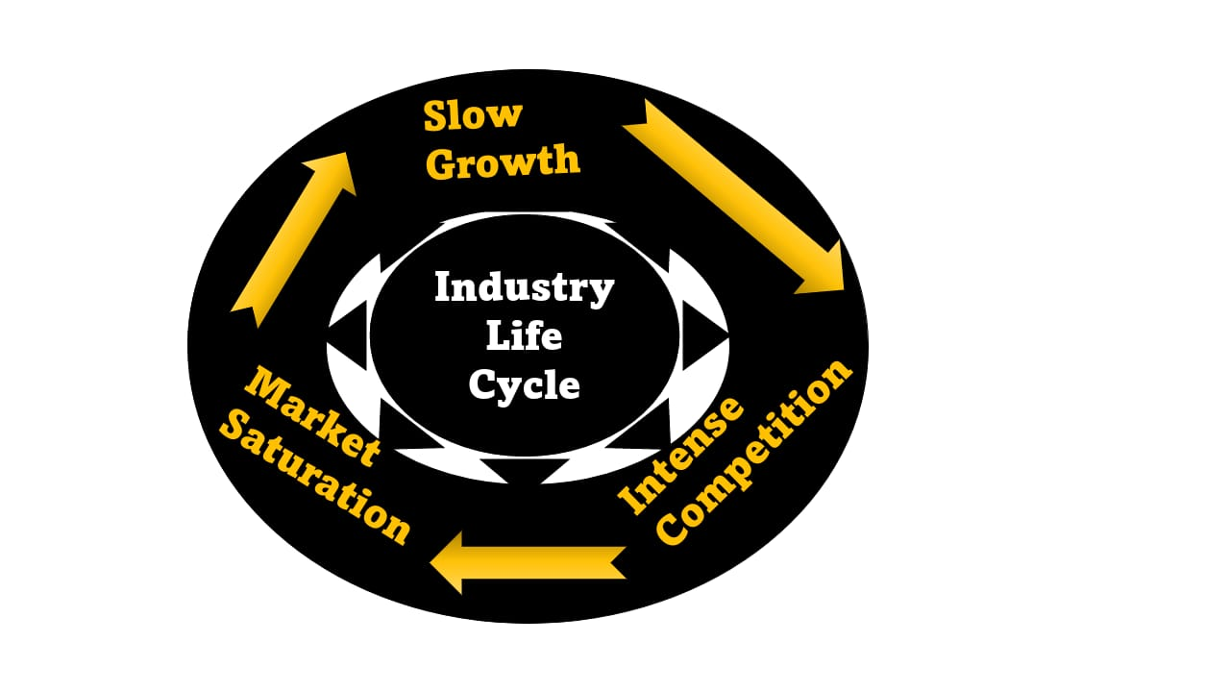

Industry Life Cycle
Marks and Spencer (M&S) is a British multinational retailer founded in 1884, specializing in clothing, household goods and food. In general, the life cycle of the retail industry can be divided into he four main stages of adoption, growth, maturity and decline.
In the introduction phase, new retailers are entering the market and competition is low. In the UK, M&S was one of the first retailers to enter the market and has established himself as a highly respected leading retailer well beyond the UK.
During the growth period, demand for retail products increases as disposable income increases and competition increases. M&S experienced significant growth during this period, opening stores in countries such as France and Canada and expanding its operations beyond the UK.
Maturity is characterized by slow growth, intense competition, and market saturation. At this stage, M&S faced challenges from new competitors, especially fast fashion brands, and struggled to keep up with changing consumer trends, negatively impacting sales and profits.
In a downturn, retailers face declining sales and profits as they struggle to compete with newer or more innovative retailers. M&S has seen store closures and restructuring efforts underway in recent years, with sales and profits declining, suggesting the company is in a state of decline.

Porter’s Industry Five Forces Analysis
Threat of new entrants: Because the retail industry is capital intensive and requires considerable expenditures in infrastructure and supply chain management, the threat of new competitors is relatively minimal. However, rising demand for sustainable products may provide doors for new entrants specialising in sustainability (Hudrasyah et al., 2019). The prospect of new competitors entering the market and upsetting the competitive landscape is referred to as the threat of new entrants. Because of the capital-intensive structure of the retail industry, the threat of new entrants is relatively minimal in the context of M&S's sustainability efforts.
Establishing a retail firm necessitates large investments in infrastructure, supply chain management, and marketing, which can prevent new entrants. Furthermore, M&S's strong brand reputation and focus on sustainability may make it difficult for new entrants to gain a market foothold. However, rising demand for sustainable products may provide doors for new entrants specialising in sustainability (Hudrasyah et al., 2019). As a result, M&S must continue to invest in sustainability in order to maintain its market leadership.
Bargaining power of suppliers:M&S obtains its products from suppliers all over the world, and the company's commitment to sustainability necessitates close collaboration with its suppliers to guarantee they satisfy ethical and environmental standards. This provides bargaining power to suppliers, particularly those with specialised sustainability experience (Hudrasyah et al., 2019). Suppliers' bargaining power refers to their ability to influence the terms and conditions of their supply relationship with their purchasers. Supplier negotiating leverage is particularly high in the context of M&S's sustainability activities, as the company relies on suppliers to offer sustainable and ethically sourced resources and goods. As a result, to secure a regular supply of sustainable materials, M&S must maintain strong connections with its suppliers and negotiate favourable terms (Isabelle et al., 2020). Furthermore, the company's commitment to sustainable sourcing may limit its supplier options while strengthening the bargaining power of suppliers who specialise in sustainable and ethical procurement.
Bargaining power of buyers: The growing demand for environmentally friendly items offers consumers negotiating leverage in the retail industry (Isabelle et al., 2020). People are more inclined to prefer shops that provide sustainable products and ethical practises; therefore M&S must continue to invest in sustainable in order to keep its customer base.
Threat of substitutes: Substitutes pose a mild danger because consumers can buy from other businesses that offer similar sustainable products. M&S's strong brand reputation and focus on sustainability, on the other hand, may minimise this threat.
Rivalry among existing competitors: M&S has concurrence from other shops who offer sustainable products or practises in the retail market, which is extremely competitive (Isabelle et al., 2020). M&S, on the other hand, has a competitive edge due to its dedication to sustainability and experience in this field.

Internal Analysis
M&S is a recognised brand with a long history of ethical and sustainable business practices. The company’s commitment to sustainability has assisted it retain a favourable brand image and position itself as a corporate sustainability leader (Jonibek, 2021).
M&S has a well-developed supply chain management system that enables the company to monitor and control the sustainable and ethical activities of its suppliers. Partnerships with groups such as the Ethical Business Initiative have helped the corporation with supply chain management.
Limited product selection: M&S's emphasis on sustainable and ethical procurement may restrict the company's product offers and pricing possibilities, making it challenging to compete with other retailers who provide a wider selection of products.
High expenses: Their products are highly expensive so the mass peoples cannot afford their products.

Mark and Spencer’s Strategic Resources and Capabilities
Mark and Spencer's strategic resources and competencies are critical to the company's sustainability objectives and retaining its position as an international sustainability pioneer.
Strategic Assets:
Strong brand reputation: One of M&S's most important strategic assets is its brand reputation. The company has a long history of ethical and sustainable practises, and its dedication to the environment has helped it establish itself as a business sustainability leader (Jonibek, 2021).
Supply chain management efficiency: M&S's management of its supply chain technology is a key strategic resource. Relationships with organizations like the Social Trading Initiative, as well as the capacity to measure and monitor suppliers' sustainability and ethical practices, serve to boost the business's supply chain management (Jonibek, 2021).
M&S's financial resources enable it to invest in sustainability projects such as technologies that save energy, environmentally friendly supplies, and ethical work practises.
Strategic Capabilities:
M&S has a strategic competency called innovation that could support sustainability projects. M&S has a track record of invention (Pan, Chen and Zhan, 2019). For instance, the company has developed a closed-loop recycling system that gathers, classifies, and regenerates recycled clothing into fresh clothing.
Sustainable product development: M&S has produced a range of green products, including clothing made from sustainable resources and food items with reduced environmental impact (Silva and Castañeda-Ayarza, 2021). The ability of the company to produce sustainable products is a strategic capability that supports its sustainability goals.
Collaborations: In its alliances with other organisations, such as the Ethical Trading Initiative and other retailers, M&S has a strategic competency that supports its sustainability aims (Phadermrod, Crowder and Wills, 2019). The company can exchange information, materials, and sustainable business practises through these collaborations.

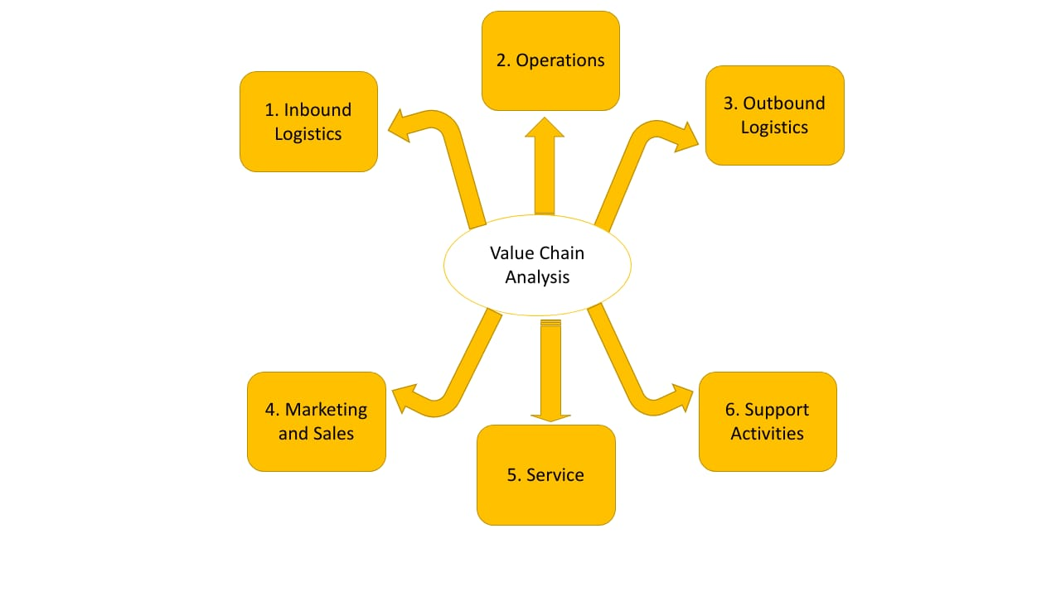

Value Chain Analysis
Mark and Spencer is a leading UK retailer known for its quality products and customer service. To maintain its competitive edge, the company has developed a well-defined value chain that covers all stages of its business. An analysis of the company's value chain reveals the following key activities: This allows the company to maintain product quality and shorten lead times.
Value chain Elements | Analysis
Inbound Logistics | Mark and Spencer have established strategic partnerships with suppliers to ensure the timely and quality delivery of raw materials for its products. This helps the company maintain product quality and reduce lead times.
Operations | The company invests in advanced technology to streamline operational processes. This includes automated warehouses for inventory management, advanced production processes, and superior quality control processes to ensure consistent quality.
Outbound Logistics | Mark & Spencer has developed an efficient distribution network for delivering products to stores and customers. This includes timely delivery of goods to stores and fast delivery of orders to customers.
Marketing and Sales | The company has built a strong brand image for him through effective marketing and advertising campaigns. The company’s marketing efforts have helped it attract a loyal customer base. This is essential for success.
Service | Marks and Spencer have a reputation for excellent customer service. Its employees are well-trained and the company implements a customer-centric policy to ensure customer satisfaction.
Support Activities | We have developed several key support functions including IT systems, human resources, finance and purchasing to support our key activities.
Overall, Mark and Spencer's value chain analysis shows that the company's success is based on a well-defined and efficient operating model. The company's ability to maintain product quality, deliver products efficiently, and provide excellent customer service has helped build a strong brand that is recognized around the world.

Primary Activities
Marks and Spencer (M&S) is a British retail giant with offices around the world. The company engages in several key activities that are critical to its success. His five main activities at M&S are Inbound Logistics, Operations, Outbound Logistics, Marketing & Sales, and Services.
M&S Inbound Logistics includes the process of procuring materials and products from suppliers. The company has a strong supply chain management system that ensures the right product is sourced at the right time and price. The company has a robust supplier management system that ensures a smooth and seamless supply of products from its suppliers. It also integrates new technologies into the supply chain, such as: B. Supply artificial intelligence to optimize and streamline the operation of his chain.
M&S Operations are critical to business success. M&S focuses on quality, sustainability and innovation in all its activities. The company has over 900 stores across the UK and an extensive network of over 430 international stores in around 60 countries. The company operates across a wide range of sectors including food, clothing, home furnishings and financial services. M&S has invested heavily in its business, introducing new concepts such as M&S Foodhall, M&S Simply Food and M&S Energy.
M&S Outbound Logistics includes the process of getting products to customers. The company implements innovative concepts such as 'Shop your way' and 'Click and Collect' to enhance customer convenience. It has also strengthened its delivery network through partnerships with external logistics providers such as Yodel and his DPD.
M&S's marketing and sales strategy is to build a loyal customer base by providing quality products, superior customer experience, and engaging customers through multiple channels such as social media, email marketing, advertising and promotional events. The focus is on building Finally, M&S services are an integral part of its main activity. We aim to provide the best customer experience through policies such as 'No Quibble Returns', 'Shop Your Way' and 'Colleagues First'. We provide comprehensive customer service across multiple touchpoints, including, social media, and more.
In summary, M&S's five main activities are interrelated and critical to the company's success. Over the years, M&S has adapted its business strategy to changing market trends and remained relevant to its customers.

Secondary Activities
As one of the UK's leading retailers, Marks and Spencer engages in a range of secondary activities that support and complement its primary retail operations. External jobs are business functions that are not directly related to the production or sale of goods or services, but are essential to support the operations of the company.
One of Marks and Spencer's main side jobs is logistics and supply chain management. The company manages a complex network of suppliers, distributors and delivery systems to ensure that products reach customers in a timely and efficient manner. To accomplish this, Marks and Spencer has developed advanced warehousing and distribution systems that enable it to manage inventory levels, reduce out- of-stocks, and streamline order processing. The company is also committed to environmental sustainability, working to reduce the carbon footprint of its supply chain by using renewable energy, optimizing transportation routes and reducing waste.
Another important side-line for Marks and Spencer is his IT and digital skills. The company has invested heavily in developing an omnichannel retail platform, allowing customers to shop seamlessly across digital and physical channels. Marks and Spencer's eCommerce his platform offers a range of features and benefits, including personalized product recommendations, fast and convenient payment options, and an easy-to-use interface. The company also uses advanced analytics and artificial intelligence to gain insight into customer behaviour and preferences, which it uses to improve its product offerings and marketing his campaigns.
Finally, Marks and Spencer focus on corporate social responsibility (CSR) and sustainability. The company is committed to reducing its environmental impact, promoting ethical work practices and supporting local communities. Marks and Spencer's CSR program includes initiatives such as reducing plastic waste, supporting fair trade, and promoting diversity and inclusion. The company also works with local suppliers and producers to source goods and services in a sustainable and socially responsible manner.
In summary, Marks and Spencer's secondary activities play an important role in supporting and enhancing its core retail business. By investing in logistics and supply chain management, IT and digital skills, CSR and sustainability, we can stay competitive in the ever-changing retail landscape while providing our customers with a seamless and sustainable shopping experience. increase.

VRIO Analysis of Distinctive Resources and Capabilities 300 Parayan
Mark & Spencer (M&S) is a leading international retailer with over 1,000 stores in 57 countries around the world. VRIO analysis consists of four main components including value, rarity, reproducibility, and organization. An analysis of M&S's diverse resources and capabilities follows.

Resources | VRIO analysis
Value | M&S’s brand equity is one of his most valuable assets, along with product quality, supply his chain management and customer service. Brand equity is valuable because it allows M&S to charge a premium for its products. A brand has been built over time and stands for quality and reliability. Supply chain management is also an important resource. This will allow M&S to better manage its distribution channels, thereby providing customers with quality products.
Rarity | M&S has some rare resources and abilities. The company has a very strong supplier network that provides unique access to quality products. We also have an established supply chain system that allows us to receive the products we sell in a timely manner. This resource is rare as building a supply chain can be time consuming and expensive. Additionally, M&S has a large share of the grocery retail market, which is unusual given the fierce competition in the industry.
Imitability | M&S’s brand equity, supplier network and established supply his chain is difficult to imitate. The company has been building these resources for a long time, but it is difficult for newcomers to replicate them in a short period of time.
Organizations | M&S has several organizational capabilities, including a highly skilled workforce, efficient management practices, and effective marketing campaigns. Resources and skills. The company has invested heavily in training its employees so that they are highly qualified and motivated to provide quality service. M&S has run an effective marketing campaign, which has helped increase awareness of their products and services. Its efficient management system enables the company to run its daily operations effectively, which translates into increased profitability.

Overall, M&S has some valuable resources and skills that enable organizations to create a competitive advantage in the retail industry.

SWOT Analysis
SWOT analysis is a strategic tool used to identify an organization's strengths, weaknesses, opportunities, and threats. It provides a comprehensive overview of an organization's internal and external factors that can impact its performance and competitive position in the market (Europe PMC, 2019). Strengths refer to the internal factors that give an organization a competitive advantage over its competitors. For M&S, its strong brand reputation, diversified product portfolio, and commitment to sustainability and corporate social responsibility are examples of strengths (Phadermrod et al 2019).

The internal elements that put a company at a competitive disadvantage are referred to as weaknesses. Weaknesses for M&S include its diminishing sales and profitability, excessive reliance on the UK market, and delayed adoption of new technology.
Opportunities are external circumstances that an organisation might utilise to enhance its performance and position itself more competitively in the market (Song, Sun and Jin, 2019). Opportunities for M&S include expanding into overseas markets, partnering with other sustainable companies and organisations, and the rising demand for ethical and sustainable products (Smarandache, 2022). Threats refer to the external factors that can negatively impact an organization's performance and competitive position in the market (Puyt et al., 2020). For M&S, intense competition from other retailers, economic uncertainty and market instability, and increasing regulations and compliance requirements around sustainability and ethical practices are examples of threats.

SWOT Analysis for Marks and Spencer:

Strengths:

- Strong brand reputation and recognition
- Commitment to sustainability and corporate social responsibility
- Diversified product portfolio across clothing, food, and home goods
- Extensive supply chain network
- Strong online presence and digital capabilities

Weaknesses:

- Declining profitability and sales in recent years
- High reliance on the UK market Limited global presence in comparison to rivals
- Relative price premiums in comparison to rivals
- Sluggish digital transformation and new technology uptake

Opportunities:

- Growing demand for sustainable and ethical products
- Expansion into international markets, particularly in emerging economies
- Growing online retail market and e-commerce capabilities
- Expansion into new product categories and markets
- Collaborations with other sustainable brands and organizations

Threats:
- Intense competition from other retailers, including online giants like Amazon
- Economic uncertainty and market instability
- Rapidly changing consumer preferences and trends
- Increasing regulations and compliance requirements around sustainability and ethical practices Threat of new entrants in the retail industry.

Strategies to Sustain Competitive Advantage
Marks & Spencer (M&S) is a British retailer that has maintained a competitive advantage over the years through the implementation of various strategies. One of our strategies is to focus on quality products and services. This allowed M&S to maintain its brand reputation, customer loyalty and market share. Also, M&S uses its own branded products, which allows us to control the quality and price. Apart from that, M&S invests in technology and innovation to improve business processes and provide customers with a better shopping experience.
Another strategy M&S uses to maintain its competitive advantage is global expansion. M&S is present in over 50 countries, serving a diverse customer base and mitigating the impact of national economic fluctuations. It also helps you attract and retain customers by tailoring your products and services to the local market.
In addition, M&S has strong ethical and sustainability policies, including reducing waste and carbon emissions. Customers are increasingly aware of the environmental impact of their purchasing decisions, and M&S is responding by implementing sustainable practices in its business. As a result, the company was able to attract environmentally conscious customers and strengthen the company's brand image.
Overall, M&S has maintained its competitive advantage by focusing on quality products and services, investing in technology and innovation, expanding globally and adopting sustainable practices. rice field. These strategies have helped M&S build a strong brand, attract and retain customers, and maintain profitability over the long term.

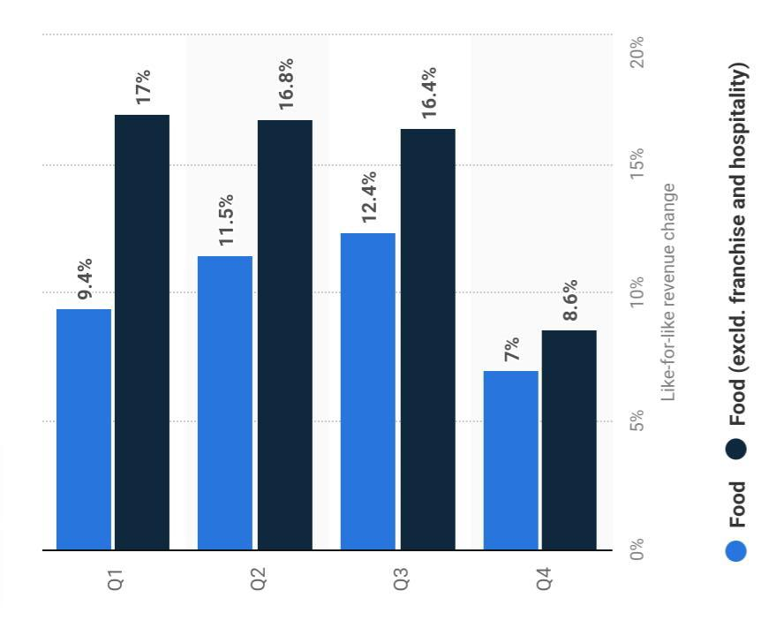

Food revenue of 2021 – 2022 in UK

Growth Strategies
Marks and Spencer's growth strategy revolves around four key areas: improving the customer experience, enhancing product offerings, expanding internationally and leveraging technology.
To improve the customer experience, the company invested in redesigning its stores, improving in-store technology and expanding its e-commerce platform. This includes the launch of the mobile his checkout service, which allows customers to pay for their purchases with their smartphones.
To improve its product offering, M&S expanded its range of trendy apparel for a younger audience, with a focus on more sustainable and healthier options.
For international expansion, the company has targeted growth markets such as India and China, opening flagship stores in key locations. We also partner with online marketplaces to expand our global reach.
Finally, M&S invests in his machine learning and other technologies to improve operations and better understand customer preferences. There is also an increasing use of data analytics to make more informed decisions.
Overall, these growth strategies aim to modernize the M&S brand, appeal to a wider audience and ultimately improve sales and profitability.

Green Strategy and CSR
Marks and Spencer (M&S), a UK-based multinational retailer, has developed a comprehensive and ambitious sustainability strategy with the aim of becoming the most sustainable large-scale retailer by 2025. bottom. The company's green strategy focuses on three main areas. Those whose purpose is to create a safe and healthy workplace for M&S employees and stakeholders. Partnerships, including working with suppliers, NGOs and other stakeholders to achieve sustainability goals.
One of M&S's key commitments is to become a carbon neutral company by 2025. As part of this, the company has invested heavily in renewable energy sources such as wind and solar power, and has implemented a range of energy-efficient measures in its stores, offices and distribution centre. M&S has also set targets to reduce greenhouse gas emissions, water use and waste generation.
In addition to its commitment to sustainability, M&S also has a comprehensive Corporate Social Responsibility (CSR) policy in place, covering issues such as ethical sourcing, human rights and community engagement. increase. The company is committed to responsibly and sustainably sourcing all of its products and working with its suppliers to improve labour standards and prevent modern-day slavery.
Overall, M&S's green strategy and CSR policy are a major step towards sustainability for the major retailer and have helped establish it as a leader in corporate sustainability.

Conclusion
In conclusion, Marks and Spencer (M&S) has been at the forefront of sustainability efforts in the retail industry, setting ambitious targets through its "Plan A" initiative and subsequent sustainability strategies. The company's focus on reducing carbon emissions, promoting sustainable agriculture, and using sustainable materials, as well as its emphasis on ethical labour practices and human rights, have helped establish M&S as a leader in corporate sustainability. M&S's sustainability efforts are influenced by several macro-environmental factors, including increasing consumer demand for sustainable and ethical products, government regulations and policies around sustainability, global supply chain challenges, and technological advancements. A PESTEL analysis and Porter's Five Forces analysis provide insight into these factors and their impact on the company's performance and competitive position in the market. Furthermore, a SWOT analysis identifies M&S's strengths, weaknesses, opportunities, and threats, providing a comprehensive overview of the company's internal and external factors. M&S's strong brand reputation, diversified product portfolio, and commitment to sustainability and corporate social responsibility are examples of strengths, while declining sales and profitability, high dependence on the UK market, and slow adoption of new technology are examples of weaknesses.

Recommendation
Based on the aforementioned study, the following recommendations for Marks and Spencer can be made:
Continue to prioritise sustainability efforts: M&S has achieved tremendous progress in its sustainability efforts, which should be prioritised (Thakur, 2021). The corporation should establish lofty goals and work hard to achieve them, all while adapting to changing consumer tastes and government laws.
Improve supply chain transparency: The worldwide supply chain can be a problem for M&S's sustainability efforts, so the corporation should focus on improving supply chain openness (Puyt et al., 2020; Werth et al., 2020). Working with suppliers to ensure ethical and sustainable practises, as well as giving customers with greater information about the products they purchase, can be part of this (Voiculet et al., 2010).

Utilise technical developments: M&S should keep using technology to improve its sustainability initiatives, such as by integrating energy-efficient technologies and sustainable materials in its products (Voiculet et al., 2010). The business ought to look into brand-new technical developments that might aid its sustainability programmes.

Increase brand recognition: M&S's sustainability activities have helped establish the company as a corporate sustainability pioneer. The company should continue to use its sustainability actions to improve its brand reputation and attract more socially conscious customers.

Keep an eye on market trends: As the retail sector evolves, M&S ought to maintain an eye on market trends to identify any fresh possibilities or challenges. This may require maintaining up to date on customer needs, regulatory directives, and technological changes that may have an impact on the company's sustainability efforts.

References
- Gopaldas, A. and Siebert, A. (2022). What You’re Getting Wrong About Customer Journeys. [online] Harvard Business Review. Available at: https://hbr.org/2022/07/what-youre-getting-wrong-about-customer-journeys.
- ‌www.marksandspencer.in. (n.d.). Marks & Spencer India | Buy Women, Men & Kids Clothing. [online] Available at: https://www.marksandspencer.in/?utm_source=google&utm_medium=search&utm_campaign=9897984394&adgroupid=100463569156&utm_content=647044952764&utm_term=%2Bmarks%20%2Band%20%2Bspencer&gclid=CjwKCAjwov6hBhBsEiwAvrvN6P-d2PFrZRhoNFgAUP8i8NCjOOXv6OyUDTNaJHasxKZW-ChOmRzEbRoCCUEQAvD_BwE&gclsrc=aw.ds [Accessed 19 Apr. 2023].
- ‌Rigby, C. (2021). Marks & Spencer on how its brand strategy is making it more relevant to its customers. [online] Internet Retailing. Available at: https://internetretailing.net/marks-spencer-on-how-its-brand-strategy-is-making-it-more-relevant-to-its-customers-24081/.
- Zigu (2021). Marks & Spencer Marketing Mix (4Ps) Strategy | MBA Skool-Study.Learn.Share. [online] MBA Skool-Study.Learn.Share. Available at: https://www.mbaskool.com/marketing-mix/services/17122-marks-and-spencer.html.
‌
- ‌Mckinnon, T. (2022). Marks & Spencer’s Turnaround Strategy, why it’s Working. [online] Indigo9 Digital Inc. Available at: https://www.indigo9digital.com/blog/marksandspencerturaroundstrategy.
- Fern Fort University. (n.d.). Marks & Spencer VRIO / VRIN Analysis MBA Solution. [online] Available at: http://fernfortuniversity.com/term-papers/vrio/c/1247-marks---spencer.php
- Sai, S. (n.d.). BUSINESS STRATEGIES FOR MARKS AND SPENCER. www.academia.edu. [online] Available at: https://www.academia.edu/43192883/BUSINESS_STRATEGIES_FOR_MARKS_AND_SPENCER.
- ‌Retail Week. (n.d.). Marks & Spencer (Strategy). [online] Available at: https://www.retail-week.com/prospect/marks-and-spencer/marks-and-spencer-strategy/7038340.supplierarticle?authent=1.
- www.marksandspencer.in. (n.d.). Marks & Spencer India | Buy Women, Men & Kids Clothing. [online] Available at: https://www.marksandspencer.in/?utm_source=google&utm_medium=search&utm_campaign=10019994644&adgroupid=100707296803&utm_content=647116988570&utm_term=marks%20and%20spencer%20company&gclid=CjwKCAjwov6hBhBsEiwAvrvN6C97Rp62_JZlGCpkLAgAfgzX6jUbyNe_V9Q86jxzKFt8CYZZHWsPmRoCTEEQAvD_BwE [Accessed 19 Apr. 2023].
- M&S (2021). Sustainability. [online] Sustainability. Available at: https://corporate.marksandspencer.com/sustainability.
- Mckinnon, T. (2022). Marks & Spencer’s Turnaround Strategy, why it’s Working. [online] Indigo9 Digital Inc. Available at: https://www.indigo9digital.com/blog/marksandspencerturaroundstrategy.

- Treadgold, A. (1988), "RETAILING WITHOUT FRONTERS: The emergence of transnational retailers", Retail and Distribution Management, Vol. 16 No. 6, pp. 8-12. https://doi.org/10.1108/eb018382
- Campbell, A. (2003). The Future of Corporate Venturing. [online] MIT Sloan Management Review. Available at: https://sloanreview.mit.edu/article/the-future-of-corporate-venturing/.
- Nyame-Asiamah, F. and Ghulam, S. (2020), "The relationship between CSR activity and sales growth in the UK retailing sector", Social Responsibility Journal, Vol. 16 No. 3, pp. 387-401. https://doi.org/10.1108/SRJ-09-2018-0245
- Ausloos, M. (2020). Valuation Models Applied to Value-Based Management—Application to the Case of UK Companies with Problems. Forecasting, 2(4), pp.549–565. doi:https://doi.org/10.3390/forecast2040029.

- ‌Priyadarshi, R., Deeba, F., Sauraj and Negi, Y.S. (2020). Chapter 11 - Modified atmosphere packaging development. [online] ScienceDirect. Available at: https://www.sciencedirect.com/science/article/pii/B9780128187951000113 [Accessed 19 Apr. 2023].
- Majid, J. (2020). ‘The Power of Celebrity as a Medium of Coercing Behaviour - A Marks and Spencer’s Case Study’. Journal of Business and Social Science Review Issue, [online] 1(3), pp.2690-0874. Available at: https://jbssrnet.com/wp-content/uploads/2020/04/4.pdf.
- Anastasiu, L., Gavriş, O. and Maier, D. (2020). Is Human Capital Ready for Change? a Strategic Approach Adapting Porter’s Five Forces to Human Resources. Sustainability, [online] 12(6), pp.1–20. doi:https://doi.org/10.3390/su12062300.
- Baxter, G. (2019). A Strategic Analysis of Cargolux Airlines International Position in the Global Air Cargo Supply Chain Using Porter’s Five Forces Model. Infrastructures, [online] 4(1), p.6. doi:https://doi.org/10.3390/infrastructures4010006.
- Benzaghta, M.A., Elwalda, A., Mousa, M., Erkan, I. and Rahman, M. (2021). SWOT Analysis applications: an Integrative Literature Review. Journal of Global Business Insights, [online] 6(1), pp.54–72. doi:https://doi.org/10.5038/2640-6489.6.1.1148.
- Boudreaux, C.J. (2019). The Importance of Industry to Strategic Entrepreneurship: Evidence from the Kauffman Firm Survey. Journal of Industry, Competition and Trade, 1(1). doi:https://doi.org/10.1007/s10842-019-00310-7.
- Cox, J. (2020). The higher education environment driving academic library strategy: A political, economic, social and technological (PEST) analysis. The Journal of Academic Librarianship, [online] 47(1), p.102219. doi:https://doi.org/10.1016/j.acalib.2020.102219.
- Europe PMC (2019). SWOT Analysis. [online] Europepmc.org. Available at: https://europepmc.org/article/med/30725987.
- Fan, G.-F., Wei, X., Li, Y.-T. and Hong, W.-C. (2020). Forecasting electricity consumption using a novel hybrid model. Sustainable Cities and Society, 61, p.102320. doi:https://doi.org/10.1016/j.scs.2020.102320.
- Hajizadeh, Y. (2019). Machine learning in oil and gas; a SWOT analysis approach. Journal of Petroleum Science and Engineering, 176, pp.661–663. doi:https://doi.org/10.1016/j.petrol.2019.01.113.
- Henry, I.P. (2022). Processes of political, cultural, and social fragmentation: changes in the macro-environment of sport policy and management: c.1980–c.2022. European Sport Management Quarterly, pp.1–21. doi:https://doi.org/10.1080/16184742.2022.2046122.
- Hudrasyah, H., Briantono, N., Fatima, I. and Rahadi, R. (2019). MARKETING STRATEGY FOR GAME DEVELOPER BASED ON MICRO AND MACRO ENVIRONMENT IN INDONESIA. Journal of Global Business and Social Entrepreneurship (GBSE), [online] 5(14). Available at: http://www.gbse.my/V5%20NO.14%20(MARCH%202019)/Paper-206-.pdf.
- Isabelle, D., Horak, K., McKinnon, S. and Palumbo, C. (2020). Is Porter’s Five Forces Framework Still Relevant? A study of the capital/labour intensity continuum via mining and IT industries. Technology Innovation Management Review, [online] 10(6). Available at: https://www.timreview.ca/article/1366.
- Jonibek, S. (2021). SWOT ANALYSIS IN THE STRUCTURE OF INFORMATION TECHNOLOGIES OF PHYSICAL EDUCATION. Web of Scientist: International Scientific Research Journal, [online] 2(05), pp.131–139. doi:https://doi.org/10.17605/OSF.IO/BVHCT.
- Pan, W., Chen, L. and Zhan, W. (2019). PESTEL Analysis of Construction Productivity Enhancement Strategies: a Case Study of Three Economies. Journal of Management in Engineering, [online] 35(1), p.05018013. doi:https://doi.org/10.1061/(asce)me.1943-5479.0000662.
- Phadermrod, B., Crowder, R.M. and Wills, G.B. (2019). Importance-Performance Analysis Based SWOT Analysis. International Journal of Information Management, [online] 44(12), pp.194–203. doi:https://doi.org/10.1016/j.ijinfomgt.2016.03.009.
- Puyt, R., Lie, F.B., De Graaf, F.J. and Wilderom, C.P.M. (2020). Origins of SWOT Analysis. Academy of Management Proceedings, [online] 2020(1). doi:https://doi.org/10.5465/ambpp.2020.132.
- Silva, A.L. da and Castañeda-Ayarza, J.A. (2021). Macro-environment analysis of the corn ethanol fuel development in Brazil. Renewable and Sustainable Energy Reviews, 135, p.110387. doi:https://doi.org/10.1016/j.rser.2020.110387.
- Smarandache, F. (2022). Collected Papers. Volume XII: On various scientific topics. [online] Google Books. Infinite Study. Available at: https://books.google.co.in/books?hl=en&lr=&id=Rn6jEAAAQBAJ&oi=fnd&pg=PA366&dq=+PESTEL+Analysis&ots=afnMXPIGmY&sig=1rB_J9HkYB07UWuDkIRebMliZvM&redir_esc=y#v=onepage&q=PESTEL%20Analysis&f=false [Accessed 19 Apr. 2023].
- Song, J., Sun, Y. and Jin, L. (2019). PESTEL Analysis of the Development of the waste-to-energy Incineration Industry in China. Renewable and Sustainable Energy Reviews, [online] 80(1), pp.276–289. doi:https://doi.org/10.1016/j.rser.2017.05.066.
- Thakur, V. (2021). Framework for PESTEL dimensions of sustainable healthcare waste management: Learnings from COVID-19 outbreak. Journal of Cleaner Production, [online] 287(1), p.125562. Available at: https://www.ncbi.nlm.nih.gov/pmc/articles/PMC7744017/.
- Voiculet, A., Belu, N., Parpandel, D.E. and Rizea, I.C. (2010a). The impact of external environment on organizational development strategy. [online] mpra.ub.uni-muenchen.de. Available at: https://mpra.ub.uni-muenchen.de/26303/.
- Voiculet, A., Belu, N., Parpandel, D.E. and Rizea, I.C. (2010b). The impact of external environment on organizational development strategy. [online] mpra.ub.uni-muenchen.de. Available at: https://mpra.ub.uni-muenchen.de/26303/.
- Werth, O., Schwarzbach, C., Rodríguez Cardona, D., Breitner, M.H. and Graf von der Schulenburg, J.-M. (2020). Influencing factors for the digital transformation in the financial services sector. Zeitschrift für die gesamte Versicherungswissenschaft, 109(2-4), pp.155–179. doi:https://doi.org/10.1007/s12297-020-00486-6.

‌
‌

‌
‌

