

LOCATION: Swansea | LLEOLIAD: abertawe
LEVEL 6 | LEFEL 6
EXAMINATION PERIOD | CYFNOD ARHOLIADAU
Mock 2024 | MOCK 2024

MODULE CODE: ACDA6018
Advanced Digital Signal Processing System

TIME: 2 HOURS
ANSWER ALL THE QUESTIONS
Each Question Carries 25 Marks

Equipment or materials required – Scientific Calculator
Adnoddau neu ddefnyddiau sydd eu hangen -

QUESTION 1

- Find the Fourier Transform of $f(t) = sin(ω_{c}t+θ)$ [15 Marks]

Note: Your answer may be selected from one of the provided options. Choosing the correct answer will earn you 1 Mark. However, to receive full marks, you must demonstrate your reasoning for the selected option. Below are the options:
- $F\left(jω\right)= = \frac{2A}{π}[\cos\left(ω_{0}t\right)-\frac{1}{4}\cos\left({3ω}_{0}t\right)+\frac{1}{9}\cos\left({5ω}_{0}t\right)-…]$
- 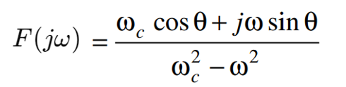
- $F\left(jω\right)= 2. sinc\left(ω\right)+4. sinc(2ω)$

- A certain function of the time $f(t)$ has the Fourier Transform $F\left(jω\right)= \frac{1}{ω^{2}+1}e^{\frac{-2ω^{2}}{(ω^{2}+1)}}$
Using the properties of the Fourier Transform, write the Fourier transforms of
- $f\left(2t\right)$ [5 Marks]
- $4\frac{d}{dt}f\left(t\right)$ [5 Marks]

QUESTION 2
- Compute the Discrete Fourier Transform (DFT) for the below sequence to identify its frequency components
$x\left(n\right)= cos\frac{nπ}{4}$ [10 Marks]
- Design an ideal LPF with a frequency response of
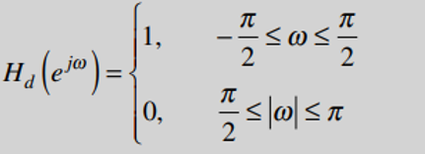
[15 Marks]
QUESTION 3
- An SDR receiver processes the RF signal 𝑆(𝑡) with an amplitude of 4, a frequency of 2200𝐻𝑧, and a phase of 𝜋/4. The local oscillator generates a signal with an amplitude of 2 and a frequency of 2150𝐻𝑧. This LO signal is used to down convert the RF signal into baseband components. The receiver generates a complex signal 𝑍(𝑡). The system also encounters a narrowband interference at 2230𝐻𝑧, which must be removed using appropriate filtering techniques.
Based on the SDR Receiver, answer the following,
- Using the given values for s(t) and the LO, specify the expressions for I(t), Q(t) and $Z(t).$
[12 Marks]
- Draw the block diagram of the SDR receiver, labelling all components including the LO signal with its amplitude and frequency. [4 Marks]
- Briefly explain how the system converts the RF input into its baseband representation.
[2 Marks]
- On Considering the impact of interference on the system, answer the following,
- An interference signal with a frequency of 2230Hz is mixed with a local oscillator operating at 2150Hz and derive the resulting frequencies from the mixing process. Explain which frequency should be retained in the baseband after applying a low-pass filter. [2 Marks]
- Discuss how the addition of interference affects the output frequency compared to the output frequency without interference. [2 Marks]
- What measures are recommended to recover the desired frequency effectively?
[3 Marks]

QUESTION 4
- For the discrete signal $y\left(n\right)=\{0, 1, 2, 3, 4, 5, 6, 7\}$, Compute the Discrete Fourier Transform Y(K) using the Decimation-in-Time Fast Fourier Transform (DIT FFT) algorithm. Show the intermediate steps including
- Dividing the sequence into 4 even and 4 odd terms. [2 Marks]
- Computing the Twiddle Factors [2 Marks]
- Using the Decimation-in-Time Fast Fourier Transform (DIT FFT) with a butterfly diagram that clearly shows the stages of computation. [21 Marks]

Diwedd/End





