

Marketing Management Assessment 2

Student Name: AHAMMED AZHARUDEEN MASTER HOUSE
Student ID: 2229990
Lecturer Name: TUSHARA BALENDRAN
Submission Date: 01/09/2023

Executive Summary
The main context of this report is to describe the necessity of effective marketing management and for developing this report, the US-based company, Apple has been chosen. A detailed overview of the organisation was provided in the first part of this report. In the next part of the report, the PESTLE analysis of Apple has been evaluated including the external environment of the US’s market. As an analysis of the external environment, Porter's five forces analysis has also been explained in the context of Apple. The SWOT analysis of Apple was explained within this report to evaluate the internal business structure including the strengths, opportunities, weaknesses and threats of Apple. Extended STP analysis and extended marketing mix of the company are also included in the next part of the report including the Ansoff matrix and product life cycle model. Some recommendations have been also provided in terms of avoiding the threats and improving the strategies of marketing of Apple.
Table of Contents
Introduction 4
Question A 4
Overview of Organisation 5
PESTLE Analysis 5
Porter’s Five Forces Model 8
SWOT Analysis 9
Extended STP Analysis 11
Extended Marketing Mix 12
Question B 12
Ansoff Matrix 12
Product Life Cycle Model 13
Recommendations 14
Conclusion 14
References 15

Introduction
Marketing management is one of the significant business terms and without efficient marketing management, the organisation will be unable to promote its business products or services accurately. Proper advertisements, accurate promotional strategies and digital marketing, all are included in the marketing management (Kotabe and Helsen, 2022). For developing this report, the company, Apple will be chosen and a detailed overview of the organisation will be provided in the first part of this report. The PESTLE and SWOT analysis will be provided along with Porter’s Five Forces Model to evaluate the external and internal business structure of Apple and its marketing strategies and some recommendations will be provided at the end of this report that will be beneficial for the company's growth.
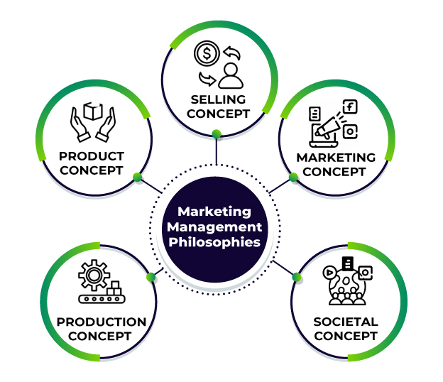
Figure 1: Marketing Management
(‌Source: Marketing Management, 2022)

Question A

Overview of Organisation
Apple Inc. is an international American company that produces technological gadgets for tech-savvy customers (Apple, 2023). The headquarters of the company is in California, Cupertino. It is one of the largest technological companies and earned the highest revenue, which was US$394.3 billion revenue in 2022. Based on the market capitalization, Apple already became the world's biggest company in March 2023.
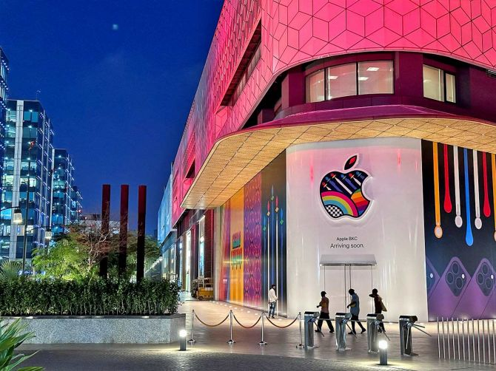
Figure 2: Apple Store
(Source: AHEAD, 2021)

PESTLE Analysis
Political: Being an American technology industry, Apple has a strong global presence across several countries. Recently the inequality of income has become a major political issue in the United States. The company is accumulating a huge amount of cash. The various social and political issues continuously disrupt the manufacturing system of Apple in China (Zhou, 2020). Besides that, the American government is enforcing the fact of low import of Chinese products to boost the manufacturing of America. All of these factors have been influencing the manufacturing system of Amazon.

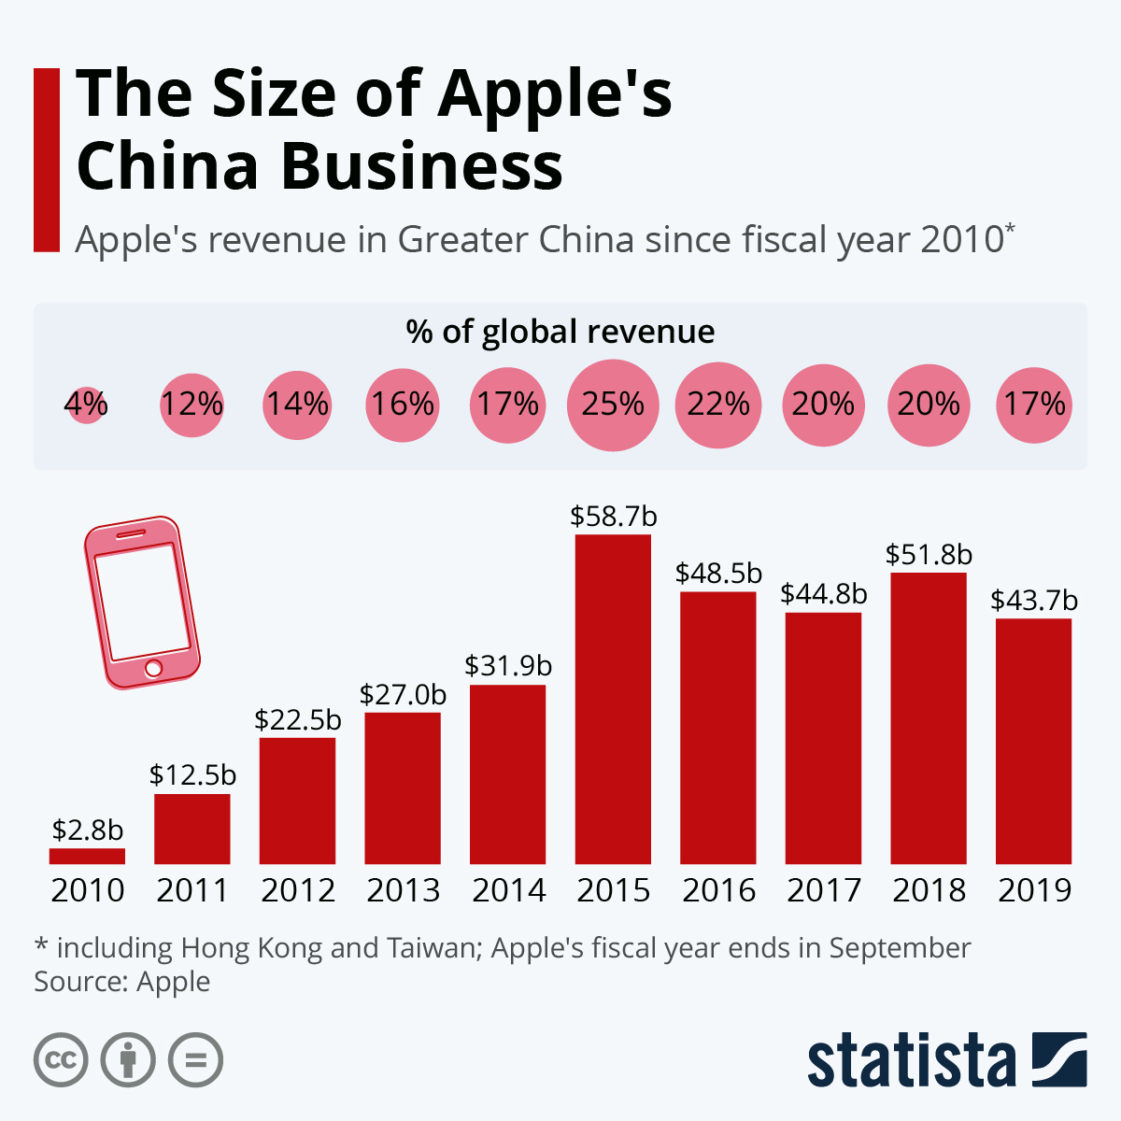
Figure 3: Manufacturing of Apple Products in China
(Source: Richter, 2020)
Economic: In the US, labour costs have increased in recent years, therefore, it affected the company to hire people to manage individual functions. According to the Employment Cost Index, the labour cost rose to 4.0% on a year-on-year basis. It is the greatest rise in labour costs since 2001 (Xing, 2019). Besides that, it has been identified that a strong U.S. dollar could enhance the exchange rates. This is making the company, Apple, perform its business more expensive in Europe and China. The company is focusing on this issue to avoid upcoming negative business results in future.
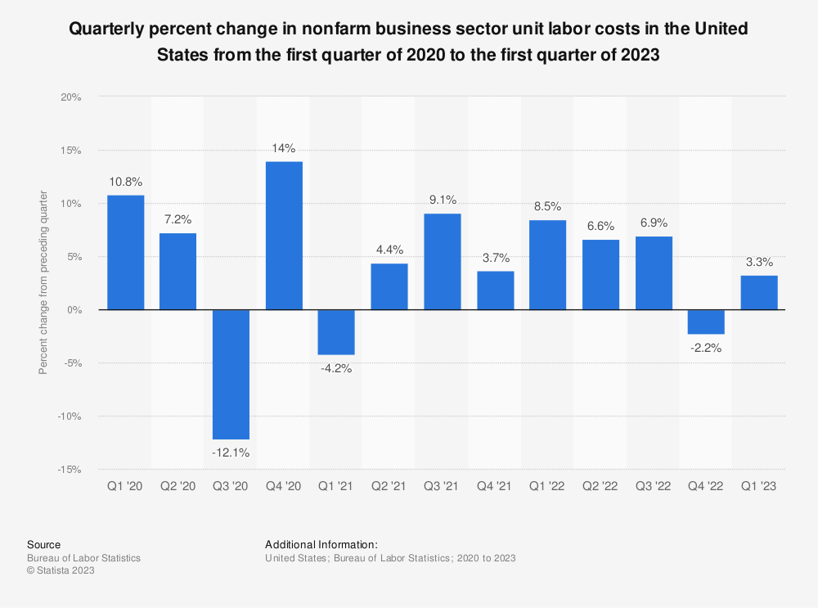
Figure 4: Increase in Labour Cost in the US
(Source: Statista, 2023)
Social: In the post-pandemic era, people of the US, as well as global countries, became very concerned regarding their health and well-being. Therefore, it created some ethical concerns in terms of manufacturing Apple's products in the US and also marketing the products among socially-conscious people.
Technological: In the United States, the integration of technology has been increasing every day, therefore, it becomes a great opportunity for technology-based organisations like Apple to extend the services to more people in the US. Therefore, the technological factors of the US help the company to run its business in this particular market.
Legal: In the recent era of digital technology, adhering to regulations which are regarding privacy and security is highly important and the government of the US also puts pressure on organisations like Apple. Therefore, it becomes very difficult for the company to run its business activities as its products of Apple largely deal with the private information of the users.
Environmental: Apple is highly concerned in terms of manufacturing more energy-efficient items and services to enhance business sustainability (Naim, 2021). In this regard, the company manufactures processors, batteries and much more equipment which emits minimal heat. Therefore, it becomes beneficial for the company to run its business as it maintains all the regulations.

Figure 5: Augmented Reality in Apple
(Source: Lovejoy, 2021)

Porter’s Five Forces Model
Bargaining power of suppliers: Suppliers always want to work with big companies and this weakens the individual positions of suppliers in imposing needs on Apple. Therefore, the supplier’s bargaining power is low for the company.
Bargaining power of customers: In recent days, customers can easily access data and information regarding the variety of features, and customer reviews of a product, therefore, they can easily switch to their preferred companies. Therefore, it can be said that the customer's bargaining power is high for the company.
Competitive rivalry: There is high competition in the technology industry and Samsung, Amazon, and Google are the main competitors of Apple (Cusumano, Yoffie and Gawer, 2020). All of these companies are highly successful technological companies and Apple faces major competition with them.
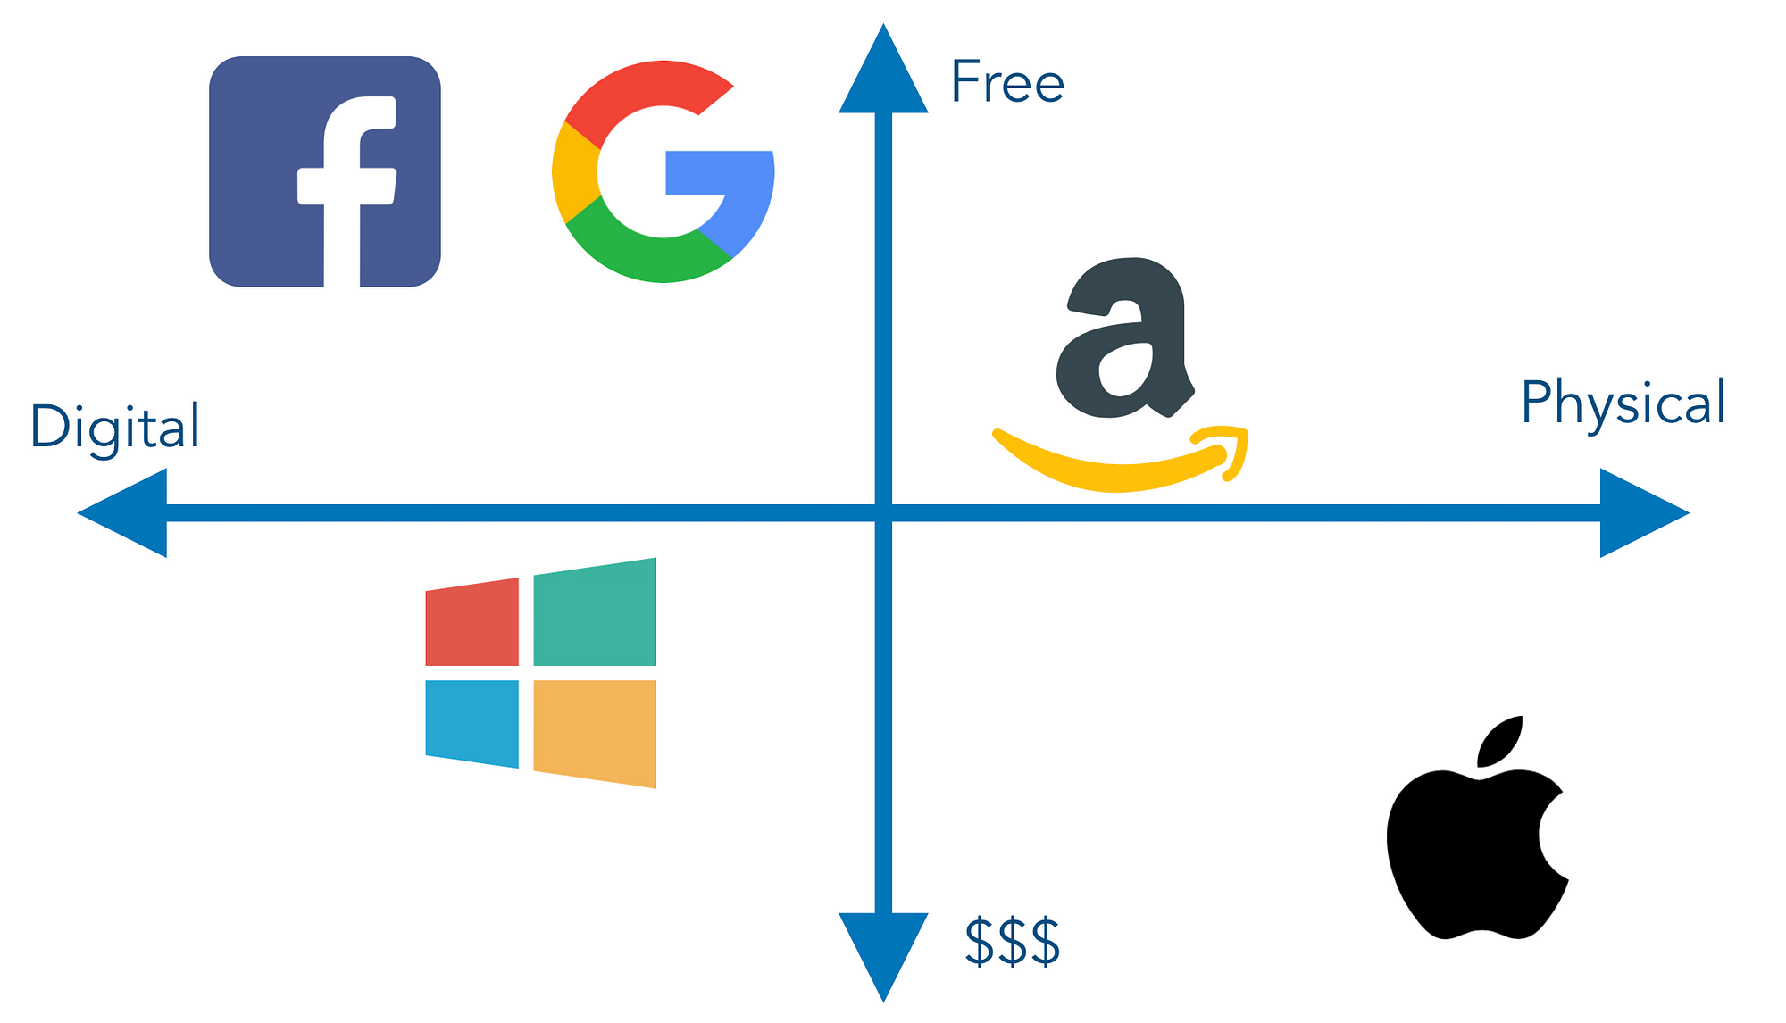
Figure 6: Competitors of Apple
(Source: Neagoie, 2019)
Threats of new entrants: There is a moderate range of threats for Apple in the case of new entrants because the company already has a strong brand image and reputation all over the world. It is very difficult for the new businesses to beat the company.
Threats of new substitutes: Substitute threat is particularly low for the company as it is highly difficult for other companies to make the same products as Apple including its special features and capabilities.

SWOT Analysis
In this part of the report, the internal business structure of Apple will be described by using the SWOT analysis.
Strengths: The brand value of the company is $408 billion and the products of the company are highly innovative and advanced. It is the main strength of the company and it is also the most reliable technological brand. The company uses high-quality advanced technology and using these top technologies, the company produces innovative tech gadgets for customers (Wu and Song, 2023). GenZ customers are already attracted by Apple’s innovative products and the Apple brand is also the first choice for the tech-savvy generations.
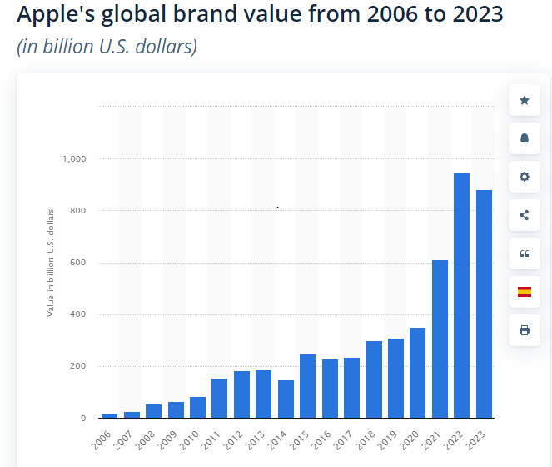
Figure 7: Brand Value of Apple
(Source: Statista, 2022)‌
Weaknesses: The main weakness of the company is the high product prices, which are not affordable for middle-class customers. Apple’s products are not compatible with the general software, therefore, the customers that are buying Apple’s products, have to adopt the new Apple software to handle their gadgets (Chen, Liu and Gong, 2021). The company has unfair practices within their business and that provides competitive advantages to its other rival companies. Apple is also accursed for unfair tracking; therefore, the iPhone users' personal information is easily tracked by the company through their iPhone applications, which creates security issues.
Opportunities: The constant consumer growth is the key potential opportunity for Apple and high-quality research is another business opportunity for the company. The strong distribution network is also very profitable for the company's growth, using this strong network the company can easily expand their business in future.
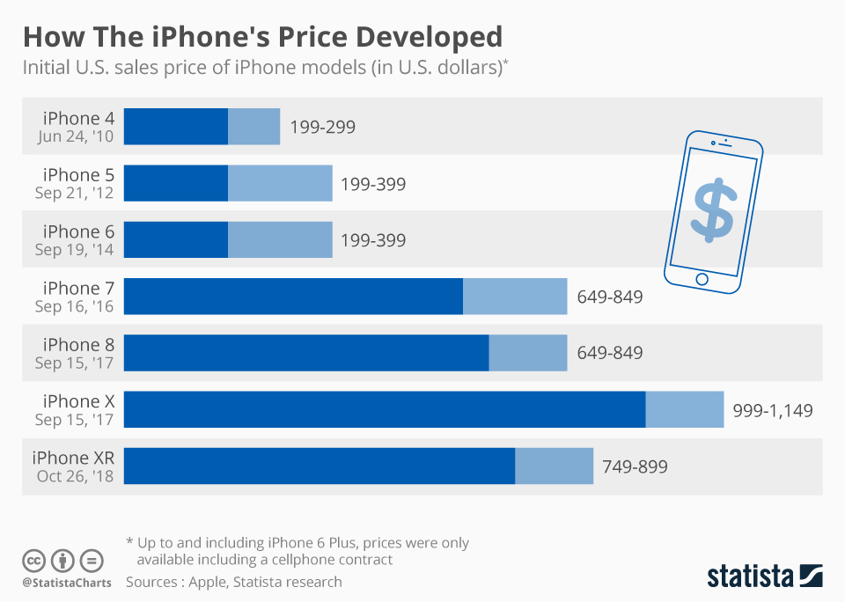
Figure 8: Constant price rise of iPhones
(Source: Niall McCarthy, 2020)
Threats: The high competition is the main future threat for the company and the pandemic outbreak has had a deep impact on the company (Yasmin et al., 2023). The company is extremely dependent on the Chinese market for supply chain and manufacturing, and China was the most affected country due to covid 19. In that situation, Apple faced a huge issue during this present situation and in future, the company might face a big threat because of this overdependence on the Chinese market.

Extended STP Analysis
STP marketing is considered an acronym and the three steps are segmentation, positioning and targeting. In a nutshell, STP marketing is a three-step model that helps in examining the services and segmenting the market. Apple’s market segmentation is demographic and it includes improving its popular products by targeting the customer’s lifestyle, age and occupation (Zamzami and Ariyawardana, 2019). Apple has entered the global market with a broader approach so geographic elements are a must-considered part in case of it. Also, the customer reach is growing as Apple has online stores besides its physical stores by targeting tech-savvy people, mainly those who are willing to spend a lump sum amount in exchange for Apple's high-quality products. In addition, Apple’s positioning approach is settled with its competitive mentality and by implementing an emotional branding style.

Extended Marketing Mix
Basically, organisations follow the 4 Ps of the marketing mix, which is price, place, promotion and product. Additionally, for apple, there are extended marketing mixes available. The extended marketing mix adds three more pillars to Apple’s marketing strategy which are people, process and physical evidence. Apple has a wide customer base from every corner of the globe and the management pays the best attention to investing time and money in its dedicated customers (Razak et al., 2020). The employees are also instructed to help customers with their best technical knowledge. Also, the customer service of Apple takes all responsibilities to answer all product-related questions they may have. The organisation has adopted simple strategies for selling its products. It has simplified the purchasing process from both its offline and online stores. It helps in engaging the consumers to stick with the brand and preventing them from going to the competitors. The stores are designed to welcome the customers and the display shows all the products widely.

Question B

Ansoff Matrix
Market penetration: Market penetration considers the process of selling existing services and products into existing markets. Apple follows this strategy very effectively by making its iPhones available in the business market for buying on several platforms such as Apple stores and other telecommunication organisations (Amin and Munsi, 2020). Apple focuses on expanding its retail business to strengthen the strategy of market penetration.
Market development: This strategy includes the process of selling existing services and products to new regions and markets. Being a global organisation, Apple is focused on developing its presence all over the world. The company mainly focuses on building a large footprint in several emerging business markets.
Product development: Apple is effectively focused on developing new products as well as selling them to all the existing markets and in this way, the company maintains its product development strategy (Adıgüzel, 2020). Apple has a strong workforce in its R&D and design sectors. Therefore, it constantly helps the company to innovate more new products as well as services such as iPad, iPod, iPhone, Apple Watch and many more.
Diversification: Diversification mainly considers the process of selling new items to new markets and Apple has proved that it is highly focused on manufacturing several products. Moreover, the company also made a strong diversified portfolio in recent years.
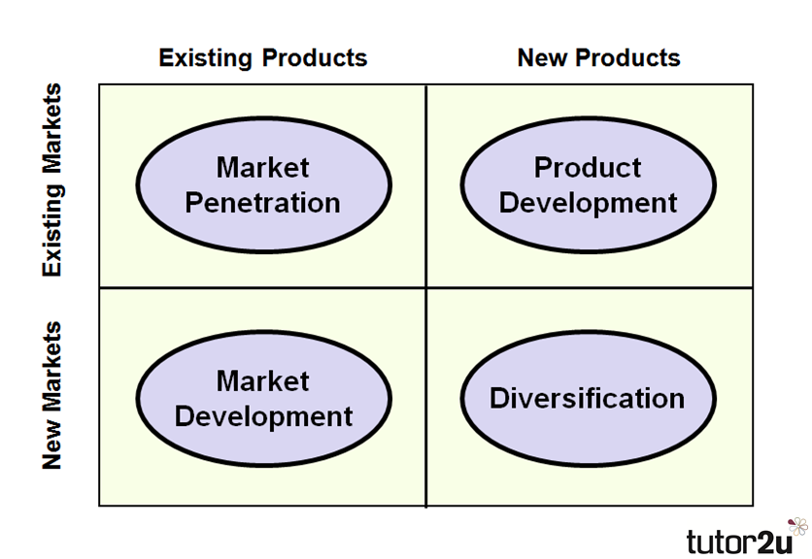
Figure 9: Ansoff Matrix
(Source: Ansoff Matrix, 2023)

Product Life Cycle Model
The product life cycle has four stages mainly such as maturity, introduction, decline and growth. In the introduction stage of Apple, the price is usually kept high in order to maintain the exclusivity of both the product and ownership (Loiseau et al., 2020). iPhone users do not prefer owning an iPhone by everybody so the price is determined highly to attract a particular segment of the audience. During advertisements, the marketing and sales are also high. After the introduction stage, a growth stage comes that helps in growing the development of the products. Then the maturity stage appears where the overall sales are conserved at a certain level. At this level, other competitors also enter the market. Lastly, in the decline stage, the customers do not keep much interest in Apple’s products so the company lowers the prices and removes after-sales support.
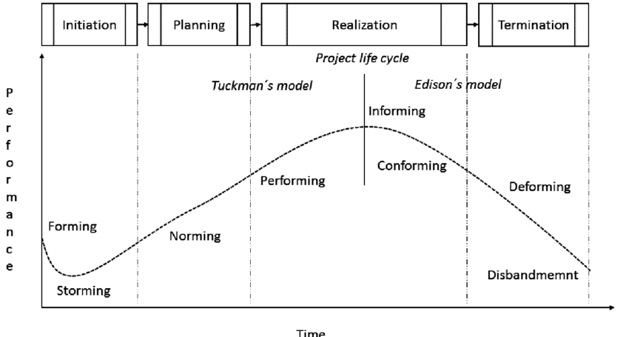
Figure 9: Project Life Cycle Model
(Source: Nekvapilová et al., 2016)

Recommendations
- Implementing an affordable pricing strategy: Due to the high price of the products of Apple, most people cannot purchase their products. In this regard, the company needs to apply a cost-effective strategy so that all types of people can afford its products. It will also lead the company to increase customer engagement and satisfaction (Alzoubi et al., 2022). It will help the company to achieve a competitive advantage in the competitive environment.
- Improving the settings of privacy and security: There is a high concern among users in terms of maintaining privacy and security in Apple products. In this regard, it is required for the company to modify and strengthen the settings of its products so that the personal information of the users cannot be leaked or hacked by others. Therefore, it will help the company to hold its brand image and reputation.

Conclusion
It can be concluded that effective marketing management is responsible for accelerating the business growth and from this report, an individual can understand the marketing strategies of Apple. The attractive marketing strategies of Apple also help the company to earn this huge worldwide revenue. The SWOT analysis and PESTLE analysis of Apple have been described in detail within this report along with Porter’s five forces Model and the overview of the company is also explained in the first part of this report. The marketing strategies of Apple are also identified with the help of Ansoff Matrix and product life cycle model and discussed and a few recommendations are also provided in this report, that will help the company to earn more profit within their business.

References
Adıgüzel, S., (2020). Market and brand positioning and sustainability strategies in international marketing. International Journal of Scientific Research and Management, 8(9), pp.9-24. Available at: https://www.academia.edu/download/77857329/2167.pdf
AHEAD, R.G., (2021). Coming Soon! Apple’s First India Store. [online] Rediff. Available at: https://m.rediff.com/getahead/report/coming-soon-apples-first-india-store/20230412.htm [Accessed 16 Aug. 2023].
Alzoubi, H., Alshurideh, M., Kurdi, B., Akour, I. and Aziz, R., 2022. Does BLE technology contribute towards improving marketing strategies, customer satisfaction and loyalty? The role of open innovation. International Journal of Data and Network Science, 6(2), pp.449-460. Available at: http://m.growingscience.com/ijds/Vol6/ijdns_2021_107.pdf
Amin, M.R. and Munsi, M., (2020). Motivational Techniques for Business Organization–A Case Study of Apple Inc. Available at: https://www.theseus.fi/bitstream/handle/10024/344717/Motivation.pdf?sequence=2
Ansoff Matrix., (2023). Available at: https://i0.wp.com/s3-eu-west-1.amazonaws.com/tutor2u-media/subjects/business/diagrams/strategy-ansoffmatrix-1.png [Accessed 25 Aug. 2023].
Apple., (2023). Apple (United Kingdom). [online] Apple (United Kingdom). Available at: https://www.apple.com/uk/. [Accessed 16 Aug. 2023].
Chen, X., Liu, Y. and Gong, H., (2021, December). Apple Inc. Strategic Marketing Analysis and Evaluation. In 2021 3rd International Conference on Economic Management and Cultural Industry (ICEMCI 2021) (pp. 3053-3061). Atlantis Press. Available at: https://www.atlantis-press.com/article/125965812.pdf
Cheng, Y., Liu, H., Wang, S., Cui, X. and Li, Q., 2021. Global action on SDGs: Policy review and outlook in a post-pandemic era. Sustainability, 13(11), p.6461. Available at: https://www.mdpi.com/2071-1050/13/11/6461/pdf
Cusumano, M.A., Yoffie, D.B. and Gawer, A., (2020). The future of platforms. MIT Sloan Management Review, 61, pp.26-34. Available at: http://marketing.mitsmr.com.s3.amazonaws.com/offers/Spring2020/Disruption2020_collection-SV.pdf#page=28
Kotabe, M.M. and Helsen, K., (2022). Global marketing management. John Wiley & Sons. Available at: http://131.193.209.39:8003/view_syllabi/static/view_syllabi/syllabus/MKTG%20469%20CRN%2016662%20Fregetto%20Spring%2014.pdf
Loiseau, E., Colin, M., Alaphilippe, A., Coste, G. and Roux, P., (2020). To what extent are short food supply chains (SFSCs) environmentally friendly? Application to French apple distribution using Life Cycle Assessment. Journal of Cleaner Production, 276, p.124166. Available at: https://www.sciencedirect.com/science/article/am/pii/S0959652620342116
Lovejoy, B., (2021). Apple’s Augmented Reality headset launching in the 2nd quarter of next year – Kuo. [online] 9to5Mac. Available at: https://9to5mac.com/2021/06/08/apples-augmented-reality-headset/
Marketing Management., (2022). Marketing Management Philosophies. [online] Available at: https://www.geeksforgeeks.org/marketing-management-philosophies/.
Naim, A., (2021). Green Information Technologies in Business Operations. Periodica Journal of Modern Philosophy, Social Sciences and Humanities, 1, pp.36-49. Available at: https://periodica.org/index.php/journal/article/download/4/3
Neagoie, A., (2019). Programmer’s guide to the big tech companies 💻. [online] Zero To Mastery. Available at: https://medium.com/zerotomastery/programmers-guide-to-the-big-tech-companies-1bfc078e5a76 [Accessed 25 Aug. 2023].
‌Nekvapilová, Ivana and Pitas, Jaromir., (2016). Factors Affecting Project Management in the Public Sector. International conference KNOWLEDGE-BASED ORGANIZATION. 22. 10.1515/kbo-2016-0037. Available at: https://www.researchgate.net/figure/Model-of-project-team-development-x-project-life-cycle-Development-of-the-project-team_fig1_305760870
Niall McCarthy., (2020). Infographic: How The iPhone’s Price Developed. [online] Statista Infographics. Available at: https://www.statista.com/chart/11067/how-the-iphones-price-developed/.
Razak, M., Hidayat, M., Launtu, A., Kusuma Putra, A.H.P.A. and Bahasoan, S., (2020). Antecedents and consequence of brand management: empirical study of Apple’s brand product. Journal of Asia Business Studies, 14(3), pp.307-322. Available at: http://repo.handayani.ac.id/46/3/10-1108_JABS-01-2019-0030.pdf
Richter, F., (2020). Infographic: The Size of Apple’s China Business. [online] Statista Infographics. Available at: https://www.statista.com/chart/13246/apple-china-revenue/.
Statista., (2022). Apple: brand value 2019 | Statista. [online] Statista. Available at: https://www.statista.com/statistics/326052/apple-brand-value/.
Statista., (2023). Business sector unit labour costs quarterly change U.S. 2023. [online] Available at: https://www.statista.com/statistics/217148/quarterly-percent-change-in-nonfarm-business-sector-unit-labor-costs-in-the-us/ [Accessed 16 Aug. 2023].
Wu, X. and Song, Z., (2023). Shanxi Yuncheng Red Fuji Apple E-commerce SWOT Analysis and Countermeasures Research. Agricultural & Forestry Economics and Management, 6(2), pp.1-9. Available at: http://www.clausiuspress.com/assets/default/article/2023/06/03/article_1685778485.pdf
Xing, Y., (2019). How the iPhone widens the US trade deficit with China: The case of the iPhone X (No. 19-21). National Graduate Institute for Policy Studies. Available at: https://core.ac.uk/download/pdf/231995627.pdf
Yasmin, B., Roy, A., Mandal, M.H., Siddique, G. and Ghosh, S., (2023). Challenges and Prospects of Apple Cultivation in Himachal Pradesh. Space and Culture, India, 10(4), pp.52-67. Available at: https://spaceandculture.in/index.php/spaceandculture/article/download/1252/532
Zamzami, L. and Ariyawardana, A., (2019). Consumer insights that drive value creation opportunities in the Indonesian domestic apple supply chain. Available at: https://kobra.uni-kassel.de/bitstream/handle/123456789/11276/JARTSVol120No1S033.pdf?sequence=1&isAllowed=y
‌Zhou, S., (2020). Research and Enlightenment of Apple’s Business Model under the Economic Globalization. Available at: http://download.bcpub.org/proceedings/2020/EDMI2020/EDMI011.pdf

