Name  Student ID Number | DEEPINDER SINGH  1813078
Module Title | ACADEMIC AND EMPLOYABILITY SKILLS
Module | BMSK4001
Module Lecturer
Word Count | 2000 |  |  | Date Submitted |  | Enter date you submitted

INTRODUCTION
Aside from the academic qualifications, employers look for range of skills called employability or soft skills that make individual different from others and enhance the changes of getting employed. It is worth mentioning that, employability skills have become decisive factors through which employers become able to judge candidates and hire the person accordingly. From an employer’s perspective, the employability skills make individual more service oriented and thereby, helping organization to grow significantly. In this regard, the aim of the study is to understand the basic employability skills and thereby, performing self-assessment in order to understand own capabilities in terms of employability skills to gain credibility in search of employment opportunities.

EMPLOYEE NEEDS TO HAVE
Employability skills can be defined as the transferable skills required by an individual in order to enhance the chances of getting employed. Along with the good academic and subject knowledge and technical understanding, employers often sketch a set of basic skills that they want from a candidate and these skills are what they believe will equip the company to grow and make the employee to carry out their role at their best of capability. Hence, as defined by Collet et al. (2015), it can be mentioned that, employability skills are often looking for the abilities that go beyond the academic qualification and experience and thus, it is the group of abilities that involve the expertise level and mind-set necessary for the success in the modern workplace.
Thus, from the above-held discussion, it can be mentioned that, employability skills are the capabilities that make individual to run the business smoothly confidently and creatively (Nirmala and Kumar, 2018). The essential employability skills that make individual unique can be provided as follows
COMMUNICATION SKILL
Depending on the requirements, the communication skills refers to the ability to express own thinking and feelings clearly so that, it can be possible to deliver the message to the targeted one significantly. According to the viewpoint of Scheider et al. (2016), some of the specific employability skills that an employee needs to comprise to nurture success in the workplace include listening skills, confidence, empathy, feedback, non-verbal communication skills and others. Verbal communication is all about the use of words effectively whether in face-to-face or writing so as to deliver the message to the target audience significantly. On the other hand, the non-verbal skills include the use of body language, tone of voice, eye contact and other practices so as to make the communication process more effective. Further, as opined by Chollet et al. (2015), improved communication skills involved active listening skills and it refers to the practices that how one interpret the verbal or non-verbal messages sent by others. From an employers’ perspective, the one who has effective communication skills is able to influence the mind-set of others and thereby, helping the organization to enhance the level of productivity.
TEAM-WORKING SKILLS
The team working skills is the ability to work with others in a group by formally and informally. According to the viewpoint of Kennedy et al. (2015), at the present time, most of the organizations in the age of globalization nurture team-working culture in the workplace and thereby, tending to hire individual with improved team working skills so that, it can be possible for the organization to reduce cultural conflict and thereby, promoting growth by leveraging the talent pool. As opined by Miller (2017), the team work can be divided into two segments and these are working as a group and as a team.
Working as a team involves people who perform together to achieve a particular goal to which the individuals are mutually committed.
Working as a group, this involves a number of people sharing something common and thereby, performing together in related to shared characteristics.
Thus, from the above-held discussion, team work involves a range of qualities such as a common purpose, common approach to work together, trust and support and the willingness to take responsibility of team actions.
EMOTIONAL INTELLIGENCE SKILLS
Emotional intelligence is the ability to recognize, interpret and management own characteristics in order to value the feelings and emotions of others and thereby, taking responsibilities which do not hurt others. Thus, with improved emotional intelligence skills, one can be able to influence the emotions of others so as to use them positively for achieving the desired outcomes. According to Li et al. (2016), in the age of globalization, the workplace experiences cultural amalgamation and hence, it is essential for the individual to behave as a global citizen and thereby, handling the feelings, values and emotions of others to as to develop decisions for the greater benefit. The strong sense of emotional intelligence involves high level of social awareness, motivation, empathy, self-awarness and self-management in the difficult situation as well (Nafukho et al. 2016).
TIME MANAGEMENT
One of the significant employability skills an individual needs to nurture is all about the time management time. According to Grissom et al. (2015), time management is all about the process of planning and organizing the entire day so as to perform the pre-defined activities within deadline. Thus, good time management enables individual to work smarter and not harder so that, it can be possible to complete more tasks in less time and thereby, managing pressure when the time is tight. Failing to manage time management damages effectiveness and thereby, causing stress. From an employer’s perspective, effective time management skill make employees to work better in less time and thereby, helping the organization to complete the tasks within deadline and improving productivity. Employer can save money by organizing their time and hence, with more organized time practices, workplace can be more creative.
CONFLICT RESOLUTION SKILLS
Conflict resolution skills refer to the ability to resolve disagreements in some of the positive ways so that, it can be possible to create a win-win situation for the individuals and thereby, maintaining working practice smooth and effective. While working in a diverse workplace, individual needs to comprise improved conflict resolution skills in order to maintain calm situation in the workplace. As opined by Gol-Guven (2017), conflict resolution depends on the ability such as managing stress quickly while remaining alert and calm and thereby, controlling own emotions and behavior. Hence, and employer demands employee with significant conflict resolution skill so that, it can be possible to make diverse workplace where individuals respect the differences.
INDENTIFICATION OF OWN EMPLOYABILITY SKILLS
From the above-held discussion, a range of basic employability skills can be understood. Hence, it is required to understand own strengths and weakness in terms of the employability skills so that, it can be possible to engage with the development of significant core skills so as to enhance the employability opportunity.
COMMUNICATION SKILLS
In terms of communications skills, it can be mentioned that, the writer has good communication skills and thus, it can be mentioned that, writer has potentiality and confidence to communicate with a group of people through writing communication skills. The writing communication skills such as writing email, blogs and other allow the writer to communicate the message with clarity and ease with far larger audience. However, it can be noted that, the writer has lack of effective public speaking skills. Hence, by performing the effective 16 personalities test, it can be noted that, the researcher is introverted (88%) and thereby, preferring to avoid any form of social events and staying corner of the meeting (Refer to appendix I). Hence, it is required to have a great deal of experience in speaking public by enhancing the public speaking skills.
TIME MANAGEMENT SKILLS
Time management skill is essential as it allows individual to perform the entire set of activities within shorter time frame. Hence, in terms of own time management skills, it can be mentioned that, by performing the time management tool psych tests, the own time management ability can be understood. It can be mentioned that, the writer scored 25% as time management efficiency and it shows the ineffective management skills. Hence, poor punctuality, nervousness and procrastination reduce the overall efficiency of the time management ability. However, on some positive notes, it can be mentioned that, the writer is well planner and thereby, the ability of doing things with significant planning helps to complete tasks on time. Thus, it can be mentioned that, by resolving the negative time management abilities, it can be possible to enhance the skill potentially (Refer to Appendix II).
EMOTIONAL INTELLIGENCE SKILLS
An employee needs to comprise significant emotional intelligence skills so that, it can be possible for the employees to interact with each other more significantly and hence, by getting feedback and using it in a positive way, it can be possible for the employer to enhance staff morally and thereby, reducing staff turnover significantly (Lee and Chelladurai, 2018). In this regard, it can be mentioned that, the writer has lack of emotional intelligence in terms of social awareness, self-management and self-awareness skills by practicing the Global EI test. Lack of such skills lead the writer not to value the emotion and feelings of others and thereby, stick to the pre-defined practices irrespective of situation. Sometimes, such kind of practices could reduce one’s morale and thus, the writer needs to resolve the incompetency in order to enhance the chances of employability (Refer to Appendix III).
TEAM WORKING SKILLS
As of above, improved team working skill enables individual to adjust with different situations and thereby, reaching the ultimate objective with shared goals. Hence, in terms of understanding own strength, the 123 test has been performed. From the findings of the test, it can be noted that, the writer has improved innovation skills and as a result, the writer prefers to perform things solely to come out with innovative ideas. Hence, it can be mentioned that, such kind of practices reduces the team working skills of the writer as the writer scores only 8% in this criterion (Refer to Appendix IV).
CONFLICT RESOLUTION SKILLS
From the above-held discussion, it can be mentioned that, the conflict resolution is all about the formal or information process where individual can create a win-win situation and thereby, reaching a peaceful solution of any form of dispute (Menkel-Meadow, 2017). Hence, in terms of conflict resolution skills, the writer performed the Quiz tool test so as to understand the own ability regarding the said skills. By performing the test, it can be stated that, the writer prefers to compromise to so as to resolve any form conflicting atmosphere and hence, the writer scored 40% as per the test in this core area. Hence, due to ineffective communication skills, the writer generally prefer to avoid conflicting situation and hence, the tendency of compromising helps to reach the win-win situation quickly ny influencing the mind set of others (Refer to Appendix V).
PERSONAL SWOT ANALYSIS
STENGTHS  - Significant innovation skills  - High level of motivation  - Tendencies of sticking to the pre-defined target and goals  - Conflict resolution skills | WEAKNESS  - Low expertise of working in a team  - Lack of effective public speaking skills  - Lack of significant time management skills  - Lack of emotional intelligence
OPPORTUNITY  - Chances of getting employed as software developer due to enhanced technology and innovation skills  - Future opportunities as leader with the online marketing emergence  - Increased number of start-ups looking for high level of communication and time management skills while employing as leader | THREAT  - Lack of time management skills can reduce the efficiency as employee  - High level of competition can reduce the future growth as software developer
Table 1:PERSONAL SWOT ANALYSIS

RECOMMENDATION: PERSONAL DEVELOPMENT PLAN
SHORT-TERM SKILLS
Target | Targeted Actions |  |  | Targeted Time Frame |  | Evidence Of Completion
Time management skills  Team working skills | - Set Deadline  - Use To Do List  - Stop Doing Multitasking  - Delegate Responsibilities  - Cultivate open communication  - Improved morale  - Sharing roles and responsibilities |  |  | 01.05.2019  01.08.2019 |  | Complete tasks within deadline  Reach office on time  Reduced percentage of procrastination
MID – TERM SKILLS
Public speaking skills | - Plan appropriately  - Improving active listening skills  - Pay attention to body language  - Reduce nervousness |  | 01.08.2019  01.02.2020 |  | High level of confidence  Improved connection with other department  Improved negotiation skills
LONG-TERM SKILLS
Improve emotional intelligence | - Communicate with others significantly  - Understand the emotions and feelings of others  - Respect others’ thinking | Within the end of 2020 |  |  | Improved relationship with others  Improved empathy  High level of motivation

CONCLUSION
It can be conclude that, employer pay special focus with the individuals having skills like effective communication, time management, team working, high emotional intelligence and other skills so as to make the workplace more attractive and thereby, enhancing the organizational productivity from the talent pool. Hence, for enhancing the chances of getting employed, the writer needs to enhance the skills such as improved time management, effective communication, team working and emotional intelligence skills so as to enhance the level of creativity and overcome the nervousness.

REFERENCEES
Chollet, M., Wortwein, T., Monency, L.P., Shapiro, A., And Scherer, S., 2015, September.
Exploring feedbeck strategies to improve public speaking: an interactive virtual audience framework. In Proceedings of the 2015 ACM International Joint Conference On Pervasive And Ubiquitous Computing (pp. 1143- 1154). ACM
Collet, C., Hine, D., And Du Plessis, K., 2015. Employability skills: perspectives from a knowledge-intensive industry. Education + Training. 57(7), pp532-559.
Gol-Guven, M., 2017. The Effectiveness Of The Lions Quest Program; Skills For Growing On School Climate, Students’ Behaviors, Perceptions Of School, And Conflict Resolution Skills.
European Early Childhood Education Research Journal, 25(4), pp.575-594.
Grissom, J.A., Loeb, S., And Mitani, H., 2015. Principal time management skills: Explaining patterns in principals’ time use, job stress and perceived effectiveness. Journal Of Educational Administration, 53(6), pp.773-793.
Kennedy, N., Armstrong, C., Woodward, O., And Cullen, W., 2015. Primary care team working in Ireland: a qualitative exploration of team members’ experiences in a new primary care service. Health & Social care in the community, 23(4). Pp.362-370.
Lee, Y.H., And Chelladurai, P., 2018. Emotional Intelligence, Emotional Labor, Coach Burnout, Job Satisfaction And Turnover Intention In Sport Leadership. European Sport Management Quarterly. 18(4). Pp. 393-412.
Li, Z., Gupta, B., Loon, M., And Casimir, G., 2016. Combinative aspects of leadership style and emotional intelligence. Leadership & Organization Development Journal, 37(1), pp. 107-125.
Menkel – Meadow, C., 2017. Dispute processing and conflict resolution: theory, practice and policy. Routledge.
Miller, D., 2017. Business Express: Successful Teamworking Skills: Working successfully and productively with others. Pearson UK.
Nafukho, F.M., Muyia, M.H., Farina, F., Kacirek, K., And Lynham, S.A., 2016. Developing emotional intelligence skills among practicing leaders: reality or Myths? Performance Improvement Quarterly, 29(1). Pp. 71-87.
Nirmala, k., and kumar, s.s., 2018. The Impact Of Basic, Higher – Order Thinking And Affective Skills On Graduate Employability. IUP Journal of Soft Skills, 12(1). Pp. 7-28.
Schneider, J., Borner, D., Van Rosmalen, P., And Specht, M., 2016. September . Enhancing public speaking skills – an evaluation of The Presentation Trainer in the wild. In European Conference On Technology Enhanced Learning (pp. 263-276), Springer, Cham.

APPENDICES
Appendix I
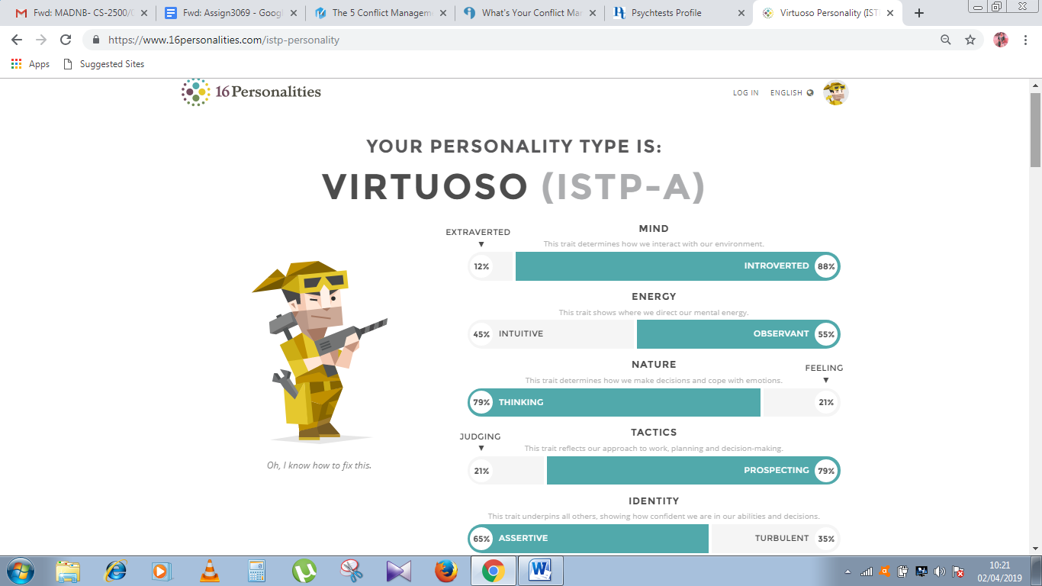
Appendix II
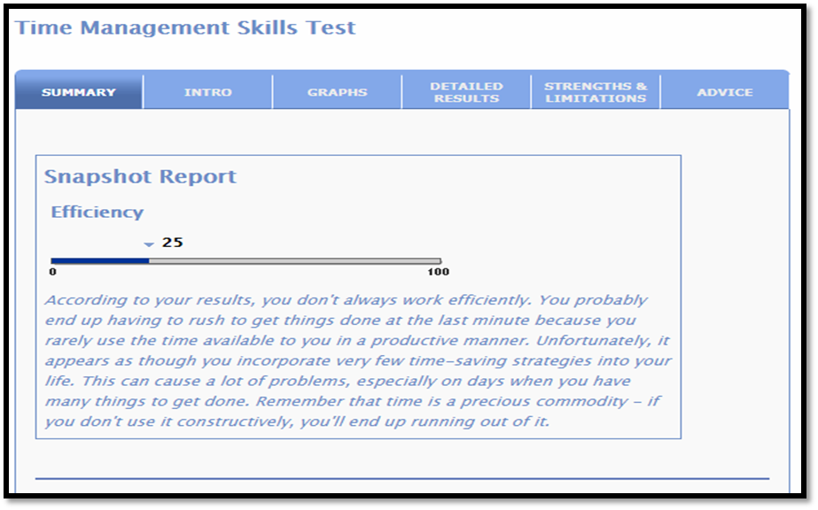

Appendix III
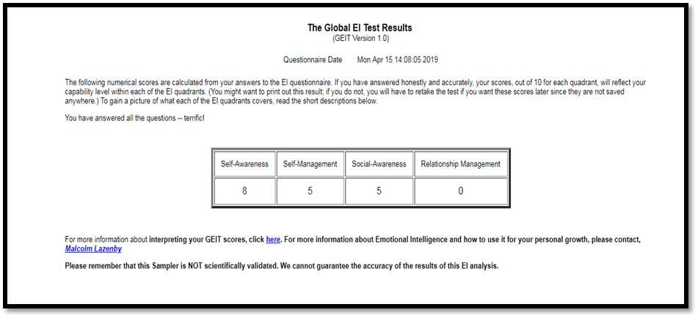
Appendix IV
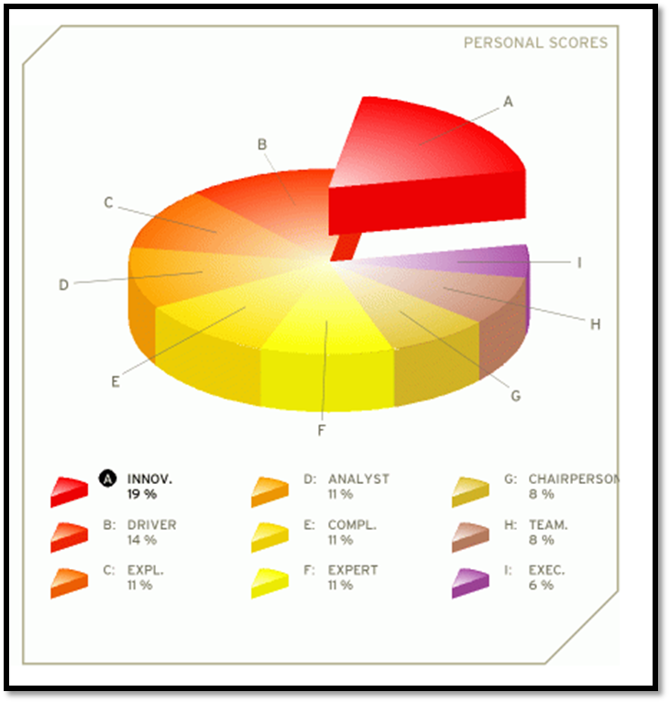
Appendix V


