Reflective Portfolio reports writing
BY

Olajumoke olaide owolawase

Student Id: 2026205

Module: professional development careers

Lecturer: Farah Islam

INTRODUCTION

This assignment, will be divide into three sections
I will be using these tools to be assessing myself.
Section 1
I will discuss the Johari window models and {SWOT} What is Johari window?
This is a framework to understanding conscious or unconscious prejudice and Swot analysis. Strengths, Weaknesses, Opportunities, Threats
section 2
I will be discussing as a manager of NHS at Dudley children hospital, using the theory of Kolb to train my staff both new and old,
Section 3
I will be discussing the portfolio reflection on open-book assessment and mock interviews and diverse types of legislation on what I have learned so far by use Gibbs models
Johari model this is a framework or tools for understanding unconscious and unconscious that can help to increase self-awareness and understanding of other. https://www.gartner.com/en/human-resources/glossary/johari-window
They are four stages are
1. Accessible area as unknown by everyone.
2. Hidden faced area which is not known by everyone, but you knew it
3. Blind spot.
4. Unknown area which is not known by anyone

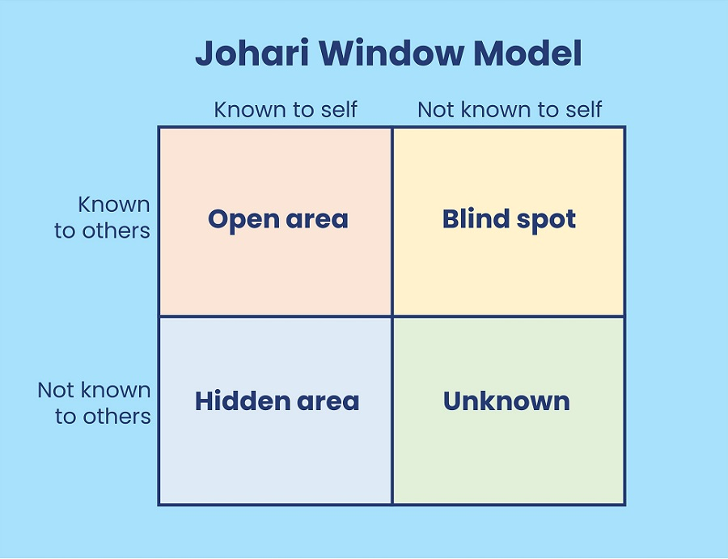
https://www.skillpacks.com/johari-window-model/
fig1 show table of Johari window table. skill packs.
Open area:
This is the information that people know about me such as attitude, behaviours, feeling, skills, the emotion that people know about me, this is the main area where communication arise and the large area becoming the productive and active relationship will be on feedback request from other people.
This is way open area can increase horizontally decreasing the blind area spot this area can also increasing down warding by reducing the Hedden and the unknown area demonstrating one feeling to others, for example in my place of work very good in communication, have a lot of skill to the job I know this, it still wants people to tell me how I was going I ask them for feedback from them.
Blind spot.
This is the information people know about me but are unaware of this., people may interpret me more indifferently than I ever think. {For example, I was talking to people in my place of work I was talking to my co-worker she told me to thank why are shouting at me, but I answer her am not shouting but she was you shouting why you are talking from that day I take caution on how I talk to people.} this blind spot reduces efficient communication finished the seeking feedback from other people.
Hidden area /façade
This is information that is known to me but kept unknown to people, this can be personal information that I feel unwilling to discuss with other people this includes experience, feeling, fears, secrete as I keep this information as private as it may affect the relationship with others, therefore hidden area must reduce by satisfying the information to the open area.
Unknowing.
This is where information that is unknown to me as well to others, this may be feeling, talents, marriage, and even of a lifetime event it may be unknown to me until I discover it, the quality and capability or through the attention of others.
https://www.communicationtheory.org/the-johari-window-model/
SWOT Analysis
Thy are [strength, weakness opportunity, threats SWOT].
This is a strategic management tool used to help to fine an individual or an organisation.
I use this swot analysis for myself, and it helps me to discover the opportunity that I have not seen to me and helps me to understand my weakness. I can manage to remove what may damage my ability to move forward as soon as I start using swot for myself, I begin to separate myself from friends and developed myself to work on my talents and the ability I need in advance in achieving my career and help me to achieve my personal goals in life. For example, I always think am very good at everything I do that did not have to do anything just to get my qualification and started working, once I started using this swot analysis it gives me a clear understanding of my strengths, weaknesses and opportunity I need to build up my career and training need and my threat that I may face and how to overcome the threat.
Strength | Weakness
Time management | Procrastination
Excellent communication | Lack of concentration
Organisation skills | Negative to stress

Opportunity | Threat s
Training | Change in networking
More qualifications and skills
Leigh, D,2009 swot analysis handbook of improving performance place of work. volume1-3. pp115-140.

Using Kolb learning theory to training staffs both new and old

AS a manager of NSH Dudley children’s hospital l I will be using the learning style of Kolb theory to be training my staff both new and old. as part of my responsibility, I needs to put this plan in place so that I will be able to train both new and the old staffs.
This will help me to divide my staffs into different team or groups according to their learning style, it also helps in development practice in place and needs to ensure they meet their goals before the probation is finished, it will allow me to identify individual strengths and weaknesses each staff; as a manager this plan will in place for both of the staffs both new and olds .
What is Kolb's learning style theory? According to David alien is an American educational theorist say is this process whereby knowledge created the transformation of experience” (Kolb, 1984). Kolb believed that ideally learning progressed through the stages to complete a cycle because of changing their experience into knowledge,
There are four learning theories that Kolb's passion on learning cognitive processes that occur to gain knowledge, He also believes that individuals understood could set up their knowledge when they were able to apply the abstract concept of a new problem.
As a manager of NHS Dudley hospital, I will be using Kolb’s learning theory style because it allows me to train my staff in a unique way that they will understand, and it will give them the ability to apply the knowledge instantly.
It will also enable staff’s teamwork and communication skills.
According to the individual learning style, I will be using Kolb's four-stage learning circle.
Concreate experience. This is the process of the cycle with concrete experience, this can be a completely new experience that has already occurred. In concrete, each learner will take active participation in the work.
Kolb believed that the main to learning is involvement. it is not enough for a learner to just read about it or watch it to develop new knowledge, the learner must actively commit to the task. As a manager of NHS Dudley hospitals, I will be using this to train my staff not just to read it.
Reflective observation after they have committed to concrete experience with others, communication at this stage is particularly important and it allows the learner to find the differences between their understanding and experience. good language enables a strong review of the events that occur.
Abstract conceptualization. This is where the learning cycle understanding what is happens, the learners must make effort to bring out the conclusion of the experience by reflecting on the previous knowledge using ideals they are examining possibility theories with the other groups. the learners move from reflection observation asses and conclusions on the occasions. these involved interpreting the experience and making the comparison to their current understanding of the concept, they evaluate the current information and improve their conclusion on the reading exiting suggestion.
Active experience; this is where the learner returns to contribute to the job and this time with their ideal to applying their conclusion to the new experience, it allows them to project and assess their job and makes plans for developing the knowledge in the future which will by enabling the learners to put their knowledge into practice and showing how is relevant to their lives and to ensure that information is maintained in the future.

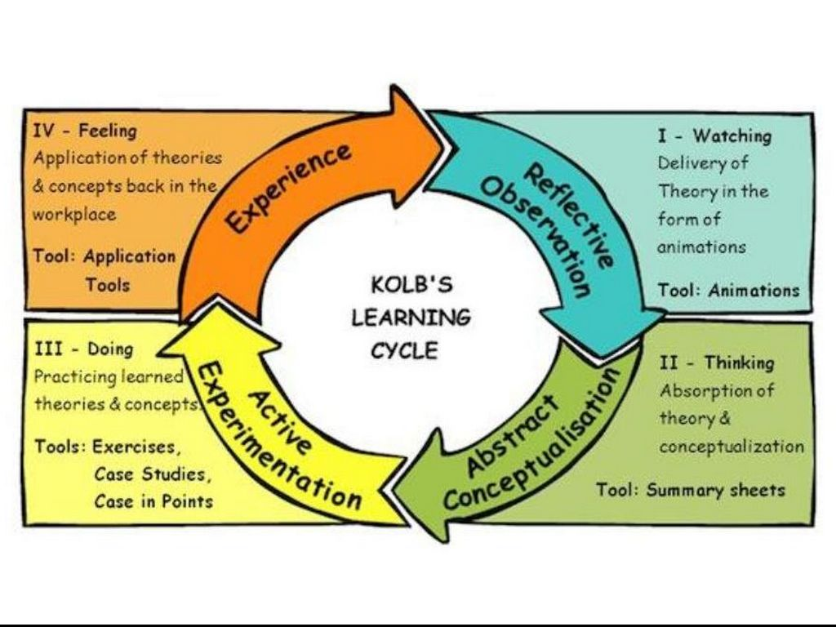
Fig2 show for Kolb learning cycle https://learningck.wordpress.com/2015/04/03/kolbs-experiential-learning-cycle/

I will be using Gibb’s reflection cycle to be accessing myself during my experiences for my open book assessment, interview, and employment law.
Gibbs reflective model this is cycle is a reflective and management tools that helps people thinking clearly and organise different experiences has gone through situation and draw to conclusion. https://www.mindtools.com/pages/article/reflective-cycle.htm

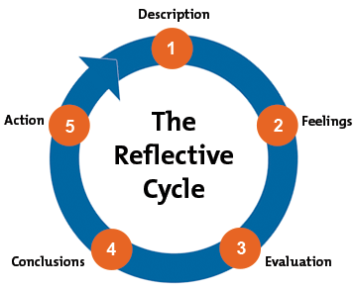fig 5 showing Gibbs reflective

Open book assessment
During the open book assessment whereby, I was giving a case study on mental health at work, I was giving two hours to do it and summit on Turnitin. I believe I cannot do it but during this stage, it helps me to understand how to work fast and develop my mind and brain it allows me to work under pressure. It also helps to understand how to answer and read a report and understand what am doing, also allow for doing more research and having access to the resource to learn. This is good opportunity to understand why it calls open book assessment because I have access to books , internet , you are allows to book some and read some thing about it ,apart for the assessment the topic help me to be aware of how to deal with mental health and the early sign of menta health and if it not be treated what will be the problem
Mock interview
During the mock interview, I was giving a slot at noon for my interview, for me to take part in the interview I must look for a job online and apply for it and write my CV and my cover letter and job distribution, with this, I will allow taking part in the interview. first, what I learn during this course I learn how to write a CV and cover letter because I am exceptionally good at how to write a cv and cover letter but am not un till learning from this muddle how ways how to write a proper cv and cover letter.
During the interview I learn how to dress smart, got to the job interview on time, use eye contact smile, sit upright and hand gestures. Also learnt how to answer, when the interviewer asked me some questions during the interview I was very nervous during the interview but I gain my confidence back because I have never performed any professional interview like this before because during my interview with my support worker it was with the agency no proper interview was given to me, but with muddle, I can learn this and I will be able to use this skill on my next interview in future but can do my interview successfully without any problems. a week after the interview the teacher gives me feedback and give proper advice on where my weaknesses and straight am incredibly grateful for the feedback because it allows me to know which area I need to work on for the future interview.

UK employment law is the relationship between employers and employees. It organizes what the employers can expect from employees and the employees right at work. https://w ww.cipd.co.uk/knowledge/fundamentals/emp-law#gref


Fig 3 shows the show employment https://www.startupdonut.co.uk/employees/employment-rights/top-20-employment-law-facts-you-need-to-know
During these muddles, I learnt diverse types of employment laws and legislation at work such as employment contract, Data protection, holiday pays entitlement, working time, health and safety at work, discrimination, discipline, grievance, and dismissals redundance.
Recruitment {equality Act 2010} I learnt is the equality act work, is that. Everyone has the right to apply for a job in any company in Uk, there is no discrimination against any application jobs, such as age, gender, disability, status or pregnancy, everyone has the right to work.
Employment contract: {Employment right Act 1996} this is the act that covers the right of the employee and the employer at work both sign it, it covers unfears of dismissal, redundancy payment, protection wages, zero-hours contract, Sunday working and flexible working, termination of the employment and suspension at work. This helps me to understand how contract employment is important at work.
Data of protection Act 1998 is act help me to understand how personal information is use by the organisation and the government body. In any place of work, all workers' personal information must be keeps in a safe place where no one can have access to it or use it for something without informing the person first.
Holiday pay and entitlement I learn more about holidays entitlements in a year’s UK expectedly for an employer both agencies because the most employee will not be informing their work and give the right holiday even the right payment. {time at work regulation 1998}.
Health and safety, Act 1974} I learnt how the employee needs to follow the health and safety act and always train all their employer on how to use the instrument and maintain all the instruments they are using all the time.
Discipline and grievance. This is where the employee and employer should follow the code of conduct the discipline their staff before they sack. Because most the employee will just discipline their work because they do not the right to challenge their employee, but most workers will get an advocate to a speaker for them in any situation regards their work.
Conclusion
In conclusion this module, it helps me to understand diverse types of tools to use both now and future and help me to identify what type of learning style have.

References list.
Bassot, B, 2020.the reflective journal, Bloomsbury publishing.
Kolb, D.A.2007.the learning styles inventory Boston, MA: Hay Resource Direct.2007.
Leigh, D, 2009, Swot analysis handbook of improving performance in place of work. Volume 1-3, pp115-140.
https://www.mindtools.com/pages/article/reflective-cycle.htm
https://www.skillpacks.com/johari-window-model/
https://learningck.wordpress.com/2015/04/03/kolbs-experiential-learning-cycle/
https://www.startupdonut.co.uk/employees/employment-rights/top-20-employment-law-facts-you-need-to-know

