MBA: Entrepreneurship
LCMB7004

LECTURER NAME- VASILIOS TAVLARIDIS

Business Plan for Home interior design
Business Company- Modern Haven Interior

Table of Contents
Overview of Business Idea 3
Addressing the market Gap 4
Proposed Business Credentials 5
SWOT of Modern Haven Interiors 7
Target Market 8
Budgeting and Financial Plan 10
Potential External Funding Sources 11
References 13

Overview of Business Idea
It is with great pleasure that I introduce Modern Haven Interiors, an interior design company based in London. Our company specializes in creating living spaces for our clients that are modern, stylish, and functional at the same time. By combining contemporary design elements with personalized touches, we strive to transform houses into inviting and comfortable homes that resemble family homes.
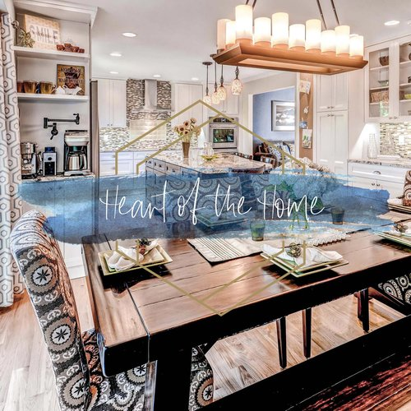
We offer a variety of services, including:

Design Consultation: The consultations Modern Haven Interiors offers are tailored to each client's needs, preferences, and budget to meet those needs. A tailored interior design plan can be created with the guidance and recommendations of our expert interior designers.

Space Planning: As part of the Modern Haven Interiors’ optimization process, we plan the layout and arrangement of furniture, and traffic flow, and maximize the functionality of the space available to us. There is no doubt that our team is capable of creating efficient floor plans that enhance the overall aesthetics and usability of a home (Huber, 2021).

Color and Material Selection: Choosing the right color schemes, materials, and finishes will create a harmonious and cohesive look for your home. As a result, we will assist you in choosing the perfect options. The modern Haven Interiors team is always up to date on the latest trends in design to ensure that the options we offer are contemporary and timeless.

Furniture and Décor: Depending on the style and budget that you are seeking and the style of your home, we will curate a selection of modern furniture, accessories, and décor items accordingly. The goal of our design process is to create a customized look for each client that reflects their lifestyle and personality.

Project Management: In addition to handling all aspects of the design project, we coordinate with contractors, oversee installation, and ensure that all aspects of the project are in order on time. In addition to providing our clients with a stress-free experience, we also provide them with project management services (Huber, 2021).

Addressing the market gap
We have identified a significant gap in the home interior design market in London, in terms of personalized and modern designs that cater to the needs and preferences of our clients and are personalized to suit their particular needs and preferences. There are several design firms in the market today that follow generic styles or cannot create spaces that are unique and contemporary and tailored to the specific lifestyles of individual clients (Leung, Ma, & Zhang, 2013). As a result of this gap, Modern Haven Interiors can stand out from the competition and meet this need more effectively. Following are how we plan to address this gap:

Client-Oriented Approach: It is our priority at Modern Haven Interiors to understand the preferences, lifestyles, and budgets of our clients. As a result of our detailed consultations, we gain a deep understanding of the client’s requirements by gathering specific information. We can create a design solution that reflects the personality of the client while fulfilling the functional needs of the client.

Modern Design Expertise: Keeping up with the latest trends and design concepts is one of the key focuses of Modern Haven Interiors, a company specializing in modern interior design. There are many ways in which we differentiate ourselves from traditional design firms, including our innovative ideas, unique color schemes, and contemporary furniture selections. The fact that we focus on modern aesthetics allows us to cater to clients who are looking for fresh, stylish, and up-to-date design solutions (Onem & Hasirci, 2020).

Detail-Oriented Design: As part of our comprehensive approach to the design process, every detail is meticulously considered, including space planning, color coordination, and the selection of materials. A space that is cohesive and visually appealing can be achieved with the addition of a few small details that give it a sense of cohesiveness. Throughout the process, we put great emphasis on attention to detail, resulting in the transformation of our client’s homes into beautiful and functional havens.

Project Management Excellence:
Choosing the right interior designer can seem overwhelming to a client, and we understand that. Our project management services are designed to address this problem comprehensively. To ensure a seamless and stress-free experience for our clients, we take care of all coordination, scheduling, and overseeing of installations through our team of experts. With this level of service, we set ourselves apart from our competitors and enhance the overall experience of our customers (Katnane, 2019).
Modern Haven Interiors aims to become one of London's premier home interior design firms by providing clients with cutting-edge and personalized solutions to the problem of a lack of personalized, modern design solutions and providing them with excellent customer service. Our approach, we believe, will be able to attract the attention of a niche market segment and make us one of the industry's most respected and sought-after design firms.

Proposed Business Credentials

Location:
A vibrant and diverse city like London is the proposed location for Modern Haven Interiors. I have the following reasons for choosing London as the location of my business:
There is a high demand for interior design services in London's booming real estate market. Thousands of residents and businesses reside in the city, where quality and aesthetics are valued. The British capital offers Modern Haven Interiors a significant market opportunity (Byrne, 2023). Additionally, it is renowned for its rich cultural heritage, artistic communities, and design-driven mentality. Design trends and styles abound in the city, creating an environment where innovative and creative design concepts thrive. Because Modern Haven Interiors is located in London, it can draw inspiration from the city's design culture, collaborating with local suppliers and artisans. The London design industry thrives thanks to the talent of its interior designers, architects, and artisans. Modern Haven Interiors has an advantage over its competitors in that it can tap into the talent pool in London and attract skilled, passionate design professionals who can contribute to its growth (Mansion global, 2022).

Legal Entity:

It will be a Limited Liability Corporation (LLC) that runs Modern Haven Interiors. This legal entity has the following justification as to why it should exist:
An LLC is a type of business entity that provides the owners with personal liability protection. As a result, the owner’s assets are generally protected against any financial or legal issues that may arise as a result of the business, limiting their liability to the extent of the amount they have invested in the business (Fernando, 2022). Furthermore, Compared to other entities such as corporations, LLCs offer fewer formalities and administrative requirements. Consequently, Modern Haven Interiors can better adapt to changing market conditions and focus on its core operations. LLCs also offer pass-through taxation, which means the business itself isn't taxed separately. Taxes are instead paid by the owners, who report profits and losses on their tax returns. As a result, taxpayers may benefit from tax advantages and the tax filing process will be simplified (Fitzpatrick, 2022).
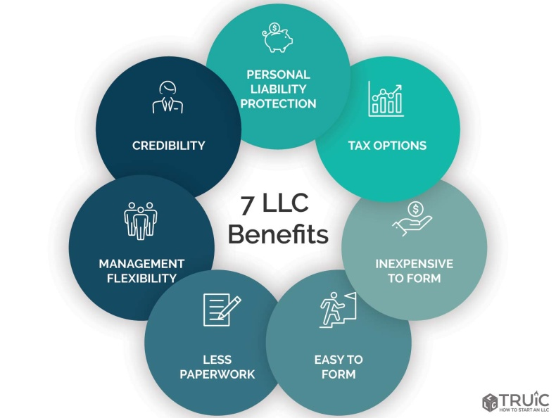

Overall, the decision of locating Modern Haven Interiors in London and establishing it as an LLC has enabled Modern Haven Interiors to obtain a competitive advantage in terms of market demand, access to skilled professionals, and legal protection, which has enabled the company to thrive and be successful in a highly competitive market.

SWOT of Modern Haven Interiors

Strengths

- Modern Design Expertise: The main difference between Modern Haven Interiors and traditional design firms is that we specialize in modern interior design. To provide our clients with contemporary and stylish design solutions, we stay up-to-date with the latest trends.

- Project Management Excellence: Managing contractors and overseeing installations are all part of our comprehensive project management services. We ensure our clients have a seamless and stress-free experience (Bonato & Fedrizzi, 2019).

Weakness

- Relatively New Business: The launch of Modern Haven Interiors as a brand-new business is likely to present several challenges, such as establishing brand recognition and building a client base within an extremely competitive market.

- Limited Resources: In the event of limited resources, the scope and scale of first-hand projects that can be undertaken may be impacted by the financial and human resources available.

Opportunities

- Growing Demand: There has been a significant increase in the demand for professional interior design services, which can be attributed to a growing population, the real estate market, and a desire for aesthetically pleasing living spaces.
- Niche Market: Taking a customized, modern approach to design, Modern Haven Interiors can target a niche market segment that values the aesthetics of contemporary design and a tailored approach to interior design (Bonato & Fedrizzi, 2019).

Threats

Competition: Several established firms and freelancers are involved in the interior design industry in London, making it one of the most competitive in the world. It can be challenging to compete for clients as well as market share when it comes to your business.

- Economic Factors: Consumers need to be aware that fluctuations in the economy, such as recessions and downturns in the real estate market, can have an impact on their discretionary spending (Bonato & Fedrizzi, 2019).

Target Market

The majority of the clients of Modern Haven Interiors are individuals and families who have a higher income bracket and reside in London. We can define our target market in the following way:
- Demographics: As an interior design company, our main target market consists of homeowners or renters between the ages of 30 and 60, who are driven by modern design aesthetics and have the financial capacity to invest in high-quality interior design services of the highest quality.

- Psychographics: Our target customers tend to prefer living spaces that are stylish, functional, and contemporary. It is important to them that every detail is taken into consideration, that personalized touches are made, and that harmony between aesthetics and functionality is maintained.

Strategies to Capture the Target Market

- Targeted Marketing Campaigns: Our marketing campaigns will be targeted so that we can reach our ideal customers most effectively. As a result, we increase our visibility and attract potential clients actively seeking interior design services by advertising on the web, using social media marketing, and using search engine optimization (SEO).

- Showcase Portfolio: To showcase our expertise in modern design and demonstrate our ability to create customized and visually stunning spaces, we will create an impressive portfolio of our previous projects and create showcase our impressive portfolio. In addition to demonstrating our capabilities, this website will also serve as a powerful marketing tool for attracting potential clients to our business (Aghdaie & Alimardani, 2015).

. Networking and Partnerships: This will be accomplished by actively participating in networking events and industry trade shows, as well as establishing partnerships with complementary businesses that, for example, are real estate agents and home improvement, contractors. By doing so, we will be able to reach more of our target market and generate more referrals, as well as generate leads within our target market (Liinkedin, 2022).

- Personalized Consultations: To better understand the needs of potential clients, establish rapport, and demonstrate our expertise, we offer free initial consultations to prospective clients. We believe that this personal approach will help increase the level of trust and confidence in our services, thereby increasing the likelihood of consultations converting into actual projects in the future.

- Exceptional Customer Service: In every stage of the design process, we will put a high priority on providing a high level of customer service to our clients. As part of our commitment to providing our clients with a seamless and enjoyable experience, we take steps to ensure effective communication, prompt responses to inquiries, and efficient service. As a result, we are more likely to have satisfied customers who recommend our services to their friends and family and become repeat clients themselves as a result.

- Online Presence and Testimonials: In addition to maintaining a strong online presence through our website, social media platforms, and online directories, we will also maintain a strong local presence. Further, we are actively seeking out and showcasing testimonials and reviews from happy clients and using this as a means to build credibility and attract new customers, leveraging the power of positive word of mouth (Forbes, 2020).

Budgeting and Financial Plan

An overview of Modern Haven Interiors' budget and financial plan, including funding requirements and potential external sources:
Start-up Costs
- Rental and setup of office space
- Tools and software for interior design
- The furniture and decor of the office
- Advertising and marketing expenses
- Services related to professional practice (lawyers, accountants)
- Development and maintenance of websites

Ongoing Operating Expenses
- Employee salaries and benefits
- Rent and utilities
- Office supplies and maintenance
- Marketing and advertising costs (online and offline)
- Insurance premiums

Revenue Streams
- The cost of design consultations
- Fees associated with project management
- Sales markup on furniture and décor

Funding Requirements
- Start-up costs (e.g., office setup, marketing, software): £60,000
- Initial operating expenses (for the first 6 months): £100,000
- Total Funding Requirements: £150,000

Profit and Loss Projections
The table below illustrates the estimated financial performance for the first year of operation of the new business start-up in terms of loss and profit.

Potential External Funding Sources
Self-Funding: A portion of the funding requirements can be covered by the owners' savings or investments. Commitment and confidence in the company are evident here.

Bank Loans: The strength of Modern Haven Interiors’ business plan, the1 projected cash flow, and the collateral can determine whether a traditional bank or financial institution will provide you with a business loan. A collateral and good credit history may be needed for this option.

Small Business Grants: Modern Haven Interiors can apply for small business grants from government agencies, non-profit organizations, and foundations that are specific to your industry. Application criteria and application processes for these grants are often specific.

Venture Capitalists: Investors interested in the interior design industry may be able to provide you with investment. A share of the business or equity can be exchanged for funding (Srivastav, 2022).

Justification of Choices
In a self-funded business, the owners retain control over the business and retain ownership. In addition to providing access to capital, bank loans also come with a high repayment rate and a lengthy process. It is possible to obtain external validation for your business by using small business grants, which are a non-dilutive source of funding. The expertise and connections of an angel investor or venture capitalist are in addition to the capital they provide. A crowdfunding campaign builds a sense of shared ownership by engaging a broader community and potential customers. Funding sources for interior design companies will vary according to the owners' financial capability, risk tolerance, and desired ownership structure.

Finally, the London home interior design business plan of Modern Haven Interiors provides an overview of the planned business. Business ideas, market gaps, target markets, business strategies, and financial considerations are outlined in the report. Our mission at Modern Haven Interiors is to contribute to the market by providing personalized, modern design solutions that meet clients' unique needs and preferences. Modern Haven Interiors will be based in London, a city known for its booming real estate market and design-focused culture. Overall, the company is well-positioned to become a well-known and trusted interior design firm in London.
In a competitive market, the company is poised for success because of its focus on modern design, personalized approach, attention to detail, and exceptional customer service, making it the ideal candidate for success.

References
1. Aghdaie, M. H., & Alimardani, M. (2015). Target market selection based on market segment evaluation: A multiple attribute decision-approaching. International Journal of Operational Research, 262-278.
2. Bonato, P., & Fedrizzi, R. (2019). State-of-the-art and SWOT analysis of building integrated solar envelope systems. Research gate, 1-11.
3. Byrne, F. (2023, Jan 25). What To Know About The Demand For Interior Design In 2023. Retrieved from https://www.baid.co.uk/: https://www.baid.co.uk/blog/what-to-know-about-the-demand-for-interior-design-in-2023#:~:text=In%20the%20U.K.%20alone%2C%20the,to%20be%20changing%20anytime%20soon.
4. Falcone, S. M. (2019). Designing Single-Family Residences: A Study of the Positive Impact of Interior Design in Creating New Home Value. University of Nebraska.
5. Fernando, J. (2022, july 31). What is an LLC? Limited Liability Company Structure and Benefits Defined. Retrieved from Investopedia: https://www.investopedia.com/terms/l/llc.asp
6. Fitzpatrick, D. (2022). How LLC Members Are Taxed. Retrieved from NOLO: https://www.nolo.com/legal-encyclopedia/how-llcs-are-taxed-29675.html
7. Forbes. (2020, Dec 9). 15 Marketing Strategies To Make The Most Of Customer Testimonials. Retrieved from Forbes: https://www.forbes.com/sites/forbesagencycouncil/2020/12/09/15-marketing-strategies-to-make-the-most-of-customer-testimonials/?sh=5dd41bcd341f
8. Huber, A. M. (2021). Exploring Informed–Design Services during the Project–Defining Phases in Commercial Interior Design. Journal of Interior Design, 1-11.
9. Katnane, E. (2019, Aug 27). What value does the interior designer-project manager add to the construction project? Retrieved from linkedin: https://www.linkedin.com/pulse/what-value-does-interior-designer-really-add-project-%D8%A7%D8%A8%D8%AA%D8%B3%D8%A7%D9%85-%D9%82%D8%B7%D9%86%D8%A7%D9%86%D9%8A/
10. Leung, C., Ma, W. Y., & Zhang, J. (2013). The Market Valuation of Interior Design and Developers Strategies: A Simple Theory and Some Evidence. SSRN Electronic Journal, 1-9.
11. Linkedin. (2022). How do you leverage your existing network and partnerships to facilitate your market entry and expansion? Retrieved from Liinkedin: https://www.linkedin.com/advice/0/how-do-you-leverage-your-existing-network-partnerships
12. The mansion is global. (2022, July 22). London’s Emerging Interior Design Talent. Retrieved from Mansion global: https://www.mansionglobal.com/articles/londons-emerging-interior-design-talent-01658487212
13. Onem, M., & Hasirci, D. (2020). Designing Brand Experience in Interior Space. IOP Conference Series Materials Science and Engineering, (pp. 1-12).
14. Srivastav, A. K. (2022). What are External Sources of Finance? Retrieved from wallstreetmojo: https://www.wallstreetmojo.com/external-sources-of-finance/
15. Statista. (2022, July 27). Interior design market value worldwide from 2013 to 2021. Retrieved from Statista: https://www.statista.com/statistics/899161/global-interior-design-market-value/

