University of Wales Trinity Saint David
course: Business and Management
Module: BMSP4012 – Global Business Challenges
Lecturer: Anthony Burns
Student Name: Codi Roberts
Student ID: 2508438
Assignment Title: How Climate Change is Forcing Businesses to Rethink Sustainability
Case Study Focus: EasyJet
Word Count: 1,619

Title: How Climate Change is Forcing Businesses to Rethink Sustainability

Introduction

Climate change is rapidly becoming one of the biggest global challenges that is affecting modern businesses. Rising temperatures, unpredictable weather patterns, and new environmental laws are reshaping how organisations run on a day-to-day basis. Issues such as supply chain delays, energy instability, and increasing operational costs mean that companies must adapt quickly to survive and remain competitive. Businesses are no longer able to ignore environmental risk, as governments, customers, and investors now expect organisations to take responsibility for their climate impact and show real efforts toward sustainability.
Sustainability has therefore shifted from being optional to becoming a central part of business strategy. Many companies, such as EasyJet and Swansea University, are taking clear steps to reduce their carbon footprint and meet long-term climate goals. EasyJet, for example, faces major challenges as an airline, yet it has introduced new strategies to cut emissions and prepare for a greener future. These actions show how businesses across different industries are being pushed to innovate, act responsibly, and help tackle climate change. The growing pressure from stakeholders is also encouraging organisations to rethink how they use resources, invest in technology, and manage environmental risks, reinforcing the idea that sustainability is now essential for long-term growth.

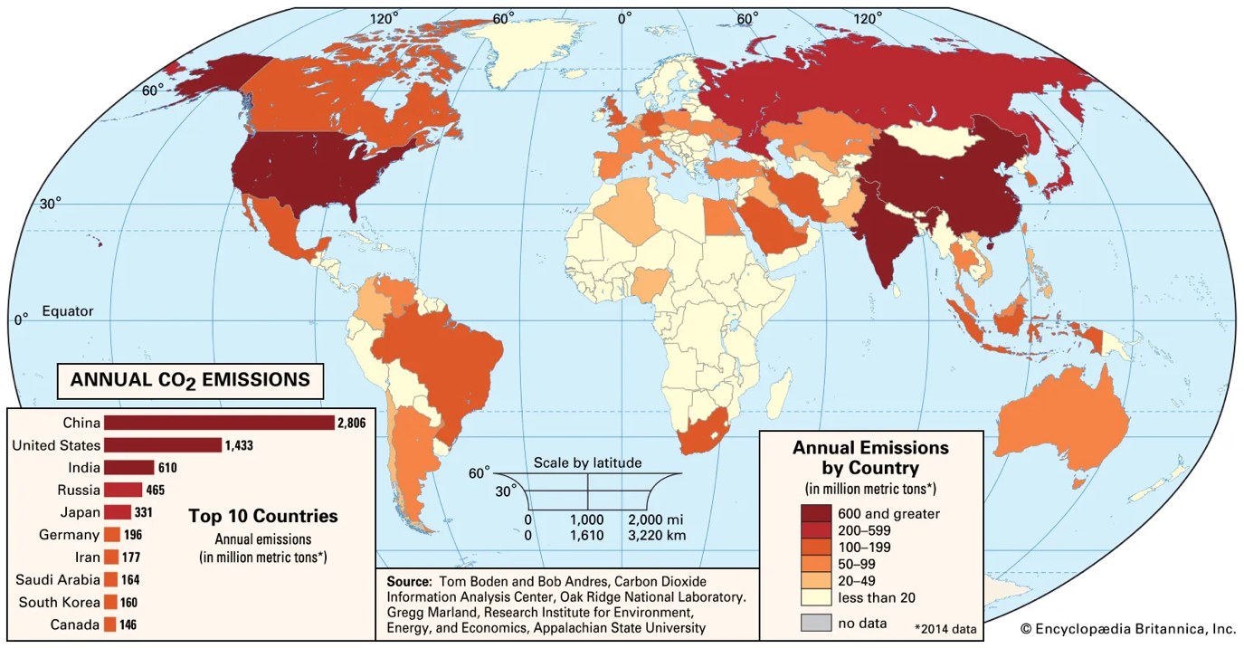

The Impact of Climate Change on Businesses
Climate change is already affecting how organisations work around the world. Many Businesses are facing higher costs, supply chain problems, and new regulations focused on reducing carbon emissions. Extreme weather events like floods, heatwaves, and storms are damaging infrastructure and increasing insurance costs. Rising energy prices also make production and transport more expensive, particularity for industries that depend heavily on fuel, such as aviation and logistics. Research also shows that climate change creates long-term operational risks for the aviation sector, with airlines needing to adapt quickly to rising temperatures and environmental pressures to remain practical (Gössling & Peeters, 2021).
According to the BCS (2023), companies now need to consider environmental risks such as power shortages, flooding, and disruption to staff working conditions. Climate change has also increased pressure for customers and investors, who expect businesses to take genuine action on sustainability instead of relying on short-term promises. In the UK, the Committee on Climate Change (2023) explains that switching to renewable energy and low-carbon technologies is vital for long-term business growth.
If businesses Fail to act on these challenges, they risk losing customer trust and damaging their reputation, therefore, organisations that invest early in green innovation can save costs, attract customers, and strengthen their brand image. These factors show that climate change is not only an environmental issue, but also a major business risk that affects performance, stability, and future success.

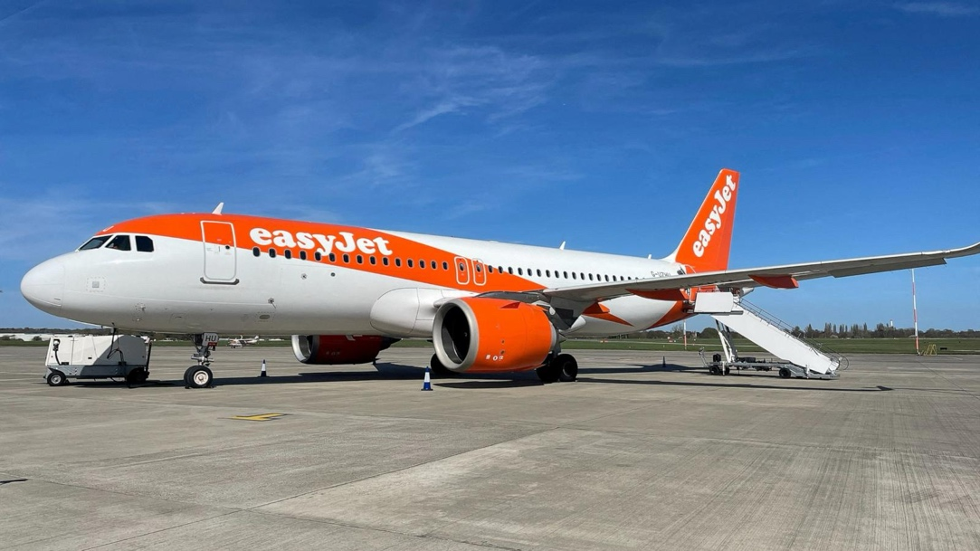
EasyJet’s Sustainability Strategy and Response to Climate Change
EasyJet is one of Europe’s leading low-cost airlines, working in an industry that faces strong criticism for its environmental impact. Air travel produces a large amount of global carbon dioxide emissions, and airlines are under increasing pressure to find cleaner ways to work. EasyJet has recognised this issue and made sustainability a key part of its business strategy.
The company aims to achieve net zero carbon emissions by 2050, aliening with global aviation targets. To reduce its environmental footprint, EasyJet has invested in new Airbus planes that are lighter and use up to 15% less fuel than earlier models (EasyJet, 2023). The airline is also supporting research into electric and hydrogen-powered planes, through partnerships with companies like Rolls-Royce and Airbus.
EasyJet has introduced several fuel-saving measures, such as using single-engine taxiing, reducing onboard weight, and improving flight planning systems. These steps help cut emissions per passenger and improve efficiency. While EasyJet previously offered carbon offsetting for all flights, it later shifted focus to direct emission reduction, acknowledging that offsetting alone cannot fully solve the problem (BBC News, 2022). By investing in technology and sustainable practices, EasyJet shows that even high-emission industries can innovate and adapt to the global climate challenge.



Challenges and Criticism
Although EasyJet has made real progress in reducing its environmental impact, the company still faces major challenges. Aviation is one of the hardest industries to make carbon neutral because it relies heavily on fossil fuels, and alternatives like hydrogen or electric planes are still years away from being used on a large-scale. EasyJet’s goal to reach net zero by 2050 is ambitious but achieving that goal will depend on future technology developments and strong global support.
Environmental groups have also accused EasyJet of greenwashing. The airline’s earlier use of carbon offsetting, paying for tree planting and renewable projects to balance emissions, was criticised for being misleading. Academic studies also show that global investors now expect businesses to prove genuine sustainability progress rather than relying on marketing claims, increasing pressure on companies like EasyJet to deliver real environmental improvements (Eccles & Klimenko, 2019). Critics, including the Changing Markets Foundation (2022), argue that offsetting does not stop pollution from happening, it only moves the responsibility elsewhere. Although EasyJet has since stopped promoting full carbon neutrality through offsetting, these concerns highlight how difficult it can be for airlines to build public trust while still running in a high emission industry.
Financial pressures also make sustainability harder. recent technology, such as hydrogen or electric planes, requires large investment and long-term planning. EasyJet must therefore balance profitability with environmental goals, a challenge faced by most businesses trying to move towards a greener economy.

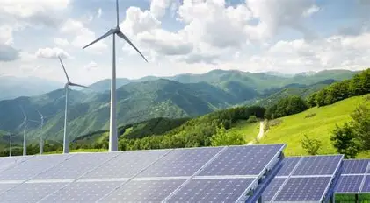
Global Perspective and Comparison
The challenge of tackling climate change is not limited to EasyJet or the aviation industry; businesses around the world are facing similar pressures to become more sustainable. Many global companies now see that reducing emissions is not only an environmental duty, but also a competitive advantage. For example, IKEA has invested heavily in renewable energy, including wind farms and solar panels on its stores to power operations. The company aims to become fully climate positive by 2030, meaning it will remove more emissions than it produces (IKEA, 2023). Similarly, Microsoft has pledged to reach carbon negativity by 2030 by developing carbon-removal technology and making its data centres more energy efficient (Microsoft, 2023).
In the transport sector, Deutsche Bahn in Germany is increasing the use of renewable electricity to power its trains, aiming for climate-neutral operations by 2040. These examples show that different businesses are moving in the same direction as EasyJet, reducing emissions, improving energy efficiency, and investing in innovation to remain competitive in a changing global market. However, progress is not equal across all sectors. Technology and retail businesses can move more easily to renewables, while airlines and heavy manufacturing still depend heavily on fossil fuels, making their transition much slower and more challenging. This difference highlights why global cooperation, long-term investment and industry-specific solutions are crucial for achieving meaningful climate progress.

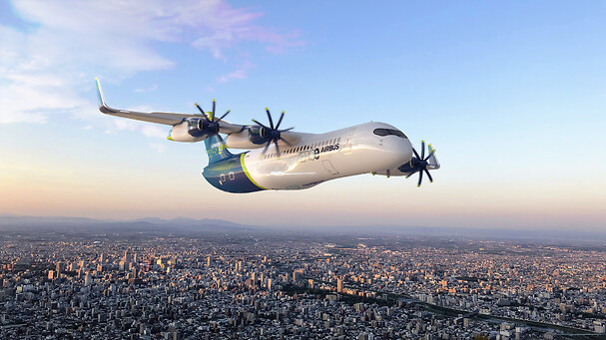
The Future of Sustainable Aviation and Business Responsibility

The future of sustainable aviation relies on ongoing innovation and collaboration between airlines, governments, and manufacturers. The global aviation sector currently contributes around 2–3% of total carbon emissions, but demand for air travel continues to grow. To meet future targets, airlines such as EasyJet, British Airways, and Lufthansa are investing in alternative fuels, electric plane technology, and carbon removal projects. Sustainable Aviation Fuel (SAF), made from waste materials and renewable sources, can cut emissions by up to 80% compared with traditional jet fuel (International Air Transport Association, 2023). However, production levels stay limited and costly slowing down widespread use.
EasyJet’s partnership with Rolls-Royce and Airbus to develop hydrogen-powered plane shows how innovation could transform the industry. These planes could potentially fly without releasing any carbon emissions, marking a major step forward for aviation. Still progress will depend on government support, new infrastructure, and public confidence in these technologies.
businesses across all sectors are realising that sustainability is about more than just technology, it is also about responsibility and transparency. Consumers are becoming more aware of greenwashing and expect companies to prove their claims. According to Deloitte (2024), 75% of younger consumers are more likely to support brands that actively reduce their environmental impact. This shift pushes companies like EasyJet to focus not only improve their operations but also their communication and accountability.
The future of sustainable business will depend on clear goals, open reporting, and collaboration. While challenges stay, continued innovation in low-carbon technology and a growing shift towards responsibility will help industries like aviation move closer to a cleaner and greener future.

Conclusion

Climate change is transforming how businesses run across every industry. Organisations are now expected to take responsibility for their environmental impact and show that they are contributing to a sustainable future. EasyJet proves that even high-emission sectors such as aviation can make meaningful progress through investment in fuel-efficient planes, reduced waste, and the development of new low-carbon technologies. These decisions highlight how the airline is trying to balance profitability with environmental responsibility while still meeting the rising expectations of customers, regulators, and wider society.
However, achieving genuine sustainability is still challenging. It requires long-term commitment, transparency, and innovation rather than short-term marketing claims. As greenwashing cases across the business world have shown, trust is only earned when companies deliver real, measurable results. The wider shift towards renewable energy and carbon reduction, seen in businesses like IKEA and Microsoft, reinforces that sustainable practices are becoming essential for long-term stability and competitiveness, not just reputation.
In today’s world where customers, investors, and governments increasingly demand accountability, sustainability can no longer be treated as optional. Businesses that act early, like EasyJet, are better positioned to manage future risks, attract environmentally conscious consumers, and remain competitive in a changing global economy. By continuing to innovate and invest in low-carbon solutions, companies can play a meaningful role in tackling climate change while also strengthening their ability to grow, adapt, and succeed in a low-carbon future.

Reference list
BBC News. (2022). EasyJet ends carbon offsetting to focus on emission cuts. https://www.bbc.co.uk/news

BBC News. (2023). 2 easyJet planes clip wings at Manchester Airport in UK [Photograph].

Airbus. (2023). Future aircraft concept [Photograph].

BCS. (2023). Preparing your business for climate change. The Chartered Institute for IT. https://www.bcs.org

Changing Markets Foundation. (2022). Licence to greenwash. https://changingmarkets.org

Committee on Climate Change. (2023). Business and industry. https://www.theccc.org.uk

Deloitte. (2024). Sustainability and consumer behaviour report. https://www.deloitte.com

EasyJet PLC. (2023). Our journey to net zero. https://corporate.easyjet.com/sustainability

Eccles, R. G., & Klimenko, S. (2019). The investor revolution. Harvard Business Review, 97(3), 106–116.

Encyclopaedia Britannica. (2014). Global carbon emissions map [Map].

geniusksy. (n.d.). Solar panels and wind turbines [Photograph]. Shutterstock.

Gössling, S., & Peeters, P. (2021). Assessing the climate impact of aviation: Issues, challenges and approaches. Journal of Transport Geography, 96, 103–123.

IKEA. (2023). Becoming climate positive by 2030. https://www.ikea.com

International Air Transport Association. (2023). The future of sustainable aviation fuel. https://www.iata.org

Microsoft. (2023). Sustainability at Microsoft. https://www.microsoft.com/sustainability

Munandar, A. (n.d.). Tree growing on globe in field [Photograph]. Dreamstime.

