Synthesize a Solution to a Potential Real Life Scenario
Jacob John Hopkins
Student University of Wales Trinity St David, Swansea, Wales
2003836@student.uwtsd.ac.uk

Table of Contents
Task 1 12
Abstract 12
Forensic Toolkit (FTK) 12
Wireshark 13
Autopsy 14
Forensic Tool Table 16
Task 2 17
Case Study 17
Methodology 17
Conclusion 18

Task 1
Abstract
Pertaining to the analysis of electronically stored information within computers and digital storage media, Computer Forensics at its core never changes. It is the application of both investigation and analysis techniques, used to gather and preserve evidence from a range of computer sources to document and present in the court of law. Throughout the years, computer forensics has evolved parallel to our technology. Its methods continuously adapt to best suit its environment, striving to achieve the desired outcomes of forensic professionals. And while the concept of computer forensics remains the same, the tools that are used to conduct these investigations always change. Throughout this research paper, the analysis, comparison, and evaluation of various computer forensic tools will help highlight the extensive library forensic professionals have available to them. A collection of both commercial and open-source tools will be covered, ensuring to underline the key differences and benefits that may come with each piece of software.
Keywords – Computer Forensics, FTK, Wireshark, Autopsy.
Forensic Toolkit (FTK)
- Introduction
Access Data’s Forensic Toolkit, better known as FTK, is a powerful and recognized tool within computer forensics. Offering a suite of software techniques, intended to provide a complete solution for computer forensic professionals, the toolkit has landed itself as a reputable and court-cited digital investigations solution ^{[1]}. Unlike its open-source counterpart FTK Imager, an imaging tool designed to quickly assess and preview data. FTK is Access Data’s commercial forensics toolkit designed to further analyse evidence past the capabilities of FTK Imager ^{[2]}.
- Use Case & Features
While many forensic tools available specialise in one particular use case, FTK tries to break that mould by offering an impressively extensive range of features and capabilities to its users. It has the ability to curate full-disk images and process a wide range of data types for forensic investigation that is unlike no other. Processing and indexing data upfront with its efficient engines, FTK can reduce optical character recognition time by up to 30% ^{[3]}. When put up against competing software, FTK and its imaging capabilities top the tables. This is highlighted in a forensic tool comparison report by Champlain College ^{[15]}, as seen in figure 1 below.
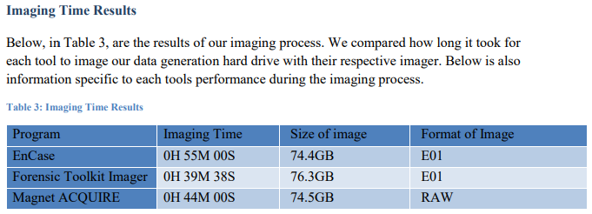^{[15]}
Figure 1
Its file decryption is a central part of the toolkit, claiming to decrypt and recover passwords from over 100+ applications ^{[3]}, including data encrypted by some of the leading security experts such as McAfee. The application can also locate, manage, and isolate mobile data from mobile devices using the Access Data mobile phone examiner (MPE), a tool that runs in conjunction with FTK. Investigators can quickly and easily acquire evidence using this feature of FTK both wired or wirelessly without altering any data on the device ^{[7]}, this is an essential factor when preparing evidence admissible to a court of law. Further features of the application include:
- Parsing system information and registry files. This can also be deployed for the analysis of emails, where is it recognised as the leading forensic tool for email analysis ^{[4]}.
- Collect and analyse Apple file system datasets, including those that are encrypted, compressed, or deleted ^{[3]}.
- And empowering users with data visualisation tools, to help construct clear graphs and geolocations across timelines.
At its core, FTK “provides user with the ability to perform complete and thorough computer forensics examinations [using] powerful file filtering and search functionalities” ^{[4]}, all to help collect and document acquired evidence. FTKs intuitive graphical user interface (GUI) binds these key features together into an effective and powerful tool that can be used to challenge a range of computer forensic evidence. An image of the FTK GUI can be seen in figure 2 below, captured on its latest software version 7.4. Appendix A documents additional features and add-ons that can be found throughout FTK.
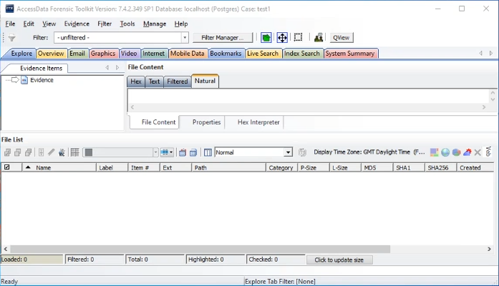
Figure 2

- Example Uses
In 2012, FTK played a key role in a court case between defendant Christopher Owen Schlingloff and the United States of America. A reported 130 media devices were seized and sent for analysis in Arlington, Virginia. Each of these media devices were subject to indexing, ensuring to catalogue any and all files identified on each drive into a viewable format ^{[8]}. All of this was done through the use of FTK and its collective tools such as the Known File Filter (KFF). HG Insights, a self-proclaimed “global leader in technology intelligence” ^{[5]} specialise in providing accurate and valuable market data to its customers. According to their databases, a reported 3,143 businesses tracked by HG Insights use FTK ^{[6]}. Of the 3,143 businesses includes the FBIs Computer Analysis Response Team (CART). Acting as its primary training tool for CART examiners, FBI Forensic Examiners are required to have an understanding and experience with FTK ^{[4]}, this alone signifies the impact and importance FTK holds as a forensic tool.
- Evaluation
FTK rightfully earns itself a place atop the leading forensic tools for computer analysts. Its vast library of features provides a use case for almost anyone after a forensics suite and bundles it together in an intuitive and powerful package. While the commercial tool does come with a substantial cost, the continuous and readily available support from Access Data quickly makes up for it.

Wireshark
- Introduction
Wireshark is “the world’s foremost and widely-used networking protocol analyser” ^{[9]}. Its rich feature set firmly places itself as a staple forensic tool for network analysis and is stated to be crucial to network forensics ^{[16]}. The open-source network tool has found itself widely deployed by practitioners and researchers alike thanks to its versatile functionality, with HG Insights reporting over 26,402 companies using Wireshark ^{[10, 11]}. Paired with its intuitive GUI, similar to that of FTK, Wireshark can display various key details of captured packets that can help with the analysis and management of gathered evidence.
- Use Case & Features
At its core, Wireshark is a packet sniffing and traffic analysis tool that utilises packet capture (PCAP) to capture and analyse data transferred across a network. The application can be used across various forms of media types, with support for wired connections including ethernet and USB, and wireless mediums such as Bluetooth and Wi-Fi to capture data. Even providing users the option to import files captured by other programs, and export those created by Wireshark for offline analysis. When analysing packet data within the analysis tool, users are able to utilise complex and precise filters to gather desirable data from within the pcapng files. Referred to as Display Filters, the feature can pick out protocols, fields, or even field values buried deep within collected packets, all using its extensive library of over 271,000 fields and 3,000 protocols as of version 3.6.3 ^{[12]}. Figure 3 depicts a display filter highlighting DNS and IP packets from the address 192.168.10.1.
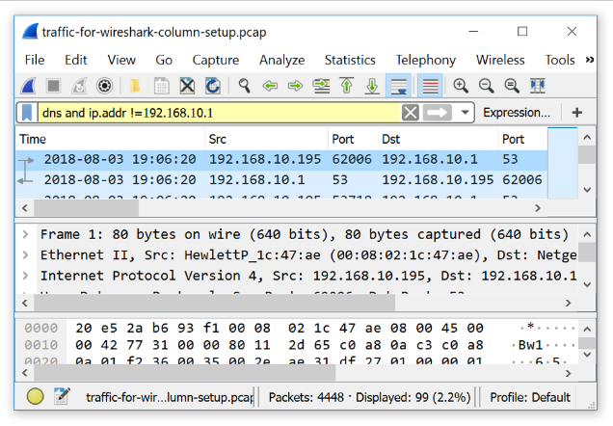
Figure 3
Capture Filters are a much more limited filter that are used during packet capture. Set before any packet capture, these filters are used to reduce the size of raw captured packets, gathering only what packet data is desired ^{[13]}. These filters are compiled ensuring to achieve peak performance during packet capture, an important and arguably essential factor when capturing in real time ^{[16]}. Further features of the application include:
- Detailed graphing for I/O and flow graphs, helping plot packet and protocol data and visualise connections between hosts. Packet time, direction, and ports can be displayed through the use of flow graphs. Figure 4 depicts an I/O graph within Wireshark, where figure 5 depicts a flow graph.
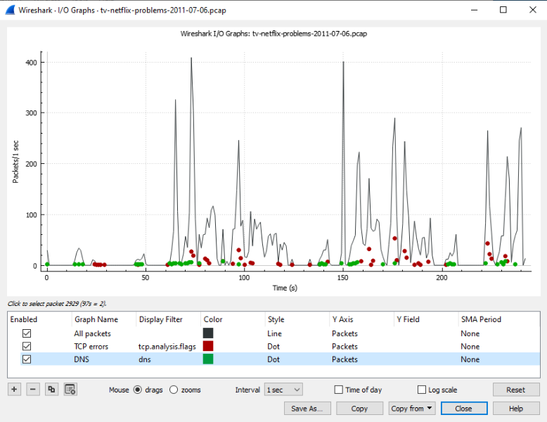
Figure 4
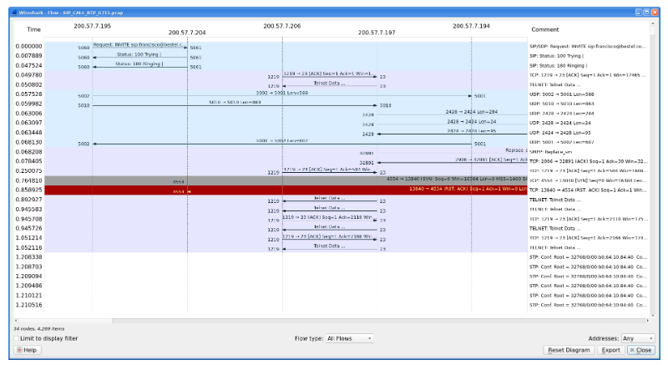
Figure 5
While Wireshark is not officially a network intrusion detection system, its packet analysis capabilities can help network forensics discover security threats and attacks across networks ^{[16]}. And under the right conditions with precise filtering commands and utilities, Wireshark can be transformed into a comprehensive intrusion detection system, all be it missing an effective alert feature ^{[14]}.
- Evaluation
Wireshark packages a powerful and versatile tool into a finely crafted user experience. Ensuring to encompass not only functionality but also usability, the software delivers an intuitive and cost-effective network analysis tool for all digital forensic experts to utilise and explore.
Autopsy
- Introduction
Autopsy is a leading open-source digital forensics platform built to provide a cost effective and intuitive user experience. Interfaced to the popular command-line analysis tool The Sleuth Kit, Autopsy analyses both hard drives and smart phones to provide detailed system images for use as evidence. The forensic tool offers support for multi-core processing and utilises parallel background operations to enhance program efficiency. Developed by Brian Carrier and Basis Technology, Autopsy is utilised by a vast audience including law enforcement, military, and corporate examiners to conduct thorough analysis of devices ^{[17]}.
- Use Case & Features
Designed as an end-to-end platform ^{[17]}, Autopsy offers an extensive line of powerful features and modules for its userbase. Through its open-source nature, both Autopsy and third parties developers can build and release new tools for the software using both Java and Python, publishing work to public repositories such as GitHub to download. Through the use of third-party database, keyword indexing, and storage tools, Autopsy supports a unique feature of collaborative case examination. These central services can be deployed and implemented within Autopsy cases to allow for collaborative analysis across a network. Progress of each connected client is kept separate through individual log files linked to the ongoing case and can be beneficial when collecting and presenting evidence in the future ^{[18]}. Autopsy offers strong keyword searching features that can be adapted to identify both regular expressions such as URLs, phone numbers, and IP addresses, in addition to more specific terms through ad-hoc searches ^{[17, 19]}. This feature can help forensic analysts and users of the platform to quickly locate essential or critical data from within large data dumps. Aiding in improving the efficiency of investigative work, and thus reduce the turnover time of potential open cases. Autopsy allows for web artifact and browser analysis on many of the world’s leading browsers such as Firefox and Chrome ^{[20]}. Extracting data such as cookies, bookmarks, history, downloads, and search queries for analysis. Students from the Universities across Nigeria have referred to Autopsy as “the best forensic tool [for] web browser investigation.” within their IJRSI journal article, praising and recommending the tool for its robustness, portability, and efficiency ^{[21]}. Further features of the application include:
- Effective hash set filtering, flagging known harmful or dangerous files through the use of custom hash sets and MD5 values.
- Thorough email analysis, parsing the likes of MBOX message formats.
- Detailed and extensive report building for investigation purposes. Including references to tagged files and key data highlighted through image examination. ^{[22]}

- Evaluation
As a widely recognised and praised open-source forensics tool, Autopsy, and its extensive library of features knowns no limit. Offering a suite comparable to the likes of FTK, the application can fulfil the needs of many forensic professionals without any upfront cost. Opening the doors to third party modules increases available features exponentially, greatly broadening the potential of Autopsy and its users.

Forensic Tool Table
No. | Feature(s) | Forensic Tool
No. | Feature(s) | FTK | Wireshark | Autopsy
1 | Compatible with most mainstream operating systems. E.g. Windows, MacOS, Linux. | No | Yes | Yes
2 | Calculates or filters MD5 hashes. | Yes | Yes | Yes
3 | Import foreign files for analysis. | Yes | Yes | Yes
4 | Export files for foreign analysis. | Yes | Yes | Yes
5 | Support multiple users on one open file/case. | No | No | Yes
6 | Create full disk/data images. | Yes | Yes (Only what is captured live) | Yes
7 | Log user activity. | No | No | Yes
8 | Extract artifacts and cache from web browsers. | No | No | Yes
9 | Export data in multiple formats. E.g. CSV, PDF. | No | Yes | Yes
10 | Identifies encrypted or deleted files. | Yes | Yes (Only those sent live over a network) | Yes
11 | Recover deleted files. | Yes | No | Yes
12 | Extract email messages/data. | Yes | No | Yes
13 | Extract data from mobile devices. | Yes | Yes (Can capture traffic from mobile device) | Yes

Task 2
Case Study
Ms Dee Rod, CEO of Swansea’s mobile manufacturing company CEC, formally contacted computer hacking forensic investigator (CHFI) Barry Lynch to conduct a forensics investigation on a believed attack on company property. In her request, she details that valuable company design assets have been “sabotaged”, and that no backup of said data exists due to its high confidential nature. It is believed that former employee Rob Jengelley is the individual behind this attack, due to the fact that only he had access to the assets. Using his selection of professional forensic knowledge and skills, Barry Lynch is to investigate the suspected sabotage of CEC’s design assets, provide evidence found to Ms Dee Rod, and recover any data that may be salvageable from Rob’s computer.
The investigation will be conducted using the popular digital forensics platform Autopsy, where salvaged data from the suspects’ drive will undertake thorough analysis to uncover any potential evidence of the suspected attack. It is known that Rob’s designs were built using the 3D graphics application Autodesk Maya, this information will be used to support the discovery of potential key evidence during analysis. All recovered files will be tagged and rightfully returned to Ms Dee Rod and CEC.

Methodology

Before any analysis of the suspects’ computer can begin, all physical evidence identified must be gathered and transferred to a secure environment. It is important that all evidence is appropriately packaged and documented as to comply with the key features of the chain of custody. The chain of custody is a collection of inspection requirements for valuable data, that aims to provide evidence of legal custody of investigation data aiding integrity retention within a court of law ^{[23]}.

Once transferred, a forensically sound duplicate of the original evidence much be created. This is done to prevent any accidental alterations to the original evidence, that subsequently would destroy all data integrity. Autopsy will create a bit-stream image of the gathered evidence, replicating data bit-by-bit to ensure original formatting is maintained, and provide more probative force to the evidence ^{[23]}. Storing the image on a forensically sterile media can help prevent the contamination of the duplicate media.
The National Institute of Standards and Technology require backup software tools to follow strict requirements in order to be considered reliable in the court of law. Appendix B lists and details these requirements.

Image integrity is then authenticated by comparing the MD5 hash value of both the original and duplicate evidence. Any difference in the hash values will signify the image is not an exact bit-by-bit copy of the evidence and could damage the integrity of any evidence gathered from the duplicate image. Therefore, it is important to ensure that both hash values are identical. If both hash values are not the same, a new bit-stream image of the original evidence must be created and authenticated again. This method is widely accepted by both the industry and the court of law.

Begin data acquisition and recovery on the created replica evidence image using the Autopsy forensic analysis tool. This action could potentially lead to the identification of key evidential data pertaining to the case and crime. The analysis of the imaged drive can uncover suspicious files on the system, such as data encrypted, hidden, or deleted by the suspect. It is essential that all parts of the drive image are scanned, including the slack space, using string searching and rebuilding tools. The slack space is a vital source of evidence that can be utilised by a forensic investigator, as it may contain residual data from system memory and sensitive information.
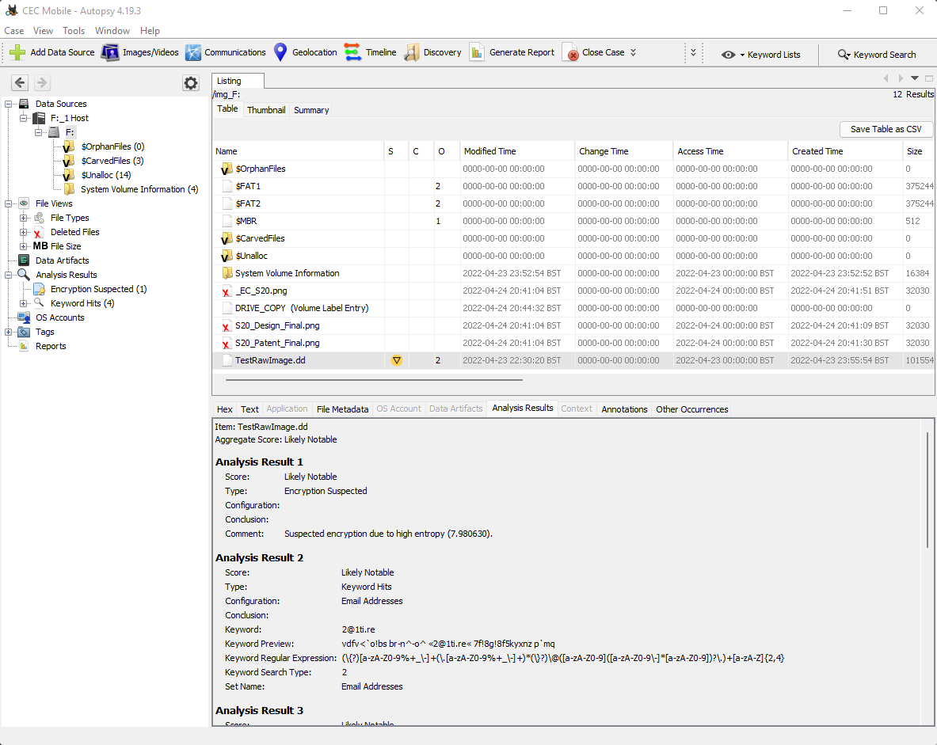
Figure 6
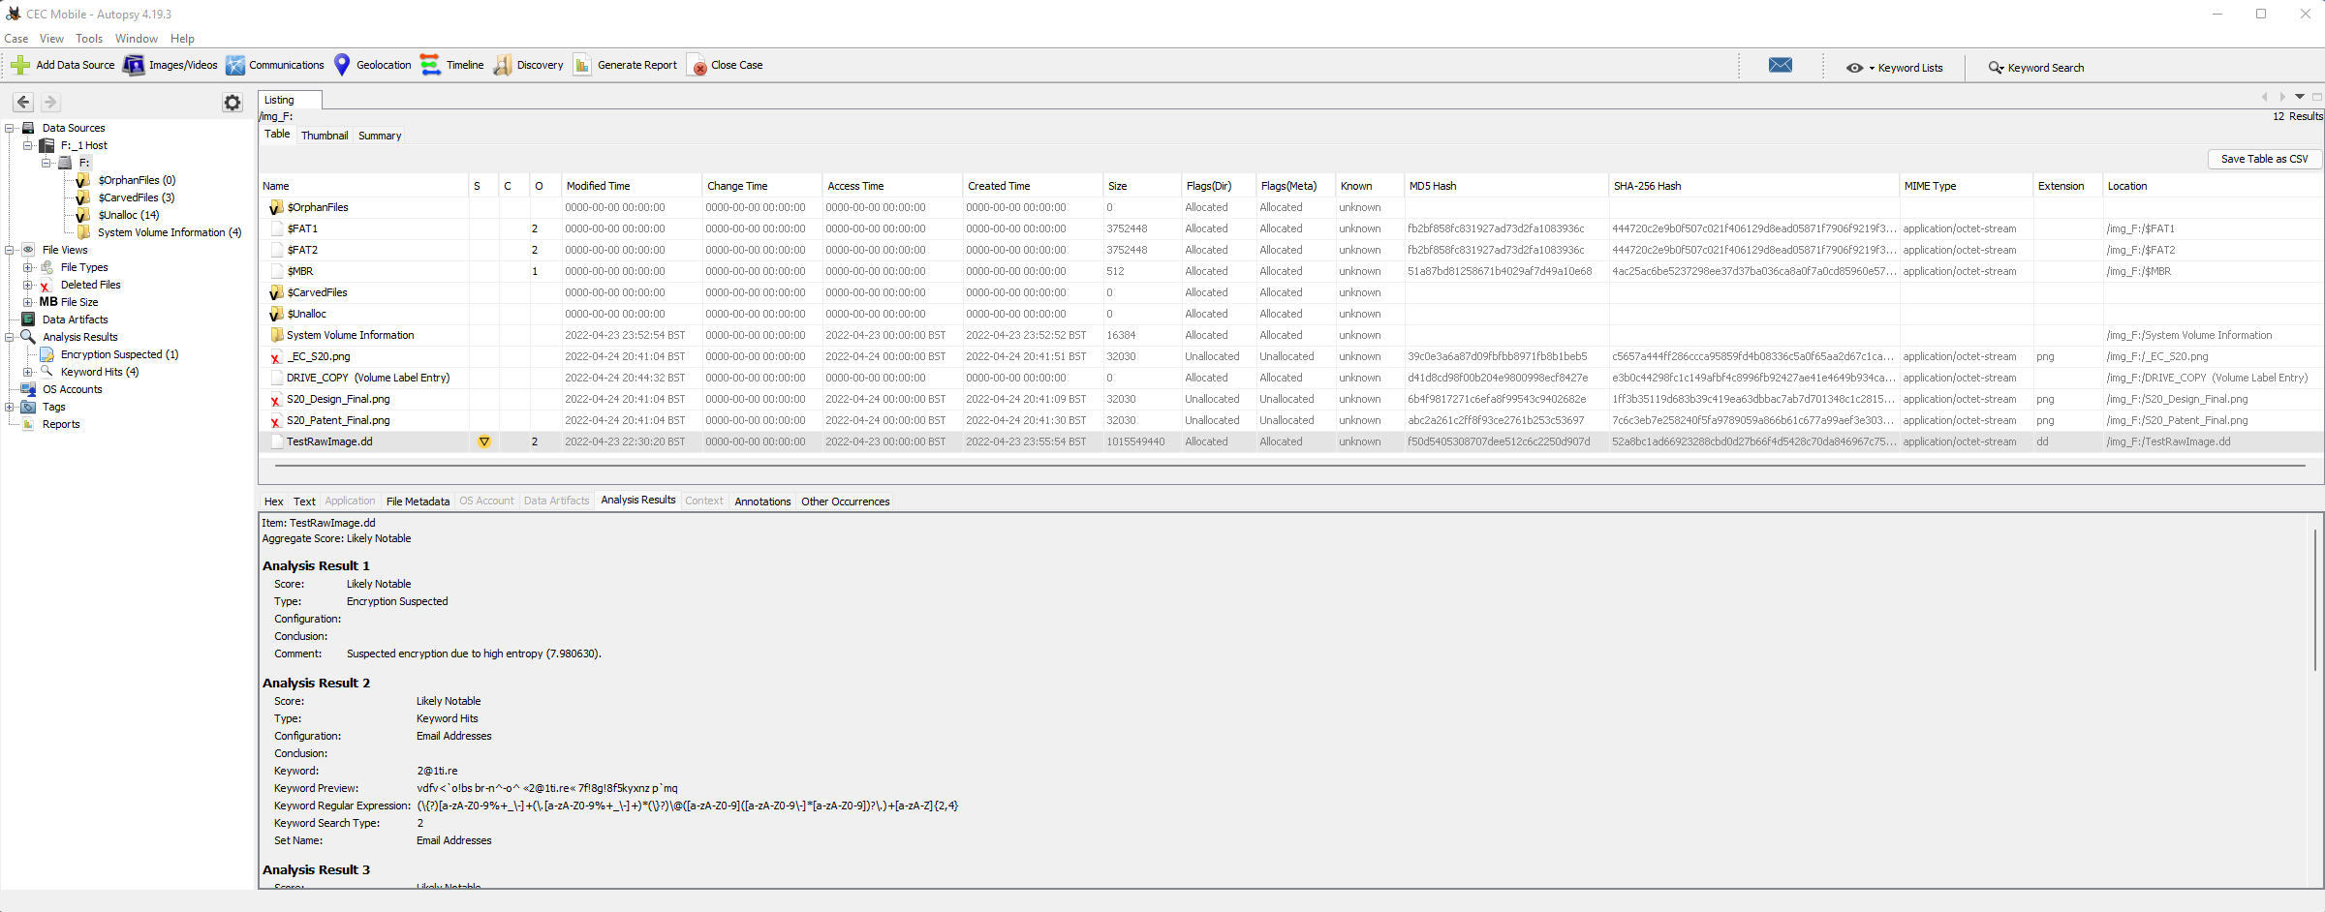
Figure 7

It is known that the sabotaged files were created and exported using Autodesk Maya, as stated by Ms Dee Rod in the brief. Taking this information, we can research and identify all possible file formats Maya exports and apply these formats to an analysis filter, highlighting potential evidence of the sabotaged designs. Autodesk Maya export formats can be found detailed in Appendix C.
Deleted files identified using Autopsy are selected and extracted from the drive image, exporting them to a secure location. Deleted files are taken to be further analysed and used as potential evidence against Rob. Figure 8 shows how identified deleted files can be extracted from the drive image.
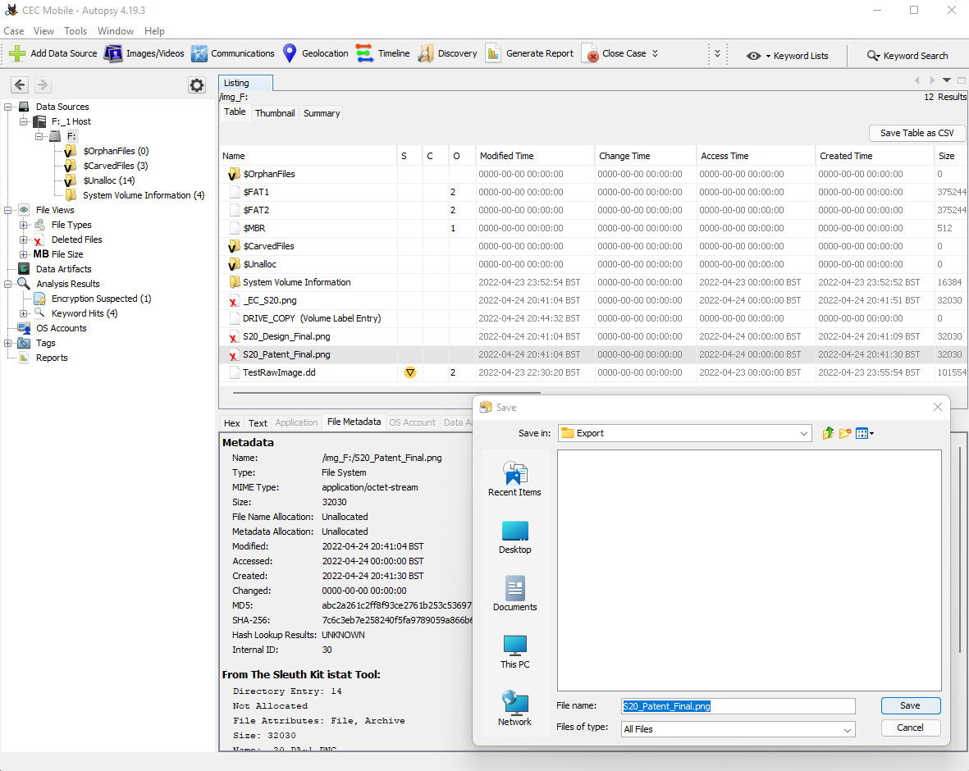
Figure 8

All evidence that is retrieved from the investigation is packaged and presented to Ms Dee Rod as per her request. Data identified to be of interest for CEC will be tagged and noted. Doing this will help highlight all accumulated evidence against Rob Jengelley and his suspected act of sabotage against the business.

Conclusion
While the digital forensics industry offers a plethora of forensic tools and software, it is important that professionals research and select the most appropriate suite of programs to conduct their investigations. Although feature sets may appear the same, many applications can produce vastly different outcomes to one another. Because of this, it is essential to ensure that selected programs offer an efficient and intuitive environment to operate within to help unearth key evidence quickly and effectively. Failing to follow this guidance could potentially lead to costly errors within an investigation, or even jeopardise it entirely.
In future reports, documenting a more extensive selection of forensic tools would allow for greater comparisons to be made. Additionally, further research into each tool could help highlight more minimal, yet important, features that could turn the tide on whether or not a tool may be utilised.

Bibliography

[1] | AccessData, “Forensic Toolkit (FTK) Brochure,” 2021. [Online]. Available: https://accessdata.com/assets/pdfs/LIT-FTK-7.4.2.pdf. [Accessed 20 April 2022].
[2] | Exterro, “FTK Imager,” Exterro, [Online]. Available: https://www.exterro.com/ftk-imager. [Accessed 20 April 2022].
[3] | Exterro, “FTK Forensic Toolkit,” Exterro, [Online]. Available: https://www.exterro.com/forensic-toolkit. [Accessed 20 April 2022].
[4] | Y. LeClaire, “The Forensic Process Examined: Creating cases for classroom use,” Lewis University, Illinois, 2010.
[5] | H. Insights, “LinkedIn: HG Insights,” [Online]. Available: https://www.linkedin.com/company/hg-insights?challengeId=AQF1QI2VPbYA6AAAAYBIaxwYN8yPjaL3rlCu7VwoMjhZ4DJR4FrXMcQUpBdobj0OtXASXdLKaPU3eJ_ua3wIOifJcytP6mHGHA&submissionId=5bd00643-04b1-e716-b7cd-5f842b760e08. [Accessed 20 April 2022].
[6] | HG Insights, “Forensic Toolkit (FTK),” HG Insights, [Online]. Available: https://discovery.hgdata.com/product/forensic-toolkit-ftk. [Accessed 20 April 2022].
[7] | M. Yates, “Practical Investigations of Digital Forensics Tools for Mobile Devices,” Association for Computer Machinery, New York, 2010.
[8] | United States of America, Plaintiff, v. Christopher Owen Schlingloff, Defendant., Illinois: United States District Court for the Central District of Illinois - Rock Island Division, 2012. Available: https://www.ilcd.uscourts.gov/sites/ilcd/files/opinions/schlingloff%20published.pdf. [Accessed 20 April 2022].
[9] | Wireshark, “About Wireshark,” Wireshark, [Online]. Available: https://www.wireshark.org/. [Accessed 21 April 2022].
[10] | L. F. Sikos, “Packet analysis for netowkr forensics: A comprehensive survey,” Forensic Science International: Digital Investigation, vol. 32, p. 5, 2020.
[11] | HG Insights, “Wireshark,” HG Insights, [Online]. Available: https://discovery.hgdata.com/product/wireshark. [Accessed 21 April 2022].
[12] | Wireshark, “Display Filter Reference,” Wireshark, [Online]. Available: https://www.wireshark.org/docs/dfref/. [Accessed 21 April 2022].
[13] | Wireshark, “Capture Filters,” Wireshark, [Online]. Available: https://wiki.wireshark.org/CaptureFilters. [Accessed 21 April 2022].
[14] | U. Banerjee, V. Ashutosh and S. Mukul, “Evalution of the Capabilities of Wireshark as a tool for Intrusion Detection,” International Journal of Computer Applications, vol. 6, 2010.
[15] | N. Champagne, C. Dumont, A. Johnson, J. Castro, A. Leonard, J. Palmer and T. Craig, “Forensic Tool Comparison,” Champlain College Leahy Center for Digital Investigation, Vermont, 2016.
[16] | V. Ndatinya, Z. Xiao, V. Rao Manepalli, K. Meng and Y. Xiao, “Network forensics analysis using Wireshark,” International Journal of Security and Networks, vol. 10, no. 2, pp. 91-106, 2015.
[17] | Basis Technology, “Autopsy,” Basis Technology, [Online]. Available: https://www.sleuthkit.org/autopsy/. [Accessed 22 April 2022].
[18] | D. Manson, A. Carlin, S. Ramos, A. Gyger, M. Kaufman and J. Treichelt, “Is the Open Way a Better Way? Digital Forensics using Open Source Tools,” 40th Annual Hawaii International Conference on System Sciences, California, 2007.
[19] | S. Nizam, N. Rahman and N. Cahyani, “Keyword Indexing And Searching Tool (KIST): A Tool to Assist the Forensics Analysis of WhatsApp Chat,” International Journal on ICT, vol. 6, no. 1, pp. 23-30, 2020.
[20] | Basis Technology, “Web Artifact Analysis,” Basis Technology, [Online]. Available: https://www.sleuthkit.org/autopsy/web_artifacts.php. [Accessed 23 April 2022].
[21] | H. Adamu, A. Ahmad, A. Hassan and S. Gambasha, “Web Browser Forensic Tools: Autopsy, BHE and NetAnalysis,” International Journal of Research and Scientific Innovation, vol. 8, no. 5, pp. 103-107, 2021.
[22] | Basis Technology, “Analysis Features,” Basis Technology, [Online]. Available: https://www.sleuthkit.org/autopsy/features.php. [Accessed 23 April 2022].
[23] | W. Kruse and J. Heiser, “Computer Forensic: Incident Response Essentials,” pp. 2-8, 2002.
[24] | The National Institute of Standards and Technology, “Digital Data Acquisition Tool Specification,” 2004. [Online]. Available: https://www.nist.gov/itl/ssd/software-quality-group/computer-forensics-tool-testing-program-cftt/cftt-technical/disk. [Accessed 24 April 2022].
[25] | Autodesk, “Supported data export formats,” Autodesk, 29 March 2022. [Online]. Available: https://knowledge.autodesk.com/support/maya/learn-explore/caas/CloudHelp/cloudhelp/2023/ENU/Maya-ManagingScenes/files/GUID-864BD203-C437-4481-8BFC-3A6C1D2C824C-htm.html. [Accessed 25 April 2022].

