`



Torsion of shafts
Ali Nalbant
SN: 2502009
ACHA4026
Deadline: 22:00 4/01/2026
Word count: 1126

Contents
Introduction 3
Experimental procedure 4
Results 5
Analysis 6
Evaluation 8
Limitations and Possible Improvements 8
References 9

Introduction

The purpose of this report is to investigate the torsional behaviour of circular shafts and determine the shear modulus of the material through experimental analysis. Torsion refers to the twisting of an object due to an applied torque, a phenomenon commonly encountered in mechanical and structural engineering components such as drive shafts, axles, and transmission systems. Understanding torsional properties is essential for ensuring the strength and reliability of these components under operational loads.
This experiment focuses on measuring the relationship between applied torque and angular displacement to calculate the shear modulus, a fundamental material property that influences rigidity and deformation under shear stress. The report will present the experimental procedure, analyse the collected data, and compare the results with theoretical and published values to validate the findings.

Experimental procedure
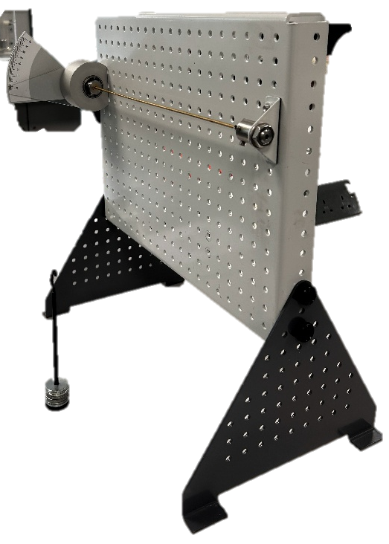
  - Apparatus Setup
The experiment was conducted using the Torsion Kit ES5. The apparatus consists of a rigid frame, a shaft mounted between a fixed end and a rotating end, a torque application mechanism, and an angular displacement scale. The shaft was securely clamped to prevent any unwanted movement.
  - Specimen Identification
The materials brass, aluminium and steel had there dimensions recorded, including their diameter (D) and length (L). The polar moment of inertia (J) was calculated using:
$$J=\frac{πD^{4}}{32}$$
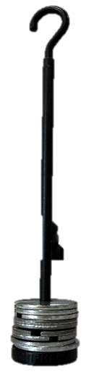
Calibration
Before loading, the angular scale was set to zero, and the shaft was checked to ensure it was free from any pre-load or residual twist.
Application of Torque
Torque was applied incrementally using the loading mechanism. For each increment, the applied torque (T) was calculated from:
$$T=W×\text{lever arm length}$$
where W is the applied weight. The corresponding angle of twist $θ$ was measured using the angular scale set in degrees.
Data Collection
Torque values and angles of twist were recorded in a results table for each loading step. Measurements were repeated to ensure accuracy and consistency.
Calculation of Shear Modulus
The shear modulus (G) was determined using:
$$G=\frac{TL}{Jθ}$$
Experimental values were compared with published data for the specimen material to validate the results.

Results
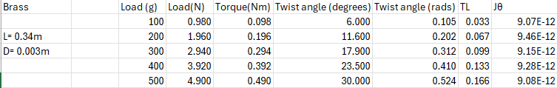
  - Brass
Table 1

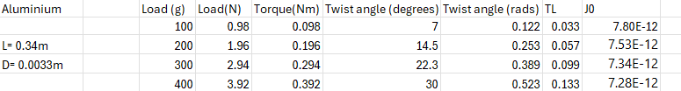
  - Aluminium
Table 2
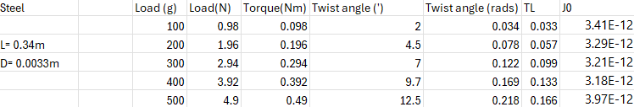
  - Steel
Table 3

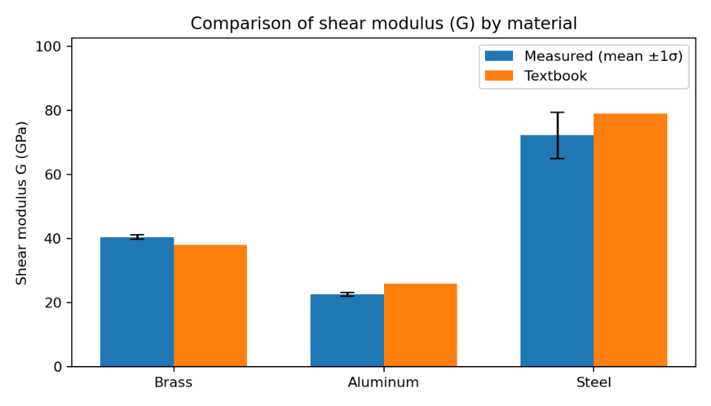
  - Shear modulus

Analysis

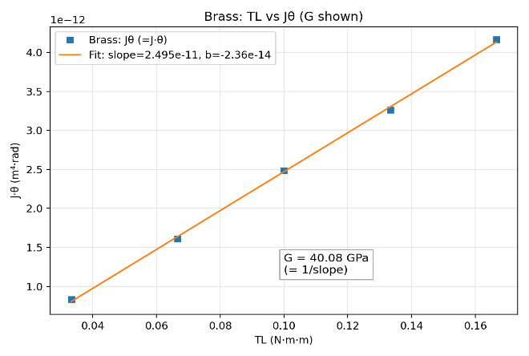
  - Brass
The graph to the right (graph 1)shows how $Jθ$ changes with $TL$(torque × length) for the brass rod. This shows that the rod behaved elastically and the experiment was accurate.
The equation of the line is:
Graph 1
$$Jθ=(2.495×{10}^{-11})⋅TL-2.36×{10}^{-14}$$
From the slope, G has been calculated as:
$$G=\frac{1}{\text{slope}}=40.08 \text{GPa}$$
This value is simliar to the figure stated in the ES5 guidance book of which brass has a GPA of 38.0. Engineers Edge (Engineers edge, 2013) had the GPa at 40.02 further backing the validity of the experiment. The intercept is almost zero, which means there was very little error in starting measurements. Overall, the graph proves that the relationship between torque and twist is linear, as theory predicts, and confirms the shear modulus for brass.
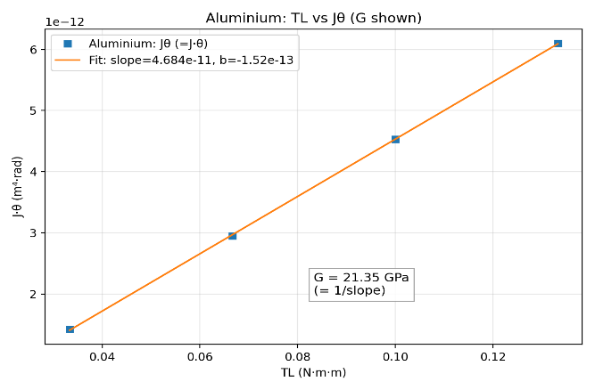
  - Aluminium
Graph 2 for aluminium again shows a very linear relationship between Jθ and TL.
The equation of the line is:
$$Jθ=(4.684×{10}^{-11})⋅TL-1.52×{10}^{-13}$$
The slope of the line equals $1/G$, where G is the shear modulus. As of this the GPa is:
Graph 2
$$G=\frac{1}{\text{slope}}=21.35 \text{GPa}$$
As before the figure stated in the ES5 guidance book has the GPA at 25.5. The straight-line trend confirms that the torque–twist relationship is linear, as the theory predicts, and that the aluminium rod stayed in the elastic range during testing. In comparison using Engineers edge (Engineers edge, 2013) table of sheer modulus. Aluminium cast had a GPa of 26.565 which is higher than what was found in the experiment, but this could be due to the assumption that the material used in the experiment was pure aluminium and was in fact and alloy as this was not stated.

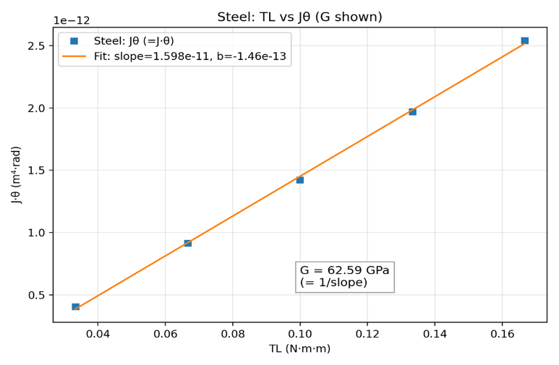
  - Steel
Finally with graph 3 which shows the Jθ vs TL for the steel rod.
The equation for this best fit line is:
Graph 3
$$Jθ=(1.598×{10}^{-11})⋅TL-1.46×{10}^{-13}$$

From this the shear modulus can be found:
$$G=\frac{1}{\text{slope}}=62.59 \text{GPa}$$
This value in comparison to the textbook figure is quite far out stating a GPa of 79.6 whilst this experiment only achieved a 62.59. Engineers edge (Engineers edge, 2013) stated a GPa of cold rolled steel at 75.555 which again puts the figure from the experiment closer to a GPa of that of malleable iron (64.860). Again, however the straight-line trend confirms that the torque–twist relationship is linear with no sign of it going past it’s elasticity.

Evaluation
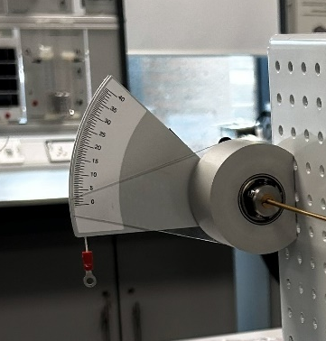
To minimise errors during the torsion experiment, careful attention was given to both setup and measurement procedures. The manual angle scale was checked and zeroed before each test, and the lever arm was positioned horizontally to ensure accurate torque application. Specimens were clamped securely in both chucks to prevent slippage, and all dimensions were measured using precise instruments such as a dial calliper. Multiple readings of the angle of twist were taken and averaged to reduce random error, while angular difference error was avoided by reading scales at eye level.

The experiment was conducted on a stable workbench, and weights were added gradually to prevent sudden shocks that could affect readings. Consistency was maintained by following the same procedure for all specimens and repeating tests to verify reliability. Data was recorded immediately and calculations were checked for accuracy, with instrument tolerances considered in the final analysis. These measures collectively helped to eliminate or minimise sources of error as much as possible.

Limitations and Possible Improvements
Despite these precautions, some limitations remained. Small misalignments in the chucks with the grub screw slipping on the softer material such as aluminium or bowing of the lever arm could introduce systematic error, and friction within the bearings of the chuck may have slightly affected torque readings. Human factors, such as when reading the scales manually, also posed a risk of minor inaccuracies. Additionally, environmental conditions like temperature were not controlled, which could influence material properties. To improve accuracy, digital angle sensors and torque sensors could replace manual scales, reducing human error. Using a fully calibrated apparatus with minimal friction and conducting the experiment in a controlled environment would further enhance reliability. Increasing the number of repetitions and applying statistical analysis to the data could also provide a more robust evaluation of results.
Furthermore, the torsion kit is not brand new and states a caution in the booklet during the method section saying:
“Do not tighten the grub screws in the chuck if there is no specimen fitted. You will damage the chuck collet” (Tec Equipment, 2012)
This may have happened already without realisation before the experiment. Damaging said collet would invalidate any torsion readings as the validity would be negatively affected.

References

Engineersedge.com. (2013). Shear Modulus of Rigidity | Engineers Edge | www.engineersedge.com. [online] Available at: https://www.engineersedge.com/materials/shear_modulus_of_rigidity_13122.htm.
‌

