LCBB5014
Data Handling & Business Intelligence

Assignment 2:
2000 words
Individual Report
Ion Ignat
Student ID - 2327723
Lecturer: Dr Xavier Matieni
Due date: 2nd May 2026

A Data-Driven Analysis of Film Ratings, Language and Audience Engagement

Contents
A Data-Driven Analysis of Film Ratings, Language and Audience Engagement 2
1. Introduction 3
2. Data Cleaning and Preparation 3
3. Descriptive Statistics and Summary 4
4. Trend Analysis and Visualisation 5
4.1 Genre-based trends in average rating 5
4.2 Audience engagement and language trends 6
5. Statistical Analysis using SPSS 7
5.1 Independent samples t-test 7
5.2 Correlation analysis 8
5.3 Regression analysis 9
6. Insights and Recommendations 9
6.1 Key insights 9
6.2 Recommendations and limitations 10
References 11

1. Introduction
This report studies the Letterbox Movie Classification Dataset to analyse how the characteristics of the film and the measures of audience-engagement can be used in the business intelligence in the entertainment industry. The analysis of the data is based on the cleaned movie data, descriptive statistics, visual trend analysis, and statistical testing, revealing patterns associated with ratings, likes, watches, and fan activity. This method is a sign of the increasing significance of quality data, analytical power, and clear visual analysis in decision-making based on evidence (Ehrlinger and Wöß, 2022). Such analysis helps to target the audience better, position the content, or evaluate the performance in the media setting (Leem et al., 2023).

2. Data Cleaning and Preparation
Data cleaning was needed to enhance the consistency, noise reduction and to prepare the data set to undergo descriptive and statistical analysis. One of the fundamental requirements of business intelligence is data quality, as the incorrect, inconsistent, or poorly organised data may misrepresent trends and undermine managerial judgments (AbuHalimeh, 2022). In this dataset, preparation was aimed at rectifying structural problems, but not changing the meaning of records.
The initial step was to delete unnecessary export content such as the additional index field since the variable did not have any analytical value. The text fields were then normalised by removing irregular spaces and turning the list-style items in variables like genres and studios to a uniform comma-separated form. Where necessary, entries like unknown studio values were interpreted as missing so that the analysis could differentiate between values that are actual and those that are unfinished (Syed et al., 2023). Runtime was stored as a numerical data to assist in summary statistics, charting and subsequent regression analysis. Other helper variables, such as language grouping and number of genres or studios per film were also developed to make the comparison across categories easier.
These cleaning procedures enhanced data usability, transparency, and comparability, which is necessary to have solid analytics and subsequent interpretation (Pierce, 2022).

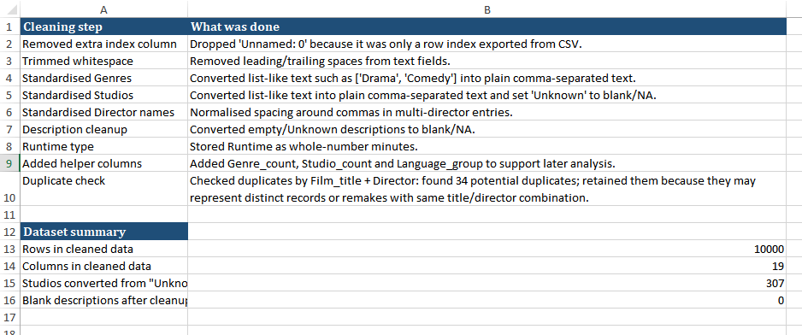
Figure 1: Cleaning Log Sheet

3. Descriptive Statistics and Summary
The dataset was summarised using descriptive statistics to determine the overall distribution of important variables before further analysis. This is an important step in business analytics as it transforms raw data into a comprehensible summary of scale, central tendency, and variation, enabling decision-makers to determine where and how they need to explore further (Gómez-Caicedo et al., 2022). The cleaned dataset was largely mixed in audience-engagement metrics especially in watches, likes and the number of fans, meaning that the film performance is not equally distributed across the titles.
Average score was relatively the same when compared to engagement variables, implying that user rating is not as changeable as behavioural indicators like viewing and liking activity. The spread in runtime was less than watches or fans, which is a helpful factor since it implies that certain variables will tend to be more predictive or explanatory in further testing. Frequency summaries revealed that a few genres occurred very much more frequently than others, with the distribution of language being centered around English-language films. This form of imbalance is significant since categorical dominance has a potential to influence the visible trends in case it is not interpreted with caution (Gutzeit and Tiberius, 2023). As far as business intelligence is concerned, such descriptive results are important since they help determine the locations of the concentration of the audience activity and the variables that are most appropriate in further visual and statistical analysis. Clearly described summaries enhance transparency and communication as they enable the dataset to be comprehended by both specialist and non-specialists (Neri et al., 2025).

Figure 2: Main Descriptive Statistics

4. Trend Analysis and Visualisation

4.1 Genre-based trends in average rating
Trend analysis was performed to determine the difference in the response of the audience with different genres, as business intelligence is more helpful when the numbers as summaries are translated into visible forms. Visualisation assists decision-makers in identifying concentration, imbalance and outliers faster than with tables alone when there is a sharp variance in engagement measures between content categories (Santini et al., 2024). Genre patterns were found in this dataset that popular categories do not necessarily produce the highest average rating, which indicates that the notions of popularity and perceived quality cannot be regarded as the same results.
The genre tables revealed that the largest number of films and the highest average rating of the key genre groups were for Drama. Crime and Romance play well in terms of average rating and Horror and Science Fiction did not feature highly in the top-ten comparison. This is important since it implies that wide catalogue coverage is not necessarily producing more successful evaluation results. For content strategy, this may aid in more discriminatory promotion of genres more appreciated by users than just more volume (Orankiewicz and Bartosiewicz, 2023).
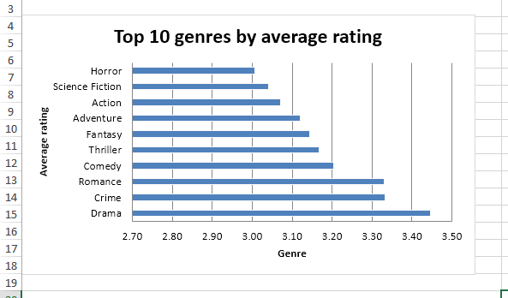
Figure 3: Top genres by average rating

4.2 Audience engagement and language trends
A positive contradiction was manifested in language-based trends. English-language films were overwhelmingly represented in the sample in terms of number but this numerical advantage was not necessarily the most effective in terms of rating. The next statistical tests prove that mean rating of non-English movies was higher and did not need as similar visual comparison to state that the viewer appreciation could not be as similar as the focus in the market. Practically, this promotes the notion that companies should not assess their performance based on the highest category, but also those that are underrepresented and have a higher reception potential (Langen and Huber, 2023).
Of special interest was the scatter plot of watches against likes. The plotted pattern was strongly positive, meaning that the more active viewing films were in good terms, the more likely they were to get likes. It is also in line with the recommendation and platform-engagement studies, in which the variables of interaction tend to co-move since the variables of attention, visibility, and preference complement each other (Lubos et al., 2023). In comparison, the relationships between runtime were visibly weaker, indicating that the film length has a smaller contribution to the audience behaviour in and of itself.
Overall, the visual analysis indicated that engagement is not evenly distributed throughout the dataset, the trends of ratings are not the same for each category, and the measures of platform interaction are more closely related to each other than to structural factors like runtime.
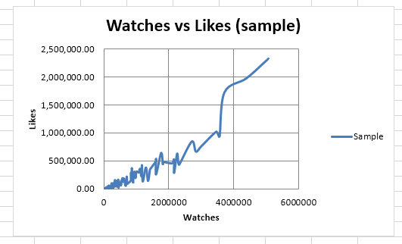
Figure 4: Watches vs Likes

5. Statistical Analysis using SPSS

5.1 Independent samples t-test
The t-test involved independent samples that were used to test the difference in average rating among English and non-English films. The test was suitable as it compares the two independent groups and assists in defining whether a certain difference observed is not a mere coincidence. Such tests have found applications in analytics-driven decision applications, as they demonstrate the association between segmentation factors, including language, and evaluable differences in user ratings (Huang et al., 2022). The findings indicated that the average rating of the two language groups was statistically significant. The mean rating of English-language films was 3.211 and non-English films had a higher mean rating of 3.510. The outcome was very significant, meaning that the difference could not have been due to chance. The effect was moderate, indicating that the difference was not just statistically significant, but to be given practical interpretation. It is implied that the category of language can affect audience assessment and that it needs to be taken into account when evaluating the performance of catalogues.

Group | N | Mean rating | Std. dev.
English | 8074 | 3.211 | 0.524
Non-English | 1926 | 3.510 | 0.461
Statistic | Value
t statistic | -24.878
p value | <0.001
Cohen’s d | -0.583

Figure 5: T-Test Table

5.2 Correlation analysis
The relationship between key numerical variables was analysed using correlation analysis to identify the strength and direction. The approach is very popular on recommendation and rating since it assists in determining whether user activity measures are moving in a predictable manner (Su et al., 2023). The most significant association in the data set was between watches and likes, with a very strong correlation of 0.951. It means that movies with more frequent views were likely to get more likes, which confirms the opinion that the visibility and user approval on content platforms are closely interrelated. Comparatively, runtime and fans had a very weak positive correlation of 0.088 indicating that length of film is by itself not a significant contributor to audience attachment. The results yielded a weak positive correlation of 0.187 between runtime and average rating, but fans and average rating, likes and average rating also produced weakly positive correlations. These results indicate that engagement variables have some correlation with ratings, but not to a significant degree to predict the success of films solely.
Variable 1 | Variable 2 | N | Pearson r | p value | Strength
Runtime | Fans | 10000 | 0.088 | <0.001 | Very weak
Watches | Likes | 10000 | 0.951 | <0.001 | Very strong
Runtime | Average rating | 10000 | 0.187 | <0.001 | Weak
Fans | Average rating | 10000 | 0.251 | <0.001 | Weak
Likes | Average rating | 10000 | 0.290 | <0.001 | Weak

Figure 6: Correlation Table

5.3 Regression analysis
A multiple regression was employed to determine whether fans, likes and runtime were predictive of average rating. Regression is useful since it approximates the overall effects of multiple predictors simultaneously to give a more realistic view compared to bivariate tests alone (Ali et al., 2022). The model proved to be significant statistically and explained 10.8% of change in average rating. The coefficients of the three predictors were all positive and this implies that higher fans, higher likes and longer runtime all led to slightly higher ratings. However, the explained variance was not large, and it demonstrates that the film ratings are influenced by other factors that are not covered by this data.
Model summary | Value
Observations | 10000
R-squared | 0.108
Adjusted R-squared | 0.108
F-statistic | 403.304
Prob(F-statistic) | <0.001

Figure 6: Regression model summary Table

6. Insights and Recommendations

6.1 Key insights
This analysis indicates that there is no one variable that explains success in films in this dataset. Instead, the performance is a synthesis of content category, grouping by language, and behaviour of the audience. Descriptive and trend results indicated that there were certain genres with stronger ratings than others and the statistical tests indicated that the average rating of non-English films was significantly higher than that of English-language films. The best overall relationship was observed between watches and likes, which means that there is a shift between user exposure and positive reaction.
Meanwhile, the regression model was only able to explain a relatively small portion of the rating variation, which implies that the audience judgement depends on other factors, not represented in the dataset. This is indicative of a broader business analytics concept: valuable decisions are based not only on determining meaningful patterns, but on the identification of the limits of the available data (Ehrlinger and Wöß, 2022).

6.2 Recommendations and limitations
Practically, the findings indicate three actions that would be applicable in a business world.
- First, cinemas and distributors are to pay attention to the genre performance in ratings instead of emphasizing on the largest content categories.
- Second, non-English content must be considered as a strategy instead of a niche market and in particular where the appreciation of the audience is high.
- Third, watches and likes should be considered in conjunction when assessing title performance, as these indicators give a better understanding of behavioural signals than runtime.
However, the predictive capabilities are constrained by the variables included in the dataset, and the variables that may be incorporated in the future, like the release year, cast, budget, or the intensity of marketing could enhance the predictive strength (Huang et al., 2022).

References
AbuHalimeh, A.A. (2022) ‘Improving data quality in clinical research informatics tools’, Frontiers in Big Data, 5, 871897. Available at: https://doi.org/10.3389/fdata.2022.871897

Ali, Y., Khalid, O., Khan, I.A., Hussain, S.S., Rehman, F., Siraj, S. and Nawaz, R. (2022) ‘A hybrid group-based movie recommendation framework with overlapping memberships’, PLOS ONE, 17(3), e0266103. Available at: https://doi.org/10.1371/journal.pone.0266103

Ehrlinger, L. and Wöß, W. (2022) ‘A survey of data quality measurement and monitoring tools’, Frontiers in Big Data, 5, 850611. Available at: https://doi.org/10.3389/fdata.2022.850611

Gómez-Caicedo, M.I., Gaitán-Angulo, M., Bacca-Acosta, J.B., Briñez Torres, C.Y. and Cubillos Díaz, J. (2022) ‘Business analytics approach to artificial intelligence’, Frontiers in Artificial Intelligence, 5, 974180. Available at: https://doi.org/10.3389/frai.2022.974180

Gutzeit, L.J. and Tiberius, V. (2023) ‘Business and management research on the motion picture industry: A bibliometric analysis’, Journalism and Media, 4(4), pp. 1198–1210. Available at: https://doi.org/10.3390/journalmedia4040076

Huang, X., Yang, S., Wang, J., Lin, F. and Jiang, Y. (2022) ‘The influencing mechanism of big data analytics technology capability on enterprise’s operational performance: The mediating role of data-tool fit’, Frontiers in Psychology, 13, 948764. Available at: https://doi.org/10.3389/fpsyg.2022.948764

Langen, H. and Huber, M. (2023) ‘How causal machine learning can leverage marketing strategies: Assessing and improving the performance of a coupon campaign’, PLOS ONE, 18(1), e0278937. Available at: https://doi.org/10.1371/journal.pone.0278937

Leem, S., Oh, J., So, D. and Moon, J. (2023) ‘Towards data-driven decision-making in the Korean film industry: An XAI model for box office analysis using dimension reduction, clustering, and classification’, Entropy, 25(4), 571. Available at: https://doi.org/10.3390/e25040571

Lubos, S., Felfernig, A. and Tautschnig, M. (2023) ‘An overview of video recommender systems: State-of-the-art and research issues’, Frontiers in Big Data, 6, 1281614. Available at: https://doi.org/10.3389/fdata.2023.1281614

Neri, G., Marshall, S., Chan, H.K.-H., Yaghi, A.Y., Tabor, D., Sinha, R. and Mazumdar, S.M. (2025) ‘Data visualization in AI-assisted decision-making: A systematic review’, Frontiers in Communication, 10, 1605655. Available at: https://doi.org/10.3389/fcomm.2025.1605655

Orankiewicz, A. and Bartosiewicz, A. (2023) ‘The COVID-19 pandemic and the adoption factors of film distribution business models in the context of sustainability’, Sustainability, 15(15), 11721. Available at: https://doi.org/10.3390/su151511721

Pierce, E. (2022) ‘A balanced scorecard for maximizing data performance’, Frontiers in Big Data, 5, 821103. Available at: https://doi.org/10.3389/fdata.2022.821103

Santini, J.F., Sacco Capurro, F., Rogger, D., Lundy, T., Kim, G., de León Miranda, J., Cocciolo, S. and Casanova, C. (2024) Data for Better Governance: Building Government Analytics Ecosystems in Latin America and the Caribbean. Washington, DC: World Bank. Available at: https://documents1.worldbank.org/curated/en/099112524084036561/pdf/P180454-6d9c7489-4a0a-401e-b09c-5b2d218d6628.pdf

Su, Z., Yang, H. and Ai, J. (2023) ‘FPLV: Enhancing recommender systems with fuzzy preference, vector similarity, and user community for rating prediction’, PLOS ONE, 18(8), e0290622. Available at: https://doi.org/10.1371/journal.pone.0290622

Syed, R., Eden, R., Makasi, T., Chukwudi, I., Mamudu, A., Kamalpour, M., Kapugama Geeganage, D., Sadeghianasl, S., Leemans, S.J.J., Goel, K., Andrews, R., Wynn, M.T., ter Hofstede, A. and Myers, T. (2023) ‘Digital health data quality issues: Systematic review’, Journal of Medical Internet Research, 25, e42615. Available at: https://doi.org/10.2196/42615

