
Module: Introduction to Independent Research Skills
Assignment Title: Component 2: Written Assignment (Research Report)
Student Name: Robert Nzeyimana
Student Number: 2329949
Lecturer Name: Rizwan Nadim
Module code: BMHP5019
Submission Deadline: 29th March 2026

Research Title: Evaluation of Dementia care in UK social and healthcare services: A Basic Thematic Analysis of Aveyard to Identify Themes

Table of Contents
1. Introduction 3
1.1 Define key concepts 3
1.2 Rationale 3
1.3 Review Question 5
1.4 Research Objectives 5
2. Background 5
2.1 Current Policies and Legislation 5
2.2 Existing Services and Practice 6
2.3 Key Challenges and Issues 6
3. Methods 7
3.1 Data Collection Approach 7
3.2 Data Analysis Approach 7
3.3 Ethical Considerations 8
4. Results 8
4.1 Summary Tables 8
4.2 Thematic Analysis 11
5. Discussion 14
5.1 Compare and contrast findings 14
5.2 Explain gaps in the research 15
5.3 Theoretical and practical implications 15
6. Conclusion and Recommendations 16
6.1 Key takeaways 16
6.2 Recommendations for future research 17
6.3 Recommendations for policy and practice 17
Reference List 19

1. Introduction

1.1 Define key concepts
Dementia is a chronic illness, which involves the impairment of memory, thinking, behaviour and daily functioning, and it is a predominant illness among older people in the UK. Dementia care is the term used to describe health and social care support that is intended to enhance the quality of life, safety and dignity. A scoping review is a process that is systematic to map and give a review of the existing studies on a subject matter and to establish the areas of significance (McCullough et al., 2023). Thematic analysis is a technique where similar ideas are pooled together within studies. Helen Aveyard's simplified approach facilitates thematic development, which is systematic.

1.2 Rationale
Dementia is a condition that is becoming common among an increasing number of individuals in the UK, and this continues to increase with age. Individuals with dementia usually require continuous assistance provided by both health and social care providers, though it has been established that the quality and consistency of food and care may differ significantly (NHS England, 2023). Such diversity may result in the poor well-being of individuals, elevated hospitalisation rates, and heightened family and carer stress (Duran-Kiraç et al., 2022). Assessment of dementia care is also necessary to learn how the services are delivered to meet the requirements of individuals with dementia and what lapses exist in practice.
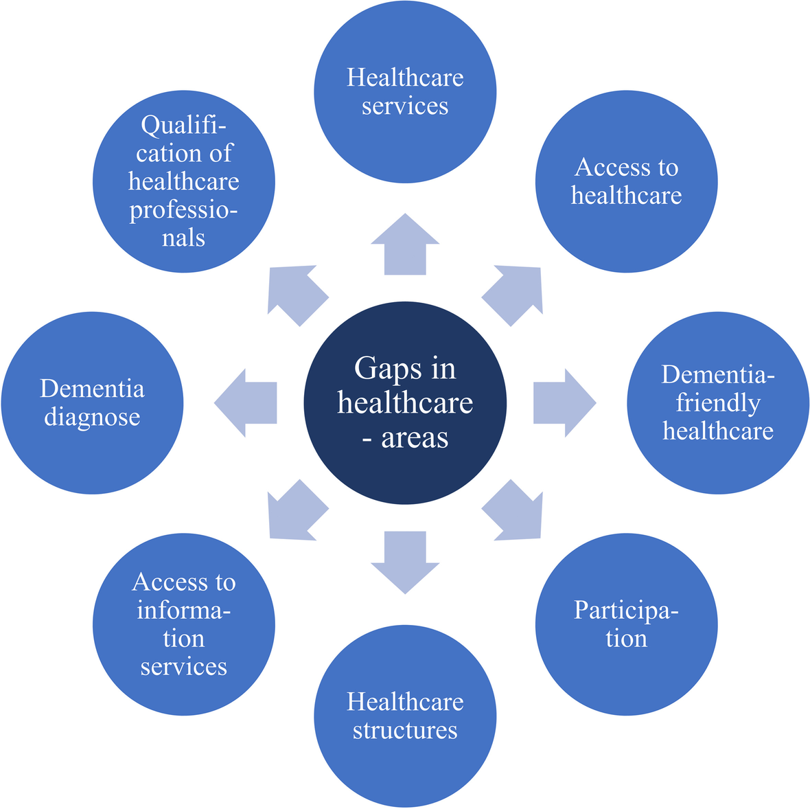
Figure 1: Gaps in healthcare areas
(Source: Schmachtenberg et al., 2022)
The research can be conducted using a scoping review and thematic analysis with reference to the methodology proposed by Aveyard, enabling him to find common themes in existing studies (NHS England, 2023). This can be used to enlighten policymakers, practitioners, and service planners in the UK on effective practices in care and possible areas of service failure (Boyle et al., 2022). Finally, the research may inform improved future care planning, the enhancement of the outcomes of individuals with dementia, and future research priorities in the UK health and social care.

1.3 Review Question
What are the main themes of dementia care in the UK health and social care practice as observed in peer-reviewed literature?

1.4 Research Objectives
- To determine and classify the major themes in the UK dementia care
- To review methods and models of dementia care as reported in the UK health and social care
- To examine how the current research findings can be applied in health and social care practice and policy
- To evaluate the relevance of the existing UK practices of dementia care to the concepts of person-centred and integrated care

2. Background

2.1 Current Policies and Legislation
According to Frank et al. (2026), the current UK policies and legislation provide the legal and practice framework of dementia care and support. This is because the Care Act 2014 obliges local authorities to assess and fulfil care needs, prevent adult abuse, and combine health and social care services for individuals with dementia and their careers. It also entails statutory guidance which focuses on person-centred care planning and protection (NHS England, 2023). The Mental Capacity Act 2005 offers legal safeguards to adults who lack decision-making capacity, which influences the decisions in their best interests, and offers safeguards to the majority of people with dementia. As per the views of Arsenault-Lapierre et al. (2023), the Health and Care Act 2022 facilitate integration of health and social care and forms the basis of the implementation of national NHS plans. Such national frameworks as the guidance on dementia care implementation by NHS England define the standards of the timely diagnosis, post-diagnostic support, and quality care delivery. The 10-Year Health Plan of England, provided by the UK Government, contains the promises of enhancing the availability of dementia care, commissioning, and coordination.

2.2 Existing Services and Practice
According to Treder et al. (2024), dementia care services in the UK cover various health, social and community-based services, which are aimed at addressing the requirements of individuals living with dementia and their careers. Once diagnosed, individuals are typically referred to memory assessment services where they are evaluated by specialists who discuss their symptoms and follow-up treatment, but the waiting time may differ significantly across regions (NHS England, 2023). NHS care planning focuses on person-centred care, which implies that care is provided based on the needs of an individual and is reviewed regularly. Integrated Care Systems (ICSs) assist with facilitating care coordination and bring together health services, local authorities, and voluntary groups to provide joined-up care routes so that community support, primary care and specialist services can pass on to each other more easily.
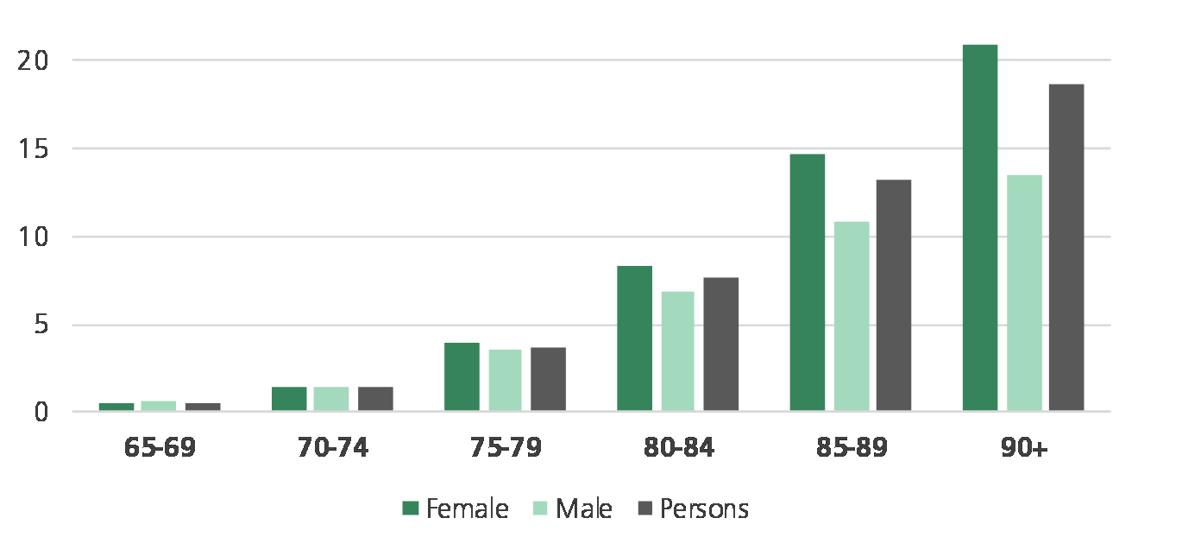
Figure: Dementia prevalence by gender differences
(Source: Baker, 2016)
As per the opinion of Singh et al. (2022), social services are the means of getting practical assistance at home, like personal care, day centres, equipment and respite breaks, many of which are often means-tested. The role of the charities is also significant as it provides professional training, resources on admiral nurse support, and expert advice.

2.3 Key Challenges and Issues
According to Wang et al. (2023), the UK dementia care has several challenges, which demonstrate why a specialised review is required. There are delays in diagnosis, and it has been reported that of the individuals with dementia, only between 50-60% are diagnosed formally, and some wait several months before being assessed and receiving further care (NHS England, 2023). Such stalling is capable of lowering access to early support and treatment. Provision of services to regions is also uneven; rural and deprived areas tend to have fewer specialist dementia support services. Studies indicate integration lapses in health and social care that may result in fragmentation of care planning, redundancy of assessment and lack of communication among care providers. As stated by Akinyemi et al. (2022), post-diagnostic support is of variable quality; not everyone is provided with a structured support plan, and not all carers receive training or respite. Some studies demonstrate the issue of the workforce, such as a lack of dementia special training of staff in both the healthcare and social care industries, which influences staff confidence and quality of care provision. The effects of these gaps on outcomes have very little research available on them in real-world contexts.

3. Methods

3.1 Data Collection Approach
In the case of the data collection method, the selection of the relevant academic databases was done to ensure that the research on dementia care in the United Kingdom is well covered. Such databases consisted of PubMed, CINAHL, Scopus, PsycINFO and the UWTSD Library. The selection of these sources is based on the fact that they index peer-reviewed journals in the spheres of health, social care, nursing, and psychology, which are the focus of dementia care (Littlejohn et al., 2022). The combinations of key terms that represented the major concepts of the review were used to carry out searches.
The search through the databases involved the use of keywords and Boolean operators to identify the search results that were closely related to the research question. Keywords were the variation of dementia care AND UK, dementia support AND health services, post-diagnostic support AND social care, and integrated care AND dementia. Connection between key concepts was carried out using Boolean operators like AND and OR, where synonyms or related terms were required to expand the search (Brent, 2023). Such combinations assisted in retrieving as much as possible peer-reviewed research that was relevant.
Inclusion criteria were developed such that they targeted high-quality and recent studies. Peer-reviewed articles in the English language were considered only in the past ten years. Research articles were required to provide primary or secondary research results on dementia care practices, service or outcome within the UK setting. The exclusion criteria eliminated non-research articles (Bacsu et al., 2022). Articles that were not related to the UK population or articles that did not explicitly tackle dementia care services were filtered out as well.

3.2 Data Analysis Approach
To analyse the selected works, they were initially examined to determine the primary focus, the methodology, and the results associated with dementia care in the UK. The articles were read, and the main information was gathered, such as the purpose of the study, the setting of the service, the characteristics of the participants, and the results (NHS, 2025). This data was prepared in a summary table, which assisted in comparing the research and identifying trends (Gadsby et al., 2022). Concepts and findings similar to those of other studies were clustered, including the themes of service access, quality of post-diagnostic care, integration of care, and effects on carers.
The method used to synthesise findings was thematic analysis since it enables the researcher to recognise and explain common ideas and topics that recur in two or more studies systematically (Bernstein Sideman et al., 2022). The thematic analysis allows going beyond simple description and makes it possible to understand what the research tells in general about the practice of dementia care. The analysis can demonstrate the connection between the evidence patterns and practice gaps, care quality, and service outcomes by using themes (Duchowny et al., 2022). This is an appropriate method when conducting a scoping review since it can accommodate the various research designs and findings, and hence easier to pull out meaningful lessons and priorities in future research, policy and practice.

3.3 Ethical Considerations
In this secondary research study, the ethical concern regards the responsible and just utilisation of the current research, without participating in any human subjects in the study. The selection and analysis of the studies should avoid bias to make sure that the review is representative of the existing evidence on dementia care in the UK. This involves the application of clear inclusion and exclusion criteria, multiple academic databases, and the consideration of all the relevant studies equally to minimise selection bias (Burton et al., 2022). This assists others in knowing how the findings were arrived at, and it also gives credence to the findings. During the review, ethical rules of research reporting, including honesty in interpretation and misrepresentation, are observed (NHS, 2025). The limitations or ambiguities of the data are also noted, and it is understood that secondary research relies on the quality and the extent of the existing studies (Loveys et al., 2022). These ethical concerns will ensure that the research is credible and of integrity, and they provide valuable evidence to inform the policy process, practice, and future studies in dementia care.

4. Results

4.1 Summary Tables
Authors, Year | Research Objectives | Methods | Key Findings | Relevance to Review Question
Giebel, C., Hanna, K., Watson, J., Faulkner, T., O’Connell, L., Smith, S. and Donnellan, W.J. (2024) | To investigate disparities in access and utilisation of community-based social care by people with dementia. | The systematic review of peer-reviewed articles about dementia and social care access. | The review discovered that there was good evidence of inequalities that were associated with income, geography, ethnicity, and the availability of services. The disadvantaged in deprived areas and the minority populations had worse access to support. | The article presents the absence of dementia care access in the community services, which makes a direct contribution to themes on inequality and service variability in UK dementia care.
Hampel, H., Vergallo, A., Iwatsubo, T., Cho, M., Kurokawa, K., Wang, H., Kurzman, H.R. and Chen, C. (2022) | To assess the national policies and health system preparedness to act early and provide care to people with dementia. | A comparative policy and systems analysis based on international data. | This research indicated that there are significant variations across countries in policy strength, the early diagnosis system, and care coordination. There were systems which were unprepared to provide care to dementia at early stages. | The research contributes to a discussion of the effect of the policy and system preparedness on the quality and consistency of dementia care in health services.
Duran-Kiraç, G., Uysal-Bozkir, Ö., Uittenbroek, R., van Hout, H. and Broese van Groenou, M.I. (2022) | To investigate the accessibility of healthcare among people with dementia of ethnic minorities. | European research study scoping review. | Results indicated that language, cultural miscommunication, and lack of awareness of good services minimised access to care by the minority groups. | This research enlightens themes of equity, inclusion and culturally sensitive care of dementia among health and social care services.
Bergqvist, M., Bastholm-Rahmner, P., Modig, K. and Schmidt-Mende, K. (2026) | To investigate care requirements and the issue of diagnosis through follow-up in the primary care setting. | Qualitative interviews with individuals with dementia and family carers. | The participants complained of poor follow-up, little information and continuity of care after diagnosis. | The journal paper contributes to the themes of post-diagnostic support and the gaps in further care, which are practical in the dementia care practice.
Frank, P., Singh-Manoux, A., Pentti, J., Batty, G.D., Sommerlad, A., Steptoe, A., Livingston, G., Howard, R. and Kivimäki, M. (2026) | To test associations between depression during middle age and dementia risk in the long term. | Prospective cohort study in the UK over 23 years. | Some of the depressive factors during middle life were closely associated with the risk of dementia in later life. | This research contributes to the information on preventive measures and early risk factors, contributing to the general picture of dementia treatment and early intervention requirements.
Table: Summary Tables of Results
(Source: Author)

4.2 Thematic Analysis
Theme 1: Inequality and Variation in Access to Dementia Care Services
Disparity in access to these services of dementia care in the UK demonstrates both strengths and issues. There are some regions where people can receive a diagnosis and care planning on time because memory clinics and community support are well-developed (Biondo et al., 2022). Nevertheless, it has been demonstrated that approximately 50-60% of individuals with dementia are given a formal diagnosis, and most of them have to wait a long time to get assessed and provided with post-diagnostic services.
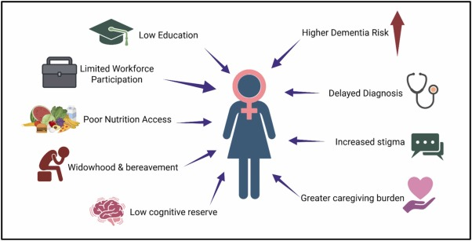
Figure 2: Global perspectives of Dementia care services
(Source: Mukherjee et al., 2025)
Citizens in rural or deprived communities and ethnic minorities usually access services and information at lower rates. Such gaps may cause delayed care, family stress, and unfair results, which underscores the necessity of enhancing equity and uniformity in the provision of dementia care.
Theme 2: Models and Methods of Dementia Care in Health and Social Care Systems
There are mixed results of models and methods of dementia care within the UK health and social care. Certain strategies, such as the service of memory assessment and multidisciplinary teams, facilitate early diagnosis and care planning. Integrated care systems have the intention of integrating health and social care services, and this is capable of enhancing communication and continuity of services across organisations (Wang et al., 2022).

Figure 3: Behavioural and social impact related to Dementia
(Source: National Institute on Ageing, 2025)
But the studies demonstrate that there are inconsistencies in the functioning of these models, and in some regions, there are no structured follow-ups and care pathways. The gap in workforce training is also a constraint on the implementation of effective best practice models (Dementia UK, 2024). The indications are that even though approaches are available to inform the provision of care to dementia, inconsistency in the implementation of these techniques results in disparities in service experiences and outcomes.
Theme 3: Person-Centred and Integrated Care in Dementia Practice and Policy
The UK dementia policy and practice are based on person-centred and integrated care, which has shown both improvement and challenges. The national guidance focuses on care, which is respectful of personal needs, preferences and life history, and numerous services rely on personalised care plans to aid this (Peryer et al., 2022). The integrated care systems are meant to enhance the coordination between the health care and the social care to minimise the repetitions of assessments and gaps in assistance (Dementia UK, 2024).
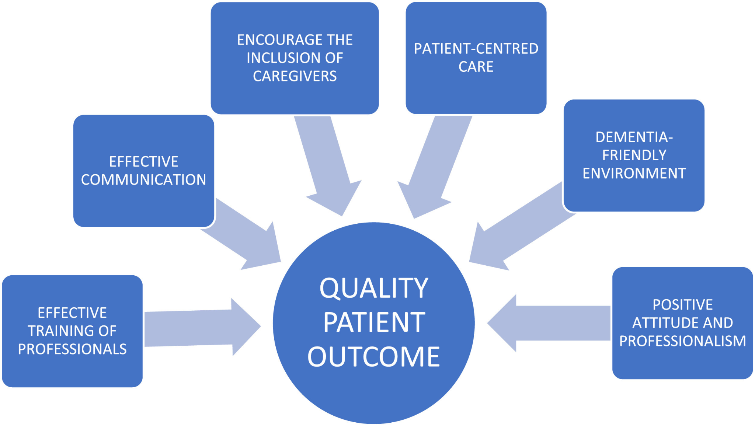
Figure 4: Person-Centred Care and Integrated care in Dementia practice and policy
(Source: Abowari-Sapeh et al., 2024)
Certain individuals with dementia continue to receive disjointed care, a lack of communication among health care professionals, and a lack of participation in decision-making. There is some evidence that person-centred, joined-up care requires more training, clear care pathways and enhanced service integration to become a regular occurrence across services.

5. Discussion

5.1 Compare and contrast findings
The studies reviewed indicate that there are some similarities and differences in the results of the study on dementia care. Several studies highlight disparities in access, indicating that individuals in deprived or minority groups have worse access to services, and this is consistent with the results of reviews of social care and European literature (Pool et al., 2022). Certain studies report a weakness in the post-diagnostic follow-up assistance and care, which is aligned with the primary care qualitative literature (CQC, 2022). Yet, the research varies in its focus, such as policy assessments that focus on the readiness of the system and variations in national models, whereas cohort studies provide a connection between mental health indicators, such as midlife depression, and prolonged dementia risk, which is not so much related to the service delivery (McCullough et al., 2023). They both demonstrate their interest in enhancing access, coordination, and the quality of care, although they focus on different aspects of dementia care.

5.2 Explain gaps in the research
The dementia care research in the UK has many gaps which need to be addressed. There is limited literature that quantifies the long-term outcomes of service models. Moreover, most of the studies are conducted in particular environments, but not in entire care pathways (Duran-Kiraç et al., 2022). Minor evidence exists on the impact of the integrated care system on patient experience and health outcomes in the long term. The sample size is usually limited or not representative of various groups of people, and the results may not be a reflection of what minority groups go through. The methods of studies also differ, and it is hard to compare them (Boyle et al., 2022). In half of the studies, there is no obvious quality or patient-reported outcome measures, which restricts the comprehension of the best alternatives in practice.

5.3 Theoretical and practical implications
The implications of the findings for dementia care in the UK are both theoretical and practical. The evidence promotes the theory of person-centred and integrated care, but also indicates that there are gaps between policy and practice (Frank et al., 2026). The results presented in the practice of healthcare reveal that the diagnosis should be done earlier, the follow-up must be more effective, and the connections between the health and social care services should be stronger (Dementia UK, 2024).
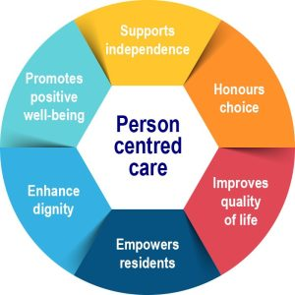
Figure: Person-Centred Care theory
(Source: Gama, 2021)
Evidence indicates that post-diagnostic support is still not provided to approximately 40-50% of the population promptly, thereby impacting outcomes (Arsenault-Lapierre et al., 2023). In future studies, the results indicate that there will be a need to conduct more studies in the UK that examine the outcomes of long-term care and integrate services to enhance the quality and equity of care.

6. Conclusion and Recommendations

6.1 Key takeaways
The key takeaways for the research are as follows:
- Access to dementia care in the United Kingdom presents itself as unequal access, with at most about 50-60% of the population receiving a formal diagnosis at a certain time, delaying the provision of support and planning.
- There are models of community and primary care, but the follow-up care and coordination are uneven, resulting in gaps in providing post-diagnostic care to many families.
- Person-centred and integrated care are powerful policy objectives, where studies reveal that the practice of service delivery is fragmented.
- Service effectiveness has little long-term outcome data, and it limits the evidence-based enhancement of dementia care systems.

6.2 Recommendations for future research
The recommendations for future research are as follows:
- Subsequent studies ought to employ larger representative samples in the UK in order to capture the experiences of different populations, particularly those of ethnic minorities, in which gaps in access are reported (Treder et al., 2024).
- Additional longitudinal research is required to quantify the outcome of the dementia care model in the long term, such as quality of life and hospitalisation.
- The researchers ought to test the integrated care systems under real-life environments to determine the effects of coordinated health and social care on the enhancement of service delivery (Singh et al., 2022).
- Studies should come up with and pilot standardised outcome measures that involve patient-reported experiences so that a comparison between services can be more obvious.
- There is a need to have evidence on the impact of workforce training and support on the quality and consistency of dementia care.

6.3 Recommendations for policy and practice
The recommendations for policy and practice are as follows:
- It should be the policy to enable quicker post-diagnostic support, so that not only the presently prevalent 50-60% of individuals with dementia receive timely care planning and follow-up planning.
- The health and social care services should have clear integrated pathways where assessment, care plans, and community support are aligned between providers (Wang et al., 2023).
- The staff training standards must be enhanced, and regular education with dementia-specific content must be introduced to improve the level of confidence and decrease the variation of care.
- Remote support and care coordination digital tools must be extended to all regions and must accommodate people with communication needs (Akinyemi et al., 2022).
- Service evaluation should focus on patient experience and outcomes as the main features of clinical guidelines that put person-centred care in the first place.

Reference List
- Abowari-Sapeh, M.E., Ackah, J.A., Murphy, J.L. and Akudjedu, T.N. (2024). Towards an improved dementia care experience in clinical radiography practice: A state-of-the-art review. Journal of Medical Imaging and Radiation Sciences, [online] 55(2). doi:https://doi.org/10.1016/j.jmir.2024.01.008. [Accessed on: 2nd Mar. 2026]
- Akinyemi, R.O., Yaria, J., Ojagbemi, A., Guerchet, M., Okubadejo, N., Njamnshi, A.K., Sarfo, F.S., Akpalu, A., Ogbole, G., Ayantayo, T. and Adokonou, T. (2022). Dementia in Africa: current evidence, knowledge gaps, and future directions. Alzheimer's & Dementia, 18(4), pp.790-809. Available at: https://alz-journals.onlinelibrary.wiley.com/doi/abs/10.1002/alz.12432 [Accessed on: 3rd Mar. 2026]
- Arsenault-Lapierre, G., Bui, T.X., Le Berre, M., Bergman, H. and Vedel, I. (2023). Rural and urban differences in quality of dementia care of persons with dementia and caregivers across all domains: a systematic review. BMC Health Services Research, 23(1), pp.102. Available at: https://link.springer.com/article/10.1186/s12913-023-09100-8 [Accessed on: 3rd Mar. 2026]
- Bacsu, J.D., Johnson, S., O’Connell, M.E., Viger, M., Muhajarine, N., Hackett, P., Jeffery, B., Novik, N. and McIntosh, T. (2022). Stigma reduction interventions of dementia: a scoping review. Canadian Journal on Aging/La Revue Canadienne Du Vieillissement, 41(2), pp.203-213. Available at: https://www.cambridge.org/core/journals/canadian-journal-on-aging-la-revue-canadienne-du-vieillissement/article/stigma-reduction-interventions-of-dementia-a-scoping-review/CA25D77824AACD1ED07E4564797962C0 [Accessed on: 3rd Mar. 2026]
- Baker, C. (2016). Dementia: age and deprivation differences. commonslibrary.parliament.uk. [online] Available at: https://commonslibrary.parliament.uk/dementia-age-and-deprivation-differences/. [Accessed on: 3rd Mar. 2026]
- Bergqvist, M., Bastholm-Rahmner, P., Modig, K. and Schmidt-Mende, K. (2026). Challenges and needs in dementia care: people with dementia and family caregivers’ experiences from diagnosis to follow-up in Swedish primary care: a qualitative study. Scandinavian Journal of Primary Health Care, 44(1), pp.1-14. Available at: https://www.tandfonline.com/doi/abs/10.1080/02813432.2025.2529414 [Accessed on: 2nd Mar. 2026]
- Bernstein Sideman, A., Al-Rousan, T., Tsoy, E., Piña Escudero, S.D., Pintado-Caipa, M., Kanjanapong, S., Mbakile-Mahlanza, L., Okada de Oliveira, M., De la Cruz-Puebla, M., Zygouris, S. and Ashour Mohamed, A. (2022). Facilitators and barriers to dementia assessment and diagnosis: perspectives from dementia experts within a global health context. Frontiers in Neurology, 13, pp.769360. Available at: https://www.frontiersin.org/journals/neurology/articles/10.3389/fneur.2022.769360/full [Accessed on: 3rd Mar. 2026]
- Biondo, F., Jewell, A., Pritchard, M., Aarsland, D., Steves, C.J., Mueller, C. and Cole, J.H. (2022). Brain-age is associated with progression to dementia in memory clinic patients. NeuroImage: Clinical, 36, pp.103-175. Available at: https://www.sciencedirect.com/science/article/pii/S2213158222002406 [Accessed on: 3rd Mar. 2026]
- Boyle, L.D., Husebo, B.S. and Vislapuu, M. (2022). Promotors and barriers to the implementation and adoption of assistive technology and telecare for people with dementia and their caregivers: a systematic review of the literature. BMC Health Services Research, 22(1), pp.1573. Available at: https://link.springer.com/article/10.1186/s12913-022-08968-2 [Accessed on: 3rd Mar. 2026]
- Brent, R.J. (2023). Cost-benefit analysis versus cost-effectiveness analysis from a societal perspective in healthcare. International Journal of Environmental Research and Public Health, 20(5), pp.4637. Available at: https://www.mdpi.com/1660-4601/20/5/4637 [Accessed on: 3rd Mar. 2026]
- Burton, J.K., Wolters, A.T., Towers, A.M., Jones, L., Meyer, J., Gordon, A.L., Irvine, L., Hanratty, B., Spilsbury, K., Peryer, G. and Rand, S. (2022). Developing a minimum data set for older adult care homes in the UK: exploring the concept and defining early core principles. The Lancet Healthy Longevity, 3(3), pp.186-193. Available at: https://www.thelancet.com/journals/lanhl/article/PIIS2666-7568(22)00010-1/fulltext [Accessed on: 3rd Mar. 2026]
- CQC (2022). Care Quality Commission. [online] https://www.cqc.org.uk/. Available at: https://www.cqc.org.uk/. [Accessed on: 2nd Mar. 2026]
- Dementia UK (2024). Dementia UK. [online] Dementia UK. Available at: https://www.dementiauk.org/. [Accessed on: 2nd Mar. 2026]
- Duchowny, K.A., Ackley, S.F., Brenowitz, W.D., Wang, J., Zimmerman, S.C., Caunca, M.R. and Glymour, M.M. (2022). Associations between handgrip strength and dementia risk, cognition, and neuroimaging outcomes in the UK biobank cohort study. JAMA Network Open, 5(6), pp.2218314. Available at: https://jamanetwork.com/journals/jamanetworkopen/article-abstract/2793510 [Accessed on: 3rd Mar. 2026]
- Duran-Kiraç, G., Uysal-Bozkir, Ö., Uittenbroek, R., van Hout, H. and Broese van Groenou, M.I. (2022). Accessibility of health care experienced by persons with dementia from ethnic minority groups and formal and informal caregivers: A scoping review of European literature. Dementia, 21(2), pp.677-700. Available at: https://journals.sagepub.com/doi/abs/10.1177/14713012211055307 [Accessed on: 2nd Mar. 2026]
- Duran-Kiraç, G., Uysal-Bozkir, Ö., Uittenbroek, R., van Hout, H. and Broese van Groenou, M.I. (2022). Accessibility of health care experienced by persons with dementia from ethnic minority groups and formal and informal caregivers: A scoping review of European literature. Dementia, 21(2), pp.677-700. Available at: https://journals.sagepub.com/doi/abs/10.1177/14713012211055307 [Accessed on: 3rd Mar. 2026]
- Frank, P., Singh-Manoux, A., Pentti, J., Batty, G.D., Sommerlad, A., Steptoe, A., Livingston, G., Howard, R. and Kivimäki, M. (2026). Specific midlife depressive symptoms and long-term dementia risk: a 23-year UK prospective cohort study. The Lancet Psychiatry, 13(2), pp.100-111. Available at: https://www.thelancet.com/journals/lanpsy/article/PIIS2215-0366(25)00331-1/fulltext [Accessed on: 2nd Mar. 2026]
- Frank, P., Singh-Manoux, A., Pentti, J., Batty, G.D., Sommerlad, A., Steptoe, A., Livingston, G., Howard, R. and Kivimäki, M. (2026). Specific midlife depressive symptoms and long-term dementia risk: a 23-year UK prospective cohort study. The Lancet Psychiatry, 13(2), pp.100-111. Available at: https://www.thelancet.com/journals/lanpsy/article/PIIS2215-0366(25)00331-1/fulltext [Accessed on: 3rd Mar. 2026]
- Gadsby, E.W., Wistow, G. and Billings, J. (2022). A critical systems evaluation of the introduction of a ‘discharge to assess’ service in Kent. Critical Social Policy, 42(4), pp.671-694. Available at: https://journals.sagepub.com/doi/abs/10.1177/02610183211065028 [Accessed on: 3rd Mar. 2026]
- Gama, M. (2021). How to Deliver Person Centred Care - Access Skills. [online] Access Skills. Available at: https://www.accessskills.co.uk/2021/10/20/how-to-deliver-person-centred-care/. [Accessed on: 2nd Mar. 2026]
- Giebel, C., Hanna, K., Watson, J., Faulkner, T., O’Connell, L., Smith, S. and Donnellan, W.J. (2024). A systematic review on inequalities in accessing and using community-based social care in dementia. International Psychogeriatrics, 36(7), pp.540-563. Available at: https://www.cambridge.org/core/journals/international-psychogeriatrics/article/ [Accessed on: 2nd Mar. 2026]
- Hampel, H., Vergallo, A., Iwatsubo, T., Cho, M., Kurokawa, K., Wang, H., Kurzman, H.R. and Chen, C. (2022). Evaluation of major national dementia policies and health‐care system preparedness for early medical action and implementation. Alzheimer's & Dementia, 18(10), pp.1993-2002. Available at: https://alz-journals.onlinelibrary.wiley.com/doi/abs/10.1002/alz.12655 [Accessed on: 2nd Mar. 2026]
- Lillekroken, D., Halvorsrud, L., Gulestø, R. and Bjørge, H. (2023). Family caregivers’ experiences of providing care for family members from minority ethnic groups living with dementia: A qualitative systematic review. Journal of Clinical Nursing, 32(9-10), pp.1625-1641. Available at: https://onlinelibrary.wiley.com/doi/abs/10.1111/jocn.16127 [Accessed on: 2nd Mar. 2026]
- Littlejohn, J., Bowen, M., Constantinidou, F., Dawes, P., Dickinson, C., Heyn, P., Hooper, E., Hopper, T., Hubbard, I., Langenbahn, D. and Nieman, C.L. (2022). International practice recommendations for the recognition and management of hearing and vision impairment in people with dementia. Gerontology, 68(2), pp.121-135. Available at: https://karger.com/ger/article-abstract/68/2/121/823802 [Accessed on: 3rd Mar. 2026]
- Loveys, K., Prina, M., Axford, C., Domènec, Ò.R., Weng, W., Broadbent, E., Pujari, S., Jang, H., Han, Z.A. and Thiyagarajan, J.A. (2022). Artificial intelligence for older people receiving long-term care: a systematic review of acceptability and effectiveness studies. The Lancet Healthy Longevity, 3(4), pp.286-297. Available at: https://www.thelancet.com/journals/lanhl/article/PIIS26667568(22)00034-4/fulltext [Accessed on: 3rd Mar. 2026]
- McCullough, K., Andrew, L., Genoni, A., Dunham, M., Whitehead, L. and Porock, D. (2023). An examination of primary health care nursing service evaluation using the Donabedian model: A systematic review. Research in nursing & health, 46(1), pp.159-176. Available at: https://onlinelibrary.wiley.com/doi/abs/10.1002/nur.22291 [Accessed on: 3rd Mar. 2026]
- Mukherjee, U., Brownell, M. and Reddy, P.H. (2025). Ageing, dementia, and care models: Global perspectives with insights from India. Ageing Research Reviews, [online] 113, p.102941. doi:https://doi.org/10.1016/j.arr.2025.102941. [Accessed on: 2nd Mar. 2026]
- National Institute on Ageing. (2025). Behavioural and Social Research on Alzheimer’s Disease & Alzheimer’s Disease Related Dementias. [online] Available at: https://www.nia.nih.gov/research/dbsr/ad-adrd. [Accessed on: 2nd Mar. 2026]
- NHS (2025). NHS. [online] NHS. Available at: https://www.nhs.uk/. [Accessed on: 2nd Mar. 2026]
- NHS England (2023). NHS England. [online] England.nhs.uk. Available at: https://www.england.nhs.uk/. [Accessed on: 2nd Mar. 2026]
- Peryer, G., Kelly, S., Blake, J., Burton, J.K., Irvine, L., Cowan, A., Akdur, G., Killett, A., Brand, S.L., Musa, M.K. and Meyer, J. (2022). Contextual factors influencing complex intervention research processes in care homes: a systematic review and framework synthesis. Age and Ageing, 51(3), pp.014. Available at: https://academic.oup.com/ageing/article-abstract/51/3/afac014/6540144 [Accessed on: 3rd Mar. 2026]
- Pool, J., Akhlaghpour, S., Fatehi, F. and Grey, L.C. (2022). Data privacy concerns and use of telehealth in the aged care context: an integrative review and research agenda. International Journal of Medical Informatics, 160, pp.104-707. Available at: https://www.sciencedirect.com/science/article/pii/S1386505622000211 [Accessed on: 3rd Mar. 2026]
- Schmachtenberg, T., Monsees, J. and Thyrian, J.R. (2022). Structures for the care of people with dementia: a European comparison. BMC Health Services Research, 22(1). doi:https://doi.org/10.1186/s12913-022-08715-7. [Accessed on: 2nd Mar. 2026]
Singh, S., Grey, A., Shepperd, S., Stott, D.J., Ellis, G., Hemsley, A., Khanna, P., Ramsay, S., Schiff, R., Tsiachristas, A. and Wilkinson, A. (2022). Is a comprehensive geriatric assessment hospital at home a cost-effective alternative to hospital admission for older people?. Age and Ageing, 51(1), pp.220. Available at: https://academic.oup.com/ageing/article-abstract/51/1/afab220/6490273 [Accessed on: 3rd Mar. 2026]
Treder, M.S., Lee, S. and Tsvetanov, K.A. (2024). Introduction to Large Language Models (LLMs) for dementia care and research. Frontiers in dementia, 3, pp.1385303. Available at: https://www.frontiersin.org/journals/dementia/articles/10.3389/frdem.2024.1385303/full [Accessed on: 3rd Mar. 2026]
Wang, J., Shen, J.Y., Conwell, Y., Yu, F., Nathan, K., Heffner, K.L., Li, Y. and Caprio, T.V. (2023). Antipsychotic use among older patients with dementia receiving home health care services: prevalence, predictors, and outcomes. Journal of the American Geriatrics Society, 71(12), pp.3768-3779. Available at: https://agsjournals.onlinelibrary.wiley.com/doi/abs/10.1111/jgs.18555 [Accessed on: 3rd Mar. 2026]
Wang, L., Zhou, Y., Fang, X. and Qu, G. (2022). Care burden on family caregivers of patients with dementia and affecting factors in China: A systematic review. Frontiers in psychiatry, 13, pp.100-4552. Available at: https://www.frontiersin.org/journals/psychiatry/articles/10.3389/fpsyt.2022.1004552/full [Accessed on: 3rd Mar. 2026]

