Effective team working and communication-BMSW4002

Lecture name –
Khaza Ahmed

Lecture name
Effective team working for team success
PENKA HRISTOVA -2108956

Contents page

Introduction………………………………………………………………………………………….1
What is a Team……………………………………………………………………………………..1
Effective teamworking……………………………………………………………………………...2
Tuckman’s model……………………………………………………………………………………2
Belbin’s team role……………………………………………………………………………………4
Coyle’s code…………………………………………………………………………………………6
Conclusion…………………………………………………………………………………………..7
Reference list………………………………………………………………………………………..7

Introduction
In this report, we will talk about team development and effective team. Abdul urgently needs to do something to deliver this project for Vodaphone to the end using Tuckman’s model, Belbin’s roles, and Cole’s code. The following lines are acquainted with the meaning of the word team and teamwork and effective team working. Let's become acquainted with a team and efficient teamwork before we look at the model and guidelines that Abdul can use for his new project for Vodaphone.

What is a Team?
A team is a group of individuals that have a similar purpose that could only be achieved by combining individual activity in the right way. As a result, teamwork is a type of collaboration. A team is a group of individuals who work together to achieve a common objective( Borrill, C. West, M.A., 2005).
The team is made up of specialists who work independently in order to do their jobs efficiently, effectively, and qualitatively. Teamwork is defined as a collection of people working together as a team, with each person's perspective and interest being weighed against the team's unity and effectiveness. It implies, however, that successful cooperation extends beyond individual accomplishments. When each member of a team works together to achieve a common goal, teamwork is successful. As a result, teamwork has become an integral aspect of the teamwork culture. More operative, creative, and dynamic people are represented in this category. N.( Orjonikidze and M. Gogidze, 2015).
Effective teamworking
A team is a more efficient, creative, and effective operating unit than a single individual. The group fosters exceptionally harmonious interactions, increases the effectiveness of relationships that occur, and unlocks creative potential. Intuitively, team members' attitudes are reinforced. It's a trait of their communication that's been kept secret. Individuals began honestly and communication beyond standards in a collaboration setting, revealing their individuality. As a result, a team develops a respect-based connection. A team is a group of professionals who work together to bring value to specific tasks. The team produces particular benefits, such as a very attractive work atmosphere for employees, and so on. (Orjonikidze, N., Gogidze, M., 2015).

Based on Abdul's case and the problems he had with his team, he can develop effective teamwork using Tuckman's model.

Tuckman’s model
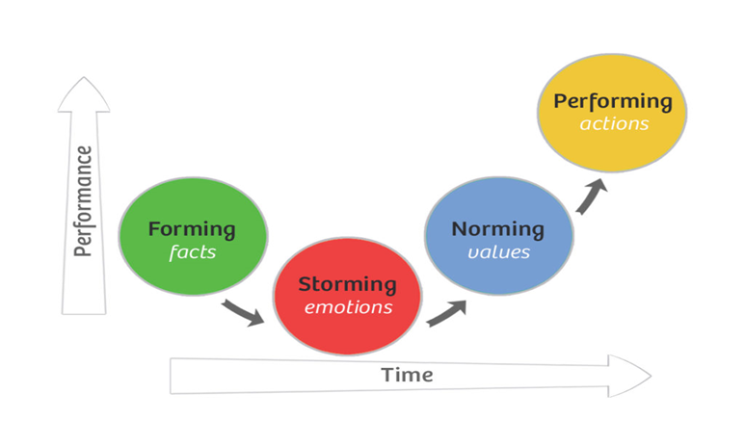(Tuckman,1965)

Bruce W. Tuckman authored a literature review study in 1965. In his paper, he discussed two aspects of group functioning: interpersonal interactions and task activity. He presented a four-stage model, with each stage requiring satisfactory completion in order to achieve efficient group functioning. Until the conclusion of the essay, he coined the terms "formation, storming, norming, and performing.".( Bonebright, D.,2010).
Forming
The concept of 'testing and dependency' is the initial step in the model. Here, the collective develops engagement to the project, creates guiding principles, and evaluates interpersonal and task behavior limits. ( Bonebright, D.,2010).
Storming
The second stage is characterized by intergroup conflict. There is a lack of cohesiveness and separation in relation to interpersonal concerns during this stage. Members of a group often resist moving into unfamiliar territories and desire to maintain their security. At this level, there may be emotional repercussions for members, especially if the objectives involve self-awareness and change. If a group uses its intellect and impersonal abilities to work on impersonal activities, intense emotions are less likely to emerge, although resistance can still occur. (Bonebright, D.,2010).
Norming
During the third stage, the group becomes cohesive. Each member of the group embraces the eccentricities of the other and has a distinct viewpoint. As a stage of building common mental models and determining the most successful methods to cooperate with each other, this stage is defined as roles and conventions are created. At this point, according to Tuckman, the group becomes an entity when members acquire in-group feelings and desire to maintain and perpetuate the group. To maintain harmony, task conflicts are avoided. (Bonebright, D.,2010).
Performing
During the last stage of the original model, the group developed functional role relatedness. By adapting to their roles, members increase task activities and turn the group into a "problem-solving instrument.” A framework enhances team performance by improving roles' flexibility and usefulness and by encouraging team enthusiasm. (Bonebright, D.,2010).
Adjourning
Tuckman and Jensen were commissioned to upgrade the model in 1977. They went through the original model again and looked over the later literature on team development, and identified the fifth step, 'adjourning,' based on their findings. As a result of this modification, the concept of separation was extended to the group life cycle. ( Bonebright, D.,2010).
From the following information, we can trace how the development of teamwork is changing therefore, Abdul can use it as a development of effective collaboration.
Three hundred sixteen proper human development participation at a big, whole-sale department store organization's local stores across the United States. Each business has a total workforce of 250 to 300 people. The study is open to all workers. The 316 members of the team were divided into 79 four-person working groups. The human resource department's execution and procedural policies were seen as critical in fostering strong employee connections. The teams were set up in such a way that team members' interaction and dependency were maximized. Teams met once a week to address current practices and problem-solving conversations and once a day in a staff meeting to discuss the status of work-related concerns. Members of the team were supposed to become specialists in a certain area of the project. Each team member was accountable for sharing information with the group members in charge of the next step of the project.
As a consequence, they became reliant on one another for information in order to finish their respective phases of the job process. Work flowed in a sequential order most of the time, but it also moved back and forwards amongst team members at times. Although members of one team may be likely to digest the tasks. In summary, team members engaged on a regular basis about independent tasks, gained specialized task-related abilities, made joint choices, completed work logically, and were partially paid as a team.. ( Neuman, G.A. Wright, J. 1999).

Belbin’s team role

According to the Tuckman model, Abdul's team is at the second stage of storming; consequently, if he wants to do practical work, he must establish some rules in the group. Belbin's team role framework is one of the most well-known, and it is now extensively utilized in a variety of relevant team improvement and strategic planning applications. Belbin identified nine distinct functions. Four characteristics characterize and categorize Belbin’s team roles: feeling, willpower, reasoning, and decisiveness. These eight positions were the product of his initial study. Belbin then added a ninth function, the specialized (SP) team role, which refers to single-mindedness, operating alone, and is committed to the specialty, to his later study.(Van de Water, H., Ahaus, K. and Rozier, R., 2008).

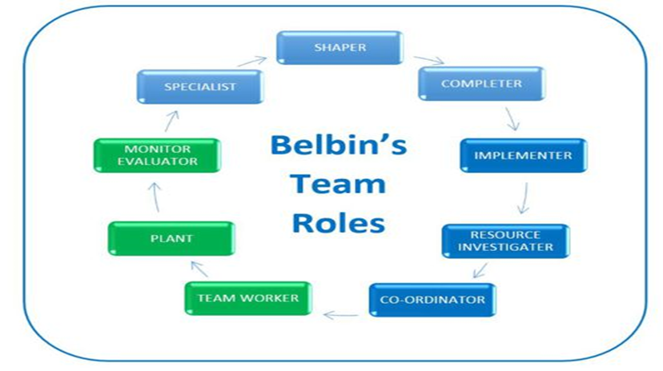
(Belbin’s,1981)

In research employing Belbin's paradigm, team performance is frequently characterized in terms of a quantitative output or a team member's self-assessment over their own performance of the team. One of Belbin's researches compared and contrasted an evaluated individual's self-evaluation with a 360-degree examination of four members of the team. In his research, Belbin demonstrated that the most successful teams were ones in which different types of people were involved (different team roles). It's important to remember that certain team members are capable of handling multiple responsibilities at the same time. It is a common reference for organizations, businesses, and leaders themselves to form teams. However, the Belbin team role typology has yet to be applicable to begin and their founders. The primary goal of the applied research team was to determine the role/roles of creators in start-up teams and, as a result, to assess the value of leaders in start-ups. The goal of the above-mentioned study is to see if there are any similar features among successful business people (start-up founders). The verification of the following hypothesis is a need for achieving the goal: 1. Every leader is responsible for many team positions, at least four of which exceed the probability of occurrence by 50%. 2. Successful start-up leaders will have the same blend of team roles. 3. There will be the same or comparable trend (high or low representation) in at least one team job. Every entrepreneur aspires to enter the market with an innovative idea, put it into effect as a start-up, dazzle prospective clients, and become successful. Although it is true that having a great concept is essential for starting a business, finding the proper personnel for such a unique venture is one of the most difficult challenges. Belbin's study, which identifies the team function performed by each start-up team's founder, is useful in establishing the suitability of certain leadership attributes for supervising a start-up team.( BEDNÁR, R., LJUDVIGOVÁ, I., 2020).

Coyle’s code
We'll look at Coyle's code within the next paragraph, as well as the effects of successful teamwork on the overall success of the company. Coyle examines the ways in which individuals work together to excel as a group in his book The Culture Code: The Secrets of Highly Successful Groups. The text concentrates on how individuals connect effectively and productively with one another, providing leaders with three abilities that can aid in the development of successful teams. Building safety, sharing vulnerability, and developing purpose are three abilities that his study found as essential for effective cooperation. (Aradillas, L.A., 2020).
Skill one building safety. This ability demonstrates how successful teams build solid emotional connections and act as a family unit where members are at ease with one another. He considers skill two, Share Vulnerable, to be a trust builder. Where the majority of individuals are frightened to be vulnerable. In the examples investigated, a simple act of displaying vulnerability, such as not being scared to declare what one needs or that one does not know all the answers, has even rescued lives. Establish Purpose, the third skill, is possibly the most fundamental of the three and one which we've seen again and time again. Simply said, individuals, require a cause to accomplish the task they do every day, as well as a pathway or guidance to follow.(Aradillas, L.A., 2020).
Coyles depicts a group of individuals from diverse industries in one of his studies. Coyle discovered that successful teams have chosen to share three common abilities after a determined search for the source of their effectiveness. Coyle distinguishes between two sorts of goals: those that involve proficiency and those that concern creativity. The ability of proficient and creative groups to manage results originated from the groups' constant renewal of their focus and work toward achieving their goals. Attention was devoted to the construction and use of language and heuristics in order to set organizational goals and work toward achieving them. The significant recommended practices among effective group culture were emphasized as engaging clarity of communication on the purpose and effective communication of stated purposes. (Reginold, T.A., 2019).
Аbdul may have barriers to effective teamwork such as ineffective leadership, communication gaps, lack of trust. It is an imperative personal connection between team members and builds at the workplace. To make a successful team, Abdul can make less formal team meetings where everyone can share problems or week load. He can introduce, discuss difficulties that every team member may have, and link a couple of team individuals. That is how he can make a powerful connection and straighten the job.

Conclusion
On the basis of the above research, it can be concluded that effective team success is significant for teams to achieve goals. Tuckman's technique can be used to establish effective teamwork. It may also describe diverse effects of teamwork, which aids productivity by using Belbin's role. Also, for a better understanding of casework by group workers, Coyle’s code can be utilized to show the potential part of a group process.

Reference list
Gilley, J. W. et al. (2010) ‘Integrated Theoretical Model for Building Effective Teams,’ Advances in Developing Human Resources, 12(1), pp. 7–28. DOI: 10.1177/1523422310365309.
BEDNÁR, R. and LJUDVIGOVÁ, I., 2020. Belbin team roles in a start-up team. Les Ulis: EDP Sciences.
BATENBURG, R., WOUTER, V.W. and WESLEY IN, D.M., 2013.’Belbin role diversity and team performance: is there a relationship?’ The Journal of Management Development, 32(8), pp. 901-913.
Bonebright, D. (2010) ‘40 years of storming: a historical review of Tuckman’s model of small group development’, Human Resource Development International, 13(1), pp. 111–120. DOI: 10.1080/13678861003589099.
Orjonikidze, N. and Gogidze, M.,( 2015).’ The Advantages of the “Teamwork” Approach during Personnel Management’. Journal of Business, 4(1), pp.17-19.
Neuman, G.A. and Wright, J. (1999) ‘Team Effectiveness: Beyond Skills and Cognitive Ability, Journal of applied psychology, 84(3), pp. 376–389. doi:10.1037/0021-9010.84.3.376.
Aradillas, L.A., 2020.’ The Culture Code: The Secrets of Highly Successful Groups’ (Book Review). Georgia Journal of College Student Affairs, 36(1), pp.68-70.
Borrill, C. and West, M.A., 2005.’ The psychology of effective teamworking’. In Teamwork: multi-disciplinary perspectives (pp. 136-160). Palgrave Macmillan.
Fisher, S. G. and Hunter, T. A. (1998) ‘The structure of Belbin’s team roles’, Journal of Occupational & Organizational Psychology, 71(3), pp. 283–288. doi: 10.1111/j.2044-8325.1998.tb00677.x.
FISHER, S.G., MACROSSON, W.D.K. and SEMPLE, J.H., 2001. Control and Belbin's team roles. Personnel Review, 30(5), pp. 578-588.
van de Water, H., Ahaus, K. and Rozier, R., 2008. Team roles, team balance, and performance. Journal of Management Development.
Regenold, T.A., 2019. Review of The Culture Code: The Secrets of Highly Successful Groups, by Daniel Coyle.

