Name: Aida Lamer
Student P Number: 1706552
Module: Programming II
Assignment Title: Assignment 1
Lecturer’s Name: Mike Dacey

Part A (Understanding)

The problem solving technique I selected was subdividing problems into functions. By doing this it can lead to “MURDER”.
M-Maintainability
U-Understand ability
R-Reuse-ability
D-Debug-ability
E-Extensibility
R-Regression
This works for a number of reasons. It is easier to maintain due to the smaller and simpler functions. By simplifying the functions and using fever lines of code, it’s also easier to understand the semantics of the function. By breaking big functions down into smaller ones, it reduces the number of functions with multiple return points. Smaller functions are also easier to reuse by moving common operations to a separate function. By doing this, you can use the same block of code in multiple places. By simplifying the functions, it’s also easier to debug the code rather than debugging a complex function. This works by isolating the potential bugs to one place rather than several different places. By being able to reuse and maintain the code, it is easier to refactor functions in 6 months. Regression testing is also more effective due to reuse and modularization. This method also helps to identify and isolate any potential problems with subtle data dependencies that would otherwise be hard to see.
There are also some problems with breaking big functions up. If a working function was modularized, it may stop working even though it was working before. If your synchronization policies are wrong or subtle, you may introduce deadlocks or even rare conditions. From the function calls, you could also introduce a performance hit. [1]
Part B

01 | Valid Values
Description |  | When choosing the first option from the menu, enter five valid numbers and sum the numbers provided.
 |  | Test Steps :
1 | Select first option by entering “1”
2 | Enter “1” as first number
3 | Enter “2” as second number
4 | Enter “5” as third number
5 | Enter “6” as fourth number
6 | Enter “7” as firth number

Response |  | Successfully sum provided valid numbers. Answer should be “21”.
Status |  |  | Date |  |  | Description
Pass |  |  | 27/03/2018 20:16 |  |  | Passed

Evidence of test 01
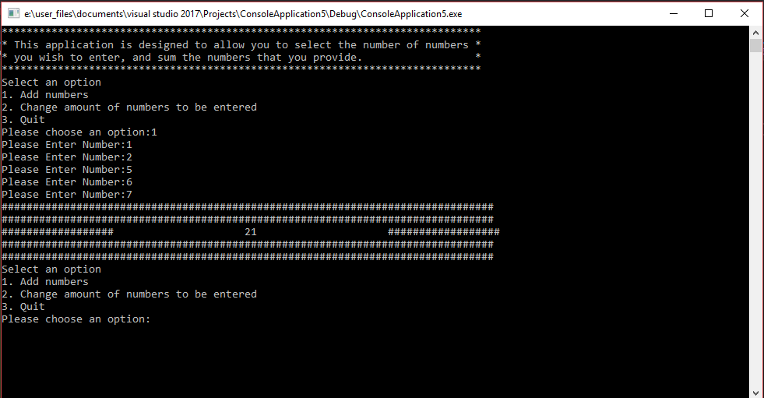

02 | Changing required numbers
Description |  | Change amount of numbers to be entered
 |  | Test Steps :
1 | Select second option by entering “2”
2 | Enter “3” for amount of valid numbers to be entered
3 | Select first option by entering “1”
4 | Enter valid number “3”
5 | Enter valid number “4”
6 | Enter valid number “2”
7 | Select second option by entering “2”
8 | Enter “2” for amount of valid numbers to be entered
9 | Select first option by entering “1”
10 | Enter valid number “3”
11 | Enter valid number “4”

Response |  | Successfully modify amount of numbers to be entered and sum up valid numbers. When providing “3” in option two, it asks for 3 valid numbers and when providing “2” in option two, it asks for 2 valid numbers.
Status |  |  | Date |  |  | Description
Pass |  |  | 27/03/2018 20:32 |  |  | Passed

Evidence of test 02
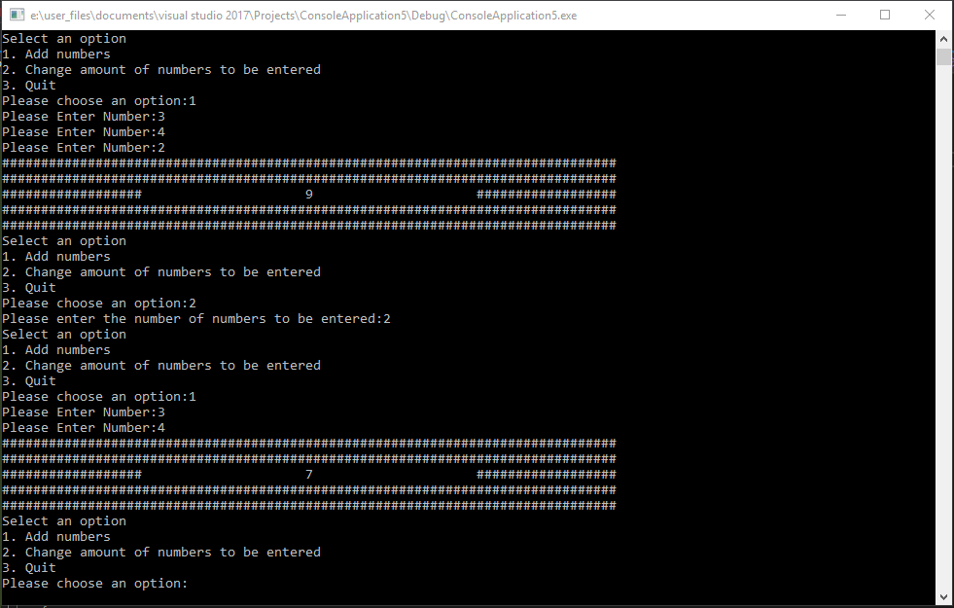

03 | Quit
Description |  | Testing option three that closes the program.
 |  | Test Steps :
1 | Select third option by entering “3”
2 | Enter “YES”
3 | Press “Enter”

Response |  | Successfully closes program
Status |  |  | Date |  |  | Description
Pass |  |  | 27/03/2018 20:42 |  |  | Passed

Evidence of test 03
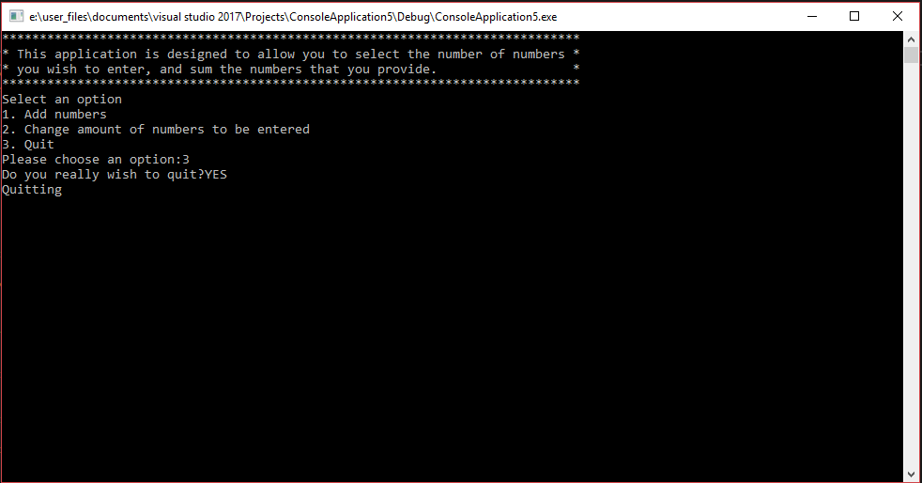
04 | Text input
Description |  | When choosing an option from the menu, entering invalid value.
 |  | Test Steps :
  1 | Enter “A” to selecting option
Response |  | “Unknown option value entered” displayed. Returned to main menu.
Status |  |  | Date |  |  | Description
Pass |  |  | 27/03/2018 20:55 |  |  | Passed

Proof of test 04
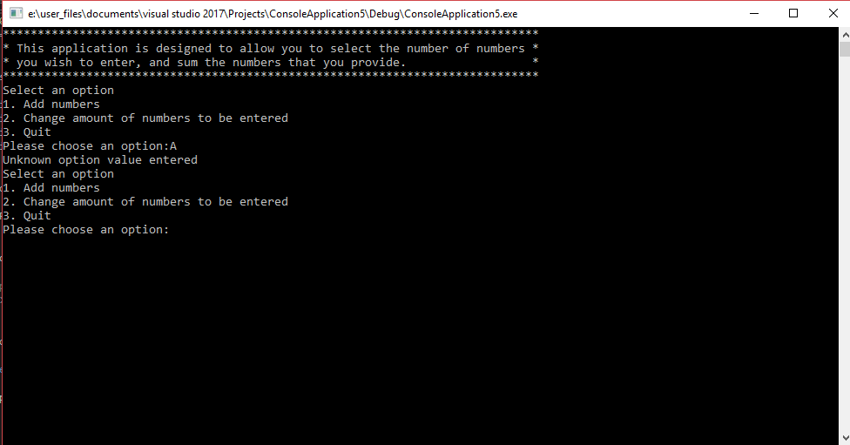
05 | Text input for requested number
Description |  | When choosing the first option from the menu, enter text as the first number.
 |  | Test Steps :
1 | Select first option by entering “1”
2 | Enter “a” as first number

Response |  | Display “Unknown value entered”. Request the first number again.
Status |  |  | Date |  |  | Description
Fail |  |  | 27/03/2018 21:06 |  |  | If entered text, program will store incorrect value and ask to also enter value 2, 3, 4 ,5 and will display an incorrect value.
Pass |  |  | 27/03/2018 21:58 |  |  | Passed

Evidence of test 05 failure
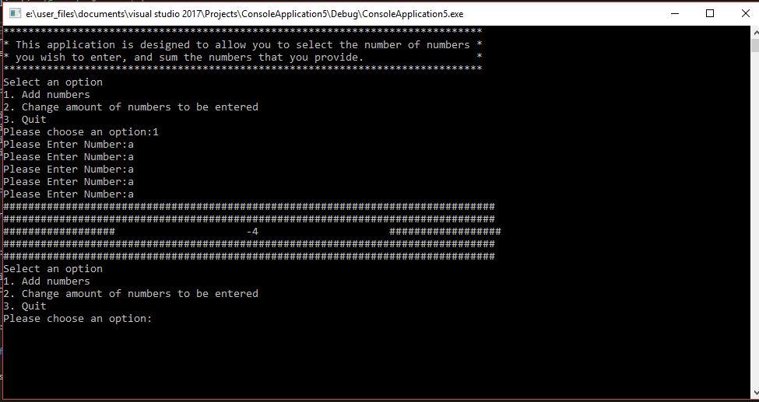
Evidence of test 05 passed

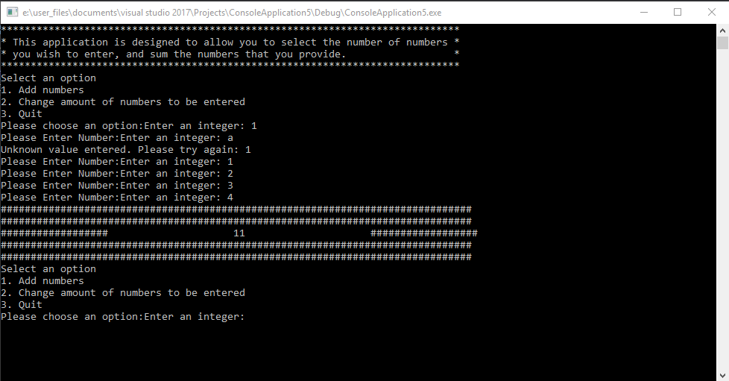

06 | Text input for requested number
Description |  | When choosing the first option from the menu, enter text as a value.
 |  | Test Steps :
1 | Select first option by entering “1”
2 | Enter “1” as first number
3 | Enter “123a” as second number

Response |  | Display “Unknown value entered”. Request the second number again.
Status |  |  | Date |  |  | Description
Pass |  |  | 27/03/2018 22:05 |  |  | Passed

Evidence of test 06
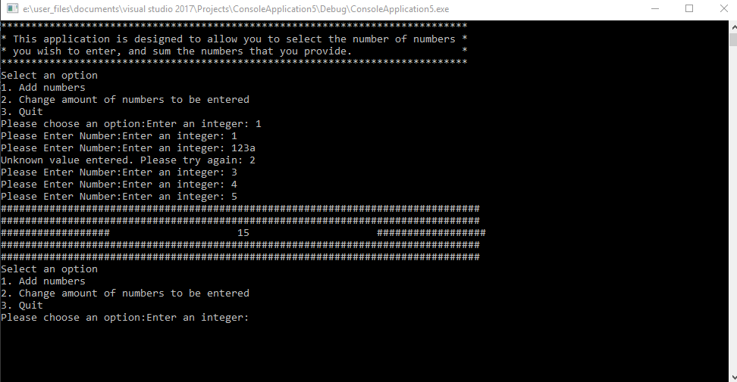

07 | Invalid input for requested number
Description |  | When choosing the first option from the menu, leave requested input field blank.
 |  | Test Steps :
1 | Select first option by entering “1”
2 | Leave input field blank and press Enter when requesting first number.

Response |  | Display “Unknown value entered”. Request the first number again.
Status |  |  | Date |  |  | Description
Pass |  |  | 27/03/2018 22:10 |  |  | Passed

Evidence of test 07
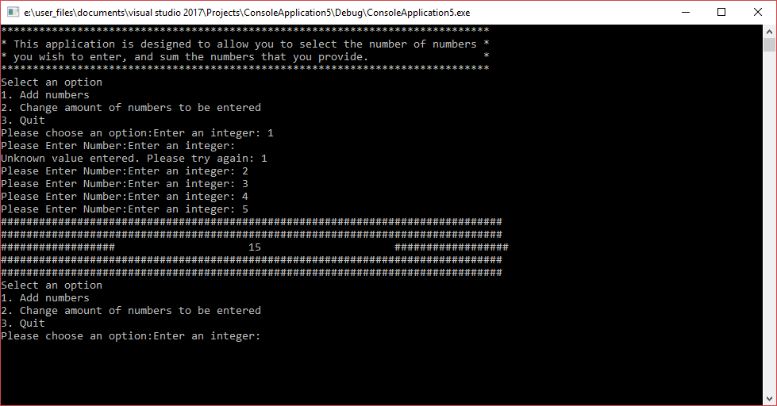

08 | Special character for requested number
Description |  | When choosing the first option from the menu, enter special character instead of valid input.
 |  | Test Steps :
1 | Select first option by entering “1”
2 | Input special character “*#@”
3 | Press Enter

Response |  | Display “Unknown value entered”. Request the first number again.
Status |  |  | Date |  |  | Description
Pass |  |  | 27/03/2018 22:15 |  |  | Passed

Evidence of test 08
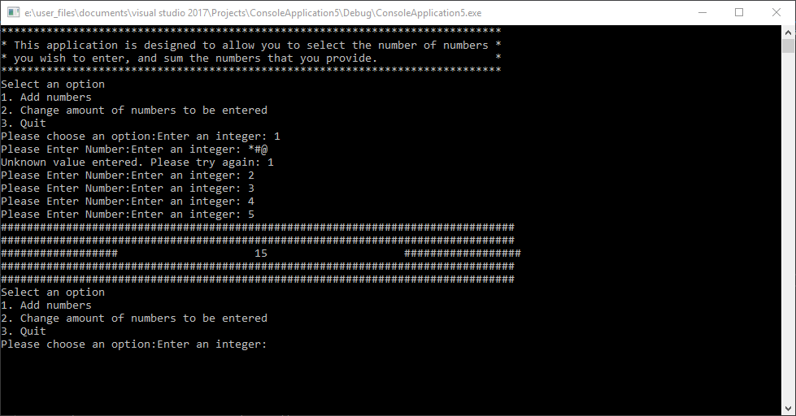

09 | Quit
Description |  | Testing other variations of input value for option three that closes the program.
 |  | Test Steps :
1 | Select third option by entering “3”
2 | Enter “Yes”
3 | Press “Enter”

Response |  | Successfully closes program
Status |  |  | Date |  |  | Description
Fail |  |  | 27/03/2018 22:20 |  |  | Failed. If enter “Yes” instead of “YES” it launches “Select an option” menu instead of closing the application.
Pass |  |  | 27/03/2018 22:32 |  |  | Passed

Evidence of test 09 fail
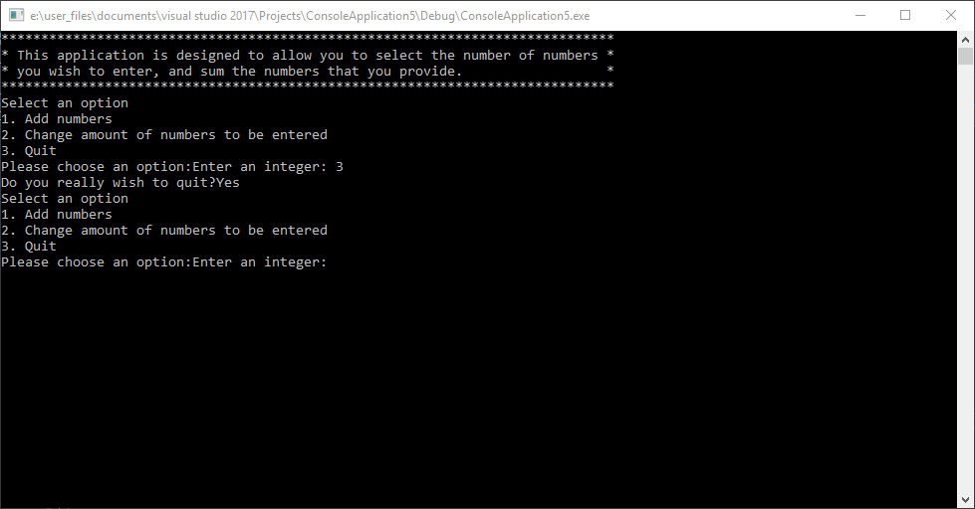

Evidence of test 09 pass
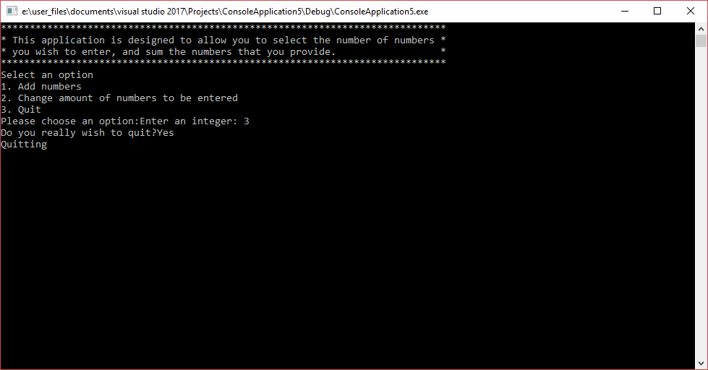

10 | Quit-incorrect input
Description |  | Testing other variations of input value for option three that closes the program.
 |  | Test Steps :
1 | Select third option by entering “3”
2 | Enter “abc”
3 | Press Enter

Response |  | Incorrect input should display “Please type “yes” or “no”” and request response again.
Status |  |  | Date |  |  | Description
Pass |  |  | 27/03/2018 22:56 |  |  | Passed

Evidence of test 10
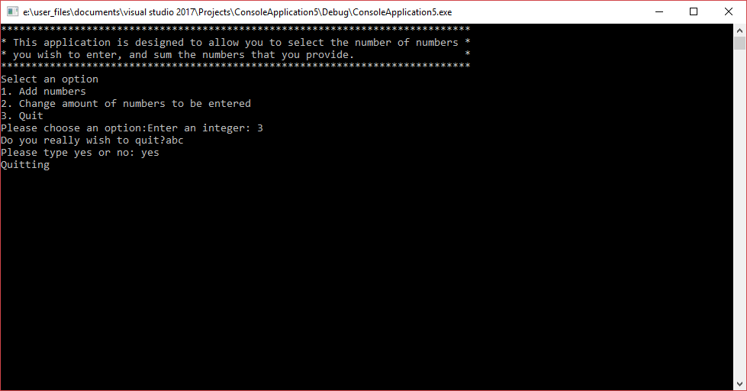
11 | Quit-numbers
Description |  | Testing other variations of input value for option three that closes the program.
 |  | Test Steps :
1 | Select third option by entering “3”
2 | Enter “123”
3 | Press Enter

Response |  | Incorrect input should display “Please type “yes” or “no”” and request response again.
Status |  |  | Date |  |  | Description
Pass |  |  | 27/03/2018 23:05 |  |  | Passed

Evidence of test 11
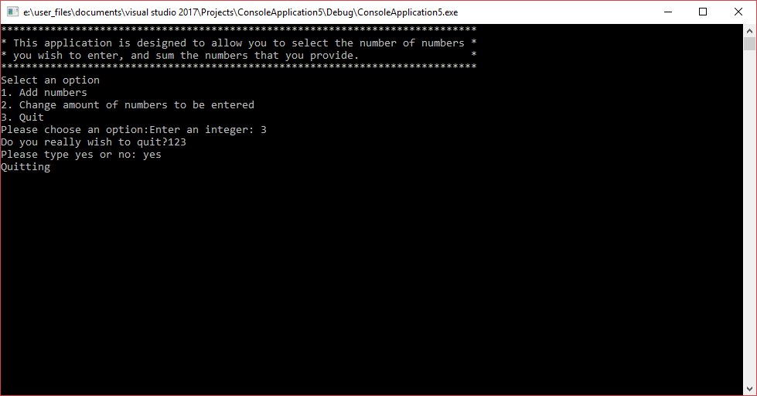
12 | Quit-blank
Description |  | Testing other variations of input value for option three that closes the program.
 |  | Test Steps :
1 | Select third option by entering “3”
2 | Leave requested field blank
3 | Press Enter

Response |  | Incorrect input should display “Please type “yes” or “no”” and request response again.
Status |  |  | Date |  |  | Description
Pass |  |  | 27/03/2018 23:10 |  |  | Passed

Evidence of test 12
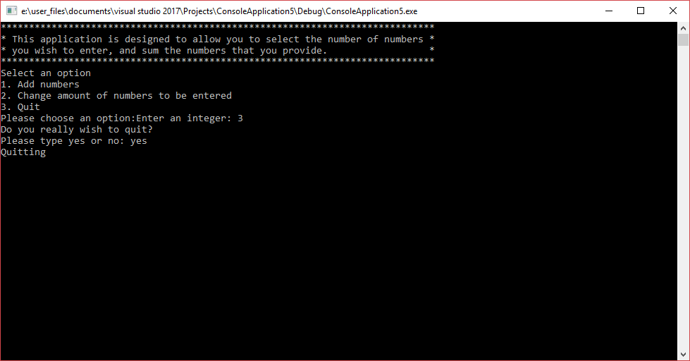
13 | Quit-special letters
Description |  | Testing other variations of input value for option three that closes the program.
 |  | Test Steps :
1 | Select third option by entering “3”
2 | Enter special letters “*@#”
3 | Press Enter

Response |  | Incorrect input should display “Please type “yes” or “no”” and request response again.
Status |  |  | Date |  |  | Description
Pass |  |  | 27/03/2018 23:15 |  |  | Passed

Evidence of test 13
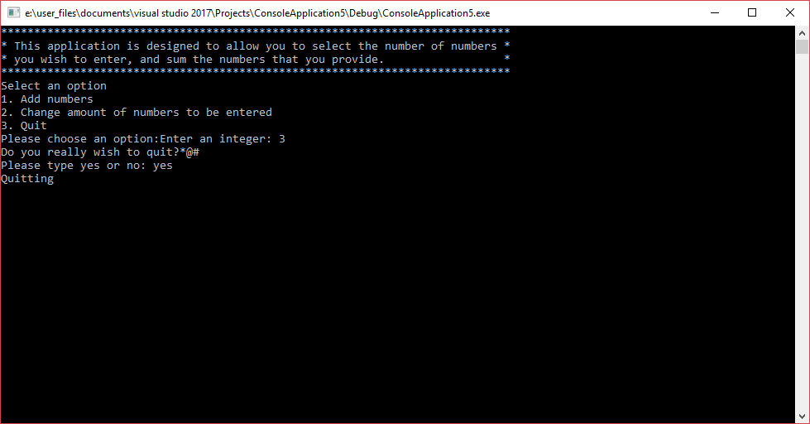
14 | Quit-no
Description |  | Testing “no” input if the used doesn’t wish to close the program.
 |  | Test Steps :
1 | Select third option by entering “3”
2 | Enter “no”
3 | Press Enter

Response |  | If typed “no” program should launch main menu again.
Status |  |  | Date |  |  | Description
Pass |  |  | 27/03/2018 23:23 |  |  | Passed

Evidence of test 14
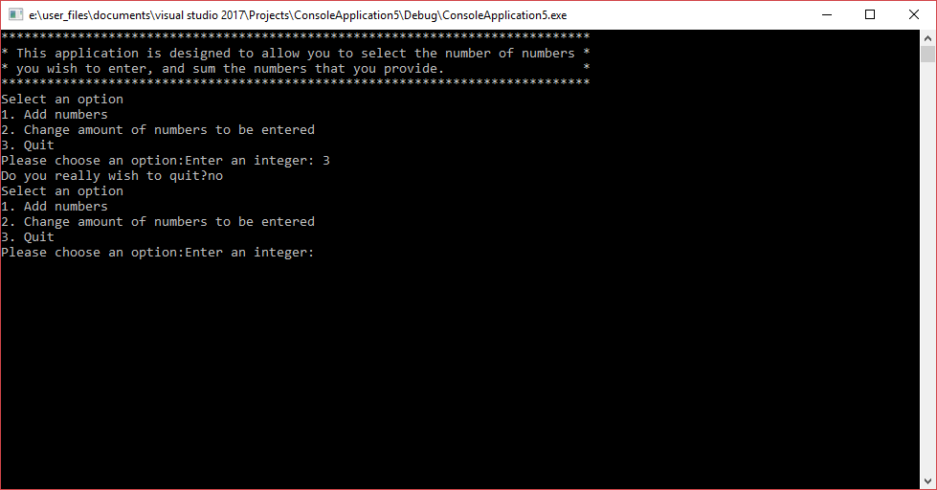
15 | Display values
Description |  | Testing display when single digit is present.
 |  | Test Steps :
1 | Select the first option
2 | Enter “1” x4
3 | Press Enter

Response |  | Program should display hash lines wrapped around value “5”.
Status |  |  | Date |  |  | Description
Pass |  |  | 28/03/2018 00:23 |  |  | Passed

Evidence of test 15
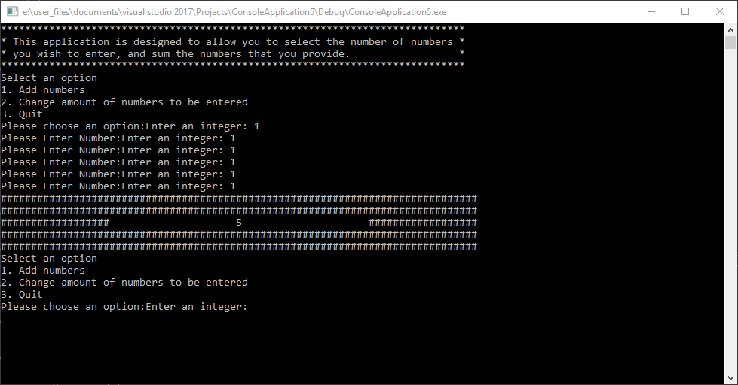
16 | Display values
Description |  | Testing display when five digit value is present.
 |  | Test Steps :
1 | Select the first option
2 | Enter 10000 x4
3 | Press Enter

Response |  | Program should display hash lines wrapped around value “50000”.
Status |  |  | Date |  |  | Description
Pass |  |  | 28/03/2018 00:35 |  |  | Passed

Evidence of test 16
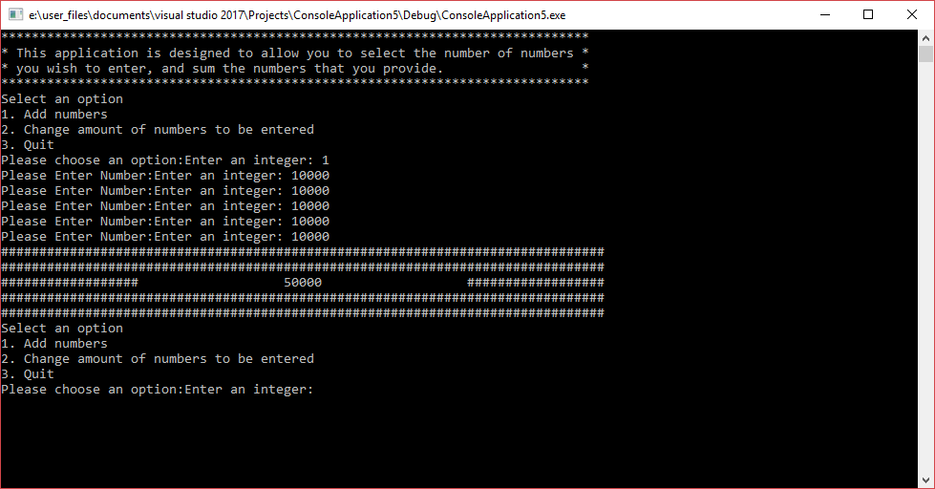
17 | Display values
Description |  | Testing display when negative value is present.
 |  | Test Steps :
1 | Select the first option
2 | Enter -80
3 | Enter -20
4 | Enter -15
5 | Enter -5
6 | Enter -5
7 | Press Enter

Response |  | Program should display hash lines wrapped around value “-125”.
Status |  |  | Date |  |  | Description
Pass |  |  | 28/03/2018 00:55 |  |  | Passed

Evidence of test 17
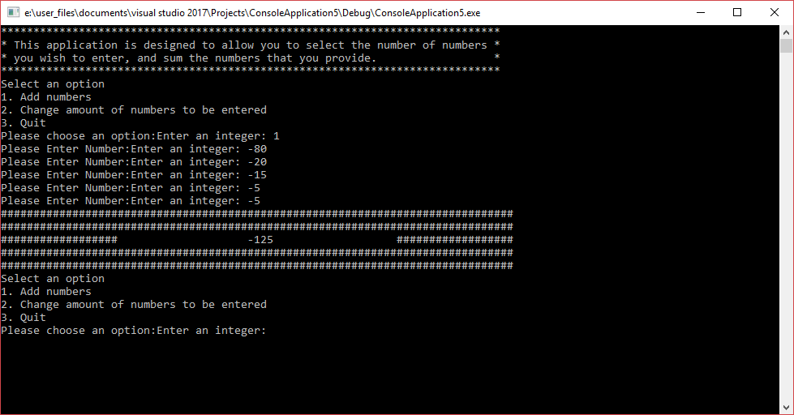
18 | Display values
Description |  | Testing display when largest int value is present.
 |  | Test Steps :
1 | Select the first option
2 | Enter 2147483600
3 | Enter 20
4 | Enter 20
5 | Enter 4
6 | Enter 3
7 | Press Enter

Response |  | Program should display hash lines wrapped around value “2147483647”.
Status |  |  | Date |  |  | Description
Pass |  |  | 28/03/2018 00:58 |  |  | Passed

Evidence of test 18
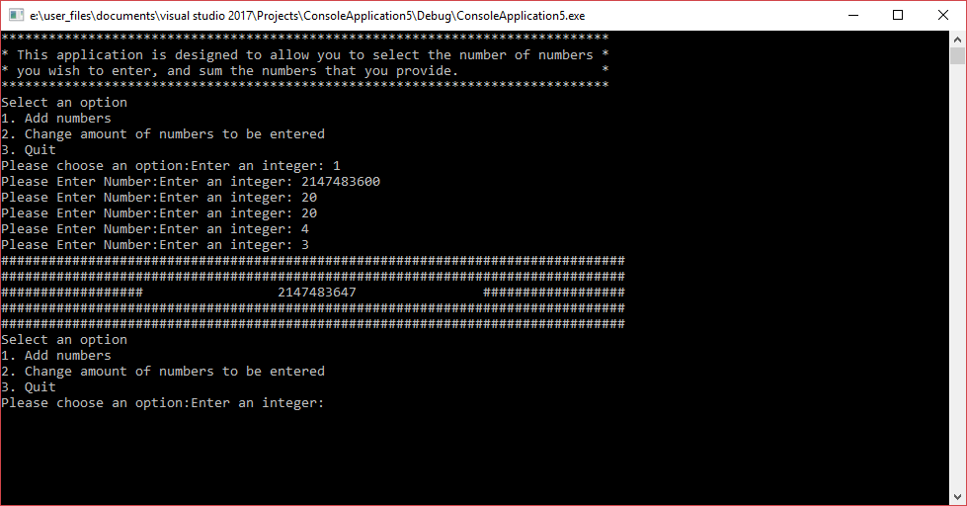
Part C
Exercise 1
This exercise generates a number between -20 and 20. This goes through a for loop up to 5 times. Whilst on the for loop it checks to see if the numbers guessed was right. If the number guessed was incorrect, it checks to see the amount of loops its been through and based on the results it provides help. If in round one the generated number was guessed incorrectly, it informs you weather the generated number is + or -. If in round two you didn’t guess the generated number right, it tells you if the generated number is within +10 or -10 of the guessed number. This works by adding 10 to the generated number and it saves the outcome value in a variable. This also works by taking away 10 from the guessed number and also saving it in a different variable. If the number provided by the user is smaller than the generated number (+10) saved in variables and bigger than the generated number (-10) it will display a message if the number was + or – 10 numbers within the generated number. If within the third try the number generated still isn’t guessed right, in a similar way to the second try, it will display if the number is within + or – 5 numbers. If the fourth try is incorrect, it will display if the generated number is within + or – 2 numbers. If the fifth try is incorrect, the generator will display that the user lost the game as well as the correct answer.

Exercise 3
Problems to be solved:
-Identifying winner
-Defining macros (yellow, red, player 1, player 2)
-7 arrays including 6 numbers
-Do not allow exceeding maximum number of counters in one row
-Function in order to place token
-While the program is running you need to know whose turn it is
-Ask user what column they with to put token in
-Be able to see where token’s been paced already
-Check for winner vertically, horizontally or diagonally

Appendix
Part B
Main.cpp
#define _CRT_SECURE_NO_WARNINGS
#pragma warning(disable:4996)

#include "stdafx.h"
#include <string>

#include "Console.h"
#include "Application.h"

using namespace std;

int main(int args, char* argv[])
{
Console* console = new Console();
Application* application = new Application(console);
bool quit = false;

console->PrintLine("*****************************************************************************");
console->PrintLine("* This application is designed to allow you to select the number of numbers *");
console->PrintLine("* you wish to enter, and sum the numbers that you provide. *");
console->PrintLine("*****************************************************************************");

while (quit == false)
{
application->DisplayMenu();
application->ChooseOption();
quit = application->ProcessOption();
}

console->Pause();

delete application;
delete console;
return 0;
}

Console.h
#pragma once

#pragma warning(disable:4996)
#include <conio.h>
#include <string>

using namespace std;

class Console
{
// Attributes
// NONE

// Constructors
// NONE

// Properties
// NONE

// Methods
public:
string ReadString();
int ReadInteger();
double ReadDouble();
void Print(string text);
void PrintLine(string line);
void Pause(void);

private:
void ClearInputBuffer();
};

Console.cpp
#include "Console.h"

string Console::ReadString()
{
char text[100];

scanf("%99[^\n]s", text);
ClearInputBuffer();

return (string)text;
}

int Console::ReadInteger()
{
int number;

/*This segment of the code limits the input to integer only
Taken from [2]
https://www.daniweb.com/programming/software-development/threads/386198/only-accept-integer-input-with-scanf
*/
char buffer[BUFSIZ];
int end;

printf("Enter an integer: ");
fflush(stdout);

while (fgets(buffer, sizeof buffer, stdin) == NULL ||
sscanf(buffer, "%d%n", &number, &end) != 1 ||
!isspace(buffer[end]))
{
printf("Unknown value entered. Please try again: ");
fflush(stdout);
}

return number;
}

double Console::ReadDouble()
{
double number;

scanf("%lf", &number);
ClearInputBuffer();

return number;
}

void Console::ClearInputBuffer()
{
char ch;
while ((ch = getchar()) != '\n' && ch != EOF);
}

void Console::Print(string text)
{
printf("%s", text.c_str());
}

void Console::PrintLine(string line)
{
Print(line + "\r\n");
}

void Console::Pause(void)
{
while (1) { if (_kbhit()) break; } // Pause
_getch();
}

Application.h
#pragma once

#include "Console.h"

class Application
{
// Attributes
private:
Console * _console;
int _chosenOption;
int _numNumbersReqd;

// Constructors
public:
Application(Console* console);

// Properties
// NONE

// Methods
public:
void DisplayMenu();
void ChooseOption();
bool ProcessOption();
private:
int ReadNumber(string prompt);
int GetTotal();
int countDigit(int n);
void DisplayResult(int result);
bool IsQuitting();
};

Application.cpp
#include "Application.h"

Application::Application(Console * console)
{
_console = console;
_chosenOption = 0;
_numNumbersReqd = 5;
}

void Application::DisplayMenu()
{
_console->PrintLine("Select an option");
_console->PrintLine("1. Add numbers");
_console->PrintLine("2. Change amount of numbers to be entered");
_console->PrintLine("3. Quit");
}

void Application::ChooseOption()
{
_chosenOption = ReadNumber("Please choose an option:");
}

int Application::ReadNumber(string prompt)
{
_console->Print(prompt);
return _console->ReadInteger();
}

bool Application::ProcessOption()
{
bool quit = false;

switch (_chosenOption)
{
case 1:
int total;
total = GetTotal();
DisplayResult(total);
break;
case 2:
_numNumbersReqd = ReadNumber("Please enter the number of numbers to be entered:");
break;
case 3:
quit = IsQuitting();
break;
default:
_console->PrintLine("Unknown option value entered");
break;
}

return quit;
}

int Application::GetTotal()
{
int total = 0;
int index;

for (index = 0; index < _numNumbersReqd; index++)
{
total = total + ReadNumber("Please Enter Number:");
}

return total;
}

void Application::DisplayResult(int result)
{
_console->PrintLine("###############################################################################");
_console->PrintLine("###############################################################################");

int numberOfDigits = 0;
numberOfDigits = countDigit(result);
if (result < 0) {
numberOfDigits = numberOfDigits + 1;
}

if (numberOfDigits == 1) {
_console->PrintLine("################## " + to_string(result) + " ##################");
}
else if (numberOfDigits == 2) {
_console->PrintLine("################## " + to_string(result) + " ##################");
}
else if (numberOfDigits == 3) {
_console->PrintLine("################## " + to_string(result) + " ##################");
}
else if (numberOfDigits == 4) {
_console->PrintLine("################## " + to_string(result) + " ##################");
}
else if (numberOfDigits == 5) {
_console->PrintLine("################## " + to_string(result) + " ##################");
}
else if (numberOfDigits == 6) {
_console->PrintLine("################## " + to_string(result) + " ##################");
}
else if (numberOfDigits == 7) {
_console->PrintLine("################## " + to_string(result) + " ##################");
}
else if (numberOfDigits == 8) {
_console->PrintLine("################## " + to_string(result) + " ##################");
}
else if (numberOfDigits == 9) {
_console->PrintLine("################## " + to_string(result) + " ##################");
}
else if (numberOfDigits == 10) {
_console->PrintLine("################## " + to_string(result) + " ##################");
}
else
{
_console->PrintLine("################## " + to_string(result) + " ##################");
}

_console->PrintLine("###############################################################################");
_console->PrintLine("###############################################################################");
}

int Application::countDigit(int result)
{
int count = 0;
while (result != 0) {
result = result / 10;
++count;
}
return count;
}

bool Application::IsQuitting()
{
string response;
bool quit = false;

_console->Print("Do you really wish to quit?");

response = _console->ReadString();

while (response != "YES" &&
response != "Yes" &&
response != "yes" &&
response != "y" &&
response != "NO" &&
response != "No" &&
response != "no" &&
response != "n")
{
_console->Print("Please type yes or no: ");

response = _console->ReadString();
}

if (response == "YES" ||
response == "Yes" ||
response == "yes" ||
response == "y" )
{
_console->PrintLine("Quitting");
quit = true;
}

return quit;
}

Part C
Exercise 1

#include "stdafx.h"
#include <string>
#include <conio.h> // For pause
#include <time.h>

using namespace std;

int main()
{
time_t theTime;
srand((unsigned)time(&theTime)); // Call at top of main

void Pause(void);
int RandomValue();

int secret = 0;
int input = 0;
int low = 0;
int high = 0;

bool foundIt = false;

secret = RandomValue();

for(int i = 0; i<5; i++) {
if (!foundIt) {
if (i == 1) {
if (secret < 0) {
printf("The number is negative\r\n");
}
else
{
printf("The number is positive\r\n");
}
}
else if (i == 2) {
low = secret - 10;
high = secret + 10;
if (low < -20) {
low = -20;
}
else if (high > 20)
{
high = 20;
}
if (input < high && input > low) {
printf("The number is within +/- 10 of the last chosen number\r\n", low, high);
}
else {
printf("The number is NOT within +/- 2 of the last chosen number\r\n", low, high);
}

}
else if (i == 3) {
low = secret - 5;
high = secret + 5;
if (low < -20) {
low = -20;
}
else if (high > 20)
{
high = 20;
}
if (input < high && input > low) {
printf("The number is within +/- 5 of the last chosen number\r\n", low, high);
}
else {
printf("The number is NOT within +/- 2 of the last chosen number\r\n", low, high);
}
}
else if (i == 4) {
low = secret - 2;
high = secret + 2;
if (low < -20) {
low = -20;
}
else if (high > 20)
{
high = 20;
}
if (input < high && input > low) {
printf("The number is within +/- 2 of the last chosen number\r\n", low, high);
}
else {
printf("The number is NOT within +/- 2 of the last chosen number\r\n", low, high);
}
}
printf("Guess the number: ");
scanf_s("%i", &input);

if (secret == input) {
foundIt = true;
i = 5;
}
}
}
if (foundIt == true) {
printf("You won\r\n");
}
else {
printf("You lost, the number was %i\r\n", secret);
}

Pause();
}

int RandomValue()
{
return rand() % 41 + (- 20);
}

void Pause(void)
{
// Pause
while (1) { if (_kbhit()) break; }
_getch(); // Clear the keypress

References
[1]W. [closed], "What is the advantage of breaking a code into several small functions in C++?", Stackoverflow.com, 2018. [Online]. Available: https://stackoverflow.com/questions/13256453/what-is-the-advantage-of-breaking-a-code-into-several-small-functions-in-c?utm_medium=organic&utm_source=google_rich_qa&utm_campaign=google_rich_qa. [Accessed: 28- Mar- 2018].
[2]"Only accept integer input with scanf()", DaniWeb, 2018. [Online]. Available: https://www.daniweb.com/programming/software-development/threads/386198/only-accept-integer-input-with-scanf. [Accessed: 28- Mar- 2018].

