Cloud Computing Architecture
Assessment 2: Practical Task:
Microsoft Azure

Student name: Svetlana Spinu
Id:2009037
Module code: ACCA5025
Lecturer name: Suneth Fernando
Submitted date: 03.05.2023.

Contents
Resources Associated with a Virtual Machine 2
Virtual Network (vNets) and Network Policy Groups 8
Demonstrating and explaining the use of images in Microsoft Azure 15
Conclusion 19
References 20

Resources Associated with a Virtual Machine

A virtual machine (VM) is a software-based emulation of a physical computer system. It allows users to create multiple virtual environments on a single physical machine, allowing for greater flexibility and scalability. VMs are used in a variety of applications, from cloud computing to gaming. By using virtualization technology, VMs can manage hardware resources more efficiently and securely.
A VM is composed of two parts: the virtual machine monitor (VMM) and the virtual machine image (VMI). The VMM is responsible for managing the virtual environment, while the VMI is responsible for providing the virtual environment with the necessary hardware resources.
Virtual machines offer several advantages over traditional physical machines. They are more efficient, as they can manage hardware resources more efficiently. They are also more secure, as they can isolate different virtual environments from each other. Additionally, they are more flexible, as they can be used to create multiple virtual environments on a single physical machine.
Virtual machines also have some disadvantages. They require more resources than traditional physical machines, as they need to manage multiple virtual environments. Additionally, they can be more difficult to manage, as they require more expertise to set up and maintain. [1]
How to create and manage a Virtual Machine in Microsoft Azure.
Virtual machines are made possible through virtualization technology. Virtualization uses software to simulate virtual hardware that allows multiple VMs to run on a single machine. The physical machine is known as the host while the VMs running on it are called guests. This process is managed by software known as a hypervisor. The hypervisor is responsible for managing and provisioning resources—like memory and storage—from the host to guests. It also schedules operations in VMs, so they don’t overrun each other when using resources. VMs only work if there is a hypervisor to virtualize and distribute host resources.
Azure is Microsoft's public cloud platform. Azure offers a large collection of services, which includes platform as a service (PaaS), infrastructure as a service (IaaS), and managed database service capabilities.
Azure, like other cloud platforms, relies on a technology known as virtualization. Most computer hardware can be emulated in software. Emulation layers are used to map software instructions to hardware instructions. Emulation layers allow virtualized hardware to execute in software like the actual hardware itself.
Azure virtual machines can be used in various ways. Some examples are:
- Development and test – Azure virtual machines offer a quick and easy way to create a computer with specific configurations required to code and test an application.
- Applications in the cloud – Because demand for the application can fluctuate, it might make economic sense to run it on a virtual machine in Azure.
- Extended datacenter – virtual machines in an Azure virtual network can easily be connected to any organization’s network. [2]
Creating a Virtual Machine: First step is to log-in on the Microsoft Azure account, to choose the create virtual machine option and to complete the requested tasks as shown in the pictures below.

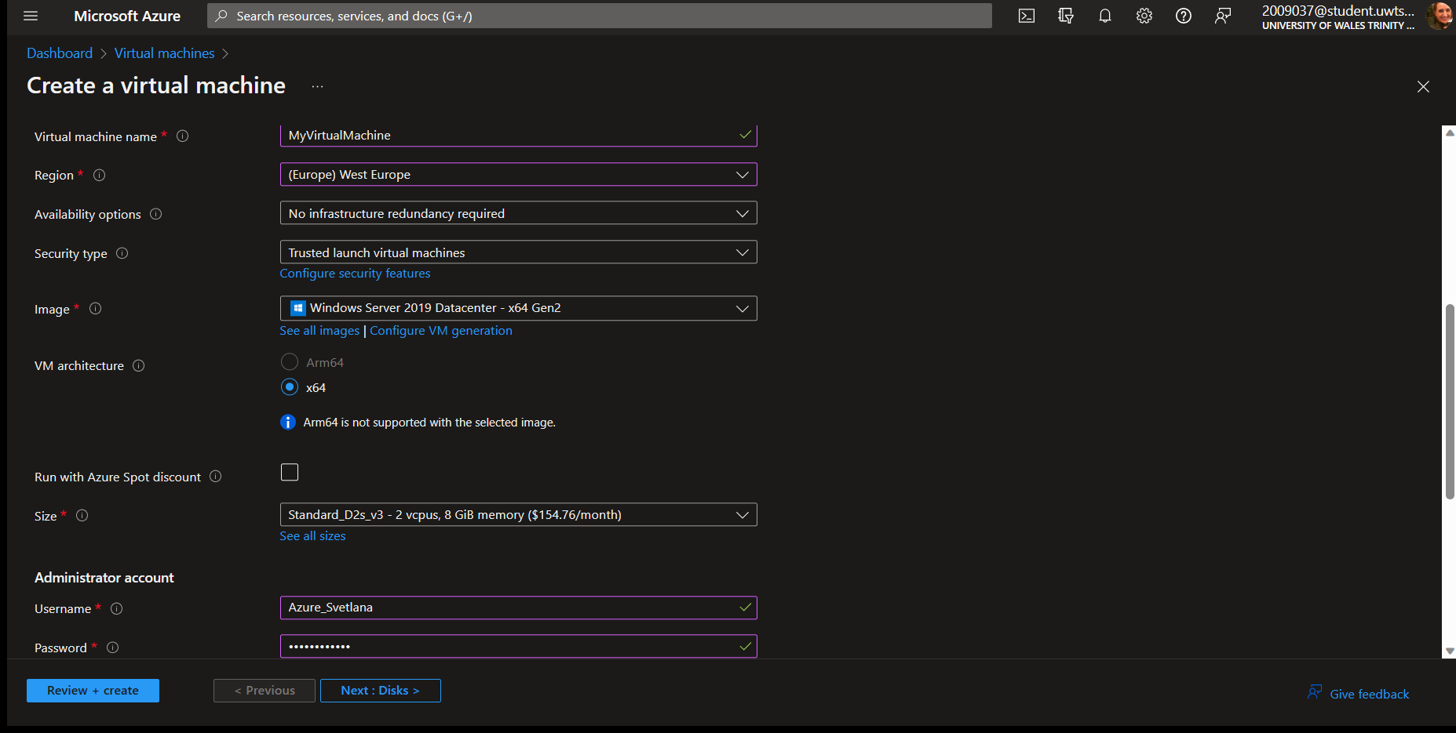
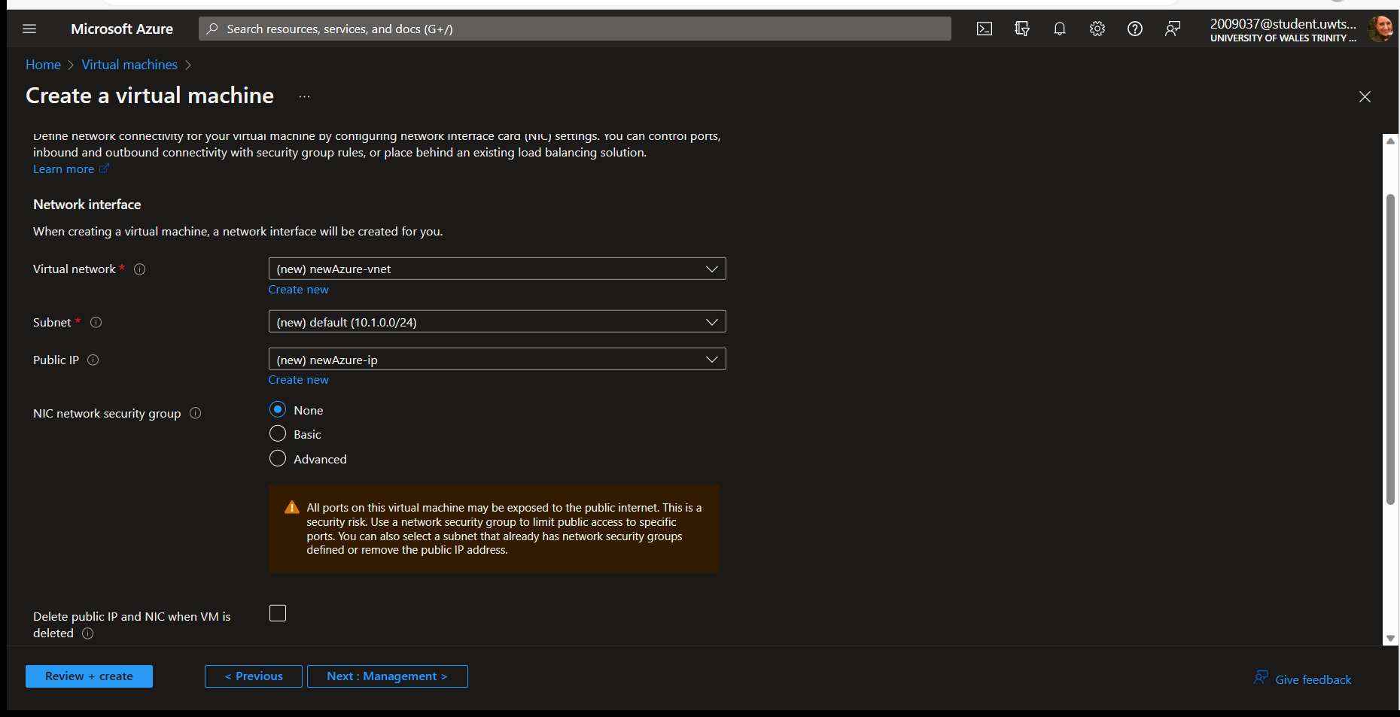
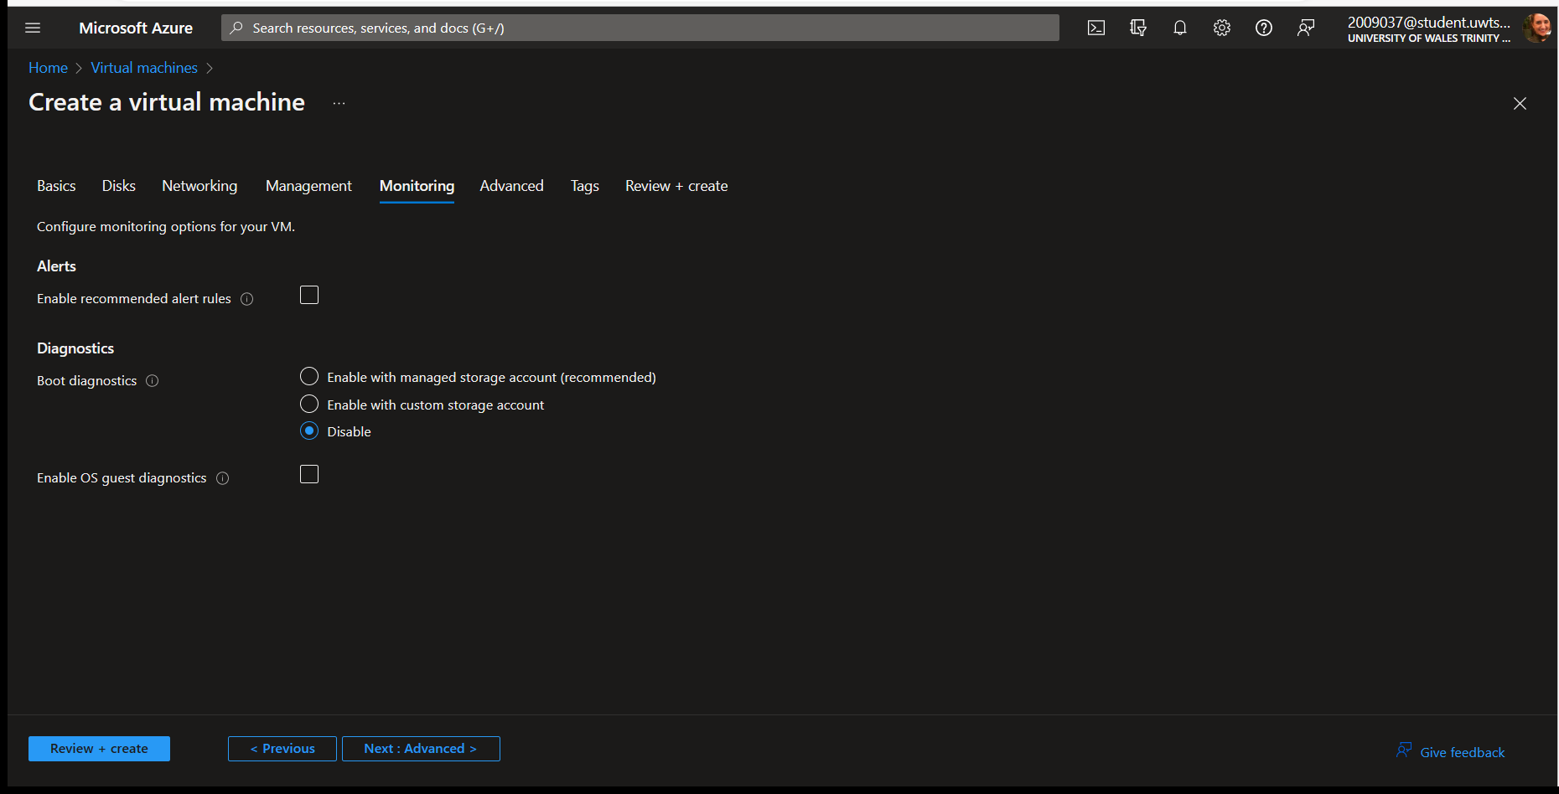

Virtual Machine and Virtual Hard Drives.
A virtual machine manages hardware resources by using virtualization technology. This technology allows the virtual machine to access the physical hardware resources of the host machine, such as memory, storage, and network resources. The virtual machine can then use these resources to create multiple virtual environments on the same physical machine.
The virtual machine can also manage hardware resources more efficiently by using resource scheduling. This allows the virtual machine to allocate resources to different virtual environments based on their needs. For example, if one virtual environment needs more memory than another, the virtual machine can allocate more memory to that environment. [1]
Creating a Virtual Hard Drive: To create a VHD I am selecting the Disk Management from the taskbar, then choosing the option the create a new disk or to attach an existing one.
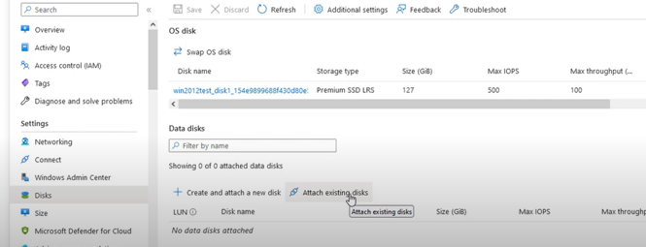
Click on the Create a new disk: entering a name for the disk in disk name option. Selecting the storage type and the memory size (in Gb) that we want for the disk.
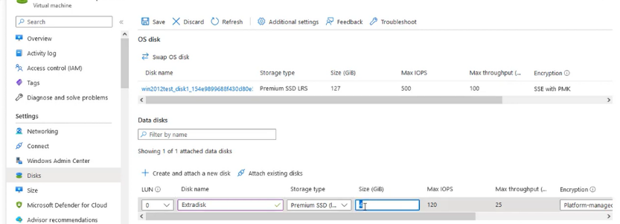

Click on “save” to save and create the virtual disk.
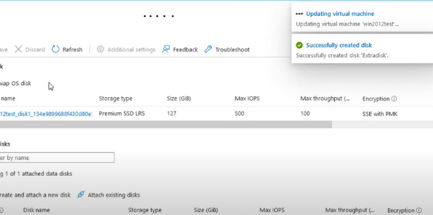

Virtual Network (vNets) and Network Policy Groups
Virtual Network
A virtual network machine is a virtual machine (VM) that connects to a virtual network, which is a software-based network that uses the internet to link computers and devices across different locations. A virtual network uses virtualized versions of network tools, like switches and adapters, to route and configure the network traffic. A virtual network can be of different types, such as VPN, VLAN, or VXLAN, depending on the purpose and scope of the network. A virtual network machine has a virtual network adapter that is exposed in the guest operating system and supports different virtualization types. To create a virtual network machine, one needs to create a virtual network switch on the host machine and connect the VM to it. [3]
Creating a Virtual network: on Virtual network page select “Create” and completing the requested information specifying the resource group, virtual network name, the region the subnet address range, enabling the Azure Bastion subnet and the Azure Bastion host that lets me connect to a virtual machine using my browser and the Azure portal. When i connect via Azure Bastion, my virtual machines don't need a public IP address, agent, or special client software:
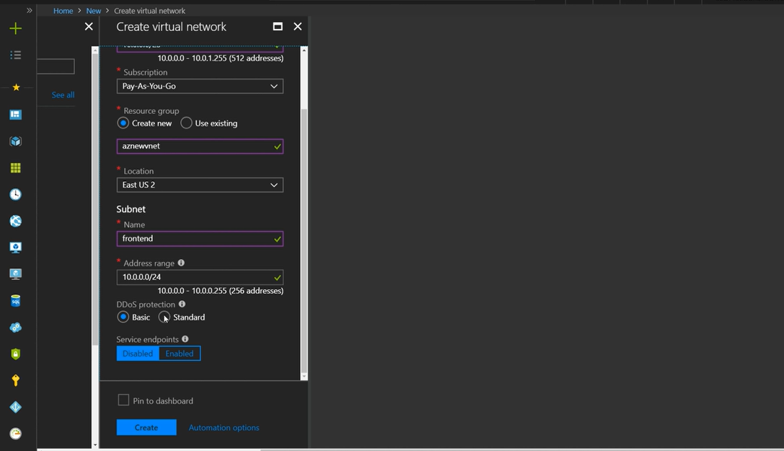
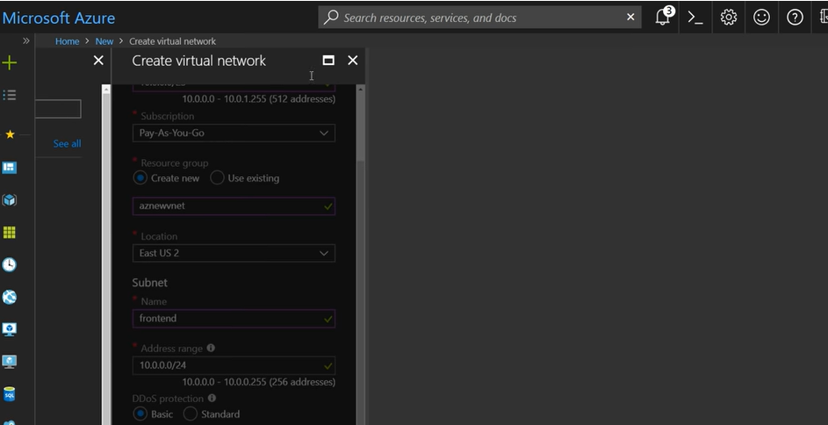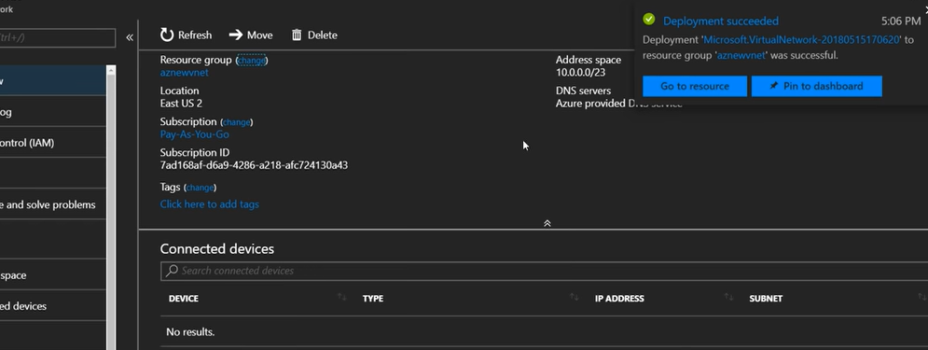

VNet concepts:
- Address space: When creating a VNet, we must specify a custom private IP address space using public and private (RFC 1918) addresses. Azure assigns resources in a virtual network a private IP address from the address space that we assign.
- Subnets: Subnets enables to segment the virtual network into one or more sub-networks and allocate a portion of the virtual network's address space to each subnet. We can then deploy Azure resources in a specific subnet. Just like in a traditional network, subnets allow to segment the VNet address space into segments that are appropriate for the organization's internal network. This also improves address allocation efficiency. We can secure resources within subnets using Network Security Groups.
- Regions: VNet is scoped to a single region/location; however, multiple virtual networks from different regions can be connected together using Virtual Network Peering.
- Subscription: VNet is scoped to a subscription. We can implement multiple virtual networks within each Azure subscription and Azure region.

Network Policy Groups
A network security group contains security rules that allow or deny inbound network traffic to, or outbound network traffic from, several types of VM resources. For each rule, we can specify source and destination, port, and protocol.
Network Policy Groups for Microsoft Azure:
For Inbound Traffic, Azure processes the rules in a network security group associated to a subnet first, if there's one, and then the rules in a network security group associated to the network interface, if there's one.
For Outbound Traffic, Azure processes the rules in a network security group associated to a network interface first, if there's one, and then the rules in a network security group associated to the subnet, if there's one. This includes intra-subnet traffic as well.
For Intra-Subnet traffic: By default, virtual machines in the same subnet can communicate based on a default NSG rule allowing intra-subnet traffic. If a rule is added to *NSG1 that denies all inbound and outbound traffic, VM1 and VM2 will no longer be able to communicate with each other. [4]
Security rules in network security groups enable us to filter the type of network traffic that can flow in and out of virtual network subnets and network interfaces.
Create a Network security group: firstly I am searching for Network security group, select “Create” option, then next I am completing the required tasks:
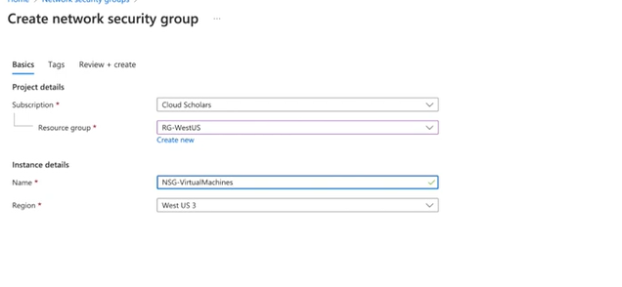
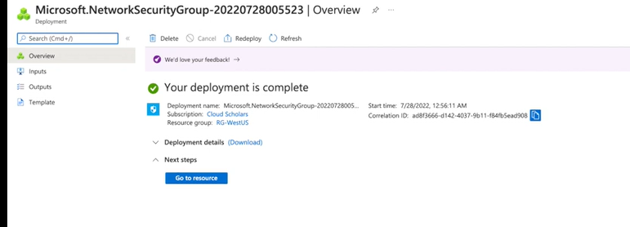
The details of Network Security Group: Under Settings, we can view the Inbound security rules, Outbound security rules, Network interfaces, and Subnets that the network security group is associated to.
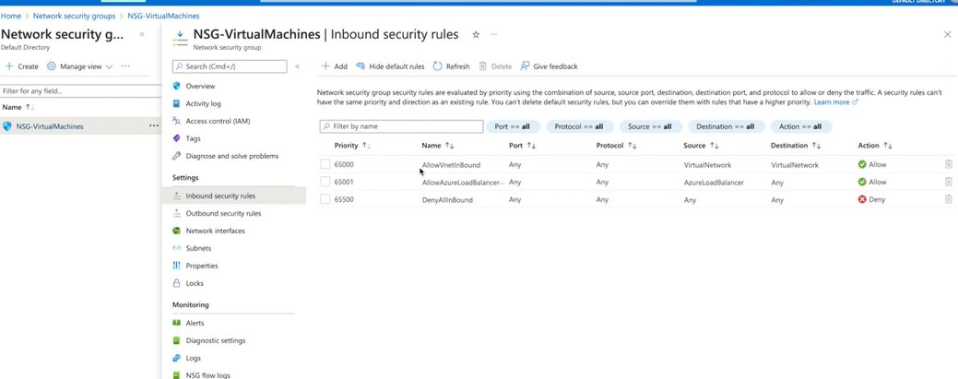

At this step I can verify the Network Policy Group following the Inbound Traffic, Outbound and Intra-Subnet Traffic rules.
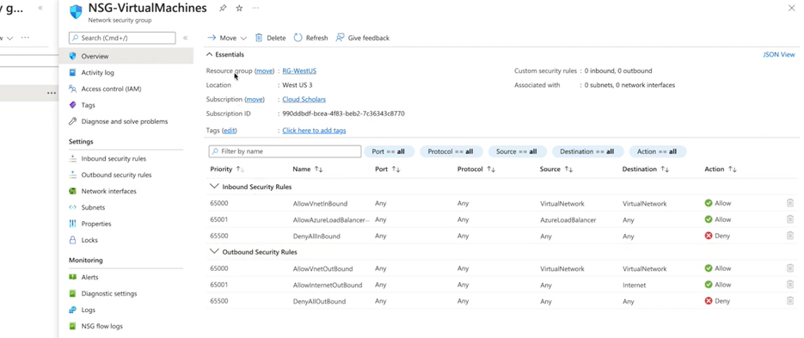
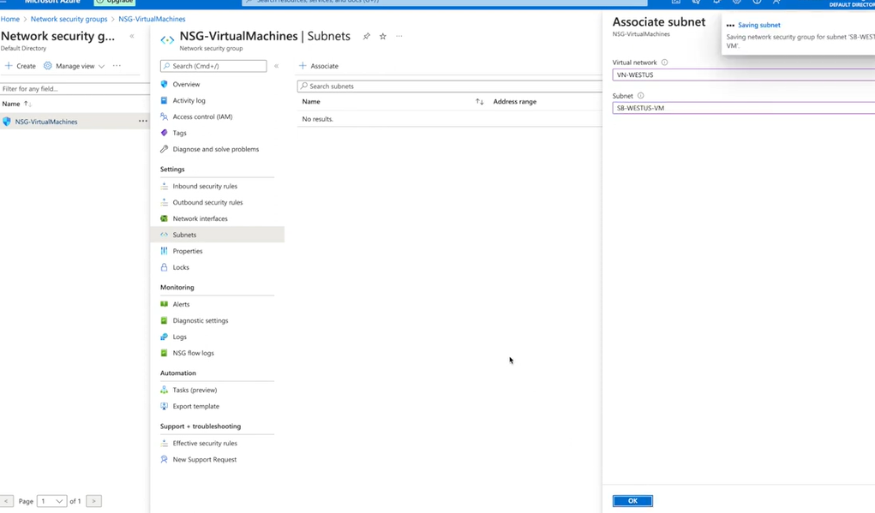

Connected the Network Security Group with the Subnet:
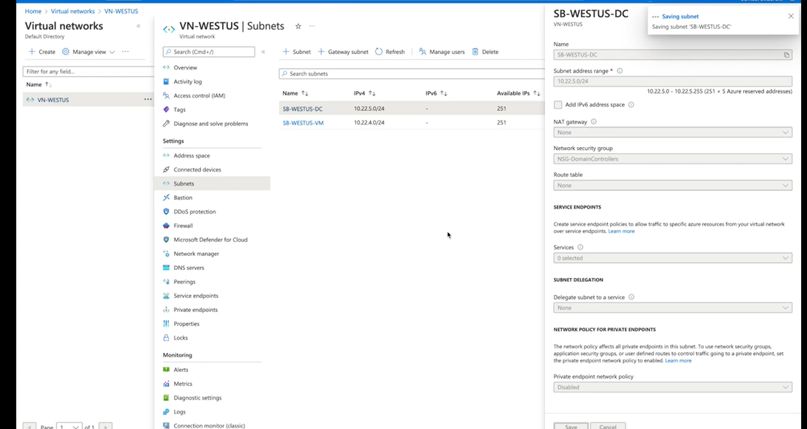
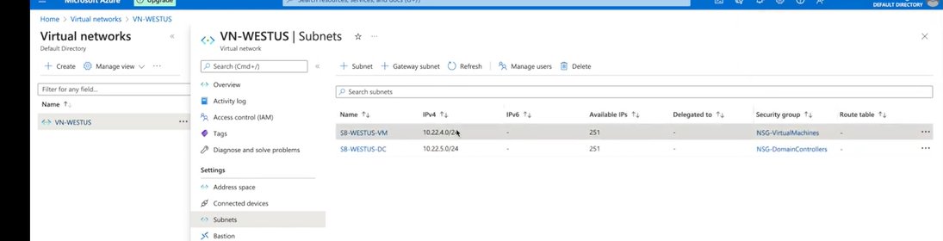

The IP addresses are private and can't be accessed from the Internet. Azure treats any address range as part of the private virtual network IP address space. The address range is only reachable within the virtual network, within interconnected virtual networks, and from the on-premises location.

Demonstrating and explaining the use of images in Microsoft Azure

By using standardized virtual machine (VM) images, an organization can more easily migrate to the cloud and help ensure consistency in a specific deployment. Images ordinarily include predefined security, configuration settings, and any necessary software. Setting up an imaging pipeline requires time, infrastructure, and many other details. With Azure VM Image Builder, it’s need only to create a configuration that describes the image and submit it to the service, where the image is built and then distributed.
An image is a copy of either a full VM (including any attached data disks) or just the OS disk, depending on how it is created. When we create a VM from the image, a copy of the VHDs in the image are used to create the disks for the new VM. The image remains in storage and can be used repeatedly to create new VMs.
To create an image in Azure we should be aware of the fallowing support factors:
- Only Linux and Windows images are supported for upload and use in Azure.
- Only the first generation of VMs are supported.
- Azure only supports VHD files, not VMX.
- Select "fixed size" rather than "dynamic" because dynamic expanding -- i.e., thin provisioned -- disks are not supported.
To use an image in VM first step is to select the “Shared image” option from the taskbar of the virtual machine, then to complete the requested fields for creating an image, such as the image name and region. It’s also important to select the same region as the virtual machine and to set the correct image type. [5]
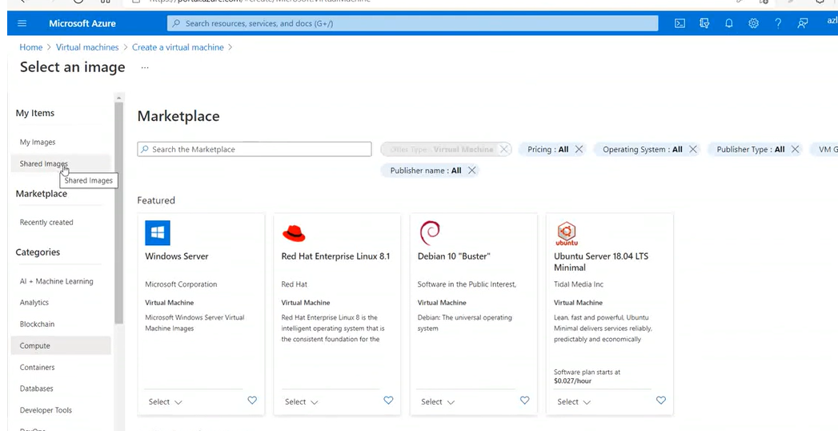
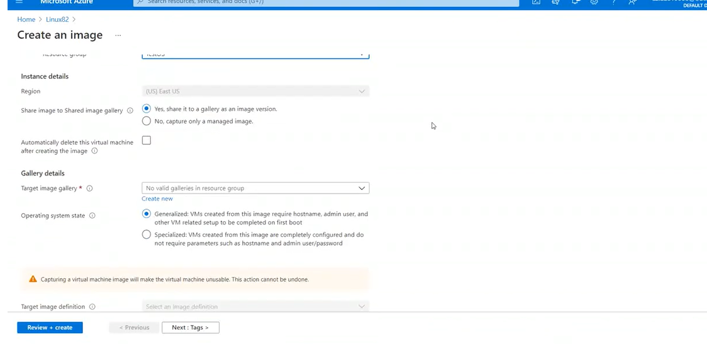

Working with the image definition where I just need to insert an image definition name, the operating system that is selected by default and to click create to pass the validation.
Image definitions are a logical grouping for versions of an image. The image definition holds information about why the image was created and contains Image metadata such as, what OS it is for, features it supports and other information about using the image. An image definition is like a plan for all the details around creating a specific image. We don't deploy a VM from an image definition, but from the image versions created from the definition.
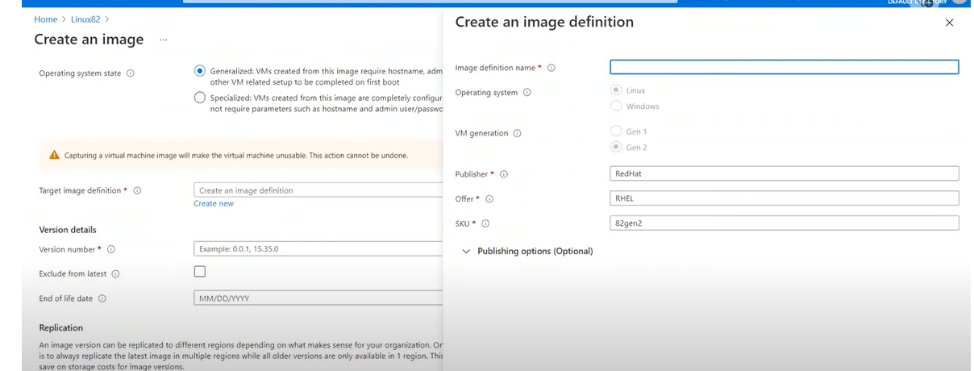
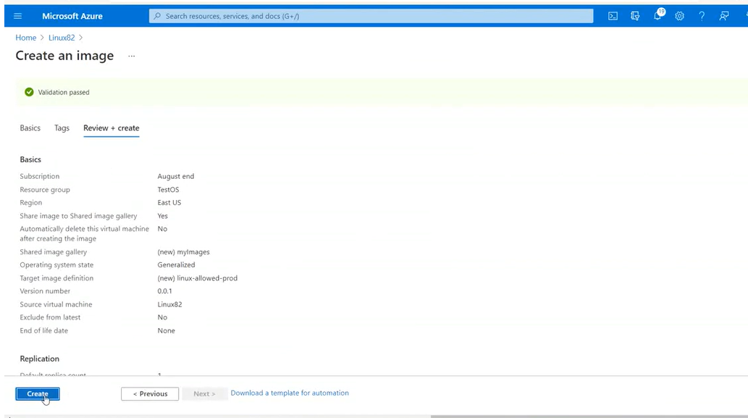
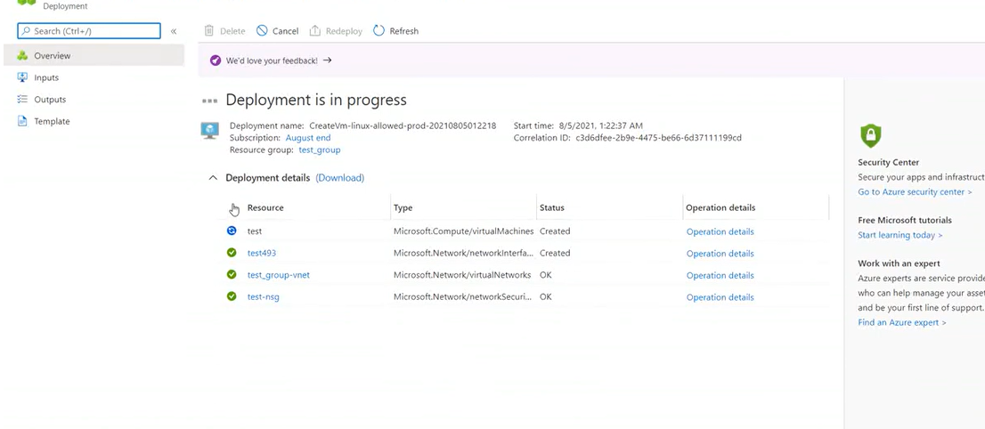

An image version is what we use to create a VM. We can have multiple versions of an image as needed for the environment. When we use an image version to create a VM, the image version is used to create new disks for the VM. Image versions can be used multiple times.
The properties of an image version are:
- Version number. This is used as the name of the image version. It is always in the format: MajorVersion.MinorVersion.Patch. When we specify to use latest when creating a VM, the latest image is chosen based on the highest MajorVersion, then MinorVersion, then Patch.
- Source. The source can be a VM, managed disk, snapshot, managed image, or another image version.
- Exclude from latest. We can keep a version from being used as the latest image version.
- End of life date. Indicate the end-of-life date for the image version. End-of-life dates are informational; users will still be able to create VMs from versions past the end-of-life date.
There are two operating system states supported by Azure. Typically, images require that the VM used to create the image has been generalized before taking the image. Generalizing is a process that removes machine and user specific information from the VM.
Specialized VMs have not been through a process to remove machine specific information and accounts. Also, VMs created from specialized images do not have an osProfile associated with them. This means that specialized images will have some limitations in addition to some benefits.
- VMs and scale sets created from specialized images can be up and running quicker. Because they are created from a source that has already been through first boot, VMs created from these images boot faster.
- Accounts that could be used to log into the VM can also be used on any VM created using the specialized image that is created from that VM.
- VMs will have the computer name of the VM the image was taken from. We should change the computer name to avoid collisions.
- The osProfile is how some sensitive information is passed to the VM, using secrets. This may cause issues using KeyVault, WinRM and other functionality that uses secrets in the osProfile. [6]

Conclusion

Azure virtual machines are one of several types of on-demand, scalable computing resources that Azure offers.
Azure is a huge collection of servers and networking hardware, which runs a complex set of distributed applications. These applications orchestrate the configuration and operation of virtualized hardware and software on those servers. The orchestration of these servers is what makes Azure so powerful. With Azure, users don't have to maintain and upgrade their hardware as Azure does this behind the scenes.

References

[1] | A. C. Bao, “How Virtual Machines manage Hardware,” Topic Center, 16 Martie 2023. [Online]. Available: https://www.alibabacloud.com/tech-news/virtualization/1kn-how-virtual-machines-manage-hardware. [Accessed 11 04 2023].
[2] | Microsoft, “Virtual Machines in Azure,” Microsoft, 28 February 2023. [Online]. Available: https://learn.microsoft.com/en-us/azure/virtual-machines/overview. [Accessed 24 April 2023].
[3] | RedHat, “Configuring virtual machine network connections,” RedHat, [Online]. Available: https://access.redhat.com/documentation/en-us/red_hat_enterprise_linux/8/html/configuring_and_managing_virtualization/configuring-virtual-machine-network-connections_configuring-and-managing-virtualization. [Accessed 11 04 2023].
[4] | Microsoft, “How network security groups filter network traffic,” Microsoft, 02 10 2023. [Online]. Available: https://learn.microsoft.com/en-us/azure/virtual-network/network-security-group-how-it-works. [Accessed 11 04 2023].
[5] | Microsoft, “Create an image definition and an image version,” Microsoft, 08 February 2023. [Online]. Available: https://learn.microsoft.com/en-us/azure/virtual-machines/image-version?tabs=portal%2Ccli2. [Accessed 21 April 2023].
[6] | Microsoft, “Store and share images in an Azure Compute Gallery,” Microsoft, 08 March 2023. [Online]. Available: https://learn.microsoft.com/en-us/azure/virtual-machines/shared-image-galleries?tabs=azure-cli. [Accessed 21 April 2023].

