BSc Health and Social Care

Changemakers: Creativity and Value Creation
BMHP5014

Component 2 – Academic Poster & Written Pitch Guidance

Louiza Avraam
2426675

Contents
The Poster 3
Poster Description 3
Title and Branding 3
Context and Problem Identification 4
Innovation 5
Target Demographic and Impact 5
Technology Integration 6
Written Pitch 7
Summary of the issue and the innovation you are proposing 7
Key components and How it Works 7
Expected impact and why it's relevant now 8
Implementation Plan 8
Timeline 9
Stakeholders, Partnerships and Resources 9
Regulations 9
Value, Feasibility and Recommendations 10
Call to Action 10
Reference List 11

The Poster
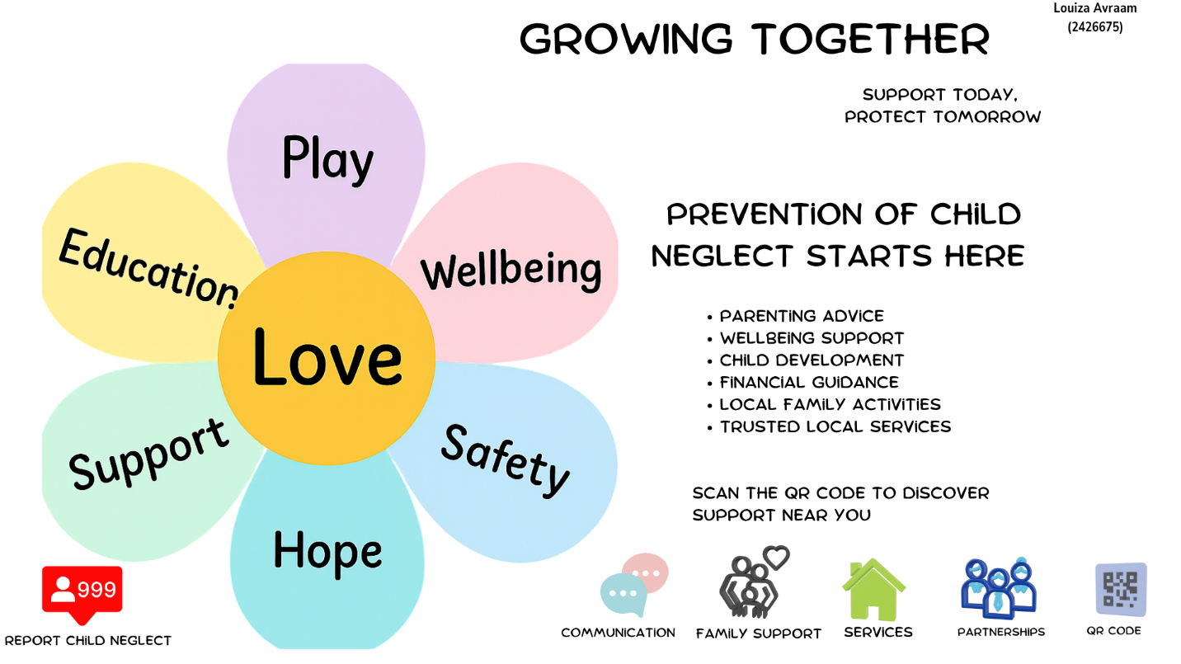

Poster Description

Title and Branding
The title Growing Together was chosen because it reflects the campaign's main message that supporting parents helps children grow up in safe, loving and nurturing environments. Rather than focusing on neglect or crisis, the title promotes hope, prevention and positive family relationships. This strengths-based approach encourages parents to seek support without feeling judged or stigmatised.
The campaign slogan, "Support Today, Protect Tomorrow," reinforces the importance of early intervention by reminding communities that timely support can prevent difficulties from developing into safeguarding concerns. Together, the title and slogan communicate that protecting children is a shared responsibility and that positive change begins by supporting families early.
The campaign's visual identity features a colourful daisy logo. The daisy represents growth, resilience and wellbeing, while each petal symbolises an important aspect of a child's life, including health, education, emotional wellbeing and family support (NSPCC, 2026). Together, the petals form a single flower, showing that children thrive when all areas of their wellbeing are supported. The bright colours create a welcoming and reassuring appearance, encouraging families to engage with the campaign.

Context and Problem Identification
Growing Together was developed in response to the continuing issue of child neglect in the UK. Child neglect is recognised as a form of child abuse and remains one of the most common reasons children require safeguarding support (Department for Education, 2023). It occurs when a child's physical, emotional, medical or educational needs are consistently unmet, affecting their health, wellbeing and overall development (NSPCC, 2026).
Neglect often develops gradually and is linked to financial difficulties, poor mental health, substance misuse, domestic abuse and social isolation (Centres for Disease Control and Prevention, 2024). Without early support, these pressures can cause long-term harm, affecting children's education, emotional wellbeing, relationships and future opportunities (Child Safeguarding Practice Review Panel, 2024).
Although many health, social care and community services already exist, parents find it difficult to identify and access the right support at the right time. Information is spread across different organisations, making services difficult to navigate, particularly for families already experiencing stress (Maternal Mental Health Alliance, 2023). Growing Together was created to address this gap by bringing existing support together into one clear, accessible campaign that encourages earlier help-seeking and prevention.

Innovation
Growing Together is a community-based campaign designed to help prevent child neglect by supporting parents and carers before difficulties become safeguarding concerns. Rather than creating new services, it brings together existing health, social care, and community support into one simple, accessible place, making it easier for families to find trusted information when they need it.
The campaign encourages early intervention by helping parents recognise when they may need support and by reducing confusion of searching across different organisations. Through a dedicated website, QR codes, community events, and partnerships with local services, Growing Together serves as a central family guide to existing resources tailored to their individual needs. This preventative approach encourages parents to seek help earlier, strengthens family relationships and supports children's health and wellbeing.
The name "Growing Together" promotes partnership, hope, and shared responsibility, while the slogan "Support Today, Protect Tomorrow" reinforces the importance of early intervention. Partnerships with GP surgeries, schools, charities and local leisure and wellbeing centres help integrate the campaign into places families already know and trust, making support more visible, approachable and easier to access within the community.

Target Demographic and Impact
Growing Together is primarily aimed at parents and carers of children, particularly those experiencing financial pressures, poor mental health, social isolation or other circumstances that may affect family wellbeing. Although the campaign focuses on supporting parents, its ultimate beneficiaries are children, as early support helps create safer, healthier and more nurturing home environments. The campaign also benefits health and social care professionals by making local support services easier to identify and promote, encouraging stronger partnership working and earlier intervention.
The campaign contributes to the common good by improving access to trusted information and encouraging families to seek support before difficulties escalate into safeguarding concerns. By bringing together existing services on a single accessible platform, Growing Together helps reduce barriers to support (Maternal Mental Health Alliance, 2023), particularly for families who may struggle to navigate complex health and social care systems. This preventative approach has the potential to reduce inequalities by ensuring that all families, regardless of their circumstances, can access clear information and appropriate support within their local community.
To reach its target audience, the campaign would use a combination of digital and community-based communication methods. Information would be promoted through the campaign website, QR codes, social media platforms, GP surgeries, schools, libraries, pharmacies, local leisure and wellbeing centres and community events. Using trusted places that families already visit increases awareness, reduces stigma and encourages parents to access support naturally within their everyday lives.

Technology Integration
Technology plays an important role in making Growing Together accessible, practical and easy to use. Rather than replacing face-to-face support, it strengthens the campaign by helping families access trusted information quickly and conveniently. The main digital feature is a dedicated website, designed as a central hub where parents and carers can find guidance, local services and practical resources in one place.
A key feature of the website is the Parenting Menu, which organises information around families' needs rather than individual organisations. Instead of searching multiple websites, parents can quickly access topics such as parenting advice, child development, emotional wellbeing, financial support, housing, education and local activities. This simple approach reduces confusion and encourages families to seek support earlier.
QR codes displayed on posters, leaflets and in partner organisations allow parents to access the website instantly using their mobile phones. Social media platforms would also be used to share parenting advice, promote local events and raise awareness of available support, helping the campaign reach a wider audience. Together, these technologies improve communication, increase accessibility and make early support easier for families to access.

Written Pitch

Summary of the issue and the innovation you are proposing
As a parent or carer, you want your child to grow up safe, healthy and happy. However, many families experience challenges such as financial pressures, poor mental health, relationship difficulties or social isolation, which can sometimes affect their ability to provide the support children need. Many parents also find it difficult to know where to access the right help before problems become more serious.
To address this, I created Growing Together a community-based campaign that brings together health, social care and community support in a single, accessible place. My aim is to help parents find trusted information sooner, encourage early intervention and strengthen families before difficulties escalate into safeguarding concerns (Social Pediatric Therapy, n.d.).

Key components and How it Works
Growing Together brings together several simple yet connected components to make it easier for parents and carers to access trusted support. The campaign includes a dedicated website, a Parenting Menu, QR codes, community partnerships and local awareness events. Rather than creating new services, these components work together to bring existing health, social care and community support into a single, accessible place.
Parents can access the campaign by scanning a QR code displayed in trusted community settings such as GP surgeries, schools, libraries, pharmacies and local leisure and wellbeing centres, or by visiting the campaign website directly. The website provides a Parenting Menu, which organises information around parents' needs rather than individual organisations. Families can quickly find support for areas such as parenting advice, child development, emotional wellbeing, financial support, housing, education and local activities.
By guiding parents towards the most appropriate local services, Growing Together reduces confusion, encourages earlier help-seeking and strengthens links between families and the support already available within their communities. This simple and preventative approach helps parents find the right support at the right time, before everyday challenges develop into safeguarding concerns.

Expected impact and why it's relevant now
I believe Growing Together has the potential to make a meaningful difference by encouraging parents to seek support earlier and making existing services easier to access. By reducing confusion and promoting early intervention, the campaign can help strengthen family relationships, improve children's health and wellbeing, and reduce the risk of difficulties developing into safeguarding concerns. It also supports health and social care professionals by increasing awareness of local services and encouraging stronger partnership working within communities.
I believe this campaign is particularly relevant now because many families continue to face increasing financial pressures, poor mental health, social isolation and rising living costs, making parenting more challenging than ever. At the same time, health and social care services are experiencing growing demand, making early intervention and prevention increasingly important. Rather than waiting until families reach crisis point, Growing Together encourages communities to support parents earlier, helping children grow up in safer, healthier and more nurturing environments.

Implementation Plan
To introduce Growing Together successfully, I would begin by designing the campaign poster, following by a website, developing the Parenting Menu and creating promotional materials such as leaflets. Before the full launch, I would pilot the campaign within one local community to gather feedback from parents, health and social care professionals and partner organisations. This feedback would help refine the campaign before it is introduced more widely.
The campaign would be delivered through existing community settings that families already know and trust, including GP surgeries, schools, libraries, pharmacies and local leisure and wellbeing centres. Using familiar locations makes support easier to access and encourages parents to seek help naturally without feeling judged or stigmatised.

Timeline
The implementation would take place in four stages: planning and development, pilot testing, community launch and ongoing evaluation. This phased approach allows the campaign to be tested, improved through feedback and gradually expanded to reach more families.

Stakeholders, Partnerships and Resources
Successful delivery would rely on collaboration between health, social care and community organisations. Key partners would include GP surgeries, health visitors, schools, libraries, pharmacies, local authorities, charities, Early Help services and local leisure and wellbeing centres. Resources required would include a campaign website, promotional materials, QR codes, community venues and funding from local authority public health budgets, community grants and charitable organisations. Partnerships with local universities and community volunteers could also support aspects of the campaign's development.

Regulations
Growing Together would operate in line with the Children Act 1989, Children Act 2004, Working Together to Safeguard Children (Department for Education, 2026), the Care Act 2014 and the Data Protection Act 2018. These frameworks ensure that safeguarding responsibilities, partnership working, confidentiality and the safe sharing of information remain central throughout the campaign.

Value, Feasibility and Recommendations
Growing Together supports current healthcare goals by promoting prevention, early intervention and partnership working rather than waiting until families reach crisis point. By bringing together existing health, social care and community services, the campaign makes support easier to access while encouraging parents to seek help earlier. This approach has the potential to improve children's wellbeing, strengthen family relationships and reduce pressure on safeguarding and other public services.
One of the main challenges may be raising awareness and encouraging parents to engage with the campaign. Some families may not know the support exists, while others may feel embarrassed or worried about asking for help. To address these barriers, Growing Together would use simple and positive messaging, trusted community settings and digital technology to make support more visible, accessible and non-judgemental. Funding could be supported through local authority public health budgets, community grants and charitable organisations, while partnerships with local universities and community volunteers could support aspects of the campaign's development.
If the campaign proves successful, I would like to see it expanded to more communities across the UK, supported by regular evaluation and feedback from parents, professionals and partner organisations. This would allow Growing Together to continue developing while responding to the changing needs of families and local communities.

Call to Action
If you are a parent or carer, I encourage you to remember that asking for help is a sign of strength, not failure. No family should face life's challenges alone, and support is available before problems become overwhelming (Children’s Commissioner for England, 2024). I invite you to join Growing Together by using the available resources, sharing the campaign with others, and encouraging open conversations about parenting and family well-being. By supporting one another and seeking help early, we can build stronger families, protect more children, and create communities where every child has the opportunity to grow up safe, loved, and able to reach their full potential.

