Component 2 - Research Report
Student Name: Aleah Khan
Student Number: 2119469
Lecturer Name: Dr Ngozi Ibeji
BMSW4003_BIRM
Digital Skills and Research Methods

Abstract
In this report, you will find the concluded answer to the research question – Are staff and students confident in using technology to collaborate?
In component one, the research question was identified and a review was conducted of existing literature.
A research method was planned and ethics were considered.
A presentation on the proposal was made for approval and the data from the proposed method was analysed, which is now included in this report with discussions and a concluded answer.
The purpose of this was to find out how staff and students were feeling in collaborating, using technology.
A questionnaire was formed by using MS forms to ethically collect data from the targeted audience.
A number of 5 participants had partaken in this questionnaire.
The main findings were that the majority of the participants were somewhat confident and satisfied in using their digital skills to collaborate with their peers or colleagues, whereas a small minority did not.
This concluded into staff and students being confident in using technology to collaborate at University of Wales Trinity Saint David.

Contents
Abstract………………………………………………………………………………………..2
Introduction………………………………………………………………………….………..4
Research design……………………………………………………………………………...5-6
Results………………………………………………………………………………………….7-9
Discussion……………………………………………………………………………………10-12
Conclusion…………………………………………………………………………………….13
Reference list………………………………………………………………………………….14
Appendix A- Blank copy of questionnaire……………………………………………….15

Introduction
The purpose of this academic report is to show the analysis of the data that was collected during the proposed method.
Discussions and a full conclusion will also be included in this report.
This report is based on component 1 – ‘How do we use technology to collaborate at University of Wales Trinity Saint David?’.
The topic that was researched was how staff and students use technology to collaborate at University of Wales Trinity Saint David, and how confident they are feeling whilst collaborating.
Digital skills are essential as these skills can help staff and students collaborate and communicate from a classroom setting or even the comfort of their own homes.
It is important that staff and students are confident with using technology to collaborate as technology is more common nowadays and it can affect the way of learning if they are not confident. (Lynch, 2017).

Research Design
The chosen research question that was selected was ‘Are staff and students confident in using technology to collaborate?’.
The reason why this was the best suitable question was due to the fact that technology is more common nowadays.
It was intriguing to research this topic as digital skills is a fundamental skill that is needed in this day and age, especially with the coronavirus being on the rise.
Due to the recent pandemic, staff and students are collaborating online which is causing applications like ‘zoom’ to have a significant rise in numbers.
In 'May 2020, Zoom was seeing 200 million daily meeting participants.' (Iqbal, 2022). ​
This suggests that many people were using this as a source of information and still are as (Iqbal, 2022) also stated 'this figure had risen to 300 million'.
The chosen research proposal method was done by conducting a questionnaire.
The questionnaire consisted of different questions.
There were a variety of questions including closed questions, rank order questions and scale questions.
The questionnaire was made by using the application MS Forms.
The first question that was asked was ‘Would you like to take part in this questionnaire?’.
It is a fairly simple yes or no question that is asking for consent before continuing on with the questionnaire.
The next question that was asked was ‘Do you feel anxious if peers or colleagues want to use OneDrive to collaborate?’.
There were three options underneath this question, which were ‘yes’, ‘no’, or ‘maybe’.
The third question that was included in this survey was a rank order question.
The title of the question was ‘Rank these applications in order of how confident you feel using them’.
Underneath, there were options such as ‘MS Teams’, ‘One Drive’, ‘WhatsApp’, ‘Moodle’ and ‘MS Word’, that the targeted audience could use to rank them in order of their confidence using them.
The next questions were statements that could be answered on a scale of ‘strongly agree’, ‘agree’, ‘disagree’ and ‘neutral’.
The statements were ‘I feel confident in using technology to collaborate with my peers or colleagues.’ And the other one was ‘Using technology to collaborate with users, improves my work.’.
The final question that was included in the questionnaire was another ‘rank order’ question.
It was ‘Rank these words in order of according to how you feel about using technology to collaborate.’.
Below the ‘rank order’ question, it had a different array of emotions like ‘confident’, ‘happy’, ‘worried’, ‘sad’ and ‘angry’.
The way that the participants were recruited was through online.
The questionnaire that was made on MS Forms was made shareable via a URL link that the targeted audience could click on and participate.
The URL link to the questionnaire was shared within the university.
The survey was shared to staff and students through the university email on outlook.
Ethical considerations were made before, during and after the collection of data.
(Bhasin, 2020) expresses on how ‘ethical considerations are values’ that anybody should go by whilst collecting any data.
An example of an ethical consideration is ensuring that any data you collect from your proposal method is kept confidential. (Western Australian Centre for Health Promotion Research, 2021)
It was ensured that any information that was collected and analysed, would be in an ethical manner.
An ethical consideration that was made whilst collecting data was that the target audience of the participants were 18 years old and over, students or staff of the university and it was kept anonymous.
Another ethical consideration that was made in this data collection method was that in the first question of the questionnaire, it asked for the consent of the individuals taking the questionnaire, before they decided to continue on.

Results
In this section, it will detail the results from the questionnaire.
Excel has been used to create graphs and charts based on the data collected from the questionnaire.
The questionnaire included 5 questions or statements.
Altogether, 5 participants from the targeted audience, participated in the questionnaire.
Question Number 1
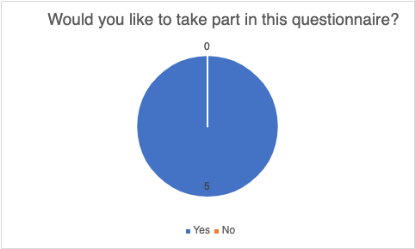
Question Number 2
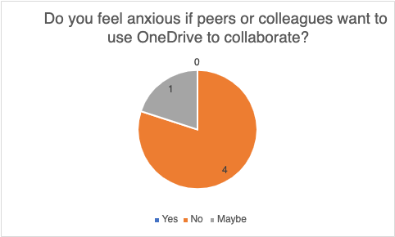
Question Number 3

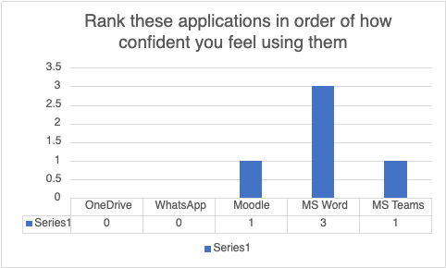
Question Number 4
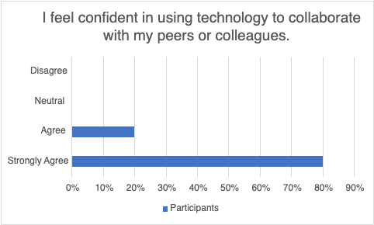
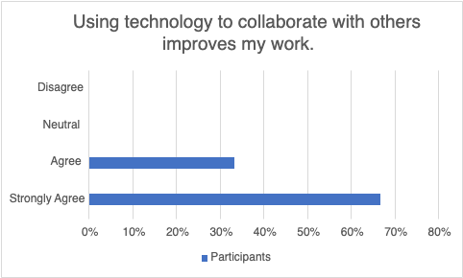
Question 5
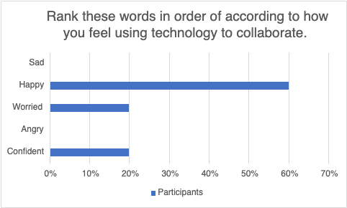

Discussion
A questionnaire was formed on MS Forms to collect the data relating to the research.
A total of 5 questions and statements were included in the questionnaire for the participants to take part in.
The first question was ‘Would you like to take part in this questionnaire?’.
This shows that ethical considerations were considered.
By looking at the pie chart for question 1, you can see that all 5 participants had given their consent to continue on with the questionnaire and answered ‘yes’.
The second question was ‘Do you feel anxious if peers or colleagues want to use OneDrive to collaborate?’.
As you can see in the pie chart, 80% of the participants answered ‘no’, meaning that they do not feel anxious whilst using OneDrive to collaborate.
The surprising part is that 20% of the participants answered ‘yes’, meaning one of the individuals that had taken part in the survey, feels anxious whilst using OneDrive to collaborate with.
The third question was a ‘rank order’ question and it was ‘Rank these applications in order of how confident you feel using them.’.
OneDrive, WhatsApp, Moodle, MS Word and MS Teams were the applications that was used in this question.
In the chart, it shows that the majority of the participants feel confident in using MS Word than the other applications.
20% of the participants feel confident using Moodle and another 20% feel confident in using MS Teams than the other applications.
These results were shocking as it shows that the participants were not feeling as confident using OneDrive and WhatsApp.
(Dean, 2021) states that ‘WhatsApp is ranked as the most used mobile messenger app in the world.’, therefore it was surprising to see that the participants were not as confident as using it.
It was also surprising to see that the participants were not as confident at using OneDrive as in the second question of the questionnaire, 80% of the targeted audience answered ‘no’ to not feeling anxious whilst using OneDrive to collaborate with.
The fourth question included two statements that the targeted audience could pick if they strongly agree, agree, disagree or stay neutral regarding the statements.
The first statement was ‘I feel confident in using technology to collaborate with my peers or colleagues.’.
80% of the participants strongly agreed with this statement, whereas only 20% agreed with it.
(Barber, 2021) shows that ‘The call comes as new polling suggests only 21 per cent of lecturers were ‘very confident’ they could design and deliver digital teaching during the pandemic – 59 per cent said they were fairly confident, and 18 per cent said they were not confident.
By comparison, 49 per cent of students said they were ‘very confident’ that they had the skills to benefit from online learning with 42 per cent somewhat confident.’.
The second statement was ‘Using technology to collaborate with others, improves my work.’.
The chart shows that 67.7% of participants strongly agreed with the statement whilst 33.3% only agreed with the statement.
(Ally, 2004) states that ‘technology improves the learning’, therefore it is understandable to why all 5 of the participants did not vote neutral or disagreed.
(Sutherland, 2019) says ‘Technology makes it easier for students to find information quickly and accurately. Search engines and e-books are replacing traditional textbooks. Instead of personal tutors, students can get one-on-one help through educational videos.’.
This could be why there was no neutral or disagreed votes as the participants can learn at their own pace and understand better.
The fifth question was a rank order question which was ‘Rank these words in order of according to how you feel using technology to collaborate.’.
The options that the participants could pick from were an array of emotions.
Sad, happy, worried, angry and confident were the emotions that were used in this particular question.
It is shown that 60% of the targeted audience picked happy as their answer, whereas 20% picked confident and the other 20% picked worried.
Out of the 5 participants, only 1 person was confident in using technology to collaborate.
3 of the participants were happy which may mean that they are somewhat satisfied or comfortable in using technology to collaborate.
One of the participants may feel less confident and anxious in using technology to collaborate as they had picked ‘worried’ as their answer.
It could be the case of the participant lacking in digital skills.
(Cherney, 2016) says ‘Technological literacy itself, in fact, is culturally considered to be a requirement for relevancy in society. Yet not everyone is technologically literate.’.
In the hypothesis from component 1, the prediction was that staff and students are confident in using technology to collaborate as technology has had a vast impact on their performances.
Also in the hypothesis, it mentioned about how beneficial technology is and how it has helped staff and students to improve their studies, learning and teaching methods, collection of information and it has helped them to become more knowledgeable.
The data collected has somewhat confirmed the hypothesis as it shows that the majority of the targeted audience are confident in using technology to collaborate and how it has improved their work.

Conclusion
A conclusion has been made based on the discussions in this report.
This is concluded to the research question – ‘Are staff and students confident in using technology to collaborate at University of Wales Trinity Saint David?’.
Staff and students are confident in using technology to collaborate at University of Wales Trinity Saint David as the results show that the majority of the participants are confident in using technology to collaborate.
One of the reasons being is because technology is helping to improve their work and the targeted audience have shown the confidence in using different digital applications.
(Sutherland, 2019) also states that ‘Many educational tools offer a variety of functionalities that promote collaboration. For example, Skype provides a way for students to hold virtual meetings with classmates from anywhere in the world. With Google Drive, students can easily share and edit projects with each other.’.

Reference List
Ally, M., (2004). Foundations of educational theory for online learning. Theory and practice of online learning, 2, pp.15-44.
Barber, M. (2021). Students more confident with online learning than lecturers are about teaching digitally - Office for Students. [online] www.officeforstudents.org.uk. Available at: https://www.officeforstudents.org.uk/news-blog-and-events/press-and-media/students-more-confident-with-online-learning-than-lecturers-are-about-teaching-digitally/.
[Accessed 10 Apr. 2022].
Cherney, K., (2016). Anxiety and Technology in the Classroom: Identification and Solutions for Multimodal Inclusivity. [online] Available at: https://www.digitalrhetoriccollaborative.org/2016/06/29/anxiety-and-technology-in-the-classroom-identification-and-solutions-for-multimodal-inclusivity/
[Accessed 10 Apr. 2022].
Dean, B. (2021). WhatsApp 2021 User Statistics: How Many People Use WhatsApp? [online] Backlinko. Available at: https://backlinko.com/whatsapp-users.
[Accessed 10 Apr. 2022].
Iqbal, M. (2020). Zoom Revenue and Usage Statistics. [online] Business of Apps. Available at: https://www.businessofapps.com/data/zoom-statistics/.
[Accessed 10 Apr. 2022].
Lynch, M. (2017). 9 WAYS THAT TECHNOLOGY BOOSTS STUDENT CONFIDENCE IN THE CLASSROOM. [online] The Tech Edvocate. Available at: https://www.thetechedvocate.org/9-ways-technology-boosts-student-confidence-classroom/#:~:text=An%20interactive%20approach%20allows%20students,build%20student%20confidence%20through%20participation.&text=Making%20learning%20fun%20can%20reduce%20student%20
[Accessed 10 Apr. 2022].
Sutherland, C. (2019). 7 Reasons why Students Need Technology in the Classroom. [online] Explorance. Available at: https://explorance.com/blog/7-reasons-students-need-technology-classroom/.
[Accessed 10 Apr. 2022].
Western Australian Centre for Health Promotion Research (2021). Ethical considerations. [online] Mypeer.org.au. Available at: https://mypeer.org.au/monitoring-evaluation/ethical-considerations/
[Accessed 10 Apr. 2022].
Appendix A – Blank copy of questionnaire



