
Tesco customer relations management report
Kevin Adams 1913062

January 29, 2022

University Of Wales Trinity Saint David

Contents.

Introduction……………………………………………………………………………………………………………………2
1 How Tesco implements customer relations and theories………………………………………..….2
- Ethical policies and practises………………………………………………………….……………………2
- Sustainability policies and practices………………………………………….…………………………3
- Influence of segmentation and the loyalty ladder…………………………………………… …4
2 Sustainability and ethical models and theories……………………………………………………………4
How Tesco engages in segmentation and how they utilise the loyalty ladder…………………4
Conclusion………………………………………………………………………………………………………………………5
Recommendations………………………………………………………………………………………………………….6
Bibliography……………………………………………………………………………………………………………………7
Appendices……………………………………………………………………………………………………………………..9

Introduction.
The purpose of this paper is to understand how Tesco uses customer relations management to attract customers form all diversities. The main objectives are to understand Tesco’s ethical policies and theories. Look at the history to see how ethical Tesco’s practices are. Look at ways how Tesco can sustain its business and keep hold of their customers and, see how they target certain customers with segregation and seeing how loyal the customers are.
Tesco is the UK’s leading company in the superstore market. Founded in 1919 by Jack Cohen. Started with just one small stall in east London Tesco has become a key part of everyday lives with over 4600 stores in the world. With big competition in this industry the paper will discover how Tesco and competing companies go about keeping competitive. This will look at how ethical these businesses are, looking at their history and what it done about their reputation also, the studies will find how Tesco attracts customers and keep customer retention, also looking at data to see what the do to resolve any problems that may arise. After the findings then we are going to see how Tesco can move forward and look at what the competition are doing.

How Tesco implements customer relations and theories.
- Ethical policies and practices

The biggest expenditure in most businesses is wages so trying to keep it at a minimum is a key focus. In UK law it is compulsory to pay a living wage which stands at £8.91 per hour as of tax year 2021. (Minimum wage rates for 2022, 2021) Tesco has ethically kept within the law and has offered a higher rate than the living wage. The wage currently stands at £9.55 per hour. (Wright, 2022) This shows Tesco is willing to go a little bit extra. Because of the covid 2019 pandemic and Brexit there was a shortage of drivers in the U.K. A bonus incentive was conducted, and Tesco offered a £1000 as a joining fee. This compared to Asda which was only a £200 to someone who referred someone to be a driver for Asda. (Quinn, 2021) These findings show Tesco are willing to pay more aggressively and reward the person and not the middleman compared to its main rival.

Looking at source C you can see a comparison of all the supermarkets bottom wage structure. As you can see all companies pay more than the living wage but most of all Tesco doesn’t compete with Asda. The two budget German stores show the most competitive wages with Aldi at the top with more than £1 per hour than Tesco. Because of the rise in wages due to lack in demand in the job market many supermarkets must rethink their strategies in costs. Tesco has investigated ways of cutting costs by reviewing the night workers. Sources say the tend to cut 1,600 staff but there are 3000 vacancies available which they could reshuffle the night workers. This comes as a loss to the night workers as they earn an extra £3000 per year working on the night shift. Sainsburys has also made cuts by closing its fresh counters (Eley, 2022) The move looks likely as Tesco already announced it is closing its budget store Jack’s to compete with Aldi and Lidl where 130 jobs are to be axed, but Tesco said they will be offered jobs in their stores. (Partridge, 2022)

Even though Tesco try their best to be ethical sometimes things can fall out of their hands. One example of this is the horsemeat scandal where Tesco own brand beef burgers were found to contain horse meat. 29% of horse DNA was found in the produce which led to a major recall of all the burgers in the chain. This also effect other companies such as Burger King, Aldi and Co-op which all complied with the withdrawal of its produce. This was all traced back to and Irish meat producer called the ABP group which is Europe’s leading cattle meat producer. (Horsemeat scandal: where did the 29% horse in your Tesco burger come from? 2013) Even though Tesco did its best to stop the sales of these items these things should not happen. They may not be internally their fault, but they should have better quality control practices to prevent this. It has been criticized by Tesco’s chief executive at the time Mark Price that this was inevitable to happen because of the competition is tough to sell the cheapest produce. (Tesco begins 'urgent' investigation after withdrawn burgers found on sale after horse meat scandal, 2013)

After the backlash of the horsemeat scandal there is now a new focus on improving the way Tesco improves food translation. To start with Mark Price will delegate a new director of agriculture. The aim is to make sure farmers have a direct point of contact. There is a plan in place by Tesco that they want to import less meat and use local farmers. This will help the British farmers sustain their business and Tesco will be able to have more control over the quality of the meat and know where its sourced. Tesco stated that by July 2013 all its fresh poultry will be 100% British and plans are put in use for frozen. Looking at source B this is backed with significant increase in British poultry production meaning farmers are growing in the industry resulting in the use of imports. (Creevy, 2013)

- Sustainability policies and practices

Looking at source A Tesco has been dominant in the market share compared to its competitors in Great Britain. The line is flat lined staying around the 27% mark while the competitors follows a similar pattern. At the end of 2019 there was the start of the coronavirus outbreak. Between the big four retailers (Tesco, Morrisons, Sainsburys and Asda) Tesco and Sainsburys managed to hold their percentage of the market share while Asda struggled to retain market share during the peak of the pandemic. This resulted in them nearly losing 1% of the market. (Great Britain: Grocery market share 2022 | Statista, 2022)
During these uncertain times including the pandemic and Brexit all supermarkets struggle with labour, supplies and increasing inflation. The big four supermarkets hade an upper hand with online delivery because consumer fear of the pandemic meant they can have less chance of contact of the virus while ordering at home. Budget supermarkets like Lidl did not lose any ground which was a success because they believe online shopping is not suited to their limited stock of budget supplies. This meant this was a success as they retained sales even though they had a disadvantage. This is backed up by Lidl as they plan to open more than 100 stores in the upcoming years. During the peak of the pandemic, it was only Tesco that outperformed the budget supermarkets. (Johnstone and Eley, 2021)

- Influences of segmentation and the loyalty ladder.
With so much competition in the market it is most important to keep your customers. If an organisation loses customers, then the competition will gain for your loss. This will be a double blow, so Tesco introduced a loyalty card. For every £1 you spend you get 1 point which have a value of 1 point. Not only you get points, but you can spend those points in Tesco’s reward partners such as Pizza express, Disney Plus and Prezzo. This card gives a constant connection to retain their customer and prefer them to shop more often and potentially make them an advocate. (O'Neill, 2022)
When dealing with customers you need to have a target market. You need to segregate the customers and target which ones will benefit your profits. One way Tesco has targeted a specific customer kind is the Tesco Clubcard plus. At the cost of £7.99 a month a shopper can save 10% on a shop up to £200 two times a month so, a total of £40 a month is possible. This shows that Tesco wants to attract big spenders. A customer who only goes in for bread and milk will not benefit at all from this deal. This also includes customers on Tesco mobile get double data on the mobile phones. This will also target younger customers and elderly are not renowned for using modern technology. (Scrimgeour, 2022) The Clubcard can also be traded in for a 16-25 railcard backing up the idea they target a younger audience. (1-year 16-25 Railcard, 2022)
2. Sustainability ethical models and theories.
It is great when businesses can grow but what is most important is to sustain the business, so it doesn’t decline or terminate. The three factors that involve sustainability is environmental, economic and social. As the population of the world is expanding, we are putting on pressure of resources. It has been studied that consumption of animals is less sustainable than consuming plant products, so businesses need to focus on not to use too much animal products. (Alun, 2017)
Sociably the demand for meat outweighs the need for plant or lab products. In 2018 it has been reported that 57.2 pounds of beef is consumed on average per person, so companies still need to cater for the animal consumers. (Van Loo, Caputo and Lusk, 2020) Economically processed vegan food is more expensive than food, this can affect the social side as customers with less income will be put off. But with growing rise in veganism the cost of these products is reducing. If you compare some products for example tofu and beans are more affordable than animal product. (Vegan options are more expensive than their nonvegetarian counterparts. Can I afford to go vegan? | PETA, 2022)
An organisation needs to be ethical if its lawful or morally. In recent times there has been a grown in unethical behaviour especially in the financial sector. Since the 1900s there has been a repeated economic bubble. The norm is a generation will experience one. Recently the late 1980s and the crash in 2007 shows that this re-occurrence are happening more often with a generation experiencing two economic bubbles burst. (Russell, Dortch, Gordon and Conrad, 2013)
There are ways an organisation can improve their ethics within the business. One way to conduct this is to use ethical intervention training. Studies have shown in large companies that employees with this training concluded that there was only 33% observed unethical practices compared with untrained staff at 62% of the time. (Zeni, Buckley, Mumford and Griffith, 2016)
The problem with this type of ethical training is that it needs to be observed and kept up to standard. Managers will need to spend more time observing, also the manager ethics may become an issue as the people below him want to go with company ethical policy’s but may feel under pressure if the manager has different values. The cost and time spent on training will have an impact on productivity. Changes in the law will make the training constantly adapt which will take up extra resources. (N Root, 2019)
3 How Tesco engages in segmentation and how they utilise the loyalty ladder.
When it comes to customer relations management the most import factor is to target certain customers. You want to keep your loyal customers happy but need to gain trust and see how you can gain less loyal customers’ trust. Then we need to segment what areas we need to target to achieve a solid customer relation.
Tesco has shown intent to drag customers up the loyalty ladder. In 1993 Tesco followed suit of the Co-op and trends from the U.S.A. They came up with a trail of the Clubcard which featured in three stores. When they launched the trail, it seemed popular with people queuing up to register for one and asking for their family size. The trend set to continue and become a great success. The timing was right due to the technology advances. This wasn’t the first time they had a loyalty system. The had a lick and stamp book called green shield stamps. It came out as the biggest reason for growth but after fifteen years the gimmick had run its course, as they were losing customers which resulted in costs of around £20 million. (Humby, Hunt and Phillips, 2008)
The loyalty card is the most common use of keeping customer relationships, in the UK there are over 150 types of cards with over 40 million in circulation. Other than satisfying customers it also gives retailers data on each individual customer. The card can be used in partnering stores. They can be used for glasses, dining out and even the auto centre. Tesco can use this data to find out their habits outside Tesco, even knowing what car they drive. Another benefit is that these partners will be near stores which will make customers make more visits to a Tesco store. Tesco is a click and brick business. With the advantage of a website customers can choose to join free clubs. These include wine club, healthy living club, toddler club and baby club. These options will also give Tesco valuable data. (Rowley, 2005)
Another example of how Tesco segregates their customers is they offered a summer scheme card. This was aimed at families with children. As children are off school for the summer this summer theme was to help deal them deal with the time consumption of shopping. They helped giving customers barbeque and picnic ideas and family days out. (Tesco Clubcard targets lifestyles with summer DM, 2002)
Tesco is a diverse business with many options to segregate. These include finance, telecoms, kitchens, estate agents and digital photo prints. One target they also reached out is the beauty industry. Tesco wanted to target Boots customers with an in-store beauty treatment. This offered waxing, nail treatment and eyebrows. Other than segregating the theory was to make the shopper feel relaxed making the shopping experience memorable. (Barnes, 2011)
Conclusion.
What the studies show is Tesco is a giant company which has made them a target to the media. With negative reputation form the horsemeat scandal it shows Tesco doesn’t have full control of the ethics. As a result, Tesco must adapt constantly and put in quality measure to make sure their reputation stays clean. Tesco also has customer trust with the loyalty card scheme. Customers are comfortable giving away personal data in return of a little extra from Tesco. Using this bond with the customers it helps Tesco grow as a business and helps the customers make shopping easier for them.
The Clubcard is a major factor to sustaining the customers. Having that little peace of plastic is a reminder of how customers to do their shop. There is stiff competition such as the Nectar card, so the Clubcard has to find creative ways to stand out form the competition. With the advantage of Tesco’s website, the customer can have more interaction with Tesco. They can update their personal information easier making the data more accurate. The customer can check what Tesco is offering and, makes Tesco advertising easier. With certain online clubs Tesco can segmentate their customers to make sure what Tesco is offering relevant.
Recommendations.
The failed attempt of Jacks stores should be looked at more closely. With stiff competition from the budget stores and they are expanding fast this should be seen as an opportunity. Rebranding the company for budget stores and rebranding their products will help Tesco break barriers into the market.
With the uncertainty in its supply chain due to Brexit and people isolating due to Covid-19 Tesco must manage tricky situations with new management tactics. Tesco should re invest in its employees. Most jobs in the stores are known to be low skilled jobs. Having a HGV program where Tesco helps finance employees to become drivers will result in sustaining employees and help sustain supply. When their stores have fully stocked shelves it will make the customer experience easier equalling to more customer retention.

Bibliography.
Alun, E., 2017. A critique of Ecological Footprinting as a tool for measuring the impacts of food-related lifestyle on sustainability. p.33.
Barnes, R., 2011. The great Tesco beauty gamble. [online] Campaignlive.co.uk. Available at: <https://www.campaignlive.co.uk/article/great-tesco-beauty-gamble/1051142> [Accessed 20 February 2022].
Creevy, J., 2013. Tesco chief Clarke: Horse meat scandal will lead to industry transformation. Retail Week.
Eley, J., 2022. Tesco looks to axe 1,000-plus roles in shift to cheaper daytime work. [online] Ft.com. Available at: <https://www.ft.com/content/27f00f60-9bc9-4240-984e-7baf2b023931> [Accessed 11 February 2022].
GOV.UK. 2021. Minimum wage rates for 2022. [online] Available at: <https://www.gov.uk/government/publications/minimum-wage-rates-for-2022> [Accessed 10 February 2022].
Humby, C., Hunt, T. and Phillips, T., 2008. Scoring points. 2nd ed. Kogan Page, pp.23,26.
Johnstone, I. and Eley, J., 2021. Lidl to create 4,000 new jobs in UK and add 100 stores. FT.com,.
Marketing, 2002. Tesco Clubcard targets lifestyles with summer DM. 9, p.1.
N Root, G., 2019. Advantages & Disadvantages of Ethical Compliance in an Organization. [online] Small Business - Chron.com. Available at: <https://smallbusiness.chron.com/advantages-disadvantages-ethical-compliance-organization-20548.html> [Accessed 20 February 2022].
O'Neill, R., 2022. Clubcard, Nectar and the best loyalty cards for saving money. [online] WalesOnline. Available at: <https://www.walesonline.co.uk/news/uk-news/best-worst-customer-loyalty-cards-22894407> [Accessed 11 February 2022].
Partridge, J., 2022. Tesco to close Jack’s discount chain of shops. [online] the Guardian. Available at: <https://www.theguardian.com/business/2022/jan/31/tesco-to-close-jacks-discount-chain> [Accessed 11 February 2022].
PETA. 2022. Vegan options are more expensive than their nonvegetarian counterparts. Can I afford to go vegan? | PETA. [online] Available at: <https://www.peta.org/about-peta/faq/vegan-options-are-more-expensive-than-their-nonvegetarian-counterparts-can-i-afford-to-go-vegan/> [Accessed 17 February 2022].
Quinn, I., 2021. Asda and Tesco offer incentives for drivers. Grocer, p.46.
Retail Week, 2013. Tesco begins 'urgent' investigation after withdrawn burgers found on sale after horse meat scandal.
Rowley, J., 2005. Building brand webs. International Journal of Retail & Distribution Management, 33(3), pp.194-201.
Russell, K., Dortch, M., Gordon, R. and Conrad, C., 2013. Case studies in organizational communication. Los Angeles: SAGE Publications, p.2.
Scrimgeour, H., 2022. How to reclaim up to two years of unused Tesco Clubcard vouchers. [online] GoodtoKnow. Available at: <https://www.goodto.com/family/money-news/reclaim-tesco-clubcard-vouchers-649799> [Accessed 16 February 2022].
Statista. 2022. Great Britain: Grocery market share 2022 | Statista. [online] Available at: <https://www.statista.com/statistics/280208/grocery-market-share-in-the-united-kingdom-uk/> [Accessed 4 February 2022].
Tesco. 2022. 1-year 16-25 Railcard. [online] Available at: <https://secure.tesco.com/clubcard/vouchers/1-year-16-25-railcard/UK-009980.prd?preservedReferrer=https://www.google.com/> [Accessed 12 February 2022].
the Guardian. 2022. Horsemeat scandal: where did the 29% horse in your Tesco burger come from?. [online] Available at: <https://www.theguardian.com/uk-news/2013/oct/22/horsemeat-scandal-guardian-investigation-public-secrecy> [Accessed 9 February 2022].
Van Loo, E., Caputo, V. and Lusk, J., 2020. Consumer preferences for farm-raised meat, lab-grown meat, and plant-based meat alternatives: Does information or brand matter?. Food Policy, 95, p.1.
Wright, G., 2022. Shop floor pay: how the UK's biggest retailers compare - Retail Gazette. [online] Retailgazette.co.uk. Available at: <https://www.retailgazette.co.uk/blog/2022/02/shop-floor-pay-how-the-uks-biggest-retailers-compare/> [Accessed 20 February 2022].
Zeni, T., Buckley, M., Mumford, M. and Griffith, J., 2016. Making “sense” of ethical decision making. The Leadership Quarterly, 27(6), p.841.

Appendices.
Source A Statista. 2022. Great Britain: Grocery market share 2022 | Statista. [online] Available at: <https://www.statista.com/statistics/280208/grocery-market-share-in-the-united-kingdom-uk/> [Accessed 16 February 2022].
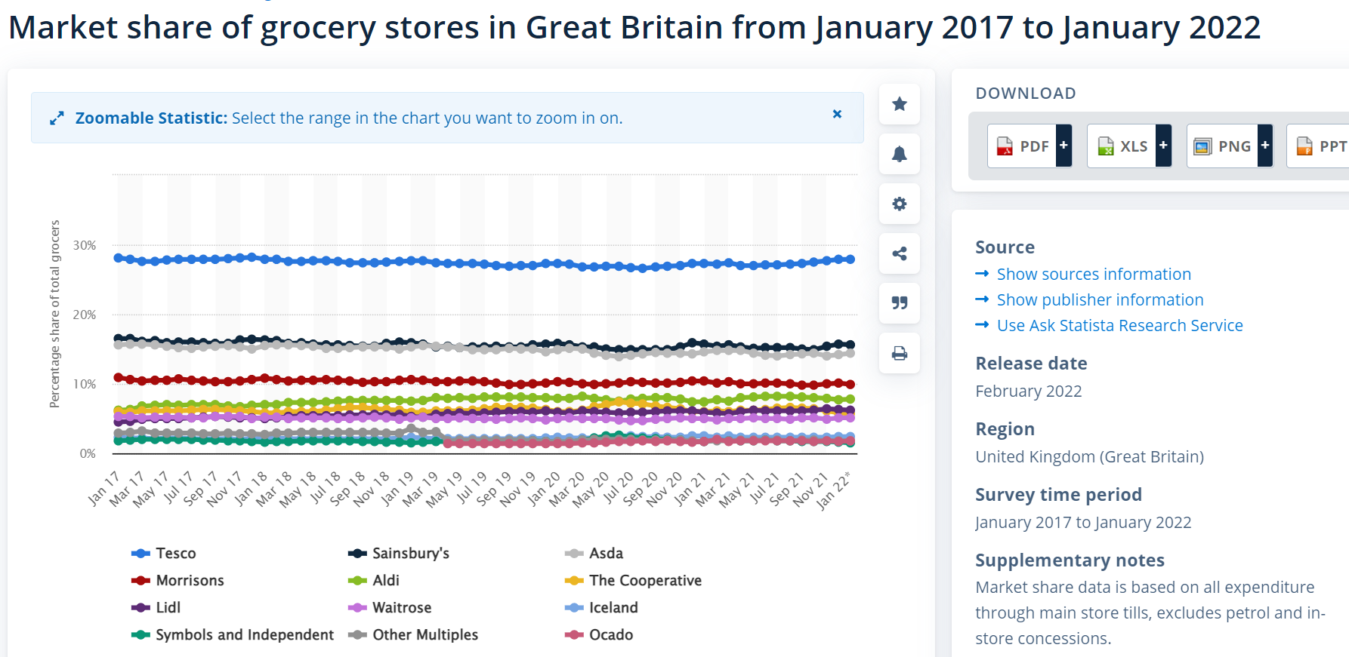

Source B GOV.UK. 2022. United Kingdom Food Security Report 2021: Theme 2: UK Food Supply Sources. [online] Available at: <https://www.gov.uk/government/statistics/united-kingdom-food-security-report-2021/united-kingdom-food-security-report-2021-theme-2-uk-food-supply-sources> [Accessed 19 February 2022].

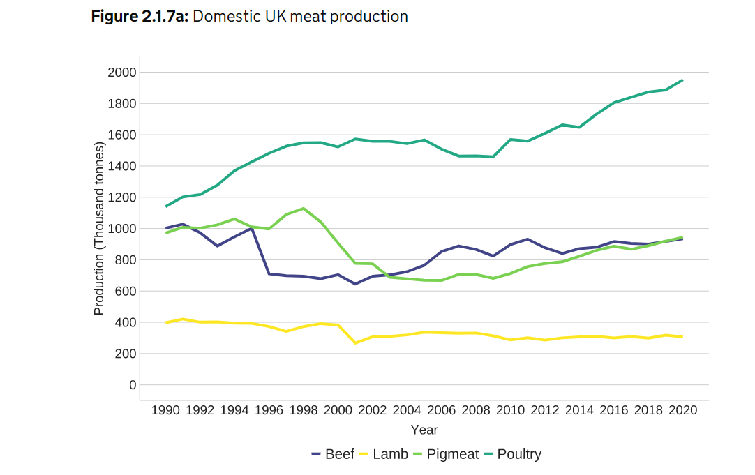
Source C Retailgazette.co.uk. 2022. Shop floor pay: how the UK's biggest retailers compare - Retail Gazette. [online] Available at: <https://www.retailgazette.co.uk/blog/2022/02/shop-floor-pay-how-the-uks-biggest-retailers-compare/> [Accessed 16 February 2022].


