Vegan and Go
Eat Well, Live Well

Owners: - Caroline Thomas; Ashleigh Williams and Annalea Evans

Contact Number: - 07957 990639

Email: - Veganandgo@gmail.com

Completed: - 20/08/2019

Table of Contents
Executive Summary 4
Business Overview 6
POLITICAL FACTORS 7
ECONOMIC FACTORS 8
SOCIAL FACTORS 8
TECHNOLOGICAL FACTORS 8
LEGAL 9
ETHICAL/ENVIROMENTAL 9
STRENGTHS 11
WEAKNESS 11
OPPORTUNITIES 11
THREATS 11
Markets and competition 12
Target Markets 12
Competition 12
Sales and Marketing 13
Local Competitors 13
Marketing and Sales 13
Management 15
Key Personnel 15
Advisors and support services 15
Operations 17
Premises and Equipment 17
Start-up costs 17
Employees 17
Suppliers 18
Financial Forecast 19
Sales 19
Cashflow 20
References 27
Bibliography 28

Executive Summary
“Vegan and Go” prepare and deliver’s fresh, tasty plant-based smoothies direct to the workplace in the vicinity of Llansamlet retail park.

Our target market is office workers, who want to eat more healthily, lose weight and feel great, but find all the information regarding healthy diets confusing. They also lack the time in their busy lives to invest in the research and preparation of lunch. There is not another service in Llansamlet that delivers to the workplace and there isn’t any specialist vegan take-away outlet in the area.

The business will be marketed directly to the local offices in the vicinity, with the engagement of the health and wellbeing groups, “Vegan and Go” will present sessions outlining the health benefits of plant-based food and how cleansing the liver with morning smoothies has a real effect of weight loss. Sales will be made by phone the day before with the option of direct bank transfer or cash on delivery. With the development of an ordering app, this will become much easier for our customer’s and for us to analyse the data.

Company owners are Caroline Thomas, Annalea Evans and Ashleigh Williams who will be equal company directors of Vegan and Go Limited.

Annalea has a background of running a successful business and a love of cooking with a developing interest in veganism.

Caroline has been a long time serving civil servant within various departments and has a knowledge of types of potential customers. She is skilled at engaging with 3rd part stakeholders as this is her current job and she has held the lead of health and wellbeing for the last 10 years within different areas of the civil service.

Ashleigh is skilled on data analysis and is very computer literate. He has successfully negotiated many deals in the past and will be leading on the buying of produce and data analysis. He will also take responsibility of developing the App.

The business will be run out of one of the director’s kitchen which will suffice in the early days but may not be practical as the business grows. The business will then require a specialist premises.

Initial set up costs are £3000 and funded by the three directors equally. However, further funding will enable the purchase of an electric car and the ability to move into premises which would enable the business to expand, offering cookery workshops, take away and evening restaurant.

Business Overview
The Company “Vegan and Go” is a food delivery service specifically aimed at a local highly populated area of workforce. Llansamlet Industrial estate employs approximately 4000 staff (Swansea.gov.uk, 2019) , over various premises within a proximity. “Vegan and Go’s name easily suggests that it caters specifically for Vegans and anyone wishing to increase their diet with more plant-based foods. The Company is also committed to doing everything it can to help protect the environment and where possible will source local food suppliers and supply food items in recyclable containers.

Company owners are Caroline Thomas, Annalea Evans and Ashleigh Williams who will be equal company directors of Vegan and Go Limited as we would like to protect the company name and can continue to trade if one of our members leave. We also feel it gives a more professional outlook and suppliers are sometimes more willing to deal with a limited company.

The idea for a business to provide and deliver smoothies, detox and vegan ready-made meals emerged because we were feeling a bit guilty about our own health, a busy lifestyle was leaving little time to research and prepare nutritious meals.

The number of consumers buying lunch to eat out of the home has risen from 64% in 2016, to 76% in 2017. The newest data according to NPD group, however, shows that next year will grow substantially by 83m visits, and deliveries will grow 101m by 2019, with the biggest increase in breakfast and lunch. Therefore, the requirement for food outlets is growing. However, there the growing trend of ditching animal products is not being fully catered for by fast food outlets and supermarket prepared lunches. (Team, 2019, Robinson, 2019)

As a general rule UK workers are entitled to one-hour break at work per day if they work more than six hours in a day, but the average lunch break for UK workers lasts 40 minutes. (Mahdaoui, 2019). This leave little time to leave the workplace, buy lunch and eat it, especially in an industrial area such as Llansamlet. There is also the benefit to the environment, to consider as 1 car delivering to workplaces in a small vicinity is far better than numerous cars driving to various outlets.

Workplace canteens offer a basic selection of sandwiches and some warm food item, with an even more limited supply for vegetarians. The civil service employs approximately 3000 people over their 4 sites in the Llansamlet area but do not offer a vegan menu.

Another benefit of targeting large organisations is that they support and encourage the benefit in health and wellbeing for their workforce and promote this with various competitions, challenges and educational talks. In any workplace you would be hard pushed not to find various group of individuals or teams taking part in a workplace diet club. “Vegan and Go” could work with these health and wellbeing leads to promote health benefits and in turn the business.

A study published in 2015 in the journal Nutrition compared the effectiveness of five different diets for weight loss in overweight adults: vegan, vegetarian, pescatarian, reducetarian or omnivorous. Those on the vegan diet lost the most weight compared to any other group. The study concluded that: ‘Vegan diets may result in greater weight loss than more modest recommendations. (Veganuary, 2019)

Taking all this into account “Vegan and Go” would address the gap in the market and target a wide customer base in a small vicinity making it a viable business opportunity that has the potential to expand as the business grows or if invested in. Possible areas for expansion would be to develop an ordering app, selling re-usable cups with the company logo and offering discount on smoothies when using this; sourcing and selling re-usable straws; making edible forks and expanding into a restaurant.

In his book “The Art of the Start” Guy Kawasaki argues that “a mantra should be 2-4 words long”. It is a bit like the mission statement, but a lot shorter. (Kawasaki, 2015) Taking this advice into account, Vegan and Co’s mantra should be based upon eating healthily to reap the benefits of a health life. Therefore, the mantra “Eat Well, Live Well” would succinctly describe what the business does.

The Mission statement builds on the mantra, “Provide healthy, Nutritional, plant-based lunches and detoxing smoothies direct to the workplace”.
So why deliver? Total jobs carried out a study which shows that a third of UK employees never leave their workplace after they arrive in the morning. More than half of the 7,135 people surveyed don’t take their full lunch break, even though two out of three feels encouraged to do so. (Mahdaoui, 2017).

A Pestle analysis has been used to help plan for factors affected by political, economic, social and technological factors.

POLITICAL FACTORS
Trends affect the food industry. Public health policies are pushing for healthier options. As “Vegan and Go” prepare healthy meals, this will support the business.
Should taxes increase, this will affect the business, but this can be mitigated by a slight rise in produce costs.

Petrol prices could increase, and this will affect the business, but this can be mitigated by a slight rise in produce costs and the intended purchase of an electric car.
Brexit is another issue at the moment, and it is not sure now how this will affect import/export. This can only be mitigated by changing menu’s in line with local produce.

ECONOMIC FACTORS
The state of the country can affect the food industry. Healthier alternatives to foods are pricier compared to fast food or easy-to-make meals, but the target market are full time workers and with the increasing trend of healthy eating, this is not expected to have an adverse effect on the business. However, should this happen, promotions and discounts will help to increase orders.

The environmental effect of the petrol used for delivery, will not give bad publicity to the company, as it promotes the fact that 1 car will make the deliveries, as opposed to many cars travelling to various outlets. The Company also intends to purchase an electric car.

SOCIAL FACTORS
Consumers dictate trends. As mentioned throughout this analysis, healthiness is the main focus for most consumers and governmental authorities.
The rise in organic and whole foods as diets and lifestyle changes are not a short-lived fad but a lifestyle choice. This can only benefit the business.

TECHNOLOGICAL FACTORS
A need to keep up with Technology is required to make the products more accessible and easier to view. Vegan and Go need to invest in developing an app for food ordering and to show new or promoted smoothies and meals as a method of marketing.

A Facebook and twitter account is required to be set up and kept up to date. Failure to this could result in the company falling behind.

LEGAL
Licensing is required for any kitchen supplying food to the public, this will be obtained and is currently a small expense of £40.00. Should rules change, this could affect the business and require further investment.

Basic Food Hygiene certificates for all directors will be necessary and currently cost £20 per person and this is available online.

ETHICAL/ENVIROMENTAL
Products will be sold in recyclable containers and we will encourage customers to use their own plates and cutlery in order to reduce waste. We would also dispose of food waste sensibly. As the company uses only fresh ingredients, any unused produce will be donated daily to local homeless hostels. The plans also contain making edible forks and selling re-usable straws.

Company owners are Caroline Thomas, Annalea Evans and Ashleigh Williams who will be equal company directors of Vegan and Go Limited as we would like to protect the company name and can continue to trade if one of our members leave. We also feel it gives a more professional outlook and suppliers are sometimes more willing to deal with a limited company.

The product consists of a choice of 6 different vegan lunches and 6 different smoothies specifically for nutrition or detox. The product will be delivered in recyclable cardboard boxes with wooden forks. However, because this is a workplace, many people will have their own cutlery and plate and therefore, emphasis on using their own will be encouraged by introduction of a loyalty card. Each time a person has a delivery in a sturdy plastic container and then returns the container for re-use, their loyalty card will be stamped, after 10 stamps they will be entitled to a half price meal.

The plan for the first 12 months would be to gain a solid and reliable customer base and to build on this with the companies and offer catering for business meetings. Within the first 3 months, the plan is to develop an app making ordering easier for the customer and assist in the analysing of data.

Selling re-usable cups with the company logo and offering discount on smoothies when using this; sourcing and selling re-usable straws and investigating and trialling edible forks. Years 1-3 would be to invest in an electric car, sign written to promote the business and expand into a restaurant premises to cater for eat in, take away and deliveries.

This would allow for cookery workshops and information sessions. Following the first 3 years of the business finances should show the company is viable and future investment can be sought to expand to a larger scale and market the produce to supermarkets providing there was a suitable scalability for the business as this would involve large factory type premises to ensure demand is catered for.

STRENGTHS  - Competitive Price,  - Premium Quality  - Growing trend  - Possibility to expand, e.g. cookery workshops, restaurant, event catering | WEAKNESS  - No qualified cook  - Lack of finances  - Industrial area premises
OPPORTUNITIES  - Massively growing trend  - Customer Loyalty  - Ease of ordering | THREATS  - High traffic levels around industrial estate  - As the trend increases, other business’s setting up who are more experienced

Markets and competition

Target Markets
As the idea for the business came about because the company directors were feeling a bit guilty about their own health but didn’t have time to invest in the minefield of information available on eating healthily and detoxing the body. Therefore, it would be fair to say that Marketing the product would be in effect selling it to ourselves and to like-minded people who would buy smoothies and plant-based meals for a daily dose of health.
Marketing the products, would be based on how a person feels now and how they could feel if they embarked on a plant-based diet.
Our target market is office worker’s in large offices, these individuals spend large amount of the day stationary at their desks and so will usually naturally struggle to maintain a healthy weight. Employers have recognised the link between a healthy and valued workforce to increased productivity and lower sickness levels. Therefore, when the health benefits are highlighted, we would endeavour the business would be supported by companies and we will be invited to promote during health and wellbeing sessions.

Competition
There are fast food and sandwich outlets in the vicinity but nothing that caters for a well-balanced specifically vegan menu.

McDonald’s for example offer only 3 Sides: Fries, Shaker Side Salad and Carrot Sticks that are suitable for vegans. Subway appear to have identified the gap in the market as on 17th April 2019, Subway launched its Vegan Sub and Salad along with their Vegan Garlic Aioli nationwide across the UK! However, this is still extremely limited. Greggs have also introduced a limited vegan option; a Mexican Bean Wrap that launched on 15 June 2018 and more recently adding a Vegan Sausage Roll to their range. This shows that whilst the UK has increased their vegetarian options, outlets are seemingly slow to catch on to the rapidly growing number of people that now recognise the health benefits of detox and a plant-based diet. Whilst, there are some vegan options, these are convenience/processed foods, which is defeating the object of eating health and fresh. (Veganuary, 2019)

Our customers will buy our products due to the convenience, affordability and the wide choice available. All our meals are fresh and using locally sourced ingredients with a commitment to sensible recycling and reducing our carbon footprint.

When the food is delivered directly to the desk, it looks aesthetically pleasing, it’s tasty AND good for you, then the most powerful marketing tool of “word of mouth”.

Sales and Marketing

Local Competitors
Tesco Meal Deal £3.00 for processed vegan wrap
Asda £3.00
Burger King Veggie Bean Burger £4.75
KFC £5.25 Vegan Quorn Burger
McDonalds Veggie wrap £4.95
Starbucks Vegan and Gluten free Wraps £5.35

In terms of quality all local competitors offer limited menu for vegans these are processed fast food items. Vegan and Go will offer similar pricing but for superior quality. We believe our customers are not looking for processed fast food items but a varied menu with quality produce from a sustainable environment. With the added benefit of the food being delivered directly to the workplace.

Marketing and Sales
In increasingly health conscious times, we believe it would the way to persuade customers the health benefit of the product would be to target what it important to us. We feel that those who would choose a vegan diet because of animal cruelty would already have done so, but it is the health and wellbeing benefits that will make the product appealing to our customer’s and there is also a huge selling point as being good for the environment. According to Oxford University researchers, going vegan is the ‘single biggest way’ we can reduce our environmental impact. A plant-based diet can cut greenhouse gas emissions, reduce pollution and water usage, prevent deforestation and save wild animals from extinction. (Wells, 2018)

Researchers have shown that a more plant-based diet may help prevent, treat, or reverse some of our leading causes of death, including heart disease, type 2 diabetes, and high blood pressure. Interventional studies of plant-based diets have shown, for example, 90 percent reductions in angina attacks within just a few weeks. Plant-based diet intervention groups have reported greater diet satisfaction than control groups, as well as improved digestion, increased energy, and better sleep, and significant improvement in their physical functioning, general health, vitality, and mental health. Studies have shown plant-based eating can improve not only body weight, blood sugar levels, and ability to control cholesterol, but also emotional states, including depression, anxiety, fatigue, sense of well-being, and daily functioning. (Nutritionfacts.org, 2019)

Do you?..
*Feel tired and fatigued a lot of the time?
* Feel out of control with your eating and drinking?
* Feel confused by all the conflicting information on the right things to eat?
*Suffer from PMS and hormonal issues?
* Struggle to maintain a healthy weight?
*Feel fuzzy headed and struggle to concentrate?

Do you want to?..
*Feel alive and full of vitality?
* Feel in control of your eating?
* Find your ideal body weight?
* Reduce your chances of heart disease, high blood pressure and stroke?
* Understand the importance of diet and nutrition?
* Tune up your digestion and get of the sugar balance roller coaster?
* Create an AMAZING healthy lifestyle

Vegan and Go will engage firstly with the local business’s and approach the Health and Wellbeing leads at the first instance and request to deliver sessions based on the benefits of detox and plant-based eating.

When vegan and go have delivered the health and wellbeing session, it is estimated that approximately 20% attending will order at least once within the first week. When the food is delivered directly to the desk, it looks aesthetically pleasing, it’s tasty AND good for you, then the most powerful marketing tool of “word of mouth” should assist in more orders. Vegan and Go will promote being friends to our customer’s and will reward regular customer’s with trials of new products for their feedback, this will create a sense of loyalty for us from our customers.

Management

Key Personnel
All Company directors will complete the basic food hygiene certificate.
The business will be supported by the 3 company directors to begin with, the need to hire additional resource will be analysed in weekly director’s meetings. They will jointly source and trial various recipes.

Annalea will hold the ultimate responsibility compiling menus due to her interest in this subject and love of cooking, she will also consider the costings of the produce to ensure value for money for the customer and profit for the company as she has extensive knowledge and background of running a successful business.

Caroline will engage with all local companies to promote the business and present sessions on the benefits of eating more plant-based foods. This will play to Caroline’s strengths of engaging with key stakeholders and he knowledge of the civil service and health and wellbeing groups. Caroline will remain the point of contact and lead on the customer feedback and on moving the company forward.

Ashleigh will source local produce and negotiate pricings with the suppliers. Ashleigh will take charge of the financial aspect; preparing accounts and profit and loss statements ready for the weekly meeting. He will transfer the sales data into graphs to identify what is going well and what will require improvement. Ashley is skilled on data analysis and is very computer literate.

Caroline and Ashley will use their own vehicles to deliver the produce at the beginning with a view to purchasing an electric car for the business in the future. All company directors have invested £1000 each into the company and have agreed not to withdraw a wage for the first 3 months of trading such is their commitment to the business.

Advisors and support services
The Directors have sought external advice from The Prince’s Trust for their input, this is because they have vast experience in assisting small business to start up. Their advice has been greatly received and helped with start up costs, advice on correct documentation and certificates required. Further advice has been sought from a local Nutritionist who has a diploma in diet and nutrition energy/intolerance testing who has offered guidance with the menu and has provided us with a cookery demonstration and taste event. These external sources have been valuable and have provided enough feedback for the business to move closer to start up.

Our skill set as directors enable us to be self-sufficient in the business.

Operations

Premises and Equipment
The Company premises will be one of the director’s home, where the large kitchen can be used to prepare the meals. The Premises will need to be assessed by the local authority. The Premises is within a 3-mile radius of Llansamlet industrial estate. This will help keep the costs down. Specialist equipment would only require two industrial smoothie makers and kitchen essentials to begin with.

Start-up costs
£249.50 x 2 for industrial smoothie maker
£500 for kitchen essentials, chopping board, knives and graters. Pestle and mortar.
£77.98 for 300 takeaway boxes (100% biodegradable and recyclable)
£47.82 per 150 plastic smoothie containers.
£60 Basic Food Hygiene Certificates
£40.00 Local Authority Certificate
£500 x 2 for business car insurance
£175 Public liability Insurance
£600 Petrol
£500 initial outlay of food items
£3000

Employees
Our skillset as directors enable us to be self-sufficient in the business, we will require basic food hygiene certificates which we are committed to obtaining before trading.

Suppliers
We are committed to buying locally and organically. We have arranged a contract with local supplier Stradey Castle Estates who grow their own produce and have been trading successfully for 5 years. They can offer credit of up to £1000 monthly. If prices increase we will look at changing the menu to include cheaper and seasonal ingredients. We have negotiated competitive deals for the fresh ingredients. With regards to the smoothies we have identified that it is more financially viable to buy frozen ingredients, which will also have the benefit of zero waste.

Financial Forecast

Sales
We estimate a starting customer base of 10% which would equal to 300 customers for smoothies and the same for lunch per week with suitable increases with the times of year (diet patterns)

Cashflow

  Gantt Chart: Vegan and Co
  Tasks | Week 1 | Week 2 | Week 3 | Week 4 | Week 5 | Week 6 | Week 7 | Week 8
  Contact Business's to arrange wellbeing sessions and complete basic food hygiene courses,
  buy in resources and equipment
  register with HMRC and domainr
  set up Facebook page with photos
  deliver sessions to business and promote marketing information
  Gantt Chart: Vegan and Co
  Tasks | Week 1 | Week 2 | Week 3 | Week 4 | Week 5 | Week 6 | Week 7 | Week 8
  Contact Business's to arrange wellbeing sessions and complete basic food hygiene courses,
  buy in resources and equipment
  register with HMRC and domainr
  set up Facebook page with photos
  deliver sessions to business and promote marketing information
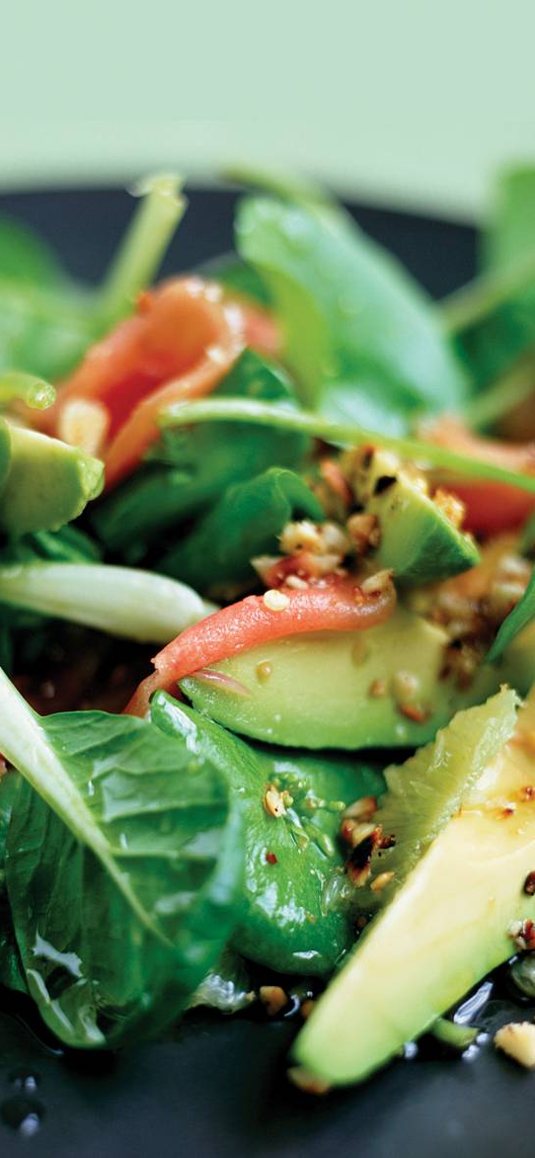

Hours of delivery:
11.30am to 3.00pm Mon-Friday
12pm – 2pm Saturday

All our meals are prepared fresh and rushed over to you at work. We know how important the enviroment is to you and so we encourage using your own cutlery to help save on refuse, however, we can provide wooden forks on request. But hey, we are in the process of developing reciepes for edible cutlery so watch this space, we will be asking our loyal customer’s to try out a fork or two for us…

We supply food in recycylabe cardboard container so please ensure you recycle responsibility, if you would like to be extra good and maybe earn some brownie points we can deliver in sturdy containers for you to transfer onto your own plate, we will simply collect the container the next day for re-use. (we won’t even ask you to wash it).

Loyalty Cards are available
Do you?..
*Feel tired and fatigued a lot of the time?
* Feel out of control with your eating and drinking?
* Feel confused by all the conflicting information on the right things to eat?
*Suffer from PMS and hormonal issues?
* Struggle to maintain a healthy weight?
*Feel fuzzy headed and struggle to concentrate?

Do you want to?..
*Feel alive and full of vitality?
* Feel in control of your eating?
* Find your ideal body weight?
* Reduce your chances of heart disease, high blood pressure and stroke?
* Understand the importance of diet and nutrition?
* Tune up your digestion and get of the sugar balance roller coaster?
* Create an AMAZING healthy lifestyle?
Research has shown that a more plant based diet may help prevent, treat or reverse some of our leading causes of death, including heart disease, type 2 diabetes, certain types of cancer and high blood pressure.
Studies have also shown plant-based eating can improve not only body weight, blood sugar levels and the ability to control choloestrol, but also emotional states including depression, anxiety, fatigue, sense of wellbeing and daily functioning.
Menu
Llansmalet Industrial Estate
Tel: 01792 415888
www goveganforhealth.com
Vegan and Go
Vegan and Go

Fresh, Delivered & Delicious
.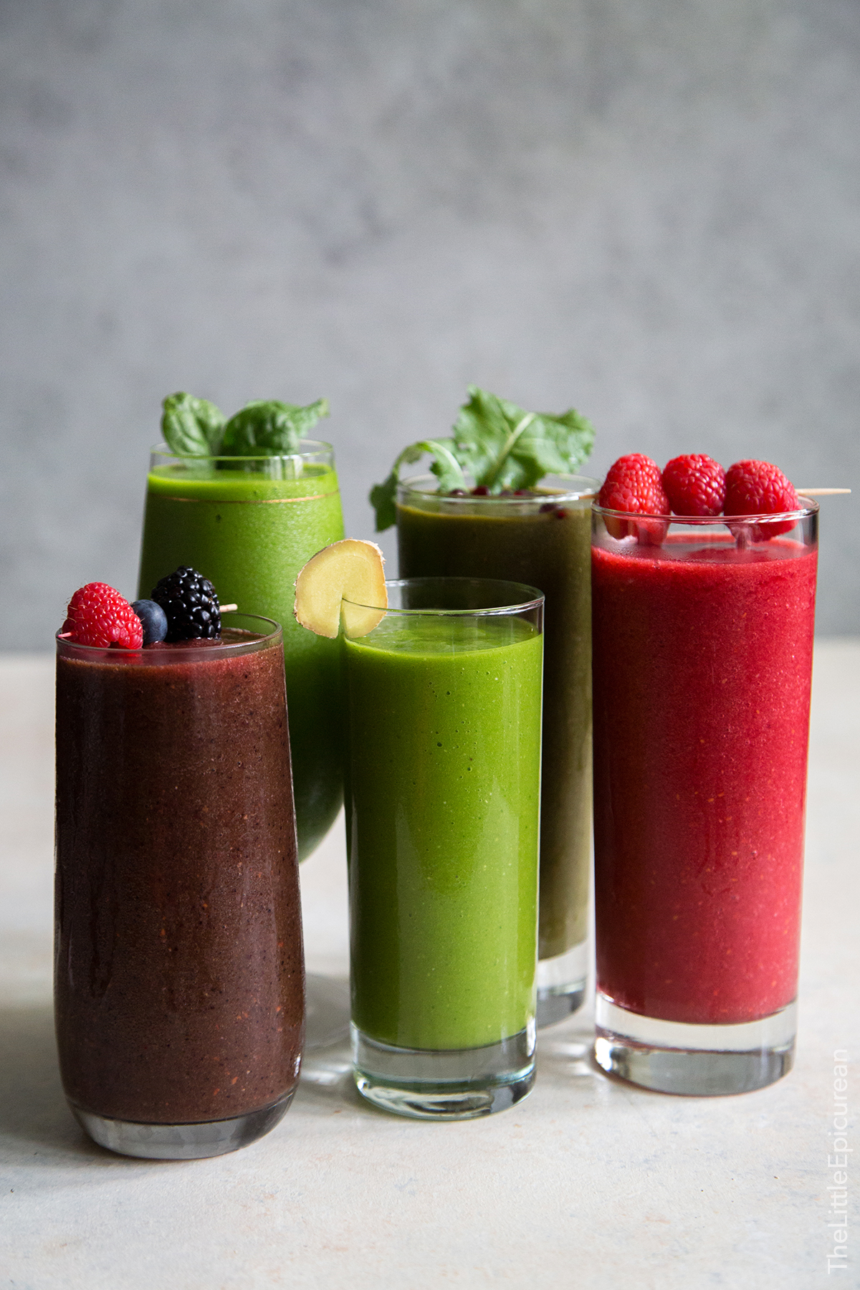
And now for Lunch..

Sweet Potato, Aubergine and Chickpea Tagine
£5.50 served with cauliflower rice.
Aromatic and warming dish
158 Calories per 211g serving

Israeli Coucous Salad £5.50
This is the ultmate “go to” salad. You’ll fall in lobe with the tangy lemon flavour and hints of the mediterranean.
415 calories per 265g serving

Greek, Italian Pizza £4.50
What? How is possible you may ask, give this a go, with vegan mossarella, caper’s garlic and lots more
580 calories per 330g serving

Tofu Soulvaki £5.50
Plant based take on a traditional Greek meat kebab, with garlic, oregano, lemon, tofu and vegetables served over shredded lettuce and pita beans
156 calories per 138g serving

Cheesy Butternut Squash and Root Vegetable tart £5.75
Completely delicious and needs no write up
301 calories per 250g servings

Baked Falafel with Pickled Red Onions and Sambal Olek £5.75
4 per serving, 180 Calories

Smoothies 180ml

Spiced Carrot £2.20
Blended specifically for diet control
This is a warmng blend of carrots with a hint of cinnamen and vanilla

Wow, its Green £2.50
Well, if it’s green it must be good for you surely? Well yes this is. Specifically blended to help detox your liver and kidney, contains bannana, strawberry, spinich, spirilina and chia seeds

Toxin Reducer £2.50
Yep, its green again but Wow, really cleansing and keeps the sugar cravigs down, with lots of lovely ingrediants like cucumber, apple, lemon, ginger and fennel

Hydrator £2.20
Is anything better than a glass of water? No? well, yes there is an this is it with Broccoli, pear, celery and mint.

Immune Booster £2.20
Keep away the pesky chills with this ymmy boost, and what’s more it’s not green . With betroot, apples, ginger and lemon.

Liver Love £2.20
Here’another one that just loves to detox your liver, with betroot, spinich, carrots and parsley

Delivered in plastic cups, please recycle responsibily. If you want your smoothie delivered in your own reusable cup or crystal glass, please let us know, we will put your name on it and treat it like our own

d

Scone $00
Cinnamon Rolls $00
Banana Bread $00
Muffins $00
Crepe $00
Cinnamon Bread $00
Sugar Cookie $00
Chocolate Cookie $00
Cakes $00
Pies $00
Madeleine $00
Danish $00

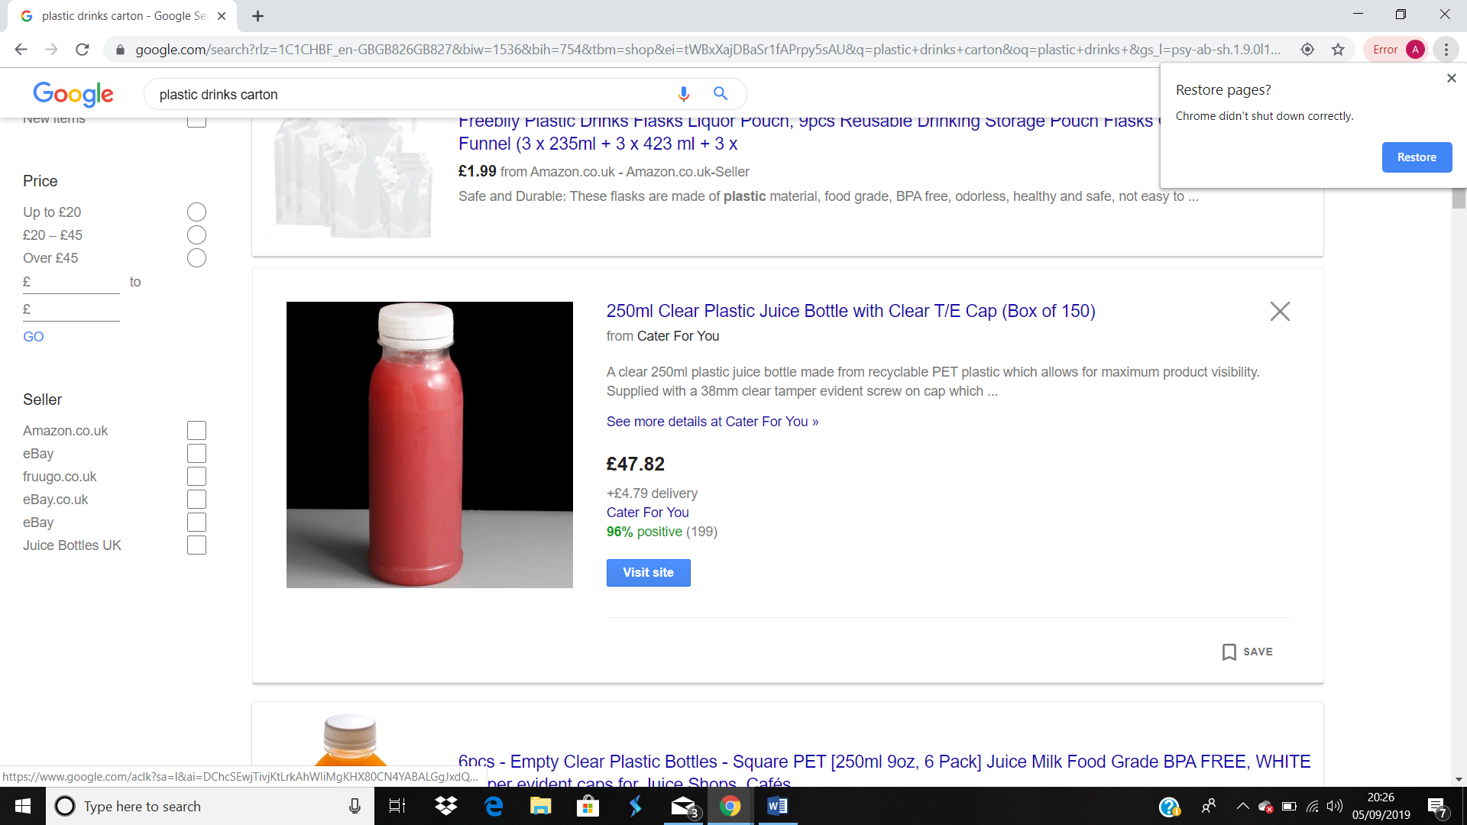

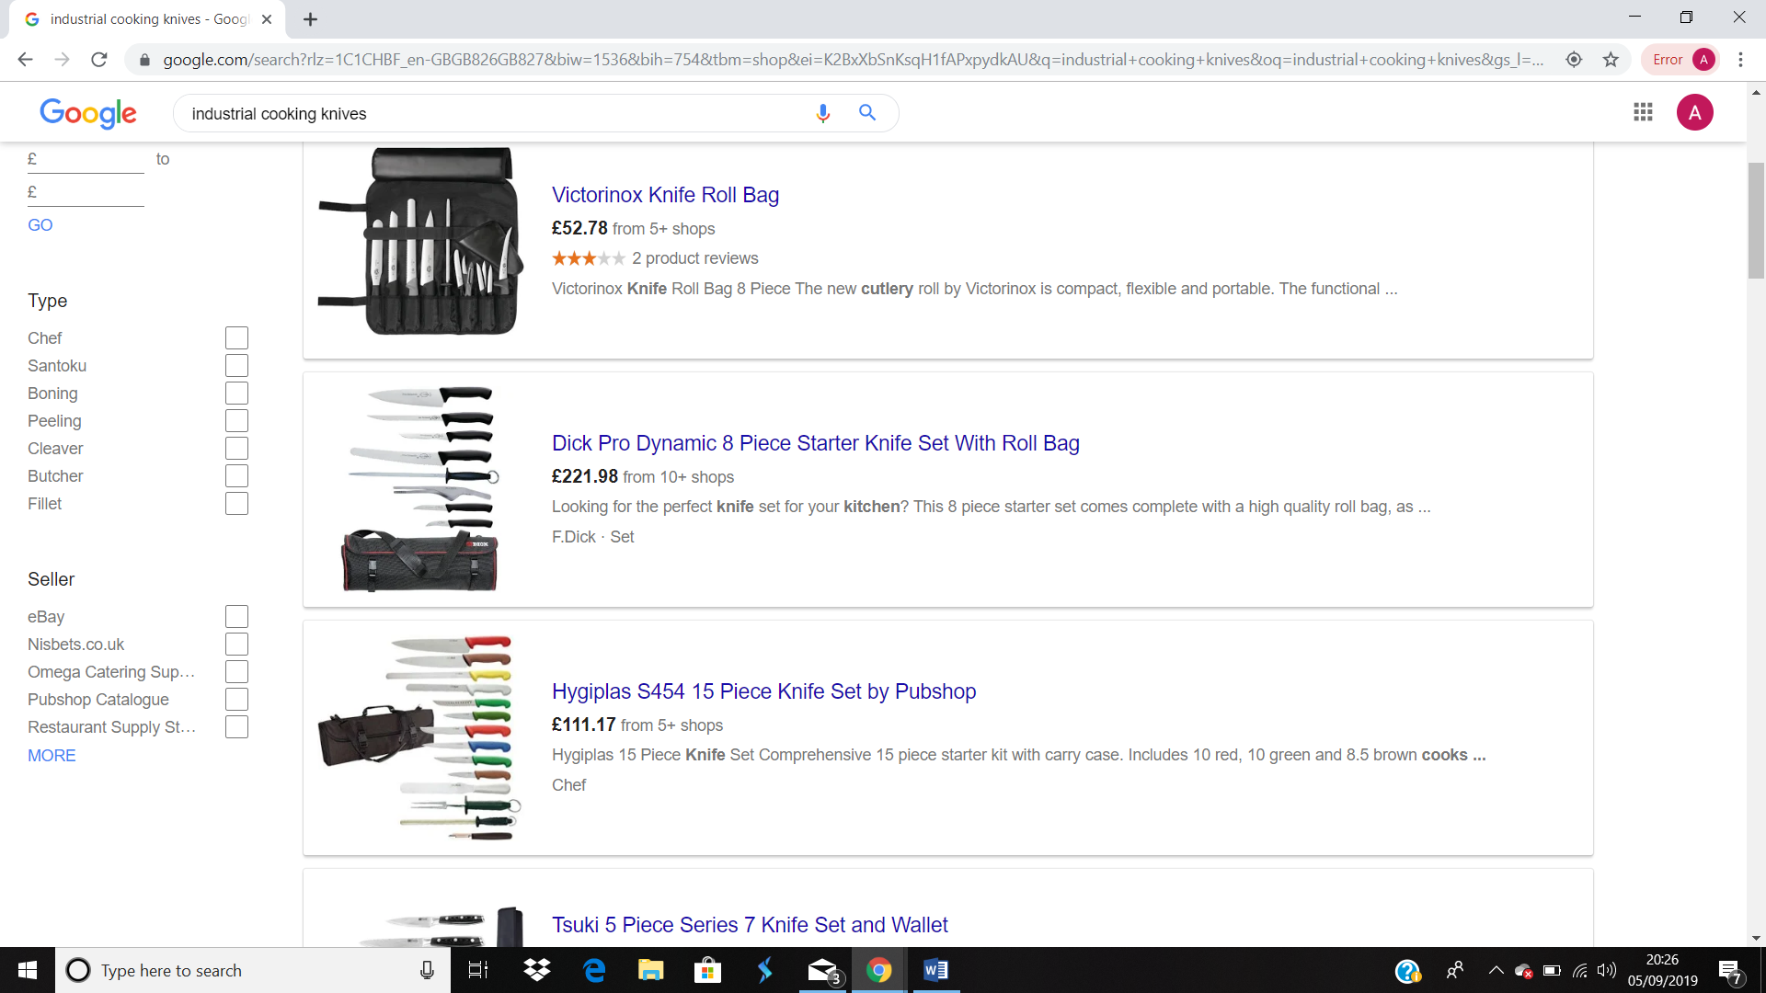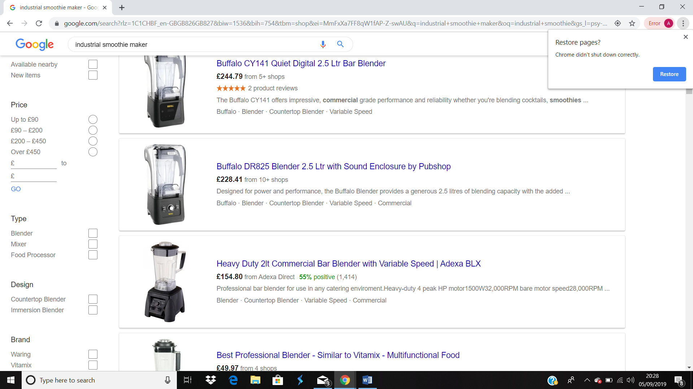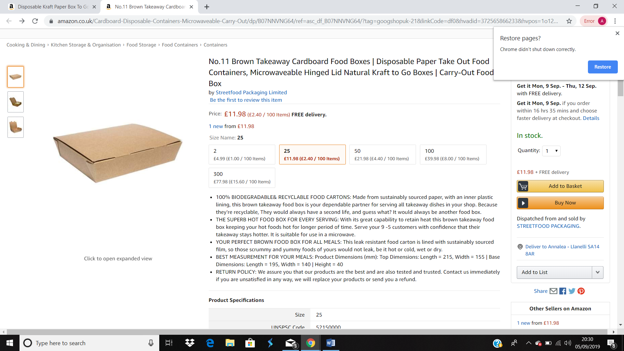

References
Kawasaki, G. (2015). The art of the start 2.0. [London]: Portfolio/Penguin.
Nutritionfacts.org. (2019). Plant-Based Diets | Health Topics | NutritionFacts.org. [online] Available at: https://nutritionfacts.org/topics/plant-based-diets/ [Accessed 8 Sep. 2019].

Mahdaoui, M. (2017). More UK workers are skipping lunch – and paying the price | Totaljobs. [online] Totaljobs. Available at: https://www.totaljobs.com/insidejob/price-lunch-breaks-research/ [Accessed 23 Aug. 2019].

Robinson, N. (2019). Eating out to grow by 83m visits next year. [online] morningadvertiser.co.uk. Available at: https://www.morningadvertiser.co.uk/Article/2017/11/15/How-many-UK-consumers-are-eating-out-in-2017-2018-and-2019 [Accessed 8 Sep. 2019].

Swansea.gov.uk. (2019). Swansea - Labour market statistics. [online] Available at: https://www.swansea.gov.uk/labourmarketstatistics [Accessed 20 Aug. 2019].
Team, M. (2019). Brits out to lunch: 76% of Brits now buy lunch out for an everyday occasion, up from 64% in 2016. [online] Mintel. Available at: https://www.mintel.com/press-centre/food-and-drink/brits-out-to-lunch-76-of-brits-now-buy-lunch-out-for-an-everyday-occasion-up-from-64-in-2016 [Accessed 20 Aug. 2019].

Veganuary. (2019). Obesity and Veganism | Veganuary. [online] Available at: https://veganuary.com/why/health/10947-2/ [Accessed 27 Aug. 2019].

Veganuary. (2019). McDonalds - Vegan Eating Out Options | Veganuary. [online] Available at: https://veganuary.com/chain_restaurants/mcdonalds [Accessed 24 Aug. 2019].

Veganuary. (2019). Subway - Vegan Eating Out Options | Veganuary. [online] Available at: https://veganuary.com/chain_restaurants/subway/ [Accessed 24 Aug. 2019].

Veganuary. (2019). Greggs - Vegan Eating Out Options | Veganuary. [online] Available at: https://veganuary.com/chain_restaurants/greggs/ [Accessed 25 Aug. 2019].

Wells, n. (2018). Oxford Study Shows Going Vegan Is The 'Single Biggest' Way To Reduce Environmental Impact - Veggie Athletic. [online] Veggie Athletic. Available at: https://www.veggieathletic.com/oxford-study-vegan-single-biggest-reduce-environmental-impact/ [Accessed 8 Sep. 2019].

Bibliography
Foreman, R. (2015). How to start a business for beginners. 2nd ed. Poland: Amazon Fulfillment.

Simmons, J. (2008). Innocent. London: Marshall Cavendish.

