Introduction to Web Development
  - Module Code No. ACCA4003
  - Module TUTUOR: Kemi Ademove
  - Ruzy Aktar 1708215 29/03/2018

Introduction
In this report I will be describing the purpose of my website and what topic I have chosen and why. Therefore, I will be outlining all the sections down below in this report in detail.

Requirements
Purpose
The purpose of this website is to target people who would like to get fit and healthy. I have created this website and made up a gym that is suitable for everyone. This website provides all the information people need to decide if they want to join. I have included affordable package deals for example if you join the gym you get free Classes and PT sessions. I know in other gyms clients have to pay for PT sessions and classes , this is why people who want to lose weight and need help do not join because it is too expensive. I knew that if I had made mine more affordable then it would target a lot more people. This is why I have made a website on this to target as many people as I can. I have notes the prices and what the gym offers to help give that motivation to people who need it.

DESIGN ELEMENTS/EVALUATION
This is the front page of my website, for the logo I have used grey background with white bold text; I decided to do this because it stands out. For the whole background page, I have made it black with white text. I have also done this because I think the information standout. My theme for this website was to make it modern. I have added a few pictures of people working out in the gym. For my heading, I have used red text because I think this goes well with black and white as well as grey.
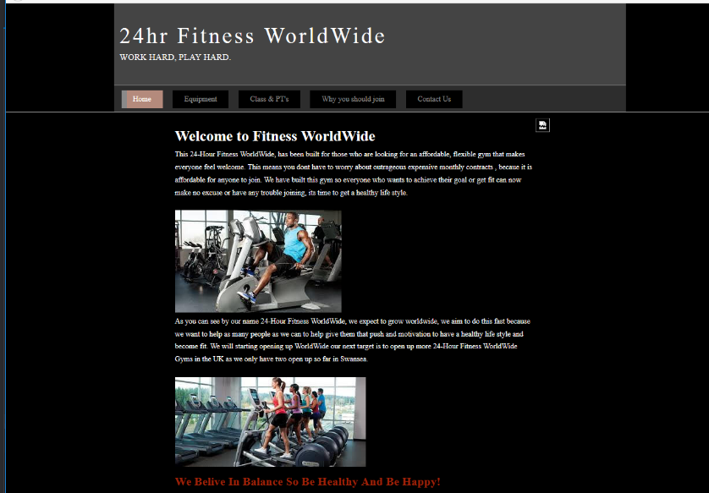

On the second page I have kept the theme same, it has modern bold colors the text color is the same as well as the background. However, on this page, I have added different pictures that are the main element because they show what equipment the gym has to offer, and these are examples of people using them. This page is called “equipment”, this page explains what type of equipment’s the gym has to offer. The website also displays how different types of equipment targets different parts of your body. I thought this was a good idea because if anyone who wants to lose weight wants to join gym it would be useful for them to know what there is for them to use to help and motivate them. In addition, to make each website tab stand out when you click on a tab it turns into a peachy brown color, I thought it would be a good idea. Below I have screenshots to prove what I have done.

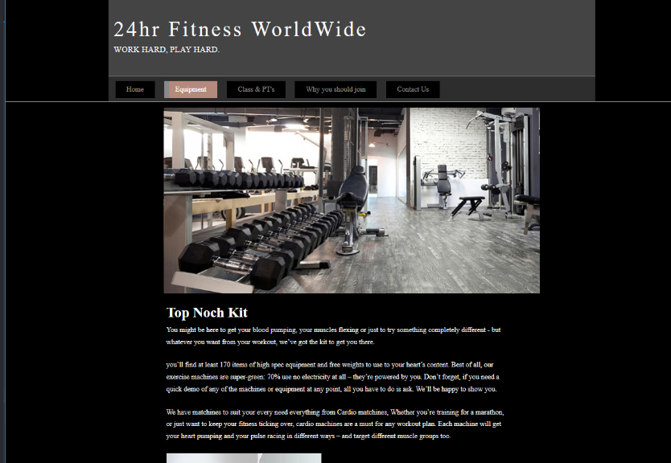

On the third, fourth page I have used the same layout, colors. Nevertheless, the only difference with each page is that I have added different images to represent the topic. Below I will provide you with screenshots to prove that I have done this.

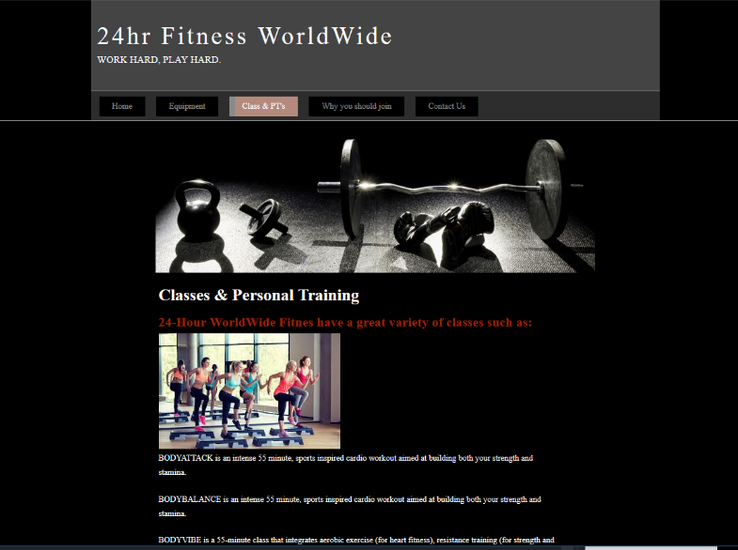

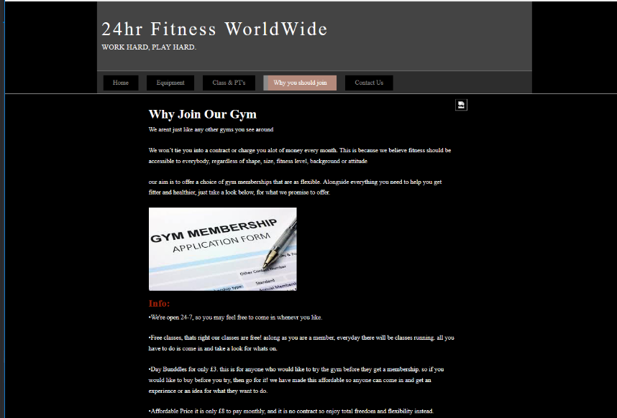

My final page is called “Contact us”, on this page, I have not added any pictures the design is still the same I have used the same colors.
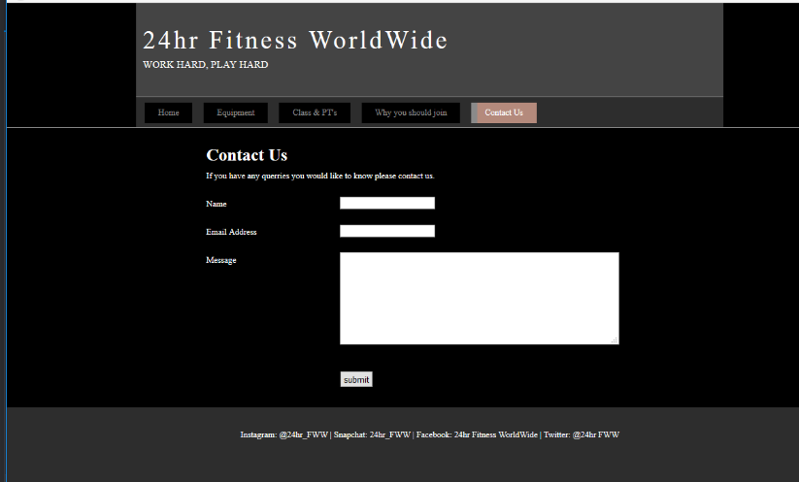

On every single page in this website below, I have added tags where you can find 24hr Fitness WorldWide on social media for more information, images, and people comments to see the progress for the gym. I thought this would be a good idea because even though I have information on the website people can go have a bigger insight to see how the gym is like and the progress people are doing.

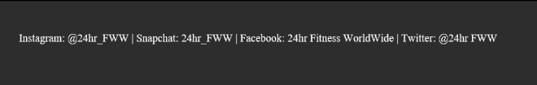

Wire frame diagram

Home page
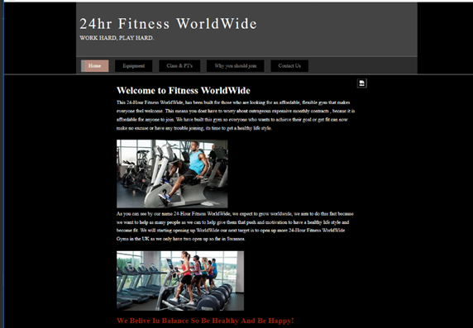
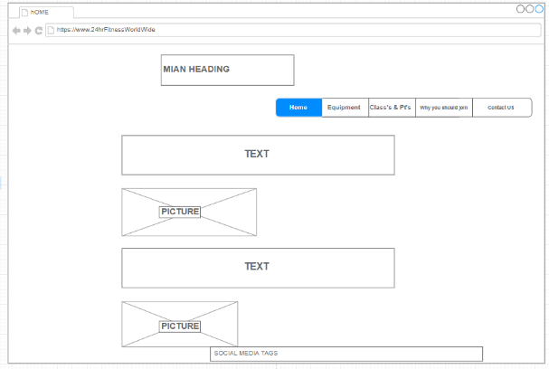

Above here, I have a screenshot of my home page and a screenshot of my wire frame diagram for my homepage. I have kept it simple and have showed the layout of where the text goes and where the pictures are placed. I have showed where my main heading is, which my logo is also. I have my menu bars on the left. Same as my actual website. Each menu link is linked with the others.
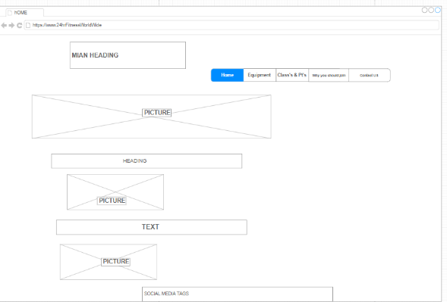
The layout of the next three pages are very same.
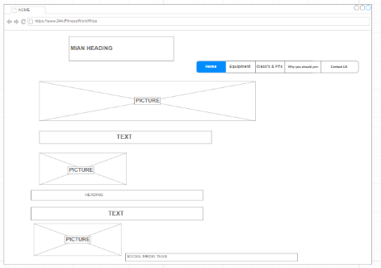
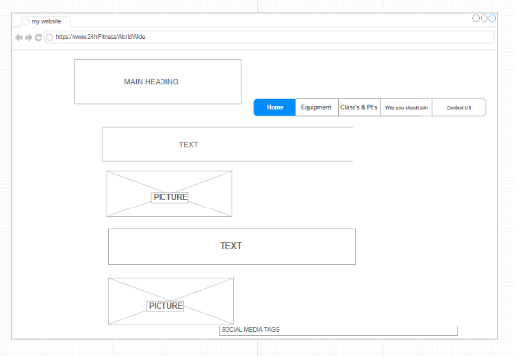
All three screenshots of the lay out are pretty much the same.

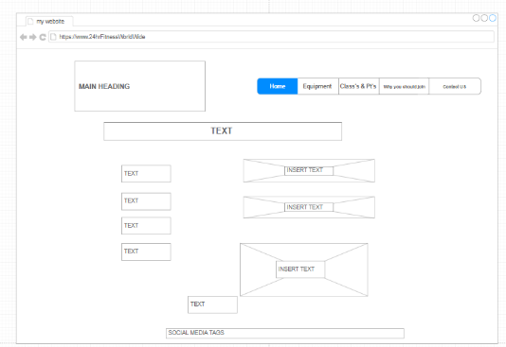
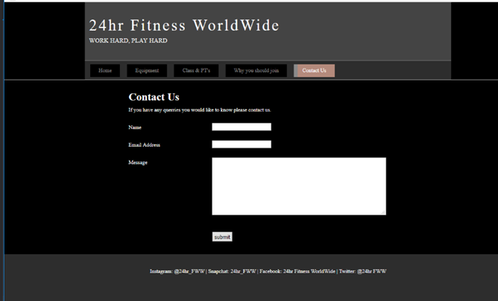

However, the fifth screenshot is different because it a comments page. The whole layout is different you have the comment boxes and the ‘Submit’ button same as the website.
If I had to make my wireframe different I would add color and more detail. However, for now I have kept it simple and straightforward.

VALIDATION
Now I will be validating my HTML and CSS code from my finished website and providing the validation results.

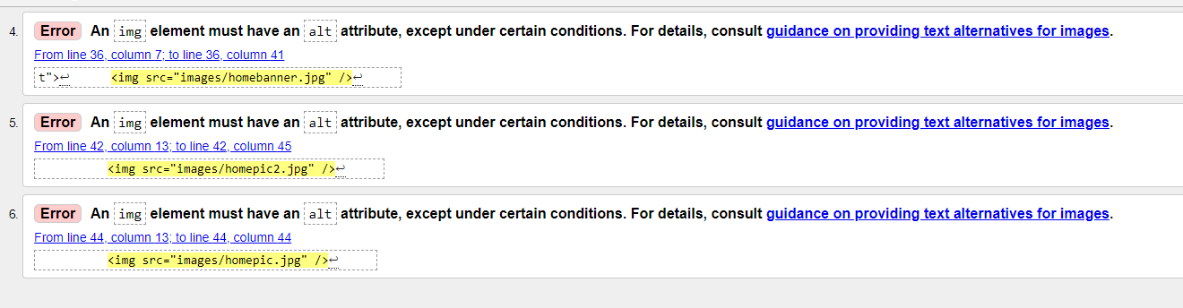

So here I discovered that there are a few Alt tag errors. To make it more accessible I have used alt tags as screen readers would be able to read these for impaired vision. An alt tag can also be a replacement of an image for when you want to save data so it doesn’t much take time either. This is very helpful for when you are on holiday. However I have fixed my errors and have added alt tags in.
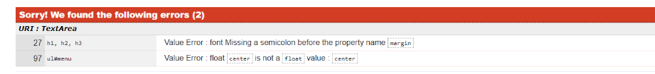
I have done the same for my CSS and have used the validating tool, I only had 2 errors a semicolon was missing which I have fixed. Another being there was no option for center. Below I have the screenshot to show what my errors were.

recommendation fro future improvements
In the future I would change my layout and make it more colorful. This is because I have used dark colors for my background and banner, such as grey and black. Next time I get a chance to make a website I will use bright colors that’s eye catching. I will also add more information and provide videos on the website that will make the website look good. I think if I do this it will look and feel more approachable to people viewing the website.

References
- https://www.thegymgroup.com/find-a-gym/swansea?gclid=Cj0KCQjwnfLVBRCxARIsAPvl82E0mQrD-owTUmwDCREGK-o-TQSq_vR2thvV7aOA88oYk3y5i7mjT5YaAr1NEALw_wcB

marking criteria and Student FEEDBACK

This section details the assessment criteria. The extent to which these are demonstrated by you determines your mark. The marks available for each criterion are shown. Lecturers will use the space provided to comment on the achievement of the task(s), including those areas in which you have performed well and areas that would benefit from development/improvement.

Common Assessment Criteria Applied (Assignment 1) | Marks available | Marks  awarded
1. Research-informed Literature
Extent of research and/or own reading, selection of credible sources, application of appropriate referencing conventions.
he reference list includes a single reference to a gym website. There is very little evidence of any research conducted for this assignment work. (Grade mark: 10.00%) | 5 | 0.5
2. Knowledge and Understanding of Subject
Extent of knowledge and understanding of concepts and underlying principles associated with the discipline.
Demonstrates an average understanding of the standards used to design and implement a website. The main area for improvement is your use of the grid system to layout and structure your content. Also take care to properly close and nest all tags and add alt attributes to all images. Also use the character set utf-8 (the <meta charset element in the head section) as this is the standard used for websites. (Grade mark: 50.00%) | 20 | 10
3. Analysis
Analysis, evaluation and synthesis; logic, argument and judgement; analytical reflection; organisation of ideas and evidence
The provided evaluation and recommendations are too brief and basic and unfortunately does not really meet the requirements of the assignment brief. (Grade mark: 15.00%) | 20 | 3
4. Practical Application and Deployment
Deployment of methods, materials, tools and techniques; application of concepts; formulation of innovative and creative solutions to solve problems.
A good attempt featuring a simple website. Well done. See your report for additional comments. (Grade mark: 50.00%) | 50 | 25
5. Skills for Professional Practice
Attributes in professional practice: individual and collaborative working; deployment of appropriate media; presentation and organisation.
The report is of average standard, but work at improving your writing style. See suggestions for additional improvements in your report. (Grade mark: 50.00%) | 5 | 2.5

Assignment Mark (Assessment marks are subject to ratification at the Exam Board. These comments and marks are to give feedback on module work and are for guidance only until they are confirmed. ) | Late Submission Penalties (tick if appropriate) |  | 41%
 | Up to one week late |  | 41%
 | 1st/2nd/3rd attempt? |  | 41%

Note that as this is a RESIT attempt, the mark is capped at 40%.

