Student number: 2305504
ECAD 7003
Part B

Targets:

Introduction
This assignment aims to critically examine the processes by which schools create their school development plans (SDPs), also known as school improvement plans (SIPs), both terms can be used. The development plan was taken from a school in South Wales and to adhere to the British Educational Research Association (BERA) ethical guidelines, the school will be referred to as School X for confidentiality (BERA, 2018). School X is located in a relatively deprived area, and currently 48% of the pupils are eligible for free school meals (FSM) (My Local School, 2024), a number that is far higher than the national average of around 20% (Palmer et al, 2021). Also, as of 2018, school X identified 38% of its pupils as having additional learning needs (ALN) (Estyn, 2018).
Whilst examining the development plan, I have identified their number one priority of improving attendance for all learners as one of interest and to investigate further. School X identifies this as a priority across the whole school but particularly in estimated FSM children, as discussed above, there is a large number of FSM children in School X. School X have chosen this as a priority as prior to the Covid-19 pandemic, attendance had increased, however since returning at the end of 2020, the attendance at the school has significantly fallen every year since and significantly fluctuates each month (see Appendix 1). Additionally, the attendance gap between FSM and non-FSM pupils is seen as significant (83.09% compared to 91.02%). It is important to note that these percentages from school X are from prior to the universal primary free school meals starting to be rolled out in Wales (Welsh Government, 2023) which entitles all children to free school meals no matter their background or financial situation.
Although the SDP is a three-year plan, School X specifically identifies targets, timeframes and ongoing reflections from September 2023 through to July 2024 and was predominantly written by the senior leadership team, however it did occasionally involve other stakeholders, including teaching staff and governors. School X identifies that it needs to further involve stakeholders to work towards improving attendance and to meet the priorities of the SDP. As attendance is such a broad topic within school development plans, this essay will particularly look at the identified objective of improving attendance specifically within pupils who are FSM pupils. It will also identify the strategy of communicating with all stakeholders as a means to improve attendance across the whole school (see Appendix 1).

Literature Review
An in-depth analysis and review of the literature surrounding SDPs indicated that there is not one simple definition of effective school development or improvement. However many researchers attempt to provide explanations as to what it means to have effective school development in both the long and short term.
According to the Welsh Government (2014), SDPs are used to strategically plan for improvement and are able to set out how different school’s will fulfil their individual different targets and priorities. The Welsh Government also state that these plans should discuss evaluation, improvement, and accountability (Welsh Government, 2022). Furthermore, SDPs should be able to identify and include resources needed or cost to the school in relation to hitting the targets they have set and include measurable objectives that line up with the goals and strategies identified (Van Gronigen et al, 2023). Although SDPs should include many different forms of information and evidence, the Welsh Government states that the main purpose of an SDP is to assist school’s in providing their learners with optimal learning experiences, opportunities, and outcomes, regardless of their situation or background (Welsh Government, 2022).
On the other hand, although SDPs are used to plan for improvement, MacGilchrist and Mortimore (1995) suggest that while SDPs can include school improvement strategies such as action plans and objectives, it is important to realise that not all SDPs will actually result in school improvement by the end of the timeframe set to meet the goals (Xaba, 2006). Although this could be seen as an outdated view as this article was published in 1995 and the way in which SDPs are designed and implemented may have changed significantly in more recent years.
During discussions with School X, it was clear that many SDPs in the local authority will have attendance in some form as a priority. Attendance at school is crucial for pupil educational attainment and academic success but the entire school context and experience holds significant value as well (Department for Education, 2023). Not only does attending school positively affect children’s social and emotional development (Heyne et al, 2019), but it also allows children access to many different opportunities and experiences that they might not always have due to socioeconomic background (OECD, 2012) which is thought to be important for social mobility in adulthood (House of Lords, 2020). Schools themselves play a vital role in attempting to improve children’s attendance, however Ofsted (2023) state that not all factors that influence attendance are within the school’s control, therefore it is necessary to look at what other influences might be affecting pupil attendance.
Absenteeism cannot be attributed to a single factor or influence, instead a combination of factors are seen to affect attendance rates (System Connecting Crae, 2023). According to System Connecting Care (2023), one of the main contributing factors is that of poverty. As discussed above and as identified in school X’s SDP, pupils who are on FSM have a much lower attendance than those who are not on FSM. This has shown to be comparable across the local authority (see Appendix 1). Estyn (2011) suggest that FSM pupils are often from a more disadvantaged background than their non-FSM peers. In addition to this, Estyn (2014) has identified that those pupils who come from a more disadvantaged background are statistically more likely than their peers to have parents or carers who are not actively involved in their education, these parents and carers are also themselves more likely to have had a negative experience of school. Furthermore, in recent years many parents and carers . This links to Bronfenbrenner’s bio ecological system theory (Bronfenbrenner, 2000) that can be used to explain how pupil’s sense of belonging in school can be linked to their parents and carers own views of schooling. This theory highlights how different factors influence a child’s development. Within this system, parents, carers, and school are all in the microsystem which is closest to the child and is believed to have the biggest influence. Therefore, the beliefs that parents and carers have around school and the importance of attending school can very easily be passed on to their children. However, on the other hand, just as caregivers can influence children’s development and behaviours, children can also affect the behaviours and beliefs of their parents and carers. These are known as bi-directional influences (Bronfenbrenner, 2000). However there are limitations to this theory in understanding the link between caregiver experiences and opinions, and child attendance as there is limited research that examines the mesosystems.
Moreover there are often cost related barriers to attendance that those from lower income or more disadvantaged backgrounds might experience. The Child Poverty Action Group (2023) has identified a number of money related barriers that can affect attendance such as cost of uniforms, needing costumes for themed days or even transport to and from school. Although these are barriers that many schools are attempting for parents and carers to overcome by introducing schemes like uniform swap shops (Welsh Government, 2023).

Action Point
The priority of attendance was introduced by School X due to a noticeable fall in attendance compared to that of before the Covid-19 pandemic. School X utilised self-evaluation in the process of writing the SDP, and involved all staff in this process. Estyn (2024) states that including all staff in the self evaluation process creates a shared understanding of the school’s improvement journey where all staff understand what the school is aiming to do and how they are aiming to do it. As stated in the school’s development plan, all teachers are aware of their responsibility to improve attendance and attendance levels are regularly shared with the governor responsible for attendance who then shares it on.
In line with this self evaluation, School X continues to evaluate attendance using the SIMS attendance trackers and to identify pupils with low attendance and persistent absences. Moreover, when pupils are identified, School X follows the All Wales Attendance Framework (Welsh Assembly Government, 2012) to communicate with parents and caregivers and to understand what process to follow.
Schools that include stake holders in decision making and also build good relationships with school families, are frequently more successful when improving their pupil’s attendance (Pijl et al, 2021). This is supported by Gorica et al (2021) who suggest that implementing good consistent communication with parents and carers plays a vital role in increasing the importance of school attendance.
Further to this, Wang and Sheikh Khalil (2014) suggest that when parents and carers are involved in different aspects within the school context, are actively involved in their child’s education and there is a good relationship between school and guardians, they are therefore modelling to their children the importance of school and their academic success. Additionally those pupils are more likely to be more motivated and have better belief in their ability to succeed. However, there are sometimes barriers to levels of parental involvement in school, the most common being that of busy work schedules of parents and carers (Berry, 2019). Although other factors such as caring for other children and even parental worries of being criticised by school staff due to their own academic levels (Hornby & Blackwell, 2018). Burtonshaw and Dorrell (2023) also suggests that when attempting to raise attendance by parental involvement, there are often times where this pushes parents and carers further away and “alienates” them and their children further.
Additional stakeholders are involved in the process of targeting pupils and families to improve attendance in School X (Appendix 1). School X works collaboratively with the education welfare officer (EWO) and the family engagement officer (FEO) regularly to identify persistent absentees and to implement action plans for pupils with the aim of improving their attendance. The use of strategies that include working with partners such as the EWO or FEO is supported by Estyn (2014) that suggest being community focused and by providing a “team around the family”, stakeholders can work together to raise attendance rates.
Although School X does not explicitly state why they might focus on improving attendance of FSM pupils, as noted in the development plan, FSM pupils are continuously at a lower attendance than their non FSM peers, and this is seen across the board within the area of School X. Research also suggests that low attendance can result in lower attainment outcomes and can even have a knock on affect on employability in later life (Dräger et al, 2023). Additionally FSM pupils are usually eligible for FSM due to their economic background, and the Welsh Government (2021) suggest that those of lower socioeconomic standing have worse outcomes in adulthood. Therefore it is vital that FSM pupils are targeted when aiming to improve attendance at school.
Although not clearly shown in the development plan, whilst in discussion with staff, the head teacher stated that there will be continuous RAG ratings (red, amber, green) used to review progress and evaluate whether the school has met the targets in the development plan. School X plans to continue utilizing a “first response approach to absences” (see Appendix 1). As well as this, when objectives and strategies are reviewed by staff, they will provide evidence of the review in the form of comments on the SDP in order to be transparent and available for all staff to view.

Reflection and Evaluation
After identifying improving attendance as a priority, School X introduced weekly attendance assemblies on Mondays to award classes for the highest attendance for the previous week. Additionally as a result of the school identifying that Friday afternoons were a low attendance day, School X introduced celebration assemblies on Friday afternoons. Celebration assemblies are seen as a positive strategy to improve attendance (H&F Council, 2021). These assemblies allow for pupils to be celebrated for a number of reasons including their weekly schoolwork and even their accomplishments outside of school such as sports clubs. School X has used self-evaluation and pupil feedback to review these assemblies and pupils stated that they enjoy and look forward to celebrating their achievements.
Additionally, there are various strategies that School X has implemented to engage with parents. This includes ensuring that clear lines of communication are established with parents and carers and stress the importance of attendance via communications such as newsletters, coffee mornings and texts to families. The importance of having open lines of communication is highlighted in Gorica et al, (2021), by using technology outreach such as the school twitter page, emails and texts, this could enhance communication with parents and carers (See et al, 2020). By enhancing communications with parents and carers, they feel more involved and as a result may be more proactive in their child’s education and promote the importance of attendance to their child. This is supported by Goodall (2017) who suggests that including parents and carers in school events and activities positively influences their children’s attendance. Furthermore School X is a rights respecting school (UNICEF, 2024), by aiming to improve attendance, this ensures that right number 28 “the right of access to education” is met for all children.
Further to this, School X is attempting to engage parents and carers in school using initiatives that are not directly linked to education. An example of this is School X is hoping to implement adult learning groups in the future such as ‘cooking on a budget’ where parents and carers themselves can learn skills that they might not have had the opportunity to do in the past. In doing so, they hope to build good relationships with pupil’s and families within the community, and as a result hope to have solid foundations in which the school and families can work together to tackle attendance issues.
Lastly, School X have also introduced breakfast club every morning for pupils. It utilises breakfast club as a way to target any pupils from disadvantaged backgrounds, whilst it is open for all pupils it is notably used as an intervention by School X to support attendance. However a future limitation to this might be cost of running. A number of school breakfast clubs have been unable to continue due to lack of funding (UK Parliament, 2023). This may be a point that School X needs to be mindful of moving forward.

Conclusions
In conclusion, SDPs are a tool used to strategically plan for improvement and are unique to each school. Furthermore, many priorities on SDPs are identified by self-evaluation within the school and many schools use learning walks and book looks to support. School X had utilised self-evaluation and these strategies to write and implement the SDP and measure impact by recording any ongoing evidence from the likes of learning walks or reviews of attendance using SIMS in the SDP for transparency. This ensures that all staff have the same understanding of what is being done in relation to the development plan and what needs to be done moving forward.
Attendance is a priority for most SDPs across the local authority as attending school is vital to pupil attainment and success (Department for Education, 2023), and as such School X has implemented many new strategies. School X attempt to involve and communicate with all stakeholders in relation to pupil attendance, and therefore are able to create a collaborative environment to improve pupil attendance and provide pupils with the support they need to maintain high aspirations and standards.
This research has helped my understanding and knowledge of including and involving parents and carers as much as possible in their child’s learning. This would contribute to me meeting the teaching standard of involving partners in learning as I now further understand how increasingly important it is to involve parents and carers in not only their child’s learning but also the child’s access to this learning such as by stressing the importance of attendance.

References
BERA. (2018). Ethical Guidelines for Educational Research. London. 4. https://www.bera.ac.uk/researchers-resources/publications/ethical-guidelines-for-educational-research-2018
Berry E. J. (2019). Barriers to Parental Involvement. Available at: https://scholarworks.umf.maine.edu/cgi/viewcontent.cgi?article=1042&context=ech_projects
Bronfenbrenner, U. (2000). Ecological Systems Theory. Oxford. Oxford University Press.
Burtonshaw, S., & Dorrell, E. (2023). Listening to, and Learning From, Parents in the Attendance Crisis. Public First. https://www.publicfirst.co.uk/wp-content/uploads/2023/09/ATTENDANCE-REPORT-V02.pdf
Child Poverty Action Group. (2023). Cost of the School Day. Available at: https://committees.parliament.uk/writtenevidence/118122/pdf/
Department for Education. (2023). Why is School Attendance so Important and What Are The Risks of Missing a Day? Gov.uk. Available at: https://educationhub.blog.gov.uk/2023/05/18/school-attendance-important-risks-missing-day/
Dräger, J., Klein, M., Sosu, E. (2023). The Long Term Consequences of Early School Absences for Educational Attainment and Labour Market Outcomes. University of Strathclyde Glasgow. https://doi.org/10.35542/osf.io/7z2bx
Estyn. (2011). Tackling Poverty and Disadvantage in Schools: Working with the Community and Other Services. Crown Copyright. https://www.estyn.gov.wales/system/files/2020-07/Tackling%2520poverty%2520and%2520disadvantage%2520in%2520schools%253A%2520%2520working%2520with%2520the%2520community%2520and%2520other%2520services%2520-%2520July%25202011.pdf
Estyn. (2014). Promoting Good Practice in Tackling Poverty and Disadvantage. Crown Copyright. https://www.estyn.gov.wales/system/files/2020-07/Promoting_good_practice_in_tackling_poverty_and_disadvantage_-_INSET_materials_for_secondary_schools_PDF_0.pdf
Estyn. (2018). A Report on (Name Withheld) Primary School.
Estyn. (2024). Including All Staff in the Self Evaluation Process. Available at: https://www.estyn.gov.wales/effective-practice/including-all-staff-self-evaluation-process
Goodall J (2017) Narrowing the Achievement Gap: Parental Engagement with Children’s Learning. Oxford: Taylor & Francis.
Gorica, P, N., Popovski, F., & Popovska, H, D. (2021). Communication Strategies for Strengthening the Parent-Teacher Relationships in the Primary Schools. International Journal of Research Studies in Education. 10. 123-134. http://dx.doi.org/10.5861/ijrse.2021.a076
H&F Council. (2021). Initiatives to Improve School Attendance. A Compilation of Ideas From H&F Council and Individual Schools. Available at: https://www.lbhf.gov.uk/sites/default/files/section_attachments/1._11._ace_initiatives_to_improve_school_attendance.pdf
Heyne, D., Gren-Landell, M., Melvin, G., Gentle-Genitty, C. (2019). Differentiation Between School Attendance Problems: Why and How? Cognitive and Behavioural Practice, 26(1). 8-34. https://doi.org/10.1016/j.cbpra.2018.03.006
Hornby G., Blackwell I. (2018). Barriers to Parental Involvement in Education: An Update. Educational Review, 70(1), 109–119. DOI: 10.1080/00131911.2018.1388612
House of Lords. (2020). Educational Opportunities for Children and Young People from Working Class Backgrounds Debate. Available at: https://researchbriefings.files.parliament.uk/documents/LLN-2020-0066/LLN-2020-0066.pdf
MacGilchrist, B & Mortimore, P. (1995). The Impact of School Development Planning in Primary Schools. Schools Effectiveness and School Improvement, 8:198-218.
My Local School, Welsh Government. (2024). (Name Withheld) Primary School.
OECD. (2012). Equity and Quality in Education: Supporting Disadvantaged Students and Schools. OECD Publishing. http://dx.doi.org/10.1787/9789264130852-en
OFSTED. (2023). Improving School Attendance. Schools and Further Education and Skills. https://educationinspection.blog.gov.uk/2023/11/16/improving-school-attendance/
Palmer, K., Brooks, L., Hedger, J. (2021). Feeding Our Future – State of the Nations Wales. Food Sense Wales. https://www.foodsensewales.org.uk/app/uploads/2021/09/Report_StateOfTheNation_Wales.pdf
Pijl, E. K., Vanneste, Y. T. M., Feron, F. J. M., Mathijssen, J. J. P., & de Rijk, A. E. (2021). Stakeholder Perspectives on Primary School Pupils and Sickness Absence - Exploring Opportunities and Challenges. Educational Review, 75(6), 1131–1149. https://doi.org/10.1080/00131911.2021.1984212
See, B, H., Gorard, S., El-Soufi, N., Lu, B., Siddiqui, N., Dong, L. (2020). A Systematic Review of the Impact of Technology-Mediated Parental Engagement on Student Outcomes. Educational Research and Evaluation, 26(3), 150-181. https://doi.org/10.1080/13803611.2021.1924791
System Connecting Care. (2023). Absences From Schools in the UK – The Key Statistics for 2023. Available at: https://www.systemc.com/knowledge-hub/blogs/absences-from-schools-in-the-uk-the-key-statistics-for-2023/#changesettings
UK Parliament. (2023). Persistent Absence and Support for Disadvantaged Pupils. Education Committee. Available at: https://publications.parliament.uk/pa/cm5803/cmselect/cmeduc/970/report.html#heading-4
UNICEF. (2024). Rights Respecting Schools. Creating Safe and Inspiring Places to Learn. Available at: https://www.unicef.org.uk/rights-respecting-schools/
Van Gronigen, B. A., Meyers, C. V., Adjei, R. A., Marianno, L., & Charris, L. (2023). The Design and Characteristics of School Improvement Plan Templates. AERA Open, 9. https://doi.org/10.1177/23328584231168378
Wang M. T., Sheikh-Khalil S. (2014). Does Parental Involvement Matter for Student Achievement and Mental Health in High School? Child Development, 85(2), 610–625. https://doi.org/10.1111/cdev.12153
Welsh Assembly Government. (2012). All Wales Attendance Framework. Young Wales. https://www.gov.wales/sites/default/files/publications/2018-03/all-wales-attendance-framework.pdf
Welsh Government. (2014). Guidance. School Development Plans. Available at: https://www.gov.wales/sites/default/files/publications/2018-03/school-development-plans.pdf
Welsh Government. (2021). A Review of Evidence on Socioeconomic Disadvantage and Inequalities of Outcome. Available at: https://www.gov.wales/sites/default/files/pdf-versions/2021/10/1/1635166770/review-evidence-socio-economic-disadvantage-and-inequalities-outcome-summary.pdf
Welsh Government. (2023). Guidance. School Uniform Exchange and Recycling Schemes. Available at: https://www.gov.wales/school-uniform-exchange-and-recycling-schemes
Welsh Government. (2023). Guidance. Universal Primary Free School Meals (UPFSM). Available at: https://www.gov.wales/universal-primary-free-school-meals-upfsm
Welsh Government. 2022. School Improvement Guidance: Framework for Evaluation, Improvement and Accountability. Available at: https://hwb.gov.wales/evaluation-improvement-and-accountability/school-improvement-guidance-framework-for-evaluation-improvement-and-accountability
Xaba, M. (2006). The Difficulties of School Development Planning. South African Journal of Education, 26(1). 15-26. https://files.eric.ed.gov/fulltext/EJ1150352.pdf

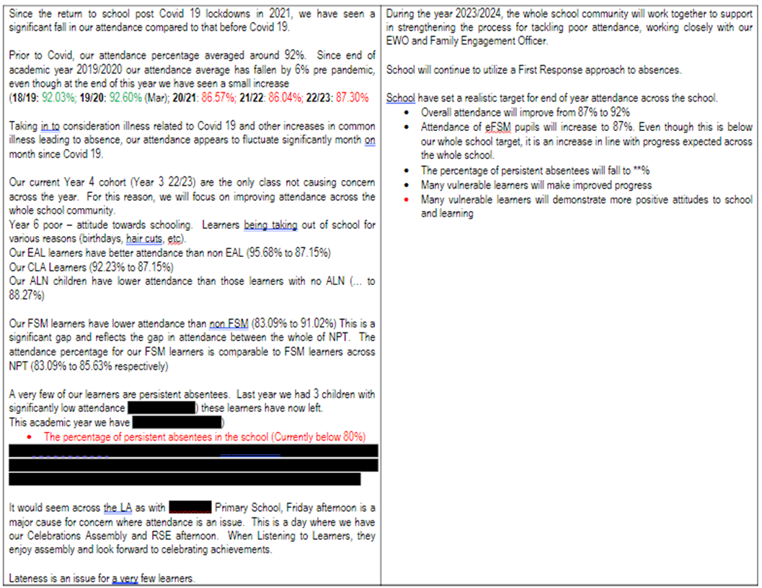
Appendix 1.


