Cyber Security (ACCA4024)
Daniel Jones

Contents
1. Introduction 3
2. Identification of Modern Threats 4
3. Modern Security Policies 5
4. Technical Mitigation Measures 6
5. Monitoring and Incident Response 7
6. Training and Awareness 8
7. Conclusion 9
8. References 10

1. Introduction
Cybercrime is becoming a growing threat to businesses and organisation with attacks becoming more targeted and powerful due to the assistance of AI [1]. The reason for these attacks could be to obtain financial details, steal personal data or even disrupt infrastructure to deny services [2]. In times where cyber-attacks are evolving and becoming more and more threatening for businesses of all sizes shows the importance of making systems secure and defendable against such attacks [1]. The aim of this report is to present a strategic, evidence-based plan for transitioning an organisation like Vigilant Trust & Asset Management to a Zero Trust security approach.

2. Identification of Modern Threats

VTAM seems to be facing a rapidly evolving threat landscape as cyber-attacks are evolving with more and more forms of attacks that affect individuals and large businesses [3]. This section hopes to present and explain potential common threats that have great affect on organisation such as VTAM.
Ransomware as a service RaaS is a form of business model that has industrialized extortion by selling professional ransomware programs to malicious users. Ransomware is a common threat, and this model only proliferates the issue [4].
AI-powered social engineering is a form of social engineering with the use of ai software that helps enhance the attack. With the use of ai attacks are now becoming more personalized, effective and scalable [5]. Experts begin to say that ai-based bot could potentially create perfect phishing messages tailored for specific targets [6].
Supply chain attack is a common attack where a compromised vendor and their product be that hardware or software they sell is breached and when sold to an organisation like VTAM it could further breach and compromise their systems [7].
Cloud adoption / Hybrid Work are both widely used in most organizations in the modern day however these methods have risks to them that unless managed properly could threaten an organization. Hybrid work means that employees can work from home or in other public spaces which could certainly be convenient however it has the potential to increase the attack surface and present more vulnerabilities for an attacker to exploit [8]. With the use of cloud computing businesses can become more organized but unless the correct measures and configurations are setup data breaches can be both common and devasted for said businesses [9]

3. Modern Security Policies

This section will present modern security policies that should be used to create a secure environment for organisation and businesses to adopt and use. The following polices will be based on the Zero Trust model that focuses on resource protection and that trust should never be granted without verification [10]. They should all align with best practice standards of NIST CSF and CISA [11] [12].
Identity & Authentication Policy requires the use of strong authentication and the implementation of identity validation for applications and devices [11] [13].
Least Privilege Access Policy is used to ensures that user accounts and systems are only provided the minimum privileges necessary [13].
Continuous Monitoring & Verification Policy is implemented to evaluate access to devices, applications and user accounts by in real time administrators to enforce systems and ensure any suspicious access can be adjusted or even revoked quickly [11] [13].
Network Segmentation divides networks into multiple smaller zones to help contain threats that have breached one network from affecting the other divided networks [13].
Data Protection Policy focuses on protecting information through the use of encryption, strict access controls and monitoring traffic flow [13].
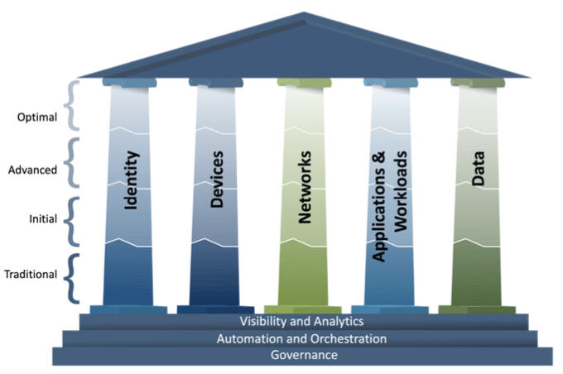
Figure 1: CISA Zero Trust Maturity Model [14]

4. Technical Mitigation Measures

To mitigate threats, businesses and organizations need to begin adopting advanced technical security measures to safeguard digital assets and sensitive data from the evolving cyber threats of current digital age. The following sections below should help provide the mitigation needed for businesses to keep secure [15].
Multi-Factor Authentication is a security measure that requires users to authorize their access by either requiring them to enter a password, a security key or even potentially a biometric information such as a fingerprint [15].
Security Information and Event Management is a security solution that provides an in-depth overview of a organisations security posture by granting the ability to detect, investigate and respond swiftly to incidents [16] [17].
Cloud Security Posture Management allows for continuous monitoring of cloud-based environments for any misconfigurations. It assists with identifying risks by automating visibility allowing for uninterrupted monitoring, threat detection and efficient misconfiguration fixes [18].
Endpoint Detection and Response is a highly important measure as endpoints are always the first thing to be attacked in a cyber-attack. By installing EDR agents on all devices a security administrator could monitor behaviour, detect malware and isolate any compromised systems automatically [15].
Combining the measures detailed above should ensure a layered defence strategy that hopefully reduces risks from cyber threats while improving detection and security overall.

5. Monitoring and Incident Response

As mentioned in previous sections 24/7 monitoring, threat detection and rapid incident response are all integral with maintaining protection for organisations against the rising threat of cyber-attacks. The use of integrated tools such as SIEM and SOAR can help provide businesses with security it needs [16] [17] [19]. Below is an outlined plan to setup a system with 24/7 monitoring, threat detection and threat response.
- Centralize Logs – deploy a SIEM platform that will allow for the collection of centralized logs from endpoints, network, cloud and applications [17].
- Create Detection Rules – define and create rules that respond to known threats such as suspected breach activity and misconfigured endpoints [20]
- Enable 24/7 Monitoring – Implement a security operations centre (SOC) to maintain 24/7 monitoring for sings of known exploits and suspicious activity [21].
- Automate Alert Enrichment – deploy a SOAR platform to automate low-level, time-consuming tasks such as alerts prioritization [19].
- Orchestrate Response Playbooks – build a SOAR playbook to create predefined security procedures to deal with common threats [19].
- Continuously Improve – work on improving security by holding post-incident reviews, update procedures and playbooks can help uncover and strengthen weaknesses [22].
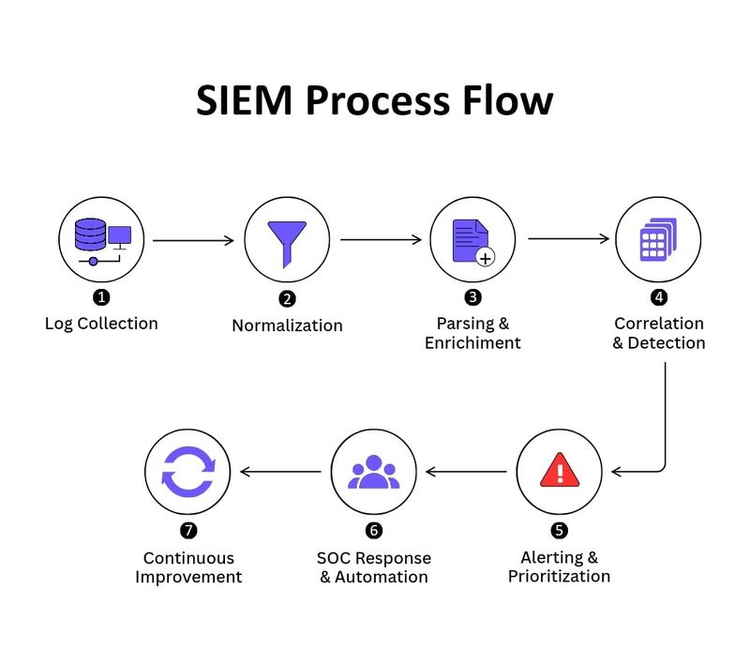
Figure 2: SIEM Process Flow [26]

6. Training and Awareness

To create and effective security training program for employees of an organization to be aware and stay alert of popular cyber-attacks such as phishing emails and vishing the program has to be continuous, engaging such as videos or scenario-based exercises to keep interest and improve retention of knowledge [23] [24].
The key components of the program should cover ways to defend yourself against phishing, using strong passwords, securing your devices and finally reporting any incidents that might have occurred. These key areas can be applied to an organisation no matter the size of the business or the type of business it is [25].
Below is a helpful infographic from the National Cyber Security Centre that should present the information needed for employees to stay alert against cyber threats.

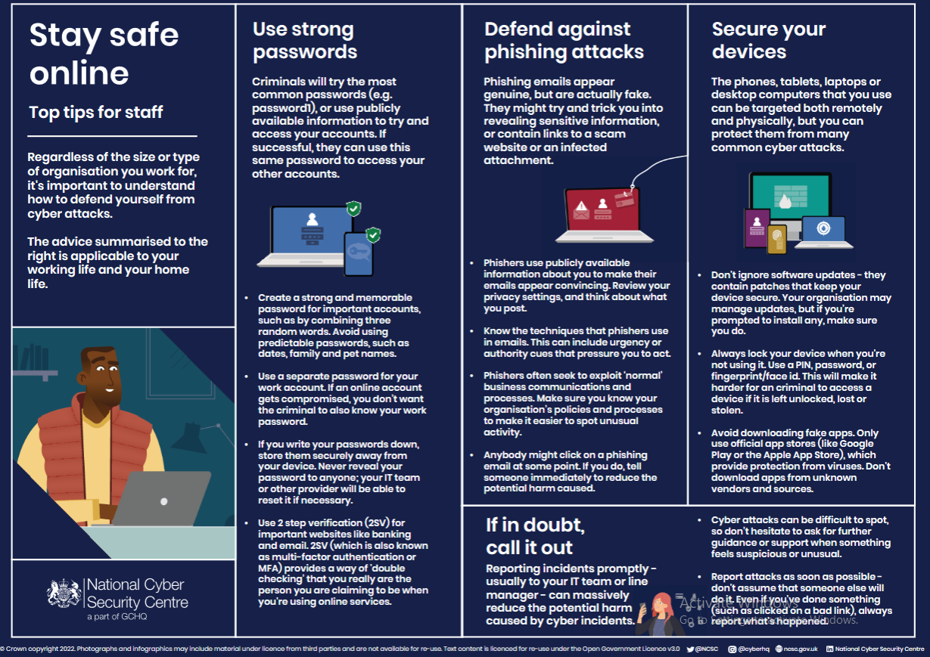
Figure 3: Stay Safe Online [25]

7. Conclusion

In conclusion it seems with the rising threats of cyber-attacks with the enhancement of ai its essential for organisations such as VTAM to increase the security to protect themselves and their assets. Through the use of adopting the zero-trust architecture, that combines a wide range of security policies (Least Privilege, Continuous Verification) with technical mitigation measures (MFA, EDR, CSPM) and the use of 24/7 monitoring through tools like SIEM and SOAR an organisation such as VTAM can hopeful secure itself from modern attacks. However, it seems the most important protection measure for an organisation is employee training which transforms security from just a static defence to a dynamic one that can protect assets and integrity in the face of evolving attacks.

8. References

[1] | R. Wilson, “Protect your business from growing threat of cybercrime in 2026,” 25 February 2026. [Online]. Available: https://www.armstrongwatson.co.uk/news/2026/02/protect-your-business-growing-threat-cybercrime-2025. [Accessed 22 April 2026].
[2] | NI Business Info, “Cyber security for business,” [Online]. Available: https://www.nibusinessinfo.co.uk/content/reasons-behind-cyber-attacks. [Accessed 22 April 2026].
[3] | CISA, “Malware, Phishing, and Ransomware,” [Online]. Available: https://www.cisa.gov/topics/cyber-threats-and-advisories/malware-phishing-and-ransomware. [Accessed 25 April 2026].
[4] | Jim Holdsworth (IBM Think), “What is ransomware as a service (RaaS)?,” [Online]. Available: https://www.ibm.com/think/topics/ransomware-as-a-service#1238298323. [Accessed 25 April 2026].
[5] | Lucia Stanham, “Social Engineering and AI,” 6 May 2025. [Online]. Available: https://www.crowdstrike.com/en-us/cybersecurity-101/social-engineering/ai-social-engineering/. [Accessed 25 April 2026].
[6] | Matthew Kosinski, Stephanie Carruthers, “With generative AI, social engineering gets more dangerous—and harder to spot,” IBM, [Online]. Available: https://www.ibm.com/think/insights/generative-ai-social-engineering. [Accessed 25 April 2026].
[7] | ICO, “Supply chain attacks,” [Online]. Available: https://ico.org.uk/about-the-ico/research-reports-impact-and-evaluation/research-and-reports/learning-from-the-mistakes-of-others-a-retrospective-review/supply-chain-attacks/. [Accessed 25 April 2026].
[8] | S. Harris, “Hybrid work, hybrid threats: securing your workers in a changing landscape,” 15 January 2025. [Online]. Available: https://www.orange-business.com/en/blogs/hybrid-work-hybrid-threats-securing-your-workers-changing-landscape. [Accessed 25 April 2026].
[9] | University of York, “Cloud computing: security risks and security measures,” [Online]. Available: https://online.york.ac.uk/resources/cloud-computing-security-risks-and-security-measures/. [Accessed 25 April 2026].
[10] | O. B. S. M. S. C. Scott Rose, “Zero Trust Architecture,” NIST Special Publication 800-207, 2020.
[11] | NIST, “Cybersecurity Framework (CSF) Overview,” The NIST Cybersecurity, 2024.
[12] | CISA, “Known Exploited Vulnerabilities Catalog,” [Online]. Available: https://www.cisa.gov/known-exploited-vulnerabilities-catalog. [Accessed 28 April 2026].
[13] | Cisco, “Framework Mapping: Cisco Identity Services Engine + CISA Zero Trust Model White Paper,” 12 December 2025. [Online]. Available: https://www.cisco.com/c/en/us/solutions/collateral/security/zero-trust/cise-cisa-zero-trust-wp.html. [Accessed 28 April 2026].
[14] | CISA, “Zero Trust Maturity Model,” 2023.
[15] | SentinelOne, “Mitigation Strategies to Combat Evolving Cyber Threats,” 5 August 2025. [Online]. Available: https://www.sentinelone.com/cybersecurity-101/cybersecurity/mitigation-strategies/. [Accessed 28 April 2026].
[16] | Microsoft, “What is SIEM?,” [Online]. Available: https://www.microsoft.com/en-us/security/business/security-101/what-is-siem. [Accessed 28 April 2026].
[17] | IBM, “What is SIEM?,” [Online]. Available: https://www.ibm.com/think/topics/siem. [Accessed 28 April 2026].
[18] | Microsoft, “What is CSPM?,” [Online]. Available: https://www.microsoft.com/en-gb/security/business/security-101/what-is-cspm. [Accessed 28 April 2026].
[19] | IBM, “What is SOAR (security orchestration, automation and response)?,” [Online]. Available: https://www.ibm.com/think/topics/security-orchestration-automation-response. [Accessed 28 April 2026].
[20] | Microsoft, “Create custom detection rules,” [Online]. Available: https://learn.microsoft.com/en-us/defender-xdr/custom-detection-rules. [Accessed 29 April 2026].
[21] | IBM, “What a security operations center (SOC) does,” [Online]. Available: https://www.ibm.com/think/topics/security-operations-center. [Accessed 29 April 2026].
[22] | CyberReason, “Post-Incident Review,” [Online]. Available: https://www.cybereason.com/resources/post-incident-review. [Accessed 29 April 2026].
[23] | Sectricity Security Team, “Security Awareness Training: Why It Matters and How to Build a Programme That Works,” 3 March 2026. [Online]. Available: https://sectricity.com/blog/security-awareness-training-guide. [Accessed 29 April 2026].
[24] | R. A. D. O. L. N. T. Rebeka Toth, “Sustaining Cyber Awareness: The Long-Term Impact of Continuous Phishing Training and Emotional Triggers,” 31 October 2025. [Online]. Available: https://arxiv.org/abs/2510.27298. [Accessed 29 April 2026].
[25] | NCSC, “NCSC's cyber security training for staff now available,” [Online]. Available: https://www.ncsc.gov.uk/blog-post/ncsc-cyber-security-training-for-staff-now-available. [Accessed 29 April 2026].
[26] | S. TCHUINTE, “Understanding the SIEM Process Flow Diagram,” 2025. [Online]. Available: https://www.linkedin.com/posts/senghor-tchuinte_cybersecurity-siem-infosec-activity-7381347188842323968-YLRV. [Accessed 29 April 2026].

