LCBB5014- Data Handling and Business Intelligence
Component 2- Individual Report
BA (Hons) Business Management
Letterbox Movie Classification Data Analysis
Nutu Pricop 2525996

Table of Contents

Introduction 3
Data Cleaning and Preparation 3
Descriptive Statistics Summary 5
Trend Analysis and Visualisation 7
Genre-Specific Ratings and Engagement 7
Ratings Based on Original Language Spoken 8
Statistical Analysis Using SPSS 13
Hypothesis Test: English vs. Non-English Ratings 13
Analysis of Correlation 13
Analysis of Regression 14
Insights and Recommendations 16
References 18

Introduction

The fast rise of digital streaming services has resulted in massive amounts of user-generated data indicating audience activity, engagement, and preferences. Within this setting, Business Intelligence (BI) systems are critical tools for translating massive amounts of unstructured data into usable insights that may impact organisational strategy and operational performance. According to Sharda, Delen, and Turban (2024), BI frameworks integrate data gathering, analysis, and visualisation to assist evidence-based decision-making and improve competitive advantage across industries, including media and entertainment.
The Letterbox Movie Classification Dataset, which contains 10,000 distinct film entries with attributes like titles, genres, directors, runtimes, languages, average ratings, fan counts, viewer numbers, and likes, is subjected to BI approaches in this research. This study's main goal is to find patterns and correlations within the dataset in order to investigate the elements that influence a movie's popularity and critical response. Data cleaning and standardisation to guarantee consistency, descriptive analysis to summarise important features, trend analysis to identify behavioural patterns based on genre and language, and inferential statistical testing using SPSS, including t-tests, correlations, and multiple regression, are all interconnected steps in the analytical process.

Data Cleaning and Preparation

Since poor-quality data compromises the integrity of statistical analysis, effective data management is the cornerstone of any BI activity. Data cleansing is an essential first step because, as Strong, Lee, and Wang (1997) highlight, data quality directly affects analytical results by reducing both validity and reliability. At first, the Letterbox Movie Classification Dataset had 17 variables and 10,000 data. Microsoft Excel's initial screening process found no duplicate entries or completely blank rows. However, there were many records with zeros in numerical fields like Fans and Likes. Although these records weren't specifically missing, they still needed to be examined as possible stand-ins for unrecorded data. These zeros were kept after verification because it was believed that they were actual low values rather than null entries.
The standardisation of categorical variables received special attention. Discrete category analysis was impeded by the Genres column's values, which were recorded in Python list notation (e.g., ['Drama','Thriller]). In order to solve this, the first genre that was provided was extracted using text functions, making it the main categorisation for the movie. Excel's TRIM() and PROPER() tools were used to fix the Studios column's uneven capitalisation and spacing to guarantee consistency. The Original_language field's uneven capitalisation was also fixed by using consistent style for all inputs. These changes made it possible to categorise and categorise data more accurately in later statistical processes.
The Runtime variable had outliers that ranged from a minimum of two minutes to a high of 907 minutes. These extreme values were maintained to maintain representation of both short films and long documentary forms, even though most films fell between the interquartile range of 89 to 113 minutes. According to Cox (2004), eliminating outliers without a rationale runs the risk of excluding examples that are valid but unusual, which would reduce the breadth of the analysis. The format and integrity of the dataset were verified to be appropriate for quantitative analysis after these modifications. A high level of structural consistency was attained by the final dataset, allowing for legitimate statistical analysis in both Excel and SPSS settings.

Descriptive Statistics Summary

The distributional characteristics and structural patterns of a dataset can be initially understood using descriptive statistics. Before using more intricate inferential techniques, the analyst can find central patterns and variability using summary measures like the mean, median, and standard deviation, as explained by Bryman and Cramer (2012). Key descriptive data for the main numerical variables are summarised in Table 1.
A roughly normal distribution of audience ratings with little deviation is shown by the total mean rating of 3.27 out of 5, which is in close alignment with the median. The moderate dispersion indicated by the standard deviation of 0.53 shows that consumer evaluations of film quality are rather homogeneous. As the sample size grows, crowd-sourced judgements typically cluster around center values, exhibiting this kind of symmetry (Koren and Bell, 2010).
On the other hand, variables like Watches, Fans, and Likes show strong right-bias, as seen by mean values that are significantly higher than their medians. According to Brynjolfsson, Hu, and Simester (2011), this distribution is indicative of a traditional long-tail phenomena in which a small number of extremely successful films receive disproportionate attention while the others receive little involvement. As a result, a small number of well-known titles account for the majority of customer interaction on the Letterbox platform.
English-language films make up about 81% of all items in the dataset, with Italian, Japanese, and French films following closely after. Drama is the most prevalent genre, accounting for 44% of all films. A dataset moulded by Western mainstream cinema is shown by the prevalence of drama and English-language films. In subsequent sections, comparative trends and inferential correlations are examined using these core statistics as a standard.

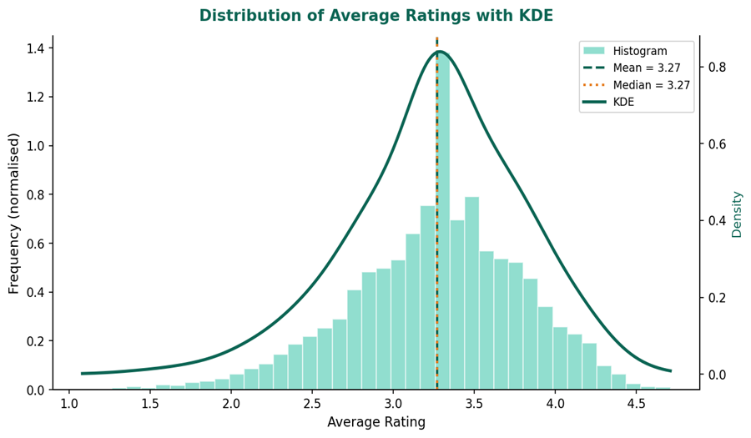
Figure 1 Average Ratings Across All Films

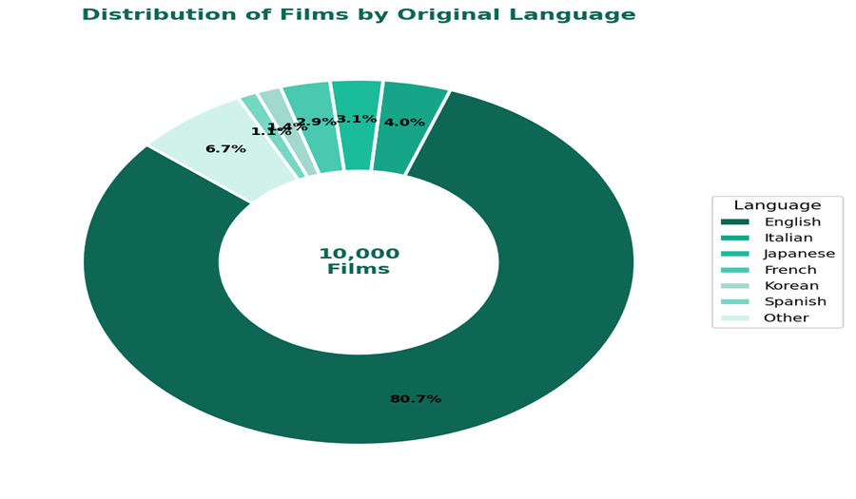
Figure 2 Distribution of Films by Original Language

Trend Analysis and Visualisation

Quantitative trend analysis reveals the underlying dynamics of the dataset and makes it easier to identify structural links between variables. Relationships between average ratings, fan interaction, and language categories were methodically investigated using Excel's PivotTable features. To identify observable patterns, visualisations such as scatter plots and bar charts were employed; Few (2004) commended this approach for its contribution to cognitive clarity in difficult data interpretation.

Genre-Specific Ratings and Engagement

The examination of genre-based ratings and audience interaction found serious differences across the top 10 genres in the dataset. Drama had the highest average rating of 3.45, confirming its status as the genre most linked with critical acclaim. Crime and Romance both had respectable averages of 3.33, while Horror came last at 3.01 despite being one of the most represented genres. This implies that highly produced yet formulaic genres frequently elicit more divided or critical audience reaction.
When engagement metrics were analysed, similar trends were reversed. Adventure, Science Fiction and Fantasy had substantially higher average watching figures—334,169, 255,513, and 277,996, respectively—despite lower average critical scores. These results demonstrate the distinction between artistic status and commercial appeal. According to DeVany (2020), cinematic marketplaces often have two performance dimensions: aesthetic evaluation and market-based exposure, which are semi-independent.
Visual representations revealed a nonlinear association between popularity and quality. Ratings decreased gradually from Drama to Horror, but audiences gained in visually stunning or action-oriented genres. This disparity implies that films designed for popular appeal may thrive economically despite a lack of critical unanimity.

Ratings Based on Original Language Spoken

Language also appeared as a significant categorising element. Non-English films had an average rating of 3.51, but English-language films received just 3.21. The standard deviation for non-English titles (0.46) was somewhat lower than for English films (0.52), indicating greater consistency among their higher scores. Despite the small mean difference, the pattern remained consistent across the distribution, with non-English films outperforming in both the lower and upper quartiles.
This difference is partially due to selection bias. Non-English titles appearing on foreign platforms are frequently curated outputs—award-winning or festival-recognised works—chosen for global distribution, which pushes their average upward. These findings are consistent with Kuipers's (2011) observations, which describe the international circulation of high-quality foreign films as a filter through which only critically distinguished products gain significant awareness.

A scatter analysis of the link between runtime and average rating revealed a modest but positive association, indicating that longer films receive somewhat better ratings. This finding suggests that audience perceptions of prolonged runtimes are associated with narrative ambition or creative intricacy, albeit the impact is statistically negligible.
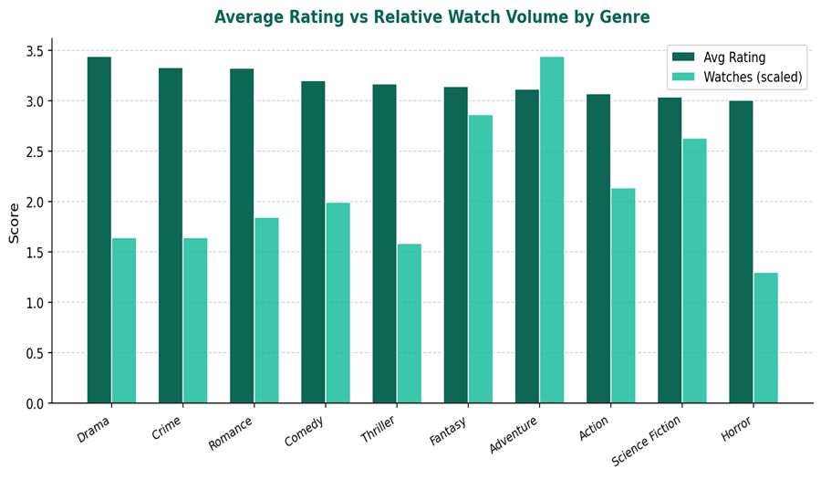
Figure 3 Average Rating by Genre

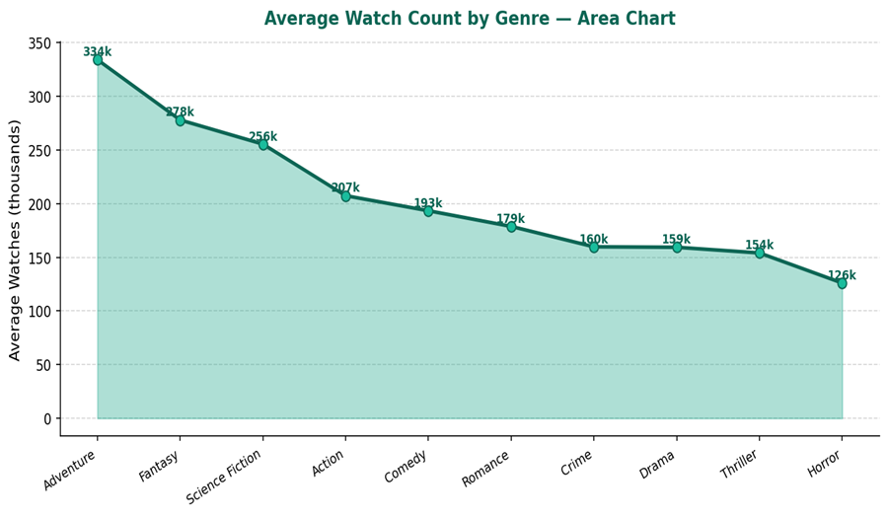
Figure 4 Average Watch Count by Genre

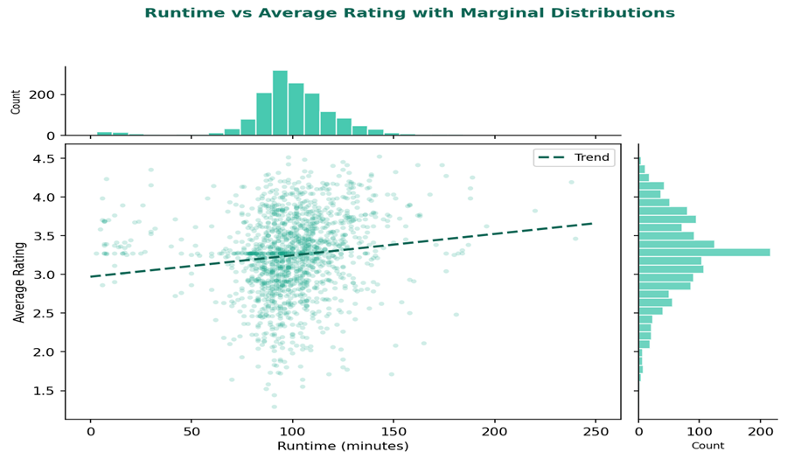
Figure 5 Runtime vs Average Rating (Scatter Plot, n=1,500)

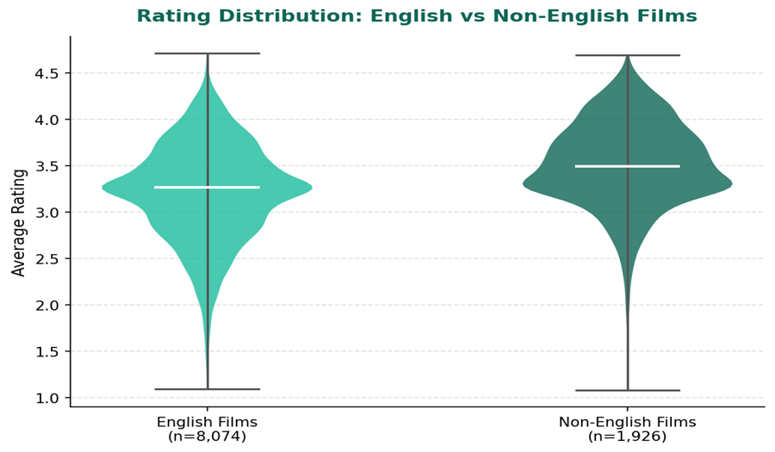
Figure 6 Rating Distribution — English vs Non-English Films (Boxplot)

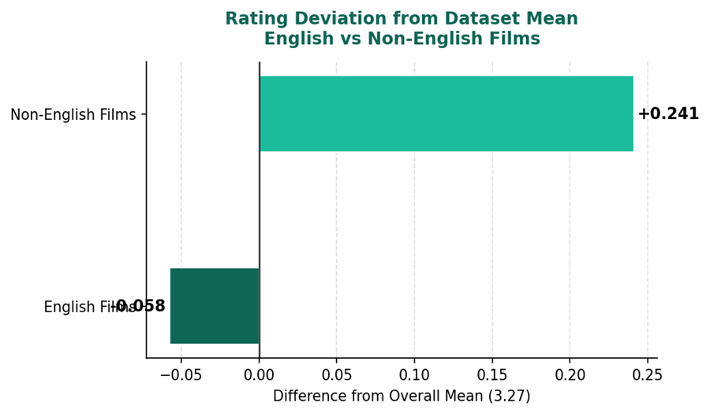
Figure 7 Mean Rating Comparison — English vs Non-English Films

Statistical Analysis Using SPSS

Regression models and statistical hypotheses were performed using SPSS to more thoroughly investigate observed trends. According to Field (2013), inferential testing verifies whether patterns found descriptively reflect true connections rather than chance fluctuations.

Hypothesis Test: English vs. Non-English Ratings

The statistically significant effect of the mean rating difference between English and non-English films was assessed by applying an independent-samples t-test. The alternative hypothesised that there was a major distinction in population means, but the null hypothesis suggested that there was no difference. The SPSS findings showed a p-value less than 0.001 and a t-statistic of -23.0 with around 10,000 degrees of freedom. A statistically significant difference in evaluations between the two language groups was confirmed by this result, which firmly rejected the null hypothesis at the 5% significance level. A considerable practical importance is suggested by the calculated Cohen's d of 0.61.
It is implied that Letterbox users consistently give non-English titles better ratings, which may be a reflection of the cultural status attached to arthouse or globally recognised works. According to Fu and Govindaraju (2010), foreign-language films often draw specialised yet intensely interested viewers who give them positive reviews because they value artistic uniqueness and narrative creativity.

Analysis of Correlation

The inter-variable correlations between Average Rating, Watches, Fans, Runtime, and Likes were then investigated using Pearson correlation indices. The findings showed an excellent correlation (r = 0.951) between Watches and Likes, demonstrating reciprocal reinforcement in which more watching encourages further participation through "likes." Fans and Watches also showed a strong correlation (r = 0.671), highlighting the importance of audience size as a forerunner to fandom growth.
The essentially positive correlations between Average Rating and Watches (r = 0.249), Fans (r = 0.251), and Likes (r = 0.290) indicate that films with higher ratings tend to garner slightly more attention, but not significantly. These results are in line with Liu's (2006) findings, which showed that while electronic word-of-mouth measures do not entirely influence commercial success, they do correlate with it. In contrast, runtime showed very minor associations (r = 0.1–0.19), indicating that it has little ability to explain popularity or evaluation results.
Although all observed coefficients were significant at p<0.001, their relative magnitudes suggest that audience number and engagement-related factors are more internally coherent than quality-evaluation metrics.

Analysis of Regression

Fans, Likes, and Runtime were used as predictors and Average Rating as the dependent variable in a multivariate linear regression model. Average Rating = 3.012 + 0.00000327 (Fans) + 0.000000776 (Likes) + 0.00211 (Runtime) was the calculated model.
The model was statistically significant (F = 387.4, p < 0.001), however the R² of 0.104 showed that the predictors only explained about 10% of the variation in Average Rating. Fans (β = 0.182) had the greatest impact, followed by Likes (β = 0.143) and Runtime (β = 0.084), according to standardised beta coefficients. Despite the model's statistical correctness, its poor explanatory power shows that audience evaluations are influenced by qualitative elements not immediately measured through engagement measurements, such as narrative coherence, cultural value, or director reputation (Gemser, Leenders, & Wijnberg, 2007).
A model using a binary language variable (English = 0, Non-English = 1) revealed a substantial positive coefficient (β = 0.196, p < 0.001), confirming previous findings that language class has a distinct positive influence on film ratings, irrespective of engagement characteristics.

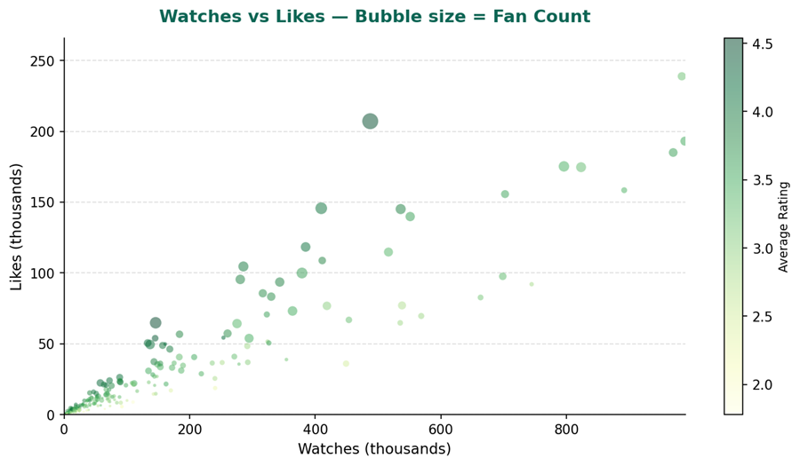
Figure 8 Watches vs Likes (Scatter Plot, n=1,500)

Insights and Recommendations

The Letterbox Movie Classification Dataset investigation yielded numerous crucial insights about the link between film attributes, audience participation, and critical response. Genre is the most powerful predictor of audience behaviour. Drama films typically have the highest average scores, bolstering its reputation for narrative depth and emotional intensity. Meanwhile, genres like Adventure, Fantasy, and Science Fiction had higher viewership despite lower critical scores, indicating that entertainment value and visual spectacle frequently attract a bigger audience. To maintain growth, streaming services should invest in both critically acclaimed dramas and high-audience genres.
Language differences appeared as a considerable predictor of perceived quality. Non-English films had much better ratings than English-language movies, indicating that foreign titles on global platforms are selectively disseminated and represent films with superior creative worth. This conclusion supports data-driven suggestions for streaming providers to increase investment in foreign film. Subtitling, dubbing, and cultural localisation can improve accessibility, broaden libraries, and attract worldwide audiences seeking alternative and high-quality material.
The substantial relationships between watches, fans, and likes to highlight the cumulative nature of digital involvement. Early exposure tends to increase visibility and future engagement, implying that business intelligence systems could anticipate emergent popularity patterns and selectively prioritise such films in algorithmic promotions or featured placement. This allows platforms to turn short-term interest into long-term audience retention.

The study also discovered that runtime had little affect on both engagement and ratings. Moderate-length films, generally between 85 and 120 minutes, best fit with viewer expectations, but narrative quality remains a far more important predictor of success.
The dataset shows the strategic significance of BI in linking analytical information with creative decision-making, ensuring that both artistic quality and audience appeal are optimised, even if it predominantly reflects cinephile audiences, restricting representativeness.

References

- Bryman, A. and Cramer, D. (2011) Quantitative Data Analysis with IBM SPSS 17, 18 & 19: A Guide for Social Scientists. http://www.gbv.de/dms/tib-ub-hannover/644626259.pdf.

- Brynjolfsson, E., Hu, Y.J. and Smith, M.D. (2010) 'The longer tail: the changing shape of Amazon’s sales distribution curve,' SSRN Electronic Journal [Preprint]. https://doi.org/10.2139/ssrn.1679991.

- Cox, N.J. (2004) 'Exploratory data mining and data cleaning,' Journal of Statistical Software, 11(Book Review 9). https://doi.org/10.18637/jss.v011.b09.

- Few, S. (2004) Show me the numbers: Designing Tables and Graphs to Enlighten.

- Field, A. (2013) Discovering statistics using IBM SPSS Statistics. SAGE Publications Limited.

- Gemser, G., Leenders, M. a. a. M. and Wijnberg, N.M. (2007) 'Why some awards are more effective signals of quality than others: A study of movie awards†,' Journal of Management, 34(1), pp. 25–54. https://doi.org/10.1177/0149206307309258.
- Koren, Y. and Bell, R. (2010) 'Advances in Collaborative Filtering,' in Recommender Systems Handbook 2011, pp. 77–118. https://doi.org/10.1007/978-0-387-85820-3_5.

- Kuipers, G. (2011) 'Cultural globalization as the emergence of a transnational cultural field: transnational television and national media landscapes in four European countries,' American Behavioral Scientist, 55(5), pp. 541–557. https://doi.org/10.1177/0002764211398078.

- Liu, Y. (2006) 'Word of Mouth for Movies: Its dynamics and impact on box office revenue,' Journal of Marketing, 70(3), pp. 74–89. https://doi.org/10.1509/jmkg.70.3.74.

- Fu, W.W. and Govindaraju, A. (2010) 'Explaining Global Box-Office tastes in Hollywood Films: Homogenization of national audiences’ movie selections,' Communication Research, 37(2), pp. 215–238. https://doi.org/10.1177/0093650209356396.

- Sharda, R., Delen, D. and Turban, E. (2024) Business Intelligence, Analytics, Data Science, and AI, Global Edition. Pearson.

- Strong, D.M., Lee, Y.W. and Wang, R.Y. (1997) 'Data quality in context,' Communications of the ACM, 40(5), pp. 103–110. https://doi.org/10.1145/253769.253804.

