Chinese Whispers – A Visual Audio Exhibition

Introduction
'All Creative work builds on what came before' – Austin Kleon .
The exhibition is all based around the idea that taking ideas and inspiration from others in creative work doesn’t hinder originality. In an age where people aspire to be unique and one of a kind, from our appearance, to our art and music tastes. We don’t spend enough time collaborating.
Art exhibitions have been a part of cultural history for hundreds of years, but there are very few times that both music and art create an exhibit with one another.
In this Exhibition Musicians and Artists create a piece of art based on only what they have seen from the previous artist. All pieces will then be systematically put on show, in chronological order, showing the outcome of each artist capturing and altering the previous artefact.
The theories behind this project stem from a lot of what both Michel Foucault and Austin Kleon have to say about looking back into the past to better our future. Be it in the medical field of the artistic. We are trying to capture the idea that collaboration creates better art, and that the feeling of an artefact can be passed through either spectrum, such as visual and auditory.
The Theme
The main theme of the exhibition is as the title implies, Chinese Whispers. A game played today by children and adults all over the word under many different names (such as grapevine, broken telephone, etc...). The game starts with everyone getting in a line and the first person whispering a chosen word or phrase to whom they are next to. The phrase is then passed down the chain of people, with the end goal of reaching the last person without any alterations. The overall outcome tends to be the complete opposite, usually a non-sensical outlandish version of what started.

This time instead of using a word to pass down, we are going to use a piece of music or art.
The base idea is to have a single practitioner create a piece of music or art purely from their own mind. This will be sent onto an artist of the opposite field (Music to Art, Art to Music) as the main focal point for their own piece. This cycle continues until all artists have contributed their own creation. The results are to be shown at an art exhibition where each piece of art will have its own place, paired with the music it was created from in chronological order.

The use of Chinese whispers in both art and music has been demonstrated before but never both together. In 2014 The Karin Janssen Project Space in London and Gallery Nasty Alice in Eindhoven collaborated together to do a version of Chinese Whispers which will be seen in detail below. In music, the game has been used by a jazz orchestra named The Mace Francis Jazz Orchestra. Who had each member create ten bars of music, whilst only being able to see the previous ten bars.

The idea is that each practitioner will have taken some form of inspiration or influence from the piece before it. The exhibit on a whole should depict a shared theme throughout, but also show each artists’ individual perception. Showing there is beauty that can come from not just purely original thought, instead from a collective of ideas.

This concept is one shared by Austin Kleon. He is a New York best-selling author of ‘Steal like an artist’ and artist who specializes on giving out tips to those working within a similar field. His beliefs on how originality is overrated and how taking inspiration from past artists can excel our own creativity, resonates with this exhibit. Michel Foucault, a French Historian and philosopher was also one who believed very strongly we could learn from how we behaved and thought about things in the past.

Nikolaus Gansterer and Matthias Meinharter

Between 2007 -2009 Gansterer and Meinharter worked on a project also named Chinese Whispers. This Exhibition was focused on forms of imitation, limitations and appropriations, focusing on the oil painting industry within Dafen Village. Wanting to show the culture and excellence of this world renown copying village. They did this with the game of Chinese whispers, starting with a film still of a Selma Hayek painting as the focus. This was painted by an artist, who was then photographed during their work, which was passed on down the chain of artists.

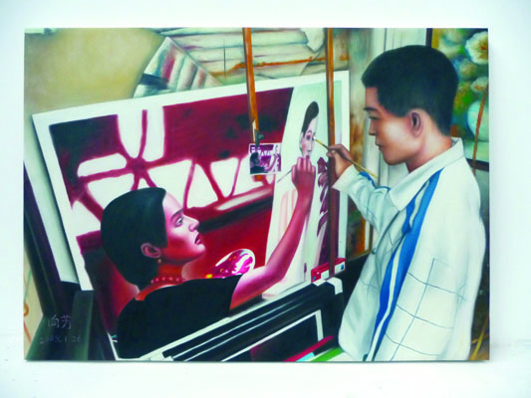

Gansterer and Meinherter conducted this to show that these workers that get paid as if on an ‘assembly line’ wage, are incredibly unique and talented artists. Even though their work is “copying” other pieces of art, their individual styles persists throughout their paintings.

In relation to the idea of how we can build on our own ideas from other people’s perspectives. This exhibition Shows how each artist has tried to capture the previous persons style, whilst still being able to add their own touch. Taking influence but still showing originality.

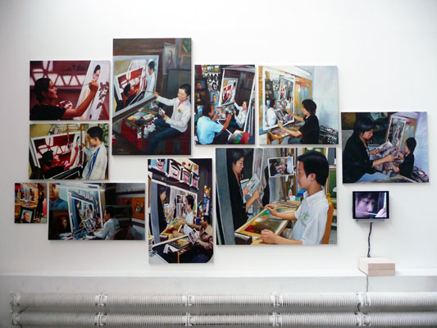

Karin Jansenn and Galerie Nasty Alice

In Winter of 2014 Karin Janssen Project Space in London and Gallery Nasty Alice in Eindhoven, the Netherlands collaborated to create an exhibit that would try to analyse the similarities and differences in artists from either country. They used the game Chinese Whispers to see how each artist would react to a similar task, and to analyse whether there was a direct correlation with someone’s art form and their nationality.

Looking through the different pieces within the exhibit, it stands out to me that each piece is significantly unique. Even though each has similar relations of mood or context to its predecessor, the originality in style still shines through the art.

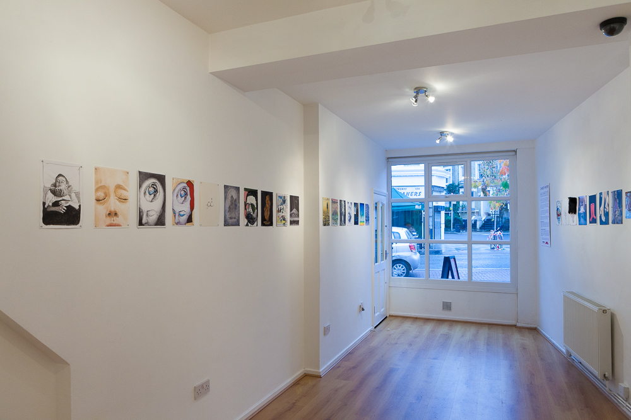

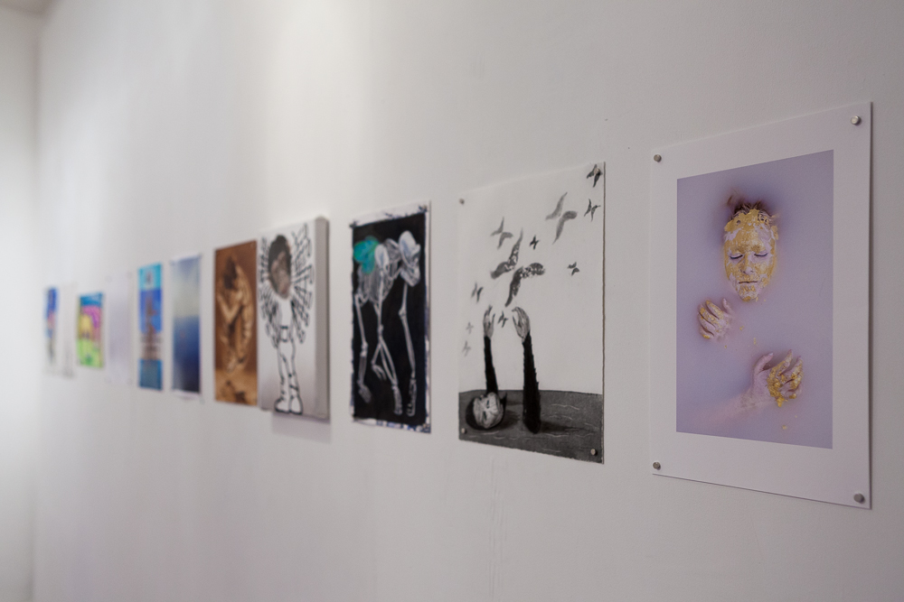

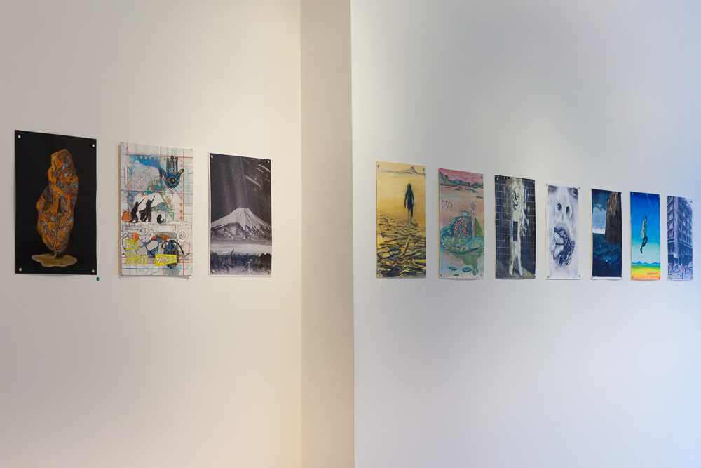

Conclusion
All These artists and exhibitions show traits of how you can create amazing things, whilst including that which you have seen before. Taking knowledge from Kleon and Foucault, and other influential names in our practices through history is the greatest way to grow. Much Like how Adam J Kurtz (an author and artist) speaks on how you should always take inspiration and ideas from other artists, it’s the sign of a great one. So long as you make sure you give credit to whom your inspiration has come from. I believe you should never be shy away from taking aspects of others work to better your own individual artistic journey, it’s how the human race came to be.

With a collection of the previous artists that participated in the projects mentioned above, this exhibition would portray a mass collection of connected art, each with a completely new perspective. Showing that within your creative work if you can keep a balance between being original, and curating ideas from past practitioners. You can express your style purely even with the influences of others.

References

Austin Kleon(2018) Austin Kleon: Steal like an Artist Available at : https://austinkleon.com/steal/ (Accessed on 17/04/18)
Britannica Encyclopedia (2018) Britannica Encyclopedia: Michel Foucault Available at: https://www.britannica.com/biography/Michel-Foucault (Accessed: 17/03/18)
Christian Jankowsi - Chinese Whisper – New Paintings (Van Gogh I-X)
Dr Micheal Petri (2015) Huffington Post - Chinese Whispers or Something Like That https://www.huffingtonpost.co.uk/dr-michael-petry/art-exhibition-chinese-whispers_b_6514786.html (Accessed on 01/04/18)
Frances Larson and Chris Wingfield (2010) Pitt Rivers' investigations into the degeneration of artistic images http://web.prm.ox.ac.uk/rpr/index.php/article-index/12-articles/217-the-drawing-game.html (Accessed on 30/04/18)
https://christianjankowski.com/works/2015-2/chinese-whispers/ (Accessed on 07/05/18)
Karin Janssen ( 2017) Chinese Whispers Available at : http://www.karinjanssen.com/chinese-whispers.html (Accessed : 25/03/18)
Leo Xavier (2018) The Coolist : Art inspired by Art Available at : http://www.thecoolist.com/van-gogh-picasso-jackson-pollock-michelangelo-art/ (Accessed: 19/03/18)
Louis Byrne (2015) Cassone - Passing it on - the art of Chinese whispers http://www.cassone-art.com/magazine/article/2015/01/passing-it-on-the-art-of-chinese-whispers/?psrc=around-the-galleries (Accessed on 01/04/18)
Mace Francis (2018) Mace Francis : Music Available at : http://macefrancis.com/music/ (Accessed 23/03/18)

Nasty Alice(2018) Galerie Nasty Alice Available at : http://www.galerienastyalice.nl/kunstenaars/ (Accessed on 20/04/18)
Nick Douglas (2017) Life hacker : An Artist explains what “Great artists steal” really means Available at : https://lifehacker.com/an-artist-explains-what-great-artists-steal-really-me-1818808264 (Accessed on 30/04/18)
Nikolaus Gansterer (2009) Chinese Whispers Available at : http://www.gansterer.org/chinese-whispers/?n=1 (Accessed : 25/03/18)
Rachel Cohen (2011) University of Sussex - Evolutionary art: the Chinese Whispers Generative Drawing Project http://www.sussex.ac.uk/cogs/seminars/videos/cohen-evolutionary-art (Accessed on 11/04/18)

