Learning In The Digital Era
Component 1: E-Portofolio

Submitted by : Esteri Paloka

Student number :2528244

Date : 08 March 2026

Table of Contents
E-Portfolio Link 3
Screenshot of “Reflection” 4
TASK 2 5
Screenshot of mind map 5
Link of mind map 5
screenshot of academic poster 6
link of academic poster 6
TASK 3 7
Screenshot of automatic referencing tool 7
task 4 screenshot of each page of the portfolio 8

E-Portfolio Link
https://sites.google.com/view/esteris-e-portofolio/academic-poster

TASK 1
Screenshot of “Essential Skills”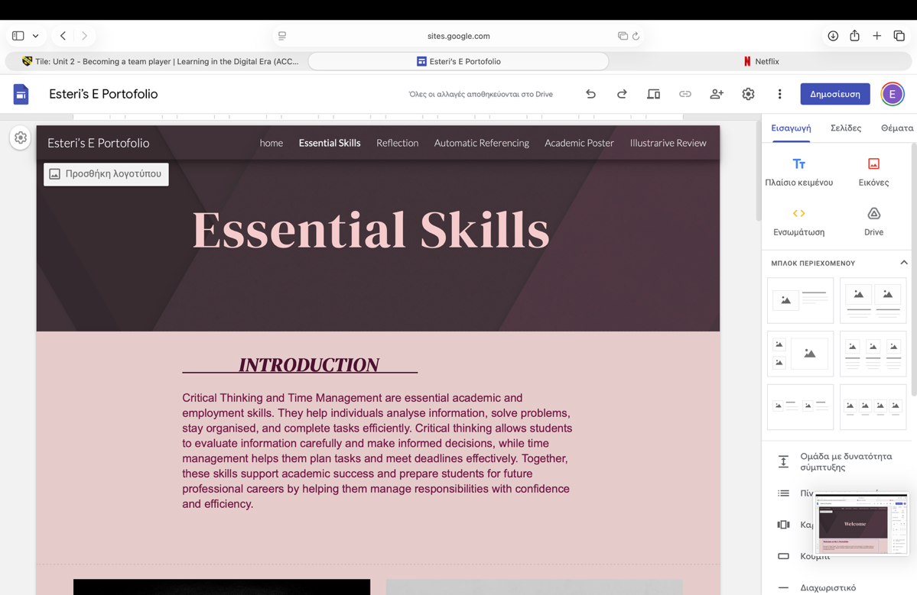

Screenshot of “Reflection”
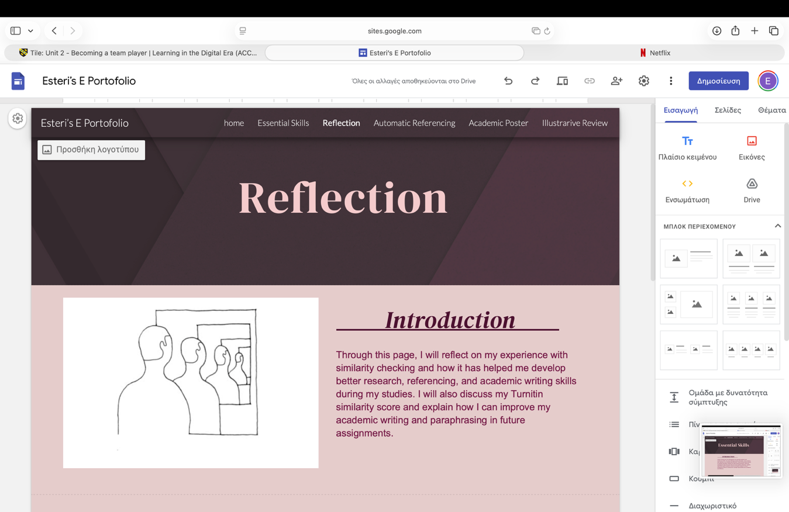

TASK 2

Screenshot of mind map

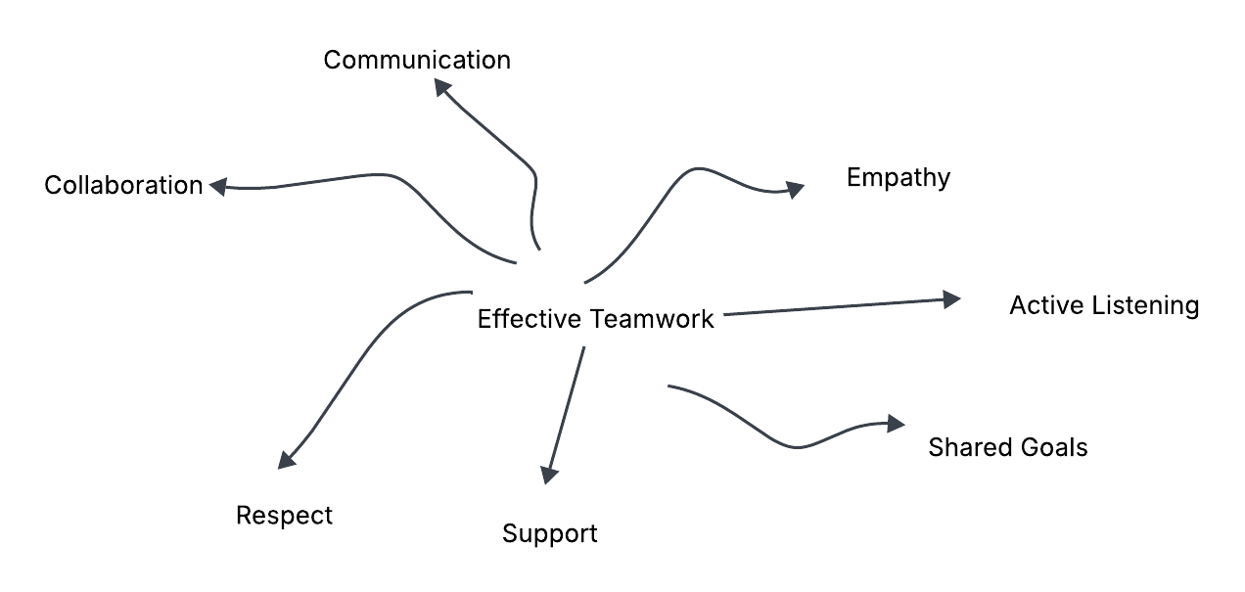

Link of mind map
https://uowtsd-my.sharepoint.com/:i:/g/personal/2528244_student_uwtsd_ac_uk/IQDESNeSJNNwRqQ2jJ42bgnfAZowMLBC0yyI1g2W88r5pKs?e=UOXcdx

screenshot of academic poster 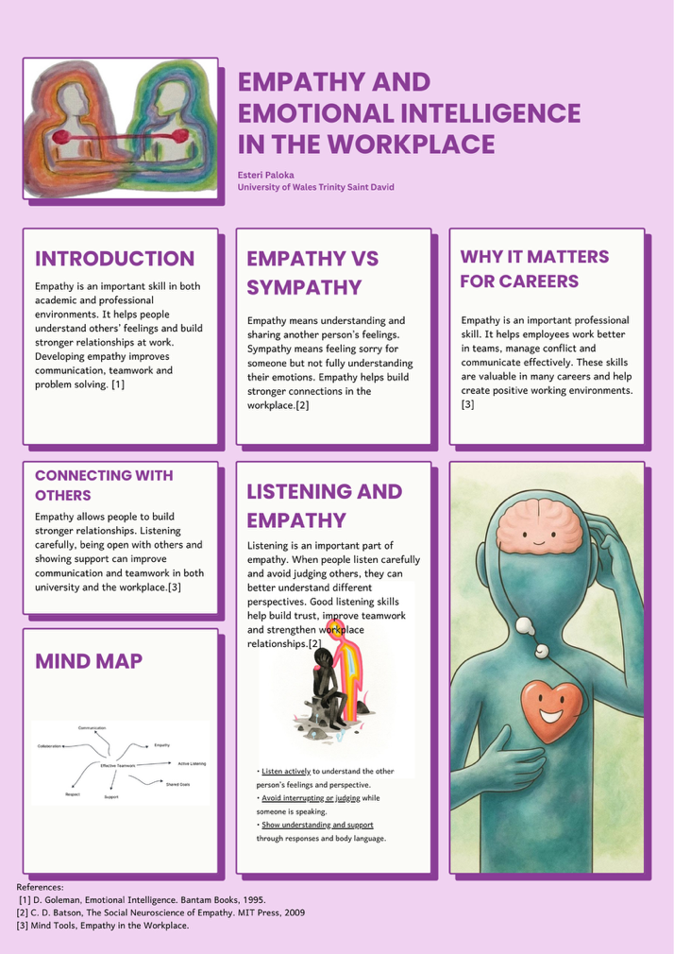

link of academic poster
https://uowtsd-my.sharepoint.com/:i:/g/personal/2528244_student_uwtsd_ac_uk/IQBjrft9QNI5Q7UPPVlLtepuAekl271GktqpKaZaiASRW64?e=an0JFo

TASK 3

Screenshot of automatic referencing tool

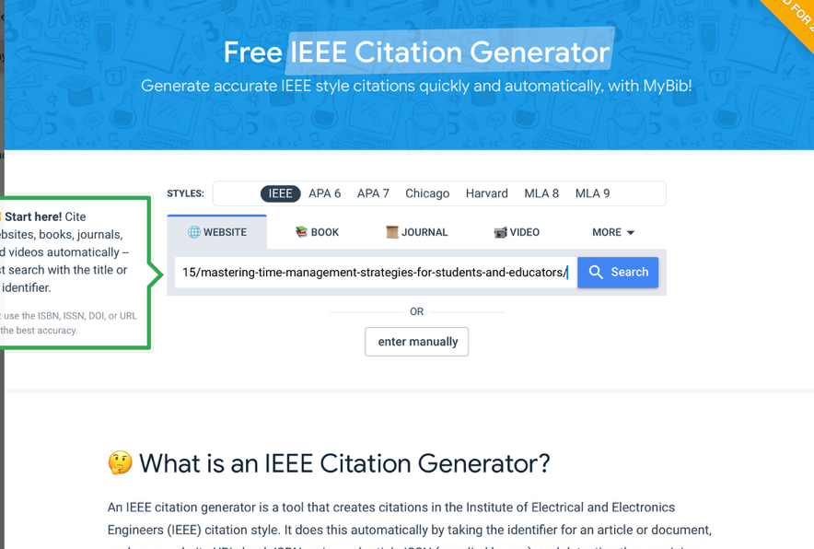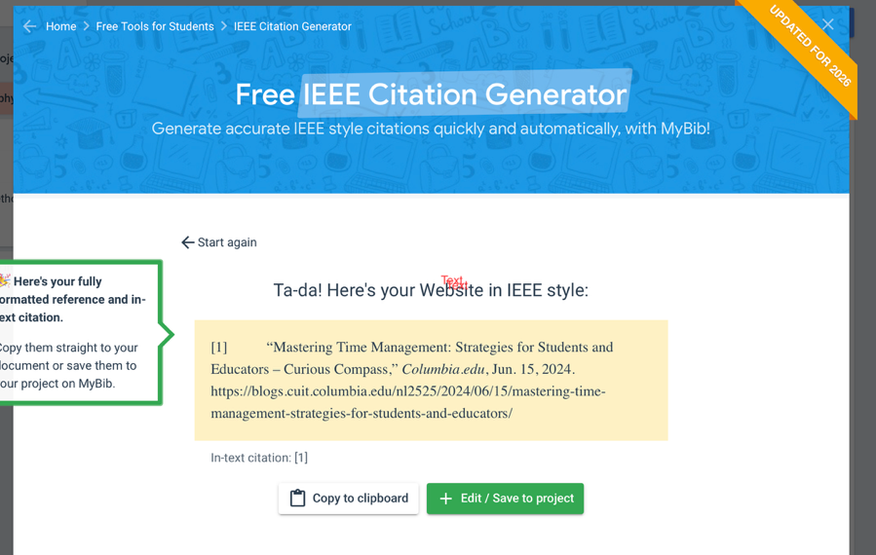

task 4 screenshot of each page of the portfolio



