NOT PROTECTIVELY MARKED

nad

NOT PROTECTIVELY MARKED

HONEY AND MUNFORD LEARNING STYLES QUESTIONNAIRE

Learning styles were developed by Peter Honey and Alan Mumford, based upon the work of Kolb, and they identified four distinct learning styles or preferences: Activist, Theorist; Pragmatist and Reflector. These are the learning approaches that individuals naturally prefer and they recommend that in order to maximise one's own personal learning each learner ought to:

- understand their learning style
- seek out opportunities to learn using that style

To understand your particular learning style Honey and Mumford have developed a Learning Style Questionnaire [see further reading] and with this information you will be in a far better position to do three really useful things [quoting P. Honey]:

- "Become smarter at getting a better fit between learning opportunities and the way you learn best. This makes your learning easier, more effective and more enjoyable. It saves you tackling your learning on a hit-and-miss basis. Equipped with information about your learning preferences, you'll have many more hits and fewer misses."
- "Expand the 'band width' of experiences from which you derive benefit. Becoming an all- round learner, increases your versatility and helps you learn from a wide variety of different experiences - some formal, some informal, some planned and some spontaneous."
- "Improve your learning skills and processes. Increased awareness of how you learn, opens up the whole process to self-scrutiny and improvement. Learning to learn is your most important capability since it provides the gateway to everything else you want to develop."

Note: However, to be an effective learner you should also develop the ability to learn in other styles too.

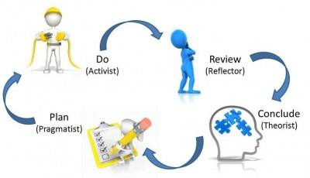

This questionnaire is designed to find out your preferred learning style(s). Over the years you have probably developed learning "habits" that help you benefit more from some experiences than from others. Since you are probably unaware of this, this questionnaire will help you pinpoint your learning preferences so that you are in a better position to select learning experiences that suit your style and having a greater understanding of those that suit the style of others.
There is no time limit to this questionnaire. It will probably take you 10-15 minutes. The accuracy of the results depends on how honest you can be. There are no right or wrong answers.

If you agree more than you disagree with a statement put a tick by it.
- If you disagree more than you agree put a cross by it.
- Be sure to mark each item with either a tick or cross.

□ | 1. I have strong beliefs about what is right and wrong, good and bad.
□ | 2. I often act without considering the possible consequences
□ | 3. I tend to solve problems using a step-by-step approach
□ | 4. I believe that formal procedures and policies restrict people
□ | 5. I have a reputation for saying what I think, simply and directly
□ | 6. I often find that actions based on feelings are as sound as those based on careful thought and analysis
□ | 7. I like the sort of work where I have time for thorough preparation and implementation
□ | 8. I regularly question people about their basic assumptions
□ | 9. What matters most is whether something works in practice
□ | 10. I actively seek out new experiences
□ | 11. When I hear about a new idea or approach I immediately start working out how to apply it in practice
□ | 12. I am keen on self discipline such as watching my diet, taking regular exercise, sticking to a fixed routine, etc.
□ | 13. I take pride in doing a thorough job
□ | 14. I get on best with logical, analytical people and less well with spontaneous, "irrational"
□ | 15. I take care over the interpretation of data available to me and avoid jumping to conclusions
□ | 16. I like to reach a decision carefully after weighing up many alternatives
□ | 17. I'm attracted more to novel, unusual ideas than to practical ones
□ | 18. I don't like disorganised things and prefer to fit things into a coherent pattern
□ | 19. I accept and stick to laid down procedures and policies so long as I regard them as an efficient way of getting the job done

□ | 20. I like to relate my actions to a general principle
□ | 21. In discussions I like to get straight to the point
□ | 22. 1 tend to have distant, rather formal relationships with people at work
□ | 23. I thrive on the challenge of tackling something new and different
□ | 24. I enjoy fun-loving, spontaneous people
□ | 25. I pay meticulous attention to detail before coming to a conclusion
□ | 26. I find it difficult to produce ideas on impulse
□ | 27. I believe in coming to the point immediately
□ | 28. I am careful not to jump to conclusions too quickly
□ | 29. I prefer to have as many resources of information as possible - the more data to think over the better
□ | 30. Flippant people who don't take things seriously enough usually irritate me
□ | 31. I listen to other people's points of view before putting my own forward
□ | 32. I tend to be open about how I'm feeling
□ | 33. In discussions I enjoy watching the manoeuvrings of the other participants
□ | 34. I prefer to respond to events on a spontaneous, flexible basis rather than plan things out in advance
□ | 35. I tend to be attracted to techniques such as network analysis, flow charts, branching programs, contingency planning, etc.
□ | 36. It worries me if I have to rush out a piece of work to meet a tight deadline
□ | 37. I tend to judge people's ideas on their practical merits
□ | 38. Quiet, thoughtful people tend to make me feel uneasy
□ | 39. I often get irritated by people who want to rush things
□ | 40. It is more important to enjoy the present moment than to think about the past or future
□ | 41. I think that decisions based on a thorough analysis of all the information are sounder than those based on intuition
□ | 42. I tend to be a perfectionist
□ | 43. In discussions I usually produce lots of spontaneous ideas
□ | 44. In meetings I put forward practical realistic ideas
□ | 45. More often than not, rules are there to be broken
□ | 46. I prefer to stand back from a situation
□ | 47. I can often see inconsistencies and weaknesses in other people's arguments

□ | 48. On balance I talk more than I listen
□ | 49. I can often see better, more practical ways to get things done
□ | 50. I think written reports should be short and to the point
□ | 51. I believe that rational, logical thinking should win the day

□ | 52. I tend to discuss specific things with people rather than engaging in social discussion
□ | 53. I like people who approach things realistically rather than theoretically
□ | 54. In discussions I get impatient with irrelevancies and digressions
□ | 55. If I have a report to write I tend to produce lots of drafts before settling on the final version
□ | 56. 1 am keen to try things out to see if they work in practice
□ | 57. I am keen to reach answers via a logical approach
□ | 58. I enjoy being the one that talks a lot
□ | 59. In discussions I often find I am the realist, keeping people to the point and avoiding wild speculations
□ | 60. I like to ponder many alternatives before making up my mind
□ | 61. In discussions with people I often find I am the most dispassionate and objective
□ | 62. In discussions I'm more likely to adopt a "low profile" than to take the lead and do most of the talking
□ | 63. I like to be able to relate current actions to a longer term bigger picture
□ | 64. 64. When things go wrong I am happy to shrug it off and "put it down to experience"
□ | 65. I tend to reject wild, spontaneous ideas as being impractical
□ | 66. It's best to think carefully before taking action
□ | 67. On balance I do the listening rather than the talking
□ | 68. I tend to be tough on people who find it difficult to adopt a logical approach
□ | 69. Most times I believe the end justifies the means
□ | 70. I don't mind hurting people's feelings so long as the job gets done
□ | 71. I find the formality of having specific objectives and plans stifling
□ | 72. I'm usually one of the people who puts life into a party
□ | 73. I do whatever is expedient to get the job done
□ | 74. I quickly get bored with methodical, detailed work
□ | 75. I am keen on exploring the basic assumptions, principles and theories underpinning things and events
□ | 76. I'm always interested to find out what people think

□ | 77. I like meetings to be run on methodical lines, sticking to laid down agenda, etc.
□ | 78. I steer clear of subjective or ambiguous topics
□ | 79. I enjoy the drama and excitement of a crisis situation
□ | 80. People often find me insensitive to their feelings

Scoring And Interpreting The Learning Styles Questionnaire

The Questionnaire is scored by awarding one point for each ticked item. There are no points for crossed items. Simply indicate on the lists below which items were ticked by circling the appropriate question number.

2 | 7 | 1 | 5
4 | 13 | 3 | 9
6 | 15 | 8 | 11
10 | 16 | 12 | 19
17 | 25 | 14 | 21
23 | 28 | 18 | 27
24 | 29 | 20 | 35
32 | 31 | 22 | 37
34 | 33 | 26 | 44
38 | 36 | 30 | 49
40 | 39 | 42 | 50
43 | 41 | 47 | 53
45 | 46 | 51 | 54
48 | 52 | 57 | 56
58 | 55 | 61 | 59
64 | 60 | 63 | 65
71 | 62 | 68 | 69
72 | 66 | 75 | 70
74 | 67 | 77 | 73
79 | 76 | 78 | 80

TOTALS
 | Activist | Reflector | Theorist | Pragmatist

Learning Styles Questionnaire Profile Based on General Norms for 1302 People

Activist | Reflector | Theorist | Pragmatist
20 | 20 | 20 | 20 | Very strong preference
19 |  |  |  | Very strong preference
18 |  | 19 | 19 | Very strong preference
17 |  |  |  | Very strong preference
16 |  | 18 |  | Very strong preference
15 |  | 17 | 18 | Very strong preference
14 |  |  |  | Very strong preference
13 | 18 | 16 | 17 | Very strong preference
12 | 17 | 15 | 16 | Strong preference
 | 16 |  |  | Strong preference
11 | 15 | 14 | 15 | Strong preference
10 | 14 | 13 | 14 | Moderate
9 | 13 | 12 | 13 | Moderate
8 |  |  |  | Moderate
7 | 12 | 11 | 12 | Moderate
6 | 11 | 10 | 11 | Low preference
5 | 10 | 9 | 10 | Low preference
4 | 9 | 8 | 9 | Low preference
3 | 8 | 7 | 8 | Very low preference
 | 7 | 6 | 7 | Very low preference
 | 6 | 5 | 6 | Very low preference
2 | 5 | 4 | 4 | Very low preference
 | 4 | 3 | 3 | Very low preference
 | 3 |  |  | Very low preference
1 | 2 | 2 | 2 | Very low preference
 | 1 | 1 | 1 | Very low preference
0 | 0 | 0 | 0 | Very low preference

Learning Styles - General Descriptions
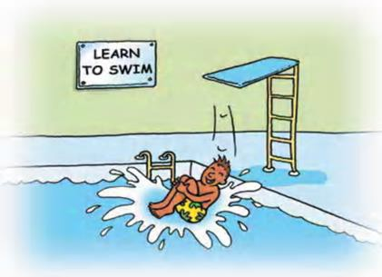

Activists: Activists involve themselves fully and without bias in new experiences. They enjoy the here and now and are happy to be dominated by immediate experiences. They are open-minded, not sceptical, and this tends to make them enthusiastic about anything new. Their philosophy is: "I'll try anything once". They tend to act first and consider the consequences afterwards. Their days are filled with activity. They tackle problems by brainstorming. As soon as the excitement from one activity has died down they are busy looking for the next. They tend to thrive on the challenge of new experiences but are bored with implementation and longer-term consolidation. They are gregarious people constantly involving themselves with others but in doing so; they seek to centre all activities on themselves.

Summary of strengths
- Flexible and open minded.
- Happy to have a go.
- Happy to be exposed to new situations.
- Optimistic about anything new and therefore unlikely to resist change.

Summary of weaknesses:
- Tendency to take the immediately obvious action without thinking.
- Often take unnecessary risks.
- Tendency to do too much themselves and hog the limelight.
- Rush into action without sufficient preparation.
- Get bored with implementation/consolidation.

Key questions for activists:
- Shall I learn something new, i.e. that I didn't know/couldn't do before?

- Will there be a wide variety of different activities? (I don't want to sit and listen for more than an hour at a stretch!)
- Will it be OK to have a go/let my hair down/make mistakes/have fun?
- Shall 1 encounter some tough problems and challenges?
- Will there be other like-minded people to mix with?

Reflectors: Reflectors like to stand back to ponder experiences and observe them from many different perspectives. They collect data, both first hand and from others, and prefer to think about it thoroughly before coming to any conclusion. The thorough collection and analysis of data about experiences and events is what counts so they tend to postpone reaching definitive
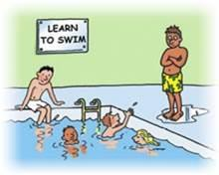
conclusions for as long as possible. Their philosophy is to be cautious. They are thoughtful people who like to consider all possible angles and implications before making a move. They prefer to take a back seat in meetings and discussions. They enjoy observing other people in action. They listen to others and get the drift of the discussion before making their own points. They tend to adopt a low profile and have a slightly distant, tolerant unruffled air about them. When they act it is part of a wide picture which includes the past as well as the present and others' observations as well as
their own.

Summary of strengths:
- Careful.
- Thorough and methodical
- Thoughtful
- Good at listening to others and assimilating information.
- Rarely jump to conclusions.

Summary of weaknesses:
- Tendency to hold back from direct participation.
- Slow to make up their minds and reach a decision.
- Tendency to be too cautious and not take enough risks.
- Not assertive - they aren't particularly forthcoming and have no "small talk".

Key questions for reflectors:
- Shall I be given adequate time to consider, assimilate and prepare?

- Will there be opportunities/facilities to assemble relevant information?
- Will there be opportunities to listen to other people's points of view - preferably a wide cross section of people with a variety of views?
- Shall I be under pressure to be slapdash or to extemporise?

Theorists: Theorists adapt and integrate observations into complex but logically sound theories. They think problems through in a vertical, step-by-step logical way. They assimilate disparate facts into coherent theories. They tend to be perfectionists who won't rest easy until things are tidy and fit into a rational scheme. They like to analyse and synthesise. They are keen on basic assumptions, principles, theories models and systems thinking. Their philosophy prizes rationality
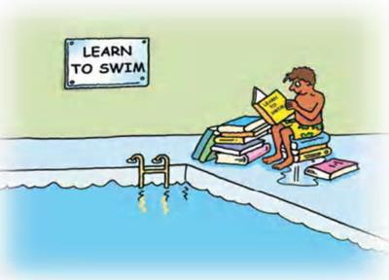
and logic. "If it's logical it's good". Questions they frequently ask are: "Does it make sense?" "How does this fit with that?" "What are the basic assumptions?" They tend to be detached, analytical and dedicated to rational objectivity rather than anything subjective or ambiguous. Their approach to problems is consistently logical. This is their "mental set" and they rigidly reject anything that doesn't fit with it. They prefer to maximise certainty and feel uncomfortable with subjective judgments, lateral thinking and anything flippant.

Summary of strengths:
- Logical "vertical" thinkers.
- Rational and objective.
- Good at asking probing questions.
- Disciplined approach.

Summary of weaknesses:
- Restricted in lateral thinking.
- low tolerance for uncertainty, disorder and ambiguity
- Intolerant of anything subjective or intuitive.
- Full of "shoulds, oughts and musts".

Key questions for theorists:
- Will there be lots of opportunities to question?

- Do the objectives and program of events indicate a clear structure and purpose?
- Shall I encounter complex ideas and concepts that are likely to stretch me?
- Are the approaches to be used and concepts to be explored "respectable", i.e. sound and valid?
- Shall I be with people of similar calibre to myself?

Pragmatists: Pragmatists are keen on trying out ideas, theories and techniques to see if they work in practice. They positively search out new ideas and take the first opportunity to experiment with
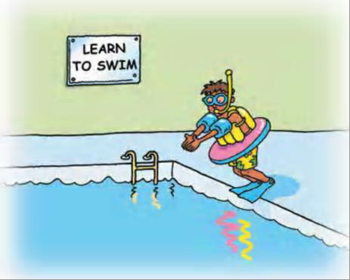
applications. They are the sorts of people who return from management courses brimming with new ideas that they want to try out in practice. They like to get on with things and act quickly and confidently on ideas that attract them. They tend to be impatient with ruminating and open-ended discussions. They are essentially practical, down to earth people who like making practical decisions and solving problems. They respond to problems and opportunities "as a challenge". Their philosophy is: "There is always a better way" and "if it works it's good".

Summary of strengths:
- Keen to test things out in practice.
- Practical, down to earth, realistic.
- Businesslike - gets straight to the point.
- Technique oriented.

Summary of weaknesses:
- Tendency to reject anything without an obvious application.
- Not very interested in theory or basic principles.
- Tendency to seize on the first expedient solution to a problem.
- Impatient with waffle.
- On balance, task oriented not people oriented.

Key questions for pragmatists:
- Will there be ample opportunities to practice and experiment?
- Will there be lots of practical tips and techniques?

- Shall we be addressing real problems and will it result in action plans to tackle some of my current problems?
- Shall we be exposed to experts who know how to/can do it themselves?

In descending order of likelihood, the most common combinations are: 1st Reflector/Theorist
2"d Theorist/Pragmatist
3rd Reflector/Pragmatist
4th Activist/Pragmatist

