 | target | What I have done in this assignment...
Target 1 | Try to use your readings to make links with practice so decisions are evidence based. | I have made links from my literature review section.
Target 2 | Ensure you critically engage with literature to a greater extent. Look for opportunities to synthesise ideas and construct arguments. | I have made arguments and synthesis based on evidence found in my literature review section.
Target 3 | Re-look at Harvard referencing protocol to ensure your citations are appropriate. | I have researched further into the Harvard referencing system and there is now a consistent Harvard style throughout.

How a school develops one aspect of its SDP: a report that critically reflects on the actions, impact and evidence base.

The school I will be discussing will be my PTE1 placement school which I will refer to as School X to maintain anonymity. School X is a large comprehensive, English-medium, school maintained by Bridgend local authority. There are approximately 1,121 pupils on roll at the school, 177 of them in 6thform. (Estyn,2016).
I have specifically chosen to look at the SDP aspect “To provide a calm, purposeful learning environment where all pupils feel safe, secure and ready to learn.”
The school’s development plan is a document of carefully considered and purposefully chosen aims for improvement for learner outcomes, along with suggested actions to achieve said aims, allocation of staff responsibilities, and a success criterion detailing clear evidence of achieving initial aims.
Owing to the Education Regulations 2014, all schools in Wales must produce a three-year long SDP, representing how the school will achieve its targets throughout that time period, and any steps the school will be implementing in progression (including staff, students and stakeholders) in order to attain said goals (School Development Plans, 2014).
To support this development and the school developing planning process, schools have access to a range of data, including data for specific groups of learners, e.g. FSM, LAC and ALN pupils. Benchmarking data is also used, so that schools may compare themselves against both the best performing schools and those within their school family (WAG, 2014). Detailed self-evaluation processes should be effectively undertaken by the schools throughout the academic year, using obtained qualitative and quantitative data, for schools to be able to evidence progression, meet targets and improve development.
This is continuous, reflective cycle that a school will use to reflect on its performance. They will use this process as a means to identify main areas for improvement, develop strategies on how to tackle the issues, then take action, and review progress and impact (highlighted in Figure 1):
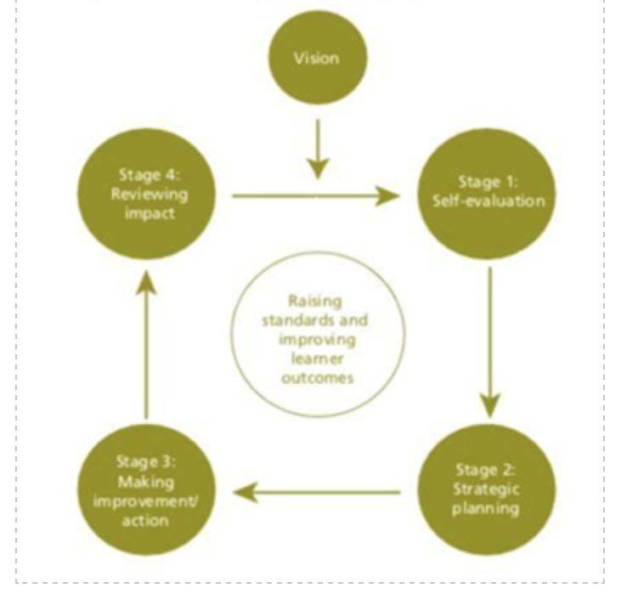

In addition, the SDP will set out how the school will achieve its target goals in relation to its priorities, what they will do to achieve this and how the school will uses its allocated funds it has available to make their vision a reality. The SDP must also detail how the school intends to develop its staff professionally in order to meet the school’s priorities and targets.
Many experts believe that all school planning should start with clear, specific, outlined goals with measurable, available data ready to track progress and accomplish goals over long term as well as short term periods. With goal setting playing a crucial role, all the other steps in the school improvement process need to take these goals into account. Vision, therefore, is placed at the top of the model in Figure 1. Further, self-evaluation and evidence-based data collection needs to be related to the vision; making improvements and actions should revolve around the vision; and the review should focus on whether or not the vision was achieved, in a ‘live’ and cyclic process.
As the SDP “is a live document that should be regularly refreshed to reflect the school’s progress in meeting its priorities” (WAG, 2014), schools must provide “contextual data to inform and self-evaluate the plan”. This data, as previously stated, can be collected formally or informally as qualitative or quantitative data, which does provide limitations when evaluating the results. (Weaver, 2020),describes formal assessments as having “data which support the conclusions” describing the assessments as “standardised measures” based on statistics which support the conclusion, however (Elwood, 2006) highlights factors such as funding issues, time consummation and objectivity of evaluators as being issues with formative assessment. Weaver also states that informal assessments are “not data driven but rather content and performance driven”, which again makes analysing the data open to scrutiny as bias and human error may play imposing factors.
In accordance to Estyn and WAG guidelines, “the school development planning cycle should be set against a clear vision of what the school is aspiring to achieve. A clear vision will set the context for the SDP. In order for the school to make sustained improvements and move forward it needs to have a clear purpose that is shared and understood by all. In setting its vision, a school should consider the context in which it operates and agree a vision that is both motivational and achievable and is underpinned by solid practical strategies.”
Creating a classroom that is organised and that is “characterised by mutual respect makes it a lot easier to teach effectively, and one of the most important things teachers can do to promote learning is to create classroom environments where students feel safe” (Dresden, 2012). Dresden continues by adding “students need to feel safe in order to learn. They need to feel secure in order to want to participate”.
Many argue the most important aspect in a safe and positive learning environment is the “rapport between a teacher and his or her students. When the students understand that their teacher cares about them and wants them to do well, students feel comfortable asking questions, making mistakes and taking risks in order to learn something new” (Learning Environment, 2019).This school of thought is continued, stating “positive, productive learning environments are key to students' academic, emotional and social success in school’, additionally “positive learning environments should offer a climate of safety, where risk-taking is encouraged, there is open authentic conversation, trust and respect are fostered, and positive interaction is the norm’” (Loveless, 2020).
Moreover, (Jensen, 2008) and (MacLean,1990) researched the effects of an unsafe learning environment, highlighting that learning is inhibited should the learner become more aware of the need for survival and protection of self from embarrassing or humiliating situations. This focus on mental well-being and safety is again echoed by a catalogue of research outlining the impact of the environment and emotional state. Stress, for example, has a detrimental negative impact on cognitive functioning (Medina, 2008). “When it comes to learning processes, the power of negative events greatly outweighs the power of positive events” (Baumeister, Bratslavsky, Finkenauer, & Vohs, 2001),demonstrating the importance of a calm and safe learning environment “by providing enough positive experiences to counteract the negative, we can help students avoid getting stuck in a “negative spiral” (Fredrickson, 2001).
However, safe learning environments can be argued to be a generalised term and subjective, as it caters for the majority of learners, but not all. Findings presented suggest that positive perceptions of the environment are associated with more positive self-esteem and adherence to adaptive learning goals. However, when students’ perceptions of the physical school environment are negative, students adapt and place more importance on other domains (McEwen, Edgarton and Mckechnie, 2011).
What is expected from schools is to “provide a safe learning environment which is suitable for raising socialised adults who will be the producing members of the society” (Sürücü, m and Ünal, 2015). Sürücü and Ünal continue, stating that “school safety is a safe environment where mainly students and teachers and directors at school feel at home and continue their education without experiencing any anxieties and fears”.
A review of previous research reveals that there is no consensus on how to measure students' perceptions of the physical learning environment.
To conclude, the literature around the area of creating safe learning environments draws more emphasis on the role of the educator and how they influence the class through interactions to aid learning by catering for learners’ emotional and mental well-being.
As referenced in the literature review, the school needs to analyse qualitative and quantitative data in order to develop an action plan. School X identified the need to tackle these particular purposes by creating a school action plan. This was developed based off of exam results, attendance data and pupil, parent and staff voices from the school, collated through surveys and questionnaires.
In addition to this, School X analysed test scores and compared their results to their school families, resulting in the development in this particular area of the SDP.

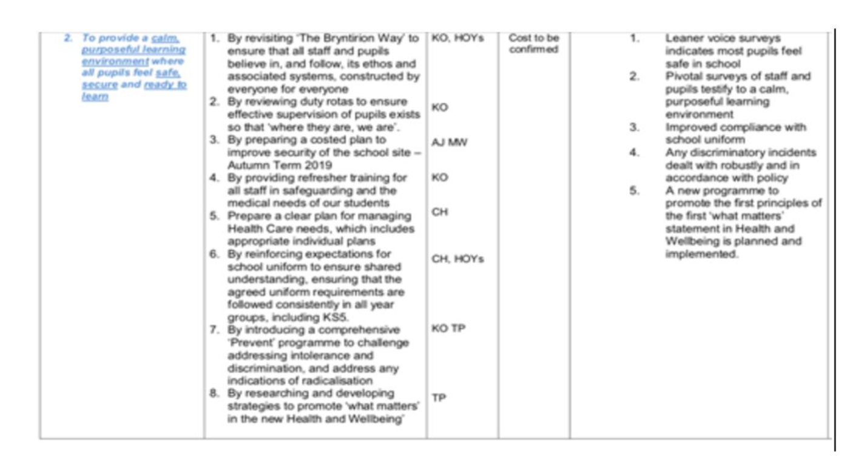
Appendix 1: School X’ s SDP sub-section: Providing a calm, purposeful learning environment.

As seen in Appendix 1, One aim was to revise the ‘School X way’. As you can see from the table, the school is working towards this development target by promoting high expectations to everybody throughout the school - this includes pupils, staff, governors and stakeholders. They have also introduced new behaviour management policies and strategies to promote good behaviour throughout the school and have a streamlined ‘Pivotal Approach’ system across the school. If successful, they expect an improvement in behaviour throughout the school, a calmer and more relaxed learning and working environment for education to flourish, and an improvement in mutual respect towards everyone in the school and improved attitudes to learning. This rationale is linked to the Pivotal Approach theory, which focuses on building up “mental and emotional well-being by developing confidence, resilience and empathy” (Pivotal Education, 2020). These practices can be seen in the adoption of Pivotal’s simple school moto; Be Ready, Be Respectful, Be safe. Which School X has coined the ‘The School X Way’.
A criticism of the Pivotal Approach, according to Pupil Voice at School X, would be the application of consistency from teachers regarding this approach. Some pupils suggested that some teachers could be easily identified as being too “soft” when managing behaviour (Appendix 2).
PTE1 Student Questionnaire | Student A | Student B | Student C
Q1: What makes you respect your teachers? | “Helping me, staying behind with me, going out of their way, showing they care.” | “They speak to you how you would like to be spoken to.” | “They respect me back.”
Q2: What kind of things do teachers say to you that help to motivate you? | “Keep going don’t be afraid to make mistakes.” | “Always try your best.” | “Revise now so you can relax during the holidays.”
Q3: What do you think of the school’s behaviour policy? | “It works best for the younger years like year 7,8.” | “It depends on the class/teacher… sometimes it works sometimes it doesn’t…” | “Not all teachers follow the behaviour policy so you can get away with a lot more with certain teachers.”
Appendix 2: Pupil Questionnaire Responses about Behaviour Management using the Pivotal Approach.

School X hopes to improve safety by enhancing security and managing supervision rotas, as well as improving safeguarding and mental health training throughout the school. Underlying this is the promotion of the School X ethos – which is outlined in the Pivotal Approach the school has adopted. Progress in this area will be judged on feedback from staff and pupils via surveys, as well as improved compliance with policies such as school uniform and discrimination (School X, 2019).
Additionally, the school draws on a range of appropriate strategies to support all learners and their families, regardless of context, to participate in all aspects of school life and specifically target ‘hard to reach’ families to ensure they are able to do so. This is done by holding weekly meetings with the Education Welfare Officer to identify barriers to attendance and work closely with families and individual learners to address issues such as transport, ongoing medical conditions, mental health concerns, family circumstances and life events.
Also, the school provides practical and financial support to families in order for students to access and attend sporting and music activities, non-uniform days and school trips to include costs and passport applications. Specific groups of learners also attend extra-curricular events such as meals and activities to support the development of social skills.
Moreover, School X has recently adopted a cashless payment system to address the stigmatisation of learners who qualify for free school meals.
This rationale is directly linked to the Welsh Government ‘What matters statements’, which describes five key qualities and attributes that all schools should instil in their pupils. These statements are:

Health & Well-being: A Statement of What Matters
Developing physical health and well-being has lifelong benefits.
How we process and respond to our experiences affects our mental health and emotional well-being.
Our decision-making impacts on the quality of our lives and the lives of others.
How we engage with social influences shapes who we are and affects our health and well-being.
Healthy relationships are fundamental to our well-being.
(Health and Well-being: Statements of what matters - Hwb, 2019)

One criticism of the way in which School X has implemented their SDP is in the way they have collated their data in the form of questionnaires and surveys. According to (The London School of Hygiene and Tropical Medicine, 2009), individual surveys/questionnaires are not reliable in keeping up with trends in real time, this is because surveys “collect data at a single point in time, it is difficult to measure changes in the population unless two or more surveys are done at different points in time” an evident limitation of the way School X collects much of their data.
They also go on to further dispute the use of surveys/questionnaires stating, “Individual surveys generally cannot provide strong evidence of cause and effect”. For example, you cannot tell what has caused the learning environment to be considered safe and purposeful, as every learner is an individual with different needs and mindsets, as emphasised by (Baumeister, Bratslavsky, Finkenauer, & Vohs, 2001).
Other key limitations of carrying out a survey/questionnaire in school for the purpose of an SDP we have to consider is the lack of time available to carry out this task by the classroom teacher. Importantly, we must consider The Hawthorne Effect (1958), when conducting this form of data collection, as the teacher presence providing the survey/questionnaire to the pupil will cause pupils to behave/answer differently because they are aware that they are being watched.
At certain stages of the academic year, School X will undertake self-evaluation processes on their SDP targets via surveys and questionnaires to pupils, parents and stakeholders. Self-evaluation is the “means by which schools reflect upon their performance and use it as a basis for sustainable improvement planning” (School Development Plans, 2014). The process of self-evaluation and improvement planning is “central to supporting advances in school improvement, professional learning and learner outcomes. Self-evaluation is a key tool in assisting a school to assess its performance”. It is also “crucial in becoming/maintaining a successful school” (Kyriakides and Campbell, 2004), helping schools identify:
- “how well they are performing”
- “areas of strength”
- “what needs to be improved”
- “what actions to take to make those improvements.”
(School Development Plans,2014)

However, a criticism of self-evaluation is that of self-serving bias. A self-serving bias is the common habit of a person taking credit for positive events or outcomes, but blaming outside factors for negative events (Herndon, 2018). Additionally, (Barber, 1996) describes self-evaluation as “restless in its quest for evidence in a school’s transparent sense of purpose, behaviour, relationships and classroom performance”.
A notable criticism of School X’s SDP is its resources column where it indicates “Cost to be confirmed.” This would suggest a lack of priority or strategic planning for this area of the SDP.
(The Department for Children, Schools and Families,2014) says, “In the context of schools, strategic planning is an integral process, bringing together the overall aims and objectives of the school from the SDP and aligning these with the budget process in the short, medium and longer term”.
Usually, schools allocate their budgets to what it perceives to be fixed costs, such as wages and maintenance, and that there is little consideration to SDP funding initially. DCSF (2014) also argue that “this uncertainty is the very reason why schools should adopt a strategic approach to managing their finances”.
Based on criticisms made previously School X needs to revaluate how they collect data, regarding their current method of using surveys and questionnaires. In the case of pupil surveys the option to remain anonymous or a quiet designated safe place could be provided in order for pupils to give a more natural response.
Another approach that could be provided to aid School X when gathering data would be The Matrix and Framework Approach. This approach provides an overview of the school's strengths and areas for development from multiple perspectives (such as teachers, pupils, stakeholders, etc). “It may be used to: gather data on the school's performance; improve home-school and outside agency relationships; measure school impact and improve parental involvement in their child’s learning” (National Improvement Hub, 2020).
To combat the issue of funding or visible lack of funding according to School X’s SDP (Appendix 1), a long-term plan is needed, aligned with the DCSF financial strategic-planning approach, as mentioned previously. Additionally, allocating budget management responsibilities may offer for more strategic management as school autonomy over budgetary matters will enable them to manage their finances more effectively, in order to fund development in SDP areas (OECD, 2017).
In conclusion, the implementations of an SDP are extremely important as it improves standards, enables schools to acknowledge areas that need improving. I found School X’s development of their learning environment hinges on their pivotal approach, which although can be effective, does have flaws in consistency and individuality with students.
This will influence my own practice by informing me how schools continuously develop and improve, it will help me as an AoLE specialist in aiding understanding on how to keep a purposeful and safe learning environment and what is needed to provide this for my own pupils, stakeholders and colleagues within my own work environment. It also helps me understand that some areas may be prioritised, as funding may be an issue in some areas, with funding playing a vital role in a school’s SDP.

References
Bryntirioncs.bridgend.sch.uk. 2019. School Aims And Ethos | Bryntirion Comprehensive School. [online] Available at: <http://www.bryntirioncs.bridgend.sch.uk/content/school-aims-and-ethos> [Accessed 11 April 2020].
Catalog of Bias. 2017. Hawthorne Effect. [online] Available at: <https://catalogofbias.org/biases/hawthorne-effect/> [Accessed 11 April 2020].
Conflict.lshtm.ac.uk. 2009. Limitations Of Surveys. [online] Available at:<http://conflict.lshtm.ac.uk/page_26.htm> [Accessed 11 April 2020].
Becton Loveless. (2020). Strategies for Building a Productive and Positive Learning Environment.Available: https://www.educationcorner.com/building-a-positive-learning-environment.html. Last accessed 13th April 2020.
Department for Children, Schools and Families. (2014). Strategic Planning the Key to Financial Sustainability. A value for money planning guide. 1 (1), 2-4.
Dera.ioe.ac.uk. 2014. Strategic Planning The Key To Financial Sustainability A Value For Money Planning Guide. [online] Available at: <https://dera.ioe.ac.uk/708/7/strategicplanning_Redacted.pdf> [Accessed 11 April 2020].
Dresden, L., 2012. Creating A Safe Classroom Environment | Education World. [online] Educationworld.com. Available at: <https://www.educationworld.com/a_curr/creating-safe-classroom-environment-climate.shtml> [Accessed 11 April 2020].
Estyn.gov.wales. 2016. [online] Available at: <https://www.estyn.gov.wales/sites/www.estyn.gov.wales/files/documents/Supporting%20MAT%20pupils%20En.pdf?fbclid=IwAR2gnoRgMrHZ2a5Gb-QlWI1ZbExElc4eJGrkx528vGWTtIzg3Z2KwgZc6fs> [Accessed 9 April 2020].
Estyn.gov.wales. 2019. Guidance Handbook For The Inspection Of Secondary Schools. [online] Available at: <https://www.estyn.gov.wales/sites/www.estyn.gov.wales/files/documents/Guidance%20handbook%20for%20the%20inspection%20of%20secondary%20schools%20-%202019_0.pdf> [Accessed 9 April 2020].
Estyn.gov.wales. 2018. Inspection Guidance | Estyn. [online] Available at: <https://www.estyn.gov.wales/inspection/inspection-guidance> [Accessed 11 April 2020].

Gov.wales. 2014. School Development Plans. [online] Available at: <https://gov.wales/sites/default/files/publications/2018-03/school-development-plans.pdf> [Accessed 9 April 2020].
Gov.wales. 2016. Th1eme 1: Leadership For A Self-Improving System Resources 1–7. [online] Available at: <https://gov.wales/sites/default/files/publications/2018-12/theme-1-leadership-for-a-self-improving-system-resources-1-7.pdf> [Accessed 9 April 2020].
Hwb.gov.wales. 2019. Health And Well-Being: Statements Of What Matters - Hwb. [online] Available at: <https://hwb.gov.wales/curriculum-for-wales/health-and-well-being/statements-of-what-matters/> [Accessed 4 April 2020].
Jaime Herndon. (2018). What Is a Self-Serving Bias and What Are Some Examples of It?.Available: https://www.healthline.com/health/self-serving-bias . Last accessed 12th April 2020.
Kyriakides, L. and Campbell, R., 2004. SCHOOL SELF-EVALUATION AND SCHOOL IMPROVEMENT: A CRITIQUE OF VALUES AND PROCEDURES. [online] Sciencedirect.com. Available at: <https://www.sciencedirect.com/sdfe/pdf/download/eid/1-s2.0-S0191491X04900028/first-page-pdf> [Accessed 11 April 2020].
Leonellha Barreto Dillon. (2019). Logical Framework Approach.Available: https://sswm.info/planning-and-programming/decision-making/planning-community/logical-framework-approach. Last accessed 12th April 2020.
McEwen, S., Edgarton, E. and Mckechnie, J., 2011. STUDENTS’ SUBJECTIVE EXPERIENCES OF THEIR PHYSICAL SCHOOL ENVIRONMENT: A QUALITATIVE & QUANTITATIVE APPROACH. [online] Research Gate. Available at: <https://www.researchgate.net/publication/265112727_STUDENTS%27_SUBJECTIVE_EXPERIENCES_OF_THEIR_PHYSICAL_SCHOOL_ENVIRONMENT_A_QUALITATIVE_QUANTITATIVE_APPROACh> [Accessed 11 April 2020].
OECD. (2017). The Funding of School Education. Connecting Resources and Learning. 1 (1), 8-11.
Parrett, W. and Budge, C., 2012. Fostering A Healthy, Safe, And Supportive Learning Environment: How HP/HP Schools Do It. [online] Ascd.org. Available at: <http://www.ascd.org/publications/books/109003/chapters/Fostering-a-Healthy,-Safe,-and-Supportive-Learning-Environment@-How-HP~HP-Schools-Do-It.aspx> [Accessed 11 April 2020].
Pivotal Education. 2020. About Us - Pivotal Education. [online] Available at: <https://pivotaleducation.com/about-us/> [Accessed 11 April 2020].
Sürücü, A., m, A. and Ünal, A., 2015. EXAMINING THE RELATIONSHIP BETWEEN SCHOOL SAFETY AND SUBJECTIVE WELL-BEING. [online] Semanticscholar.org. Available at: <https://www.semanticscholar.org/paper/EXAMINING-THE-RELATIONSHIP-BETWEEN-SCHOOL-SAFETY-Sürücü-m/da85ffe73e428f05b20cd81aaafd27ad4cabd7b3> [Accessed 11 April 2020].
Schildkamp, K., 2018. Data-Based Decision-Making For School Improvement: Research Insights And Gaps. [online] Taylor & Francis. Available at: <https://www.tandfonline.com/doi/full/10.1080/00131881.2019.1625716> [Accessed 9 April 2020].
Weaver, B., 2020. Formal Vs. Informal Assessments | Scholastic. [online] Scholastic.com. Available at: <https://www.scholastic.com/teachers/articles/teaching-content/formal-vs-informal-assessments/> [Accessed 11 April 2020].
Www2.education.uiowa.edu. 2019. Learning Environment. [online] Available at: <https://www2.education.uiowa.edu/html/eportfolio/tep/07e190-191folder/LearningEnvironment/learning_environment.htm> [Accessed 11 April 2020].

