

MODULE CODE: ECPT6006

ASSESSMENT COMPONENT: A Critical Evaluation of the Role of Digital Innovation in Professional Practice

STUDENT NAME: Alex Thomas

STUDENT NUMBER: 2520474

Use of Generative AI in Assessment

(Lecturer to indicate Yes or No against each element)

RESEARCH | For this assessment, you can use Generative AI to support you in research, including searching for bibliography, using tools to summarise, compare and interrogate materials. | Yes ☒  No ☐
STRUCTURE | For this assessment, you can use Generative AI to support you in structuring your submission, including creating a draft argument structure, identifying parts and headings, etc. | Yes ☒  No ☐
PROOFREADING | For this assessment, you can use Generative AI to check your own text/creation for grammatical and syntactical mistakes, including rephrasing of your own work within specific standards. | Yes ☒  No ☐
WRITING | For this assessment, you can use Generative AI to create text for submission. | Yes ☐  No ☒
CREATIVE | For this assessment, you can use Generative AI to create creative materials, such as images. | Yes ☒  No ☐
PROGRAMING | For this assessment, you can use Generative AI to create and check code. | Yes ☐  No ☒
NONE | For this assessment, you are not allowed to use any type of Generative AI support. This includes research support, structure support, writing/proofreading support and creative support. | Yes ☐  No ☒

AI Acknowledgement
I confirm that I have not used any AI tools in the research and creation of this assignment.
I confirm that I have not presented any AI generated materials as my own work.
I confirm that I have copies of my drafts, notes, and other resources I used, which I may be asked to provide in evidence.

A critical evaluation of the role of digital innovation in professional practice

1.) Introduction
Global advancements in technology have meant that digital tools have inevitably become more of a presence within education – and this is no different in the post-16 sector. In fact, it is arguably of greater relevance here, since there has historically been more leniency for the use of technology at colleges than other settings – such as primary or secondary schools. For example, use of a personal mobile phone by a learner in the latter two, if caught by a teacher, resulted (and in many schools still results) in immediate confiscation. As the landscape has shifted however, we are seeing technology welcomed and event encouraged in academic contexts – both by teachers and learners. Whilst we should not forget that traditional pedagogy must continue to lead the way, Digital Innovation in professional practice evidently can not only facilitate learning in times where it has otherwise been impossible (such as through Microsoft Teams in dangerous weather and mass closures due to the Covid-19 pandemic), but also allows teachers to ‘Demonstrate a commitment to sustainability’ (EW, 2025) through making material and resources instantly shareable without the need for printing and distributing.
The following section of this writing (2) focuses on the body of research into digital word clouds that I conducted before choosing and making practical use of Mentimeter in a lesson that took place on 09/02/2026 at UWTSD. Following this, I offer two sections which explain my reasons for this choice of tool (3) and a step-by-step account of how I set up and implemented Mentimeter as part of the lesson (4). Finally, a reflective account is given (5) where I consider several aspects of the process and how I intend to use the knowledge and skills I have gained for future professional practice.
2.) The role of creativity and Digital Innovation
Proposal/Focus: Using digital word clouds to broaden the role of the teacher and learner
The vast majority of the literature on digital word clouds in the classroom environment focuses on how they increase student engagement (Nkomo, Danial and Butson, 2021), act as an effective visualisation tool (Leshchenko and Zhovnir, 2020) and can be used as a means of formative assessment (Çekiç and Bakla, 2021). In spite of their effectiveness here – to which there is no question, very little focuses specifically on how word clouds can be used by post-16 teachers and their learners as a tool to conduct language and memory experiments within the classroom. The very concept of a word cloud essentially involves use of the written word (language) and the learner’s knowledge of a particular concept to partake in the activity (memory). Since psychology is a non-compulsory subject available to study only from G.C.S.E. onwards, it has as much of a relationship with the post-16 sector as it does with the very topics of memory and language. Digital tools offering the word cloud function - such as Mentimeter and Veevox - are therefore potential assets for vocational teachers specialising in psychology and/or linguistics. Illustrated, a teacher or a researcher may set a word cloud activity and gather responses from learners within the classroom. The role of the teacher has therefore extended to embody a researcher, the learners have effectively become research participants and the responses given by the participants now form a collection of data. With reference to the SAMR technological framework, this would see the role of digital tools that support word cloud functions give opportunities for both the teacher and learner to move from the enhancement level and into the transformation level (Zamri and Mohamad, 2025). Since the conducting of small-scale research is a mandatory part of the Psychology AS/A Level under the WJEC/CBAC examination board, there is serious creative opportunity here to utilise digital word clouds for research purposes within the classroom.
Retrieval practice and formative assessment as a starting point
A promising amount of research has looked at how word clouds can be used as an effective tool by teachers to conduct retrieval practice activities for their learners. Specifically, Gascoine, Walls and Higgins (2024) point out that their effectiveness for this very purpose is evident across multiple teaching sectors and research conducted by Ebbels et al (2022) shows that this also to the case specifically in the post-16 sector. Whilst no literature has been identified thus far for how digital word clouds may be used to support the learning of Welsh as a second language in classrooms, evidence of their applicability in other bilingual/second language acquisition contexts is clear, with Leshchenko and Zhovnir (2020) showing how the function for retrieval practice was used successfully for students learning Ukranian as a foreign language and research published in the same year saw equally positive results for the teaching of English as a second language in a Thai classroom (Jumpakate & Rungruangthum, 2020). It is therefore reasonable to assume that similar results would be generated if used in classrooms for those learning Welsh as a second language. The effectiveness of word clouds is also not limited to subject areas in which written or qualitative data is at the forefront of learning, as show by Lin, Cui and Powell’s (2025) study on its use in Mathematics.
But what about Psychology?
Since retrieval practice is an act of memory, the literature on how word clouds can be used to facilitate this activity holds relevance for teachers working within the cognitive domain of learning, such as psychology in a FE college (Anand et al, 2024), in which the majority of the exam is a test of semantic memory (Elibol, 2014). As well as reaping the widely cited benefits of increasing student engagement, improving key-term vocabulary and developing digital skills (Michaelsen, 2020), Psychology students at AS/A Level learn extensively about the complexities of human memory and so the inclusion of word clouds as a tool within the classroom offers fertile ground for this learning to be enhanced from different directions. As well as retrieval practice for the purposes of excelling on the course itself, the function offers a more niche opportunity for Psychology students to learn innovatively about how digital tools and human memory work together. However, research exploring the use of word clouds in the specific context of psychology classrooms is understandably scarce due to it being a non-compulsory subject. Fortuño and Hernández (2020) however, elucidate how they were shown to be effective in improving psychology key term retention and acquisition for Spanish learners studying Psychology through the medium of English, in addition to improving the learners’ digital skills more generally. Whilst the cultural disparity between Spain and Wales may make generalisability more problematic here, the key terms used as part of their study are consistent with what is featured as part of the WJEC/CBAC curriculum (WJEC/CBAC, 2024), making the article a potentially useful read for psychology and language-related teachers (or those training to be) in other countries such as Wales, who are looking to integrate digital tools into their lessons a little more.
Use of the results function: Digital word clouds as a research tool
Teachers who are reasonably confident in the use of word clouds are likely to know and practice using the results function to adapt future lessons based on overall student performance on a particular task (Panero and Aldon, 2016). However, its purpose here begins and ends within the confines of the classroom – which is fine if this is the aim. Some of the literature is however dedicated to how word clouds in educational contexts can be used to conduct research that serves a purpose that extends beyond the classroom. For example, Gascoine, Walls and Higgins (2024) explain how word clouds can be used as an effective data gathering and analysis tool. Whilst their specific focus in this study is on collecting student views/feedback rather than delivery of a curriculum, they highlight how the ‘structure and consistency [of word clouds]…support helpful comparisons and, when used alongside other methods, they can offer a complementary and insightful view.’ (p. 17). Notably, this research showcases the word cloud function as a useful tool when dealing with data in an individual, descriptive and qualitative sense. In contrast, a recent study conducted by Su and Chang (2025) focusing on the overall performance of STEM education illustrates how word clouds can also be used to identify patterns and trends, which is an example of a quantitative approach. Crucially, these two studies alone show the versatility of the word cloud results function and how it caters towards researchers with diverging scientific preferences and approaches. Furthermore, they represent a smaller but important part of the overall literature on word clouds in an educational context in that their focus is on how the function can be used to glean findings as part of research. For many teachers, the idea of conducting and publishing research is an appealing and exciting one (Watkins, 2006), but the complex and arduous processes involved when eventually discovered can be averting, leading to the goal never coming to fruition. The simple singing-up process of free digital tools supporting word clouds ultimately make them accessible, convenient, and cost friendly (Filatova, 2016) for anyone interested, not least teachers interested in conducting research. The results function only strengthens this prospect, through which the scrutiny and analysis of the collected data is made possible (DePaolo and Wilkinson, 2014).
Summary
The available literature unanimously points towards word clouds being a useful function to generate student engagement, increase key-term vocabulary and improving digital skills for both the teacher and learner. Comparatively less research has been done on how word clouds and the digital tools that support them can be used to conduct experiments within classrooms. Even less so has been done on how the elements of memory and language that underpin word clouds crucially relate to psychology and linguistics, in which recognition would not only give these two non-compulsory subjects a leg up, but also allow memory and language related studies to be conducted by psychology teachers and learners, all from within the classroom. As such, this writing would like to tentatively propose a gap in the current research landscape in which a study focusing on the interplay between word clouds, memory and language related research and the transformational role of teacher and learner could potentially fill.
3.) Selection and Justification of appropriate teaching tool(s)/resources
My choice of digital tool has been informed by four primary factors: (1) my current level of digital skill and ability (competence); (2) the settings of my teaching placements (college and MH centre); (3) the learning domains of my subject area (cognitive and affective) and (4) my desire to show how word clouds can be used to replicate a classic memory experiment. With these factors considered, I have decided that Mentimeter is the tool I aim to use in a lesson. Although the latter stages of the decision-making phase also featured Vevox as a candidate, this was discounted shortly after sign-up since the word cloud feature was not available on the basic, free membership, alluding to the fact that cost is a real and pertinent factor when trying to integrate technology into classrooms (Tummons, 2020, p. 310). Below, I break down why I came to this decision and reference how my use of Mentimeter fits into the SAMR technological framework (Zamri and Mohamad, 2025).
Current level of understanding/competence of digital tools
De Coito and Richardson (2018) state that for technology to be effective in the classroom, teachers need to be ‘knowledgeable about both the technology itself and its implementation to meet educational goals.’ (p. 362). Although we were given an extensive list of digital tools to choose from, Metimeter was one of four tools that was given practical attention in class, with our lecturer and the group assigned to present and demonstrate how Mentimeter worked to the rest of us - acting as what Lev Vygotsky would describe as the ‘more knowledgeable other’ (Kolly-Shamne, 2021). In seeing the group deliver factual information about this tool, in conjunction with how they made practical use of it, this allowed the rest of the class to bridge the gap between what they did not know and could not currently do pertaining to Mentimeter, to what they would be able to do with some assistance. Independently exploring Mentimeter after these presentations, with search engines and online videos acting as scaffolding in times of uncertainty (Hussein et al, 2025), subsequently allowed me to progress into the next zone as part of Levgotsky’s theory – to be able to know how do something unaided (in this case, use Mentimeter). My improvement and confidence navigating Mentimeter from first exposure to the present time, which I illustrate in section (5), is substantiated by Piaget’s theory of constructivism, in how ‘learning is the active process of creating knowledge rather than passively obtaining knowledge’ (Chuaungo, 2022, p. 107). My choice to use Mentimeter was also supported by the fact that it was the tool that I navigated most naturally on, which only strengthened this active learning phase. My preference for the tool was likely due to its simplistic, ‘one-dimensional’ layout and colour co-ordinated font to distinguish between different functions/activities (e.g.) yellow represented a word cloud. In contrast, the multi-layered features of Padlet (which is the tool my group had been assigned to research and show practical use of were more challenging, having to tediously alternate between pages several times in which prolonged use would have likely resulted in platform fatigue for me (BHSF, 2025). As a trainee teacher with still much to learn about the relationship between technology and pedagogy (Barton and Haydn, 2006), it felt appropriate not to take unnecessary risk when selecting a tool – particularly as I aim to make practical use of it in a lesson in one week (from the time of this writing). It may be seen, then, that my decision to use Mentimeter was largely informed by an introspective assessment of my current skill level and knowledge of digital tools, in which I wanted my selection to provide the right balance between comfort and challenge.
Learners, setting and domains of learning
- College

Since teaching psychology at college is one of my long-term goals, this was an essential factor to consider when choosing the right digital tool. Formally observing a teacher in this very context for 3 hours at Graig Campus helped me distinguish between digital tools that had the potential to work well in this kind of classroom, and others which were unlikely to work as well. I noticed during observations, for example, how many of the teaching and assessment strategies that generated a medium to high level of learner participation (Tanner, 2013), such as brainstorming and last-session recaps, could be effectively substituted with digital tool functions (e.g.) a word cloud to initiate brainstorming, previous lesson recap or discussion/debate (Pearcy, 2016). If we are also to consider the primary aim of a teacher in a Psychology AS/A Level classroom more specifically - which is to prepare students as best as possible to successfully complete their summer exams - the test/assessment like functions available on Mentimeter are also clearly applicable. For example, discovering the ‘knowledge-check quiz’ feature quickly seemed relevant here, and I envisage being able to assess my future students’ knowledge through these such means on a sporadic yet careful basis. This is strongly supported in the available literature, where Mentimeter is frequently cited as being a useful formative assessment tool (Musliha and Purnawarman, 2020).
- MH centre

The ways in which learners are able to participate on Mentimeter (at the most basic: scanning a bar code and submitting a word to a word cloud) makes it possible to extend use of the tool to MH centres, where its simplicity is likely to be embraced by learners who are cognitively impaired, sedated due to psychiatric medications and those advanced in age why may not be so computer literate (Ennis et al, 2012). Quieter individuals who find it difficult to verbalise in front of the group may find that submitting their answers to a word cloud to be an effective way in which their input is made possible and subsequently valued. This would be an example of Mentimeter going beyond substitution and into the augmentation level – since there is functional improvement in the form of increased participation for some individuals (Zamri and Mohamad, 2025). Whilst the higher-pressure functions of Mentimeter i.e. knowledge-check quizzes, will usually not be appropriate for learners in MH centres, options like ‘Open-ended questions’ would allow the teacher to pose questions which are aimed to elicit less pressured, more descriptive answers from MH learners. Of even greater relevancy, the tool offers a ‘stress-management training’ template which focuses on asking emotive questions to learners, such as ‘How do you react when you are stressed?’ - questions that are frequently used to drive self-management sessions. Not only does this once again show how the tool can complement teaching strategies such as the Q&A and Discussion, but also illustrates how it is equally possible to effectively use Mentimeter in the cognitive (College: Psychology AS/A Level) and affective domain of learning (MH Centre: Self-management).
Desire to replicate a classic memory experiment using a digital tool
There is a desire here to try and replicate Murdock’s (1962) ‘serial position experiment’ using a digital word cloud which, needless to say, was not part of the original study’s methodology. Successful execution of this, even on a small-scale, could illustrate how digital tools can be used in fields such as psychology and linguistics to conduct meaningful research. By extension, we would also see a transformative shift in the role of teacher and learner within such classrooms, where the teacher also acts as a researcher, learners as research participants and the responses gathered on a word cloud as a collection of data (Zamri and Mohamad, 2025).

3.) Application of the chosen learning tool(s)
This section illustrates the process of accessing Mentimeter and setting up a desired activity for the lesson (which is due to take place on 09//02/2026). A lesson plan is provided below which includes details of how and when I aim to use the tool in my upcoming lesson. The most useful information relating to the digital implementation has been bolded.



Lesson Plan

Topic: Use of a Mentimeter word cloud to perform a memory recall experiment |  | Class: PCET part-time
Date: 09/02/2026 | Length of lesson: 15 minutes |  | Number of students: 9
Resources required:
Teacher: Personal laptop, large display screen, HDMI cable, mobile phone timer
Learners: Mobile devices (to scan the QR code and submit their answers)
Aim of Lesson
To show how a digital tool can be effectively used to replicate a classic memory experiment
Learning Outcomes – The Learners Should Be Able To:
- Develop a working knowledge of why certain words from a list are better recalled from memory than others
- Actively participate in a recall experiment
Previous student knowledge required for the session:
No prior knowledge required – the task will be explained clearly at the beginning of the lesson, including how to scan the QR code and submit words to the cloud
Anticipated difficulties (if applicable):
- Switching fluidly between two digital tools (PPT and Mentimeter) – must avoid rushing and fumbling
- Technical difficulties (e.g.) users unable to connect to wi-fi or mobile data; Mentimeter crashing due to multiple people on the website at once - contingency plan in place in which the learners can use pen and paper to log recalled words
- If the immediate results do not tie in with the classic theories then adjust angle of explanation (e.g.) ‘it’s possible that these results are different to other studies because…’the inclusion of a Welsh word was designed to throw you’ or ‘it has never been done on Mentimeter before.’
Professional Standards (where are these being met within the session)
Demonstrate a commitment to sustainability – Using Mentimeter eliminates the need for the learners to use paper and ink to log their words.
Understand the importance of the Welsh culture and language as a bilingual nation – I have included a Welsh word amongst the list of words to recall (the classic studies only include lists of words in one language).
Critically reflect on own values, knowledge and skills to improve learning and leadership – I am showing that I have taken my past experiences and feedback seriously (e.g.) the microteach incident, and am still willing to challenge myself with digital technology through using two digital tools (PPT and Mentimeter).
Demonstrate commitment to learners, their learning, safety and well-being – Explain the task clearly to learners at the beginning of the session so there is transparency. If someone is unclear, I will repeat the instruction or try and explain in a way that makes sense to them. Reassure learners that the task is not ‘marked’ in any way and there is no pressure to perform well.

Lesson Detail:

Stage | Focus | Strategy | Time
Introduction  Development  Plenary/conclusion | Introduce the session topic/task.  Explain that the learning objectives will not be discussed until the end as doing this before may alter how people approach the activity.  Ask learners to scan the QR code and lock their devices (so that their devices will be on the right page straight after exposure to the words and there is minimal time lapse/distraction between exposure and recall)  Ask learners if they are clear on the instructions and if they have any questions  Play Powerpoint of word list to learners and switch to Mentimeter after the PowerPoint has finished  Click the ‘Turn on responses’ function on Mentimeter which will allow users to begin submitting.  Set mobile phone timer for 90 seconds (this is how long the learners will be given to recall as many words as they can)  Stop mobile phone timer after 90 seconds and click the ‘Turn off responses’ so no more words can be submitted.  Click the ‘Show responses’ button which will reveal the word cloud submissions.  Do a superficial analysis of the words that are on the word cloud and explain to the class, tying it to theory if possible (e.g.) ‘ this is why word x was recalled more than word y’, etc.  Ask learners how they felt the activity went and give them an opportunity to ask their own questions. | Lecture / Request to confirm that the task is clear for all / Follow-up questioning  Lecture, Online and Digital Learning Technologies, Gaming/Quiz, Experiment  Lecture, Request for feedback | 3 minutes  10 minutes  2 minutes

Assessment Strategies: when and how are they included within the lesson?
Asking if the task explanation has been understood/Q&A – To be done by asking aloud after explaining the task/before the task commences
Using results of the word cloud to assess overall performance (bigger sized words = higher recall, smaller sized words = lower recall) – To be done after participants have completed their role in the activity/as part of the superficial analysis
Request for feedback – To be done by asking aloud in the plenary/conclusion phase. Learners will also be told here that they can give their feedback privately (e.g.) via e-mail, if they so wish.

Informal reflection (to be completed after the session)

- Largely a success – proud to have been able to conduct a small-scale memory study where the learners were effectively research participants
- Generated enough data to yield findings consistent with previous literature (e.g.) Murdock (1962)
- Happy to have been able to alternate between two digital tools (PowerPoint and Mentimeter) during the lesson without major problems
- Learners seemed engaged and some even competitive during the task itself (wanting to recall as many words as possible)
- Positive feedback given from learners

Step 1: Sign-up and e-mail verification
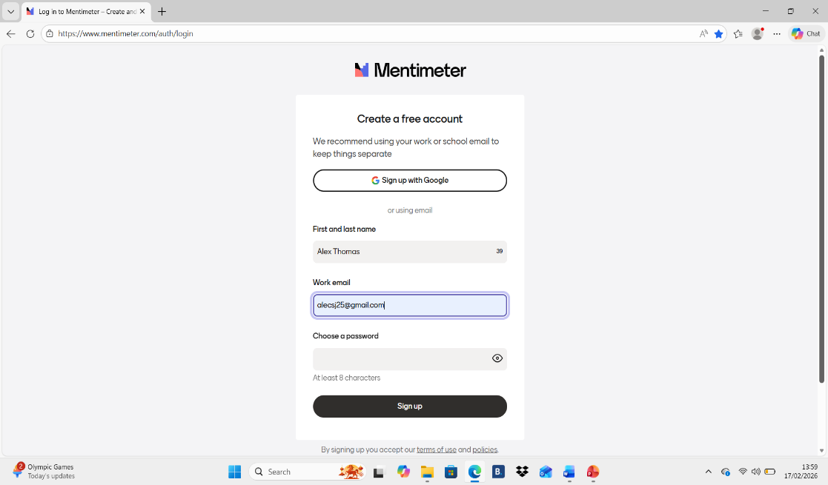

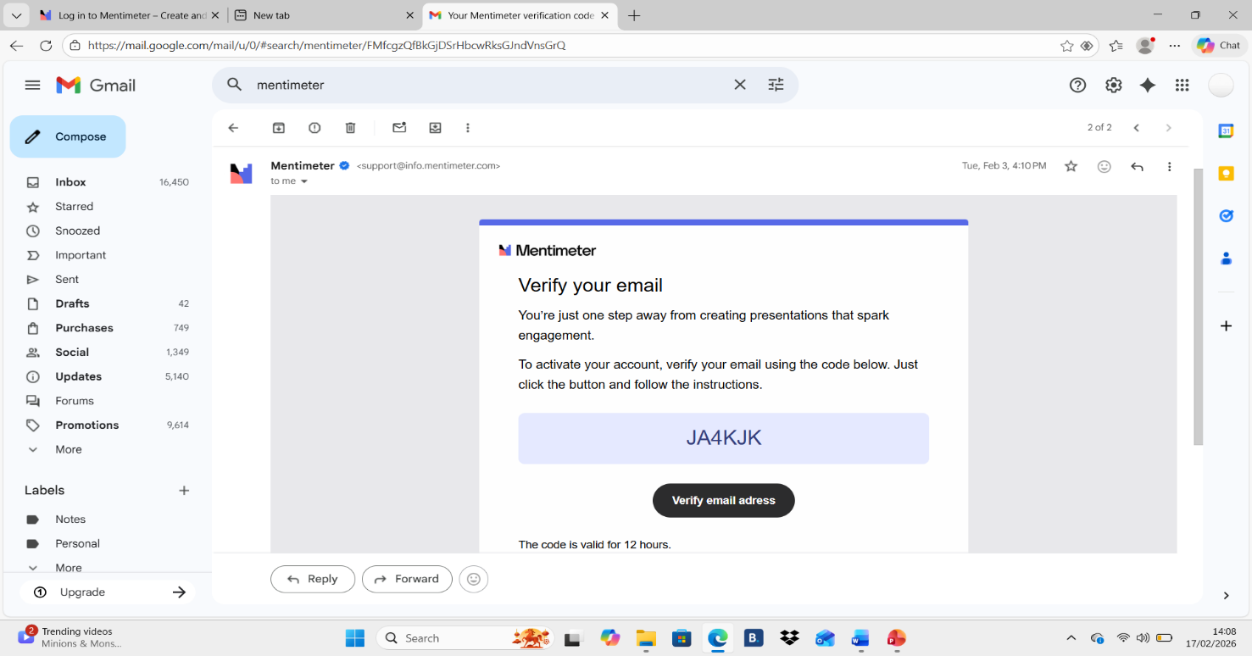

This initial stage involved accessing Mentimeter via: https://www.mentimeter.com/auth/signup?referral=homepage , inputting basic personal data (first and last name and e-mail address) and choosing a password. A security code was then sent to my e-mail address which I needed to use to complete the verification process.

Step 2: Directed to the Mentimeter homepage/Choosing a function for the classroom activity
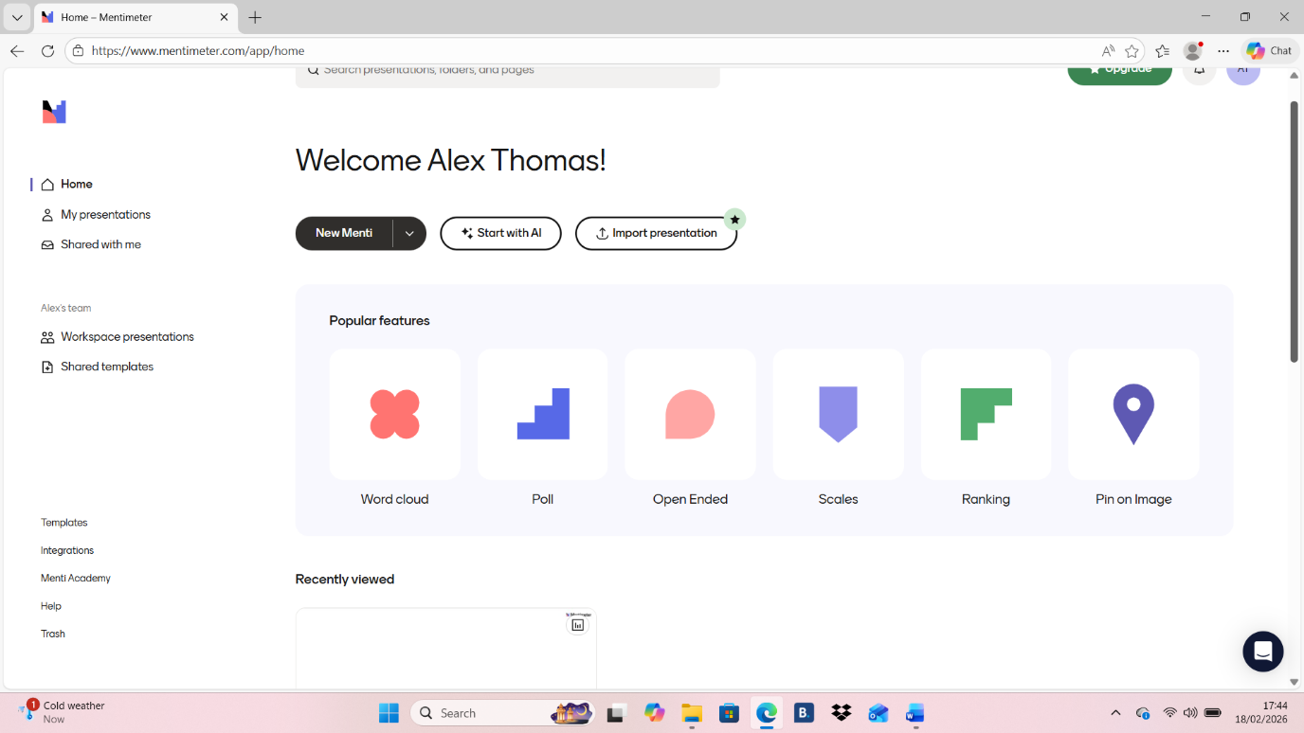

Following registration, the Mentimeter homepage was displayed showing its activity features. As a word cloud was of interest for my particular classroom activity, I clicked on this option to select it (circled above, red).

Step 3: Selecting an appropriate word cloud for the activity
‘Collect responses’ – This describes the word cloud’s primary function (gathering input from multiple individuals)
‘highlight the most common ones [responses]’ – This describes the word cloud’s secondary function (identifying common responses from multiple individuals)
‘A very popular way to start or end a session’ – This gives users an idea as to when during a lesson the use of a word cloud is usually most effective (here, teachers may identify a ‘last session recap’ or ‘brainstorming’ as possible strategies for the start and ‘quizzes’ or a student led ‘learning outcomes’ exercise at the end

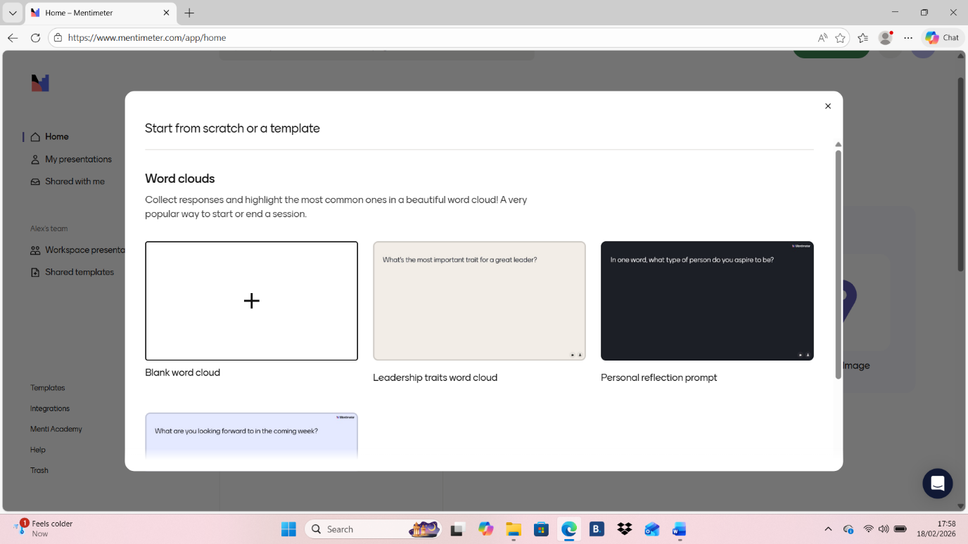

Due to a desire to start ‘from the bottom and up’, the ‘Blank’ template (squared above, red) became my choice for the activity.

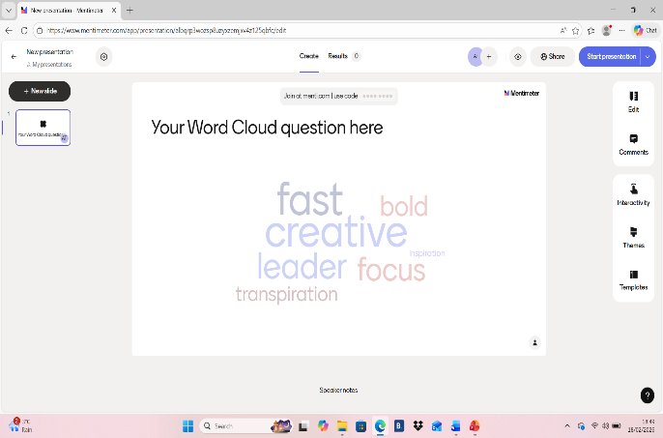
Step 4: Editing the template/Inputting the task question/instruction
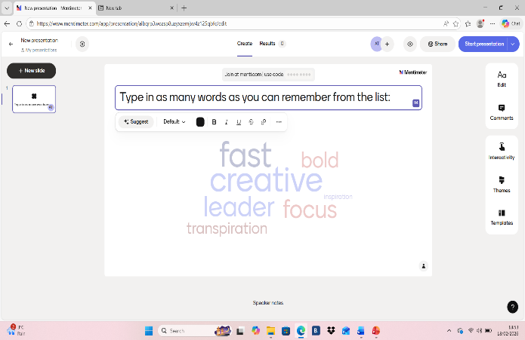

The blue arrow above shows how the original word cloud was edited to reflect what I wanted from the learners as part of the activity.

Step 5: Full presentation mode and QR code testing
Editing mode
Presentation mode
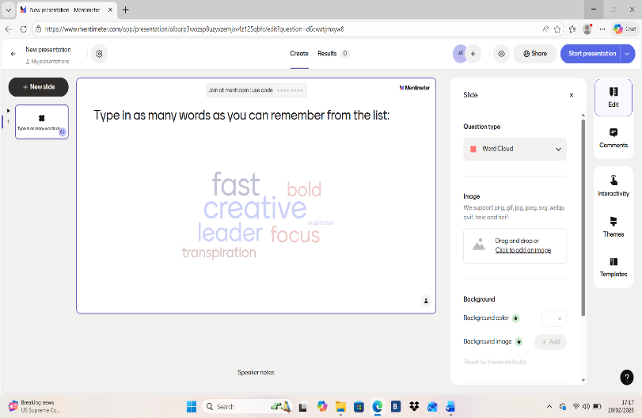
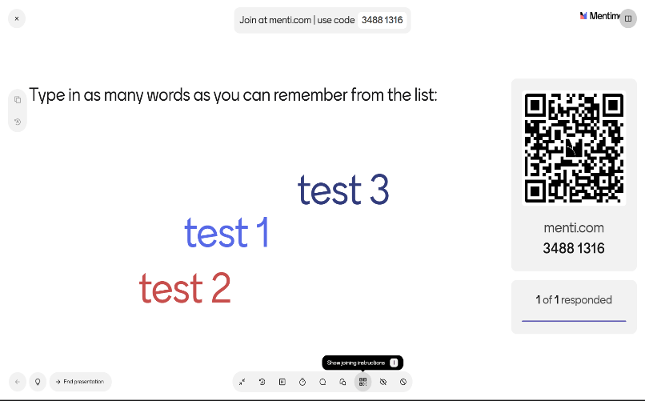

Different mobile devices were used in practice and in the pilot study to ensure that multiple responses could be made without problems being encountered
I tested the QR code (squared above, blue) with my own phone, and with help from family members who used their devices to connect to Mentimeter. No problems (e.g.) crashing, were encountered during this phase. The full-screen presentation mode (circled above, red) was also used in a pilot study with family, since this was the same screen that the learners were going to see on the day. This was also done to ascertain if the task was of the right difficulty for the cohort (e.g.) if family performed too poorly or too well, then the speed in which the words flashed on the PowerPoint would subsequently need to be slowed/quickened, or the number of overall words in the list decreased/increased, etc.

Step 6: Active use of the Mentimeter word cloud in a lesson
The ‘Do not show responses’ feature was used during the experiment so that learners could not simply copy and submit words that others had recalled from the screen, ensuring research validity. Only after the end of the task I showed and discussed the responses.
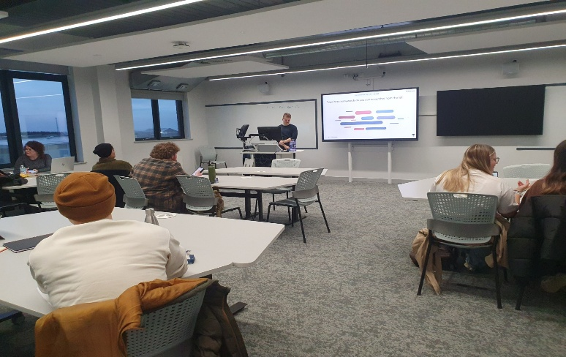
Laptop was connected via HDMI cable so the primary screen was extended onto the larger screen.

The picture above evidences my use of the word cloud in a lesson at UWTSD. My laptop was extended onto the larger screen via a HDMI cable so learners could see which words had been recalled at the end of the activity. The larger screen also allowed me to implement movement such as walking away from my laptop and use pointing gestures close to the board to discuss certain words more specifically. No major issues occurred during the implementation.

Step 7: Results and first stage of analysis
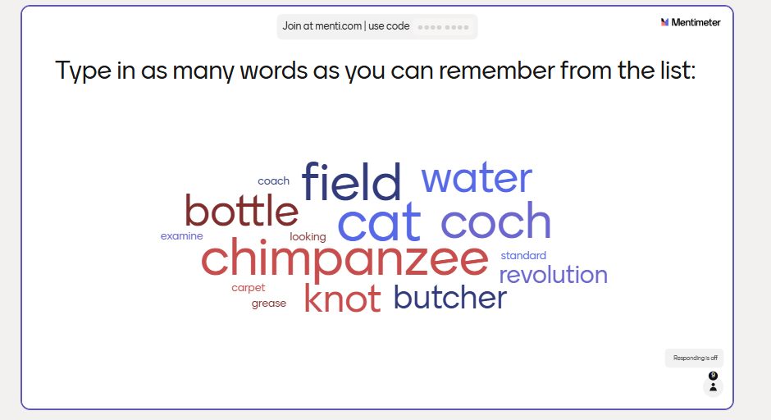

The above word cloud is a print screen of the learners’ responses to the task. The larger the size of the word, the more times it was recalled (Heimerl et al, 2014). This allowed for a superficial analysis to be done as part of the lesson itself, where I briefly explained classic memory and language theories to the learners and how these theories likely explain why certain words were recalled more than others.

Step 8: Results and second stage of analysis:

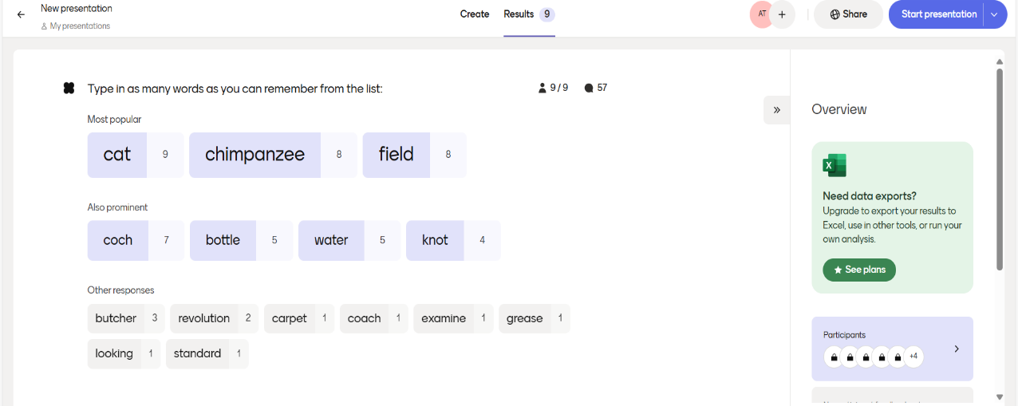

I used the ‘Results’ function on Mentimeter (circled above, red) which provided a more in-depth breakdown of the data.
Of the 9 learners who scanned the QR code before engaging in the activity (which was everyone in the class) all 9 responded – suggesting that the choice of digital tool and activity was an effective one (circled above, green). The activity garnered a total of 57 responses (circled above, blue) meaning that on average, each learner gave 6 responses.
The primacy and recency effect was successfully shown since words that appeared at the beginning and end of the list were better recalled than those in the middle (Murdock, 1962).The results also echo findings from other classic word-memory experiments where concrete words are better recalled than more abstract words (e.g.) ‘chimpanzee’ is more concrete than ‘examine’ which is why it was recalled more.
Inclusion of a Welsh word: ‘Coch’ in a predominantly English-speaking classroom also showed high recall (7 times), demonstrating a twist on the classic study, and how Mentimeter could be used in bilingual memory research.

5.) Evaluation and Reflection
This reflection focuses on my experience in setting up and making use of a Mentimeter word cloud in a classroom environment. Its primary aim is to give an honest and balanced account, drawing on both the positive and negative aspects of the experience, the overall feedback obtained from my cohort and how this information can be used for my future professional development.
My primary objective was to conduct a session in which the implementation of the digital tool was visibly successful (that is, simply achieving a word cloud with multiple responses). Witnessing the board fill up after only a few seconds of activating the cloud was an emotional relief and confirmation that my choice of activity was not only appropriate, but highly successful. The high level of participation from the learners (57 responses) clearly illustrates that my primary objective of generating a good digital word cloud had been achieved, and moreover, that online and digital learning technologies can generate high level of class participation if utilised properly (Liu, 2025). In doing this, I am ‘demonstrat[ing] commitment to learners…’and…’their learning.’ (EW, 2025)
My secondary objective was to generate findings that were consistent with the classic literature on memory and language – particularly those found in Murdock’s (1962) serial position study. After learners had been given 90 seconds to recall as many words as possible, seeing various words appear in different sizes on the cloud was particularly exciting. This meant that I had successfully generated results which implied the level of recall was dependent on factors such as its position in the PPT list during exposure and whether the word was concrete or abstract. As the results were clear to me immediately after displaying the responses, I was at ease when explaining the findings to learners and could confidently give the very explanation, backed by classic psychological research, that I had hoped to give, therefore actively showing knowledge of ‘how to use evidence and research’ as part of professional practice (EW, 2025).
Despite these triumphs, I have identified two areas in which the implementation may warrant improvement. The first of these comes from informal feedback obtained by one of my learners during the recall task. This individual, who is openly dyslexic, made a comment jestingly that whilst he could recall a particular word, he was unable to spell it correctly. Evidently, some may argue that from an ethical standpoint, use of a word cloud in this class, which was made visible to all after the recall phase, risks unintentionally exploiting one individual leading to ‘humiliation, anxiety, and fear of failure for [the] student with dyslexia’ should they have spelled a word incorrectly (Mori et al, 2025). However, the anonymity of a Mentimeter word cloud is a plausible counter for this argument, in that whilst all words submitted by users will appear on the screen, the author of these words is not immediately visible. If using a word cloud in future classrooms, I could ensure that I ‘Value and promote diversity, equality of opportunity and inclusion’ (EW, 2025) by taking a further step in quietly approaching known individuals in which use of a word cloud could be disadvantageous, and give them the opportunity to either sit-out that particular part of the session or welcome their contribution vocally or in writing if they are comfortable in doing so.
The second aspect which could be improved upon relates to the excessive time I spent focusing on one aspect of the digital tool. In doing so, opportunities to explore other features which may have been of equal use for my cohort have been missed, since my time, attention and efforts were solely dedicated to making this task an isolated success. This logic also seems to parallel with a minor error that took place during the lesson itself, where after the Mentimeter activity was complete, I forgot to present the learning outcomes as part of my plenary/conclusion. The literature highlights this phenomenon as ‘cognitive tunnelling’, where heightened focus on the largest or most important part of a task can lead to other aspects being forgotten about (Keller et al, 2022, p. 254). In moving forward then, I aim to be cautious of being fully attentive and immersed in one aspect of a task in a bid to ensure that other elements which have less weight (but are still important, such as explaining learning outcomes) are also remembered and completed. To evidence that I am ‘Critically reflect[ing] on [my] own values, knowledge and skills to improve [my] learning and leadership’ (EW, 2025), I have made a conscious effort to revisit and explore Mentimeter even though its implementation has now fulfilled the requirements for this module. Moreover, I am considering how I can use its other features, such as ‘Knowledge check quizzes’ and ‘Stress management training’ in my own upcoming teaching placements.
On a final and more positive front, use of this Mentimeter function has unequivocally put at rest any scepticism I had of word clouds before my lesson, such as the actions I would need to take if learners abused the tool through submitting inappropriate messages onto the cloud, a concern relating to the anonymity effect which has been explored by Mondal et al (2020). In my own case, it seems that having a good rapport with my peers and creating a task that alluded to ‘test-like’ conditions without being too overwhelming was successful in averting users from abusing the tool, instead embracing and giving the task a good go. Relative to this, I have learnt through further exploring Mentimeter post-lesson that there are censoring functions available, such as how the teacher can view all submissions made by users before they actually appear on the cloud, and subsequently approve those which are appropriate and denying those which are not. Making use of the very digital function that I was most concerned about for this reason has clearly been beneficial in increasing my confidence with digital tools more generally and by extension, my future willingness to foster a ‘give it a chance’ attitude with this kind of technology in the classroom.
Whilst I still find myself hoping that my position in preferring traditional pedagogical tools is not compromised anytime soon, the experience of using Mentimeter for the first time in a lesson has mellowed any bias I may have had against higher-level technologies and their place in education (Nazaretsky et al, 2021). By extension, I am beginning to take seriously that ‘digital literacy and the use of digital technologies to enhance teaching and learning’ is in fact a professional standard (EW, 2025) and will make active efforts to utilise tools where they truly give benefit, without employing to the extent where they start detracting from pedagogy.
Word count: 4,124 (excluding lesson plan and screenshot annotations).

References
Anand, B., Mishra, I., Beri, G. and Chaudhary, K.L. (2024) ‘Types of learning: domains of learning–cognitive, affective, and psychomotor, learning theories, experiential learning,’ Extension Methods, ICT and Educational Technology, pp. 53-82. Available at: https://www.researchgate.net/profile/Basu-Anand-2/publication/383704726_Types_of_Learning_Domains_of_Learning-_Cognitive_Affective_and_Psychomotor_Learning_Theories_Experiential_Learning_3/links/66d8054dfa5e11512c73eed0/Types-of-Learning-Domains-of-Learning-Cognitive-Affective-and-Psychomotor-Learning-Theories-Experiential-Learning-3.pdf [Accessed: 24 February 2026].
Barton, R. and Haydn, T. (2006) ‘Trainee teachers’ views on what helps them to use information and communication technology effectively in their subject teaching,’ Journal of Computer Assisted Learning, 22(4), pp. 257–272. Available at: https://doi.org/10.1111/j.1365-2729.2006.00175.x [Accessed: 22 February 2026].
Begoña Bellés-Fortuño and Ana-Isabel Martínez-Hernández (2020) ‘The use of wordclouds for vocabulary retention in the English for Psychology classroom,’ The EUROCALL Review, 28(2), pp. 64–77. Available at: https://doi.org/10.4995/eurocall.2020.12995 [Accessed: 22 February 2026].
BHSF (2025) Digital Fatigue Is Real: How HR can safeguard employee wellbeing. Available at: https://www.bhsf.co.uk/news-insights/opinion/digital-fatigue-is-real-how-hr-can-safeguard-employee-wellbeing [Accessed: February 27 2026].
Çekiç, A. and Bakla, A. (2021) ‘A review of digital formative assessment tools: Features and future directions,’ International Online Journal of Education and Teaching, 8(3), pp. 1459-1485. Available at: https://files.eric.ed.gov/fulltext/EJ1308016.pdf [Accessed: 19 Febuary 2026].
Chuaungo, M.L. et al. (2022) Integrating technology with constructivist pedagogy. International Journal of Engineering Technology and Management Sciences, 5(6), pp. 104-109. Available from: https://d1wqtxts1xzle7.cloudfront.net/109852332/Vol-6-Issue-5-14-libre.pdf?1704096812=&response-content-disposition=inline%3B+filename%3DIntegrating_Technology_with_Constructivi.pdf&Expires=1772236161&Signature=Ae3qyhsqjUJWzVpwvxwc8C2r-yM5g4n5XA08V2wBgdGsd93ne~50VtGq~6gxeCMsofLDM9e3n4QU3cpBW3sLUWEW5SJ4MSr5rt8RR-G34FAwXUbXM5-FWbZQ6xDh688OPDo0jJpsXBjb9~0ObFkt5QAzzDuMuUsUMxPrxRcjQvA586n1IvbmTNUbJ3VcTgNe7Rx7w5lKrjtBfYSE67V3oK5ri0kPK~XOe2eVsWaI3GzxsZ6djSfhetRu-33DnfRaOwVLx59QEF3CkqEOYL4VUvbPDjksLpojva6bfasTUj8v9im9O1JXGy5PH4NxY-9J3szFaZU~JRWK~8a9QvqPPA__&Key-Pair-Id=APKAJLOHF5GGSLRBV4ZA [Accessed: 27 February 2026].
DeCoito, I. and Richardson, T. (2018) Teachers and technology: Present practice and future directions. Contemporary Issues in Technology and Teacher Education, 18(2), pp. 362-378. Available at:file:///C:/Users/joshu/Downloads/article_180395.pdf [Accessed: 24 February 2026].
DePaolo, C.A. and Wilkinson, K. (2014) ‘Get your head into the clouds: Using word clouds for analyzing qualitative assessment data,’ Tech Trends, 58(3), pp. 38–44. Available at: https://doi.org/10.1007/s11528-014-0750-9 [Accessed: 27 February 2026].
Ebbels, S.H. et al. (2022) ‘Effectiveness of intervention focused on vocational course vocabulary in post‐16 students with (developmental) language disorder,’ International Journal of Language & Communication Disorders, 57(6), pp. 1334–1353. Available at: https://doi.org/10.1111/1460-6984.12758 [Accessed: 19 February 2026].
Educators Wales/Addysgwyr Cymru (2026) professional standards for further education and work-based learning leaders in Wales. Available at: https://educators.wales/leaders-professional-standards [Accessed: 21 February 2026].
Elibol, N. (2014) The role of episodic and semantic memory on exam performance among freshmen and senior students in psychology (Master's thesis, Middle East Technical University (Turkey) Available at: file:///C:/Users/joshu/Downloads/index.pdf [Accessed: 26 February 2026].
Ennis, L. et al. (2012) ‘Can’t surf, won’t surf: The digital divide in mental health,’ Journal of Mental Health (Abingdon, England), 21(4), pp. 395–403. Available at: https://doi.org/10.3109/09638237.2012.689437 [Accessed: 27 February 2026].
Filatova, O. (2016) “More Than a Word Cloud,” TESOL Journal, 7(2), pp. 438–448. Available at: https://doi.org/10.1002/tesj.251 [Accessed: 27 February 2026].
Gascoine, L., Wall, K. and Higgins, S. (2024) What can creative data analysis using word clouds tell us about student views of learning something new?. The Handbook of Creative Data Analysis, pp.1-506. Available at: https://www.researchgate.net/profile/Steven-Higgins-4/publication/383946489_Word_clouds_as_creative_data_analysis_-_what_can_they_tell_us_about_student_views_of_learning_something_new/links/69417c840c98040d481e4ee4/Word-clouds-as-creative-data-analysis-what-can-they-tell-us-about-student-views-of-learning-something-new.pdf [Accessed: 21 February 2026].
Heimerl, F. et al. (2014) ‘Word cloud explorer: text analytics based on word clouds,’ in 2014 47th Hawaii International Conference on System Sciences. IEEE, pp. 1833–1842. Available at: https://doi.org/10.1109/HICSS.2014.231 [Accessed: 25 February 2026].
Hussein, K. et al. (2025) ‘Adapting pedagogical scaffolding for digital natives through technology.’ Education, 7(26), pp.766-776. Available at: https://www.researchgate.net/profile/Siti-Ahmad-Khairundin-2/publication/396220053_INTERNATIONAL_JOURNAL_OF_MODERN_EDUCATION_IJMOE_ADAPTING_PEDAGOGICAL_SCAFFOLDING_FOR_DIGITAL_NATIVES_THROUGH_TECHNOLOGY/links/68e32d6c9383755fd7095d8d/INTERNATIONAL-JOURNAL-OF-MODERN-EDUCATION-IJMOE-ADAPTING-PEDAGOGICAL-SCAFFOLDING-FOR-DIGITAL-NATIVES-THROUGH-TECHNOLOGY.pdf [Accessed: 27 February 2026].
Jumpakate, T. (2020) ‘Word clouds and English language teaching in Thai classroom’. RMUTK Journal of Liberal Arts, 2(1), pp.15-26. Available at: file:///C:/Users/joshu/Downloads/kiatisak_s,+2+(49)Word+Clouds+and+English+Language+Teaching+in+Thai+Classroom%20(2).pdf [Accessed: 22 February 2026].
Keller, L. et al. (2022) ‘Noticing and weighing alternatives in the reflection of regular classroom teaching: Evidence of expertise using mobile eye-tracking,’ Instructional Science, 50(2), pp. 251–272. Available at: https://doi.org/10.1007/s11251-021-09570-5 [Accessed: 24 February 2026].
Kolly-Shamne, A. (2022) ‘The concept of zone of proximal development and its derivatives: Problems and prospects of modern interpretations,’ Scientific Bulletin of Mukachevo State University Series “Pedagogy and Psychology, 8(3), pp.81-95. Available from: https://pp-msu.com.ua/web/uploads/pdf/Scientific%20Bulletin%20of%20Mukachevo%20State%20University.%20Series%20%E2%80%9CPedagogy%20and%20Psychology%E2%80%9D_2022_Vol.%208,%20No.%204.-81-95.pdf [Accessed: 23 February 2026].
Leshchenko, Т. and Zhovnir, M. (2020) ‘Visualization tools: using word clouds in teaching Ukrainian as a Foreign Language,’ Available from: https://repository.pdmu.edu.ua/server/api/core/bitstreams/8c0bb346-3852-40d1-9bee-5be06f4d88c9/content [Accessed: 26 February 2026].
Lin, X., Cui, H. and Powell, S.R. (2025) ‘Supporting mathematics vocabulary development for students with learning difficulties: an instructional routine,’ Intervention in School and Clinic, 61(1), pp. 38–46. Available at: https://doi.org/10.1177/10534512251337394 Accessed: 24 February 2026].

Liu, N. (2025) ‘The integration of digital educational tools in english classrooms: a mixed-methods study on student participation and skill development in higher education,’ Education and Information Technologies, 30(18), pp. 25707–25751. Available at: https://doi.org/10.1007/s10639-025-13743-x [Accessed: 27 February 2026].

Michaelsen, A. S. (2020) The digital classroom: transforming the way we learn. Routledge.
Mondal, M., Correa, D. and Benevenuto, F. (2020) ‘Anonymity effects: A large-scale dataset from an anonymous social media platform,’ in Proceedings of the 31st ACM Conference on Hypertext and Social Media, pp. 69–74. Available at: https://doi.org/10.1145/3372923.3404792 [Accessed: 27 February 2026].
Mori, J. et al. (2025) ‘Challenging school-related situations faced by students with dyslexia: a scoping review,’ Annals of Dyslexia [Preprint]. Available at: https://doi.org/10.1007/s11881-025-00356-9 Accessed: 19 February 2026].
Murdock, B.B., Jr. (1962) ‘The serial position effect of free recall’, Journal of Experimental Psychology, 64(5), pp. 482–488. Available at: doi:10.1037/h0045106 [Accessed: 20 February 2026].
Musliha, S. and Purnawarman, P. (2020) ‘Using mentimeter for eliciting the students’ responses in formative assessment practice,’ In 1st International Conference on Information Technology and Education (ICITE 2020) pp. 318-325. Available at: file:///C:/Users/joshu/Downloads/125948645.pdf [Accessed: 22 February 2026].
Nazaretsky, T., Cukurova, M., Ariely, M. and Alexandron, G. (2021) ‘Confirmation bias and trust: human factors that influence teachers' attitudes towards AI-based educational technology,’ In CEUR Workshop Proceedings, Vol. 3042. Available from: https://discovery.ucl.ac.uk/id/eprint/10141423/1/paper_4.pdf [Accessed: 25 February 2026].
Nkomo, L.M., Daniel, B.K. and Butson, R.J. (2021) ‘Synthesis of student engagement with digital technologies: a systematic review of the literature,’ International Journal of Educational Technology in Higher Education, 18(1), pp. 34–26. Available at: https://doi.org/10.1186/s41239-021-00270-1 [Accessed: 19 February 2026].
Panero, M. and Aldon, G. (2016) ‘How teachers evolve their formative assessment practices when digital tools are involved in the classroom,’ Digital Experiences in Mathematics Education, 2(1), pp. 70–86. Available at: https://doi.org/10.1007/s40751-016-0012-x [Accessed: 24 February 2026].
Pearcy, M. (2016) ‘‘A wordle to the wise’: using ‘word clouds’ meaningfully in the classroom,’’ Social Studies Research & Practice, 11(2), pp. 96–110. Available at: https://doi.org/10.1108/SSRP-02-2016-B0008 [Accessed: 22 February 2026].
Su, W.S. and Chang, C.Y. (2025) ‘An integrative review with word cloud analysis of STEM education,’ Journal of Science Education and Technology, 34(5), pp. 1227–1240. Available at: https://doi.org/10.1007/s10956-024-10134-8 [Accessed: 26 February 2026].
Tanner, K.D. (2013) ‘Structure matters: twenty-one teaching strategies to promote student engagement and cultivate classroom equity,’ CBE—Life Sciences Education, 12(3), pp. 322-331. Available at: https://www.lifescied.org/doi/pdf/10.1187/cbe.13-06-0115 [Accessed: 25 February 2026].
Tummons, J. (2020) PCET: Learning and teaching in the post compulsory sector. SAGE Publications Ltd.
Watkins, A. (2006) ‘So what exactly do teacher-researchers think about doing research?,’ Support for Learning, 21(1), pp. 12–18. Available at: https://doi.org/10.1111/j.1467-9604.2006.00394.x [Accessed: 26 February 2026].
WJEC/CBAC (2024) WJEC GCE AS/A Level in psychology. Available at: https://www.wjec.co.uk/media/veplsnrk/wjec-gce-psychology-spec-from-2015-e-07-08-24.pdf [Accessed: 27 February 2026].
Zamri, M.T. and Mohamad, S.A. (2025) ‘Technology integration in education: A review and analysis of SAMR model,’ International Journal of Research and Innovation in Social Science, 8(3), pp. 6195-6200. Available at: https://www.researchgate.net/profile/Mohd-Zamri/publication/388002093_Technology_Integration_in_Education_A_Review_and_Analysis_of_SAMR_Model/links/67a57c22461fb56424cca6bb/Technology-Integration-in-Education-A-Review-and-Analysis-of-SAMR-Model.pdf [Accessed: 24 February 2026].

