Motivation in Leadership and Management

Sioned Phillips

14th March 2019

Contents Page
Page 3
- Abstract
- Introduction

Page 4
- Introduction
- Main Body

Page 5
- Main Body

Page 6
- Main Body
- Conclusion

Page 7
- Recommendations
- Appendix

Page 8 & 9
- References

Abstract
The task was to evaluate the role of leaders and managers in the NHS. The health service needs a strong management and leadership team to act as a foundation in order to provide fundamental essential care for the UK’s ever increasing population. It was discovered that good communication between management and staff is essential and members of staff need to be listened to at all times. The NHS has moved on since the days of the stand-alone heroic leader with everyone in the NHS playing a crucial part in delivering the best care possible for all patients. Henry Mitzberg recognised and understood that managers are constantly switching roles due to changeful circumstances and he recommends using his ten behaviours that can suit and assist a manager’s role. These ten behaviours were figurehead, leader, liaison, monitor, disseminator, spokesperson, entrepreneur, disturbance handler, resource allocator and negotiator. It was seen that over the last 70 years since the NHS was established, management and leadership roles have changed dramatically. When it was first established the NHS was a small, less complex organisation and hospitals were managed by a medical superintendent, a matron and a lay administrator. Chris Ham who is the chief executive of the King’s Fund stated that “the NHS cannot be run without high quality management and leadership. This will only happen through a commitment of time and resources and a willingness to value the role of managers whatever their background”. It was also found that there have been several attempts to improve the management and leadership in the NHS over the last 50 or so years, followed by never ending train of Government paperwork and legislation. In 1967, the King’s Fund/Institute of Hospital Administrators joint working party reported that a hospital board was required to safeguard public interest but there should be a clear gain of command.
Introduction
According to The King’s Fund (2011) the requirement for good management is almost a given. Nothing effective happens without budgeting, scheduling and implementation and an organisation with good leadership and management would get nowhere without administration. In other words without leadership there can be no effective management and without good administration management would be rendered ineffective.
On the 5th of July 1948, the NHS was set up and the purpose was to provide a comprehensive range of health services to all UK residents, funded by general taxation and free to use (Harker, 2012). In the earliest days of the NHS, the task managers were administration rather than leadership- organisations were smaller and less complex. Increasing complexity has shaped the development of the management task: the NHS has grown exponentially, with complex structures developing to underpin it. While there was once a simple accountability hierarchy from front-line services to the Secretary of State, there is now a complex system of public and private providers, with a plethora of regulators who impact on what managers need to do (The King’s Fund, 2011).
Effective leadership and quality management are fundamental in a changeable business setting. This is no less true of the NHS which currently faces some of its hardest challenges: staff are under pressure constantly to improve performance at a time of diminishing resources (Gritton, 2013). Other issues may include new demands, new institution and high expectations from patients and the public that service and care will be provided efficiently, effectively and with compassion (Storey & Holti, 2013).
Main body
Official statistics put the proportion of managers in the NHS around 2.9% but new data shows that around 30% of staff in acute trust has some form of managerial role. Many of these are hybrid roles- the clinical manager, such as ward sister or clinical director, who combine patient care with supervision of staff, holding budgets and planning services. These hybrid roles outnumber dedicated service managers by four to one. However, most are part-time with little management education and support. Most importantly, they often do not see themselves as managers (HS&DR, 2013). The term leaders and managers are often used interchangeably and in some contexts management has been defined as governing in a steady state, whereas leadership is about managing change. In practice, most senior roles demand both management and leadership. However, it is useful to turn to the particular evidence base on leadership to chart the shift in understanding these terms (HS&DR, 2013).
There have been many attempts to improve the management and leadership in the NHS over the last 50 or so years, followed by never ending train of Government paperwork and legislation (Gritton, 2013)
There are three main management styles, authoritarian, democratic and laissez-faire. Authoritarian also known as autocratic is a leadership style defined by individual control over all decision making with little contribution from group members. Authoritarian leaders often make decisions based on their judgments and ideas and rarely accept advice from others (Cherry, 2019).
Democratic leadership also known as participative/shared leadership is where members of the group get involved in the role of the decision making process. This type of leadership is usually seen in schools, private businesses and government (Cherry, 2018).
Delegative or laissez-faire leadership is where leaders are less involved in decision making and allow group members to do the decision making. Research shows that this style of leadership eventually leads to lowest productivity among group members (Cherry, 2019).
After studying leadership and management for twenty years, Lake (2016) claims that the definition of management is planning, organising, commanding, coordinating and control. This is all well and good but as soon as budgets are cut and performance within certain sections starts to slip, causing pressure to build, resulting in staff sickness and low morale. This point shows that leadership and management are equally important. Good management leaders needs to be able to handle a budget and write business cases as well as having HR skills such as being able to manage sickness and grievances.
Powell and Thompson (2010) state that the main political parties have highlighted a number of opportunities to cut back in the NHS while protecting front line services, one of them being cutting back on staff pay and pensions. This would lead to low staff morale, staff shortages and hospitals having to rely on bank staff. This is false economy as nurses are selling their services at a higher rate and it also leads to conflict between the bank staff and other members of staff as they are getting paid different rates to do the same job.
Today’s healthcare managers at all levels in the organisation face increased demands, rapidly changing environments and strained resources. Traditional boundaries and silos have often been broken down, which creates new challenges for those running services. Many of the problems facing middle or frontline managers are complex issues without simple, technical solutions. They require negotiation and political skills, engaging a range of stakeholders in networks and partnerships forms (HS&DR, 2013).
In general management research, there has long been recognition of the gap between what managers are supposed to do- in Mintzberg’s words “plan, organise, coordinate, control” – and what they actually do in their working day. This classic study showed that managers’ work was fragmented and contingent, with considerable discretion as to what they did and how they did it (HS&DR, 2013).
Management expert Professor Henry Mintzberg understood that managers are constantly switching roles due to change of circumstances. He argued that there are ten behaviours that can be used to categorise a manager’s different roles. In his book “Mintzberg on Management: Inside our Strange World of Organisations”, these ten behaviours were published as, figurehead, leader, liaison, monitor, disseminator, spokesperson, entrepreneur, disturbance handler, resource allocator and negotiator (Mind Tools, n.d).
Also in his book, Mintzberg puts these ten behaviours into three categories: interpersonal roles, informational roles and decisional roles (Zartler, 2016).
The figurehead’s role is for social, ceremonial and legal matters- they represent their company in a professional way. The leader must communicate with, coach and inspire their team and they should be able to go to the manager for support and guidance. Liaisons are in charge of networking outside of the company and relaying important information. All of these behaviours are in the interpersonal group (Caramela, 2018).
In the informational group there is: the monitor and they seek information within and outside their company to identify issues that need to be approached or changes that need to be made. Disseminator should then deliver important information to employees and delegate assignments appropriately. A spokesperson should deliver information externally and represent the company (Caramela, 2018).
Finally, in the decision-making group, the disturbance-handler who should deal with any conflict, issues or roadblocks. Resource allocator, managers should allocate and oversee various resources, from finding to equipment. The negotiator’s role is participating and directing negotiations within the organisation. Acting as an entrepreneur, managers should push change and innovation and create new ideas (Caramela, 2018).
In terms of decision-making and responsibilities, a more distributed leadership with a range of styles among many tiers and professions is being seen throughout an organisation (HS&DR, 2013).

Conclusion
Over the last 70 years since the NHS was established, management and leadership roles have changed dramatically. When it was first established the NHS was a small, less complex organisation and hospitals were managed by a medical superintendent, a matron and a lay administrator. Many of the research studies use a mixture of methods, including observational research, to generate evidence on how managers work in practice. This addresses gaps noted in previous evidence, which often examined leadership traits and characteristics in isolation divorced from the reality of lived experience (HS&DR, 2013). In 1967, the King’s Fund/Institute of Hospital Administrators joint working party reported that a hospital board was required to safeguard public interest but there should be a clear gain of command. In 2010, all political parties expressed a desire to move away from “command and control” management to an increasingly shared agenda between managers and clinicians. The King’s Fund established a commission also in 2010 to investigate and report on management and leadership in the NHS. They looked into the quality and financial challenges facing the healthcare system and attempted to come up recommendations to strengthen and develop management and leadership in the NHS. Chris Ham, the chief executive of the King’s Fund stated that “the NHS cannot be run without high quality management and leadership. This will only happen through a commitment of time and resources and a willingness to value the role of managers whatever their background” (The King’s Fund, 2011).

Recommendations
- Give staff support, recognition and encouragement
- Happy staff make happy patients
- Staff need to feel respected, empowered, listened to and influenced to improve care
- Managers should promote resilience, optimism and self-belief
- Build team commitment and a positive emotional environment (Storey & Holti, 2013)
- Encourage staff involvement and engagement (Storey & Holti, 2013)
- Provide and justify a clear sense of purpose and contribution (Storey & Holti, 2013)

Appendices
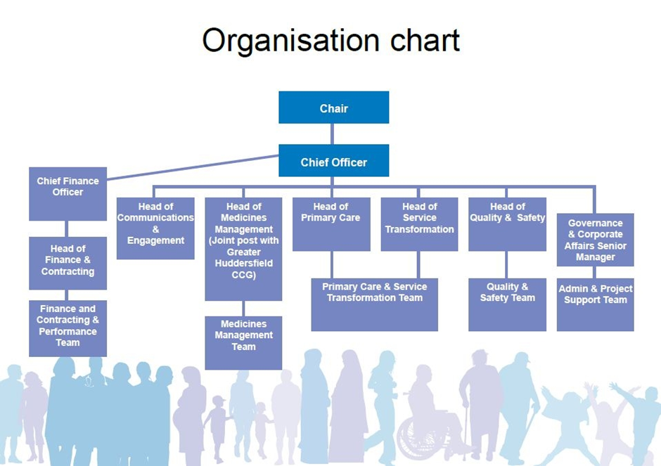
(NHS, 2014) Word count – 1,811
References
Cherry, K (2018) what is democratic leadership? [online] available at: https://www.verywellmind.com/what-is-democratic-leadership-2795315 accessed on 22/03/2019
Cherry, K (2019) autocratic leadership [online] available at: https://www.verywellmind.com/what-is-autocratic-leadership-2795314 accessed on 22/03/2019
Cherry, K (2019) what is laissez-faire leadership? [online] available at: https://www.verywellmind.com/what-is-laissez-faire-leadership-2795316 accessed on 22/03/2019
Gritton, J (2013) NHS leadership framework: distributed leadership or emperor’s new clothes? [online] available at: https://www.academia.edu/9439556/The_New_NHS_Leadership_Framework_Distributed_Leadership_or_Emperor_s_New_Clothes accessed on 20/03/2019
Harker, R (2012) NHS funding and expenditure [online] available at: http://www.nhshistory.net/parlymoney.pdf accessed on 21/03/2019
Health Services and Delivery Research Programme (2013) new evidence on management and leadership [online] available at: https://www.journalslibrary.nihr.ac.uk/downloads/research-programmes/HSDR/New-Evidence-on-Management-and-Leadership.pdf accessed on 20/03/2019
Mind Tools (n.d) Mintzberg’s management tools [online] available at: https://www.mindtools.com/pages/article/management-roles.htm accessed on 20/03/2019
NHS (2014) Organisation chart [online] available at: https://www.northkirkleesccg.nhs.uk/about-us/meet-the-senior-management-team/attachment/organisation-chart-2/ accessed on 23/03/2019
Storey, J & Holti, R (2013) towards a new model of leadership for the NHS [online] available at: https://www.leadershipacademy.nhs.uk/wp-content/uploads/2013/05/Towards-a-New-Model-of-Leadership-2013.pdf accessed on 20/03/2019
The King’s Fund (2011) the changing role of managers in the NHS [online] available at: https://www.kingsfund.org.uk/publications/future-leadership-and-management-nhs/changing-role-of-NHS-managers accessed on 20/03/2019
The King’s Fund (2011) the future of leadership and management in the NHS [online] available at: https://www.kingsfund.org.uk/sites/default/files/future-of-leadership-and-management-nhs-may-2011-kings-fund.pdf accessed on 22/03/2019
Zartler, J (2016) Mintzberg model: 10 different roles of a successful manager [online] available at: https://medium.com/taskworld-blog/mintzberg-model-10-different-roles-of-a-successful-manager-77f9d87b773c accessed on 20/03/2019

