University of Wales Trinity Saint David
School of Engineering



Application of CAE Processes

ACHA6010

Nicholas Davey
2104746
07/12/2025
Word Count: 3,080 (Not including titles & Reference list)
Contents
1.0 - Abstract 4
2.0 - Introduction 4
3.0 - CAE Theory 5
3.1 - Kinematic Analysis 5
3.2 - Static Structural Finite Element Analysis 6
3.3 - Thermal Effects on Structural Analysis 6
4.0 - Assembly 7
5.0 - Methodology 8
5.1 - Kinematic Analysis Methodology 8
5.2 - Structural, Thermal & Fatigue Analysis Methodology 8
6.0 - Ansys Simulation 9
9
10
11
6.1 - Kinematic Analysis 15
7.0 – Design Optimisation 15
8.0 – Limitations 16
9.0 - Conclusion 17
10.0 – References 18

1.0 - Abstract
This study investigates the application of Computer Aided Engineering (CAE) software to the structural assessment and optimisation of a specific mechanical component operating within a multi-body assembly.
Using the provided components, an assembly was created and analysed to replicate realistic operating conditions, starting with a Kinematic Simulation to determine reaction forces generated during motion. These loading conditions were then applied to a Static Structural Analysis of a specific component, incorporating temperature-dependant material degradation to more accurately represent real world scenarios. Using the chosen part, a redesign process took place to enhance structural performance, improve fatigue life, and reduce mass while maintaining adequate safety margins. Finally, a validation study was performed using Ansys Workbench 2024 to compare numerical predictions with theoretical results. A mesh study was also completed to assess solution accuracy and investigate the influence of boundary condition definitions.
The data gathered will highlight both the strengths and limitations of CAE tools in supporting engineering decision making. Overall, this study demonstrates the importance of realistic load generation, robust validation, and a step-by-step optimisation process of the effectiveness of CAE within the engineering design process.

2.0 - Introduction
Computer Aided Engineering (CAE) has become a crucial component of modern engineering design, enabling engineers to model, simulate and refine components long before physical prototypes are produced. Within automotive and motorsport sectors where reliability, structural performance and weight optimisation is essential, CAE tools like Ansys play a decisive role in supporting data-driven, and informed design decisions. By allowing complex assembles to be visualized and analysed under realistic driving conditions, CAE significantly reducing development time and cost by improving accuracy of predictions made.
This study focus’ on the Simulation and structural assessment of a chosen mechanical component operating within a multi-body assembly. The process begins with the creation of a multi-body assembly using the provided parts.
A kinematic analysis is conducted to determine reaction forces, accelerations, and constraints generated during motion. These results form the loading conditions for a static structural analysis of a chosen component. Incorporating thermal effects into the simulation allows for a more relative representation to assess component performance, particularly material degradation during increased temperatures.
A core objective of this assignment is to improve component design. The analysis of stress distributions, deformation patterns, and fatigue indicators allow for further design modifications to enhance structural integrity while minimizing mass. This reflects real-world engineering practice, where iterative refinement is vital in achieving performance targets.
Finally, a validation study is undertaken to evaluate the reliability of the computational results. By using Ansys to replicate and compare outcomes, the accuracy and limitations of the approach can be assessed. Furthermore, a mesh independence study further evaluates how element sizing influences solution accuracy, while additio0nal consideration is given to the sensitivity of boundary layer conditions.
Overall, this report will demonstrate how CAE tools can be used in the engineering design process which highlights both their capabilities and limitations.
The combination of kinematic analysis, structural assessment, optimisation, and validation provides a comprehensive insight into the practical application of CAE in real-world engineering environments.

3.0 - CAE Theory
Computer Aided Engineering (CAE) Refers to the use of computational tools to predict the behaviour of engineering systems under specified conditions. In mechanical, automotive and motorsport engineering, CAE is widely used to assess structural performance, component geometry optimisation and to reduce development time and cost before practical testing. However, while CAE provides a valuable insight into system behaviour, its accuracy is highly dependent on model fidelity, boundary condition, and validation against theory.

3.1 - Kinematic Analysis
Kinematic Analysis is concerned with the motion of a mechanical systems without the consideration of deformation or internal stresses. In multi-body systems, components are assumed to behave as rigid bodies connected through joints that constrain degrees of freedom. By defining joint types, constraints, and prescribed motions, kinematic simulations can be used to determine displacements, velocities, accelerations, and reaction forces throughout an assembly.
Within a CAE workflow, Kinematic Analysis plays a pivotal role in generating realistic loading conditions for structural analysis. Reaction forces calculated at joints or interfaces represent the forces transmitted between components during operation. Using kinematic-derived loads improves the realism of structural simulations when compared to applying simplified or assumed loading conditions.

3.2 - Static Structural Finite Element Analysis
Finite Element Analysis (FEA) is a computational technique used to predict how a structure behaves when loads and constraints are applied. The method works by dividing a component into many small elements, allowing the overall behaviour of the structure to be calculated from the response of each element. In a static structural analysis, the component is assumed to be in a steady state, meaning that inertia and time-dependent effects are ignored.
Linear static FEA assumes that the material behaves elastically and that deformations remain small. Under these assumptions, stress is directly proportional to strain and material behaviour can be defined using properties such as Young’s modulus and Poisson’s ratio. The von Mises stress criterion is commonly used to evaluate yielding in ductile materials by providing a single stress value that can be compared to the material’s yield strength.
Although static structural FEA is widely used due to its efficiency, the accuracy of the results depends strongly on modelling assumptions, mesh quality, and how loads and boundary conditions are applied. For this reason, validation and critical interpretation of results are essential to ensure that the analysis provides meaningful and reliable engineering insight.

3.3 - Thermal Effects on Structural Analysis
Thermal loading can significantly influence structural behaviour, particularly in automotive and motorsport applications where components operate at higher temperatures. Changes in temperature can lead to thermal expansion, internal stresses and degradation of material properties such as strength and stiffness.
Incorporating thermal effects into structural analysis typically involves applying a uniform temperature distribution and using temperature-dependent material properties. When combined with mechanical loading, thermal strains can either increase or reduce overall stress depending on constraint conditions. Including thermal effects allows CAE simulations to more accurately represent real operating environments, though assumptions regarding temperature distribution and material behaviour remain a source of uncertainty.

4.0 - Assembly
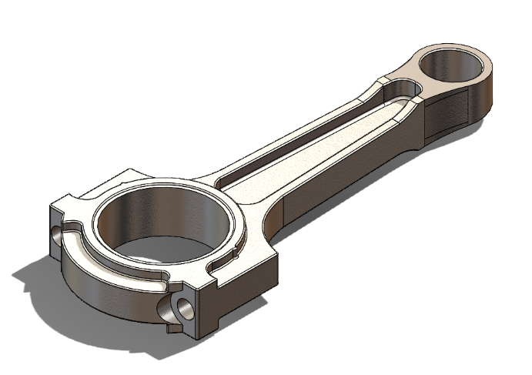
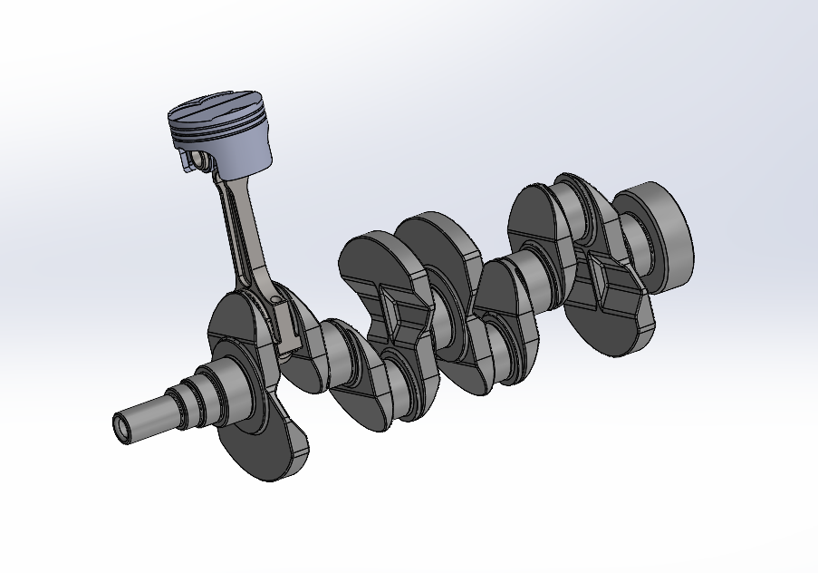
Figure 2, Connecting Rod
Figure 1, Assembly Investigated
The mechanical system analysed in this study is a simplified internal combustion engine assembly. The assembly consists of a piston, connecting rod, crankshaft & pin, and main shaft supports, which forms a multi-body system with both rotational and translational motion.
The crankshaft provides rotational input, which is transferred through the connecting rod to drive the linear motion of the piston within the cylinder. The connecting rod experiences complex loading conditions during operation, including axial forces and bending effects resulting from inertial and gas loads transmitted through the piston-crank interface.
Due to its critical role, the Piston was selected as the primary component for structural, thermal and fatigue analysis. The assembly geometry was provided as part of the assignment and imported into ANSYS for analysis, with appropriate kinematic constraints applied to replicate realistic engine motion. Any modelling assumptions and simplifications applied during the analysis are considered later when discussing the limitations of the CAE approach.

5.0 - Methodology

5.1 - Kinematic Analysis Methodology
A kinematic analysis is conducted to determine realistic loading conditions within the slider–crank assembly during operation. The assembly is imported into ANSYS and appropriate joint definitions are applied to replicate the physical constraints of the mechanism. The crankshaft is constrained to rotate about its main axis, while the piston is restricted to linear translation along the cylinder axis. Revolute joints are used to connect the crankshaft to the connecting rod and the connecting rod to the piston, allowing relative rotational motion between components.
A prescribed rotational input is applied to the crankshaft to simulate engine operation. The kinematic simulation is used to calculate displacements, velocities, accelerations, and reaction forces generated within the assembly throughout the motion cycle. Reaction forces acting at the interfaces of the connecting rod are extracted from the simulation and used as representative loading conditions for subsequent structural analysis. Using kinematic-derived loads ensures that the structural assessment reflects realistic dynamic behaviour rather than simplified or assumed loading scenarios.

5.2 - Structural, Thermal & Fatigue Analysis Methodology
The Piston is analysed using a static structural finite element approach within ANSYS. Material properties representative of a typical Piston are assigned, and appropriate boundary conditions are applied to represent the constraints imposed by the surrounding assembly. Reaction forces obtained from the kinematic analysis are applied to replicate operational loading conditions. The component is meshed using suitable element types, with mesh refinement applied in regions of expected stress concentration.
Thermal effects are incorporated by applying an assumed operating temperature to the Piston. Temperature-dependent material properties are used to account for material degradation at elevated temperatures, and the combined influence of mechanical and thermal loading on stress distribution is assessed. This approach provides a more representative evaluation of component performance under realistic operating conditions.
Fatigue analysis is performed using stress results obtained from the static structural simulation. A stress-life (S–N) approach is used to estimate fatigue life under cyclic loading conditions representative of engine operation. Critical regions of high stress concentration are identified and assessed to determine fatigue-critical locations. The results of the structural and fatigue analyses are used to inform subsequent design modifications aimed at improving fatigue life and reducing component mass.

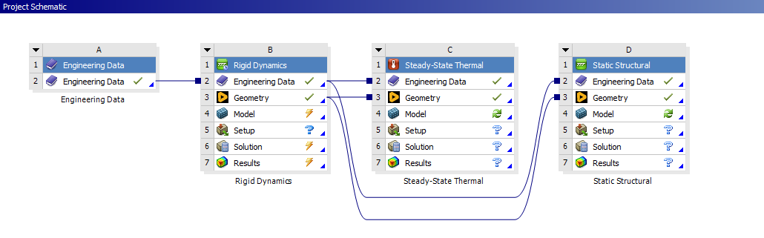
6.0 - Ansys Simulation
Figure 3, Ansys Full System Setup
ANSYS Workbench allows multiple analysis systems to be fully linked within a single project schematic, enabling the transfer of data between simulations. In this study, a rigid dynamics analysis is linked to both steady state thermal and static structural analyses, allowing realistic operating conditions to be applied without redefining geometry or material properties. Reaction forces obtained from the rigid dynamics simulation are passed directly into the static structural analysis, ensuring that structural loading is derived from actual system motion rather than assumed values.

Similarly, temperature distributions calculated in the steady-state thermal analysis are transferred into the structural simulation to account for thermal effects on material behaviour and stress distribution. This linked workflow improves modelling consistency and reduces the risk of user error associated with manually reapplying loads or boundary conditions. By maintaining a common geometry and material definition across all analysis stages, the results more accurately reflect real-world engineering scenario.
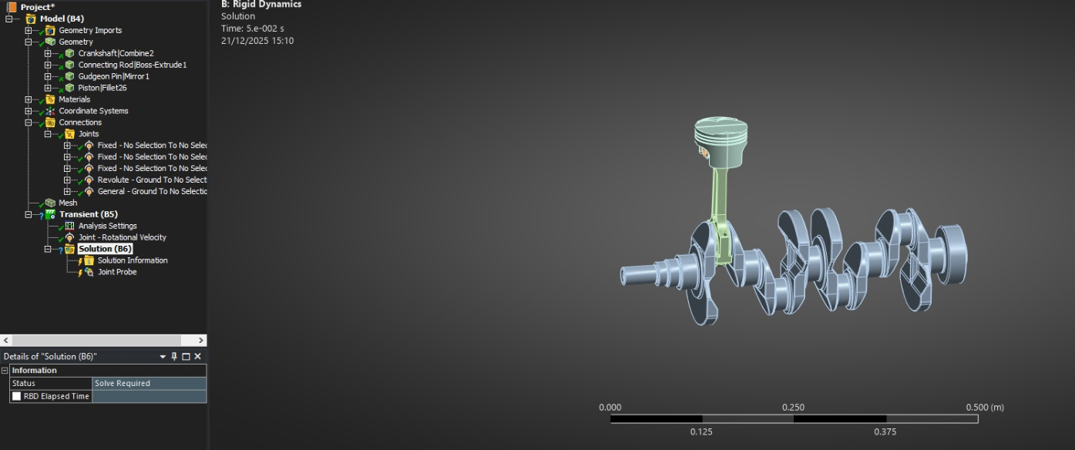
However, this approach also introduces limitations. The linked workflow used in this study represents a one-way coupling, meaning that structural deformation does not influence the kinematic behaviour of the system. As a result, potential effects such as elastic compliance and thermo-mechanical feedback are not captured. Despite these limitations, the use of fully linked systems provides an efficient and robust framework for evaluating component performance within a realistic CAE design process.
Figure 4, Fully Linked Ansys System

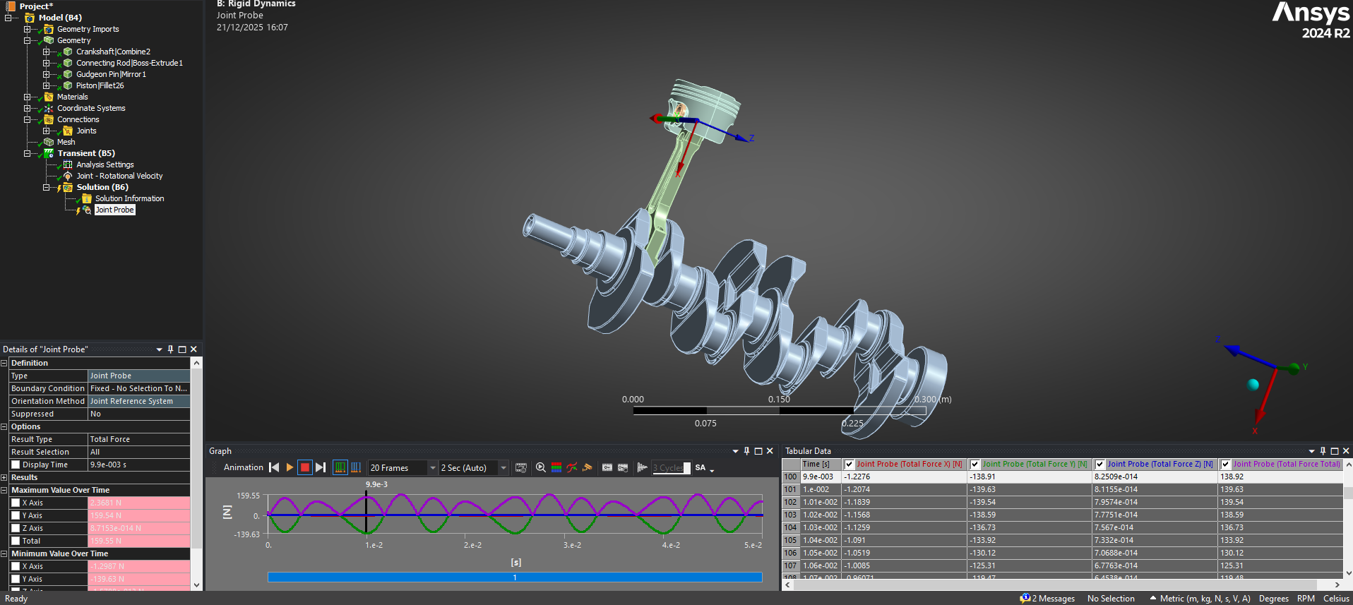
Figure 5, Motion Load Simulation

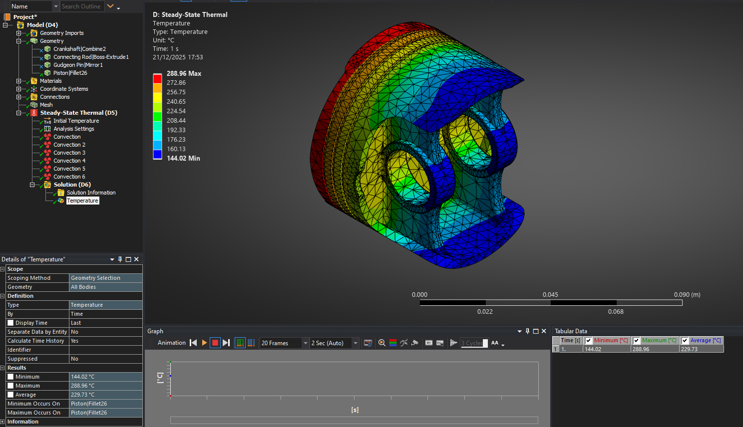
Figure 6, Temperature Profile across Piston
The steady-state thermal analysis shows a non-uniform temperature distribution across the component, with temperatures ranging from approximately 144 °C to 289 °C. The highest temperatures are observed on the outer crown surface, which is directly exposed to the applied thermal boundary conditions, while lower temperatures occur in regions further from the heat source and closer to areas subjected to convective cooling. This temperature gradient indicates effective heat dissipation through the component geometry and surrounding boundaries.
Regions around internal features and thicker sections exhibit more moderate temperature levels, suggesting that local geometry influences heat conduction and thermal storage. The presence of temperature gradients across the component is representative of realistic operating conditions in engine components, where heat input from combustion-facing surfaces is transferred through the material and dissipated to cooler regions.
The resulting temperature field is subsequently used as an input for the static structural analysis, allowing the influence of thermal expansion and temperature-dependent material behaviour to be assessed alongside mechanical loading. While the applied thermal conditions are simplified and represent an idealised steady-state scenario, the results provide a reasonable approximation of operating temperatures and enable the investigation of thermo-mechanical effects within the CAE workflow.
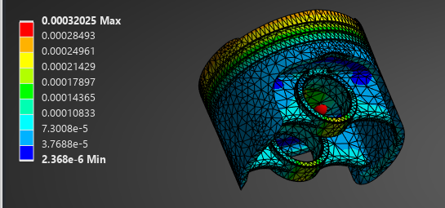
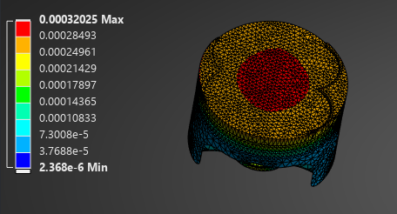
Figure 7, Total Deformation (Bottom-side)
Figure 8, Total Deformation (Topside)
The total deformation results indicate a maximum displacement of approximately 0.32mm with deformation predominantly concentrated at the piston crown. This behaviour is consistent with the applied loading and thermal conditions, as the crown is directly exposed to elevated temperatures and mechanical loading, while the skirt and lower regions are more constrained and experience reduced deformation. The relatively smooth deformation gradient across the component suggests that the applied boundary conditions and load transfer are well-defined, with no evidence of numerical instability.
Lower deformation values are observed around the skirt and gudgeon pin regions, where structural stiffness is increased due to geometry and constraint conditions. This indicates that the piston structure effectively distributes load away from critical internal features. The magnitude of deformation remains small relative to the overall component dimensions, suggesting that the piston operates within the elastic range under the applied thermo-mechanical loading conditions.
The deformation results provide important context for subsequent stress and fatigue analyses. Regions exhibiting higher deformation correspond to areas of increased strain and are therefore potential locations for elevated stress. While the deformation values are acceptable for the operating conditions considered, it should be noted that the analysis assumes linear elastic behaviour and steady-state loading, which may not fully capture transient effects or contact interactions present during real engine operation.

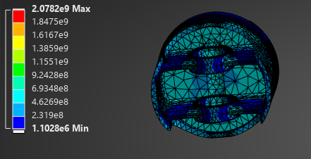
Figure 9, Equivalent Stress (Bottom-side)
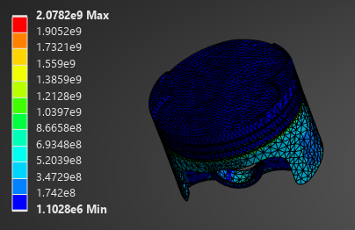
Figure 10, Equivalent Stress (Topside)

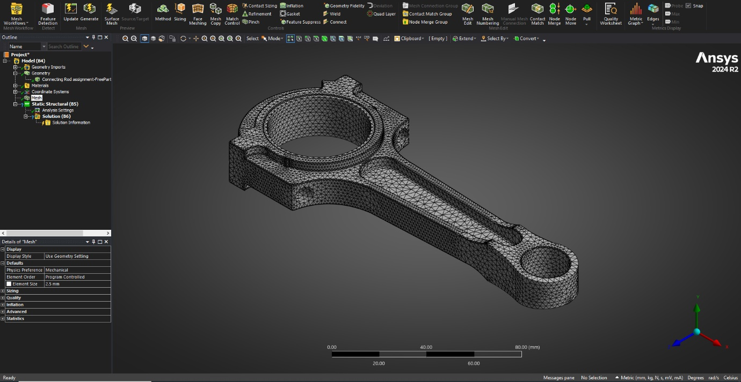
6.1 - Kinematic Analysis
Figure 4, Mesh Generation (Static Structural)

7.0 – Design Optimisation
The results obtained from the structural and thermal analyses were used to inform potential design optimisation of the piston. Areas of increased deformation and stress were identified, particularly around the piston crown and internal features, indicating regions where geometry refinement could improve structural performance. Conversely, regions exhibiting low stress and minimal deformation suggest opportunities for material reduction without compromising structural integrity.
Potential optimisation strategies include reducing material thickness in low-stress regions of the piston skirt to decrease mass, while maintaining or locally increasing thickness around the crown and gudgeon pin bosses to preserve stiffness and load-carrying capability. Such modifications would aim to reduce overall component mass while maintaining acceptable stress levels and fatigue performance.
Although a full iterative optimisation study was not undertaken, the analysis demonstrates how CAE tools can be used to guide informed design decisions. By identifying critical and non-critical regions within the component, CAE provides a systematic approach to balancing mass reduction with structural and thermal performance in engine component design.

8.0 – Limitations
While ANSYS Workbench 2024 provides powerful tools for simulating complex mechanical systems, the accuracy and reliability of its results are inherently dependent on modelling assumptions and user-defined inputs. In this study, several limitations associated with the use of CAE tools must be acknowledged when interpreting the results.
A primary limitation arises from the use of simplified kinematic and structural models. In the kinematic analysis, components are treated as rigid bodies and joints are idealised as frictionless revolute or translational connections. This approach neglects joint clearances, friction, bearing compliance, and elastic deformation, all of which can influence the true dynamic loading experienced by the connecting rod. As a result, reaction forces extracted from the kinematic simulation may differ from those observed in real engine operation.
In the structural analysis, linear elastic material behaviour is typically assumed. This limits the ability of the model to capture non-linear effects such as plastic deformation, and strain-rate dependency, which may become significant under extreme loading or high-temperature conditions. Additionally, temperature distributions are often simplified and applied as uniform values, whereas real components experience complex and spatially varying thermal gradients.
Fatigue analysis performed within ANSYS is also subject to uncertainty. Stress–life (S–N) data is commonly derived from idealised laboratory specimens and may not accurately represent the behaviour of a real connecting rod with manufacturing defects, surface roughness, and residual stresses. Furthermore, fatigue life predictions are highly sensitive to local stress concentrations and mesh resolution, making accurate meshing and validation essential.
Boundary condition definition represents another significant source of potential error. Constraints and loads must be idealised to allow a solvable numerical model, but small changes in how these conditions are applied can lead to large differences in predicted stress and fatigue life. This highlights the importance of boundary condition sensitivity studies and mesh independence assessments when using CAE tools for engineering decision-making.
Finally, while ANSYS Workbench 2024 provides advanced solvers and automation features, it does not replace engineering judgement. Numerical results should be interpreted as approximations rather than exact solutions and should be validated against analytical calculations and physical understanding wherever possible. For this reason, CAE should be considered a decision-support tool that complements, rather than replaces, fundamental engineering analysis.

9.0 - Conclusion
This study has demonstrated the application of Computer Aided Engineering (CAE) processes to the analysis and optimisation of a mechanical component operating within a multi-body assembly. Using ANSYS Workbench 2024, a structured workflow was developed that integrated kinematic analysis, steady-state thermal analysis, and static structural finite element analysis to assess the performance of a Piston within a simplified internal combustion engine assembly.
A kinematic analysis was undertaken to generate realistic loading conditions based on system motion rather than assumed forces. Reaction forces obtained from this analysis were used to inform the static structural assessment, ensuring that the applied loads reflected representative operating behaviour. The inclusion of steady-state thermal analysis enabled the influence of elevated operating temperatures on deformation and stress distribution to be considered, improving the realism of the structural results compared to purely mechanical loading.
The structural analysis highlighted deformation and stress distributions consistent with the applied thermo-mechanical loading conditions. Deformation magnitudes remained small relative to the overall component geometry, indicating elastic behaviour under the simulated conditions, while regions of increased deformation and stress were identified as critical areas for fatigue performance. These results demonstrate how CAE tools can be used to identify potential design weaknesses and guide informed design optimisation.
Although a formal validation methodology was planned, including analytical comparison and mesh independence assessment, this could not be fully implemented within the scope of the study. This represents a key limitation of the work, as CAE results are highly sensitive to modelling assumptions, boundary condition definition, and mesh quality. As a result, the numerical results presented should be interpreted as indicative rather than definitive predictions of real-world behaviour.
Overall, this project demonstrates the capability of CAE tools to support engineering analysis and design decision-making when applied within a structured workflow. However, it also highlights the importance of validation and engineering judgement when interpreting simulation results. Future work would include the completion of a full validation study and further refinement of modelling assumptions to improve confidence in the numerical predictions. Despite these limitations, the study reflects effective use of CAE processes in an automotive engineering context and demonstrates an understanding of both the strengths and limitations of simulation-based design.

10.0 – References
- ANSYS Inc. (2024) ANSYS® Workbench User’s Guide. Release 2024 R2. Canonsburg, PA: ANSYS Inc.
- ANSYS Inc. (2024) ANSYS Motion Theory Guide. Canonsburg, PA: ANSYS Inc.
- ANSYS Inc. (2024) ANSYS Mechanical User’s Guide. Canonsburg, PA: ANSYS Inc.
- ASM International (2015) ASM Handbook Volume 19: Fatigue and Fracture. Materials Park, OH: ASM International.
- Boresi, A.P. and Schmidt, R.J. (2003) Advanced Mechanics of Materials. 6th edn. Hoboken, NJ: John Wiley & Sons.
- Budynas, R.G. and Nisbett, J.K. (2015) Shigley’s Mechanical Engineering Design. 10th edn. New York: McGraw-Hill Education.
- Cook, R.D., Malkus, D.S., Plesha, M.E. and Witt, R.J. (2007) Concepts and Applications of Finite Element Analysis. 4th edn. Hoboken, NJ: John Wiley & Sons.
- Dowling, N.E. (2012) Mechanical Behavior of Materials: Engineering Methods for Deformation, Fracture, and Fatigue. 4th edn. Harlow: Pearson Education.
- Heywood, J.B. (2018) Internal Combustion Engine Fundamentals. 2nd edn. New York: McGraw-Hill Education.
- Norton, R.L. (2020) Design of Machinery: An Introduction to the Synthesis and Analysis of Mechanisms and Machines. 6th edn. New York: McGraw-Hill Education.
- Stephens, R.I., Fatemi, A., Stephens, R.R. and Fuchs, H.O. (2001) Metal Fatigue in Engineering. 2nd edn. New York: John Wiley & Sons.
- Totten, G.E. (2014) Handbook of Mechanical Alloy Design. New York: Marcel Dekker.

