University of Wales Trinity Saint David
Wales Institute of Science and Art


Report On Engine Characteristics (ACHA4012)

March 2023

Contents
Introduction 3
Equipment Used 4
Data Analysis 5,6,7
Conclusion 8
Evaluation 9
References 10
Figure 1: Image shows the Engine dynamometer used. 4
Figure 2: Image shows torque arm that was attached to the dynamometer to help with calibration. 4
Figure 3: Image shows Honda engine hooked up to the dyno. 5

Introduction
This report I will be going over engine dynos an engine dyno is short for dynamometer which is an essential tool used in the automotive industry to measure the power and torque output of an engine. It allows engineers and mechanics to simulate the conditions under which an engine would operate while on the road, making it an essential part of developing and optimising an engine's performance. In this report, we will explore the purpose of engine dynos, and how they are used in the automotive industry. Engine dynos are used for a variety of purposes, including research and development, performance tuning, and quality control. They provide a controlled environment for testing and analysing engines, enabling engineers to gather accurate and reliable data on engine performance. Engine dynos can also help identify any weaknesses or areas for improvement in an engine's design, allowing manufacturers to make necessary adjustments to optimize performance also engine dynos are used to measure and analyse the emissions produced by an engine. This data is essential for ensuring that the engine meets emissions regulations and standards.
For this report the goals are to analyse the performance of the Honda engine and to provide a clear accurate table alongside graphical data to be discussed about whilst providing references to back up the points that were made.

Equipment Used
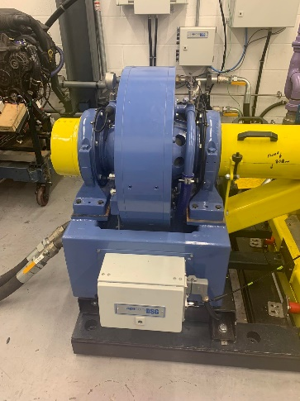
You must become acquainted with the various parts of the dynamometer, in order to go over the dyno's equipment. The power source is a highly magnetised electric motor which is what the engine attaches to via a shaft, as well as the performance-tracking tools, including torque sensors and dynamometer control systems, may be included. There will be control systems to help the user calibrate the apparatus and decipher the data it produces. Overall, for effectively assessing the power and performance of an engine or motor, a detailed grasp of the dyno equipment is necessary.
When it comes to setting up the dyno a few procedures must take place before starting the motor:
- The dynamometer must be calibrated using the torque arm and a few weights, with this a calibrations can take place to see if all the equipment is all tuned together perfectly, you can see the torque arm used in figure two.
- Once the machine is calibrated and the torque arms are removed all people are to leave the dyno room and a door is shut isolating the motor with the dyno from the operators, the operators can view the working engine via a window behind all the computers that control the input of the motor.
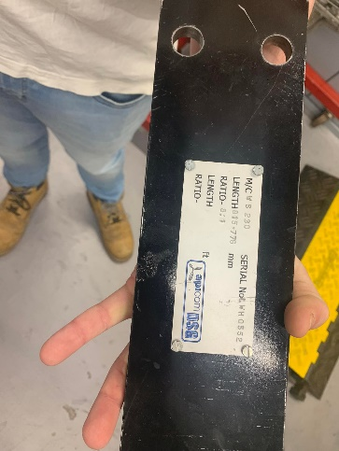
- Once the door is closed and everyone has left the room the fans that help circulate air around the room are turned on alongside the fuel being turned on.
Figure 1: Image shows the Engine dynamometer used.
- Now the engine can be engaged, the operator has two adjustment knobs one that regulates the dynamometer resistance, this made engine work harder to stay at a chosen rpm and one that controls the RPM of the motor.
Now that the steps have been described a brief explanation on what was done on the day can be provided.
When the motor was started up a goal of keeping the motor at 2000rpms whilst applying more engine dyno load was given, this was done to try achieving a number of one hundred newton meters of torque. But because the engine load was being applied this made the engine try and stall out so a directly proportional amount for throttle was required to allow the motor to stay at 2000rpms.
Figure 2: Image shows torque arm that was attached to the dynamometer to help with calibration.
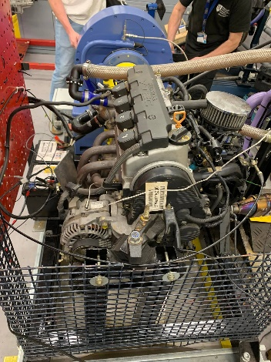
Once the goal was achieved, next the engine had to lower its rpms and its engine load simultaneously to prevent stalling from occurring. When this was completed a data log was pulled to see how the engine reacted. This allowed to determine weather the motor was running lean or rich and help determine other information.
With this data, capabilities such as measuring brake horsepower, fuel flow rate and thermal efficiency is possible, and this data can be inserted into a graph to help analyse and understand what the engine was doing under different loads.

Figure 3: Image shows Honda engine hooked up to the dyno.
Data Analysis
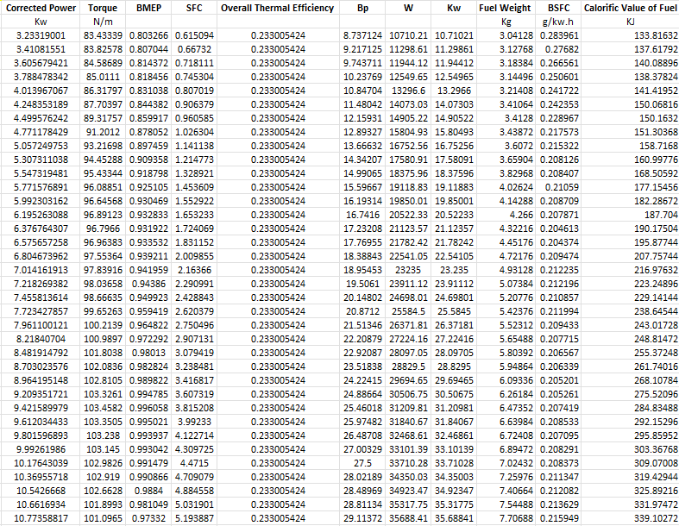
In this section, we will focus on analysing and presenting the data generated from the engine dyno tests. Specifically, we will look into the various graphs and tables that were produced from the data, which provide valuable information into the engine's performance characteristics. These visualizations and summaries of the data will help us understand the engine's brake power, torque, SFC, thermal efficiency, corrected power and BMEP. Using this information we can gauge other key performance metrics, as well as any trends or patterns that emerge from the testing. By examining and interpreting these data outputs, we can gain a deeper understanding of the engine's behaviour and make informed decisions about how to optimize its performance.
Tabular data for corrected power, torque, BMEP, SFC, and overall thermal efficiency provide information on engine performance.
• Performance fixes:
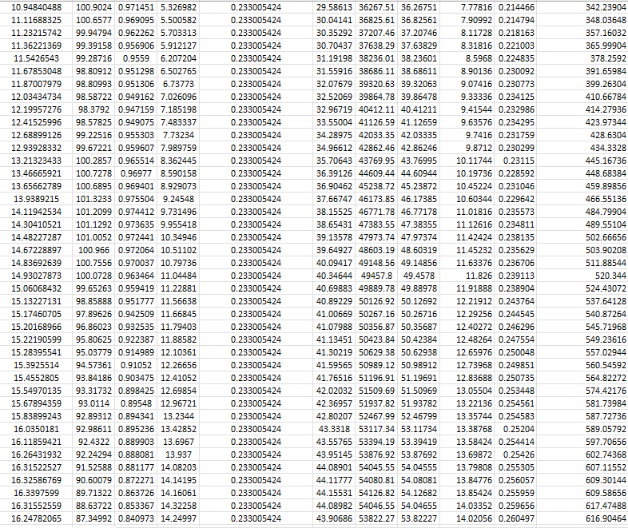
This is engine power, measured in horsepower (hp) or kilowatts (kW). These terms are adjusted for atmospheric conditions such as temperature, pressure, and humidity. Corrected horsepower indicates the engine's overtime capability and is a key indicator of the engine's overall performance.
• Torque:
Torque is the rotational force of a motor, measured in pound-feet (lb-ft) or newton-meters (Nm). Reflects engine traction and is directly proportional to engine power.
• BMEP (Mean Effective Brake Pressure):
BMEP is a measure of the average pressure exerted on the piston during the engine's power stroke. It is expressed in pounds per square inch (psi) or kilopascals (kPa). BMEP is a key measure of engine efficiency and is used to compare engine designs.
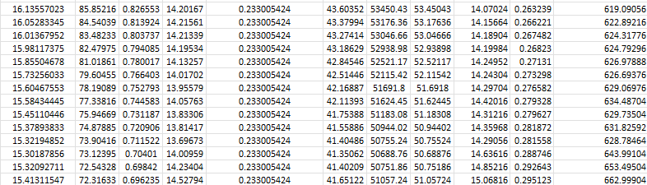
• SFC (Specific Fuel Consumption):
SFC is a measure of the amount of fuel used by the engine. It is usually expressed in pounds of fuel per hp-hour (lb/hp-hr) or grams of fuel per kilowatt-hour (g/kW-hr). SFC is a key factor in engine efficiency and is used to compare engine performance.
• Overall Thermal Efficiency:
This is a measure of how efficiently the engine converts the fuel's energy into useful work. Expressed as a percentage. The higher the overall thermal efficiency, the more efficiently the engine converts the fuel's energy into work.

This section will focus on three scatter graphs that show how different engine parameters vary with engine speed. Specifically, the analysis will focus the scatter graphs of SFC vs engine speed, Torque vs engine speed, and Brake power vs engine speed. These scatter graphs are useful for understanding the engine's performance characteristics and can provide insights into how the engine can be altered for better fuel efficiency and power output. By examining these graphs, we can identify the engine's optimal operating range for fuel efficiency, peak torque range, and peak power range.
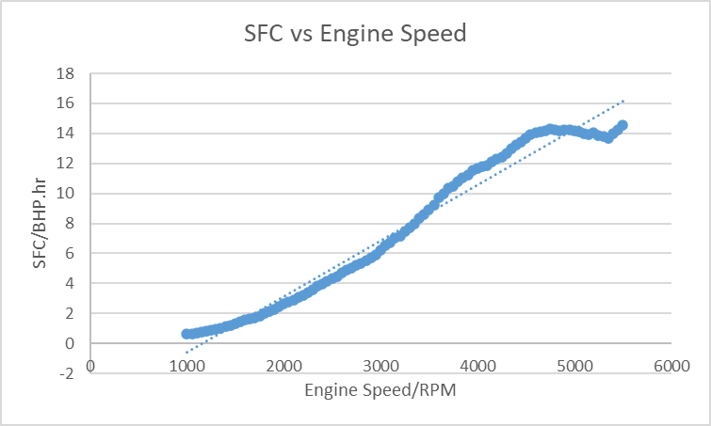
SFC vs Engine speed:
The specific fuel consumption (SFC) is a measure of the amount of fuel consumed by the engine per unit of power output. As the engine rpm increases, there are several factors that can cause the SFC to vary such as:
- At higher engine speeds, the combustion process becomes less efficient due to reduced time for fuel-air mixture to burn completely. (Direct)
- At higher engine speeds, there is increased friction between engine components such as pistons, bearings, and valves. Therefore, increasing the friction causing the motor to consume more fuel. (Direct)
- At higher engine speeds, there is also increased pumping losses due to the higher volume of air being drawn into the engine. This increased pumping work can cause the engine to consume more fuel. (Direct)
- Air-fuel ratio: At different engine speeds, the air-fuel ratio may need to be adjusted to maintain perfect combustion. If the air-fuel ratio is too rich or too lean, the SFC can increase. (Direct)
Torque vs Engine Speed
The torque output of an engine is a measure of its rotational force that it can deliver to a shaft. As the engine rpm increases, the torque output of the engine can vary due to several factors:
- As engine speed increases, the engine's ability to draw in more air and deliver more fuel to the combustion chamber also increases. This increased airflow and fuel delivery results in an increase in torque output. (Torque)
- At higher engine speeds, the combustion process may become less efficient due to shorter ignition and combustion times, which could be the reason of the nonlinear torque curve.
- Just like SFC as engine speed increases, frictional losses within the engine components, such as the pistons, crankshaft, and bearings, can also increase. These losses can cause a reduction in torque output. (Torque)
- Changes in the engine's valve timing can also impact the torque output. For example, at higher engine speeds, variable valve timing may adjust the valve timing to ensure that the intake and exhaust valves open and close at the correct times for best possible combustion, which can affect the engine's torque output as well . (Torque)
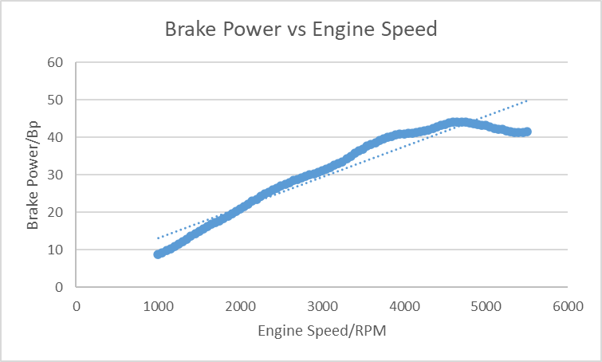
Brake Power vs Engine Speed
As the engine rpm increases, the brake power can vary due to several factors:
- As engine speed increases, the engine's ability to draw in more air and deliver more fuel to the combustion chamber also increases. This increased airflow and fuel delivery results in an increase in power output.
- At higher engine speeds, the combustion process can become more efficient due to improved airflow and fuel delivery just like engine torque, which results in an increase in power output.

Conclusion
In summary, an engine test bench provides a controlled environment for testing an engine and producing accurate and factual data about its performance. Data collected from engine dyno tests can provide insight into an engine's power output, fuel economy, thermal efficiency, as well as its operating range and optimal performance parameters. By analysing this data, engine designers and performance tuners can make informed decisions about how to improve engine performance, efficiency, and reliability. Overall, engine test benches play a key role in the development and testing of modern engines. This is because it provides the accurate and reliable data essential for optimizing engine performance and improving fuel economy.

Evaluation
Overall I felt this assignment went well, I understood the concept of the engine dyno and I have learnt a lot of information when it comes to engine dynos. I do wish that I took more photos that I could provide for this report but overall I feel all went well.

References
Direct, Science. “Specific Fuel Consumption - an Overview | ScienceDirect Topics.” Www.sciencedirect.com, 25 Mar. 2023, www.sciencedirect.com/topics/engineering/specific-fuel-consumption.
Torque. “Horsepower vs. Torque Performance.” Automotive Training Center, 22 Mar. 2016, autotraining.edu/automotive-technology/engine-technology/horsepower-vs-torque-performance/.
Harrison, Andrew. Handout Master. 7 Mar. 2023.

