Leadership and Management

M7X01697
Team Selection, Formation and Leadership

With John Rees

By Paige Harris
P145700

Contents
1.0. Introduction 3
2.0. Executive Summary 4
3.0. Selection and Recruitment 5
3.1. Public Sector Equality Duty 5
3.2. Application 6
3.3. Selection 7
3.4. Interview 8
3.5. Interview Decision and Sealing the Deal 9
3.6. Recommendations 9
4.0. Team Development 11
4.1. Building a team 11
4.1.1. Choosing the Team Members 12
4.1.2. Choosing the Team Manager 13
4.2. Developing a High Performance Team 16
4.3. Recommendations 17
5.0. Leadership Approaches 18
5.1. Transactional Leadership 18
5.2. Transformational Leadership 19
5.1. Recommendations 20
6.0. Key Performance Indicators 21
6.1. Recommendations 22
References 24

Figure 1- Equality Act [4] 6
Figure 2- Effects of Team Size [28] 11
Figure 3- Cohesion [10] 12
Figure 4- Mintzberg’s Model [12] 14
Figure 5- Three Levels of a High Performance Team [17] 16
Figure 6 Transformational Leadership [30] 18

Introduction
This report will be for the Managing Director for the software development company Swansea App Synthesis Ltd. It will lay out the vision in which the development of the team is to take, by firstly recruiting 5 team members to assist the other 5 team member which are already recruited for an existing project group. The team is being gathered for the NHS Wales Informatics Service to address the user of analytics on health data.
The report will include a section for each of the following:
- Selection and Recruitment
- Team Development
- Leadership Approaches
- Key Performance Indicators
Each section will be researched and recommendations will be made regarding the best practices and theory to use for this project.
An executive summary has been created to summaries the report, for the managing director.

Executive Summary
As there are already 5 members of the team, and another 5 need to be employed, following theory’s within the Selection and Recruitment section, of this report will aid in the recruitment of the remaining team members. By following the recommendations that have been evaluated, these can be used as guide to the different phases through the recruitment process. The Public Sector Equality Duty needs to be considered during the application and recruitment phase so not to discriminate against any person. The job description needs to be written, explain all the details of the job including the responsibilities and workload, any specific responsibilities, along with the grade and salary range. The job description will not specifically request any type of person in order to abide by the PSED act. The job will then be posted on Swansea App Synthesis Ltd.’s website as well as on job sites and a closing date assigned. The applications will be sifted through in the rejection processes to decrease the applications. The successful applications will then follow onto an aptitude test, specifically designed for software developers. Once these have been completed, marks are examined and rejections are made once more. There will be a remainder of 15 applicants who will have successfully reached the final phase of recruitment, the interview. Interviews will take place in house, in a conference room for 45 minutes each as well as 15 minutes for questions, with a 15 minuet break to follow on for both managers to discuss the interview. The interview questions will be scripted from the job description and the applicant will be informed fully of the roles and responsibilities of the job. Successful applicants will be informed and a salary and start date will be negotiated.
The team will be developed into a high performance team by first appointing a team manager. The team manager will be the leader for the team, they will need to be able to use Mintzberg’s Management Roles. The team manager will be able to encourage the team to develop their skills and aim for success, to tod this they must be respected within the workplace so the team members will follow. The goal is to make the team a High Performance Team, this is a “group of people who share a common vision, goals, metrics and who collaborate, challenge and hold each other accountable to achieve outstanding results” [1]. The team manager is able to build his or her team by defining roles clearly and giving feedback on how individuals and the team are progressing. By having good communication skills and positive relationships with all team members will encourage the team members to complete the work within the timescale and to the proposed standard as there is respect for the manager. The team manager should be able to communicate outside of the business also, in the case of project meetings with NHS Wales Informatics Service.
By using B.M.Bass’ concepts of transformational leadership, selecting the team manager will be made easier. B.M.Bass states that the team manger must able to motivate the team to increase employee productivity, and that the team manager is passionate about the vision so they are able to deliver and pass on that passion to the team members. They should be approachable for the team members to be able to speak to them be there any issues that need resolving or and queries regarding the project, their tasks or the workplace.
The following key performance indicators should be used against the software development team to show development and possible areas for improvement or risks within the projects. Cycle time, Velocity, Throughput, work in Progress, Cumulative Flow, Release cycle time, Difficulty of Feature Implementation, Should we release faster? These key performance indicators can all be used, or only some could be used. Either way there will be enough information to improve the team’s development.

Selection and Recruitment
This section of the report will discuss how the selection process will take place, whilst addressing the aspects of the Personal, Social & Emotional Development within the team. There is currently 5 members within the team, another 5 need to be recruited. The current team members are all male and within the range of 25 and 35 years old. When selecting the team, it must be ensured that the right people are chosen to create the right mix of people.
The selection process is begun by the application being generate and posted out, for example online. The applicant then applies for the job and the company then needs to begin the initial selection process including application forms and background checks on the applicant, this could include a criminal check or just looking at the applicant social media profiles. If the applicant then meets the basic criteria required for the job they are they subjected to a substantive selection, where those applicants whom are less qualified than others become rejected. Once the applicant has passes the substantive selection they are then subjected to a contingent selection, including drug tests or sometimes the background checks if not completed during the initial selection. If the applicant passes, they then receive a job offer.

Public Sector Equality Duty
“The Public Sector Equality Duty (the Equality Duty) was created by the Equality Act 2010 in order to harmonise the previous race, disability and gender equality duties and to extend protection to the new protected characteristics listed in the Act. The Equality Duty replaced these duties and it came into force on 5 April 2011.” [2] It covers the equality duties of “age, disability, gender, gender reassignment, pregnancy and maternity race, religion or belief and sexual orientation” [3]. This act is used throughout Wales, England and Scotland and they must have due regard to the need to:
- “Eliminate unlawful discrimination, harassment and victimisation
- Advance equality of opportunity between different groups
- Foster good relations between different groups” [3]

The act needs to be considered during the selection and recruitment section to ensure that no applicant is discriminated. PSED also includes marriage and civil partnership in regards to employment issues.

Figure 1- Equality Act [4]

Application
Firstly, there needs to be a job description to promote the new job, the job description should specify the role in which the applicant will be undertaking. Before creating the job description, the role specification should be fully evaluated by the recruiter, knowing what they want, making the amount of work the applicant will be undertaking along with any special requirements that are needed to successfully get the job. The job specification should clearly indicate the details of responsibility and workload, any specific responsibilities, along with the grade and salary range. The job description should be in line with the Public Sector Equality Duty Act to ensure that no applicant is discriminated against.
It needs to state the type of person that is required, for example the personality of the applicant along with the qualification or certifications along with the technical knowledge and experience that is required. When stating the person specification there are two systems which can be considered, there is Rodger’s Severn Point Plan and Munro Fraser’s patter of personality.
Rodgers seven point plan helps to draw up the criteria that is wanted from the applicant. Making sure that a decision has been made on what criteria is desirable and what criteria is essential.
Rodger’s Severn Point Plan
- “Physical make-up health, appearance, bearing and speech.
- Attainments: education, qualifications, experience.
- General intelligence: intellectual capacity.
- Special aptitudes: mechanical, manual dexterity, facility in use of words and figures.
- Interests intellectual, practical, constructional, physically active, social, artistic.
- Disposition acceptability, influence over others, steadiness, dependability, self-reliance.
- Circumstances: any special demands of the job, such as ability to work unsocial hours, travel abroad, etc.” [5]
Monro Fraser’s Patter of Personality helps to identify the type of applicant wanted, by looking into the personality of the applicant, this can also show in their previous work experience and goals.
Monro Fraser’s Patter of Personality
- “Impact on others physical make-up, appearance, speech and manner.
- Acquired qualifications education, vocational training, and work experience.
- Innate abilities quickness of comprehension and aptitude for learning.
- Motivation individual goals, consistency and determination in following them up, success rate.
- Adjustment emotional stability, ability to stand up to stress and ability to get on with people.” [5]
Either of the plans would work when deciding on an approach to take when in the application part of the employment process.

Selection
Selection refers to the stage of recruitment after the applicants have shown interest in the job and have applied, it is now the company recruiting’s time to sift through the applications ready for the next stage in the selection process.
There are many methods of selection which can be used, these are,
- By creating the application within the business
- Using a Recruitment Agency
- Using a Selection Consultant
- By using a “Head Hunter”
All of these methods will still include the business to interview the applicant.
Once all the applications have been collected and the closing date is reached, the number of applications will most likely be high and the number will need to be reduced. To do this we reject applications and many factors must be considered, these could include;
- “Qualifications
- Experience
- Grammar
- Spelling
- Presentation
- Paper or Ink Colour
  - “Reject the one-size-fits-all CV
  - Has the candidate included an opening summary of their career aims and is this tailored to the job vacancy?
  - Have they emphasized any skills that were stipulated in the job ad?
- Take a look at their hobbies and interests
- An inappropriate email address
- Employment gaps
- Being sent a URL to download the CV
- The use of clichés or quotes
- A CV written in the third person” [6]
After the initial sift has been done, there will be an assessment prior to the interview, there are different types of assessments which can be done, these will include psychometric tests, Professional case studies, and aptitude tests. Psychometric tests can be found online using websites, an example website for this is, Test Partnership. “Test Partnership have online tests designed to accurately and fairly assess your candidates. They use robust modern performance algorithms to guard against candidate cheating. Their tests present an excellent candidate experience and the questions are designed to cover all ranges of difficulty.” [7] There are a number of psychometric test which can be accessed through this website, these include;
- “Numerical Reasoning
- Verbal Reasoning
- Inductive Reasoning
- Diagrammatic Reasoning
- Logical Reasoning
- Mechanical Reasoning
- Verbal Comprehension
- Situational Judgement Test
- Capp Numerical Assessments
- Capp Verbal Assessments
- Test Partnership Numerical Reasoning
- Test Partnership Verbal Reasoning
- Deductive Reasoning
- Personality Questionnaire
- Error Checking Tests
- Psychometric Tests” [7]
Not all are going to apply to the job role, but selecting the right ones which will and ensuring that all candidates who made it successfully through the initial sift take part in these tests can help to narrow down the selection further. Before thinning the applicants, deciding on the number of interview which will take place is a good decision before there are suddenly too many applicants and too little time, or not enough choice. Once this has been done, the decisions can be made on which applicants to dismiss.

Interview
Once the applicants have successfully passed the testing stage of the selection, an interview is now to take place. When deciding on an interview date and time, making sure it is convenient for both interviewer and the applicant is vital. Choosing the right interviewers is essential, if there is a large number of applicants, then perhaps many interviewers are needed. If there is only to be a small number of applicants then perhaps on the manager or duty manager could interview. The location on the interview should also be considered, will the interview be held on-site or off-site? When holding the interview onsite, ensure it is in a private place so no other workers can listen in, a conference room is suitable if not an office. Holding an interview off site can be more relaxing for the candidate however choosing the right setting when moving the interview offsite can be challenging. Thinking about meeting in a local coffee shop, local restaurant or a large hotel lobby is a good start, avoiding situations which will make the candidate feel uncomfortable. Once the location is decided, the successfully candidates can be made aware of the date and time and discussions can be made if anyone cannot make it to be rearranged. When deciding on the times for the interviews, making sure there is enough time between the interviews for any extra notetaking. Preparation is key to interviewing, making sure all the correct questions are being asked to get enough information from the candidates as possible, ensuring the questions are open ended so they can be discussed. They should be scheduled through to ensure the time with the candidate is well spent and all key areas have been discussed as well as not running over the stated duration. Before beginning the interview, ensure that there will be no interruptions, turning the phone off, closing the computer and informing other staff members of the interviews (or by leaving a note outside the door). During the interview, taking notes will be essential to remembering the candidates, it also shows respect that they are being listened to. The job specification which has previously been chosen can be used as a checklist. When discussing the job role, it is important to make the requirements of the job clear, ensuring the candidate is fully aware of working hours, roles and responsibilities so there is no surprises if they were successful, being completely honest at all times. The candidate is most likely to want to ask questions, assign time for this, however if they do not have any questions about the job, be concerned, why are they not asking? Do they not care? Or was the interview in depth enough there is no possible questions? This will depend solely on how the interview was carried out.

Interview Decision and Sealing the Deal
When making the decision on whether the applicant has been successful or unsuccessful, consideration has to be made for the team the applicant may be joining, will they fit in? The applicant should also evidence the qualifications and skill set which is required for the job. The candidate should be motivated and show the desire they have for the job as well as developing themselves within the company. When the decision has been made as to which applicant will be employed, the salary is likely to be negotiated. If the applicant has come from another company, they are most likely to want equal pay or an increased salary. Having a set figure in mind, deciding on what the job is worth to the company and the amount that the company can afford, will stop the negotiation at the maximum amount.

Recommendations
Swansea App Synthesis Ltd. needs to recruit 5 new team members that will be placed on the existing team of 5 males all within the age range of 25 and 35 years old. The Public Sector Equality Act must be considered during this stage as not to discriminate against any applicant. During the application process, when writing the job description, ensuring not to discriminate by specifically asking for certain characteristics is extremely important as it is unlawful, the nine characteristics mentioned within Public Sector Equality Duty should not specify any type of person. The job description should not show preference to hiring a particular gender or age, which seem to be then main familiarities within the current team.
Once the job description has been completed, following the guides in the PSED act, the job can be posted to the general public for applications to begin. The application should be posted online on the company’s website as well as on jobsites. Once the application has reached the closing date, all applications will be sifted using rejection at first. Those applicants who do not have the qualifications and experience will be rejected first. Then the remaining applications will be further sifted through the points highlighted in Selection.
Once the applications have been reduced enough, the remaining applicants are informed they have reached the next step in the application. They must take part in a psychometric test, in this case, as the job is for a software engineer, an aptitude test specifically designed for software engineers will be used. An example version is “Mettl Aptitude Test for Software Developers is specially designed to cater to the level of aptitude that an analyst would be expected to possess” [8], these tests will help to narrow down the applications further, rejecting a number of applicants. The number of applicants which should be accepted to go through to the next stage will be a maximum of 15 applicants, as there are 5 job postings.
The 15 applicants will now be informed they have made it successfully through to the final interview stage and that an interview will take place. The interviews will take place in house, and set in a meeting room. The interviewers will be the company manger and the project manager. Each interview will last 45 minutes and a remainder of 15 minutes will be allocated for questions. A break of 15 minutes between interviews for extra note taking and discussions between the interviewers. The rooms will be private and all members of staff we be informed not to disturb the interviews unless deemed an emergency. Interview questions will be drafted from the job description and notes will be taken throughout the interview. Interviews will be voice recorded and the participant will be made aware on this prior to the interview beginning and a consent agreement will be signed. All elements of the role will be fully explained to each applicant, ensuring they are fully aware of the responsibilities. Question time will be allocated at the end of the interview.
Once all applicants have been interviewed, the successful applicants will be informed first to ensure the job is still suitable for them. The rejected applicants will then be informed. The applicants will be told over the phone by either the company manager or the project manager, giving feedback on the interview explaining why they were successful or unsuccessful. Negotiations will be made regarding the salary and a start date will then be assigned with each successful applicant.

Team Development

Building a team
To build a team, first, all team members should be select from current employees. If the project requires specialist or more members of staff then the selection and recruitment process would need to take effect. “Within a group, there is no shared goals. Each person is responsible for their own outcomes.” [9] A team on the other hand is different. A team is defined as “A small number of people with complementary skills who are committed to a common purpose, a set of performance goals and an approach for which they hold themselves mutually accountable” [9] the characteristics for a high performance teams are as follows:
- “A clearly defined and commonly shared purpose
- Mutual trust and respect
- Clarity around individual roles and responsibilities
- High Levels of communication
- Willingness to work towards the greater good of the team
- A leader who both supports and challenges team members
- A climate of co-operation
- An ability to voice differences and appreciate conflict” [9]
One of the benefits of working within a team is ideas and knowledge can be spread through the team often resulting in new knowledge being gained by each member.
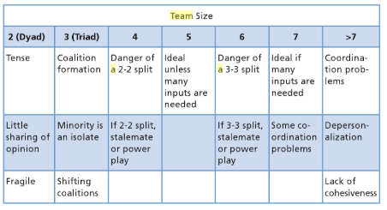
When deciding on the number of member within the team, it is important to be aware that when there is a larger group, managing the team becomes more difficult. An example diagram below shows the effects of team sizes:
Figure 2- Effects of Team Size [28]

The image below shows a team where there is bad communication and good communication. The left image shows one member who all team member but one, communication with, some only communication with a single person. The image on the right shows good communication throughout the team, not everyone may speak to all team members but information is moving through the team more effectively.
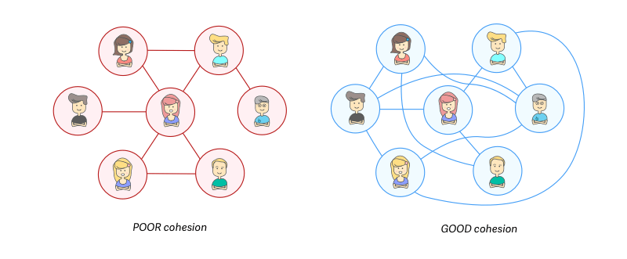
Figure 3- Cohesion [10]

Choosing the Team Members
When building the team, different elements should be considered when choosing the members of the team, ensuring they have good connections, the same vision and are all motivated for the project. Choosing the team members does not just come down to selecting all of the employees with the most knowledge, as they might not work together well. There must be a variety of employees who are each able to contribute to the project that best meets their skill set. All team members should effectively complement each other’s work and help each other when required. The team should be able to communicate well with one another, whether that be one-to-one or during project meetings, they must be able to speak freely, offer up their ideas and be open to any constructive criticism. Before selecting the team members, assess their previous work. If an employee has had previous issues when working in a team, considering them not to be selected unless essential, (specialist skill set required) is unfair, discussing the new project and how he or she feels about working in a team again should be done before overlooked from selection. A good team needs to meet all the required skills and knowledge needed to complete the project as well as the right work methods being applied.
Skills and Knowledge
- “Having the right balance of technical skills and know-how
- Using previous knowledge and relevant experience
- Knowledge of the organisational and team goals
- Brainstorming and decision-making skills
- Time and self-management skills
- Interpersonal skills – for example, listening, supporting, challenging, differing, compromising” [9]
“…the effective team member adds value by addressing issues, building confidence and trust, demonstrating personal leadership and bringing pit the best thinking and attitude of everyone on the team” [11]
Look at previous teams whom have be put together, was there a lack of effort made by any members, and why was this? Were the deadlines for the previous project met? If not, why not? Ensuring the right team members are selected is essential, F.LaFesto and C.Larson say, “…the dysfunctional team member erodes trust and makes it harder to get at the issues, make decisions, and move forward.” [11]

Choosing the Team Manager
Choosing a team manager for the team is important; the manager must be able to manage the project, managing the team and making effective decisions. “The primary role of a leader is to provide the right amount of direction, challenge and support to the team to enable the team to perform effectively in achieving its objectives” [9] consider the last team manager chosen, was the project a success? The manager needs to have good communication and social skills to be able to dictate tasks that need to be completed, by whom and by when. The manager should able to be approachable for all team members to come forward with any issues or concerns and give constructive feedback and criticism. Management will sometimes have to deal with any conflicts within the team that might occur they need to be strong and not have too deep of a personal relationship with any of the team members, in case of favouritism or discrimination.
Leaders and manager’s primary roles stated by S.Cook are:
- “Listening
- Gathering Information
- Refocusing
- Supporting
- Directing
- Checking and testing understanding
- Summarising/recapping
- Persuading
- Building on ideas
- Mediating” [9]
Ensure to select the employee who possesses these qualities will provide direction, challenge and support to the team.

Mintzberg’s Management Roles
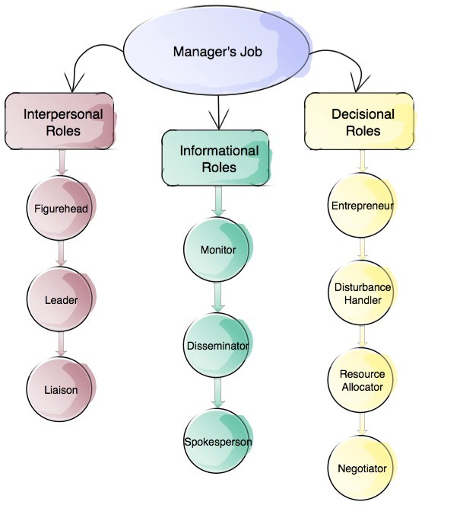
Mintzberg’s Management Roles states that there are ten management rolls, covering a number of tasks and reasonability’s a managers must take at one point within a project. They come into Interpersonal Roles, Informational Roles and Decisional Roles.

Figure 4- Mintzberg’s Model [12]

Interpersonal Roles
“Interpersonal skills are the qualities and behaviours a person uses to interact with others properly. In the business domain, the term refers to an employee's ability to work well with others while performing their job. Interpersonal skills range from communication and listening to attitude and deportment. Strong interpersonal skills are a prerequisite for many positions in an organization.” [13]
Figurehead – Performing Ceremonial duties such as greeting all dignitaries as they are representing the business. This also includes gathering and comforting employees if there is a bereavement within the workplace. “A good leader will project confidence so that everyone involved feels a sense of security and reassurance that the job will be done right.” [14]
Leader – A manger should be able to lead the team to success, guiding the team members to the goal. They will include telling the team what tasks need to be completed any by when. “Organizing the structure of the team members to highlight specific skills that each possesses, and even offering rewards for a job well done.” [14]
Liaison – This requires the team manager to interact with a number of people, including members of the team, peers within the same business (possibly those who are of higher rank), and also people from outside of the business e.g. in other companies, government etc. “This point is all about communication, and it is one of the main things that determines the ultimate success or failure of a manager. Being able to properly communicate with a range of people in such a way that the project remains on track is a crucial skill to develop.” [14]

Informational Roles
“Managers must collect, disseminate and transmit information and these activities have three corresponding informational roles: monitor, disseminator and spokesperson.” [15]
Monitor – The team manager should be aware of changes within the business, this could include any changes that could affect the project. “What goes on in the organisation, a manager will seek and receive information about both internal and external events and transmit it to others” [15]
Disseminator – The team manger should inform the team immediately (if the information is not confidential) of any information that could affect them of the project. “The point of gathering that information is so that your team can benefit from it directly, so the next informational role is dissemination - getting information out quickly and effectively to the rest of your team.” [14]
Spokesperson - The team manager must be able to communicate well as a spokesperson as “representative of that team when it comes to meetings, announcements, etc. Being a spokesperson is the final informational role on the list, and it is an important one because perception is often a big part of reality.” [14]

Decisional Roles
“Mintzberg argues that making decisions is the most crucial part of any managerial activity.” [16]
Entrepreneur – The team manager is always seeking to improve the project, by thinking of new ways to improve production levels as well as the project itself. “Managers make decisions about changing what is happening in an organisation. They may have to initiate change and take an active part in deciding exactly what is done – they are proactive” [16]
Disturbance Handler – Whether there is a conflict between team members, or an issues with suppliers, the team manager should still be able to get the team back into production as soon as physically possible. This of course depends on the issue at hand as to how fast the issue can be resolved, for example if a natural disaster was to occur and production would completely stop. “Responds involuntarily to pressures too severe to be ignored. Examples: a looming strike, a major customer gone bankrupt, or a supplier reneging on a contract.” [12]
Resource Allocator – The team manager will effectively decide on which member of the team will be allocated what, this can equipment or budget. “As a resource allocator, it is your job to best use what you have available in order to get the job done and meet your defined goals and objectives. Resources can include budget that has been made available for a project, raw materials, employees, and more.” [14]
Negotiator – Good team mangers will be able to negotiation well within and outside of the team. This can include negotiation with another business to come to a deal, or negotiation with other departments to perhaps borrow specific equipment or employee. A good negotiator will ensure the challenges that face the team will be resolved in order to keep the project on track. “…most of the important negotiation will take place right within your own team itself. Getting everyone to buy in to the overall goal and vision for a project likely will mean negotiating with individual team members to get them to adopt a role that suits their skills and personal development goals.” [14]

Developing a High Performance Team
Developing a high performance team is a the ability to select a “group of people who share a common vision, goals, metrics and who collaborate, challenge and hold each other accountable to achieve outstanding results” [1] The team members should all be aware of the goals of the project and what they have been asked to accomplish. The team members should each be excited about the project, this shows interest for the project, most likely to result in a good quality outcome. The team should be acting from the priorities of the project, where they have clearly be defined by the project manage, this helps to ensure that all task are completed to the standard required and within the given timescale. Other elements of a high performance team include:
- “Have clear measures of success and receive feedback about how they’re doing
- Maintain open communication and positive relationships with each other
- Identify and solve problems
- Make decisions when and where they occur
- Successfully manage conflict
- Share leadership responsibilities
- Participate in productive meetings
- Have clearly defined roles and work procedures
- Cooperate cross-functionally” [1]
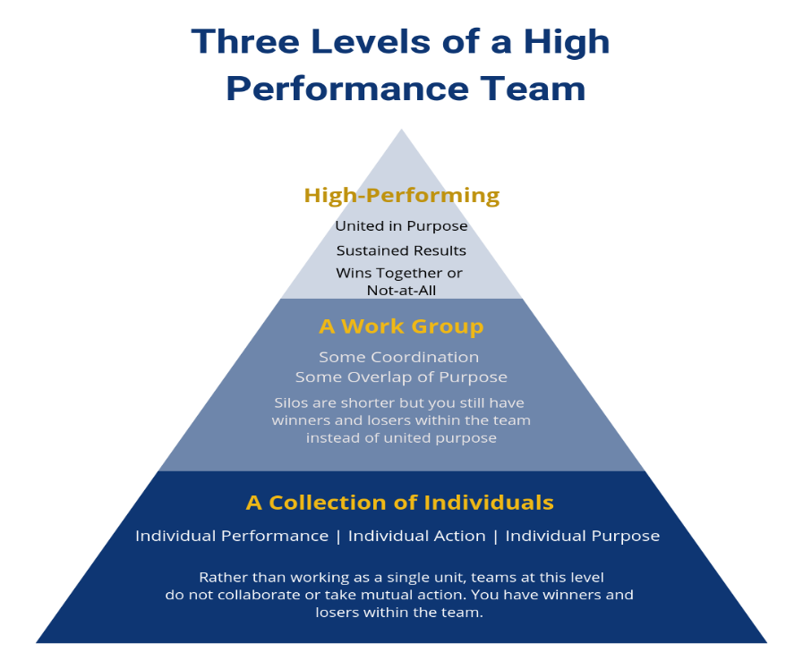
In order to create a high performance team, the team must go through 3 stages of team development. Firstly, the team are seen as a collection of individuals “Characterized by individual performance, action, purpose, and accountability, this level is more of a collection of individuals working alongside each other. Rather than working as a single unit, each operates within their own personal, high-walled silo. At this level, individuals do not collaborate or take mutual action, as it is each man or woman for himself or herself.” [17] If the team proceeds the project with this attitude the team is failed as they are working solo and not within a team. The second stage is the team becomes a work group “Teams at this level have achieved some coordination of their efforts. Enough collaboration regularly happens that individual purpose begins to overlap. At this stage the silos have gotten shorter – people can look out over them, but they have not yet achieved a level of teamwork that puts the best interests of the group over those of individuals. The final result is that there are still individual winners and losers.” [17] The third stage is where the team becomes a high performance team. The people and the results will have met the objectives consistently “All the individuals are winning, and when they do, the business results demonstrate this.” [17]

Figure 5- Three Levels of a High Performance Team [17]
To help to drive the team, the team manager select plays a big part. The team manager must be inspiring, creating energy and enthusiasm within the team setting each team member with a stretched goal that will encourage the team to achieve exceptional work. The team manger must be able to communicate with every member of the team, forever reminding the team of the end goal. They should be able to resolve any conflicts that occur within the team quickly ensuring that they do become worse. Increasing the cooperation within the team is essential as all members are essentially reliant on one another to finish the project. “High performing teams are built purposefully by leaders.” [17]

Recommendations
The existing project group that is currently in place has five members; the existing members of the team are all male with ages ranging between 25 and 35 years old. The team was awaiting five new team members; these have been recruited and added to the team. The team will be developed into a high performance team by following these steps. The team manager will be selected, they will need to be able to follow the management roles set by Mintzberg and be able to address the Leaders and manager’s primary roles stated by S.Cook in Choosing the Team Manager. The team manager will be able to encourage the team to develop their skills and aim for success. The team manager will help to make the team a high performing by giving the team members clear defined roles and give feedback on how individuals and the team are progressing. They should be able to communicate and have positive relationships with all team members, being able to manage any conflicts quickly and effectively. The team manger should be able to communicate with a range of people, within the team, company and outside the company.

Leadership Approaches
A leader must have the ability to “A person or thing that holds a dominant or superior position within its field, and is able to exercise a high degree of control or influence over others.” [18] There are 10 common leadership styles, by understanding them all to a certain extent, the leader is able to make a decision on the style to be used, and styles can be changed depending on the situation. The 10 common leadership styles are:
- “Coach
- Visionary
- Servant
- Autocratic
- Laissez-faire or hands off
- Democratic
- Pacesetter
- Transformational
- Transactional
- Bureaucratic” [19]
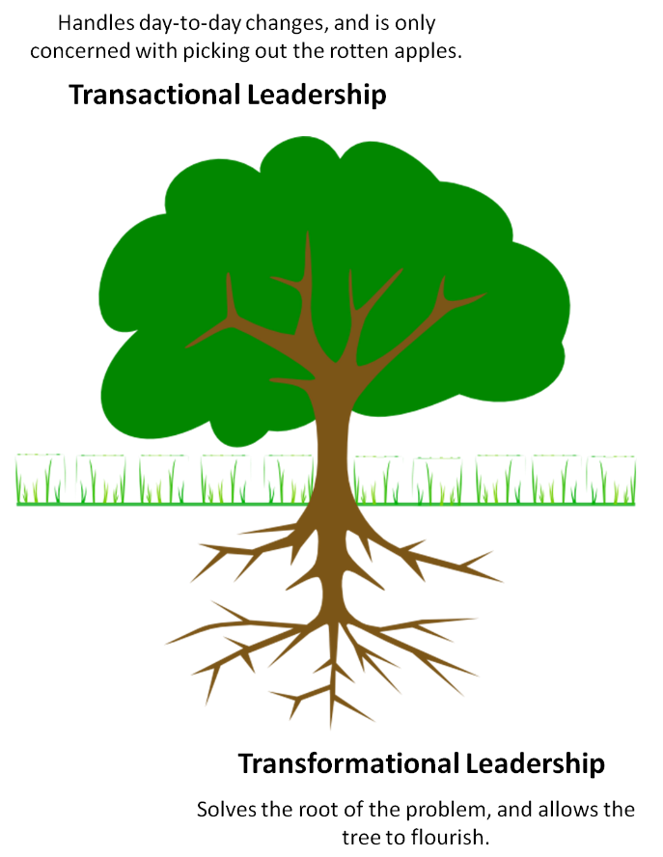
There are two types of leadership styles this report will look at, a transactional leader, and a transformational leader. B.M.Bass’ definition is “transactional leaders work within their organizational cultures following existing rules, procedures, and norms; transformational leaders change their culture by first understanding it and then realigning the organization's culture with a new vision and a revision of its shared assumptions, values, and norms” [20]
Figure 6 Transformational Leadership [30]

Transactional Leadership
This theory is based on rewards and punishments, “…transactional leaders develop exchanges or agreements with their followers, pointing out what the followers will receive if they do something right as well as wrong. They work within the existing culture, framing their decisions and action based on the operative norms and procedures characterizing their respective organizations” [20] this style of leadership enforces contingent rewards, this system is worked by motivation, rewarding those team member who complete their tasks and reach goals. This reinforces the leader’s thankfulness by proving the team member with a reward. For this theory to work, the rewards must be interesting to the team members, some of which could include, bonuses, memberships, extra paid holiday etc. if the reward is of no interest to the team member, they are unlikely to be as effective as somebody who would be interested. For example, one reward could include a round of golf, not every team member will be interested, and therefore the reward should be suitable for all team members. Passive management by exception is on element of the transactional leadership theory when the team manger does not actively involve his or herself with the workflow and will only do so if an issue was to arise. Active management by exception is where the team manager will do risk assessments to help to anticipate the problems and correct any issues that arise. The team manager will also monitor the progress of the team. An example of a transactional leader and their success is Bill Gates “As a transactional leader, he used to visit new product teams and ask difficult questions until he was satisfied that the teams were on track and understood the goal.” [21] Another example includes Howard Schultz, with the help of investors, bought into Starbucks and expanded it to be an international brand, “As a transactional leader, he was responsible for the vision and implementation of the Starbucks model.” [22]

Transformational Leadership
This theory is based on focusing on the team itself and not the leader, it is used when the business work style ensure that the employees are satisfied, productive and successful. “Transformational leaders have been characterized by four separate components or characteristics denoted as the 4 Is of transformational leadership (Avolio, Waldman, and Yammarino (1991). These four factors include idealized influence, inspirational motivation, intellectual stimulation, and individualized consideration.” [20] The features and the traits that are involved within a transformational leader include, B.M.Bass identified four features, and these are:
- “Charisma/idealised influence
- Inspirational motivation
- Intellectual stimulation
- Individualised consideration” [21]
According to the book written by B.M.Bass is the book “Leadership and Performance Beyond Expectations” published in 1985, he has defined the concept of transformational leadership as a number of key points, these include the team manager to be:
- “Is a model of integrity and fairness
- Sets clear goals.
- Has high expectations.
- Encourages others.
- Provides support and recognition.
- Stirs the emotions of people.
- Gets people to look beyond their self-interest.
- Inspires people to reach for the improbable.” [23]
Developing a transformational leadership style can be done by having all the characteristics stated above and by addressing the following steps.
By creating and inspiring vision for the team, will give the team reason to follow the manager. By encouraging the team to deliver the vision by the use of a mission statement, clearly informing them of the end goal. By talking about the vision often enough, and linking it to the team members goals will give the vision some context, making it easier for the team members to understand why the tasks need to be completed. Transformational leaders also need to understand the different ways team members can be motivated. Managing the delivery of the vision, communicating with each member of the team, ensuring all are aware of the responsibilities, setting each team member with SMART goals. If the team manager is to become a transformational leader, then, building trusting relationships with the team members, helping each one to achieve their goals.
In conclusion, a team manager can become a transformational leader by following these steps:
- “Create an inspiring vision of the future.
- Motivate people to buy into and deliver the vision.
- Manage delivery of the vision.
- Build ever-stronger, trust-based relationships with your people.” [23]
Conger (1991) has identified the different characteristics which appear on followers when they are devoted to the leader of the team. He has been able to identify four main characteristics, these are:
- “Followers show high levels of devotion, loyalty and reverence to the leader.
- Followers are both enthusiastic and committed to the ideas and vision espoused by the leader
- Followers willingly make self-sacrifices for the general good of the group as a whole.
- Followers show levels of performance and behaviour greatly beyond what would normally be expected.” [24]
Limsili and Oqunlana (2008) had found that the use of a transformational leadership approach encourage both employee productivity and organisation commitment.

Recommendations
By using the transformational leadership theory, the team manager will develop a good following by the other 9 members of the team. In order to select the right team manager the employee should be admired and respected by all the team members. They should be able to motivate the team to increase employee productivity. The team leader should be passionate about the vision so they are able to deliver and pass on that passion to the team members. The team manager should be fair to all team members, and set clear goals for the team. They should be approachable for the team members to be able to speak to them be there any issues that need resolving or and queries regarding the project, their tasks or the workplace. By following B.M.Bass’ concepts of transformational leadership, selecting the team manager will be made easier.

Key Performance Indicators
Key performance indicators are used within businesses as an indicator for progression and operations. Key performance indicators includes setting targets for the team members, helping to track the progress for each team member or for the team as a whole. “Key performance indicators (KPIs) are business metrics used by corporate executives and other managers to track and analyse factors deemed crucial to the success of an organization. Effective KPIs focus on the business processes and functions that senior management sees as most important for measuring progress toward meeting strategic goals and performance targets.” [25] Having good KPI’s will evidence any progress which is effecting the project or goals, they should be able to measure important areas which will help the business on decision making. KPI’s can also be used to compare different team members or different performances over time, may this be at different times of the year or over any period of time. Key performance indicated will help to track the efficiency of the team and the business. They can be used to analyse project performance and personal performance.
From the personal experience of the writer, Debenhams used KPI’s to analyse an employee’s performance, some of the KPI’s used include, beauty cards, e-mail captures, new credit card account openings and in store orders.
There will be other KPI’s within the business, however these are the ones the sales assistants are aware of.
When the KPI’s are being decided upon, they should be:
- “Be well-defined and quantifiable.
- Be communicated throughout your organization and department.
- Be crucial to achieving your goal. (Hence, key performance indicators.)
- Be applicable to your Line of Business (LOB) or department.” [26]
There are an extensive number of KPI’s a business can choose from, however only those that are relevant to the business and its needs for now, and needs for the future.
Some examples of KPI’s are:
“Financial
- Profit
- Cost
- Revenue vs Target
- Cost of Goods sold
- Day sales Outstanding
- Sales by Region
Customer Metrics
- Customer Lifetime Value
- Customer Acquisition Cost
- Customer Satisfaction & Retention
- Net Promoter Score
- Number of Customers

Process Metrics
- Customer Support Tickets
- Percentage of Products Defects
- LOB Efficiency Measure
People Metrics
- Employee Turnover Rate
- Percentage of response to Open Positions
- Employee Satisfaction” [26]
To set up the key performance indicators for this project, firstly the business needs a goal to show whether or not the business is on track to meet their desired goals. Setting a target to meet within a desired timescale will help to identify the stages that need to be in-between. For example if the business is setting a 5 year target, creating targets every year in-between will make the goals feel more achievable.

Recommendations
As the company is software development company Swansea App Synthesis Ltd. The KPI’s that are used should adapt to the business and the work being completed. To help manage productivity of the team, the following KPI’s should be used.
Cycle time – how long does it take the team to successfully move from one stage of an issue, to another? This is measured by recording the time when an issues arises and when a change to the issues has occurred. This is measured to set expectations of tasks as well as identifying any bottlenecks that may affect the team during this project and the next.
Velocity – this is the number of elements of the project which has been completed over a certain time scale. This is measured to estimate delivery times for certain elements of a project.
Throughput – this is how the total output of the team is measure, there is a number of features that can be used within throughput such as “tasks or chores, and bugs completed within a period that are ready to ship or ready to test. When teams refer to their throughput, they’re usually reviewing last period’s throughput, but average throughput can also be useful.” [27]
Work in Progress – this is the measurement of the total issues that a software development team is working on “It is an objective measure of a team’s speed similar to throughput, but as a present moment indicator, rather than a lagging one.” [27]
Cumulative Flow – “Cumulative flow is a measure of both the time to delivery and the repeatability and health of your process.” [27] This measure will help to highlight the bottlenecks discussed in cycle time, and for the team members to review their work.
Release cycle time- similar to cycle time, only measures the total time taken per project, measuring from the begging, to the time of release.
Difficulty of Feature Implementation – this is how the team found the tasks, a measure of how difficult they were to complete. This measurement is used to “identify when your team is ready to take on more challenging work, or when your team needs additional resources or training to complete its work effectively.” [27]
Should we release faster? – This measurement is used to decide whether the software development team are able to release the project. This information can be collected every time a milestone is hit with a project. “Knowing how your team feels about the pace of their sprints can tell you a lot about overall velocity, throughput, and overall team health.” [27]
There are various pieces of software available for these key performance indicators, which could be used to analyse and conclude each KPI.
In conclusion, it believed that the key performance indicated should be used to analyse the project and the software development team.

References

[1] | “DEVELOPING HIGH PERFORMING TEAMS,” The Centre for Organizational Design, [Online]. Available: http://www.centerod.com/developing-high-performance-teams/. [Accessed 02 05 2019].
[2] | “public-sector-equality-duty,” equalityhumanrights, [Online]. Available: https://www.equalityhumanrights.com/en/corporate-reporting/public-sector-equality-duty. [Accessed 02 05 2019].
[3] | “public-sector-equality-duty-faqs,” equalityhumanrights, [Online]. Available: https://www.equalityhumanrights.com/en/public-sector-equality-duty-scotland/public-sector-equality-duty-faqs. [Accessed 03 05 2019].
[4] | “Public-Sector-Equality-Duty-explained,” hillingdon, [Online]. Available: https://www.hillingdon.gov.uk/article/33743/Public-Sector-Equality-Duty-explained. [Accessed 02 05 2019].
[5] | “Alec Rodger’s Seven-Point Plan And Munro Fraser’s Five-Fold Grading System,” Pawel Bzowy – Human Resources and Knowledge Management Best Practise Share Point, [Online]. Available: https://bzowy.wordpress.com/2010/11/08/alec-rodgers-seven-point-plan-and-munro-frasers-five-fold-grading-system/. [Accessed 19 03 2019].
[6] | “how-to-filter-cvs,” totaljobs, [Online]. Available: https://recadvice.totaljobs.com/how-to-filter-cvs/. [Accessed 26 03 2019].
[7] | “companies,” assessmentday, [Online]. Available: https://www.assessmentday.co.uk/companies.htm. [Accessed 30 04 2019].
[8] | “Online Aptitude Test for hire Software Developers For Your Organization,” mettl, [Online]. Available: https://mettl.com/en/test/aptitude-test-software-development/. [Accessed 02 05 2019].
[9] | S. Cook, Building a High Performance Team: Proven Techniques for Effective Team Working, IT Governance, 2009.
[10] | “High Performing Teams: What Are They and How Do I Build One?,” ActiveCollab, [Online]. Available: https://activecollab.com/blog/collaboration/high-performing-teams. [Accessed 01 05 2019].
[11] | C. L. Frank LaFasto, When Teams Work Best: 6,000 Team Members and Leaders Tell What it Takes to succeed, sage, 2001.
[12] | “Mintzberg Model: 10 Different Roles of a Successful Manager,” medium, [Online]. Available: https://medium.com/taskworld-blog/mintzberg-model-10-different-roles-of-a-successful-manager-77f9d87b773c. [Accessed 02 05 2019].
[13] | “interpersonal-skills,” investopedia, [Online]. Available: https://www.investopedia.com/terms/i/interpersonal-skills.asp. [Accessed 02 05 2019].
[14] | “Mintzberg's Management Roles,” free-management-ebooks, [Online]. Available: http://www.free-management-ebooks.com/faqld/leadmodels-01.htm. [Accessed 02 05 2019].
[15] | “Managing and managing people,” The Open University , [Online]. Available: https://www.open.edu/openlearn/money-management/management/leadership-and-management/managing-and-managing-people/content-section-4.3.2. [Accessed 02 05 2019].
[16] | “Managing and managing people Decisional roles,” The Open University , [Online]. Available: https://www.open.edu/openlearn/money-management/management/leadership-and-management/managing-and-managing-people/content-section-4.3.3. [Accessed 02 05 2019].
[17] | “The 3 Levels of a High-Performance Team,” business2community, [Online]. Available: https://www.business2community.com/strategy/the-3-levels-of-a-high-performance-team-02178320. [Accessed 02 05 2019].
[18] | “leader,” businessdictionary, [Online]. Available: http://www.businessdictionary.com/definition/leader.html. [Accessed 02 05 2019].
[19] | “10-common-leadership-styles,” indeed, [Online]. Available: https://www.indeed.com/career-advice/career-development/10-common-leadership-styles. [Accessed 02 05 2019].
[20] | B. M. BASS, TRANSFORMATIONAL LEADERSHIP, 1993.
[21] | “transformational-leadership-what-is-it,” investorsinpeople, [Online]. Available: https://www.investorsinpeople.com/transformational-leadership-what-is-it/. [Accessed 02 05 2019].
[22] | “what-is-transactional-leadership,” STU Online, [Online]. Available: https://online.stu.edu/articles/education/what-is-transactional-leadership.aspx. [Accessed 02 05 2019].
[23] | “transformational-leadership.,” mindtools, [Online]. Available: https://www.mindtools.com/pages/article/transformational-leadership.htm. [Accessed 02 05 2019].
[24] | P. D. c., The Social Psychology of Behavious in Small Groups, 2002.
[25] | “Key performance indicators,” searchbusinessanalytics, [Online]. Available: https://searchbusinessanalytics.techtarget.com/definition/key-performance-indicators-KPIs. [Accessed 02 05 2019].
[26] | “18 key-performance-indicator,” clearpointstrategy, [Online]. Available: https://www.clearpointstrategy.com/18-key-performance-indicators/. [Accessed 02 05 2019].
[27] | “8-essential-software-development-metrics-for-team-productivity,” [Online]. Available: https://blog.usenotion.com/8-essential-software-development-metrics-for-team-productivity-273737868960. [Accessed 02 05 2019].
[28] | L. K. Ray Aldag, Creating High Performance Teams: Applied Strategies and Tools for Managers and Team Members, Routledge, 2015.
[29] | “public-sector-equality-duty-faqs,” equalityhumanrights, [Online]. Available: https://www.equalityhumanrights.com/en/public-sector-equality-duty-scotland/public-sector-equality-duty-faqs. [Accessed 02 05 2019].
[30] | “course-information,” 1stenterprisetraining, [Online]. Available: https://www.1stenterprisetraining.co.uk/course-information. [Accessed 02 05 2019].

