Appendix A: Pre-Site Briefing Operation Information Documents

PRE-SITE INFORMATION FORM
Main Contact Details
Name | David Welton
Company | University of Wales Trinity St David
Address | UWTSD  Carmarthen campus  Carmarthen  Carmarthenshire
Postcode | SA31 3EP
Telephone | 01267 676767
Mobile phone | 07713637126
Email | d.welton@uwtsd.ac.uk

Site Details
Site address  (if different to above) | University of Wales Trinity St David  Cynefin  Johnston  Carmarthen
Postcode | N/A
Permissions | Yes from UWTSD
Description of site | Cynefin: UWTSD outdoor training centre and storage facility

Operation Overview
Description of Operation | Students to carry out drone filming with the DJI Mini5 Pro and Neo in order to capture footage for aerial film Assessment. Students with their own drone or University drone will be able to fly under strict supervision and within the University guidelines and CAA regulations.  Flight demonstration with DJI Mavic Cine Pro

Operation Details
Detailed Description of Operation Requirements and Tasks | The operation will involve student(s) carrying out pre-flight checks, discussing safety issues, risk assessments, CAA guidelines and code of conduct. The students will fly their own or University drones under supervision by DW  Flight with DJI Mavic 3 Cine will be flown by DW and directed by students  The drone(s) will be used for a variety of shots including tracking, lift and reveal, follow and orbits of a mountain biker on the pump track and the field next to the centre and river  Photos/video may be taken of Carmarthen Town, playing fields, river Towy in the distance as well as the Cynefin Site  Students with their own drone or University drone will be able to fly under strict supervision and within the University guidelines and CAA regulations
Timescale of operation (fixed date, variable date) | Set up at 0900 - complete by 1400
Additional Notes | Advice sought from the Senior Lecturer for permission and hazards on site

Potential Hazards and Risks
Description of Potential Hazards and Risks | Flights will take place on UWTSD property and advice will be sought as to special hazards at this site.  There is an overhead power line (NNW to SSE) which crosses a nearby field and is approximately 30m from the closer take off site.  The site has trees and buildings close to the take-off site.  Students and members of staff from other courses may be using the same site. They will be fully informed of the operation and asked to not enter the take-off and landing site. Should anyone be involved as a demonstration film shoot, for example a mountain biker on the purpose-built track, they will be fully informed as to the drone location and movement during the shoot and will be under the control of the PIC.  Windspeed will be checked before each flight including recognising turbulence around trees and buildings. Will not fly if gusts exceed 22mph.  Weather forecast suggests increasing likelihood of rain showers. No flights to take place if raining due to damage to aircrafts electronics.  This is a large site and able to accommodate more than one aircraft. If more than one drone is used there will be strict separation zones implemented. No more than 2 drones to be flown at any one time. Only DW/LO to be in overall control of any drone flights

Appendix B:Site Survey and Risk Assessment

SITE SURVEY FORM
1) Operation Details
Name/Company | David Welton, Animality Productions
Reference No. | UWTSD6
Planned Date(s) and times | 12th October 2026  0900 - 1400

2a) Site Inspection
Site address | UWTSD
Postcode or 6 figure grid ref. | SN401 181 | Elevation (AMSL) | 8m
Latitude | 51 (degrees) 50' 19" N | Longitude | 4 (degrees)19' 17" W

General map below shows the site of the UWTSD land and the location of the take off site. The site will be assessed on arrival for additional hazards

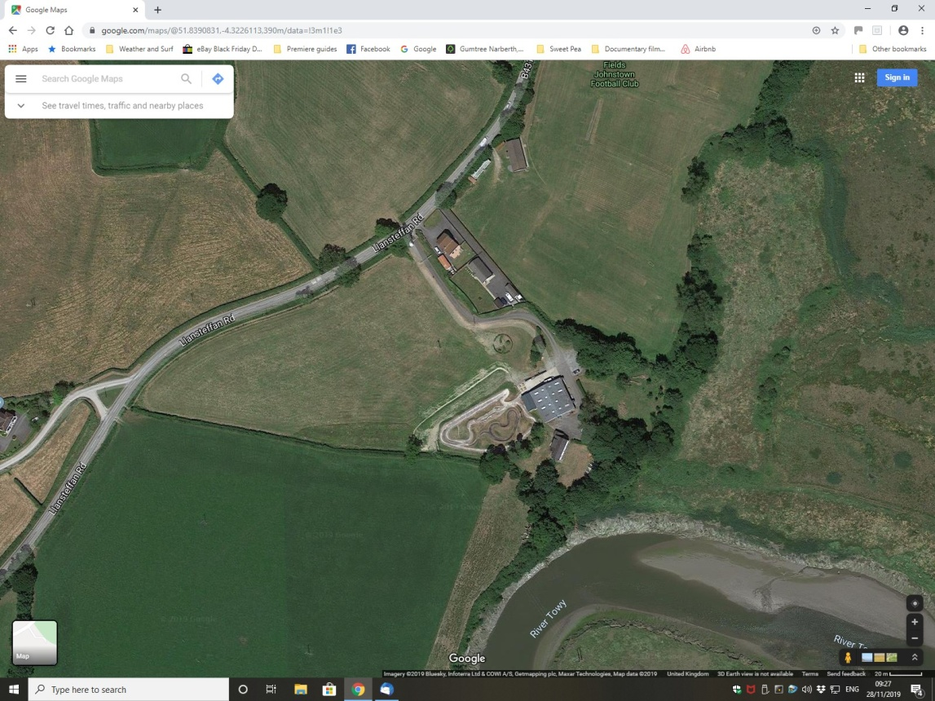-4.3220150
Site Details
Above image of site showing surrounding landscape.

3x Detailed take off and landing locations + hazards in images below.
The positions and further hazards will be assessed on arrival and relocated if deemed necessary.

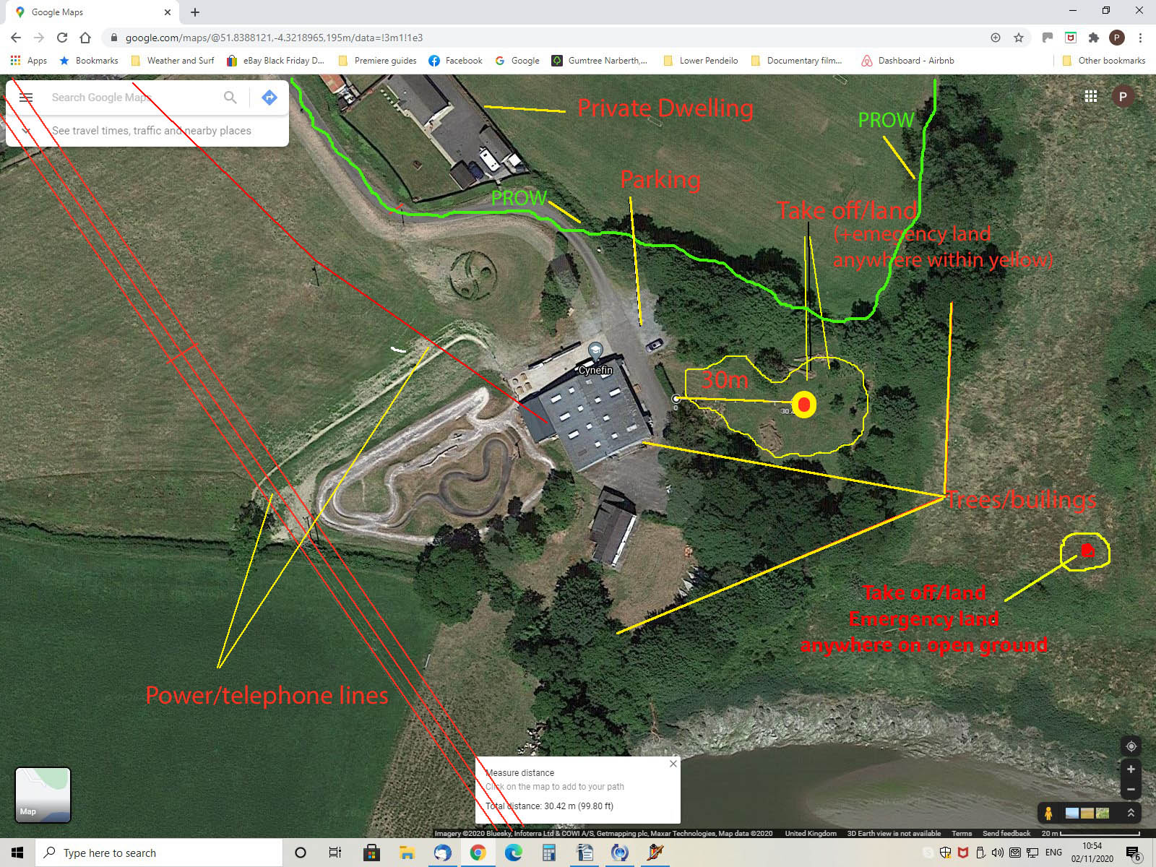

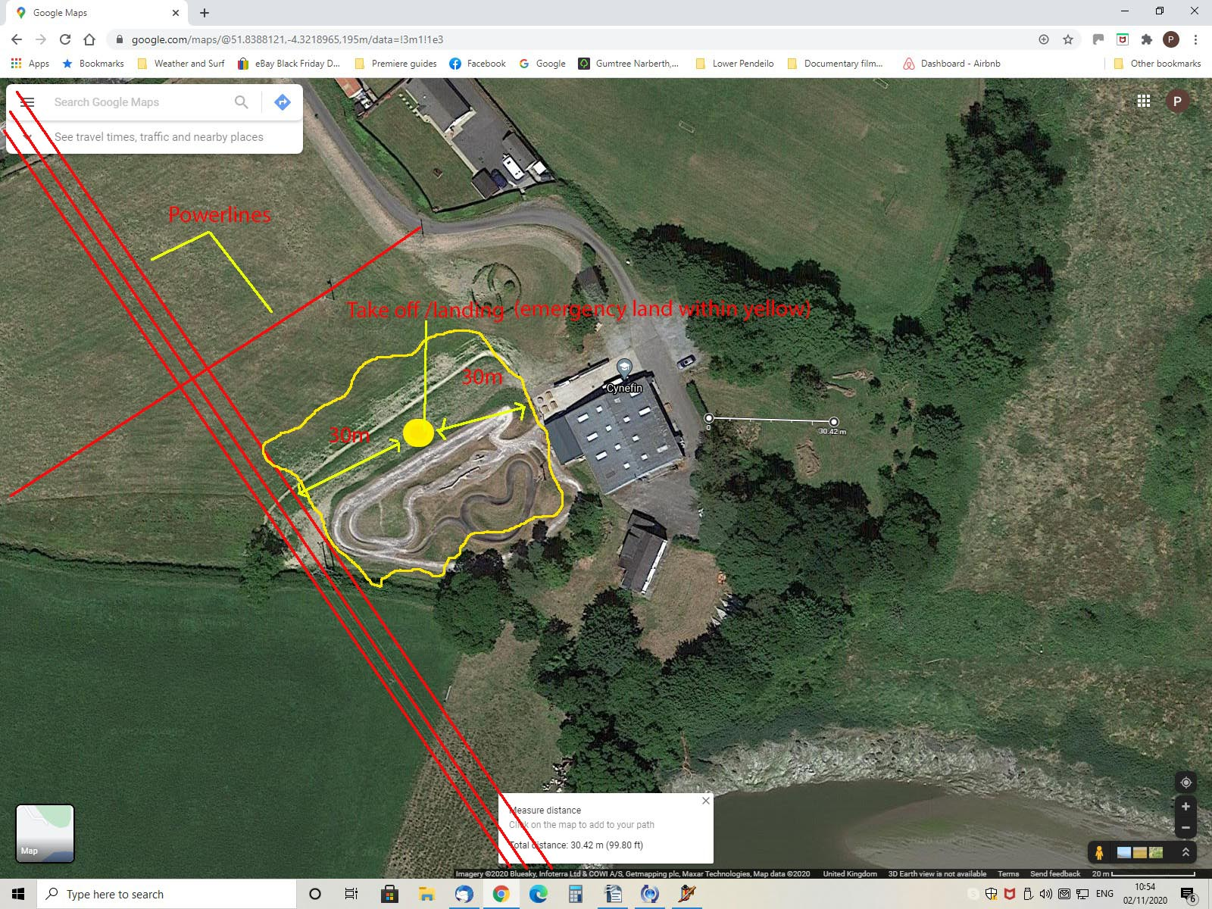
Required Equipment
Aircraft | DJI Mavic 3 Pro Cine, ( University aircraft DJI Mini 5 Pro, DJI Neo
Payload | Built in camera on all drones
Extra Equipment (in addition to the standard equipment as specified in the QRH relating to the above aircraft | No extra equipment for drone  Landing mat would be recommended to avoid sand /salt water/grass to contaminate aircraft

Final Checks
Weather Forecast | Showers all day  Southerly 11-14mph. | Date Checked | 12-10-26  (and on day)
NOTAMs  (notice to airmen) | No NOTAMS  Checked NATS (National Air Traffic services) | Date Checked | 12-10-26  (and on day)
Permission Details (ATC, Location other authorities) | UWTSD owned site. Permission sought via senior lecturer  OA, RA + 3PL provided

RISK ASSESSMENT FORM

Risk Matrix Legend
Probability: |  | Severity:
5 | Very Likely | 5 | Fatality | Major Env. Incident
4 | Likely | 4 | Major Injury | Severe damage
3 | Probable | 3 | Medical Injury | Damage
2 | Possible | 2 | Minor Injury | Small Impact
1 | Very Unlikely | 1 | No Injury | No Env. Impact

The risk score, the value entered into the green, yellow or red boxes under Initial Risk Score and Final Risk Score, is a multiple of Probability x Severity.

If a Risk Score is 1 to 5 (Green) then no further control measures are required.

If a Risk Score is 6 to 10 (Yellow) then further control measures are required.

If a Final Risk Score is greater than 12 (Red) then the risk is unacceptable and operation should not proceed.

Hazard |  | At Risk | Initial Risk Score
Public Access |  |  | Probability | 5
Public Area | Yes | Pilot injury  Observer / camera operator injury  Public injury | Probability | 4
Private Land | Yes |  | Probability | 3
Other non involved students | Yes |  | Probability | 2 |  | 4
Involved students | Yes |  | Probability | 1
 |  |  | Probability | 0 | 1 | 2 | 3 | 4 | 5
 |  |  | Probability | Severity
Control Measure |  |  | Final Risk Score
PIC and Observers to keep constant lookout for incursion  Cordon off take off and landing area as necessary  Do not allow public or anyone not under control of the PiC or observer within 30m of take off  Be aware of public footpath North of buildings  Pic and observer to wear High Visibility jackets.  Do not fly within 50m of any person not in control of the PiC  Attend briefing to be aware of any unplanned for hazards.  Drone operator to be fully briefed on safe operation of drones in line with CAA guidelines.  Ensure non involved students and lecturers are briefed if on site at the same time and do not allow within cordon if not involved.  Ensure all students involved – in particular mountain bikers (if  being filmed) are fully informed of aircrafts movement prior to flight and are briefed on safety calls should the drone fly too close. Mountain bikers must wear suitable clothing and helmets/face shields. |  |  | Probability | 5
 |  |  | Probability | 4
 |  |  | Probability | 3
 |  |  | Probability | 2
 |  |  | Probability | 1 |  | 2
 |  |  | Probability | 0 | 1 | 2 | 3 | 4 | 5
 |  |  | Probability | Severity

Hazard |  | At Risk | Initial Risk Score
Obstacles |  |  | Probability | 5
Trees |  | Aircraft making contact with obstacle.  Injury from out of control aircraft.  Aircraft in contact with power lines | Probability | 4
Lamp posts |  |  | Probability | 3
Masts/wires |  |  | Probability | 2 | 2
Structures |  |  | Probability | 1
Poles |  |  | Probability | 0 | 1 | 2 | 3 | 4 | 5
Birds |  |  | Probability | Severity
Control Measure |  |  | Final Risk Score
Carry out thorough observation of obstacles and familiarisation of site prior to take off  Ensure observer is present and warns PiC if UAS is within 10m of any obstacle in particular power lines. This is specific to the pump track which has multiple power lines nearby.  Ensure aircraft separation from power lines. Descend vertically to landing site clear of power lines  Ensure wind direction and speed is accounted for during any maneuver.  Be aware of flocks of birds and avoid disturbing them. If birds are airborne – land well away immediately |  |  | Probability | 5
 |  |  | Probability | 4
 |  |  | Probability | 3
 |  |  | Probability | 2
 |  |  | Probability | 1 | 1
 |  |  | Probability | 0 | 1 | 2 | 3 | 4 | 5
 |  |  | Probability | Severity

Hazard |  | At Risk | Initial Risk Score
Interference |  |  | Probability | 5
WiFi Present |  | Aircraft may lose control link and engage the failsafe. | Probability | 4
Unknown antenna |  | Aircraft may lose control link and engage the failsafe. | Probability | 3
Other UAS in area |  | Aircraft may lose control link and engage the failsafe. | Probability | 2 |  | 4
 |  | Aircraft may lose control link and engage the failsafe. | Probability | 1
 |  | Aircraft may lose control link and engage the failsafe. | Probability | 0 | 1 | 2 | 3 | 4 | 5
 |  | Aircraft may lose control link and engage the failsafe. | Probability | Severity
Control Measure |  |  | Final Risk Score
Ensure any WiFi is turned off during flights  Max 2 UAS to operate at a time and when not in operation transmitter and aircraft powered off.  Clear separation zones to be implemented with students nominated as observers  Ensure PiC and observer are familiar with emergency procedures. |  |  | Probability | 5
 |  |  | Probability | 4
 |  |  | Probability | 3
 |  |  | Probability | 2
 |  |  | Probability | 1 |  | 2
 |  |  | Probability | 0 | 1 | 2 | 3 | 4 | 5
 |  |  | Probability | Severity

Hazard |  | At Risk | Initial Risk Score
Loss of control link |  | Aircraft may lose control link and engage the failsafe.  Fly away situation | Probability | 5
Battery failure |  |  | Probability | 4
Software failure |  |  | Probability | 3
 |  |  | Probability | 2
 |  |  | Probability | 1 |  |  | 3
 |  |  | Probability | 0 | 1 | 2 | 3 | 4 | 5
 |  |  | Probability | Severity
Control Measure |  |  | Final Risk Score
Ensure latest UAS software updates are installed tested prior to commercial operations.  Ensure batteries in transmitter and UAS are maintained correctly and disposed should any fault occur  Set maximum distance and height parameters for each aircraft and job specific if required. |  |  | Probability | 5
 |  |  | Probability | 4
 |  |  | Probability | 3
 |  |  | Probability | 2
 |  |  | Probability | 1 | 1
 |  |  | Probability | 0 | 1 | 2 | 3 | 4 | 5
 |  |  | Probability | Severity

Hazard |  | At Risk | Initial Risk Score
Mechanical Failure |  | PiC, observer and public | Probability | 5
Motor Failure |  |  | Probability | 4
Rotor failure |  |  | Probability | 3
Hardware failure |  |  | Probability | 2
 |  |  | Probability | 1 |  |  |  | 4
 |  |  | Probability | 0 | 1 | 2 | 3 | 4 | 5
 |  |  | Probability | Severity
Control Measure |  |  | Final Risk Score
Ensure all equipment is correctly serviced  Inspect all parts of the UAS and transmitter before and after each flight |  |  | Probability | 5
 |  |  | Probability | 4
 |  |  | Probability | 3
 |  |  | Probability | 2
 |  |  | Probability | 1 | 1
 |  |  | Probability | 0 | 1 | 2 | 3 | 4 | 5
 |  |  | Probability | Severity

Hazard |  | At Risk | Initial Risk Score
Weather |  | Weather conditions exceed UAS capability. | Probability | 5
Wind |  |  | Probability | 4
Rain |  |  | Probability | 3
Lightning |  |  | Probability | 2 |  | 4
Visibility |  |  | Probability | 1
 |  |  | Probability | 0 | 1 | 2 | 3 | 4 | 5
 |  |  | Probability | Severity
Control Measure |  |  | Final Risk Score
Ensure weather forecast is consulted prior to flight to assess appropriateness of conditions.  Assess conditions on site and only fly within the capabilities of the UAS and pilot  Avoid locations that are likely to create severe turbulence  Be familiar with the capabilities of UAS  Use anemometer to measure wind speed and only fly within the UAS capability. Below are Max figures. Ensure flights are well within this windspeed due to stronger gusts and reduced battery life  Cease flying aircraft if raining  Mini 5 pro – max 26.8mph  Mavic Cine – max 26.8mph  Mini 3 Pro – Max 24mph  Neo – Max 17.8 mph |  |  | Probability | 5
 |  |  | Probability | 4
 |  |  | Probability | 3
 |  |  | Probability | 2
 |  |  | Probability | 1 |  | 2
 |  |  | Probability | 0 | 1 | 2 | 3 | 4 | 5
 |  |  | Probability | Severity

Hazard |  | At Risk | Initial Risk Score
Other aircraft operating |  | Other pilots, PiC and observer | Probability | 5
Other UAS's |  |  | Probability | 4
Manned aircraft |  |  | Probability | 3
 |  |  | Probability | 2
 |  |  | Probability | 1 |  |  |  |  | 5
 |  |  | Probability | 0 | 1 | 2 | 3 | 4 | 5
 |  |  | Probability | Severity
Control Measure |  |  | Final Risk Score
Ensure UAS operated under 120m and within 500m (VLOS)  Consult aviation charts for location  Check NOTAMs prior to operating  Check no other aircraft are present  Observers to inform PIC immediately should another UAS, or manned aircraft be spotted or heard.  Ensure and agree safe separation if more than one UAS in flying |  |  | Probability | 5
 |  |  | Probability | 4
 |  |  | Probability | 3
 |  |  | Probability | 2
 |  |  | Probability | 1 | 1
 |  |  | Probability | 0 | 1 | 2 | 3 | 4 | 5
 |  |  | Probability | Severity

Hazard |  | At Risk | Initial Risk Score
People |  | Mountain bikers and other people on site | Probability | 5
Mountain Bikers |  |  | Probability | 4
Other people involved |  |  | Probability | 3
 |  |  | Probability | 2
 |  |  | Probability | 1 |  |  | 3
 |  |  | Probability | 0 | 1 | 2 | 3 | 4 | 5
 |  |  | Probability | Severity
Control Measure |  |  | Final Risk Score
Ensure all people involved in the operation are fully informed of aircraft movements prior to take off  Observers to be in place at all times to warn pilot and/or bikers of obstacles or other issues. |  |  | Probability | 5
 |  |  | Probability | 4
 |  |  | Probability | 3
 |  |  | Probability | 2
 |  |  | Probability | 1 | 1
 |  |  | Probability | 0 | 1 | 2 | 3 | 4 | 5
 |  |  | Probability | Severity

