Digital Receipt
This receipt acknowledges that Turnitin received your paper. Below you will find the receipt information regarding your submission.
The first page of your submissions is displayed below.

Submission author: Assignment title: Submission title:
File name: File size:
Page count: Word count:
Character count: Submission date: Submission ID:
Russell Christopher Baptist
Submit your assignment here Part 1 (Moodle TT) MYBA400_GROUP 4
72456_Russell_Christopher_Baptist_MYBA400_GROUP_4_7522…
592.26K
28
6,163
36,747
24-Aug-2026 09:35PM (UTC+0100)
288042150




Copyright 2026 Turnitin. All rights reserved.



LEVEL 4 ASSESSMENT SPECIFICATION

Student name: | - Russel Christopher Baptist  - Amiel Nashiheen Bin Aminuddin  - Muhammad Nazmi Aiman Bin Muhammad Nazri  - Mhd Danial Hadriss Bin Zainol  Abidin | Student ID number: | 1. 2527785  2. 2527794  3. 2527791  4. 2527784
Module: | Contemporary Challenges: Making a Difference
Module code: | MWBA4000 | Contribution to Overall Module  Assessment (%): | 100%
Lecturer: | Emma Roberts | Internal  Verifier: | Vic Saunders

Assignment Title: | The Significance of Global Teams in Solving Shortened Attention Spans and Deteriorating Academic Performance | Word count (or equivalent): | 6000
Submission deadline: | Monday 24th August 2026 (23.55/11.55 pm British Summer Time BST) | Return date of provisional marks & written  feedback: | 21st September 2026
Submission method: | All written assessments, where practical and possible, must be submitted via Turnitin unless otherwise instructed by the Lecturer. (Please DO NOT put this assessment specification into Turnitin, or it will match many similarities with other students’ submissions.)  Alternative submission method (if applicable):  Late submission of the assessment will result in a late penalty mark:  Work which is submitted up to 1 week late will be capped at 40% for the first attempt and will be awarded a mark of 0% for re-assessment. Late submission penalties may be lifted only if there is an approved extenuating circumstances claim.  Work submitted more than 1 week late will be considered as a non-submission and will not be marked. The work may be considered as a submission for reassessment if offered by an Examining Board or if there is an approved extenuating  circumstances claim.

Academic honesty/refer encing: | Academic honesty is required. In the main body of your submission, you must give credit to authors on whose research and ideas your work is based. Append to your submission a reference list that indicates the books, articles, etc. that you have used,  cited or quoted to complete this assessment.

Module Learning Outcomes (from module syllabus)
- Identify and evaluate historical and contemporary issues and their impact on today's global society.
- Apply appropriate collaborative working practices to manage conflict and support effective decision-making.
- Implement Design Thinking techniques to investigate problems and generate and evaluate

solutions.

USE OF GENERATIVE AI IN ASSESSMENT

(Lecturer to indicate Yes or No against each element)

RESEARCH | For this assessment, you can use Generative AI to support you in research, including searching for bibliography, using  tools to summarise, compare and interrogate materials. | Yes ☒  No ☐
STRUCTURE | For this assessment, you can use Generative AI to support  you in structuring your submission, including creating a draft argument structure, identifying parts and headings, etc. | Yes ☒  No ☐
PROOFREADING | For this assessment, you can use Generative AI to check your own text/creation for grammatical and syntactical mistakes, including rephrasing of your own work within  specific standards. | Yes ☒  No ☐
WRITING | For this assessment, you can use Generative AI to create text for submission. | Yes ☐  No ☒

CREATIVE | For this assessment, you can use Generative AI to create creative materials, such as images. | Yes ☒  No ☐
PROGRAMING | For this assessment, you can use Generative AI to create and check code. | Yes ☐  No ☒
NONE | For this assessment, you are not allowed to use any type of Generative AI support. This includes research support, structure support, writing/proofreading support and creative  support. | Yes ☐  No ☒

STUDENT FEEDBACK FORM
This section details the extent to which the assessment criteria are demonstrated by you, which in turn determines your mark. The marks available for each category of skill are shown. Lecturers will use the space provided to comment on the achievement of the task(s), including those areas in which you have performed well and areas that would benefit from development/improvement.

Generic Assessment Criteria | Marks available | Marks awarded
1. Engagement with Literature Skills | 10
2. Knowledge and Understanding Skills | 30
3. Cognitive and Intellectual Skills | 15

4. Practical Application Skills | 15
5. Transferable Skills for Life and Professional Practice | 30

Assessment Mark (Assessment marks are  subject to ratification by the Exam Board. | Late Submission Penalties (tick if  appropriate) |  | %
These comments and marks are intended to provide feedback on module work and are  for guidance only until they are confirmed.) | Up to 1 week late (40% Max) |  | %
 | Over 1 week late (0%) |  | %

Name: Russell Christopher Baptist Student ID: 2527785
Section 1
Slides Link: C:\Users\Elwyn Baptist\Downloads\Beige Black Vintage Landscape Illustration

Simple Presentation .pdf

Video Presentation Link: https://youtu.be/FRsw-7kMvU0?si=cc2B9yfMLa5JsOib

Section 2

Section 2

For Group 4, there were a total of 4 members (the number of the group is the same as the participants). The topic for Group 4 is the importance of global teams in problem-solving, emphasizing the impact of diversity on teams’ performance, particularly on how diversity in Malaysia is different from anywhere else due to its long and intricate history of colonial and modern factors. The presentation also focused on the bigger picture of how diversity also affects global leaders, and how diversity is, in fact, a contemporary challenge as the factors surrounding diversity are constantly changing, leading to newer and more complex issues. The main message of the presentation, however, is that diversity should not be ignored or simplified by corporate jargon; rather, it should be embraced fully by global leaders. The flow of the presentation started with Russell Christopher Baptist, who introduced the title of the presentation and delivered a short introduction to the problem, the problem being diversity. After that, it was followed by Russell giving his main point on Wicked Problems. Russell began his point by stating why Diversity is a contemporary challenge, as the factors surrounding diversity are constantly changing. He then followed it up by stating his next point on why diversity is a wicked problem. Russell made this distinction by stating that diversity has no single way to solve it.
After Russell, it was Amiel who presented the design thinking approach on navigating conflicts. He first investigated some of the common cultural differences and how people interpret these situations and approach problems. He made his point by expressing that diversity creates both challenges and opportunities for global leaders, as suppressing it is also ineffective in the long run. He did, however, provide two potential solutions to effectively solve these problems. He did this through both the MBI method (Map, Bridge, Integrate) and Inclusive Leadership. The third presenter was Nazmi Aiman. His point was on recognizing individual differences in marginalization; it was then followed by the role of emotional

intelligence in conflict management. His first point, to sum it up, was on moving beyond stereotypes, embracing intersectionality, valuing cognitive diversity, and designing equitable solutions. His second point leans more towards how someone's emotional intelligence plays in conflict management. He covered three main ways: self-awareness and self-regulation, empathy, and relationship management. The key takeaway of Nazmi’s point was basically on conflict management: how to help solve it and how emotions play in the whole process of resolving it.
The fourth and final presenter for the topic is Muhammad Daniel Hadriss. He focused on the significance of interdisciplinary thinking. He started it out with the definition of the term, its importance, and even proposed a solution for working with a diverse team. To put it in rudimentary terms, Daniel defined the term as bringing together a team of different people to solve a problem. The importance of this is that it provides multiple different approaches and solutions for working on the same goal. He then proposed that the solution for this is to simply listen to what others have to offer and come to a collective agreement on what the main problem is.
2.1 How Wicked Problems interrelates to these ideas and overall group conclusion Wicked problems: the idea presented in this group relates to the problem of diversity, especially the challenges it presents in Malaysia. Russell, the first presenter, essentially lays the foundation for the rest of the group to present their idea. Russell basically introduces his point on how diversity is both a contemporary challenge and a wicked problem, as the factors surrounding it are constantly changing due to technological advancements as well as a shift in demographics. It also has no real solution and affects multiple stakeholders like the government and ethnic communities, that is verdantly interconnected with many issues such as equality vs equity. Overall, the group concluded that, while diversity doesn't have a single solution to fully fix, there are smaller steps global leaders could take to better understand what it means to be diverse, especially in the workforce, since diversity isn’t limited to race and religion. The solutions provided by the group can make working together far easier and less tense when the people working in a group feel understood and heard.

Section 3 :Critique

Group 4 had delivered an in-depth presentation on the importance of global teams in problem-solving, emphasizing the impact of diversity on teams’ performance. The first presenter made the distinction that diversity in Malaysia is, in fact, a contemporary challenge and a wicked problem; the last presenter placed an excellent emphasis on the definition and significance of interdisciplinary thinking, as well as the small steps global leaders could use in working together, not to solve the issues of diversity but to make life easier.
Nevertheless, there are certain issues and ideas that the group presented which is need of critiquing. Particularly, for the first presenter. Although he had made the distinction that diversity in Malaysia is different than anywhere else, and that diversity as a whole is a contemporary challenge, the points he had used for the presentation were weak and too general. Although it didn’t differ from the group, in fact, it laid the foundation for the group to fully flourish their points and ideas, it still lacked being fully fleshed out as opposed to the other group members. It is, however, believed that the points made by Russell are rooted in his own personal experience as a minority in Malaysia, having felt left out and not included in many social and academic circles mainly for his race and not his capabilities or prowess over certain subject matters.
Critical Thinking was used in the making of the presentation. Russell had fact-checked and responsibly chosen sources that provided a different outlook on diversity rather than the same old sources that only focus on the good. Russell had also steered the group, albeit last minute, to a topic that fully encompasses the guidelines of the module. This was done through logical and future thinking, which led to no conflict in the group.

Section4:Reflection
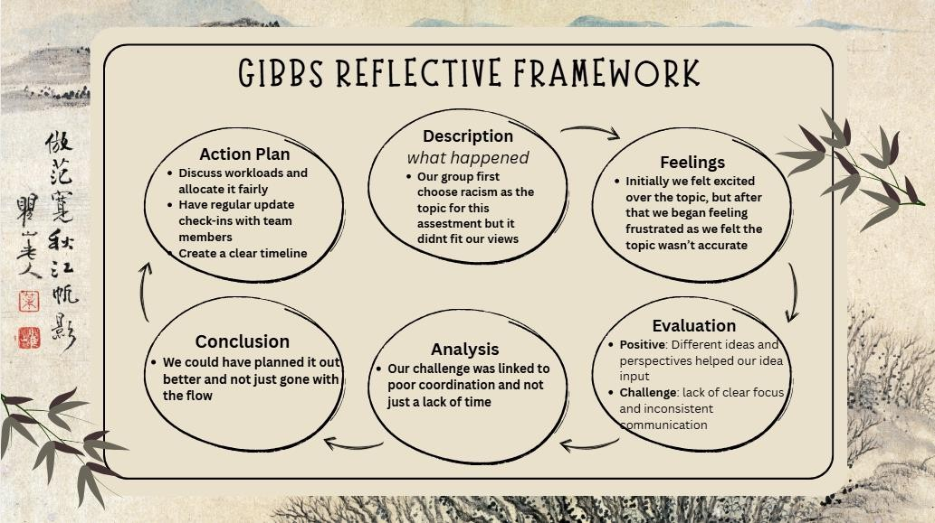

Description
We had settled on navigating racism in Malaysia and the role global leaders play as our initial topic, but we felt like it didn’t match the criteria of the module. So, we made a pivot and switched to exploring diversity instead, and why it’s different in Malaysia. We had only settled on the new topic through a collective agreement between the other members, after they had presented their own ideas.

Feelings
At first, we were pretty excited about tackling such a complex topic, as we felt strongly about making the distinction that racism is far different in Malaysia as opposed to anywhere else. But I had a gut feeling that the topic was inadequate, which caused me to fear and panic that we may not gain good marks if we continued on the initial topic. After we made the switch, we began to feel confident again.

Evaluation
The positive aspect that came out of this is that we practiced what we preached. In a sense, we had all presented our ideas, listened to them, and then we proceeded to give feedback on the idea presented. From there, we arrived at the final idea based on all that was shared. We did face some challenges. Some of us in the group are working, which led to inconsistent communication and a lack of clear focus as we juggled other assignments.

Analysis
Based on the analysis we had conducted, our biggest challenge wasn’t just a lack of time but also poor coordination, as we had also started this project quite late. If we had set a clearer timeline earlier, the issue that we had faced could have been resolved far earlier.

Conclusion
Based on all said and done, our group could have planned our whole timeline out much clearer and better, rather than us pivoting last minute. If we had done so earlier, we could have avoided the many issues our group faced, both external and internal.

ActionPlan
Time doesn’t repeat itself, but if it did, this would have been our action plan to resolve the issues we faced. Firstly, we would have discussed our workloads and allocated them fairly between members. Secondly, we would also implement group progression updates on the progress of the assessment to help out the members who are facing difficulties. Lastly, we would have created a clear timeline, from the start of the project to submission.

4.2Conclusion
In conclusion, I learned that we should not have gone “with the flow”, but rather fully sat down and discussed the idea in depth with my group mates before proceeding with the final idea. Overall, the group experience was pretty fun. We all shared our different ideas, we had short debates on them, and we even reached a collective agreement on them. There were also bouts of panic and fear that I felt over what we had initially chosen, but thankfully, the group was responsive, and the pivot was made. I had also learned the importance of diversity, as having my ideas being listened to felt good.

Name: Amiel Nashiheen Bin Aminuddin Student ID: 2527794

SECTION 2

A group of four students, consisting of Russell Christopher Baptist, Amiel Nashiheen, Muhammad Nazmi Aiman, and Mhd Danial Hadriss, produced a presentation entitled “The Significance of the Global Teams in Effective Problem Solving: The Effect of Diversity in Global Teams Operation.” The presentation was delivered in the order of Russell Christopher Baptist, Amiel Nashiheen, Muhammad Nazmi Aiman and Mhd Danial Hadriss. The presentation examined diversity as a contemporary challenge and a wicked problem within global teams, before exploring approaches for managing differences and improving collective problem solving. The presentation concluded that diversity should not be suppressed, but understood and integrated to support effective teamwork.
Russell presented diversity as a contemporary challenge, pointing out that while diversity is not new, globalization, social media, technology, artificial intelligence, and demographic shifts have made it more difficult for various groups to connect. Subsequently, he presented diversity as a wicked problem because it involves multiple stakeholders, conflicting values and interconnected issues, with no definitive solution or permanent endpoint. This established the complexity of the topic and demonstrated the significance of flexible approaches to problem solving.
The second section, presented by Amiel, focused on applying design thinking to investigate, define, propose and evaluate solutions to diversity within global teams. The investigation considered the way cultural differences influence communication, decision-making, conflict and leadership expectations. It was recognised that diversity can generate more ideas, but unmanaged differences can also create conflict and reduce team performance. Therefore, the problem was defined as how global teams could leverage cultural differences to improve problem solving while reducing communication barriers and conflict.
The proposed solution combined the Map, Bridge and Integrate approach with inclusive leadership. Mapping involves identifying cultural differences and working preferences, bridging focuses on adapting communication, active listening and shared communication norms, while integration involves combining perspectives and managing disagreements constructively. Therefore, the design-thinking section provided a practical connection between

the complex problem identified by Russell and the subsequent approaches for managing diversity.
Then, Nazmi discussed recognising individual differences and the role of emotional intelligence in conflict management. His section emphasised moving beyond stereotypes, recognising intersectional identities and valuing cognitive diversity. It also identified self-awareness, empathy and relationship management as important capabilities for managing conflict and creating psychological safety. These ideas complemented the design-thinking approach because successful integration of different perspectives requires individuals to communicate effectively and manage disagreements constructively.
Danial concluded the main content by explaining the significance of interdisciplinary thinking. The presentation demonstrated that bringing together individuals with different knowledge, skills and experiences can produce more ideas, reduce blind spots, improve understanding and support better decision-making. The key message was that the goal is not for team members to think identically, but to work towards the same solution.
Thus, the four contributions were closely interrelated. Russell established the reason diversity represents a complex and ongoing problem, while the design-thinking section proposed a structured process for investigating and responding to that problem. Nazmi demonstrated the interpersonal and emotional capabilities needed to manage differences, while Danial showed the way different knowledge and perspectives can be combined to improve solutions. The presentation subsequently used Gibbs' Reflective Cycle to consider the group's own experience of collaborative problem solving.
Amiel's main contribution was to provide a practical design-thinking framework that connected the identification of diversity as a wicked problem with the methods required to manage it. The section demonstrated how mapping, bridging and integrating cultural differences can help global teams transform diversity from a potential source of conflict into a resource for effective problem solving.

SECTION 3

A key area for critique is the assumption that diversity automatically produces better problem-solving outcomes. Diverse global teams can offer different viewpoints, expertise, and methods, but these benefits rely on how differences are managed. The presentation recognised that cultural differences may create misunderstandings, conflict, reduced participation and slower decision-making. Therefore, diversity can be considered a double-edged asset rather than an unconditional advantage.
From Amiel’s perspective, the effectiveness of diversity depends less on simply having different people within a team and more on how the team governs those differences. Clear communication, inclusive leadership, trust and psychological safety are necessary to ensure that different perspectives are genuinely considered. This perspective is supported by DiStefano and Maznevski (2000), whose work informed the Map, Bridge and Integrate approach used in the presentation. Their perspective emphasises actively recognising and integrating cultural differences rather than suppressing them.
Lu, Swaab and Galinsky (2022) provide another relevant perspective by highlighting the relationship between multicultural experience, communication competence and leadership effectiveness. Their research supports the presentation's emphasis on leadership but also suggests that leaders require the ability to communicate effectively across cultural differences rather than simply being aware of them.
Throughout the process of this assessment, critical thinking was applied by evaluating ideas according to their relevance to the central problem. Influencing involved explaining and supporting suggestions while remaining open to other viewpoints. Conflict management required focusing on differences in ideas rather than individuals, while decision-making involved comparing alternatives and selecting the most suitable for the group's shared objective. These experiences demonstrated that constructive disagreement can improve group work when managed appropriately.
The critical reflection indicates that diversity should neither be viewed entirely as an advantage nor as a problem. Its value depends on effective leadership and collaboration. The group process demonstrated that critical thinking, influencing, conflict management and decision-making are necessary for turning different viewpoints into a coherent collective outcome.

SECTION 4
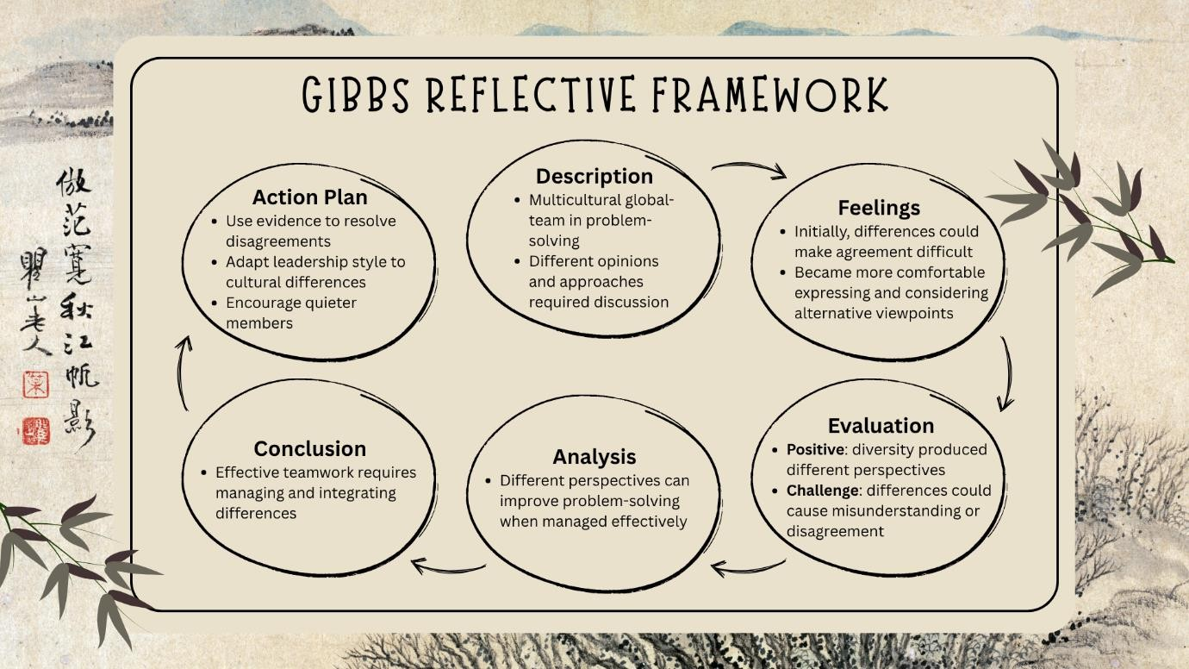

Description

Gibbs' Reflective Cycle was used to reflect on the experience of completing the group presentation. The group consisted of four members who worked collaboratively to investigate the effect of diversity on global team operations. Each member was responsible for a particular area of the presentation. Amiel was responsible for the design-thinking section and participated in the reflection component. Collectively, the group researched the topic, developed ideas, prepared presentation materials and coordinated the sequence of the final assessment.

Feelings

Initially, differences in opinions and approaches made agreement more difficult. However, the process gradually became more positive as group members became more comfortable expressing and considering alternative viewpoints. This demonstrated that disagreement does not necessarily indicate ineffective teamwork. Instead, it can encourage members to reconsider their assumptions and develop a broader understanding of the problem.

Evaluation

A major strength of the group process was the diversity of ideas contributed by different members. This allowed the presentation to examine multiculturalism from several perspectives, including design thinking, emotional intelligence and interdisciplinary thinking. However, differences in opinions also created potential for misunderstanding and disagreement. The experience demonstrated that diverse perspectives are valuable only when team members are willing to listen and integrate them.

Analysis

The experience provided a deeper understanding of the relationship between diversity and problem solving. Different perspectives can improve the quality of solutions when they are managed effectively. Critical thinking was applied when evaluating whether ideas were relevant to the group's central argument rather than accepting suggestions without consideration. Influencing involved explaining ideas and using reasoning to encourage their consideration. Conflict management involved focusing on the issue rather than the individual, while decision-making required comparing different suggestions and selecting those that best supported the group's objective. This proved that diverse viewpoints should contribute to a common answer rather than requiring everyone to think in the same manner.

Conclusion

The group experience showed that effective teamwork requires communication, flexibility and mutual respect. Amiel learned that disagreement can be constructive when it is focused on improving the outcome rather than winning an argument. The experience also reinforced the importance of recognising individual differences and creating opportunities for different members to contribute.

Action Plan

For future group assessments, Amiel would establish clearer responsibilities, internal deadlines and regular progress check-ins from the beginning. Additionally, more focus would be placed on encouraging quieter people to join and actively listening. Evidence would be used to support decisions and resolve disagreements, while communication approaches would be adapted according to different team members' needs. These actions would create a more structured and inclusive collaborative environment.

Overall, the assessment provided valuable learning about collaborative working and the practical application of critical thinking, influencing, conflict management and decision-making. Most importantly, it demonstrated that successful global teamwork does not require differences to be eliminated. Instead, differences should be understood, managed and integrated to support effective problem solving.

Name: MUHAMMAD NAZMI AIMAN BIN MUHAMMAD NAZRI Student ID: 2527791

Section 1 Group Presentation

Slide Link: C:\Users\nazmi\Downloads\Beige Black Vintage Landscape Illustration Simple Presentation .pptx
Video Link: https://www.youtube.com/watch?v=FRsw-7kMvU0

Section 2 Discussion

The group presentation comprised the collective work of Russell, Amiel, Nazmi, and Danial, who assessed the value of diverse global teams in achieving effective problem-solving. The presentation established the premise that diversity, when harnessed correctly, is not a weakness but a mechanism through which appropriately managed teams can reach better solutions. However, the presentation also established that diversity is a wicked problem, which means it cannot be solved by a single entity or approach. Overall, the group presentation proposed that managing different approaches is the key to resolving problems better while using the strengths of each team member.
Russell opened the discussion by framing diversity as a wicked problem that has become more intense in recent decades due to specific circumstances. Firstly, although diversity has always existed, the current demographic, globalization, social media, and artificial intelligence trends have changed its nature. Secondly, Russell explained that diversity is a wicked problem because it does not have an agreed solution or end-state condition and causes constant change or instability. At the policy level, diversity is a wicked problem since there are “conflicting values or interests, such as equality versus equity. Therefore, any initiatives would have wicked effects and cause unintended harm since some groups will feel oppressed.
After framing the problem, Amiel suggested using design thinking as an approach to addressing the issue. Amiel stated that the question the group needed to answer was how can global teams leverage cultural differences to enhance problem solving while mitigating communication barriers? Therefore, the solution involved developing inclusive leaders and using the “Map, Bridge, Integrate” (MBI) approach. MBI comprises Map “communication and decision-making preferences,” Bridge “communication and decision-making preferences,” and integrate conflicting points of view to manage disagreements and synthesize ideas.

Nazmi’s contribution included analysing the team’s problem-solving process at the individual level and developing insights into how emotional intelligence could be used to navigate conflicts. The author’s discussion highlighted that to manage differences, teams need to recognize people as individuals and embrace intersectionality. Using the individual’s approach enables teams to acknowledge differences resulting from class, education, and neurodiversity and ensure that they value cognitive diversity. This way, organizations do not develop default assumptions and policies that suppress the needs of the majority but rather design policies aimed at meeting individuals’ diverse needs. Besides individual differences, Nazmi also noted the importance of recognizing individuals’ emotional intelligence to manage disagreements. In this regard, self-awareness prevents emotional reactions, while empathy allows team members to shift from stating who is right to understanding needs. Using relationship management, leaders could then manage tensions and enable teams to have the psychological safety to reach logical conclusions amicably.
Danial built on the interventions by addressing the importance of using interdisciplinary thinking in leveraging differences to achieve effective problem-solving. Danial asserted that most problems have several dimensions and that interdisciplinary thinking is essential because it allows individuals to think of the challenge from more than one perspective. Additionally, interdisciplinary thinking reduces the risk of missing information and unintended consequences and allows teams to develop more complete solutions. Overall, the author argued that interdisciplinary thinking would enhance the effectiveness of the MBI framework because it would allow teams to combine individual strengths and perspectives rather than forcing people to conform to a particular perspective. Interdisciplinary thinking entails understanding, defining, ideating, and testing the challenge, with the final solution comprising an amalgam of ideas.
Nazmi's contribution fitted within the group’s discussion as the individual analysis formed the basis for developing organizational solutions. In essence, although Russell addressed diversity as a wicked problem affecting organizations at large, the author’s input provided a nuanced understanding of how individuals could address the challenges inherent in managing diversity. Additionally, the author’s emphasis on emotional intelligence was a critical aspect of Amiel’s MBI, since empathy is integral to bridging differences and synthesizing information for effective decision-making. Ultimately, the individual approach highlighted by the author is the best way to fit within Danial’s interdisciplinary thinking approach since it allows individuals to share their knowledge and skills to find the best solution. Essentially, the individual would

feel safe to air their views without being victimized, which fits within the interdisciplinary thinking of valuing everyone’s input.
Conclusion

Overall, Nazmi feels that his contribution was integral to the group’s recommendations because it established that diversity is most useful when every individual is valued as unique. As such, emotional intelligence is paramount to ensuring that individuals accept differences, which subsequently allows effective decision-making.

Section 3 Critique

While the group presentation effectively identified multiculturalism as a complex wicked problem, there are certain limitations in the suggested approaches. The presentation used design thinking and the Map, Bridge, integrate model to address the conflict in managing a team of global workers. However, I argue that these measures may actually undermine the issue due to its complexity. Being Malaysian, Nazmi’s point of view reflects the country’s multicultural traditions and social norms. Hence, it is not entirely accurate to state that the main source of conflict is people’s attitudes and ineffective communication, thus neglecting to consider the power dimension. Thomas and Ely (1996) provide an interesting insight into managing diversity in the workplace. They suggest that simply acknowledging differences is not enough, and organizations need to adopt a learning-and-effectiveness paradigm, which would require changing the way work is done. In other words, if individual differences are not embedded in the company’s work systems, processes, and structure, the mere use of design thinking will not resolve the issue and will appear as ‘just another change initiative’. Throughout the collaboration process, we used critical thinking and decision-making to manage the conflict. I was particularly engaged when the group decided to narrow the topic to racism, considering this issue too specific and not aligned with our academic perspectives. Using influencing skills, I encouraged my colleagues to shift the focus to a comprehensive range of issues associated with managing a group of workers from diverse backgrounds. During the discussion, I tried to manage the conflict by appealing to the group’s emotions and using such emotional competencies as empathy (Goleman, 1998). To avoid undermining my colleagues’ suggestions, I explained the academic side of the topic and managed to facilitate the consensus building by combining my ideas with theirs.
Conclusion

In conclusion, managing a critical reflection within a group requires a lot of attention to detail and emotional intelligence to ensure that the colleagues’ ideas are considered, and the collaborative problem-solving process is effective.

Section 4 Reflection
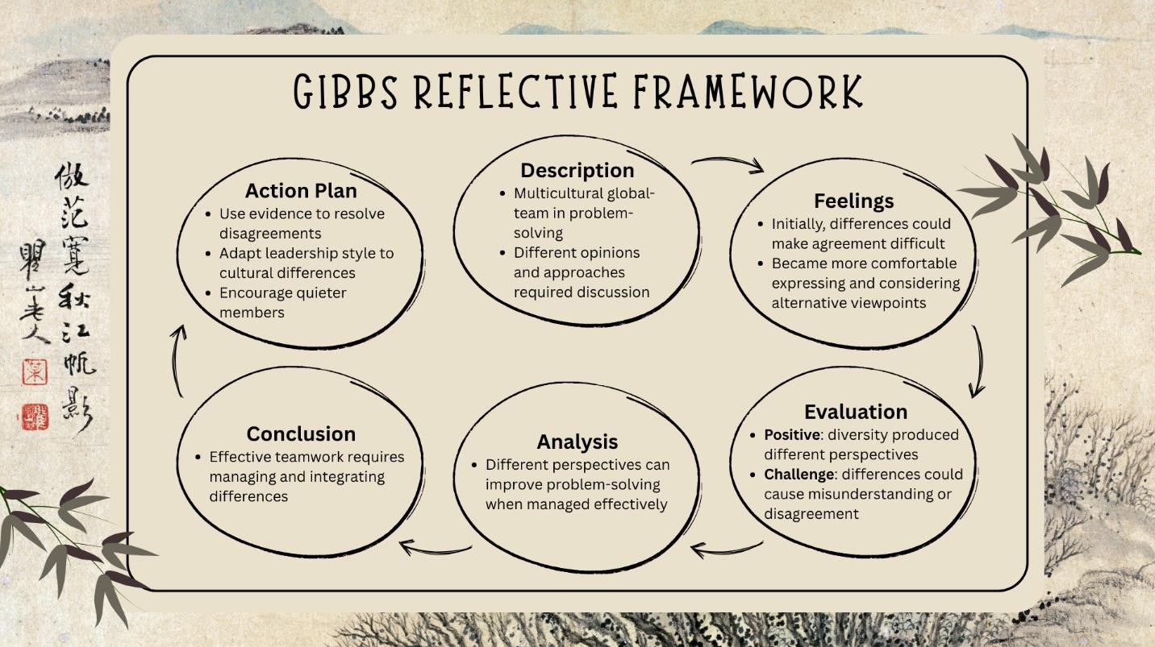

Description

Our group was a multinational team that had to address a certain social issue. First, we selected racism as our issue, but as we started researching it, we discovered that this topic did not entirely reflect our views. Our team consisted of people with different cultural backgrounds and approaches, so we had a hard time choosing the issue that would suit everyone. After a long discussion, we decided to shift our focus to the influence of multiculturalism on the team of global workers.

Feelings

At first, our group felt very enthusiastic about the project because we all wanted to participate. However, this enthusiasm faded away when we realized that we had misunderstood the brief. We were frustrated that our initial topic choice was incorrect and that it was hard for us to reach an agreement. Later, as we started listening to each other, our feelings toward each other improved. I felt that I could express my opinions more freely, and I stopped seeing other team members’ positions as some kind of personal judgements.

Evaluation

Speaking about the positive aspects of our work, I should say that our multiculturalism was our main strength. It allowed us to approach the task from different angles and find a comprehensive solution. However, the same diversity was also our weakness because in the beginning, we could not understand each other’s opinions. When our initial topic choice failed, we did not have a clear vision of what to do next, which slowed us down considerably.

Analysis

With reference to Unit 2, I believe that the problems we experienced were related to poor coordination rather than time management. We failed to properly utilise our different approaches to task accomplishment. It would be incorrect to say that diversity is not important in collaborative work because it clearly is. However, it is even more important to manage it properly.

Conclusion

I think that our group could have planned the brainstorming session more carefully instead of ‘going with the flow’ and expecting some brilliant idea to come into our minds. Our main lesson learned is that it is essential to manage differences in team members’ opinions rather than trying to rely on spontaneous decisions.

(Mhd Danial Hadriss part) Student ID: 2527784
Presentation Slide’s Link: https://canva.link/qvthfqnm0go46zi Video Link: https://www.youtube.com/watch?v=FRsw-7kMvU0

Discussion

The group presentation focused on how effective teamwork, communication and different perspectives can help people understand and solve wicked complex problems. The presentation was delivered by 4 students in the following order: Russell Baptist, Amiel, Nazmi and Danial. Overall, the presentation explored different aspects of working in teams, including interdisciplinary thinking, diversity, communication, emotional intelligence, conflict management and decision making. The main conclusion was that complex problems are rarely solved effectively from only one perspective. Instead, teams need to combine different strengths, communicate openly and work towards a shared goal.
The first section of the presentation introduced Russell Baptist. This section provided the foundation for understanding the main issue and explained why effective teamwork is important. It introduced ideas that were later connected to the other sections of the presentation. The second section, presented by Amiel, focused on Design Thinking. This connected with the overall presentation because it acts as the process that turns different perspectives into an actual solution. The third section, presented by Nazmi, discussing about Recognizing Individual Differences, which further showed the importance of understanding different viewpoints when working in a team. Finally, I discussed Interdisciplinary thinking, helping to bring the different ideas together and showing how teams can respond to challenges in a practical way.
My own section was focused on interdisciplinary thinking. The first slide explained that interdisciplinary thinking involves bringing people with different knowledge, skills and experiences together to solve a problem. Examples from IT, finance, HR, marketing and legal departments were used to demonstrate that each area may look at the same problem differently. For example, when introducing new technology, IT may focus on whether the system works, finance may consider the cost, while HR may focus on how employees will adapt to the change. This shows that one department may not have all the information needed to make the best decision.

The second slide explained why interdisciplinary thinking is important. Complex problems usually have more than one side, so relying on only one perspective can result in important information or risks being missed. Combining different perspectives can lead to more ideas, fewer blind spots and more realistic decisions. The section also emphasised that the purpose is not to make everyone think in exactly the same way. Instead, team members can have different opinions while still working towards the same objective.
The third slide connected interdisciplinary thinking with diversity in global teams. Team members may come from different countries, cultures, academic backgrounds and work experiences. These differences may sometimes create communication challenges, but they can also be a valuable source of ideas. For example, a team member from another cultural background may identify an issue that other members had not considered. Therefore, diversity can become a strength when team members are willing to listen to one another and use their different perspectives constructively.
The final slide introduced Design Thinking as a way to turn different perspectives into practical solutions. The process involves understanding the problem, defining the main issue, generating ideas, testing a possible solution and improving it based on feedback. This is particularly useful for global teams because it provides a structured process where different members can contribute rather than allowing one person or department to control the entire decision-making process.
The student's section was closely connected to the other parts of the presentation. Interdisciplinary thinking showed why different perspectives are important, while diversity explained where those perspectives can come from. Communication and conflict management were also important because having different opinions can sometimes create disagreement. Design Thinking then provided a practical way for the team to move from different ideas towards a shared solution.
Overall, My contribution’s supported the main conclusion of the presentation by showing that effective teamwork is not simply about putting different people together. It requires people to listen, communicate, respect different viewpoints and combine their knowledge. Interdisciplinary thinking therefore contributed to the overall presentation by showing how diversity and different areas of expertise can be transformed into better understanding and more effective solutions.

Conclusion

In conclusion, My own contribution highlighted the importance of using different perspectives when dealing with complex problems. Interdisciplinary thinking connected the different areas of the presentation by showing how knowledge, diversity and teamwork can be combined to support better decision making. The use of Design Thinking also demonstrated how teams can turn different ideas into practical solutions. Overall, the contribution helped reinforce the group's conclusion that successful collaboration requires more than individual knowledge; it requires people to communicate, listen and work together towards a common goal.

Critique

One key strength of the presentation was its positive view of interdisciplinary teamwork. Bringing people with different knowledge and experiences together can help teams identify issues that may be missed when a problem is viewed from only one perspective. My section supported this idea by explaining how diversity can provide different ways of understanding a problem. However, the presentation could have explored more clearly that diversity does not automatically lead to better teamwork. Differences in communication styles, priorities, cultural expectations and knowledge can also create misunderstanding or conflict. Without effective communication and leadership, having many different perspectives may even make decision making slower.
My personal viewpoint is that interdisciplinary thinking is most useful when team members are willing to listen and explain their ideas clearly. Simply having people from different backgrounds is not enough. Their knowledge needs to be shared and combined in a respectful way. This slightly differs from the simple idea that having more perspectives will automatically result in better solutions. In reality, a team may have many good ideas but still struggle to agree on one direction. Therefore, communication, emotional intelligence and conflict management are important parts of successful interdisciplinary teamwork.
Research also provides a more balanced perspective. Arthars et al. (2024) highlight the challenges of creating a shared understanding when people from different disciplines approach the same problem using different forms of knowledge. Reijula et al. (2023) similarly explain that interdisciplinary work involves different forms of expertise being divided among team members. This suggests that the value of interdisciplinary thinking depends not only on having different perspectives but also on how those perspectives are connected.
During the group task, critical thinking was used when comparing different ideas rather than immediately accepting the first suggestion. Influencing involved explaining why certain ideas could improve the presentation, while conflict management required listening to different opinions and finding common ground. Decision making involved selecting the strongest ideas while considering the overall presentation.
Overall, the task showed that interdisciplinary thinking has significant benefits, but it needs to be supported by communication, respect, critical thinking and effective decision making.

Reflection Using Gibbs' Reflective Cycle

Description

The group task involved preparing and presenting a topic related to teamwork, problem solving and working with different perspectives. Each group member was responsible for a specific part of the presentation, while the group worked together to make sure the sections connected logically. My main contribution focused on interdisciplinary thinking. This included explaining what interdisciplinary thinking means, why it is important, how diversity can be used as a strength, and how Design Thinking can help teams turn different ideas into practical solutions.

Feelings

At the beginning of the task, there was some uncertainty about how the individual section would connect with the other members' content. There were many possible ideas that could be included, so deciding what was most relevant required some discussion. As the group work continued, confidence improved because members shared suggestions and helped each other connect the different sections. Preparing the slides also became easier once the topic was linked to simple examples involving global teams and different departments within an organisation.

Evaluation

One positive aspect of the group task was that the work could be divided between members, making the overall workload more manageable. Each person was able to focus on their own section while still contributing to the wider presentation. Another positive aspect was the variety of ideas shared by the group. Different opinions helped improve the content and presentation structure.
However, one challenge was avoiding repetition between sections. Some ideas, particularly teamwork, communication, diversity and problem solving, appeared in more than one part of the presentation. The group therefore needed to discuss which points were most relevant to each section and remove unnecessary repetition.

Analysis

The experience showed that collaborative working involves more than simply dividing the workload. The topic of interdisciplinary thinking was also reflected in the way the group completed the assignment. Each member had different ideas and perspectives, and combining these helped create a more complete presentation.
The skills introduced in Unit 2 were useful throughout the process. Communication was important when explaining ideas and understanding other members' suggestions. Critical thinking was used when deciding whether information was relevant and whether the presentation followed a clear argument. Influencing was involved when suggesting changes to slides or recommending examples. Conflict management was important when members had different opinions, as disagreements needed to be handled respectfully. Decision making was required when selecting the strongest ideas while considering the presentation's time limit.
The main learning from the experience was that effective teamwork does not mean everyone has to agree immediately. Different opinions can actually improve the final result when they are discussed openly and respectfully. The task also showed the importance of individual responsibility. Completing one section well is not enough if it does not connect with the rest of the presentation.

Conclusion

Overall, the group task showed that successful collaboration requires both individual effort and shared responsibility. My section on interdisciplinary thinking contributed to the wider

presentation by showing how different perspectives can be combined to understand complex problems and develop better solutions. The experience also increased awareness of the importance of communication, critical thinking and decision making when working with others.

Action Plan

For future group assignments, I would communicate with other members earlier to identify overlapping content before the slides are completed. More effort would also be made to share ideas confidently and ask questions when something is unclear. Rather than focusing only on completing an individual section, greater attention would be given to how the section connects with the group's overall argument.
The student would also continue developing conflict management skills by listening carefully to different opinions before responding and looking for solutions that benefit the group as a whole. Overall, the experience has shown that effective collaboration requires flexibility, communication and a willingness to learn from other people.

GENERIC ASSESSMENT CRITERIA

Level 4
In accordance with the Framework for Higher Education Qualifications, at the end of Level 4, students will be expected to have demonstrated knowledge of the basic underlying concepts and principles of a subject, and an ability to evaluate and interpret these within the context of that area of study. They should be able to present, evaluate and interpret qualitative and quantitative data to develop lines of argument and make sound judgments in accordance with basic theories and concepts of their subject(s) of study. They will have learned how to evaluate different approaches to solving problems, and will be able to communicate the results of their study/work accurately and reliably, and with structured and coherent arguments. They will be able to undertake further training and develop new skills within a structured and managed environment,
and will have the qualities and transferable skills necessary for employment requiring the exercise of some personal responsibility.

Level 4 | FAIL | MARGINAL FAIL | SATISFACTOR Y  (3rd / Pass) | GOOD  (2.2 / Pass) | VERY GOOD  (2.1 / Merit) | EXCELLENT  (1st / Distinction) | EXCEPTIONAL  (1st / Distinction)
Category | 0-29% | 30-39% | 40-49% | 50-59% | 60-69% | 70-84% | 85-100%
Engagement with literature (including reading, referencing,  academic conventions and | Little or no evidence of reading and/or reliance on inappropriate sources.  Views and findings | Poor engagement with essential reading. No evidence of wider reading. Reliance on inappropriate sources, and/or  indiscriminate | Engagement with a limited range of mostly relevant and credible sources, but with some reliance on information gained through class contact. Some | Engagemen t with an appropriate range of literature, including sources retrieved independen  tly. Some | Engagement with a wide range of literature, including sources retrieved independently. | Engagement with an extensive range of relevant and credible literature.  Consistently accurate application of referencing. | Exceptional engagement with an extensive range of relevant and credible literature. High-level referencing skills consistently applied.

Level 4 | FAIL | MARGINAL FAIL | SATISFACTOR Y  (3rd / Pass) | GOOD  (2.2 / Pass) | VERY GOOD  (2.1 / Merit) | EXCELLENT  (1st / Distinction) | EXCEPTIONAL  (1st / Distinction)
Category | 0-29% | 30-39% | 40-49% | 50-59% | 60-69% | 70-84% | 85-100%
academic honesty) | mostly unsupported and non-authoritative.  Referencing conventions are used incoherently or are largely absent. | use of sources. Heavily reliant on information gained through class contact. Inconsistent and weak use of referencing. | omissions and minor errors.  Referencing conventions are evident, though not always applied accurately or consistently. | over-reliance on texts rather than other sources.  Referencin g may show minor inaccuracie  s or | Selection of relevant and credible sources.  Generally sound referencing, with no/very few inaccuracies or

Level 4 | FAIL | MARGINAL FAIL | SATISFACTOR Y  (3rd / Pass) | GOOD  (2.2 / Pass) | VERY GOOD  (2.1 / Merit) | EXCELLENT  (1st / Distinction) | EXCEPTIONAL  (1st / Distinction)
Category | 0-29% | 30-39% | 40-49% | 50-59% | 60-69% | 70-84% | 85-100%
 |  |  |  | inconsisten  cies. | inconsistencies  .
Knowledge and understandin g (Knowledge of the basic underlying concepts and principles of a  subject.) | Major gaps in knowledge and understandin g of the basic underlying concepts and principles of  the subject | Gaps in knowledge of the basic underlying concepts and principles, with a flawed or superficial  understanding. | Limited knowledge and understanding of the basic underlying concepts and principles within the subject area. | Knowledge of the basic underlying concepts and principles is accurate, with a good  understandi | Competent knowledge of the basic underlying concepts and principles.  Exhibits a very good  understanding. | Excellent knowledge and understanding of the basic underlying concepts and principles of the subject. | Exceptional, detailed knowledge and understanding of the basic underlying concepts and principles

Level 4 | FAIL | MARGINAL FAIL | SATISFACTOR Y  (3rd / Pass) | GOOD  (2.2 / Pass) | VERY GOOD  (2.1 / Merit) | EXCELLENT  (1st / Distinction) | EXCEPTIONAL  (1st / Distinction)
Category | 0-29% | 30-39% | 40-49% | 50-59% | 60-69% | 70-84% | 85-100%
 | matter. Inclusion of irrelevant material.  Substantial  inaccuracies. | Some significant inaccuracies and/or irrelevant material. | Some elements may be missing. | ng of the field of study, but lacks depth and/or  breadth.
Cognitive and intellectual skills  (Evaluate underlying | Wholly or almost wholly descriptive work. Little | Largely descriptive work, with superficial evaluation of the | Limited attempt at evaluation of the underlying concepts and principles, tending | Good evaluation of the underlying concepts | Sound evaluation of the underlying concepts and principles. Can | Excellent evaluation of the underlying concepts and principles. Can | Exceptional evaluation of the underlying concepts and principles based on evidence.

Level 4 | FAIL | MARGINAL FAIL | SATISFACTOR Y  (3rd / Pass) | GOOD  (2.2 / Pass) | VERY GOOD  (2.1 / Merit) | EXCELLENT  (1st / Distinction) | EXCEPTIONAL  (1st / Distinction)
Category | 0-29% | 30-39% | 40-49% | 50-59% | 60-69% | 70-84% | 85-100%
concepts and principles of a subject and interpret qualitative and quantitative data to develop lines of argument and make sound judgements.) | or no evaluation of the underlying concepts and principles.  Failure to develop arguments, leading to  illogical or | underlying concepts and principles.  Weak interpretation of data, flawed development of arguments and judgements.  Information is accepted | towards description.  Can interpret qualitative and quantitative data, but with some errors. Some evidence to support emerging arguments and  judgements, but | and principles. Can interpret qualitative and quantitative data, with minor errors. | interpret qualitative and quantitative data accurately. Ability to devise arguments using evidence to make mostly appropriate and | interpret qualitative and quantitative data accurately and with some insight. Excellent ability to devise arguments using evidence and make appropriate | Outstanding interpretation of qualitative and quantitative data.  Exceptional ability to devise arguments using evidence and make wholly appropriate and valid judgements.

Level 4 | FAIL | MARGINAL FAIL | SATISFACTOR Y  (3rd / Pass) | GOOD  (2.2 / Pass) | VERY GOOD  (2.1 / Merit) | EXCELLENT  (1st / Distinction) | EXCEPTIONAL  (1st / Distinction)
Category | 0-29% | 30-39% | 40-49% | 50-59% | 60-69% | 70-84% | 85-100%
 | invalid judgements. Minimal or no use of  evidence to back up views. | uncritically, uses generalised statements made with scant evidence and unsubstantiated opinions. Ideas are sometimes illogical and contradictory. | these may be underdeveloped or with a little inconsistency/misi nterpretation. | An emerging ability to use evidence to support the argument.  Mostly valid arguments  and logical | valid judgements. | and valid judgements.

Level 4 | FAIL | MARGINAL FAIL | SATISFACTOR Y  (3rd / Pass) | GOOD  (2.2 / Pass) | VERY GOOD  (2.1 / Merit) | EXCELLENT  (1st / Distinction) | EXCEPTIONAL  (1st / Distinction)
Category | 0-29% | 30-39% | 40-49% | 50-59% | 60-69% | 70-84% | 85-100%
judgements

.
Practical skills  (Different approaches to solving problems in particular contexts.) | Limited or no use of taught, basic methods, materials, tools and/or techniques.  Little or no appreciation | Rudimentary application of taught, basic methods, materials, tools and/or techniques, but without consideration | An adequate awareness and mostly appropriate application of basic methods, materials, tools and/or techniques. | A good and appropriate application of basic methods, materials, tools and/or techniques. | A very good application of a range of basic methods, materials, tools and/or techniques.  Very good consideration | An advanced application of a range of taught, basic methods, materials, tools and/or techniques.  The context of the application is | Exceptional levels of application and deployment skills in particular practical contexts.  Outstanding identification of problems in particular contexts

Level 4 | FAIL | MARGINAL FAIL | SATISFACTOR Y  (3rd / Pass) | GOOD  (2.2 / Pass) | VERY GOOD  (2.1 / Merit) | EXCELLENT  (1st / Distinction) | EXCEPTIONAL  (1st / Distinction)
Category | 0-29% | 30-39% | 40-49% | 50-59% | 60-69% | 70-84% | 85-100%
 | of the context of the application.  Very weak evidence of different approaches to problem-solving in | and competence. Flawed appreciation of the context of the application.  Weak evidence of different approaches to problem-solving | Basic appreciation of the context of the application.  Can identify problems in particular contexts and propose basic alternative approaches or solutions, though | Clear appreciatio n of the context of the application.  Good evidence of different approaches  to problem- | of the context of the application. Very good evidence of different approaches to problem-solving in particular contexts, and | well considered and insightful.  Excellent evidence of different approaches to problem-solving in particular contexts, and proposes | and formulation of wholly appropriate, thoughtful solutions  / different approaches.

Level 4 | FAIL | MARGINAL FAIL | SATISFACTOR Y  (3rd / Pass) | GOOD  (2.2 / Pass) | VERY GOOD  (2.1 / Merit) | EXCELLENT  (1st / Distinction) | EXCEPTIONAL  (1st / Distinction)
Category | 0-29% | 30-39% | 40-49% | 50-59% | 60-69% | 70-84% | 85-100%
 | particular contexts. | in particular contexts. | there may be errors. | solving in particular contexts, and proposes mostly appropriate  solutions. | proposes appropriate solutions. | appropriate solutions.
Transferable skills for life  and | Work is poorly  structured, | Work is poorly presented in a  disjointed | Mostly ordered presentation and  structure in which | Mostly coherent,  organised | Work is accurate,  coherent, | Work is coherent, very  fluent and is | Work is accurate, exceptionally  coherent, very

Level 4 | FAIL | MARGINAL FAIL | SATISFACTOR Y  (3rd / Pass) | GOOD  (2.2 / Pass) | VERY GOOD  (2.1 / Merit) | EXCELLENT  (1st / Distinction) | EXCEPTIONAL  (1st / Distinction)
Category | 0-29% | 30-39% | 40-49% | 50-59% | 60-69% | 70-84% | 85-100%
professional practice  (Communicate the results of their study/work accurately and reliably, and with structured and coherent  arguments; the | disorganised, inaccurate and/or confusingly expressed.  Very weak use of language and/or very inappropriate style. Failure | manner. It is loosely, and at times incoherently, structured, with information and ideas often poorly expressed.  Weak use of language and/or | relevant ideas/concepts are reasonably expressed. Work may lack coherence and/or accuracy in places. Can work as part of a group, meeting most obligations to | and accurate work, in a suitable structure and is for the most part clearly expressed. Can work effectively | fluent, well-structured and organised.  Can work effectively independently and/or as part of a team, with a very good contribution to  group | presented professionally. Can work effectively independently and/or as part of a team, with an excellent contribution to group activities. Demonstrates | fluent and presented well. Can work effectively independently and/or as part of a team, with an exceptional contribution to group activities.  Demonstrates exceptional skills

Level 4 | FAIL | MARGINAL FAIL | SATISFACTOR Y  (3rd / Pass) | GOOD  (2.2 / Pass) | VERY GOOD  (2.1 / Merit) | EXCELLENT  (1st / Distinction) | EXCEPTIONAL  (1st / Distinction)
Category | 0-29% | 30-39% | 40-49% | 50-59% | 60-69% | 70-84% | 85-100%
qualities needed for employment requiring the exercise of some personal responsibility within a structured and managed environment.) | to work effectively individually or as part of a group.  Little or no evidence of the skills for employment requiring the exercise of | inappropriate style. Flawed approach to individual or group work, meeting only partial obligations to others. Limited evidence of the skills for | others, but perhaps with limited involvement in group activities.  Demonstrates the basic skills for employment requiring the exercise of some personal  responsibility, with | independen tly and/or as part of a team, with clear contributio n to group activities.  Demonstrat es the skills for | activities. Demonstrates very good skills for employment requiring the exercise of some personal responsibility, with just occasional | excellent skills for employment requiring the exercise of some personal responsibility with an appetite for further development. | for employment requiring the exercise of some personal responsibility with an appetite for further development.

Level 4 | FAIL | MARGINAL FAIL | SATISFACTOR Y  (3rd / Pass) | GOOD  (2.2 / Pass) | VERY GOOD  (2.1 / Merit) | EXCELLENT  (1st / Distinction) | EXCEPTIONAL  (1st / Distinction)
Category | 0-29% | 30-39% | 40-49% | 50-59% | 60-69% | 70-84% | 85-100%
 | some personal responsibility  . | employment requiring the exercise of some personal responsibility. | some areas of minor weakness. | employmen t requiring the exercise of some personal responsibili ty, with some areas of strength  and some | minor weakness.

Level 4 | FAIL | MARGINAL FAIL | SATISFACTOR Y  (3rd / Pass) | GOOD  (2.2 / Pass) | VERY GOOD  (2.1 / Merit) | EXCELLENT  (1st / Distinction) | EXCEPTIONAL  (1st / Distinction)
Category | 0-29% | 30-39% | 40-49% | 50-59% | 60-69% | 70-84% | 85-100%
of minor

weakness.

