

Assignment Title: Component 1 information booklet od long-term condition management

Module code: LCHS7003
Programme Name: - Msc in public health and social care in practices
Student Name:- Zakiyabanu Zakirhusen Malek
Student ID: 2531983
Submission Date: - 19th March 18, 2026
Lecturer: Muhammed Khan

Institution: University of Wales trinity saint David London Campus City, Country London Uk

Table of Contents
1. OVERVIEW OF THE ASSIGNMENT AND LONG-TERM HEALTH CONDITIONS 3
2. EXPLANATION AND EVALUATION OF THE LONG-TERM CONDITION 3
2.1 DEFINITION OF THE CONDITION 3
2.2 GLOBAL BURDEN AND PREVALENCE 4
2.3 UK PREVALENCE 4
2.4 RISK FACTORS AND AETIOLOGY 4
3. IMPACT OF THE LONG-TERM CONDITION 5
3.1 PHYSICAL IMPACT 5
3.2 PSYCHOLOGICAL IMPACT 5
3.3 SOCIAL IMPACT 5
3.4 IMPACT ON FAMILIES AND CAREGIVERS 6
3.5 EVIDENCE-BASED TREATMENTS AVAILABLE IN THE UK 6
4. THEORETICAL PERSPECTIVES AND MODELS OF CARE 6
4.1 UK MODEL FOR LONG-TERM CONDITION MANAGEMENT 6
4.2 INTERNATIONAL MODEL 7
5. HEALTH AND SOCIAL CARE POLICIES 8
5.1 NATIONAL POLICIES 8
5.2 LOCAL INITIATIVES 8
6. RECOMMENDATIONS FOR IMPROVING CARE 8
6.1 PERSON-CENTRED CARE APPROACHES 8
6.2 SELF-MANAGEMENT STRATEGIES 8
6.3 END-OF-LIFE CARE 9
7. CONCLUSION 9
8. REFERENCE LIST 10
9. APPENDICES 14
APPENDIX A: “HOW MANY PEOPLE IN THE UK HAVE DIABETES?” 14
APPENDIX B: “HOW DOES DEPRESSION AFFECT DIABETES?” 15

Abstract - The research project investigates Type 2 Diabetes as a permanent medical condition which affects both people and the healthcare system of the United Kingdom. The report describes the condition through its causes and risk factors and common occurrences and its resulting health problems. The study shows how physical and psychological and social elements affect the well-being of patients and their relatives and their healthcare providers. The study assesses two different treatment methods which include the Chronic Care Model and the Self-Management Model. The assignment examines UK health policies through its assessment of the NHS Long Term Plan which promotes preventive measures and early disease detection and unified patient care. The management of diabetes requires patient-focused treatment and healthcare learning programs and better healthcare access to achieve better health outcomes and enhanced life quality.
Key Words: Healthcare, Occurrences, Treatment, UK, NHS Long Term Plan, Diabetes, Patient-Focused, Learning, Programs

1. OVERVIEW OF THE ASSIGNMENT AND LONG-TERM HEALTH CONDITIONS
Analysing Type 2 Diabetes as it ranks among the most prevalent permanent medical conditions because it causes elevated blood sugar levels when the body fails to produce enough insulin or develops resistance to insulin. Long-term health conditions of Type 2 Diabetes have different factors such as obesity, unhealthy diet, physical inactivity, genetic predisposition, aging, and social determinants such as low income and limited access to healthy food (Młynarska et al., 2025). The worldwide health systems face a major challenge from these conditions which also create a significant problem for the United Kingdom.
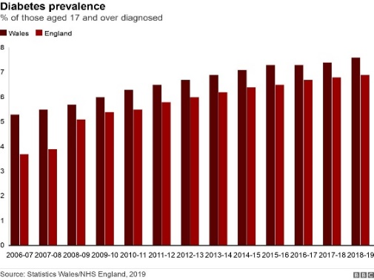
Fig 1: Type 2 diabetes Growth in UK (Source: BBC, 2025)
The World Health Organization reports that chronic diseases contribute to a major part of worldwide human health problems and death rates. The rising number of long-term conditions in the United Kingdom creates mounting demand for National Health Service operations. Serious medical problems develop through inefficient medical treatment which affects the patient's ability to live a normal life (England NHS, 2025). This information booklet aims to provide health and social care professionals and service users with an overview of Type 2 Diabetes, including its prevalence, risk factors, impacts, and evidence-based management strategies available in the UK.

2. EXPLANATION AND EVALUATION OF THE LONG-TERM CONDITION

2.1 DEFINITION OF THE CONDITION
People with Type 2 Diabetes experience lifelong metabolic issues which prevent their bodies from maintaining normal blood sugar levels because their bodies either produce insufficient insulin or their cells develop insulin resistance (Iafusco et al., 2023). The hormone insulin enables glucose to exit the bloodstream and enter cells, where it provides energy. When this process fails, glucose accumulates in the bloodstream.
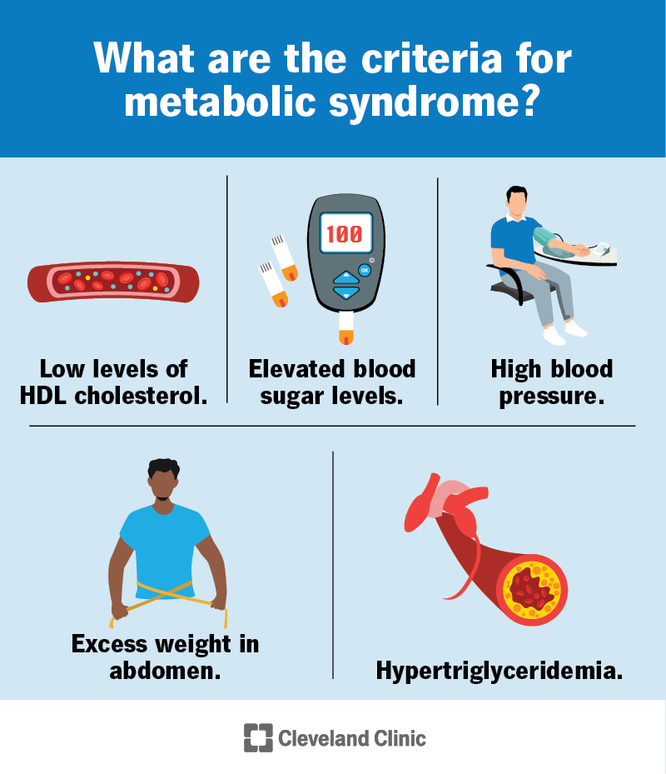
Fig 2: Metabolic Syndrome (Source: Cleveland Clinic, 2023)
The Metabolic Syndrome of Type 2 Diabetes condition leads to excessive thirst for low levels of HDL and sugar level fatigue, while also causing high blood pressure (Cleveland Clinic, 2023). The National Health Service in the UK identifies diabetes cases through routine checks for adults who are over 40 years old or who have obesity, sedentary behavior, or diabetes in their family history.

2.2 GLOBAL BURDEN AND PREVALENCE
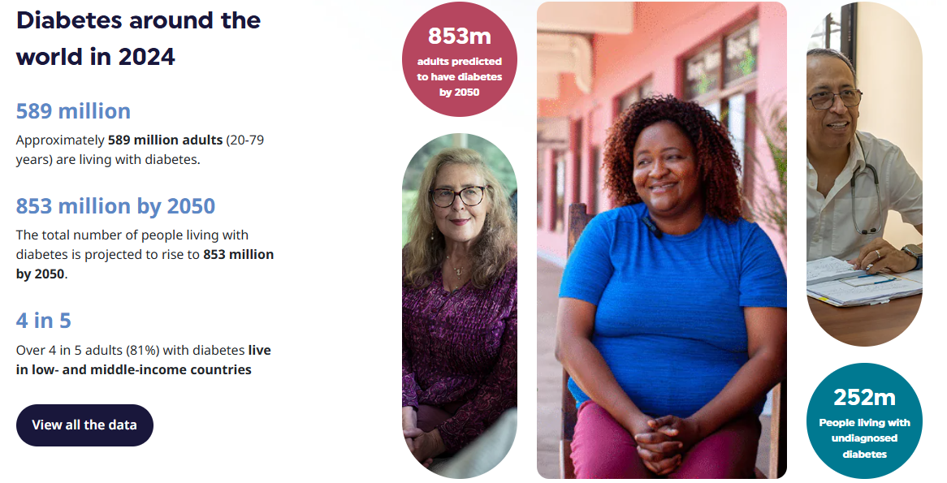
Fig 3: Diabetes around the world in 2024 (Source: IDF, 2025)
Type 2 Diabetes is one of the most widespread chronic diseases worldwide. Type 2 Diabetes accounting for most of these cases such as 830 million of adults worldwide face this problem as per the World Health Organization reports (WHO, 2025). The increasing urbanization and aging populations together with decreased physical activity and poor dietary habits are driving the growth of this problem (Cacciatore et al., 2025). The condition creates multiple health problems which include heart disease, kidney failure, and stroke, thus resulting in major demands on worldwide healthcare systems. Countries around the world are now making diabetes prevention programs their main focus because medical staff need large amounts of time and resources to treat diabetes complications.

2.3 UK PREVALENCE
The public health system in the UK considers Type 2 Diabetes to be its most significant health problem. The NHS England data shows that more than 4 million people in the country currently have diabetes, with Type 2 diabetes making up about 90 percent of all cases (England NHS, 2024). The actual number of people with the condition remains unknown because many individuals have not yet received their diagnosis [refers to Appendix A]. The United Kingdom has experienced a continuous increase in diabetes cases during recent years. The 2021 study found that approximately 3.6 million adults in England had Type 2 Diabetes which accounted for 7.8% of the adult population (ONS, 2025). However, The UK diabetes population reached 4.3 million people by 2023, with Type 2 Diabetes accounting for 90% of diagnosed cases (ONS, 2025). The latest estimates from 2024 to 2025 indicate that approximately 4.6 million people in the UK have diabetes, while 1.3 million additional people probably have undiagnosed Type 2 Diabetes, which increases the pressure on the healthcare system. The National Health Service incurs include cardiovascular disease and kidney damage that conduct major financial break through as it spends billions of pounds every year on diabetes treatment as a related health issues (PMC, 2025). the UK use blood glucose testing method such as GP surgeries which helps to give lifestyle recommendations by medication to monitor patients to avoid complications in minimize hospitalizations (Mathew et al., 2023).

2.4 RISK FACTORS AND AETIOLOGY
Risk | What Happens (Impact) | How to Mitigate (Solution)
Poor diet and obesity | - Increases blood glucose levels  - Developing Type 2 Diabetes | - Promote healthy diet  - Weight management programmes  - Nutrition education
Physical inactivity | - Leads to insulin resistance  - Poor blood sugar control | - Encourage regular physical activity  - Lifestyle changes through health campaigns
Late diagnosis | - Heart disease  - Kidney damage | - Implement regular screening  - Early detection GP check-ups
Poor medication adherence | - Uncontrolled glucose levels  - Higher complication risk | - Provide patient education  - Diabetes management programmes.
Lack of healthcare access | - Delays treatment  - Monitoring, increasing health risks | - Healthcare services  - Digital consultations  - Community health programmes.
Table 1: Risk Analysis
Type 2 Diabetes highlights the genetic factors that people inherit from their parents create a significant risk for individuals who have relatives with diabetes. The condition becomes more likely to develop when people experience obesity together with unhealthy eating patterns and insufficient physical exercise (Misra et al., 2025). Urban populations experience environmental conditions that lead to reduced physical activity because they lack sufficient opportunities to exercise (Ogunjobi et al., 2025). The probability of risk highlights the social determinants including income level, educational attainment, and availability of nutritious food items. In the UK. Public Health England organizes public health campaigns to promote healthy eating patterns such as weight control methods while encouraging people to undergo screening tests, which will help decrease Type 2 Diabetes cases (PMC, 2025).

3. IMPACT OF THE LONG-TERM CONDITION

3.1 PHYSICAL IMPACT
Type 2 Diabetes can lead to severe medical problems for patients when they fail to keep their blood glucose levels within safe limits (Mayo Clinic, 2024). The condition causes people to have extreme thirst, tiredness, and need to urinate frequently, while their wounds take a long time to heal. Diabetes that health professionals do not manage properly will progress to advanced medical issues which include heart disease and kidney damage and nerve damage and vision impairment (Hezam et al., 0224). The National Health Service in the United Kingdom uses routine check-ups at GP surgeries to monitor patients who require check-up monitoring to avoid medical problems (George et al., 2025; Małecka et al., 2025). Diabetes patients receive foot examinations such as eye screenings as their condition causes nerve damage in diabetic retinopathy, restricts mobility results in permanent disability so decreased life quality.

3.2 PSYCHOLOGICAL IMPACT
Type 2 Diabetes directly impacts the mental health of individuals who live with this condition. The management of a chronic illness requires people to monitor their blood glucose levels throughout the day while taking their medications and making changes to their lifestyle, which leads to both psychological and physical stress (Mathew et al., 2023). Patients struggle with anxiety when they think about facing complications that will hinder their ability to stick to dietary restrictions.
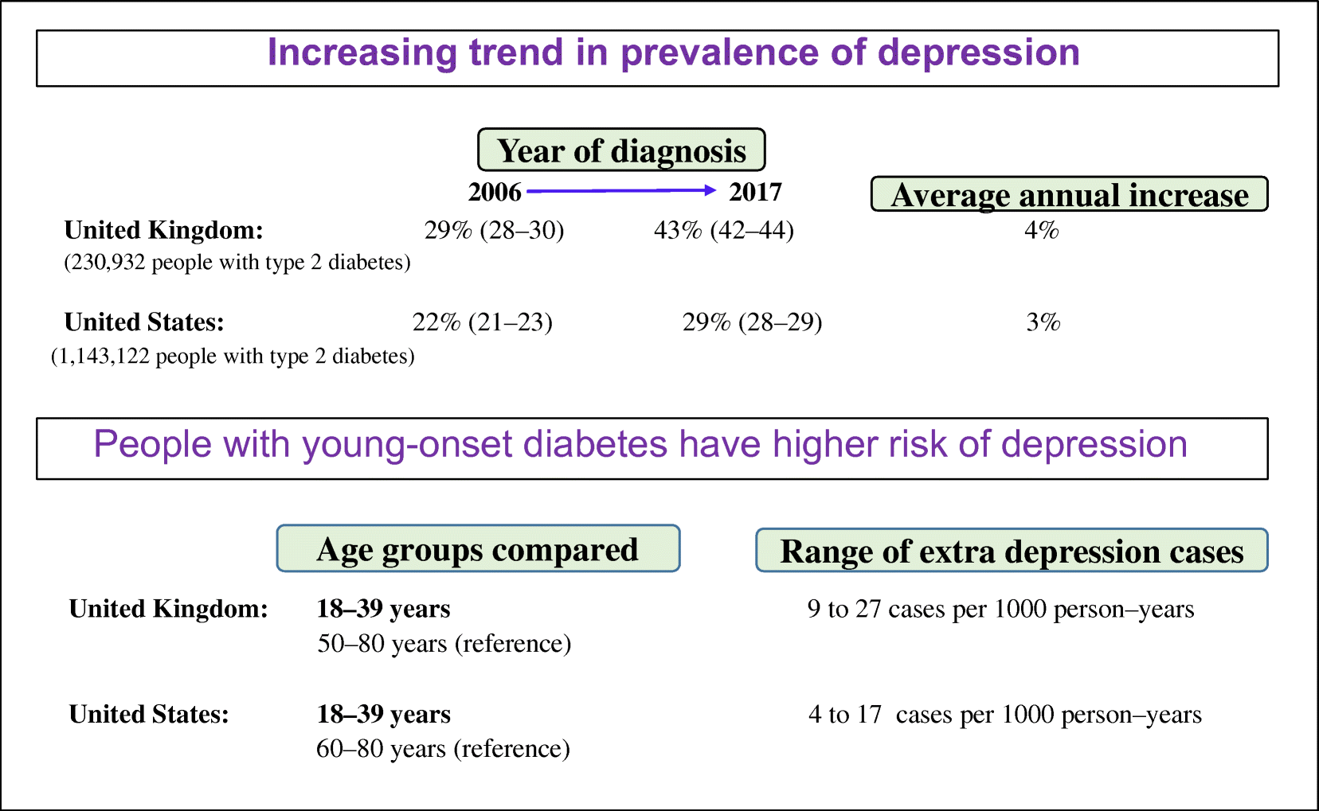
Fig 4: Individuals with young onset type 2 diabetes (Source: Diabetologia, 2025)
According to studies conducted in the UK, people with diabetes show higher rates of depression than those in the general population [Refer to Appendix B]. Mental health support has become essential for National Health Service services, which now provide some diabetes clinics with counselling services and referrals to psychological treatment centers that assist patients with their emotional challenges during extended disease management.

3.3 SOCIAL IMPACT
Type 2 Diabetes has a major impact on how people socialize and complete their daily responsibilities (Ahmad et al., 2022). People with this condition face work difficulty because they need to attend medical appointments and check their blood glucose levels and follow strict dietary rules. The National Health Service restrict specific job functions which reports vision problems in create complications which decrease work efficiency and (Clinical Services Journal, 2025).
The sociological framework of Talcott Parsons's "sick role theory" demonstrates how chronic illness transforms a person's societal obligations and social standards (Abrutyn, and Lizardo, 2023). People with diabetes face social isolation because they must maintain their dietary restrictions which include not consuming sugary foods at social events. People from lower socioeconomic backgrounds in the UK face additional financial challenges which result from needing to spend money on both medical transportation and healthy food.

3.4 IMPACT ON FAMILIES AND CAREGIVERS
Type 2 Diabetes impacts both family members and caregivers who need to provide support for diabetes management throughout its duration (Ahmad et al., 2022). Medical appointments such as family members take on extra responsibilities to help with medication reminders in meal preparation. According to Diabetes UK, helping their members establish better eating habits so, families has frequently dedicated participants to continue more active lifestyles (Diabetes, 2025).
The Stress Process Model shows family members continuously perform caregiving tasks that will suffer from both emotional distress in mental health problems (Mauno et al., 2025). Healthcare transportation expenses highlight difficult for low-income families in the UK, so, financial burden of diabetes management, includes healthy food costs.

3.5 EVIDENCE-BASED TREATMENTS AVAILABLE IN THE UK
The management of Type 2 Diabetes Diabetes management requires blood glucose level regulation and complication prevention through prescribed lifestyle modifications and medications and continuous health monitoring (Młynarska et al., 2025). The National Health Service in the United Kingdom serves as the primary provider of diabetes treatment which includes established treatment protocols for patients with diabetes (England NHS, 2025).
The treatment process includes lifestyle changes as a fundamental treatment aspect (Espinola et al., 2025). Patients should follow healthy eating habits while they should engage in more physical activities and keep their body weight within healthy limits. The NHS diabetes education programs teach people how to control their diabetes and how their daily activities impact their blood glucose levels (England NHS, 2025). The doctor will conduct structured education sessions to teach patients about nutrition and exercise and how to monitor their glucose levels.

4. THEORETICAL PERSPECTIVES AND MODELS OF CARE

4.1 UK MODEL FOR LONG-TERM CONDITION MANAGEMENT

Fig 5: Chronic Care Model (CCM) for Long-Term Condition (Source: Self-developed)
CHRONIC CARE MODEL (CCM)
The Chronic Care Model (CCM) serves as the primary framework for supervising Type 2 Diabetes and other chronic health conditions (Al‐Qahtani, 2024). The model works to enhance patient understanding through better communication between patients who have knowledge and healthcare professionals who take active roles in their work (Pomey et al., 2024). The framework consists of six main elements which include health system organisation, community resources, self-management support, delivery system design, decision support, and clinical information systems.
The UK healthcare system uses CCM to provide regulated diabetes treatment through general practitioners and specialist clinics and community healthcare services (Al‐Chalabi et al., 2025). The diabetes program provides patients with ongoing blood glucose measurements together with information about necessary lifestyle modifications and unified treatment strategies. Healthcare workers use electronic health records and clinical guidelines to assist their decision-making process which is based on scientific evidence (Hants et al., 2023).
The model establishes better patient results through its two main functions which are preventive care promotion and patient empowerment support. Research demonstrates that diabetes patients who receive CCM-based treatment achieve superior blood sugar management and experience reduced health risks and enhanced daily functioning (Liu, 2025). Patients need to take an active role in their medical treatment by testing their blood sugar levels while maintaining a balanced diet and exercising regularly.
NHS LONG TERM PLAN
The NHS Long Term Plan, introduced in 2019, is a strategic framework designed to improve the management of chronic diseases across England. Long-term conditions of prioritises plan may prevent diagnosis system that has integrated care for such as diabetes, cardiovascular disease, and respiratory illnesses.
Organisations deliver coordinated care by using Integrated Care Systems (ICS), it is brought together hospitals, general practitioners, local authorities, and community (Dunn et al., 2022). The NHS use digital monitoring tools to diabetes management system that highlight structured education programmes in lifestyle support services (Dunn et al., 2022).
Developing Type 2 Diabetes in the NHS Diabetes Prevention Programme helps individuals to maintain high risk that adopt healthier lifestyles (McManus et al., 2022). Digital health technologies in making those services more reachable include remote monitoring in online consultations provide patients with better ways to interact with healthcare services (Liu, 2025). Enhancing healthcare provider collaboration in NHS Long Term Plan enables better management of long-term conditions through its dual approach of developing preventive measures.

4.2 INTERNATIONAL MODEL
SELF-MANAGEMENT MODEL

Fig 6: Self-Management Model for Type 2 Diabetes (Source: Self-developed)
The Self-Management Model is widely recognised in international healthcare systems for managing chronic diseases (Allory et al., 2024). Tracking their health status in model demonstrates how patients can manage their health conditions such as learning and making lifestyle changes.
According to research patients who practice effective self-management achieve better health outcomes because their confidence increases and diabetes complications decrease. Patients gain the essential skills for independent condition management through the combination of education programmes and support groups. The model accomplishes two objectives through its implementation because it decreases hospital admissions while superior disease management extends throughout the patient's lifetime.
INTEGRATED CARE MODEL AND WHO FRAMEWORK
The Integrated Care Model serves as an international method that healthcare providers use to maintain control over chronic conditions (Raaijmakers et al., 2023). The system establishes healthcare connections between primary care facilities and hospitals and social services and community health organizations. The system aims to deliver continuous patient care which maintains its focus on individual patient needs instead of providing disconnected health services.
The World Health Organization (WHO) framework for chronic conditions also supports integrated care by emphasising partnerships between patients, healthcare providers, and communities (Sum et al., 2022). The framework promotes effective chronic disease management through its support of prevention programs and health promotion initiatives and its development of strong health systems.
COMPARISON OF UK AND INTERNATIONAL APPROACHES
Both UK and international models share several similarities. The systems show their main focus through patient-centred healthcare and self-management and their need for healthcare professionals to work together with each other. The approaches empower patients to manage their health while they safeguard themselves from complications that arise from long-term medical conditions.
The UK's approach receives strong backing from its national healthcare system (NHS), which delivers diabetes treatment and structured diabetes prevention programs to all citizens (Whelan and Bell, 2022). Decreasing their need for hospital stays such as Type 2 Diabetes strengthen their disease management capabilities while enhancing their overall well-being (Sebire et al., 2025).

5. HEALTH AND SOCIAL CARE POLICIES

5.1 NATIONAL POLICIES
The UK government has implemented several national policies to improve the prevention and management of long-term conditions such as Type 2 Diabetes. The Department of Health and Social Care collaborates with NHS England to create solutions which assist patients suffering from chronic conditions (England, 2022). The NHS Long Term Plan serves as the principal policy which aims to enhance early disease detection and digital health monitoring and community health services for diabetes treatment
(NHS England, 2025).

The Biopsychosocial Model provides theoretical insights which demonstrate that effective chronic disease management requires treatment of biological and psychological and social aspects of patient health (Smart, 2023). The national policies decrease hospital admissions while enhancing life quality, but different areas experience varying implementation success because of their specific resource and workforce availability.

5.2 LOCAL INITIATIVES
Local health initiatives provide vital support to Type 2 Diabetes patients who live throughout various UK communities (Ahmad et al., 2022). Integrated Care Systems deliver multiple services by bringing together healthcare providers and social services with local authorities to enhance patient care results. Diabetes education sessions and lifestyle coaching together with screening services are provided through GP practices and local health centres by community health programmes (Diabetes, 2025). Diabetes UK-supported initiatives operate to raise community awareness while they teach people how to manage their diabetes.
Michael Marmot's Social Determinants of Health theory states that income and housing and education determine people's ability to access medical treatment and maintain good health (Marmot, 2022). Local initiatives assist in finding patients early and providing them with proper medical care but their success depends on available funding and staff resources and the ability of all people to access services in both rural areas and underprivileged regions. Some people experience difficulties because they cannot access programs or receive ongoing care for diabetes management.

6. RECOMMENDATIONS FOR IMPROVING CARE

6.1 PERSON-CENTRED CARE APPROACHES
Type 2 Diabetes and other chronic illnesses require person-centred care as its primary treatment method. The treatment approach establishes active patient participation in their healthcare processes instead of treating them as passive recipients of medical care (He et al., 2023). It enables healthcare professionals to maintain patients by using the process of shared decision-making functions as an essential element to work in choosing suitable treatment methods. The implementation of this method results in higher patient satisfaction and better treatment compliance (Nwosu et al., 2024). Holistic care provides treatment for all three dimensions of diabetes which include physical health and psychological health and social well-being (Yuceer and Cinar, 2025). Healthcare professionals can deliver better support for diabetes management by evaluating emotional health and social factors and the patient's daily habits.

6.2 SELF-MANAGEMENT STRATEGIES
Self-management serves as a vital element which enables Type 2 Diabetes patients to achieve better treatment results. Patients require educational programs as their primary method to obtain essential knowledge and skills for effective disease management. The United Kingdom provides structured diabetes education programs which assist patients in learning about blood glucose monitoring and medication management and healthy lifestyle behaviors (Oser et al., 2022). Blood sugar levels stay controlled and complications get avoided through dietary management and physical activity increases and body weight reduction. Diabetes management has seen a growing reliance on digital health tools during the past few years (Stevens et al., 2022).

6.3 END-OF-LIFE CARE
End-of-life care is an essential component of treating long-term diseases because it helps patients who experience severe Type 2 Diabetes complications. Palliative care aims to enhance patient life quality through its functions which include symptom management and pain relief and emotional support for people with serious medical conditions. Patients need advanced care planning because it enables them to state their treatment and protection preferences for future health situations (Giordano et al., 2022). This process guarantees that medical choices will be made according to what the patient wants and needs. Families and caregivers need suitable assistance to help them through this time (Applebaum et al., 2024).

7. CONCLUSION
Healthcare systems face significant difficulties because people throughout the world experience Type 2 Diabetes as a permanent health condition. Proper handling of these health issues enables better patient results together with reduced medical system demands. People with Type 2 Diabetes experience three major impacts which affect their physical health together with their mental health and their ability to engage in work and social activities.
The United Kingdom depends on its National Health Service and Department of Health and Social Care to establish and execute health policies together with treatment standards and disease prevention initiatives. The NHS Long Term Plan together with national health strategies through their national health strategies demonstrate how vital it is to establish early diagnosis systems and create unified medical systems while delivering educational material to patients.

8. REFERENCE LIST
- Al‐Chalabi, S., Sinha, S. and Kalra, P.A., 2025. Enhancing clinical service design for multimorbidity management: A comprehensive approach to joined‐up care for diabetes, chronic kidney disease, and heart failure. Diabetic Medicine, 42(2), p.e15403. https://onlinelibrary.wiley.com/doi/pdf/10.1111/dme.15403.
- Allory, E., Scheer, J., De Andrade, V., Garlantézec, R. and Gagnayre, R., 2024. Characteristics of self-management education and support programmes for people with chronic diseases delivered by primary care teams: a rapid review. BMC Primary Care, 25(1), p.46. https://link.springer.com/content/pdf/10.1186/s12875-024-02262-2.pdf.
- Al‐Qahtani, A.A., 2024. Improving outcomes of type 2 diabetes mellitus patients in primary care with Chronic Care Model: A narrative review. Journal of General and Family Medicine, 25(4), pp.171-178. https://onlinelibrary.wiley.com/doi/pdf/10.1002/jgf2.659.
- Applebaum, A.J., Kent, E.E., Ellington, L., Campbell, G., Donovan, H., Trivedi, R., Van Houtven, C., Gray, T.F., Gebert, R.R., Rosa, W.E. and Odom, J.N., 2024. Top ten tips palliative care clinicians should know about caring for family caregivers. Journal of Palliative Medicine, 27(7), pp.930-938. https://journals.sagepub.com/doi/pdf/10.1089/jpm.2023.0640.
- Cacciatore, S., Mao, S., Nuñez, M.V., Massaro, C., Spadafora, L., Bernardi, M., Perone, F., Sabouret, P., Biondi-Zoccai, G., Banach, M. and Calvani, R., 2025. Urban health inequities and healthy longevity: traditional and emerging risk factors across the cities and policy implications. Aging clinical and experimental research, 37(1), p.143. https://link.springer.com/content/pdf/10.1007/s40520-025-03052-1.pdf
- Cleveland Clinic (2023) Metabolic Syndrome. Available form: https://my.clevelandclinic.org/health/diseases/10783-metabolic-syndrome. Accessed on 06.03.2026
- Diabetes (2025) Depression and diabetes. Available from: https://www.diabetes.org.uk/living-with-diabetes/emotional-wellbeing/depression. Accessed on 06.03.2026
- Diabetologia (2025) Individuals with young onset type 2 diabetes at substantially higher risk of depression. Available from: https://diabetologia-journal.org/2022/09/06/individuals-with-young-onset-type-2-diabetes-at-substantially-higher-risk-of-depression/. Accessed on 06.03.2026
- Dunn, P., Fraser, C., Williamson, S. and Alderwick, H., 2022. Integrated care systems: what do they look like. Health Foundation. https://www.health.org.uk/sites/default/files/pdf/2022-06/2022%20-%20ICS%20characteristics.pdf.
- England NHS (2024) NHS identifies over half a million more people at risk of type 2 diabetes in a Year. Available from: https://www.england.nhs.uk/2024/06/nhs-identifies-over-half-a-million-more-people-at-risk-of-type-2-diabetes-in-a-year/. Accessed on 06.03.2026
- England NHS (2025) Diabetes treatment and care programme. Available from: https://www.england.nhs.uk/diabetes/treatment-care/. Accessed on 06.03.2026
- Espinola, O.P., Tobias, D.K. and Manson, J.E., 2025. The role of lifestyle interventions for the prevention and treatment of type 2 diabetes: a narrative review. American Journal of Lifestyle Medicine, p.15598276251372427. https://pmc.ncbi.nlm.nih.gov/articles/PMC12411468/
- George, A., Badrinath, P., Newton, S., Hooper, A., Bhavsar, A., Chambers, M., Lacey, P., Kulkarni-Johnston, R. and Whitlow, H., 2025. The population health impacts of changes to the national health service health check programme: A system dynamics modelling approach in a local authority in England. Systems, 13(2), p.101. https://www.mdpi.com/2079-8954/13/2/101
- Giordano, A., De Panfilis, L., Perin, M., Servidio, L., Cascioli, M., Grasso, M.G., Lugaresi, A., Pucci, E., Veronese, S. and Solari, A., 2022. Advance care planning in neurodegenerative disorders: a scoping review. International Journal of Environmental Research and Public Health, 19(2), p.803. https://www.mdpi.com/1660-4601/19/2/803.
- Hants, L., Bail, K. and Paterson, C., 2023. Clinical decision‐making and the nursing process in digital health systems: an integrated systematic review. Journal of clinical nursing, 32(19-20), pp.7010-7035. https://onlinelibrary.wiley.com/doi/pdfdirect/10.1111/jocn.16823.
- He, Q., Chen, X. and Zeh, P., 2023. Promoting self-care and management for patients with type 2 diabetes based on lifestyle changes under the concept of person-centered care: a review. Altern Ther Health Med, 29(5), pp.302-7. http://www.alternative-therapies.com/oa/pdf/8182.pdf.
- Hezam, A.A.M., Shaghdar, H.B.M. and Chen, L., 2024. The connection between hypertension and diabetes and their role in heart and kidney disease development. Journal of Research in Medical Sciences, 29(1), p.22. https://journals.lww.com/jrms/fulltext/2024/04290/the_connection_between_hypertension_and_diabetes.4.aspx?context=latestarticles
- Iafusco, D., Franceschi, R., Maguolo, A., Guercio Nuzio, S., Crinò, A., Delvecchio, M., Iughetti, L., Maffeis, C., Calcaterra, V. and Manco, M., 2023. From metabolic syndrome to type 2 diabetes in youth. Children, 10(3), p.516. https://www.mdpi.com/2227-9067/10/3/516
- IDF, (2025) Facts & Figs. Available from: https://idf.org/about-diabetes/diabetes-facts-Figs/. Accessed on 06.03.2026
- Liu, P.Y., 2025. Care Logic in Diabetes Care and Nursing: Conflicts and Ethical Tensions in German Healthcare Practice (Vol. 1). transcript Verlag. https://books.google.com/books?hl=en&lr=&id=4l5SEQAAQBAJ&oi=fnd&pg=PP1&dq=diabetes+patients+who+receive+CCM-based+treatment+achieve+superior+blood+sugar+management+and+experience+reduced+health+risks+and+enhanced+daily+functioning&ots=LVHzgyqffk&sig=92qsn_cJz6dXVV6OESnJbI0m8Nw.
- Małecka, D., Tyrańska-Fobke, A., Kubiak, K.B., Kuich, A., Zapaśnik, A. and Robakowska, M., 2025. Association Between Use of a Primary Care Health Check-Up Tool and the Early Detection of Chronic Diseases: A Non-Randomised Comparative Study from the POZ PLUS Pilot Programme in Poland. Medicina, 62(1), p.56. https://www.mdpi.com/1648-9144/62/1/56
- Mathew, T.K., Zubair, M. and Tadi, P., 2023. Blood glucose monitoring. https://www.ncbi.nlm.nih.gov/books/NBK555976/
- Mayo Clinic (2024) Overview: Type 2 diabetes. Available from: https://www.mayoclinic.org/diseases-conditions/type-2-diabetes/symptoms-causes/syc-20351193. Accessed on 06.03.2026
- McManus, E., Meacock, R., Parkinson, B. and Sutton, M., 2022. Population level impact of the NHS Diabetes Prevention Programme on incidence of type 2 diabetes in England: an observational study. The Lancet Regional Health–Europe, 19. https://doi.org/10.1016/j.lanepe.2022.100420
- Misra, A., Sattar, N., Ghosh, A., Nassar, M., Jayawardena, R. and Gupta, R., 2025. Type 2 diabetes in south Asians. bmj, 390. https://www.researchgate.net/profile/Anoop-Misra/publication/394452127_Type_2_diabetes_in_South_Asians/links/68e68521ffdca73694b634be/Type-2-diabetes-in-South-Asians.pdf
- Młynarska, E., Czarnik, W., Dzieża, N., Jędraszak, W., Majchrowicz, G., Prusinowski, F., Stabrawa, M., Rysz, J. and Franczyk, B., 2025. Type 2 diabetes mellitus: new pathogenetic mechanisms, treatment and the most important complications. International journal of molecular sciences, 26(3), p.1094. https://www.mdpi.com/1422-0067/26/3/1094
- Nwosu, N.T., Babatunde, S.O. and Ijomah, T., 2024. Enhancing customer experience and market penetration through advanced data analytics in the health industry. World Journal of Advanced Research and Reviews, 22(3), pp.1157-1170. https://www.researchgate.net/profile/Tochukwu-Ijomah-2/publication/383847388_Enhancing_customer_experience_and_market_penetration_through_advanced_data_analytics_in_the_health_industry/links/66dc439efa5e11512ca4ed44/Enhancing-customer-experience-and-market-penetration-through-advanced-data-analytics-in-the-health-industry.pdf.
- Ogunjobi, T.T., Adeyanju, S.A., Akinwande, K.G., Obasi, D.E., Aigbagenode, A.A., Musa, A. and Abdul, S.O., 2025. Improving the prevention and treatment of Lean Type 2 Diabetes in Sub-Saharan Africa: A review. European Journal of Sustainable Development Research, 9(2). https://www.researchgate.net/profile/Sulaimon-Abdul-2/publication/391052642_Improving_the_prevention_and_treatment_of_Lean_Type_2_Diabetes_in_Sub-Saharan_Africa_A_review/links/6816c3aa60241d5140225e45/Improving-the-prevention-and-treatment-of-Lean-Type-2-Diabetes-in-Sub-Saharan-Africa-A-review.pdf
- Oser, T.K., Cucuzzella, M., Stasinopoulos, M., Moncrief, M., McCall, A. and Cox, D.J., 2022. An innovative, paradigm-shifting lifestyle intervention to reduce glucose excursions with the use of continuous glucose monitoring to educate, motivate, and activate adults with newly diagnosed type 2 diabetes: pilot feasibility study. JMIR diabetes, 7(1), p.e34465. https://diabetes.jmir.org/2022/1/e34465/.
- PMC (2025) How can the UK National Health Service be broke? Available from: https://pmc.ncbi.nlm.nih.gov/articles/PMC2083406/. Accessed on 06.03.2026
- Pomey, M.P., Schaad, B., Lasserre‐Moutet, A., Böhme, P. and Jackson, M., 2024. Towards a new integrated model for taking into account the experiential knowledge of people with chronic diseases, integrating mediation, therapeutic education and partnership: the expanded chronic care patient–professional partnership model. Health Expectations, 27(5), p.e70054. https://onlinelibrary.wiley.com/doi/pdf/10.1111/hex.70054?domain=p2p_domain&token=K5TBY8Z26Q7NHW8ZX4D5.
- Raaijmakers, L.H., Schermer, T.R., Wijnen, M., van Bommel, H.E., Michielsen, L., Boone, F., Vercoulen, J.H. and Bischoff, E.W., 2023. Development of a person-centred integrated care approach for chronic disease management in Dutch primary care: a mixed-method study. International journal of environmental research and public health, 20(5), p.3824. https://www.mdpi.com/1660-4601/20/5/3824.
- Sebire, N.J., Adams, A., Arpiainen, L., Celi, L., Charlesworth, A., Gorgens, M., Gorsky, M., Magrabi, F., Nagasawa, Y., Onoka, C. and McKee, M., 2025. The future hospital in global health systems: the future hospital as an entity. The International journal of health planning and management, 40(3), pp.730-740. https://onlinelibrary.wiley.com/doi/pdf/10.1002/hpm.3893.
- Stevens, S., Gallagher, S., Andrews, T., Ashall-Payne, L., Humphreys, L. and Leigh, S., 2022. The effectiveness of digital health technologies for patients with diabetes mellitus: a systematic review. Frontiers in Clinical Diabetes and Healthcare, 3, p.936752. https://www.frontiersin.org/journals/clinical-diabetes-and-healthcare/articles/10.3389/fcdhc.2022.936752/pdf.
- Sum, G., Lau, L.K., Jabbar, K.A., Lun, P., George, P.P., Munro, Y.L. and Ding, Y.Y., 2022. The World Health Organization (WHO) Integrated Care for Older People (ICOPE) framework: a narrative review on its adoption worldwide and lessons learnt. International journal of environmental research and public health, 20(1), p.154. https://www.mdpi.com/1660-4601/20/1/154.
- Whelan, M. and Bell, L., 2022. The English national health service diabetes prevention programme (NHS DPP): A scoping review of existing evidence. Diabetic Medicine, 39(7), p.e14855. https://onlinelibrary.wiley.com/doi/pdf/10.1111/dme.14855.
- WHO (2025) Diabetes. Available from: https://www.who.int/news-room/fact-sheets/detail/diabetes. Accessed on 06.03.2026
- Yuceer, B. and Cinar, F.I., 2025. Multidimensional factors associated with treatment adherence in Type II diabetes: The roles of spiritual well-being and mindfulness. Complementary Therapies in Medicine, p.103251. https://www.sciencedirect.com/science/article/pii/S096522992500127X.
- Ahmad, E., Lim, S., Lamptey, R., Webb, D.R. and Davies, M.J., 2022. Type 2 diabetes. The Lancet, 400(10365), pp.1803-1820. https://www.academia.edu/download/86145616/dme.pdf
- Marmot, M., 2022. Public health and health inequalities: a half century of personal involvement. Journal of Public Health, 44(Supplement_1), pp.i23-i27. https://discovery.ucl.ac.uk/id/eprint/10165786/2/Marmot_Public%20health%20and%20health%20inequalitiesRev.pdf
- NHS England (2025) Diabetes treatment and care programme. Available from: https://www.england.nhs.uk/diabetes/treatment-care/. Accessed on 13.03.2026
- Diabetes (2025) Healthy eating. Available from: https://www.diabetes.org.uk/about-diabetes/looking-after-diabetes/healthy-eating. Accessed on 13.03.2026
- Clinical Services Journal (2025) Report warns NHS staff fatigue is still not recognised as a serious risk to patient safety. Available from: https://www.clinicalservicesjournal.com/story/48061/report-warns-nhs-staff-fatigue-is-still-not-recognised-as-a-serious-risk-to-pati. Accessed on 13.03.2026
- Abrutyn, S. and Lizardo, O., 2023. A motivational theory of roles, rewards, and institutions. Journal for the Theory of Social Behaviour, 53(2), pp.200-220. https://www.researchgate.net/profile/Seth-Abrutyn/publication/362586344_A_Motivational_Theory_of_Roles_Rewards_and_Institutions/links/647f341d2cad460a1bf8c3bf/A-Motivational-Theory-of-Roles-Rewards-and-Institutions.pdf?origin=journalDetail&_tp=eyJwYWdlIjoiam91cm5hbERldGFpbCJ9
- Mauno, S., Mäkikangas, A., Mäkiniemi, J.P. and Puttonen, S., 2025. Career calling in the work stress process: a conceptual and review analysis. Work & Stress, 39(4), pp.369-395. https://www.tandfonline.com/doi/pdf/10.1080/02678373.2025.2483205
- England, N.H.S., 2022. Working in partnership with people and communities: statutory guidance. Care DoHS. https://localdemocracyandhealth.com/wp-content/uploads/2024/11/8f21c-nhs-england-working-in-partnership-with-people-and-communities-statutory-guidance.pdf
- Smart, K.M., 2023. The biopsychosocial model of pain in physiotherapy: past, present and future. Physical Therapy Reviews, 28(2), pp.61-70. https://www.tandfonline.com/doi/pdf/10.1080/10833196.2023.2177792
- ONS (2025) Population estimates for the UK, England, Wales, Scotland and Northern Ireland: mid-2024. Available form: https://www.ons.gov.uk/peoplepopulationandcommunity/populationandmigration/populationestimates/bulletins/annualmidyearpopulationestimates/mid2024. Accessed on 16.03.2026

9. APPENDICES

APPENDIX A: “HOW MANY PEOPLE IN THE UK HAVE DIABETES?”
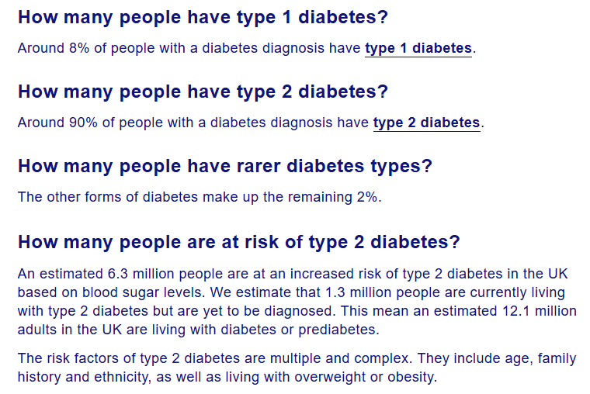
(Source: https://www.diabetes.org.uk/about-us/about-the-charity/our-strategy/statistics)

APPENDIX B: “HOW DOES DEPRESSION AFFECT DIABETES?”
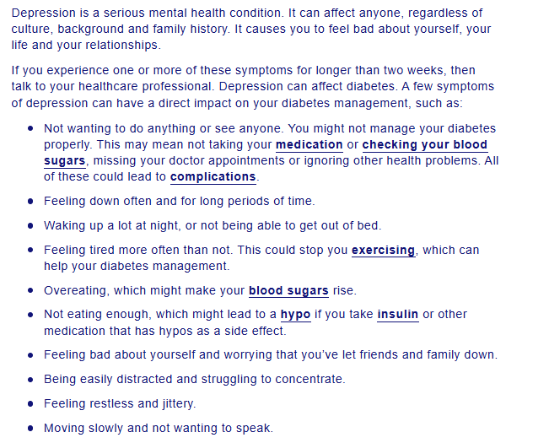
(Source: https://www.diabetes.org.uk/living-with-diabetes/emotional-wellbeing/depression)

