Validating Refactoring Predictions with Tests: A Machine Learning Approach
Parjal Rai, 2420643

Table of Contents
1. Introduction 3
2. Background, Literature Review and Motivation 3
2.1 Refactoring 3
2.2 Software Metrics as Refactoring Indicators 4
2.3 Traditional Refactoring Process 6
2.4 Machine Learning Paradigms 7
2.5 Recent Advances in Machine Learning for Refactoring 10
2.6 Motivation 11
3. Aim and Objectives 12
3.1 Aim 12
3.2 Objectives 12
4. Methodology 13
4.1 Data Collection and Labelling 13
4.2 Feature Extraction 13
4.3 Model Training and Evaluation 13
4.4 Behavioural Validation of Refactorings 14
4.5 Optional Comparison to Large Language Models (LLMs) 14
5. Expected Outcomes and Deliverables 14
6. Technical Requirements 15
7. Limitations and Risk Mitigation 16
8. Gantt chart 17
9. Conclusion 17
10. References 18

Introduction
Modern software engineering relies on high software quality and maintainability to ensure that applications remain scalable, efficient, and adaptable as requirements evolve [2]. Over time, software systems often grow in complexity, which can make maintenance more challenging and increase the risk of defects. To address this, refactoring plays a critical role in mitigating the decline of code quality. Refactoring can occur at different levels of granularity—from high-level architectural changes to low-level transformations such as renaming variables or extracting methods. This project focuses on low-level refactorings, which are both frequent and automatable, making them ideal candidates for machine learning–based prediction and validation [1–5].

Background, Literature Review and Motivation

2.1 Refactoring
Refactoring is the disciplined process of improving the internal structure of source code without altering its external behaviour, as defined by Fowler [4]. While its primary objective is to enhance code maintainability and comprehensibility, refactoring also plays a vital role in improving software reusability, extensibility, and testability [3]. Numerous empirical studies [1–9] have shown that systematic refactoring enhances software quality, readability, and long-term maintainability—all of which are essential for sustainable software evolution.
In the context of software maintenance, refactoring is crucial because software systems must continually adapt to changing requirements, fix defects, and improve performance. Maintenance activities often account for the majority of a software system's total lifecycle cost, and poor code quality can significantly increase the effort and risk involved in these tasks. By improving the internal structure of the codebase, refactoring reduces complexity and technical debt, which in turn lowers maintenance costs and makes future enhancements easier and safer to implement [3, 9].
As software systems undergo continuous feature additions and architectural changes, maintaining high code quality becomes increasingly challenging. In such a dynamic environment, refactoring provides a structured and repeatable approach to improving code clarity, modularity, and resilience to change [3].
A common indicator of degraded code quality is the presence of code smells—surface symptoms in source code that suggest deeper design issues. These range from concerns such as duplicated code and overly long methods to more fundamental problems like low cohesion, high coupling, or inappropriate class responsibilities [5]. According to Beck and Fowler, identifying code smells is often the first step in recognising where refactoring is required. For example, large or complex methods can be simplified using techniques such as Extract Method or Decompose Conditional, thereby improving both readability and modularity [5, 8, 9].
More broadly, code smells often reflect violations of object-oriented design principles and are closely associated with the accumulation of technical debt—the long-term cost of design compromises made during development. Refactoring serves as a key mechanism for managing and reducing technical debt, enabling developers to improve internal code quality without affecting the system’s external behaviour [3, 9].

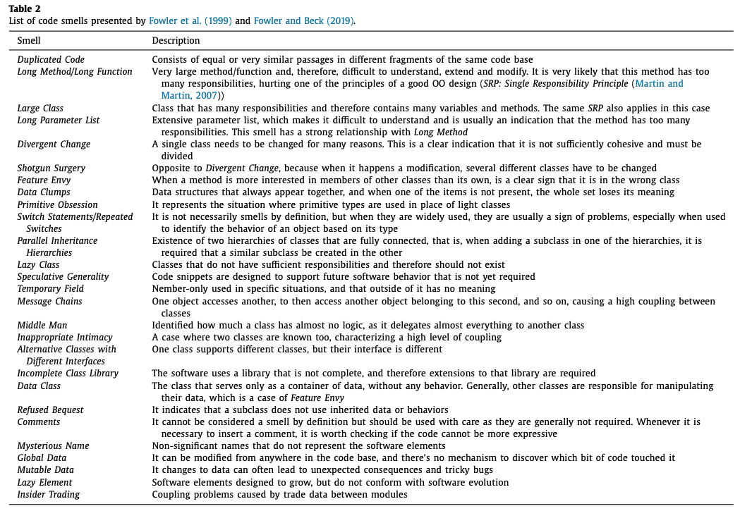
Table 1 – List of code smells presented by Fowler et al (1999) [1].

2.2 Software Metrics as Refactoring Indicators
While code smells offer qualitative cues of poor design, software metrics provide quantitative insights that help developers make more informed decisions about when and where to refactor. These metrics capture key structural attributes of code—such as complexity, cohesion, coupling, and size—and enable the systematic identification of potential design flaws. When metric values deviate from accepted thresholds or established best practices, they serve as refactoring indicators, highlighting areas where code quality may be improved.
Some of the most commonly used metrics include:
- Cyclomatic Complexity (CC):
Measures the number of independent control paths in a method and serves as a proxy for testability and cognitive complexity [13]. Methods with high CC values are often strong candidates for refactoring techniques such as Extract Method, Decompose Conditional, or Replace Nested Conditional with Guard Clauses, all of which aim to simplify control flow and reduce mental load [15].
- Lack of Cohesion in Methods (LCOM):
Introduced by Chidamber and Kemerer [14], LCOM quantifies how closely related the methods in a class are, based on their shared use of instance variables. A high LCOM score indicates low cohesion, which is commonly linked to the "God Class" smell. Refactorings such as Extract Class or Move Method can help improve modularity and enforce the Single Responsibility Principle [15].
- Lines of Code (LOC) and Number of Methods:
These are simple yet powerful indicators of code size and structural complexity. Excessively long classes or methods often correlate with poor readability and reduced maintainability. High LOC values may point to "Long Method" or "God Class" smells, and typically prompt decomposition or simplification [24].
- Coupling Between Objects (CBO):
High coupling reflects strong interdependence between classes, which reduces modularity and hinders reuse. Classes with high CBO values are often difficult to test and modify. Refactorings that reduce coupling—such as Extract Interface or Introduce Parameter Object—can improve both system flexibility and testability [25].
- Depth of Inheritance Tree (DIT) and Number of Children (NOC):
These metrics assess the complexity of the inheritance hierarchy. While deeper trees can promote reuse, they also increase the difficulty of comprehension and modification. Extremely high or low DIT and NOC values may signal violations of object-oriented design principles and warrant a review of class hierarchies [24].

2.3 Traditional Refactoring Process
Translating refactoring principles into practice typically involves a manual, multi-step process comprising the following stages [10]:
- Understanding the Code and Identifying Refactoring Opportunities:
The process begins with a thorough understanding of the existing codebase to identify areas in need of improvement. This step is often guided by the detection of code smells—surface indicators of deeper design issues. Fowler et al. identified 22 common code smells in their foundational work [11].
- Selecting Appropriate Refactoring Techniques:
Once problematic areas are identified, developers select suitable refactoring techniques. These range from minor adjustments at the variable level to more substantial structural changes at the class or module level (see Table 2). Martin Fowler’s catalogue of refactoring techniques remains a key reference [4].
- Applying the Refactoring:
Developers implement the selected changes carefully, aiming to keep modifications focused and manageable to minimise disruption.
- Assessing the Impact of Refactoring:
After changes are made, developers must ensure that the system’s external behaviour remains unchanged. This is typically achieved by executing existing unit tests to verify functional equivalence.
- Ensuring Consistency and Following Best Practices:
Refactored code should uphold recognised design principles such as Don’t Repeat Yourself (DRY), Keep It Simple, Stupid (KISS), and the Single Responsibility Principle (SRP), ensuring overall maintainability and quality.
While refactoring is widely recognised as a means of improving code quality, its adoption is often hindered by practical challenges. Effective refactoring requires a deep understanding of the codebase to avoid introducing bugs or degrading performance. Common obstacles include limited development time due to competing priorities, the complexity of legacy code, lack of managerial support, inadequate tooling, and, at times, a shortage of experienced developers [7]. Moreover, the manual nature of refactoring increases the risk of inadvertently introducing errors [10].
The concept of automated refactoring began to emerge in the late 1990s and early 2000s with the advent of integrated development environments (IDEs). Tools such as Eclipse and IntelliJ IDEA introduced features like Rename, Extract Method, and Move Method, which assist developers by suggesting safe structural changes. However, these tools still require user confirmation and rely primarily on static code analysis and heuristic rules to identify refactoring opportunities [10, 11, 16].
From the mid-2000s onwards, fully automated refactoring systems began appearing in research contexts. Like early IDE tools, these systems also rely on static analysis and heuristics but aim to detect and apply refactorings automatically—without developer intervention. Many such systems incorporate program transformation frameworks that ensure behavioural preservation. Nevertheless, the widespread use of fully automated refactoring in real-world software development remains limited, due largely to concerns around correctness, reliability, and developer trust [10, 16].

2.4 Machine Learning Paradigms

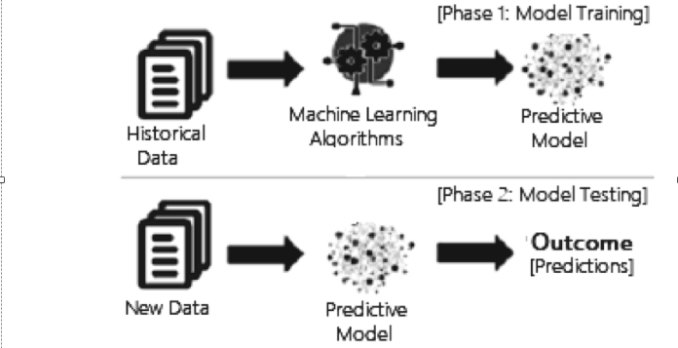
Figure 1: Process of Machine Learning [23].
Machine learning (ML) is a subfield of artificial intelligence focused on enabling systems to learn patterns from data and make informed decisions or predictions without being explicitly programmed. The origins of ML trace back to Arthur Samuel’s pioneering work in 1959 and were more formally defined by Mitchell (1997), who stated that “a computer program is said to learn from experience EEE with respect to some class of tasks TTT and performance measure PPP, if its performance at tasks in TTT, as measured by PPP, improves with experience EEE” [18, 19]. The ML process begins with collecting and preparing data, which is then used to train a model. The model learns to recognise patterns and relationships within this data and, once trained, can make predictions on new, unseen inputs (fig. 1). Model accuracy typically improves over multiple training iterations, enhancing performance over time [23].
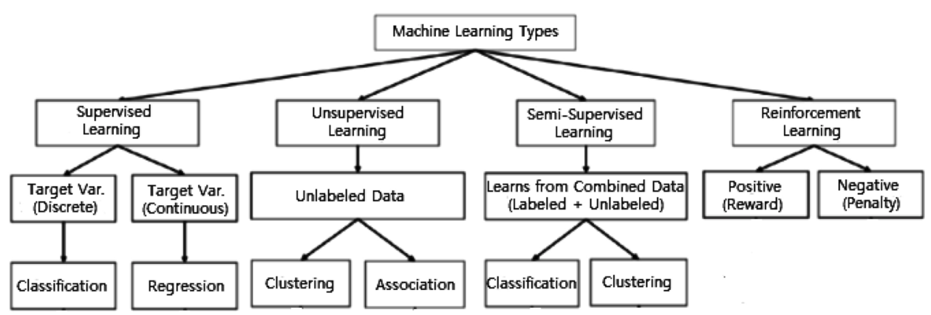
Figure 2: Machine Learning Types [23].
ML methods are broadly categorised into four main paradigms: supervised learning, unsupervised learning, semi-supervised and reinforcement learning. Although all three have applications within software engineering, supervised learning is the most pertinent to automated code refactoring and is therefore the primary focus of this project [1, 23].
In supervised learning, models are trained on labelled datasets that map input features to known outputs, such as specific refactoring types. The model learns to generalise from these examples and can subsequently predict appropriate refactoring strategies for previously unseen code segments. This makes supervised learning particularly suitable for tasks such as identifying where refactoring is needed and recommending the most appropriate technique. The effectiveness of supervised learning is further enhanced by the availability of open-source datasets annotated with refactoring labels.
In contrast, unsupervised learning involves discovering patterns in unlabelled data and is commonly applied to clustering or anomaly detection tasks. Reinforcement learning trains an agent to make sequential decisions based on reward feedback. While these paradigms offer intriguing possibilities—such as using reinforcement learning to explore alternative refactoring sequences guided by code quality metrics—they fall outside the scope of this study [1, 23].
Within supervised learning, classification is a key method whereby a model predicts a class label for a given input. This process involves using labelled data to learn relationships between input features and corresponding categories. Classification types include [1]:
- Binary classification, which involves two class labels, such as yes/no or true/false.
- Multiclass classification, which includes more than two possible class labels.
- Multi-label classification, where each example can be associated with multiple labels simultaneously.
Several algorithms are commonly employed for classification tasks, including Support Vector Machines (SVM), Decision Trees (DT), and Random Forests (RF).
Support Vector Machines (SVM) operate by finding a boundary—known as a hyperplane—that best separates different groups of data within a high-dimensional space. SVM attempts to maximise the margin, or distance, between the closest data points of each class and the hyperplane, with a wider margin generally leading to better generalisation on unseen data. For more complex datasets, kernel functions (such as linear or polynomial kernels) transform data to enhance separability. However, SVM may struggle with noisy data or when classes overlap significantly [23, 26].
A Decision Tree (DT) is a non-parametric supervised learning method that recursively partitions the dataset based on input feature values, forming a tree-like structure. Starting from the root node, internal decision nodes evaluate attributes until a leaf node assigns the predicted class or value. Prominent algorithms include ID3, C4.5, and CART, which differ in attribute selection and tree pruning techniques. Splitting criteria such as Gini impurity or entropy assess the quality of splits by measuring class separation. Decision trees are valued for their interpretability and ability to handle both numerical and categorical data, although they can be prone to overfitting without proper regularisation [1, 23].
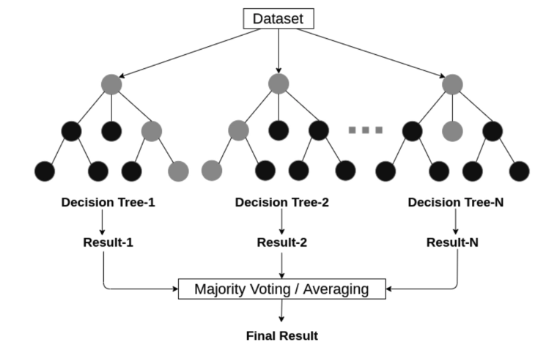
Figure 3: Random Forest structure considering multiple decision trees [23].
Random Forest (RF) utilises an ensemble approach by training multiple decision trees in parallel on different subsets of the training data. Final predictions are made through majority voting (for classification) or averaging (for regression), which improves accuracy and reduces overfitting risk. RF achieves robustness via two key strategies: bootstrap aggregation (bagging), which generates diverse training datasets through random sampling with replacement, and random feature selection, which promotes tree diversity. This combination yields a collection of varied yet accurate trees, resulting in more reliable predictions compared to single decision tree models [1, 23].

2.5 Recent Advances in Machine Learning for Refactoring
Recent years have seen significant advances in applying machine learning (ML) techniques to software refactoring and code quality improvement. Aniche et al. (2020) investigated the use of supervised ML methods to predict whether a method within a software system requires refactoring, utilising static code metrics such as lines of code, cyclomatic complexity, and coupling. Their classifiers, including Random Forests and Support Vector Machines (SVM), were evaluated on open-source Java projects using standard classification metrics such as precision, recall, and F1-score, providing a foundational baseline for ML-based refactoring prediction [1]. However, the study did not assess whether the suggested refactorings preserved programme behaviour or improved maintainability, highlighting an evaluation gap that this project aims to address.
Building on this foundation, Sharma et al. (2022) proposed a machine learning framework combining code smell detection with refactoring recommendations. Their classifiers—Random Forests, SVM, and K-Nearest Neighbours (KNN)—were trained on static code and design metrics, and their approach was evaluated for accuracy in identifying problematic code and aligning with developer decisions [2]. While advancing practical support for refactoring decisions, the evaluation did not extend to validating the correctness or quality improvements of the recommended refactorings when applied to real codebases [28].
Cui et al. (2022) introduced RMove, a technique focusing on Move Method refactorings by integrating structural and semantic representations of code. Using a Random Forest classifier trained on Java projects, RMove’s performance was assessed primarily through classification accuracy and relevance of refactoring recommendations [3]. Although this represents an advance in incorporating richer code representations, the study lacked detailed evaluation of the impact on software maintainability or behavioural preservation [27].
More recently, Liu et al. (2024) leveraged Large Language Models (LLMs) such as ChatGPT (GPT-4) and Google Gemini to automate refactoring detection and code transformation. Their evaluation was twofold: first, measuring the detection accuracy of refactoring opportunities, where ChatGPT’s baseline accuracy was 15.6%, increasing to 86.7% when provided with explicit prompt labels specifying the refactoring type (e.g., Extract Method, Rename Variable). Second, they assessed the quality of the generated refactorings by comparing them with human developer solutions, finding that 63.6% of ChatGPT’s suggestions matched or surpassed human performance. Crucially, to ensure correctness, they developed RefactoringMirror, a hybrid system that re-applies LLM-proposed changes using IDE refactoring tools such as Eclipse and IntelliJ, achieving a high reapplication success rate of 94.3%. This combination of prediction accuracy and practical validation exemplifies a more comprehensive evaluation approach [8,29].
Yu et al. (2024) proposed MovePerf, a deep learning framework predicting both the likelihood and runtime and memory performance impacts of Move Method refactorings. Their evaluation incorporated performance metrics alongside traditional accuracy measures, reflecting an emerging trend towards multi-dimensional assessment of refactoring quality. Nevertheless, the interpretability of their model remains limited, a challenge highlighted by ongoing research [7, 30].
Yadav et al. (2024) provided a comprehensive survey of 42 studies on machine learning approaches for code smell detection. They identified persistent evaluation challenges, including the scarcity and imbalance of labelled datasets, subjective and inconsistent definitions of code smells, and difficulties in generalising models across projects and programming languages. Moreover, the lack of standardised benchmarks and metrics complicates cross-study comparison and replication. These findings underscore the need for robust, transparent evaluation methodologies—motivating this project’s emphasis on ensuring that ML-based refactorings preserve behaviour and improve maintainability in real-world settings [5].
Together, these studies demonstrate the growing interest in applying machine learning to software refactoring, with notable progress in detecting refactoring opportunities and recommending code transformations. However, persistent challenges remain. Most approaches evaluate prediction accuracy but fall short of validating whether the proposed refactorings preserve program behaviour or genuinely improve maintainability. In addition, the heavy reliance on static code metrics limits the models’ capacity to capture deeper code semantics and context, constraining both accuracy and generalisability.
While recent advances with Large Language Models (LLMs) offer new capabilities, concerns about transparency, training data contamination, and safe deployment remain unresolved. Broader issues—such as the scarcity and imbalance of labelled datasets, the subjectivity in defining code smells, and the lack of standardised benchmarks—further hinder robust evaluation and cross-study comparison.
These gaps highlight the need for comprehensive, rigorous evaluation frameworks that verify not only the identification of refactoring opportunities but also the functional correctness and real-world maintainability benefits of ML-driven refactoring techniques.

2.6 Motivation
Despite notable progress in machine learning–based refactoring, several critical challenges remain unresolved. Prior work by Aniche et al. (2020), Sharma et al. (2022), and Cui et al. (2022) has developed supervised classifiers to detect refactoring opportunities based on static code metrics. However, these approaches focus primarily on prediction accuracy and often fail to verify whether the proposed refactorings preserve program behaviour or improve software maintainability in practice. This absence of rigorous validation introduces substantial risk when deploying such tools in real-world development environments.
More recent studies using Large Language Models (LLMs), such as Liu et al. (2024), demonstrate enhanced capabilities in both detection and transformation tasks. Nonetheless, their black-box nature, limited interpretability, and high sensitivity to prompt variations raise concerns about their reliability—particularly in safety-critical domains where behavioural correctness and maintainability are essential.
This project addresses these limitations by proposing a supervised machine learning approach that prioritises transparency, controllability, and behavioural validation. A central component of this work involves the use of test suites to confirm that suggested refactorings preserve functional correctness, thereby increasing trustworthiness and practical applicability.
This study focuses on Java, as much of the prior work on automated refactoring—both traditional and machine learning–based—has been conducted in the Java ecosystem. Java’s static typing, widespread use in open-source projects, and availability of mature tooling (e.g., RefactoringMiner, EvoSuite) make it particularly suitable for analysing and validating refactoring transformations at scale [1, 31].
By explicitly modelling refactoring decisions and rigorously evaluating their impact on software behaviour and maintainability, this project aims to bridge the gap between theoretical ML-driven refactoring research and the practical needs of software maintenance. In doing so, it responds to the growing demand for trustworthy automated refactoring tools that can be confidently integrated into real-world development workflows.

Aim and Objectives

3.1 Aim
To develop and evaluate a supervised machine learning–based approach for predicting the type of refactoring in Java projects, with a primary focus on ensuring that applied refactorings preserve functional correctness, as verified by automated test suites.

3.2 Objectives
- To collect and label at least 1,000 real-world refactoring instances (e.g., Extract Method, Move Method) from Java-based open-source software repositories using RefactoringMiner, creating a high-quality training dataset.
- To extract and engineer a set of interpretable code features (e.g., method length, cyclomatic complexity, number of parameters) from both refactored and non-refactored code segments within the dataset, enabling effective input representation for supervised learning.
- To design, train, and evaluate a supervised classification model that predicts refactoring types, using standard metrics including accuracy, precision, recall, and F1-score, with cross-validation to assess generalisability.
- To apply the predicted refactorings automatically to unseen target code and validate behavioural correctness by running existing test suites or EvoSuite-generated tests, ensuring no regressions occur.
- (Optional, time permitting) To compare the model’s refactoring predictions with those generated by large language models (e.g., GitHub Copilot, GPT-4), analysing differences in correctness, transparency, and maintainability through case studies and qualitative assessmen

Methodology
To address the stated aim, this project follows a structured pipeline that aligns directly with the proposed objectives. The methodology is grounded in prior research and employs widely used tools and techniques within the software engineering community.
4.1 Data Collection and Labelling
Refactoring instances will be mined from open-source Java repositories using RefactoringMiner, a state-of-the-art tool for identifying refactoring operations from version histories [1]. Focus will be placed on a manageable set of refactoring types—e.g., Extract Method, Move Method, and Rename Variable—selected for their prevalence and relevance across different levels of programme structure (method, class, and variable level) [2–4]. The study will aim to include at least one representative refactoring type from each level, subject to data availability and the characteristics of the selected projects. Publicly available Java projects hosted on GitHub will serve as the source corpus. Projects will be selected to ensure they include existing test suites and contain meaningful commit histories. Specific repositories will be identified and finalised during the initial data collection phase, based on these criteria.
The collected dataset will comprise several hundred to a few thousand refactoring instances. The precise number of instances will depend on the availability of suitable projects, the chosen refactoring types, and practical considerations such as time constraints. Previous studies have utilised datasets ranging from 573 to over 2 million refactoring instances for classification tasks [23][33]. Given the limited timeframe of this project, the dataset size will balance feasibility with the necessity of providing sufficient data to train and evaluate the machine learning model effectively.
Data collection and labelling will also consider the diversity of projects to ensure generalisability. The dataset will be split into training, validation, and testing subsets to facilitate effective model development and evaluation. Specifically, 70% of the data will be reserved for training the machine learning model, 15% for validation to fine-tune model parameters and prevent overfitting, and the remaining 15% for testing to assess final prediction performance [32]. Depending on dataset size and characteristics, an alternative 80/20 train-test split may be employed if a separate validation set is not feasible.
4.2 Feature Extraction
For each candidate refactoring instance and its surrounding context, a set of static code features will be extracted. These include structural and syntactic properties (e.g., method length, parameter count, class cohesion) and software metrics (e.g., cyclomatic complexity, fan-in/out) [1, 23, 33]. The goal is to construct interpretable, engineered features that can effectively inform the classification of refactoring types.
4.3 Model Training and Evaluation
A Random Forest classifier will be trained to predict the type of refactoring applied based on the extracted features. Random Forest is selected for its robustness, ability to handle mixed and high-dimensional feature spaces, and its interpretability—particularly its capacity to rank feature importance, which aligns with the project’s transparency goals [1, 33]. Alternative classifiers such as Support Vector Machines (SVMs) were considered; however, Random Forest offers practical advantages, including superior handling of noisy features and easier interpretability, both critical to producing reliable predictions for software maintenance [1].
As a baseline for comparison, a majority class classifier will be used. This simple model always predicts the most frequent refactoring type found in the training data, providing a minimal benchmark that the Random Forest model is expected to outperform [8, 33].
The classifiers will be trained and validated using standard evaluation metrics including accuracy, precision, recall, and F1-score.
4.4 Behavioural Validation of Refactorings
To verify that the predicted refactorings do not compromise functional correctness, they will be applied automatically (or semi-automatically) to target Java code. Correctness will be validated using test suites:
- If the project already includes a reliable test suite, it will be reused.
- Otherwise, unit tests will be automatically generated using EvoSuite, a widely used test generation tool for Java that produces high-coverage test suites based on the structure of the code under test [31].
A refactoring will be considered functionally valid if all tests pass after the transformation. The proportion of tests passing before and after refactoring will serve as a key indicator of functional correctness. Additionally, static analysis metrics will be employed to evaluate improvements in code quality, based on established software maintainability criteria.
4.5 Optional Comparison to Large Language Models (LLMs)
If time permits, the project will evaluate whether modern LLMs (e.g., GitHub Copilot or GPT-4) can recommend equivalent or superior refactorings for the same examples. While not the primary focus, this comparison will provide valuable insight into the trade-offs between traditional machine learning and LLM-driven approaches, particularly regarding transparency, correctness, and maintainability. The evaluation criteria for LLM recommendations will include functional correctness, as verified by test suites, and improvements in maintainability metrics

Expected Outcomes and Deliverables
At the conclusion of the project, the following outputs are expected:
- A supervised machine learning model trained to classify refactoring types based on interpretable static code features. This will include:
  - The final trained model (e.g., Random Forest)
  - Feature extraction scripts
  - Model training and evaluation notebooks/scripts
- A labelled dataset of refactoring instances mined from open-source Java projects using RefactoringMiner. The dataset will include:
  - Refactoring type
  - Associated code context and extracted features
  - Split into training/validation/test subsets
- Behavioural validation pipeline, including:
  - Scripts to apply selected refactorings
  - Automated test validation using existing or EvoSuite-generated test suites
  - Reports verifying functional correctness post-refactoring
- Quantitative evaluation of the model’s performance using standard classification metrics (accuracy, precision, recall, F1-score), and where relevant, summary tables comparing maintainability metrics (e.g., cyclomatic complexity, code length) before and after refactoring.
- Qualitative comparison with Large Language Models (if time allows), consisting of:
  - Sample prompts and corresponding outputs from models like GPT-4 or GitHub Copilot
  - Commentary on behavioural correctness, maintainability, and transparency
  - Comparative analysis against the supervised approach
- Final dissertation/report, documenting:
  - Background research
  - Methodology
  - Experimental design and evaluation
  - Discussion of results and limitations
  - Conclusions and future work
- Supporting artefacts, such as:
  - Source code (hosted on GitHub or equivalent)
  - Documentation for reproduction
  - Setup scripts or Jupyter notebooks for model use and testing

Technical Requirements
To carry out this project, the following resources will be required:
- Hardware:
  - A standard development machine with at least 8–16 GB of RAM and modern multi-core CPU
  - No GPU is required unless LLM experiments involve fine-tuning, which is not planned
- Software and Tools:
  - Java Development Kit (JDK) (version 8+)
  - RefactoringMiner for mining refactorings
  - EvoSuite for automated test generation
  - Python 3.x and libraries such as:
    - scikit-learn, pandas, numpy, matplotlib
  - Optionally: Jupyter notebooks for experiment documentation
  - Git for version control
- Data and Repositories:
  - Access to open-source Java projects on GitHub with meaningful commit history and existing test suites
  - Internet access to retrieve project histories and documentation
- (Optional): Access to GitHub Copilot or OpenAI GPT-4 (via ChatGPT or API) for conducting LLM comparisons

Limitations and Risk Mitigation
While the proposed methodology is designed to be robust, a few potential limitations are acknowledged:
- Test Suite Availability and Coverage: Not all open-source projects include comprehensive unit tests. In such cases, EvoSuite will be used to automatically generate test suites. If generated suites lack coverage of key behaviours, manual tests will be written to supplement or replace them, ensuring meaningful behavioural validation of refactorings.
- RefactoringMiner Precision: Although RefactoringMiner is widely used, it may miss or misclassify some refactoring operations. To mitigate this, mined refactorings will be manually reviewed (on a sample basis) to ensure dataset quality.
- Data Imbalance: Some refactoring types (e.g., Extract Method) may be more common than others, which could bias the classifier. This will be addressed using appropriate techniques such as resampling or weighted loss functions if necessary.
- Time Constraints: The optional comparison with LLMs (e.g., GPT-4 or GitHub Copilot) may be scaled down or omitted if project timelines do not allow for meaningful evaluation.
By anticipating these risks and incorporating fallback strategies—such as writing supplemental tests and manually reviewing critical data points—the project aims to ensure the reliability and validity of its findings.

Gantt chart
Weeks (Month) | Tasks
Weeks 1–2 (July) | Finalise project scope, tools (RefactoringMiner, EvoSuite, Random Forest), select projects
Weeks 3–4 (July) | Collect data, extract refactorings from repos
Weeks 5–6 (Aug) | Feature engineering: extract code metrics and structural features
Weeks 7–8 (Aug) | Prepare dataset and start model training (Random Forest)
Weeks 9–10 (Sept) | Evaluate model, tune hyperparameters, analyse feature importance
Weeks 11–12 (Sept) | Apply predicted refactorings and run automated tests (existing/generated)
Weeks 13–14 (Oct) | Analyse functional correctness, perform static code quality analysis
Weeks 15–16 (Oct) | Optional: LLM-based refactoring comparison (if time permits)
Weeks 17–18 (Nov) | Write Methodology, Results, and Discussion chapters
Weeks 19–20 (Nov) | Revise, incorporate feedback, finalize write-up
Weeks 21–22 (Dec) | Final editing, formatting, submission preparation

Conclusion
This project addresses a critical gap in machine learning–based software refactoring by emphasising not only accurate prediction of refactoring types but also rigorous validation of their behavioural correctness. By combining data-driven models with automated test-based verification, the study aims to deliver practical, trustworthy tools that can support real-world software maintenance. With a well-defined methodology, clear objectives, and a feasible timeline, this research is positioned to contribute valuable insights and techniques to the field of automated refactoring.

References

[1]
M. Aniche, E. Maziero, R. Durelli, and V. Durelli, “The Effectiveness of Supervised Machine Learning Algorithms in Predicting Software Refactoring,” IEEE Transactions on Software Engineering, pp. 1–1, 2020, doi: https://doi.org/10.48550/arXiv.2001.03338

[2]
V. Veeramachaneni, "AI-Driven Software Development: Enhancing Code Quality and Maintainability Through Automated Refactoring," International Journal of Research in Developmental Science and Technology (IJRDST), vol. 2, no. 11, pp. 1–7, Nov. 2021.

[3]
A. Almogahed et al., “Code Refactoring for Software Reusability: An Experimental Study,” pp. 1–6, Aug. 2024, doi: https://doi.org/10.1109/esmarta62850.2024.10638872.

[4]
M. Fowler, Refactoring: Improving the Design of Existing Code. Boston, MA, USA: Addison-Wesley, 1999.

[5]
E. Oliveira, H. Keuning, and Johan Jeuring, “Student Code Refactoring Misconceptions,” Jun. 2023, doi: https://doi.org/10.1145/3587102.3588840.

[6] K. Beck and M. Fowler. 2018. Bad Smells in Code. In Refactoring: improving the design of existing code. Chapter 3.

[7]
D. L. Lima, R. De, G. P. Garcia, Silva, C. França, and Luiz Fernando Capretz, “Software Testing and Code Refactoring: A Survey with Practitioners,” arXiv (Cornell University), Oct. 2023, doi: https://doi.org/10.1109/icsme58846.2023.00064.

[8]
M. Agnihotri and A. Chug, “A Systematic Literature Survey of Software Metrics, Code Smells and Refactoring Techniques,” Journal of Information Processing Systems, vol. 16, no. 4, pp. 915–934, 2020, doi: https://doi.org/10.3745/JIPS.04.0184.

[9]
G. Lacerda, F. Petrillo, M. Pimenta, and Y. G. Guéhéneuc, “Code smells and refactoring: A tertiary systematic review of challenges and observations,” Journal of Systems and Software, vol. 167, p. 110610, Sep. 2020, doi: https://doi.org/10.1016/j.jss.2020.110610.

[10]
S. M. Akhtar, M. Nazir, A. Ali, A. S. Khan, M. Atif, and M. Naseer, “A Systematic Literature Review on Software-refactoring Techniques, Challenges, and Practices,” VFAST Transactions on Software Engineering, vol. 10, no. 4, pp. 93–103, Oct.–Dec. 2022.

[11]
M. Fowler, K. Beck, J. Brant, W. Opdyke, and D. Roberts, Refactoring: Improving the Design of Existing Code, Boston, MA, USA: Addison-Wesley, 1999.

[12]
S. I. Khaleel and R. A. Mahmood, "Automatic Software Refactoring to Enhance Quality: A Review," J. Ilm. Tek. Elektro Komput. dan Inform. (JITEKI), vol. 10, no. 4, pp. 734–746, Dec. 2024, doi: 10.26555/jiteki.v10i4.30277.

[13]
T. J. McCabe, “A complexity measure,” IEEE Transactions on Software Engineering, vol. SE-2, no. 4, pp. 308–320, Dec. 1976. https://doi.org/10.1109/TSE.1976.233837

[14] S. R. Chidamber and C. F. Kemerer, “A metrics suite for object oriented design,” IEEE Transactions on Software Engineering, vol. 20, no. 6, pp. 476–493, Jun. 1994.
[Online]. Available: https://doi.org/10.1109/32.295895

[15] R. Alzamil, “A Coupling-Cohesion Quality Model for Software Components,” Journal of Systems and Software, vol. 203, p. 111677, May 2023.
[Online]. Available: https://doi.org/10.1016/j.jss.2023.111677

[16]
G. Bavota, A. De Lucia, R. Oliveto, and M. Di Penta, “Automated refactoring: A systematic review,” in Proc. IEEE 37th International Conference on Software Maintenance and Evolution (ICSME), 2021, pp. 311–322, doi: 10.1109/ICSME52100.2021.00038.

[17]
S. Wang et al., “Machine/Deep Learning for Software Engineering: A Systematic Literature Review,” IEEE Transactions on Software Engineering, pp. 1–1, 2022, doi: https://doi.org/10.1109/tse.2022.3173346.

[18] A. L. Samuel, "Some studies in machine learning using the game of checkers," IBM Journal of Research and Development, vol. 3, no. 3, pp. 210–229, Jul. 1959, doi: 10.1147/rd.33.0210.

[19] T. M. Mitchell, Machine Learning. New York, NY, USA: McGraw-Hill, 1997.

[20] S. Sharma, A. Kumar, and R. Singh, "Automated Detection of Code Smells and Refactoring Recommendations Using Machine Learning," Journal of Software Maintenance and Evolution: Research and Practice, vol. 34, no. 3, pp. 1-20, 2022. doi: 10.21203/rs.3.rs-6474801/v1

[21]
P. S. Yadav, R. S. Rao, A. Mishra, and M. Gupta, “Machine Learning-Based Methods for Code Smell Detection: A Survey,” Applied Sciences, vol. 14, no. 14, pp. 6149–6149, Jul. 2024, doi: https://doi.org/10.3390/app14146149.

[22]
J. Pereira dos Reis, F. Brito e Abreu, G. de Figueiredo Carneiro, and C. Anslow, “Code Smells Detection and Visualization: A Systematic Literature Review,” Archives of Computational Methods in Engineering, vol. 29, no. 1, pp. 47–94, Mar. 2021, doi: https://doi.org/10.1007/s11831-021-09566-x.

[23]
I. H. Sarker, “Machine Learning: Algorithms, Real-World Applications and Research Directions,” SN Computer Science, vol. 2, no. 3, pp. 1–21, Mar. 2021, Available: https://link.springer.com/article/10.1007/s42979-021-00592-x

[24]
D. A. Rebro, S. Chren, and B. Rossi, "Source Code Metrics for Software Defects Prediction," in Proc. 38th ACM/SIGAPP Symp. on Applied Computing (SAC '23), New York, NY, USA: ACM, 2023, pp. 1469–1472. doi: 10.1145/3555776.3577809

[25]
S. Counsell, Mahir Arzoky, G. Destefanis, and D. Taibi, “On the Relationship Between Coupling and Refactoring: An Empirical Viewpoint,” arXiv (Cornell University), pp. 1–6, Sep. 2019, doi: https://doi.org/10.1109/esem.2019.8870191.

[26] D. Al-Fraihat, Y. Sharrab, A. Al-Ghuwairi, N. Sbaih, and A. Qahmash, "Detecting refactoring type of software commit messages based on ensemble machine learning algorithms," Scientific Reports, vol. 14, no. 1, Art. no. 21367, Sep. 12, 2024, doi: 10.1038/s41598-024-72307-0.

[27] D. Cui, S. Wang, Y. Luo, X. Li, J. Dai, L. Wang, and Q. Li, "RMove: Recommending Move Method Refactoring Opportunities using Structural and Semantic Representations of Code," in Proceedings of an IEEE venue, 2022. (Available as arXiv:2212.12195v1)

[28] A. Sharma, X. Zhang, and Y. Li, “A machine-learning framework combining code smell detection with refactoring recommendations,” in Proc. Int. Conf. on Software Engineering and Knowledge Engineering (SEKE), 2022.

[29] B. Liu, Y. Jiang, Y. Zhang, N. Niu, G. Li, and H. Liu, “An empirical study on the potential of LLMs in automated software refactoring,” arXiv preprint arXiv:2411.04444, Nov. 7, 2024.

[30] S. Yu, M. Li, W. Zhang, and X. Zhao, “MovePerf: Predicting performance impacts of Move Method refactorings using deep learning,” in Proc. IEEE Int. Conf. on Software Maintenance and Evolution (ICSME), 2024.

[31]
Abhishek Singh Verma, A. Choudhary, and S. Tiwari, “Software Test Case Generation Tools and Techniques: A Review,” International Journal of Mathematical Engineering and Management Sciences, vol. 8, no. 2, pp. 293–315, Apr. 2023, doi: https://doi.org/10.33889/ijmems.2023.8.2.018.

[32]
G. Ramesh, S. Sunder, Gandikota Ramu, P. Reddy, and J. Somasekar, “An Empirical Study on Discovering Software Bugs Using Machine Learning Techniques,” Lecture notes on data engineering and communications technologies, pp. 195–201, Sep. 2022, doi: https://doi.org/10.1007/978-981-19-3391-2_14.

[33]
Dimah Al-Fraihat, Yousef Sharrab, Abdel-Rahman Al-Ghuwairi, Nour Sbaih, and Ayman Qahmash, “Detecting refactoring type of software commit messages based on ensemble machine learning algorithms,” Scientific Reports, vol. 14, no. 1, Sep. 2024, doi: https://doi.org/10.1038/s41598-024-72307-0.
‌

